Vans
Author | Guillaume Calviac
Date | 2021-04-12 08:42:39
Categories

VANS

The ExpressLiner range
From loading of bulk industrial full loads to large products on double decks, from long-distance trips to intensive drop-offs with frequent loading, the diversity of uses calls for perfectly suited equipment.
FRUEHAUF, the van specialist, has developed the ExpressLiner range to meet every transport need in terms of load and volume.
Courier Service
Distribution
Industrial load
Large Volume
Urban delivery

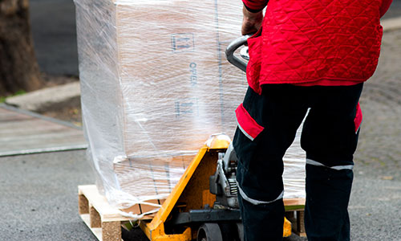
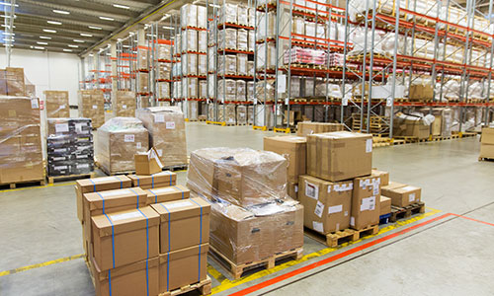
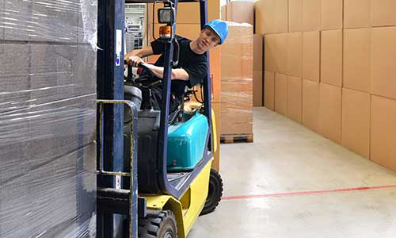
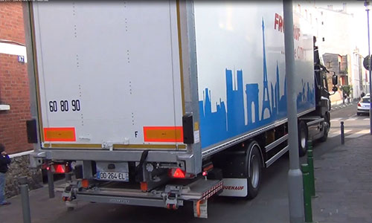

Courier service
Fruehauf designs and manufactures equipment that is recognised by the market for its sturdiness. Specially adapted to courier companies, the ExpressLiner van guarantees operation with no risk of downtime.

Sturdiness

2,700 mm
Its mechanically welded chassis and its reinforced rear frame with lifting door are perfectly suited to intensive, harsh, consecutive applications for intensive drop-offs and frequent loading.
Numerous equipment variants enable reinforced protection during loading or unloading operations.
- Sturdiness
- Reliability
- Adaptability
Reinforced mechanically welded chassisGuillaume Calviac2021-01-27T14:16:10+01:00
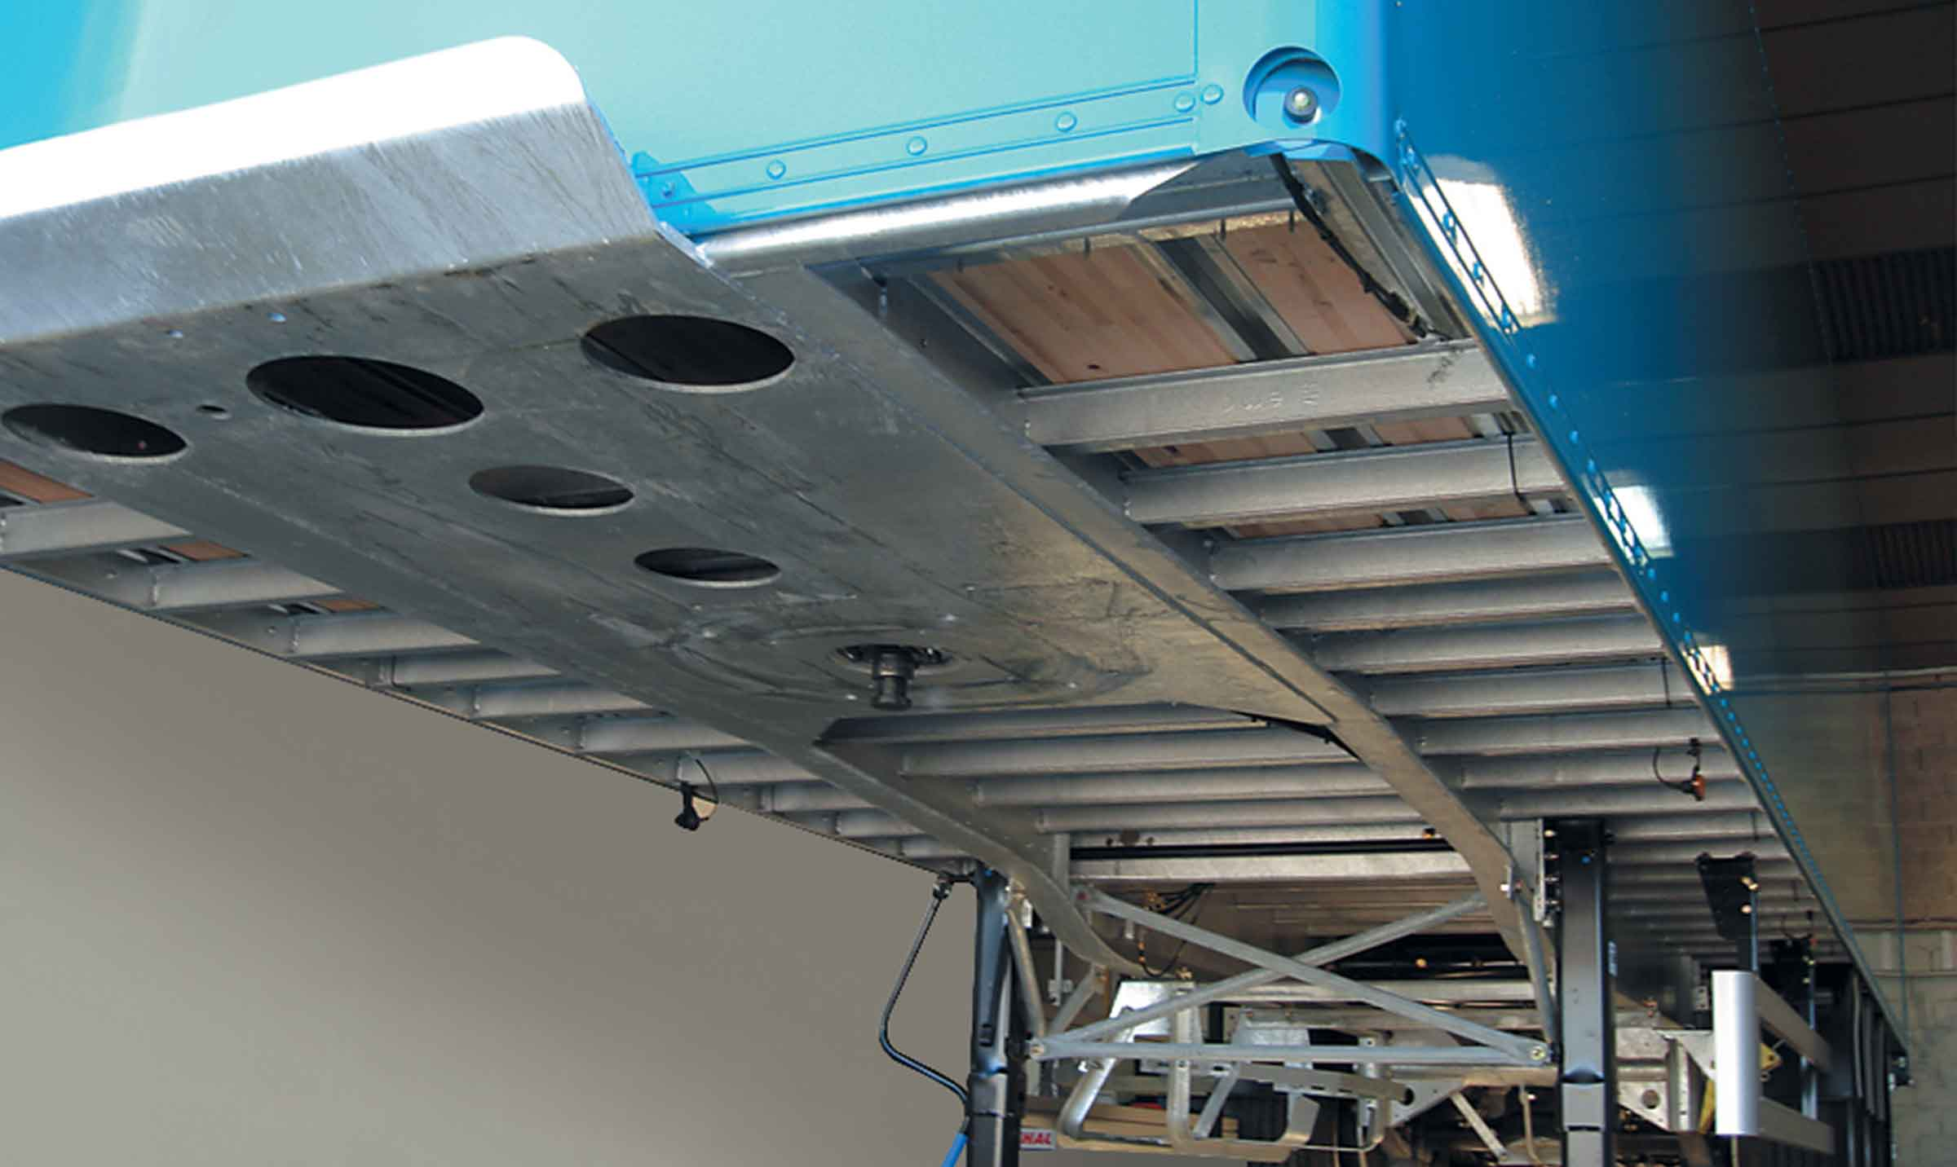
Gallery

Reinforced mechanically welded chassis
ExpressLiner Messagerie
Reinforced protectionGuillaume Calviac2021-01-27T14:15:32+01:00
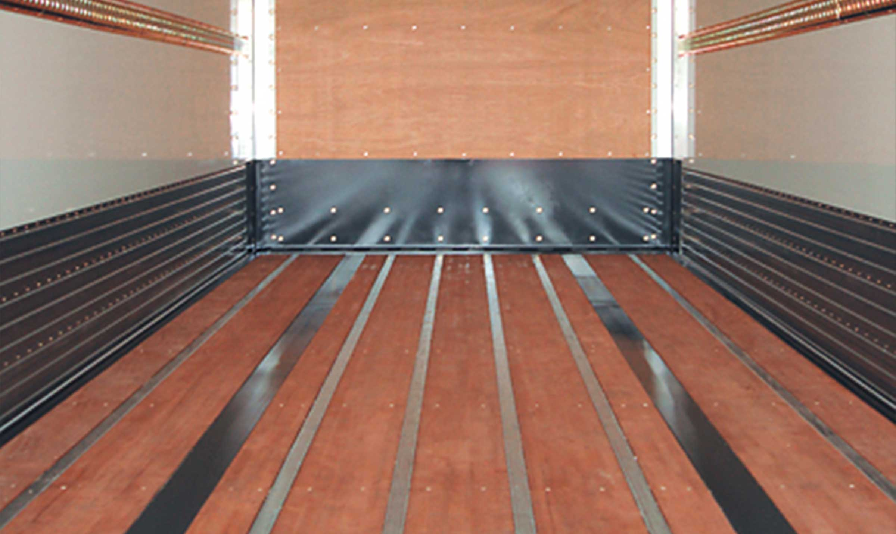
Gallery

Reinforced protection
ExpressLiner Messagerie
Reinforced frameGuillaume Calviac2021-01-27T14:15:01+01:00
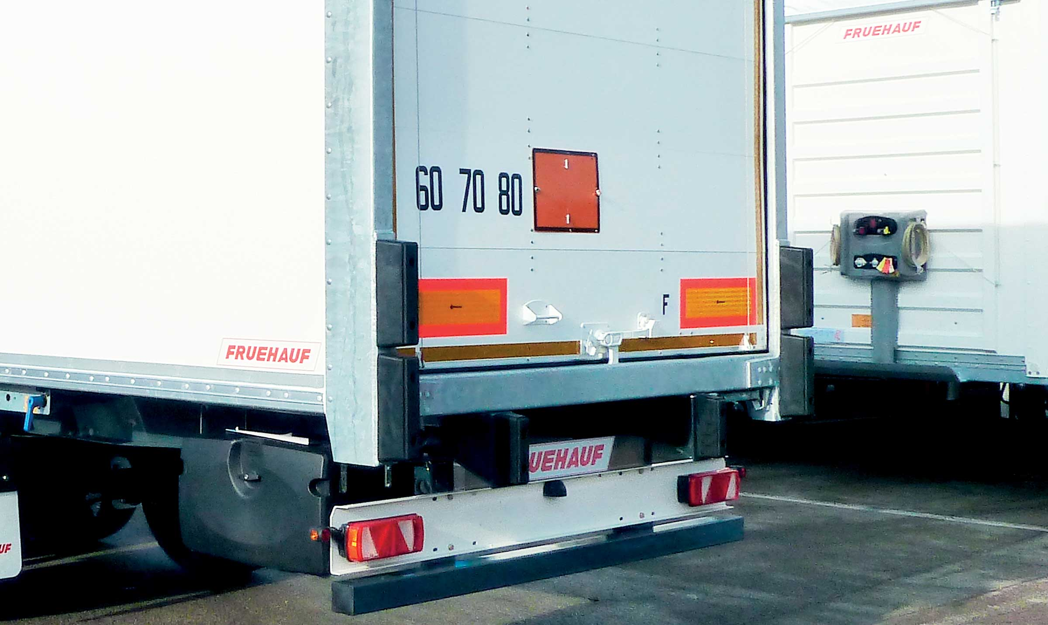
Gallery

Reinforced frame
ExpressLiner Messagerie
ExpressLiner Courier ServiceGuillaume Calviac2021-01-27T14:13:50+01:00
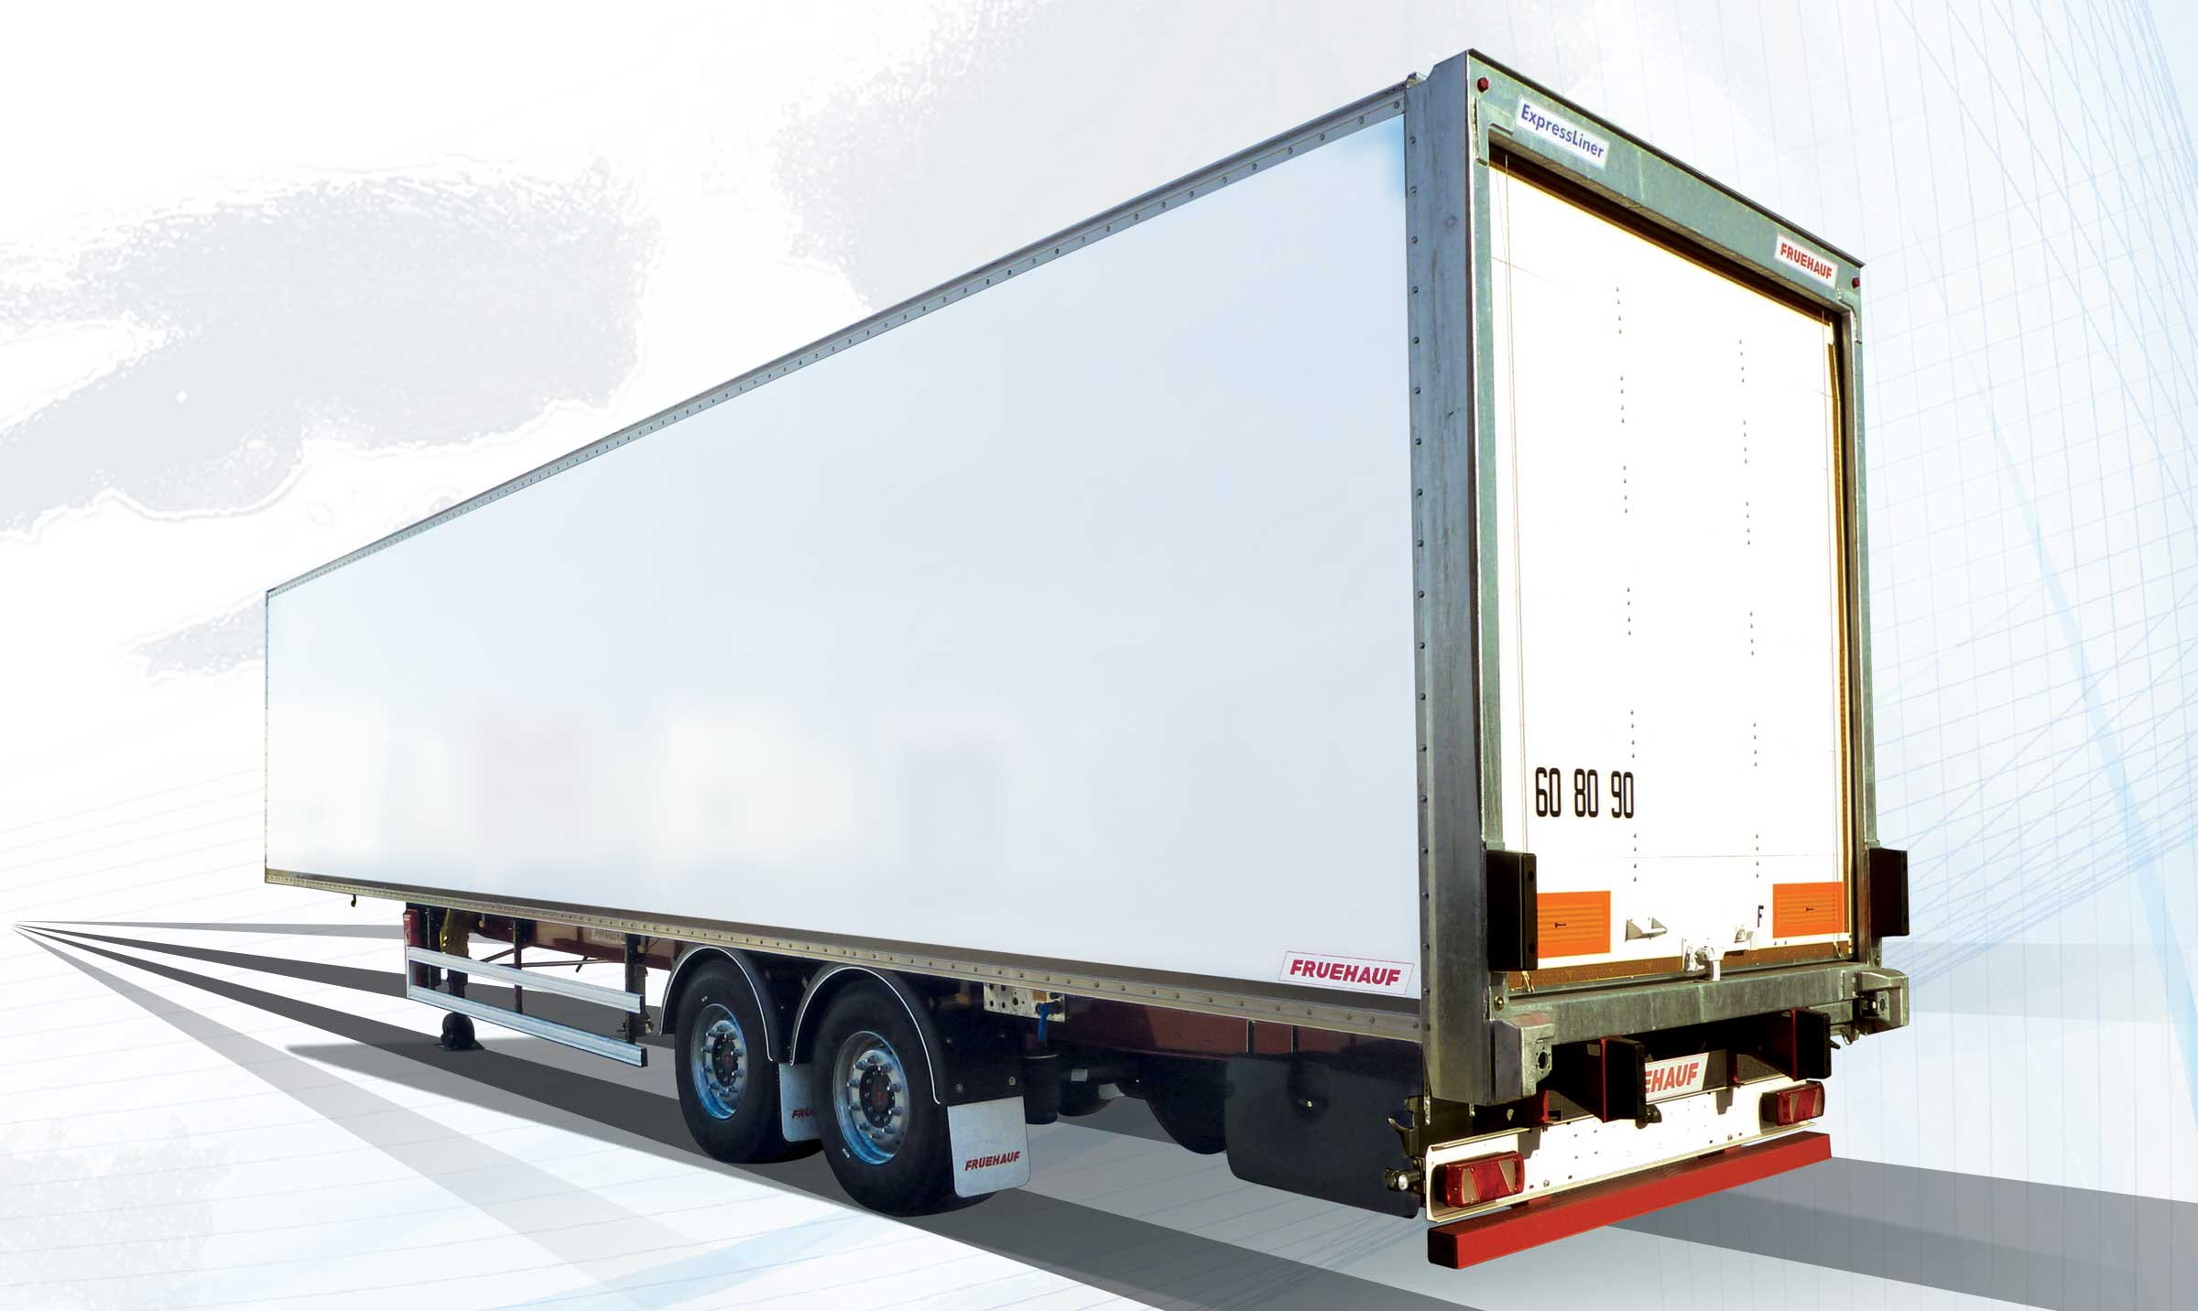
Gallery

ExpressLiner Courier Service
ExpressLiner Messagerie
Roller Shutter doorGuillaume Calviac2021-01-27T14:13:07+01:00
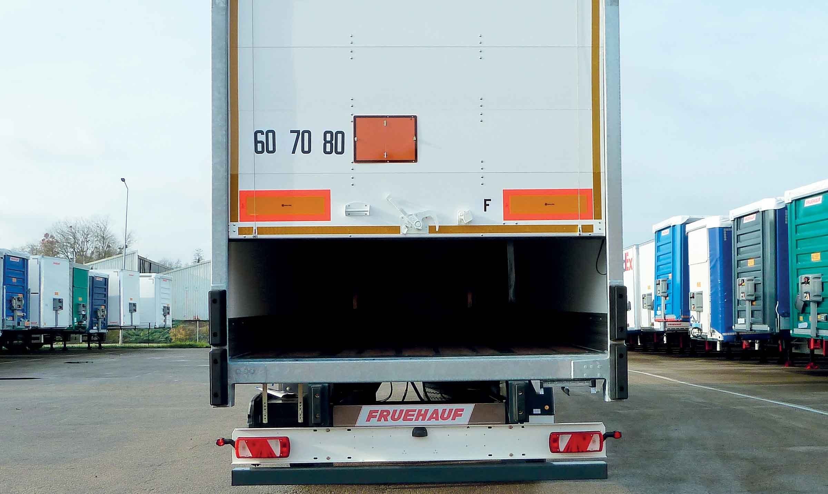
Gallery

Roller Shutter door
ExpressLiner Messagerie
Documentation

Distribution and industrial loads
The wide range of types of transport calls for perfectly suited equipment. As standard equipment cannot hope to meet every requirement, the ExpressLiner van is the versatile product par excellence.

Versatility

2,700 to 2,800 mm
Its freight security and bodywork protection equipment are perfectly suited to transporting full loads.
Available with two twin axles or three single axles, it guarantees maximum payload.
- Adaptablity
- Safe loading
- Reliability
Cargo retaining barGuillaume Calviac2021-02-09T16:40:23+01:00
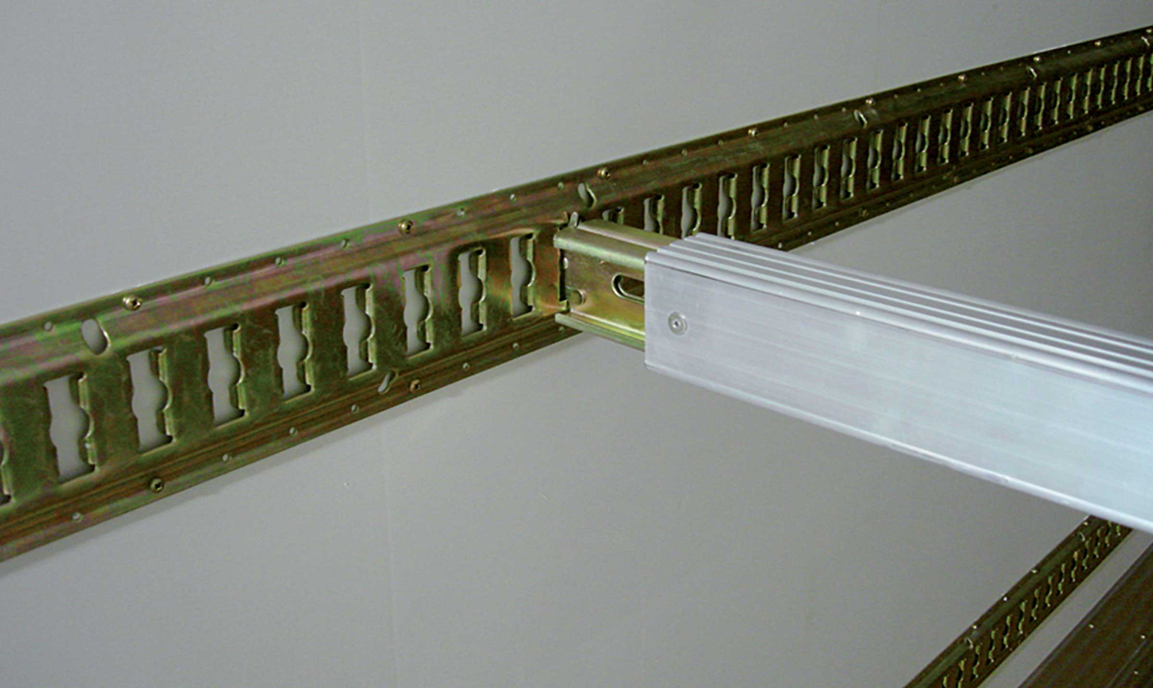
Gallery

Cargo retaining bar
ExpressLiner Distribution Lots
ExpressLinerGuillaume Calviac2021-01-27T14:28:54+01:00
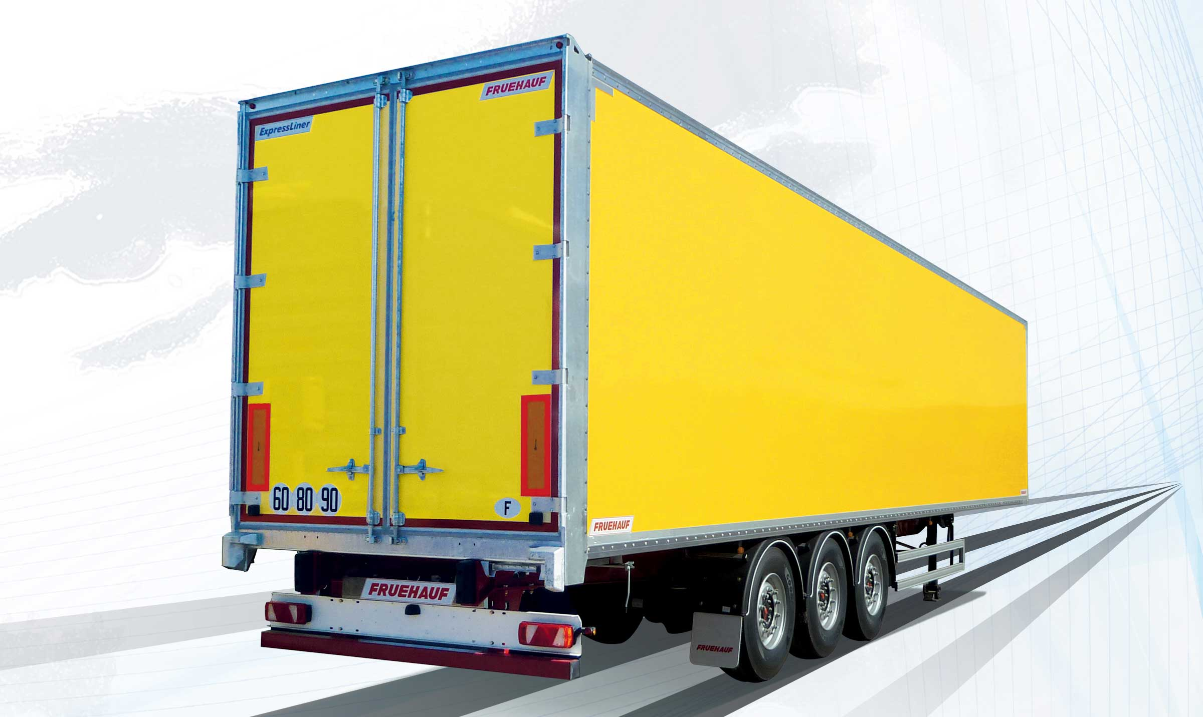
Gallery

ExpressLiner
ExpressLiner Distribution Lots
ExpressLinerGuillaume Calviac2021-01-27T14:28:36+01:00
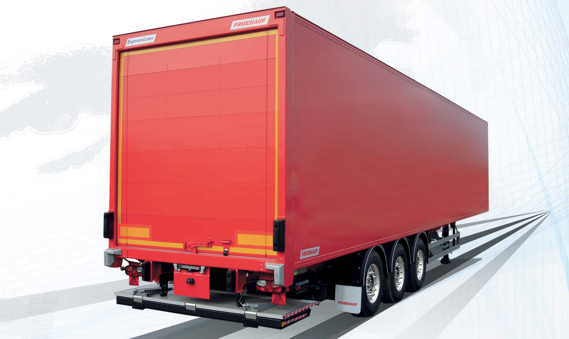
Gallery

ExpressLiner
ExpressLiner Distribution Lots
Cargo searing railsGuillaume Calviac2021-02-09T16:39:50+01:00
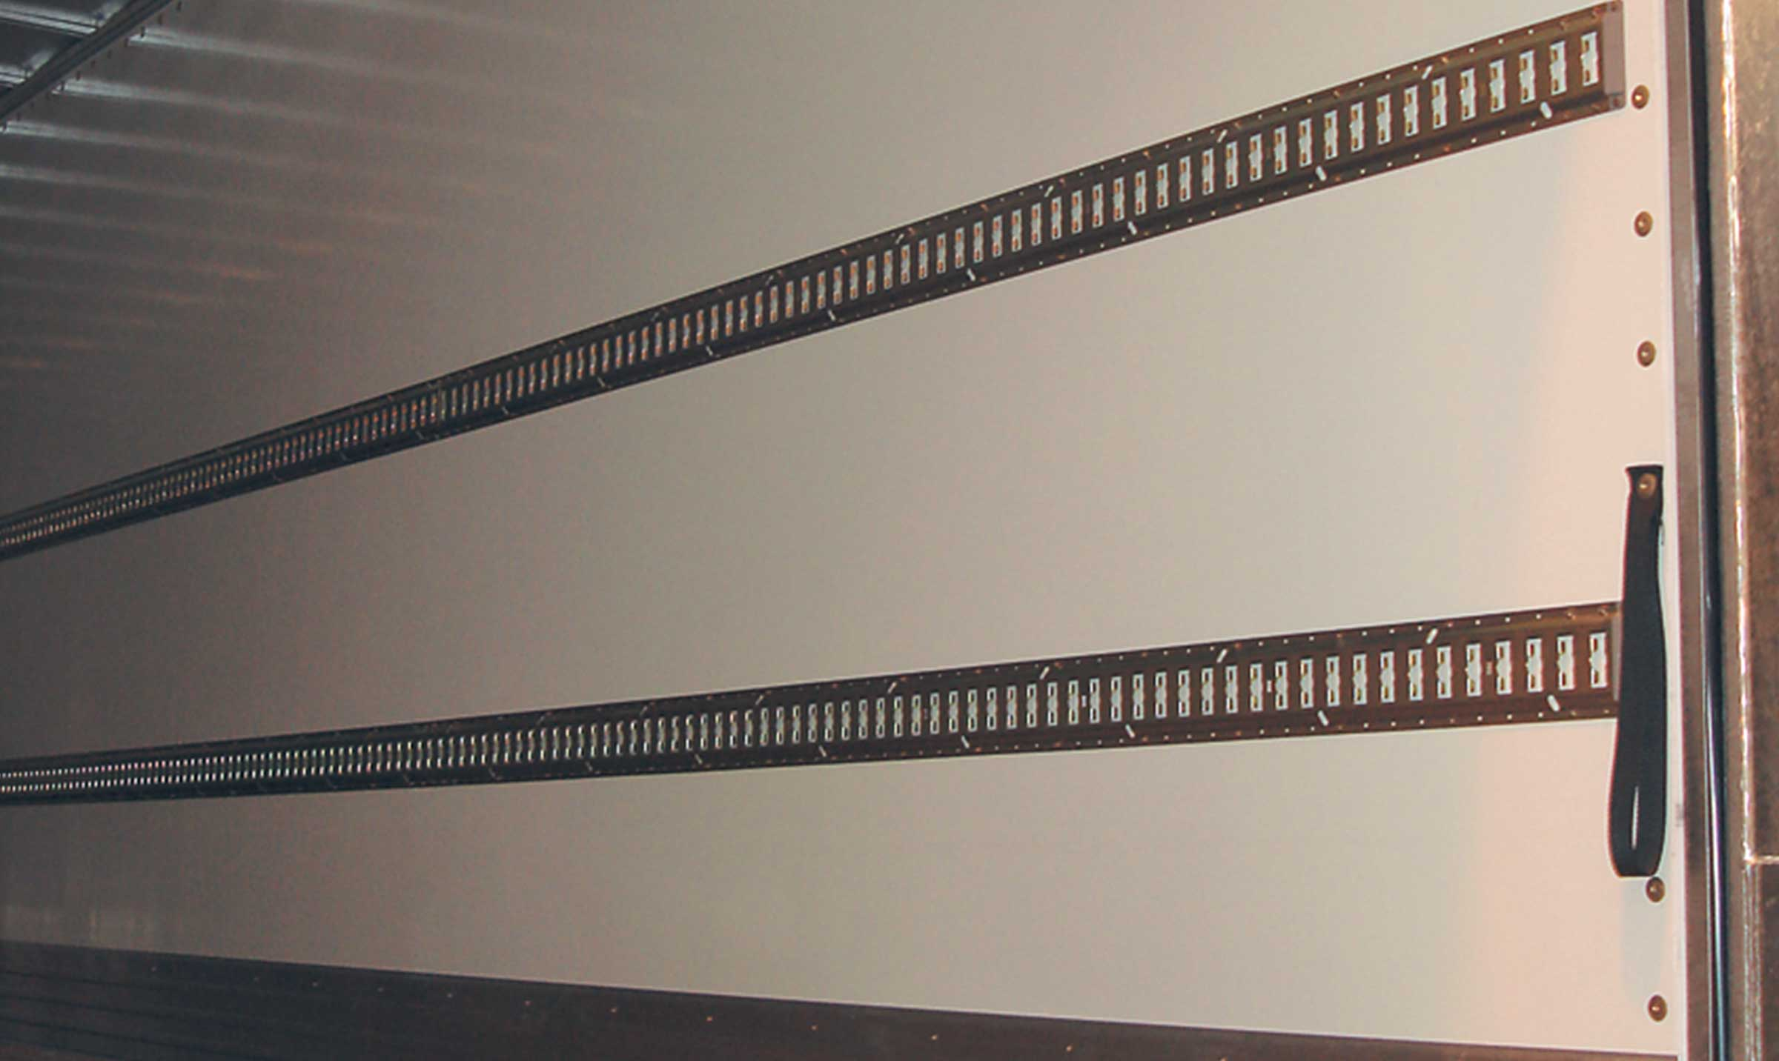
Gallery

Cargo searing rails
ExpressLiner Distribution Lots
Retractable tail liftGuillaume Calviac2021-04-15T11:10:36+02:00
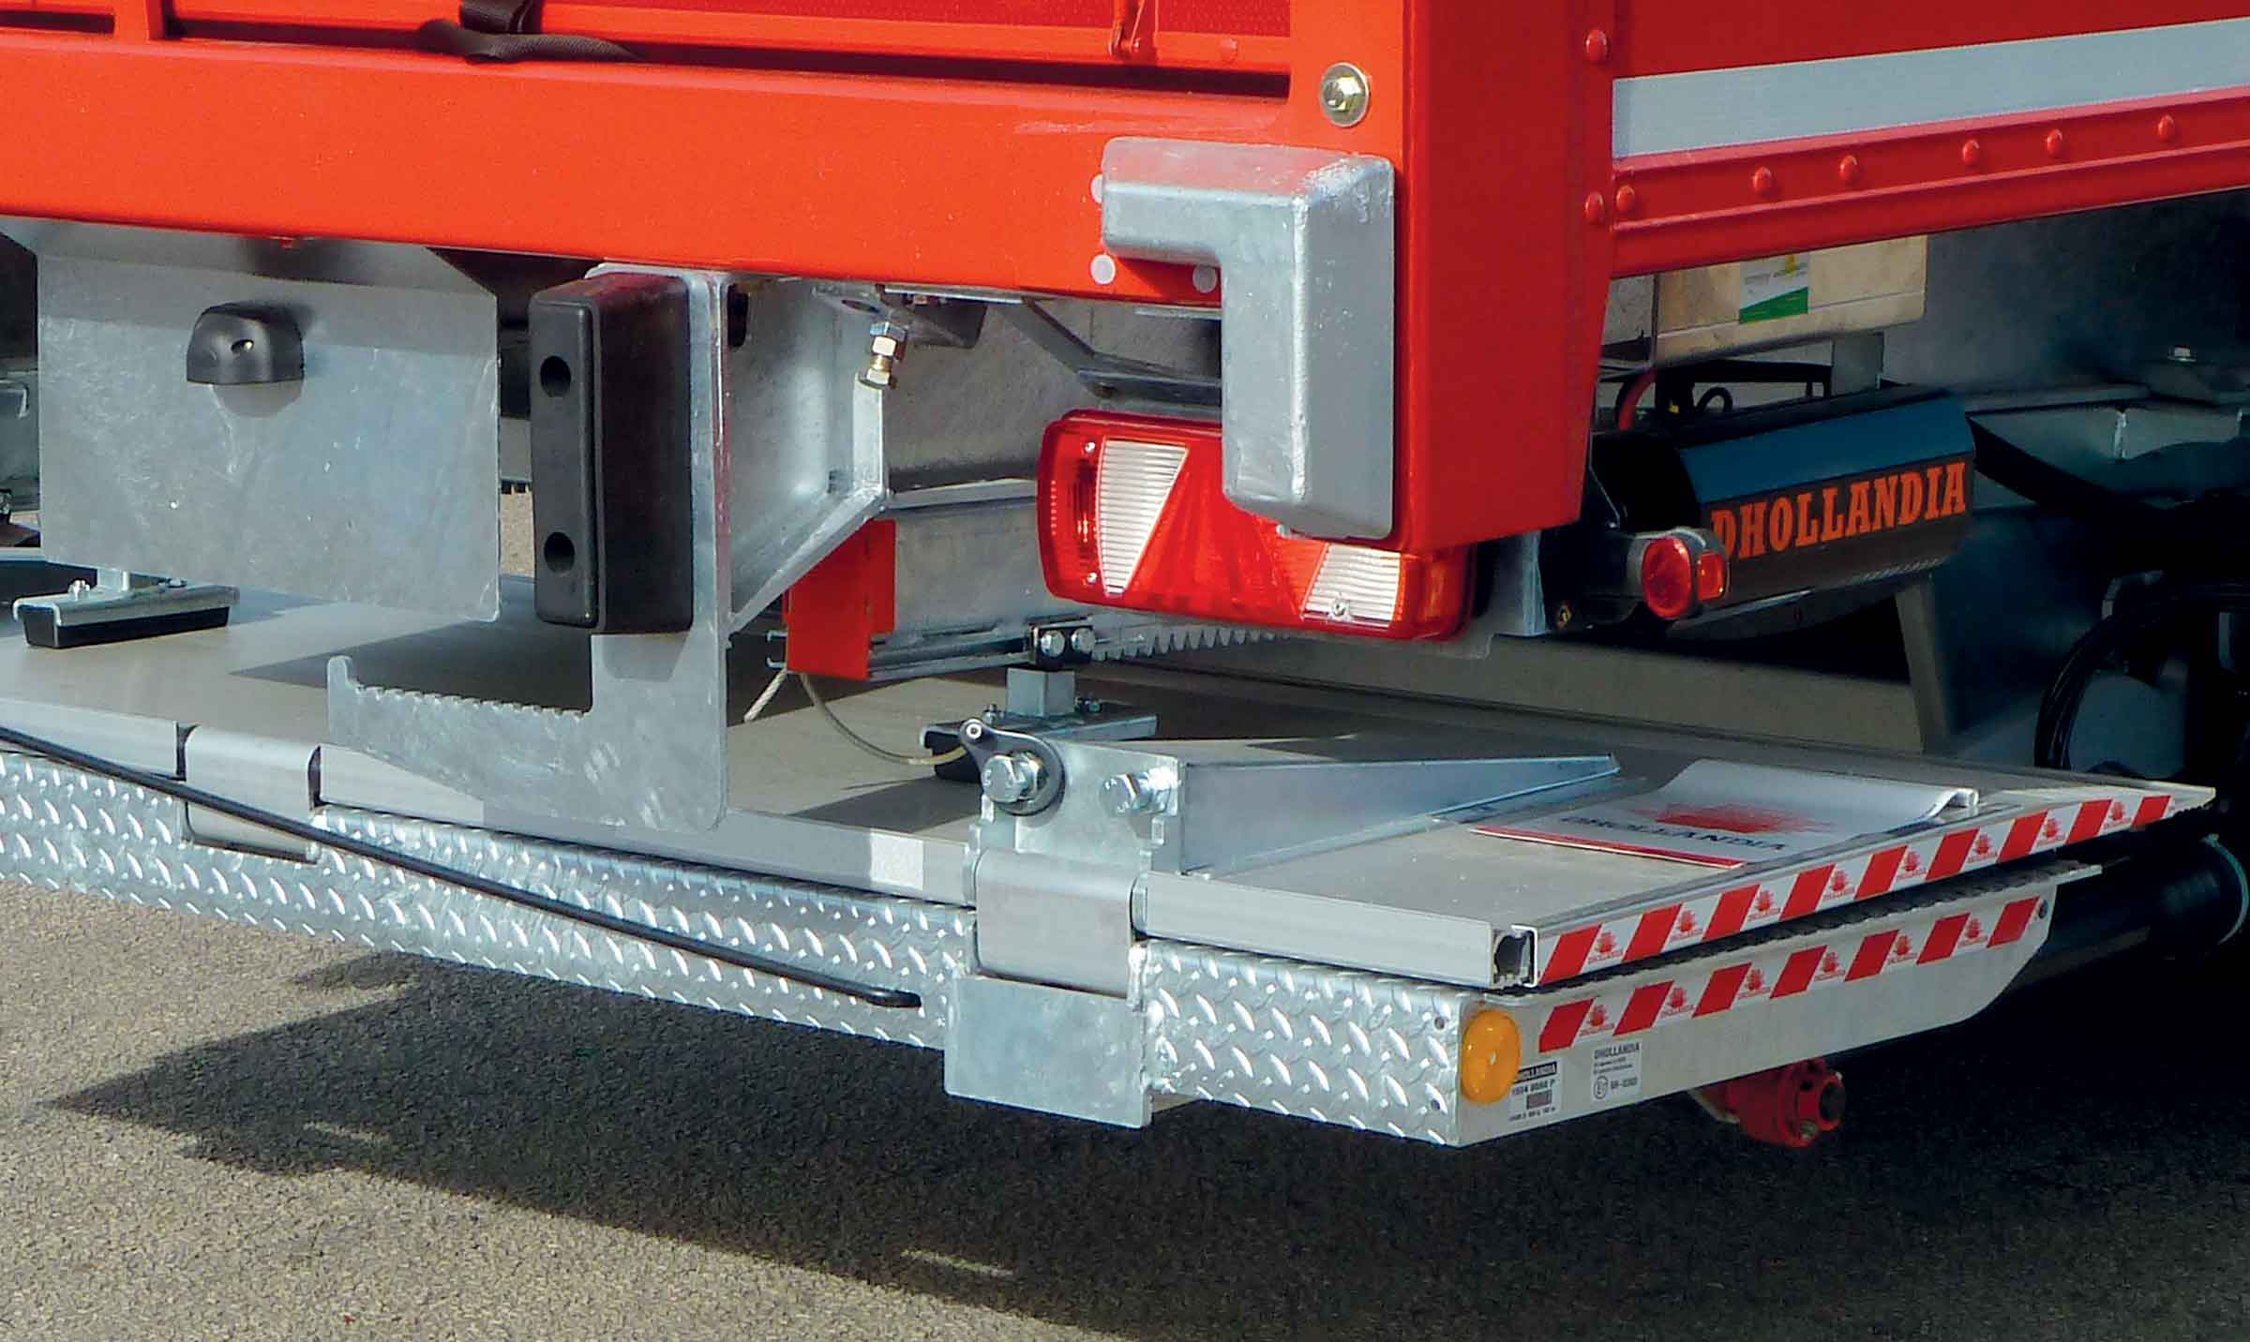
Gallery

Retractable tail lift
ExpressLiner Distribution Lots
2nd load levelGuillaume Calviac2021-02-10T09:45:48+01:00
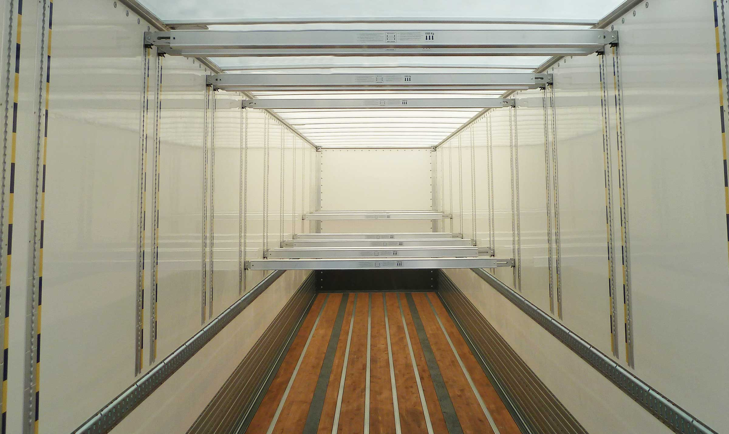
Gallery

2nd load level
CITY - Urban - Fourgons EN, City Fourgon, ExpressLiner Distribution Lots
Documentation

Large volume
Dedicated to the transport of large, non-heavy goods, the ExpressLiner Large Volume van offers maximum interior height.

Maximum interior height

From 2,900 to 3,100 mm
Available in 2 or 3 axle versions, Large Volume vans are equipped with an undercarriage for low-level coupling.
Equipped with a double deck, the vehicle can be loaded over its full height without any risk of the goods being transported getting damaged.
- Maximum interior height
- Versatile use
- Adaptability
Translucent polyester roofGuillaume Calviac2021-01-27T14:37:55+01:00
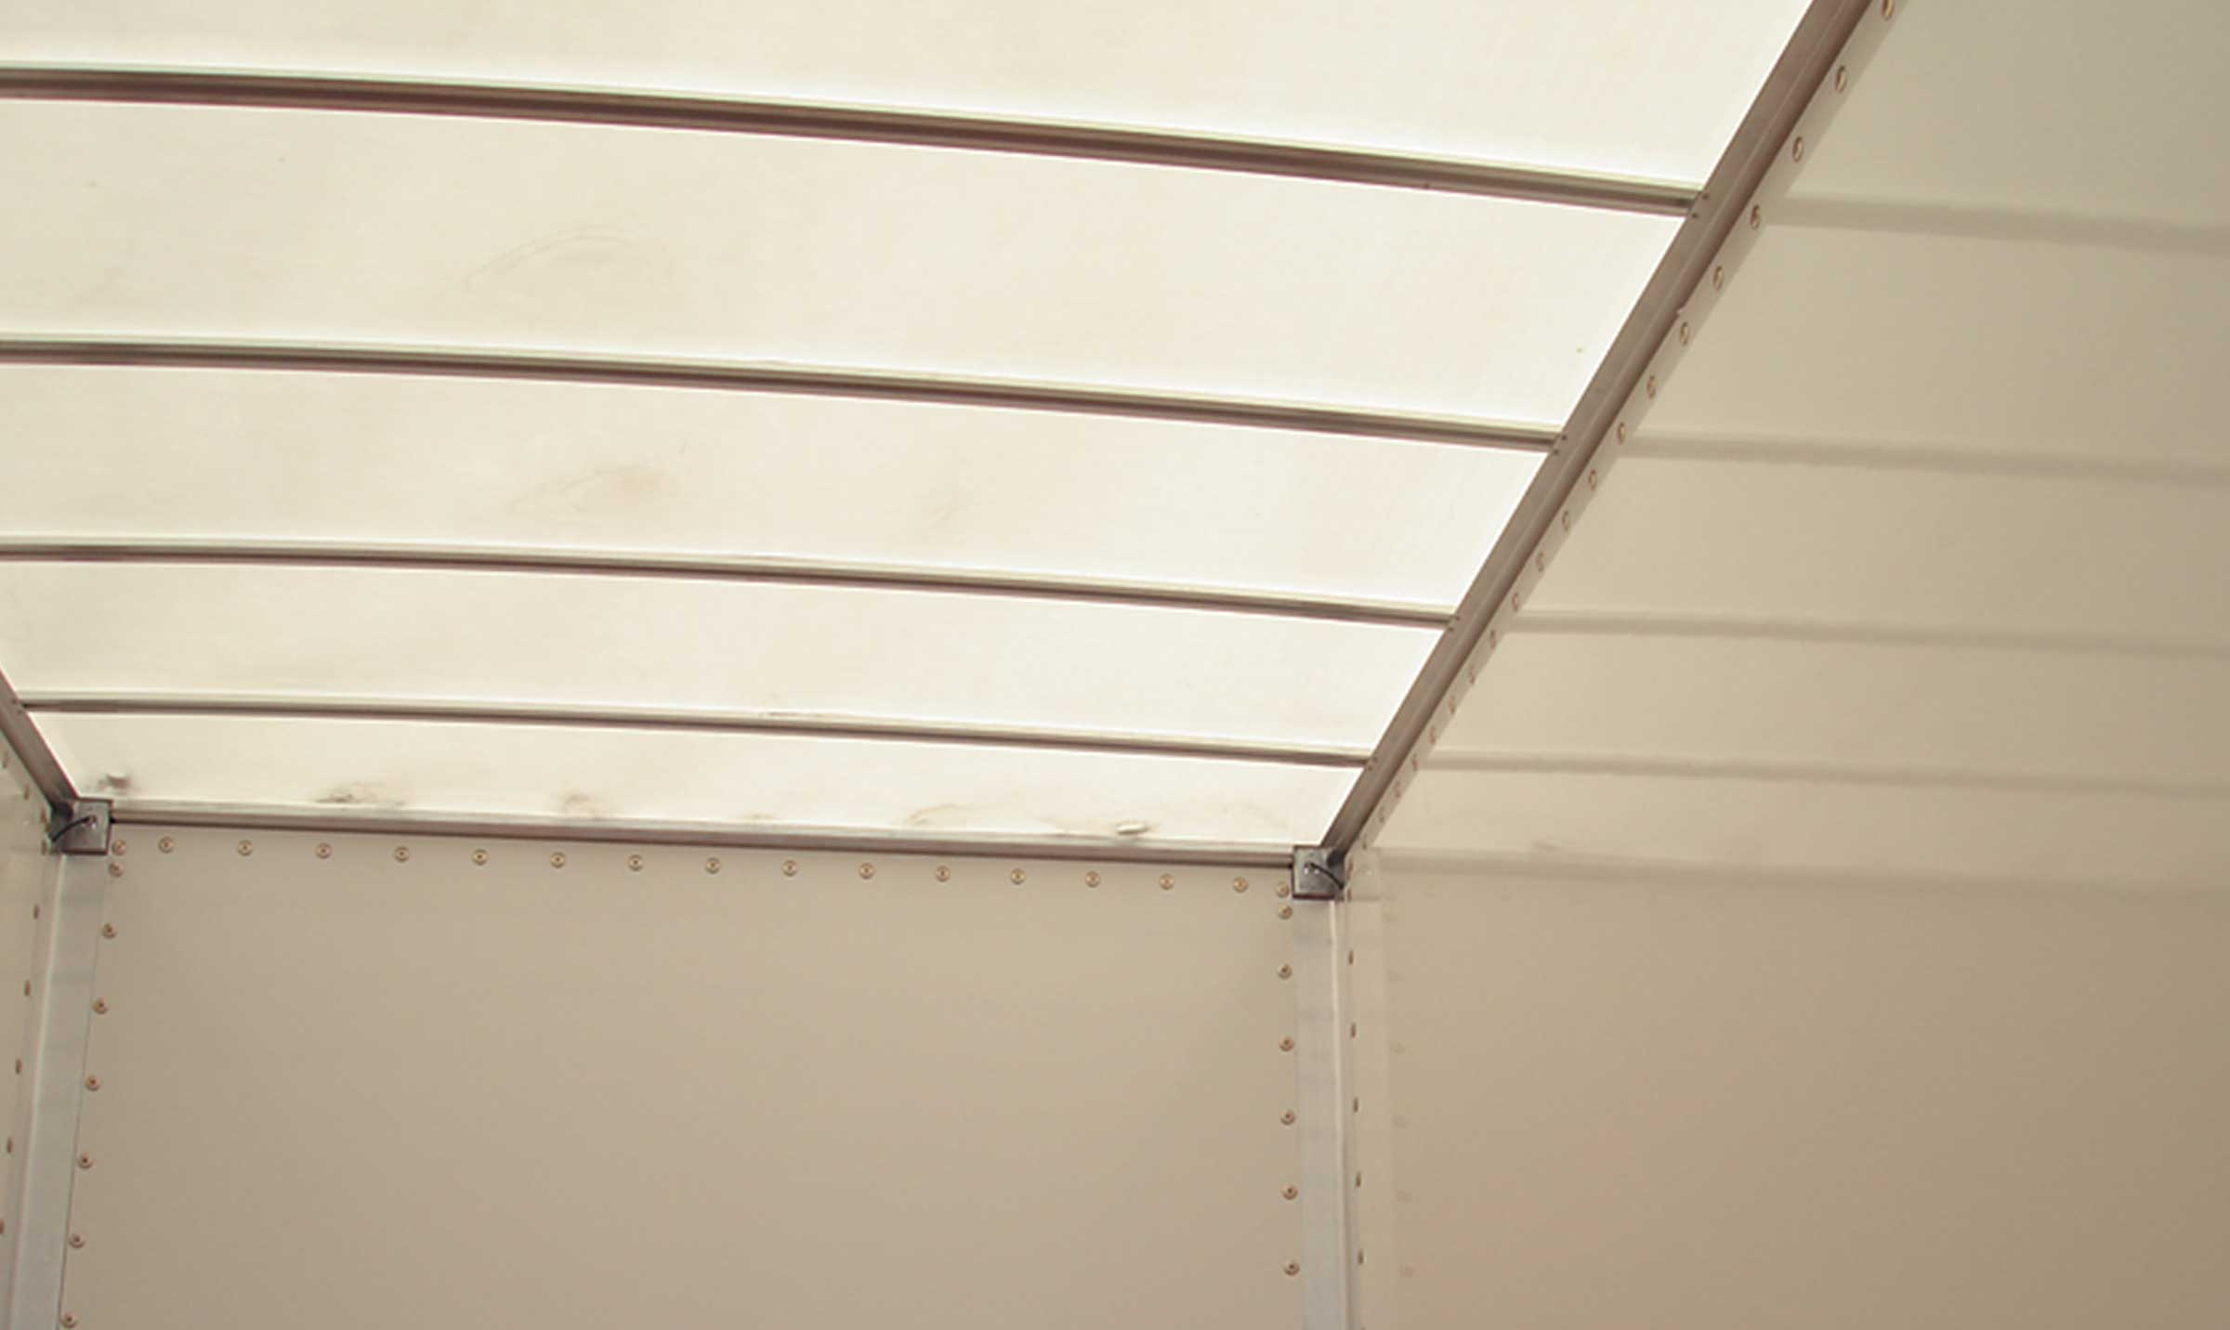
Gallery

Translucent polyester roof
ExpressLiner Grand Volume
Plain roofGuillaume Calviac2021-01-27T14:37:30+01:00
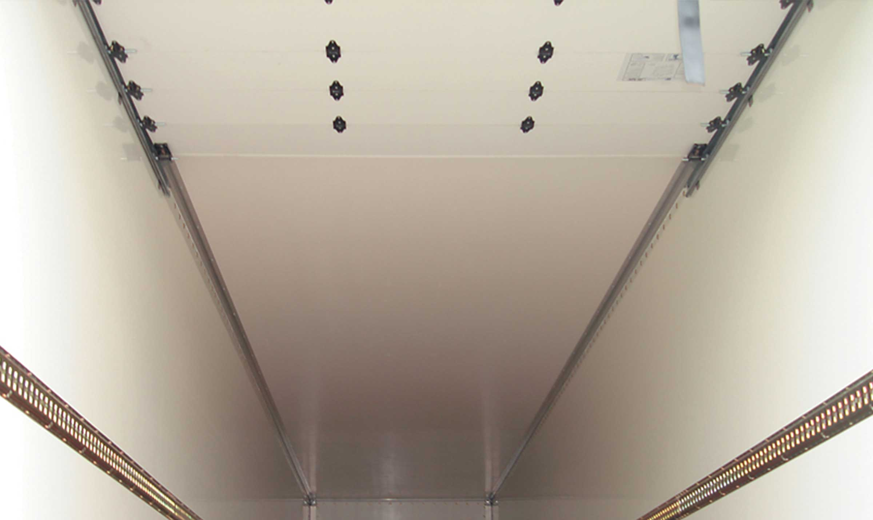
Gallery

Plain roof
ExpressLiner Grand Volume
Double deck installationGuillaume Calviac2021-04-12T10:01:50+02:00
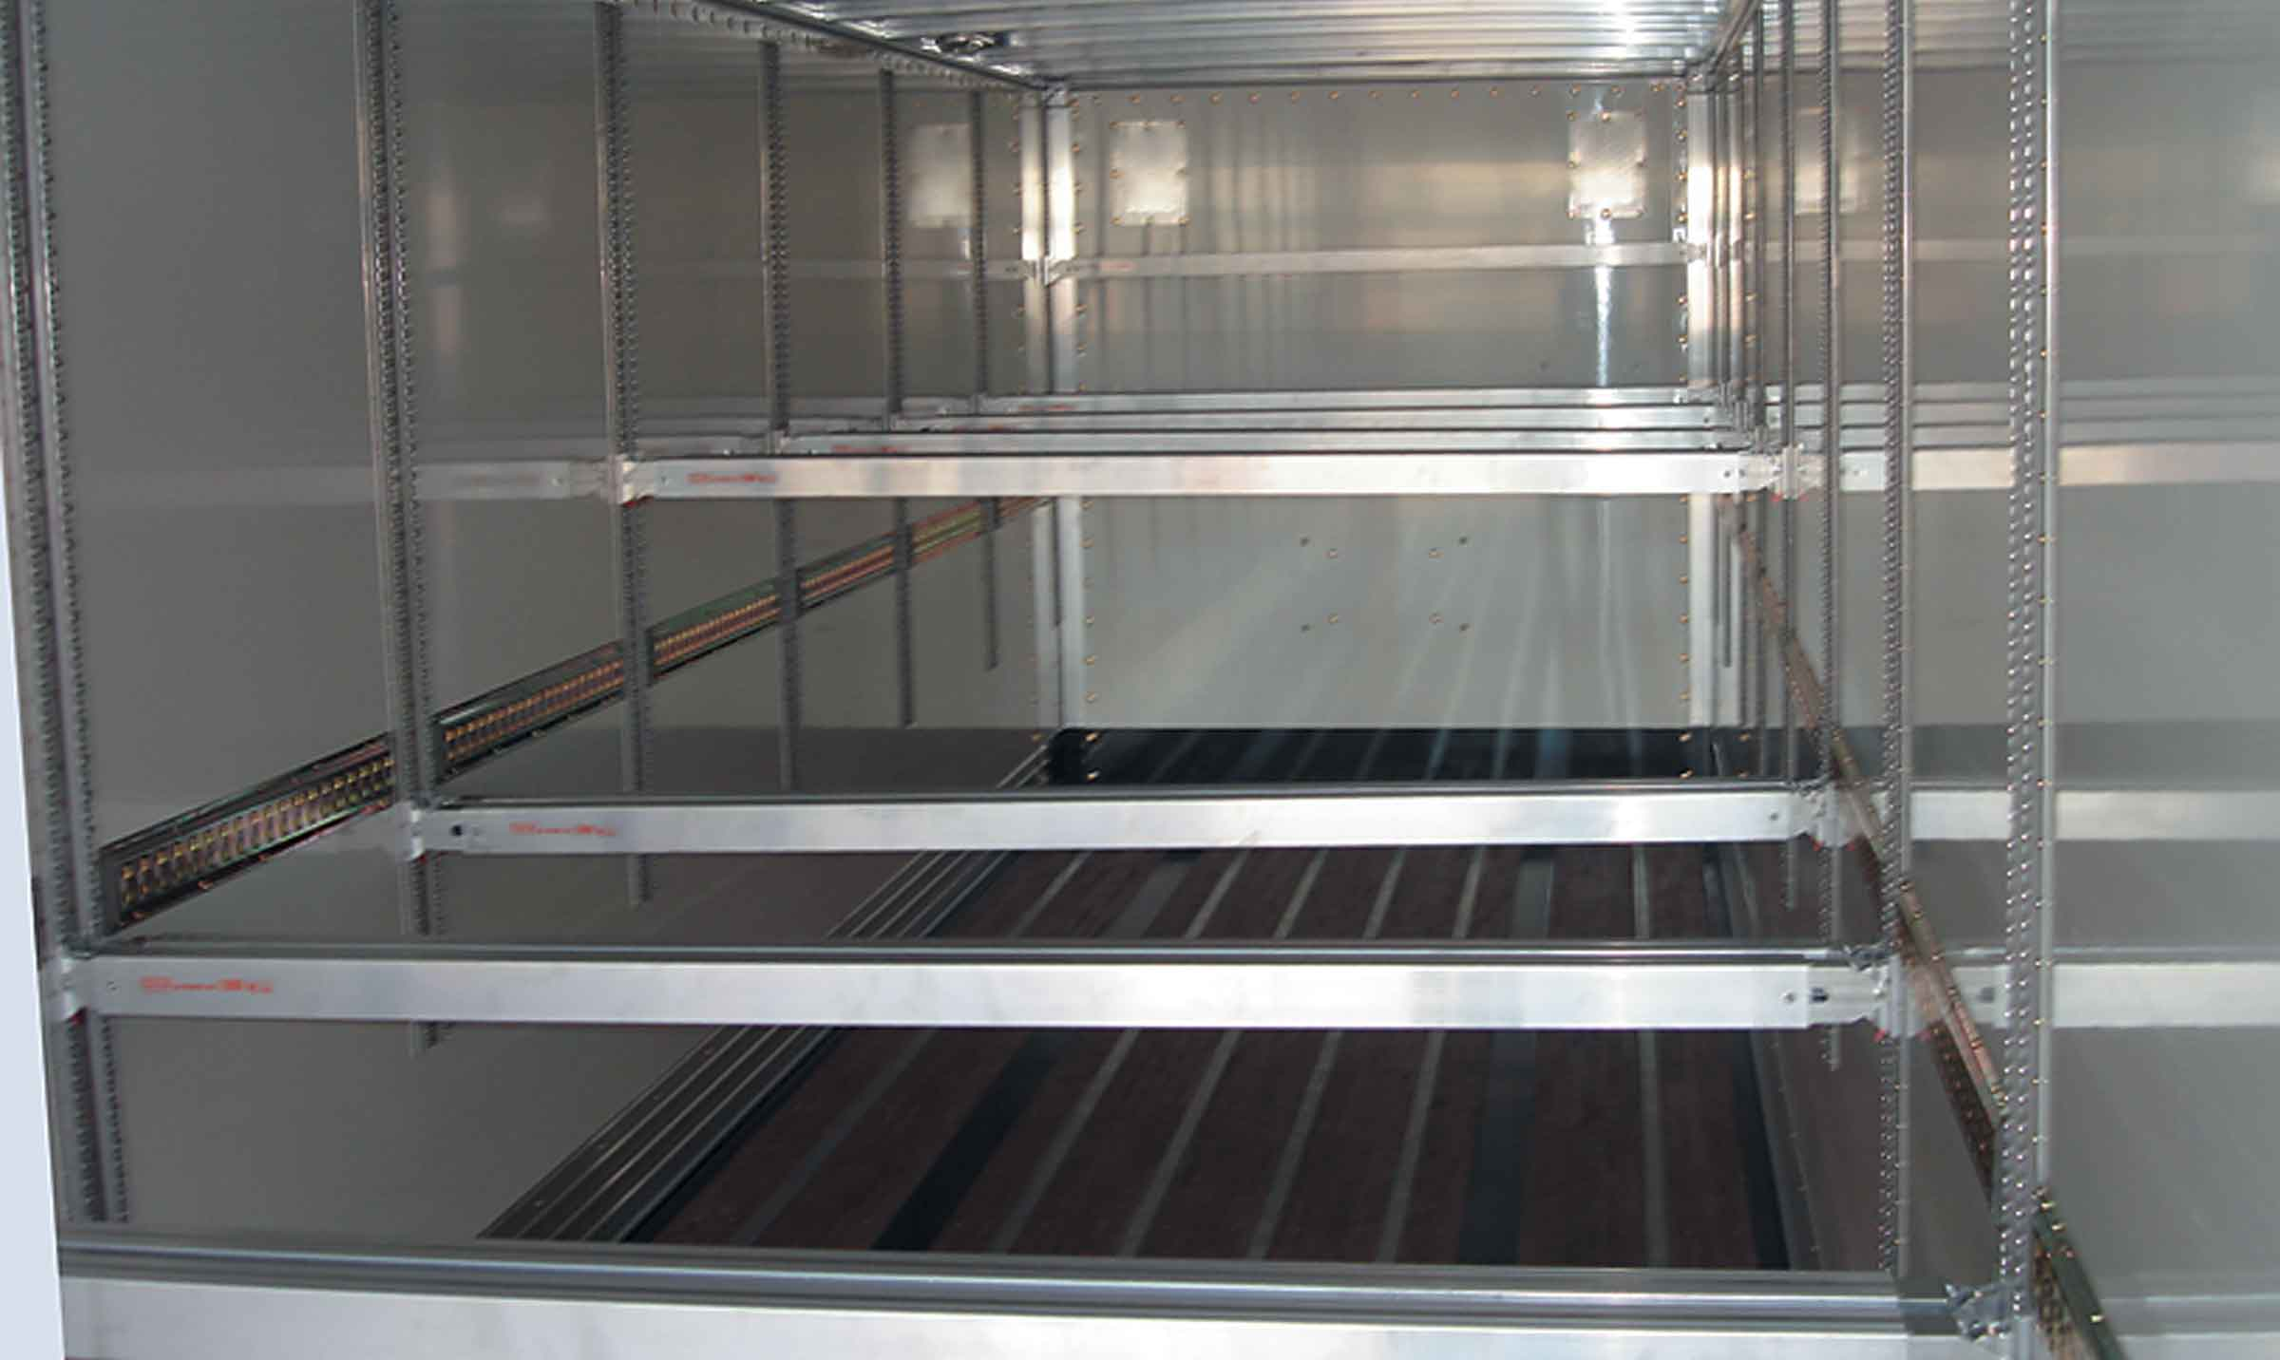
Gallery

Double deck installation
ExpressLiner Grand Volume
ExpressLinerGuillaume Calviac2021-01-27T14:36:18+01:00
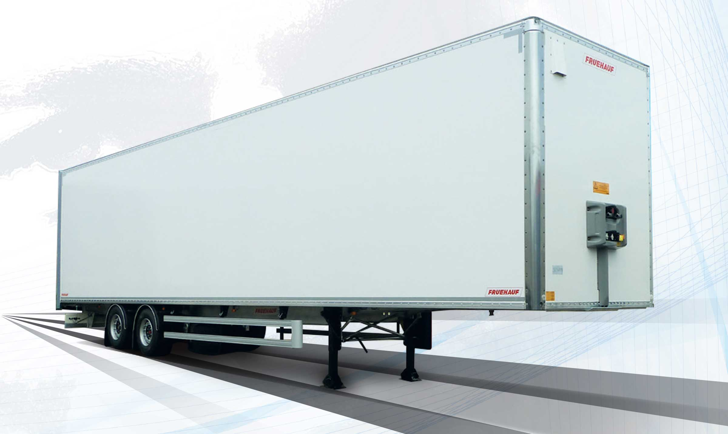
Gallery

ExpressLiner
ExpressLiner Grand Volume
Documentation

Urban delivery
Perfect for deliveries to local shops and courier companies, the CITY ExpressLiner offers a payload and manoeuvrability much better than traditional carriers, becoming the best solution for urban deliveries.

The best solution for distribution

From 21 to 27 palettes

Max. GVW 24 or 30 t
Its rear steering axle and its short wheelbase guarantee a trajectory almost identical to that of the truck.
Thanks to the permissible load on its rear axle, it offers an exceptional and unrivalled payload.
- Best payload
- Better manoeuvrability
- Ease of use
VanGuillaume Calviac2021-01-27T15:01:36+01:00
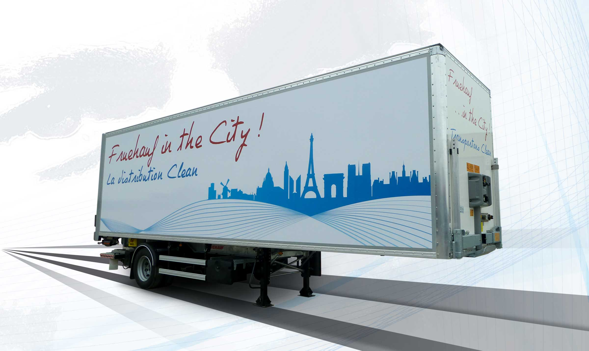
Gallery

Van
City Fourgon, Innovations - City
PIEK certificationGuillaume Calviac2021-01-27T14:59:29+01:00
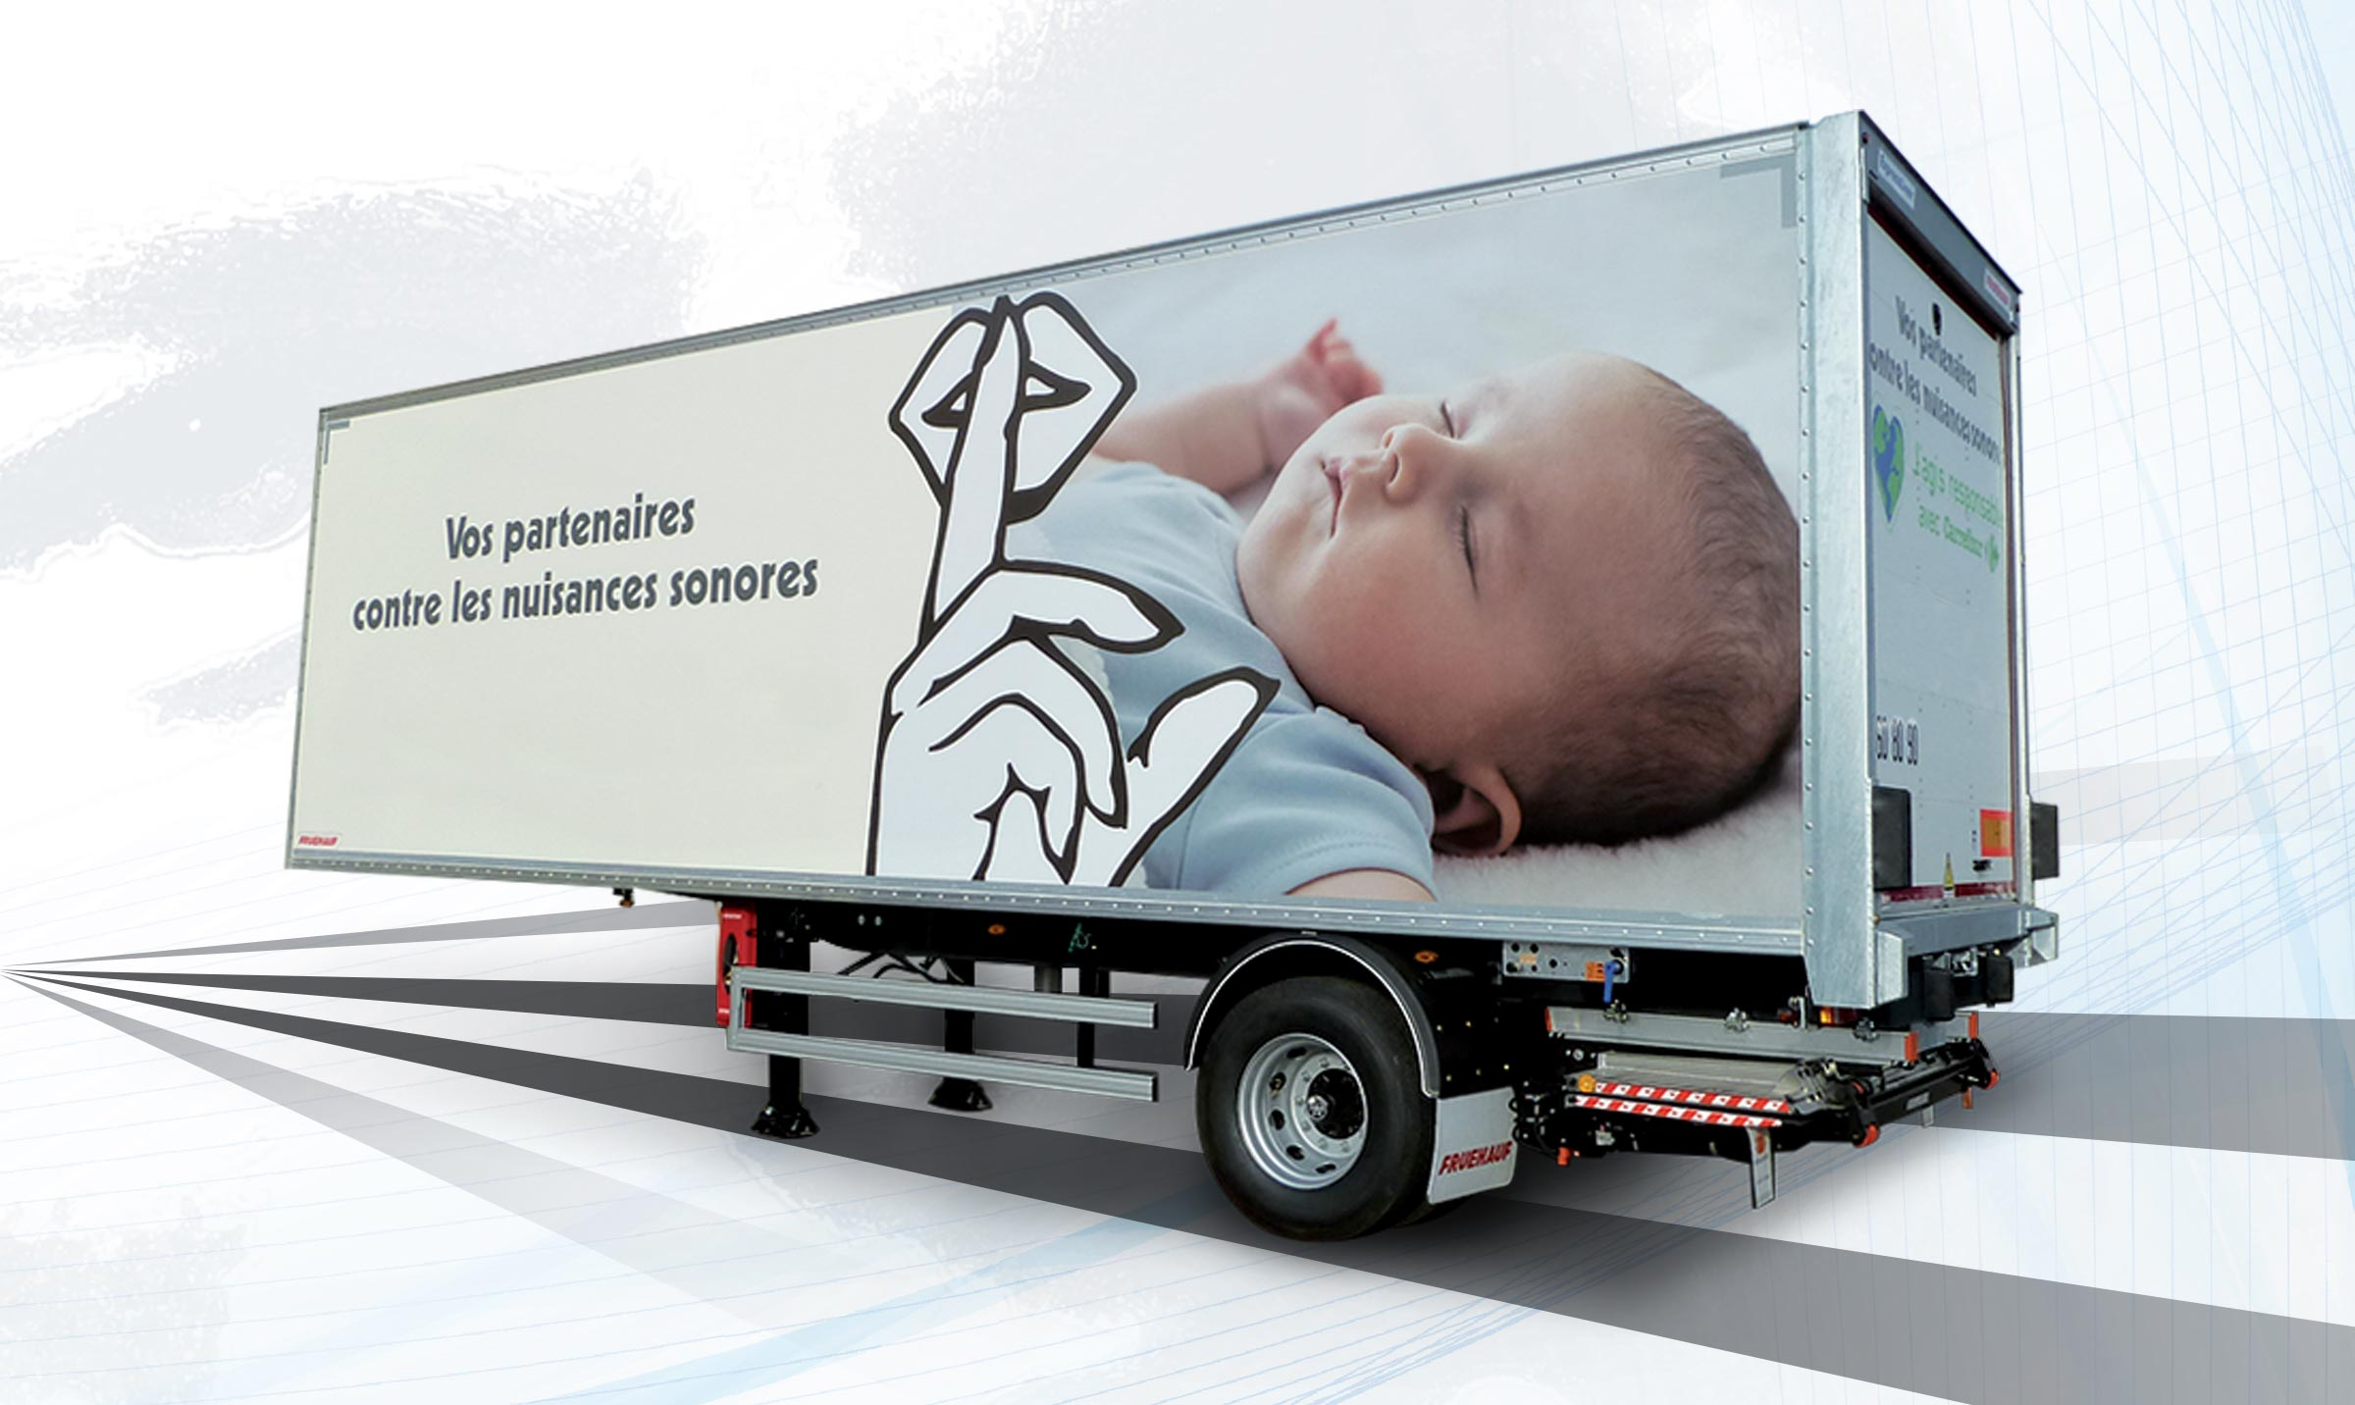
Gallery

PIEK certification
City Fourgon
Roll-up doorGuillaume Calviac2021-01-14T09:48:07+01:00
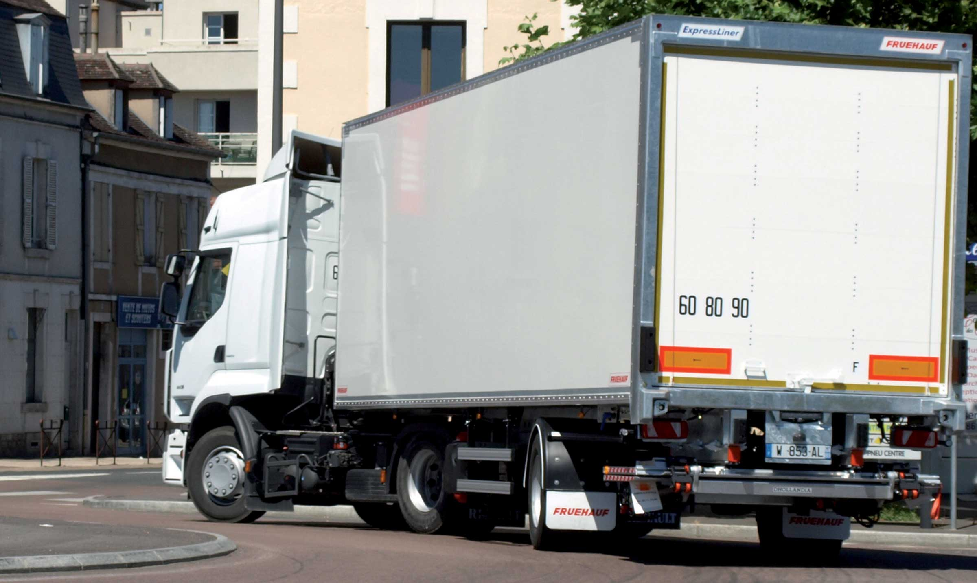
Gallery

Roll-up door
CITY - Urban - Fourgons EN, City Fourgon
Folding lift rear doorGuillaume Calviac2021-04-12T10:06:33+02:00
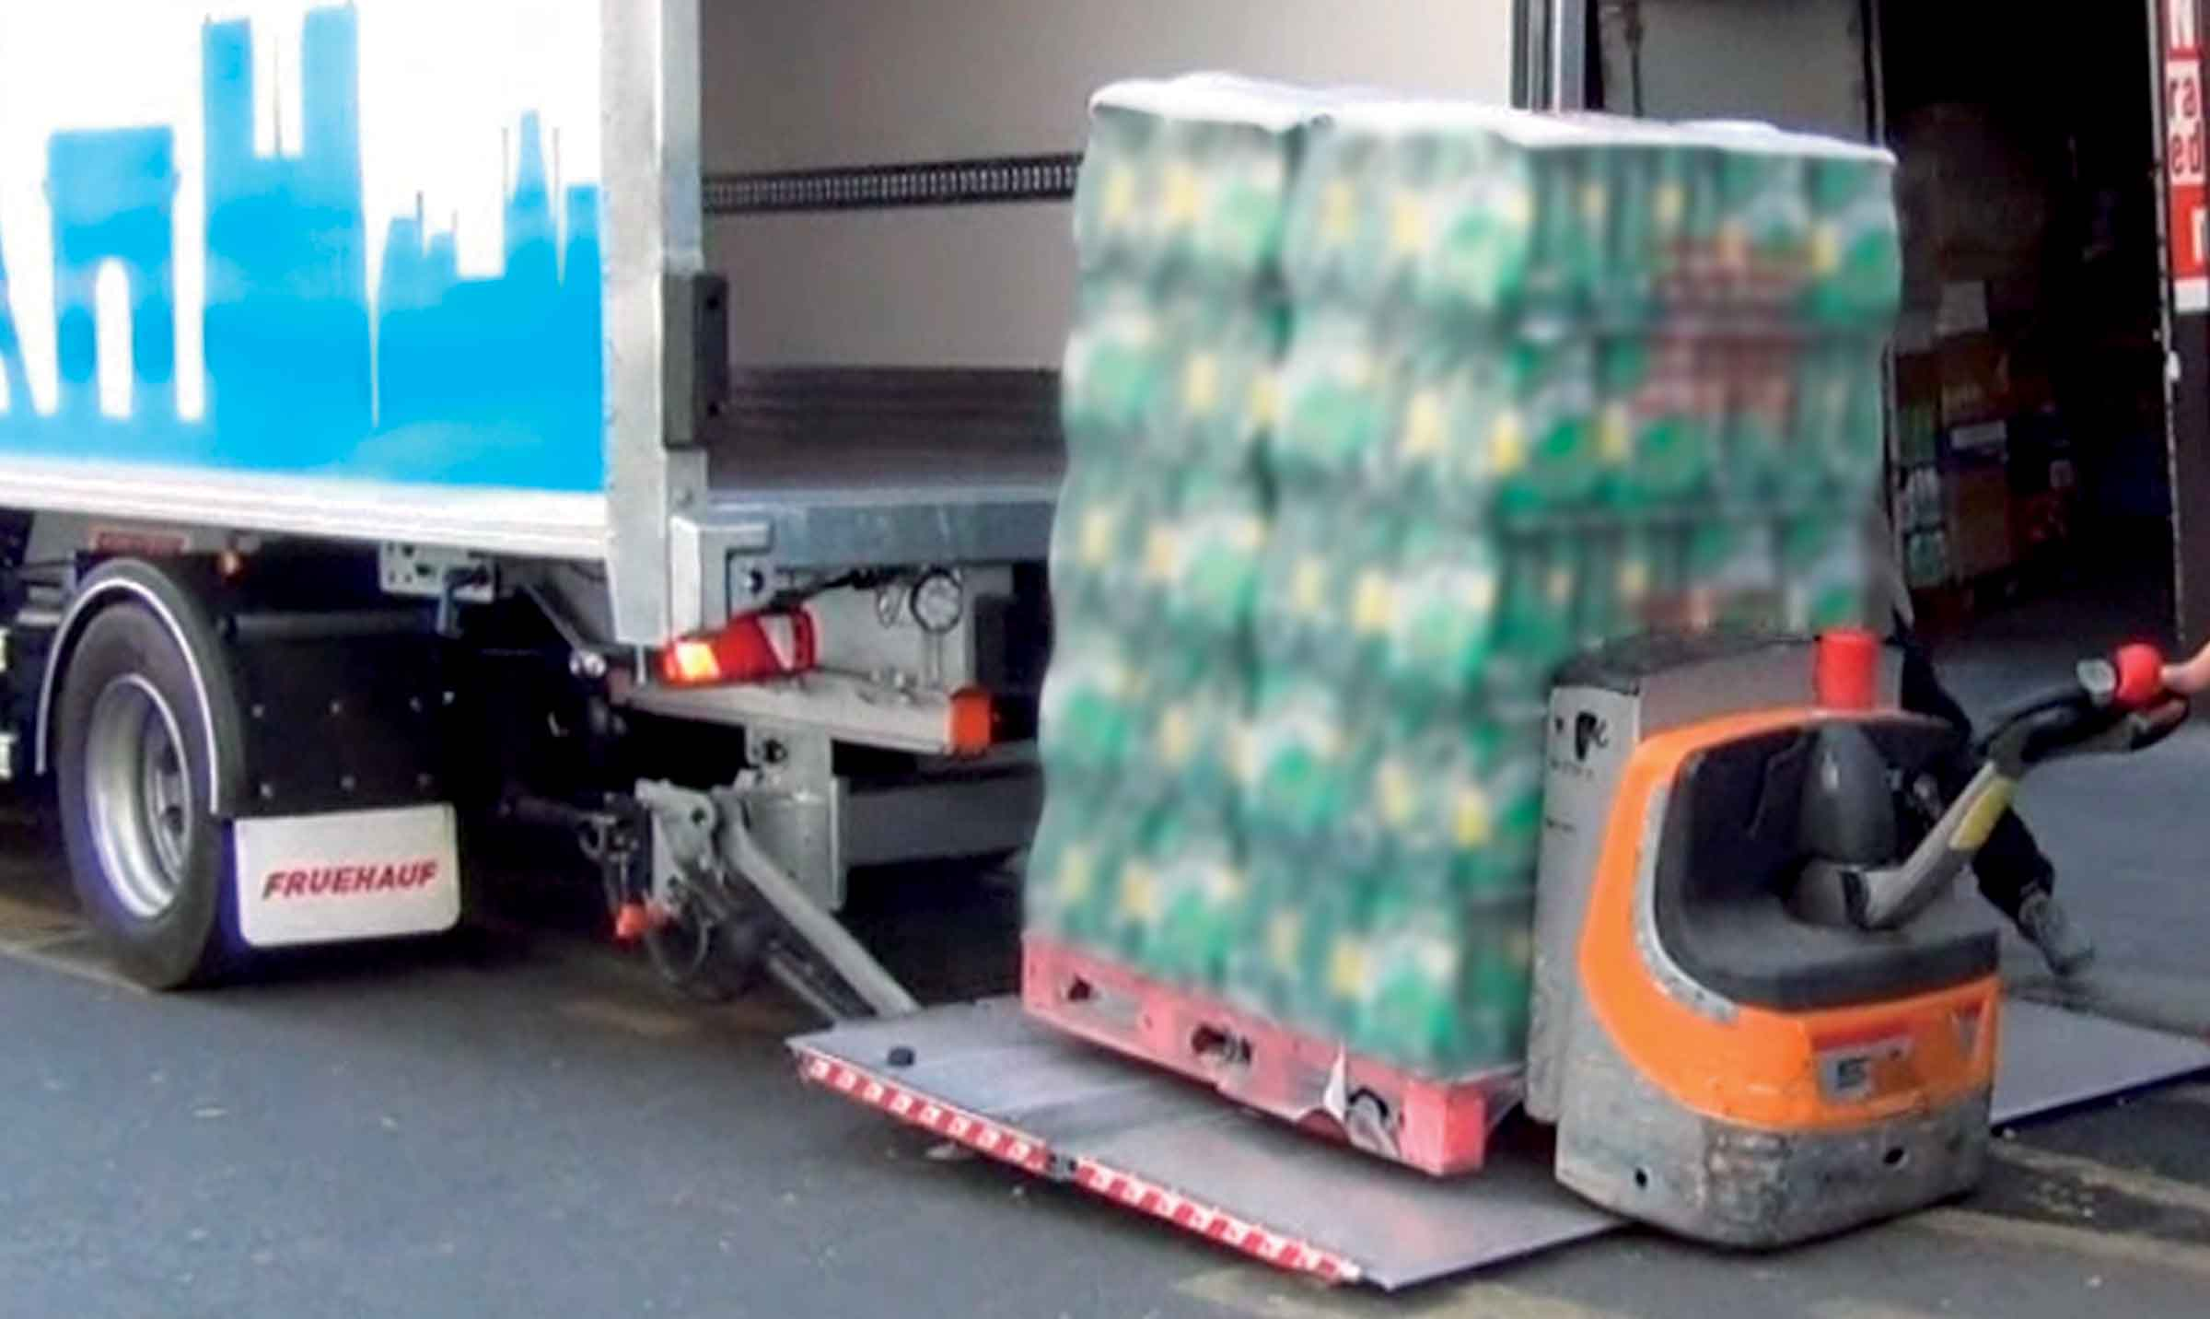
Gallery

Folding lift rear door
CITY - Urban - Fourgons EN, City Fourgon
Safety stabilizing crutchesGuillaume Calviac2021-06-01T13:42:45+02:00
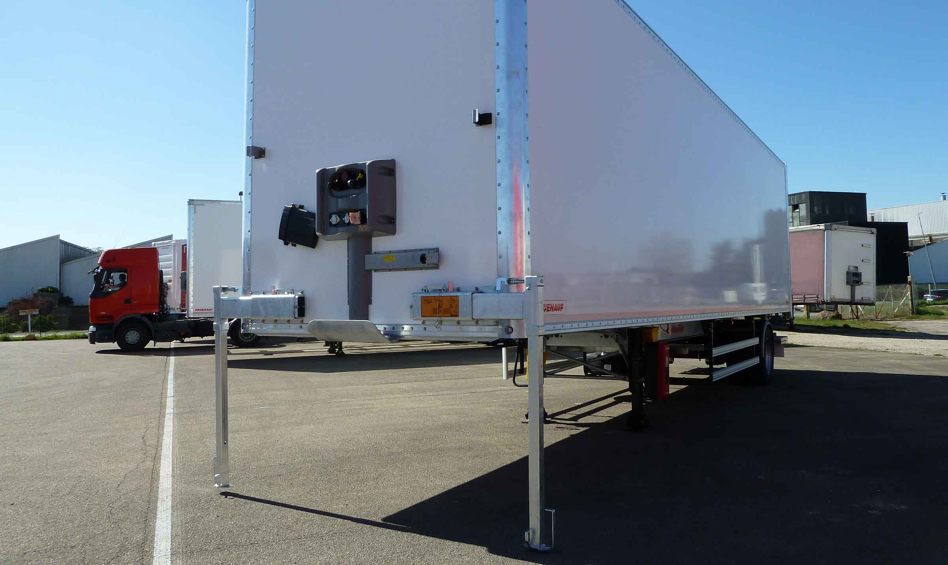
Gallery

Safety stabilizing crutches
CITY - Urban - Fourgons EN, City Fourgon
Retractable lift rear doorGuillaume Calviac2021-04-12T10:05:20+02:00
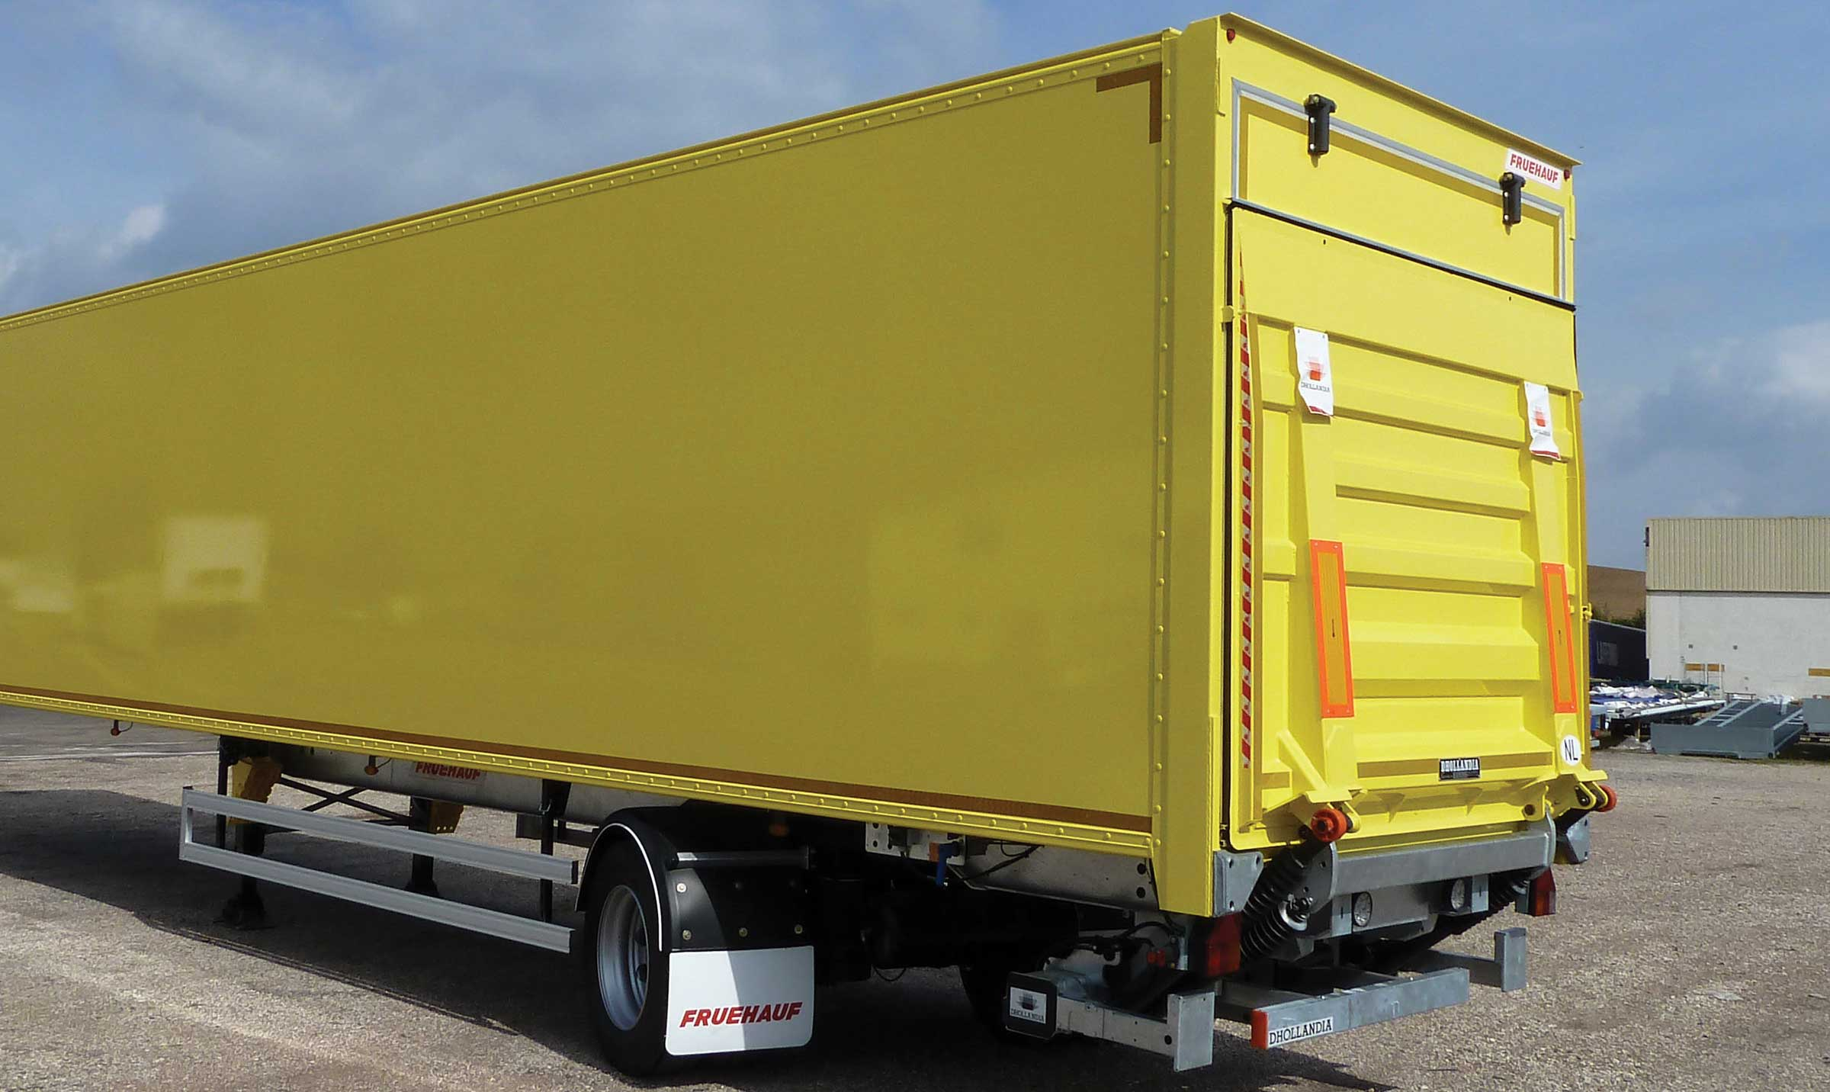
Gallery

Retractable lift rear door
CITY - Urban - Fourgons EN, City Fourgon
2nd load levelGuillaume Calviac2021-02-10T09:45:48+01:00
Gallery

2nd load level
CITY - Urban - Fourgons EN, City Fourgon, ExpressLiner Distribution Lots
Documentation
Demo Video

Easy UP®
By listening to its customers and users, FRUEHAUF is able to continuously design new innovative and high-performance equipment for increased savings, productivity and safety. Protection of personnel and equipment, reduced fuel consumption, anticipation of new requirements.
- Ergonomy
- Safety
- Reliability
ERGONOMICS – Accessible controlsGuillaume Calviac2021-03-29T08:42:10+02:00
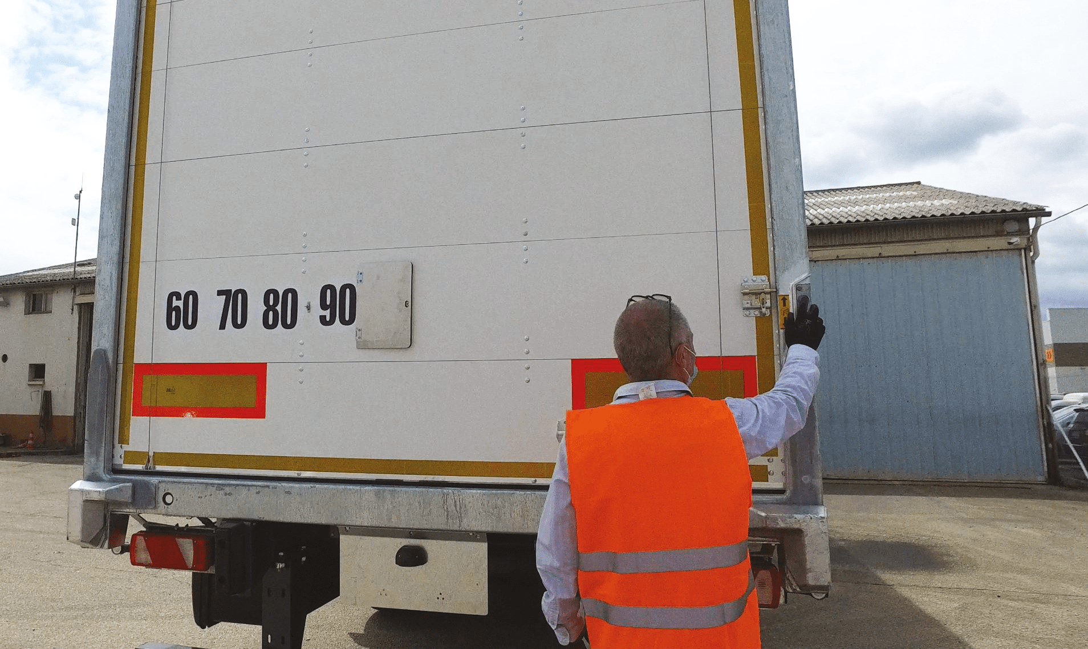
Gallery

ERGONOMICS – Accessible controls
Fourgons - Innovations, Innovations - Easy UP
Freight safetyGuillaume Calviac2021-03-29T08:41:09+02:00
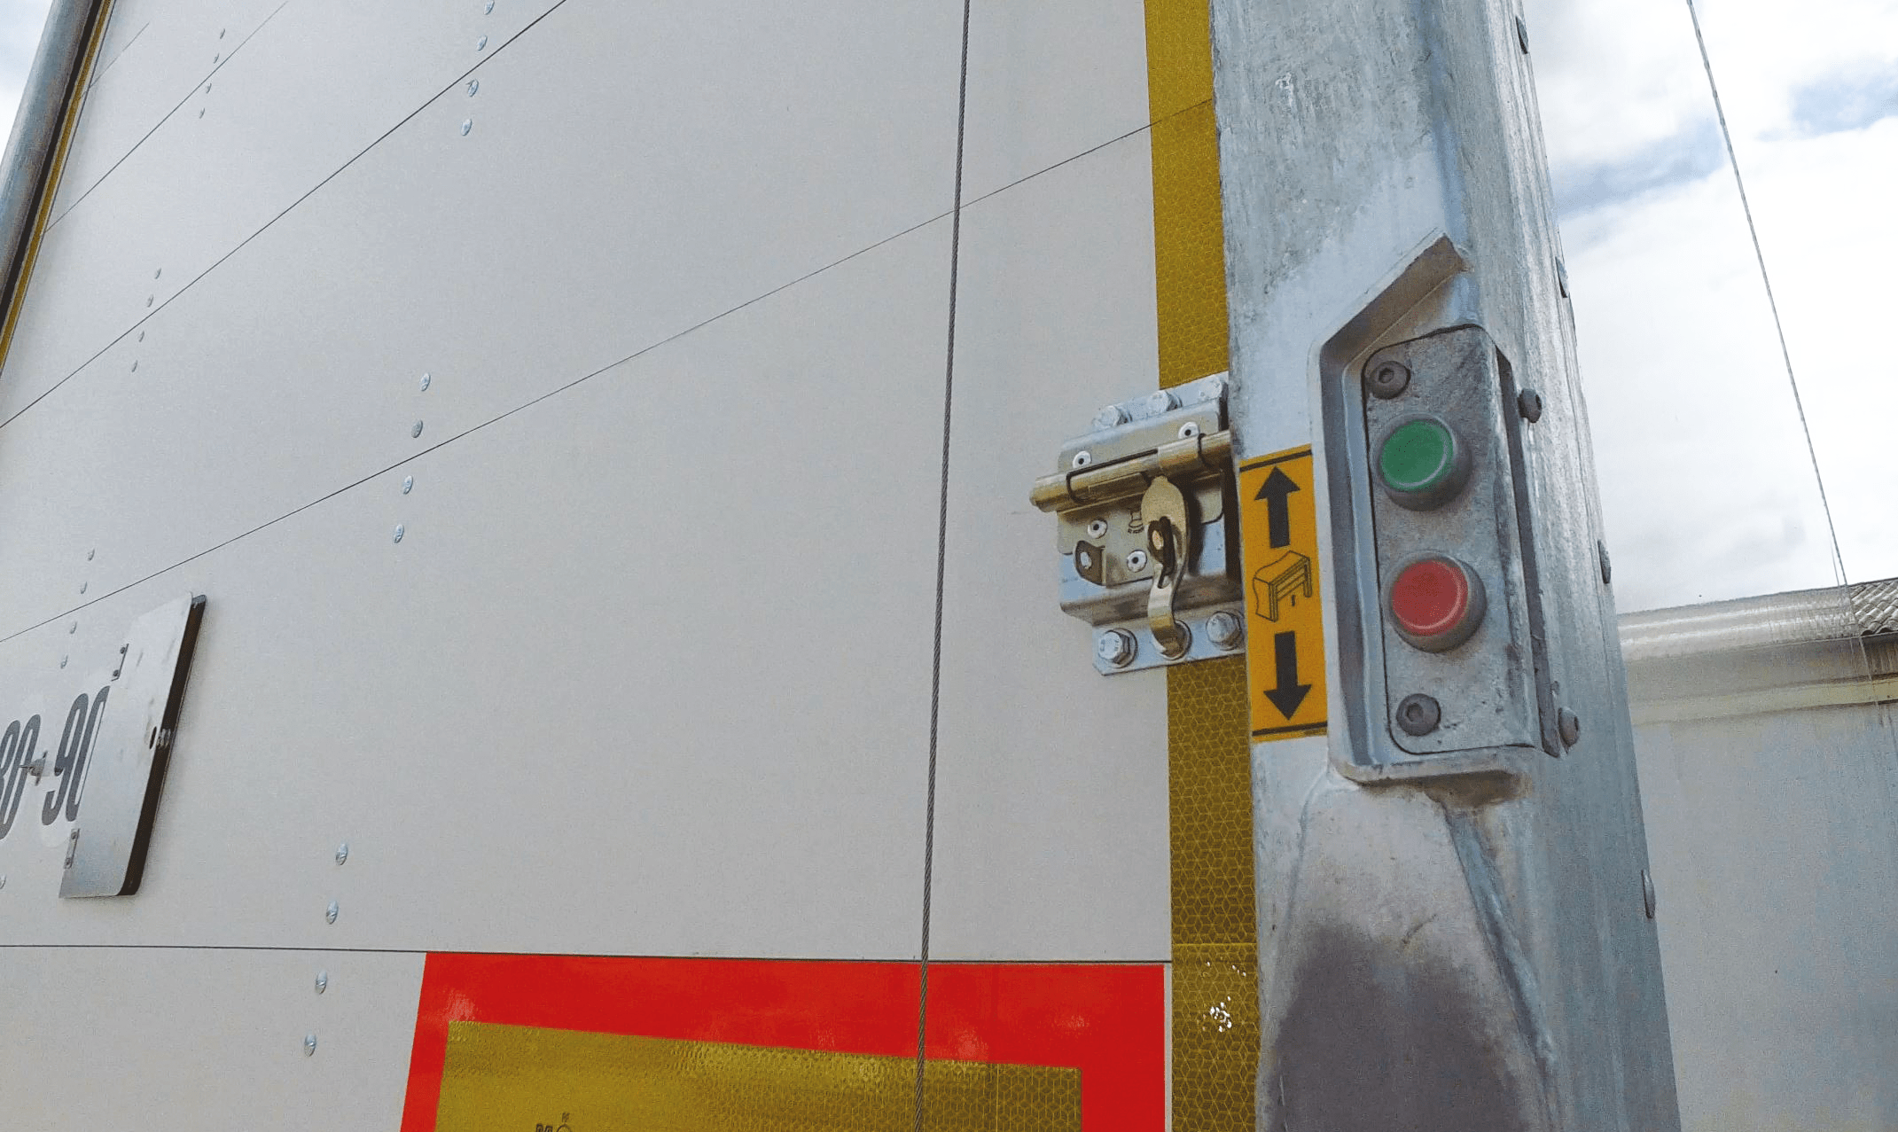
Gallery

Freight safety
Fourgons - Innovations, Innovations - Easy UP
SAFETY – Low pressure cylinderGuillaume Calviac2021-03-29T08:39:48+02:00
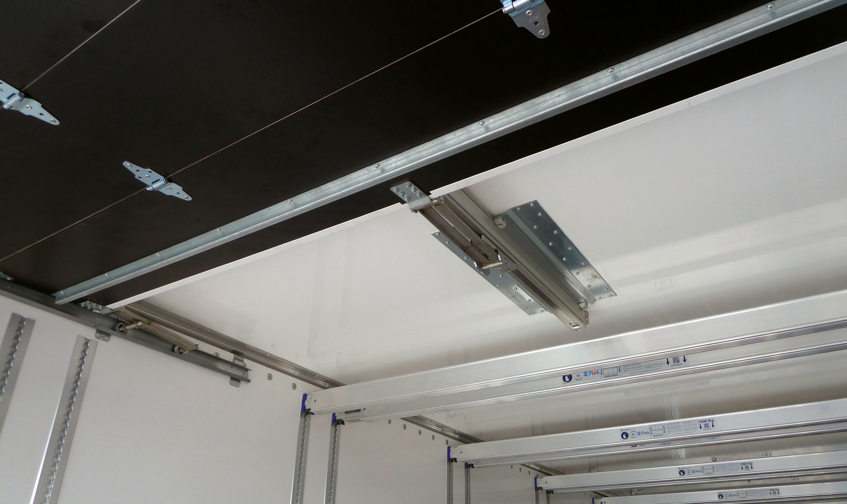
Gallery

SAFETY – Low pressure cylinder
Fourgons - Innovations, Innovations - Easy UP
Compensating spring retentionGuillaume Calviac2021-03-29T08:38:12+02:00
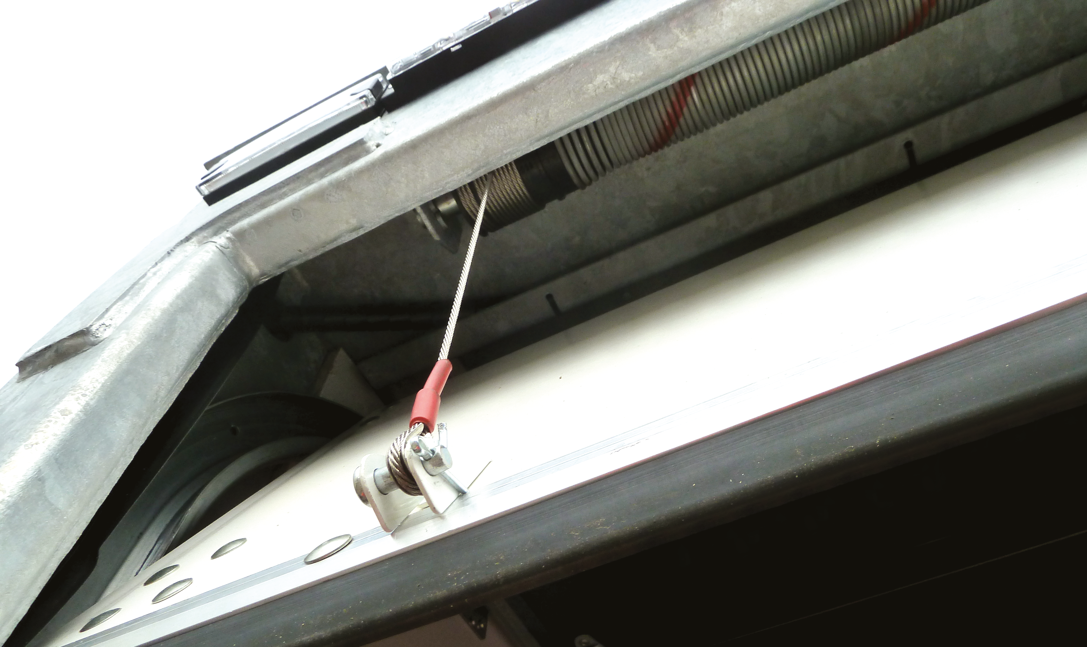
Gallery

Compensating spring retention
Fourgons - Innovations, Innovations - Easy UP
RELIABILITY – Additional air tankGuillaume Calviac2021-03-29T08:33:00+02:00
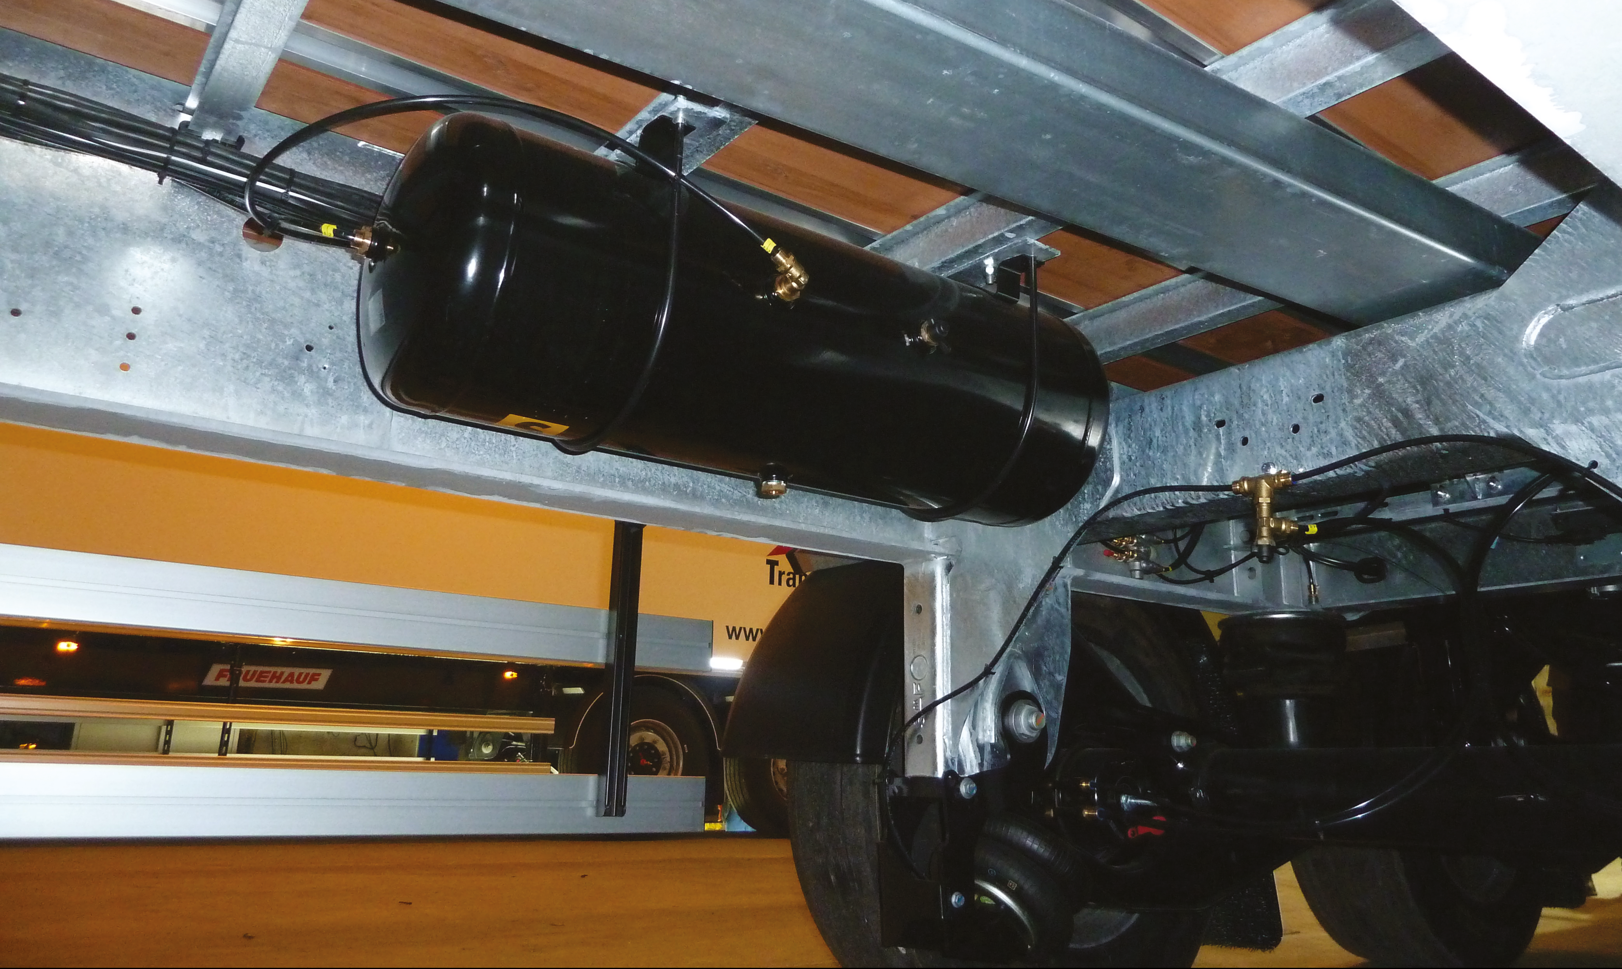
Gallery

RELIABILITY – Additional air tank
Fourgons - Innovations, Innovations - Easy UP
PIEK certification (option)Guillaume Calviac2021-02-26T09:53:19+01:00
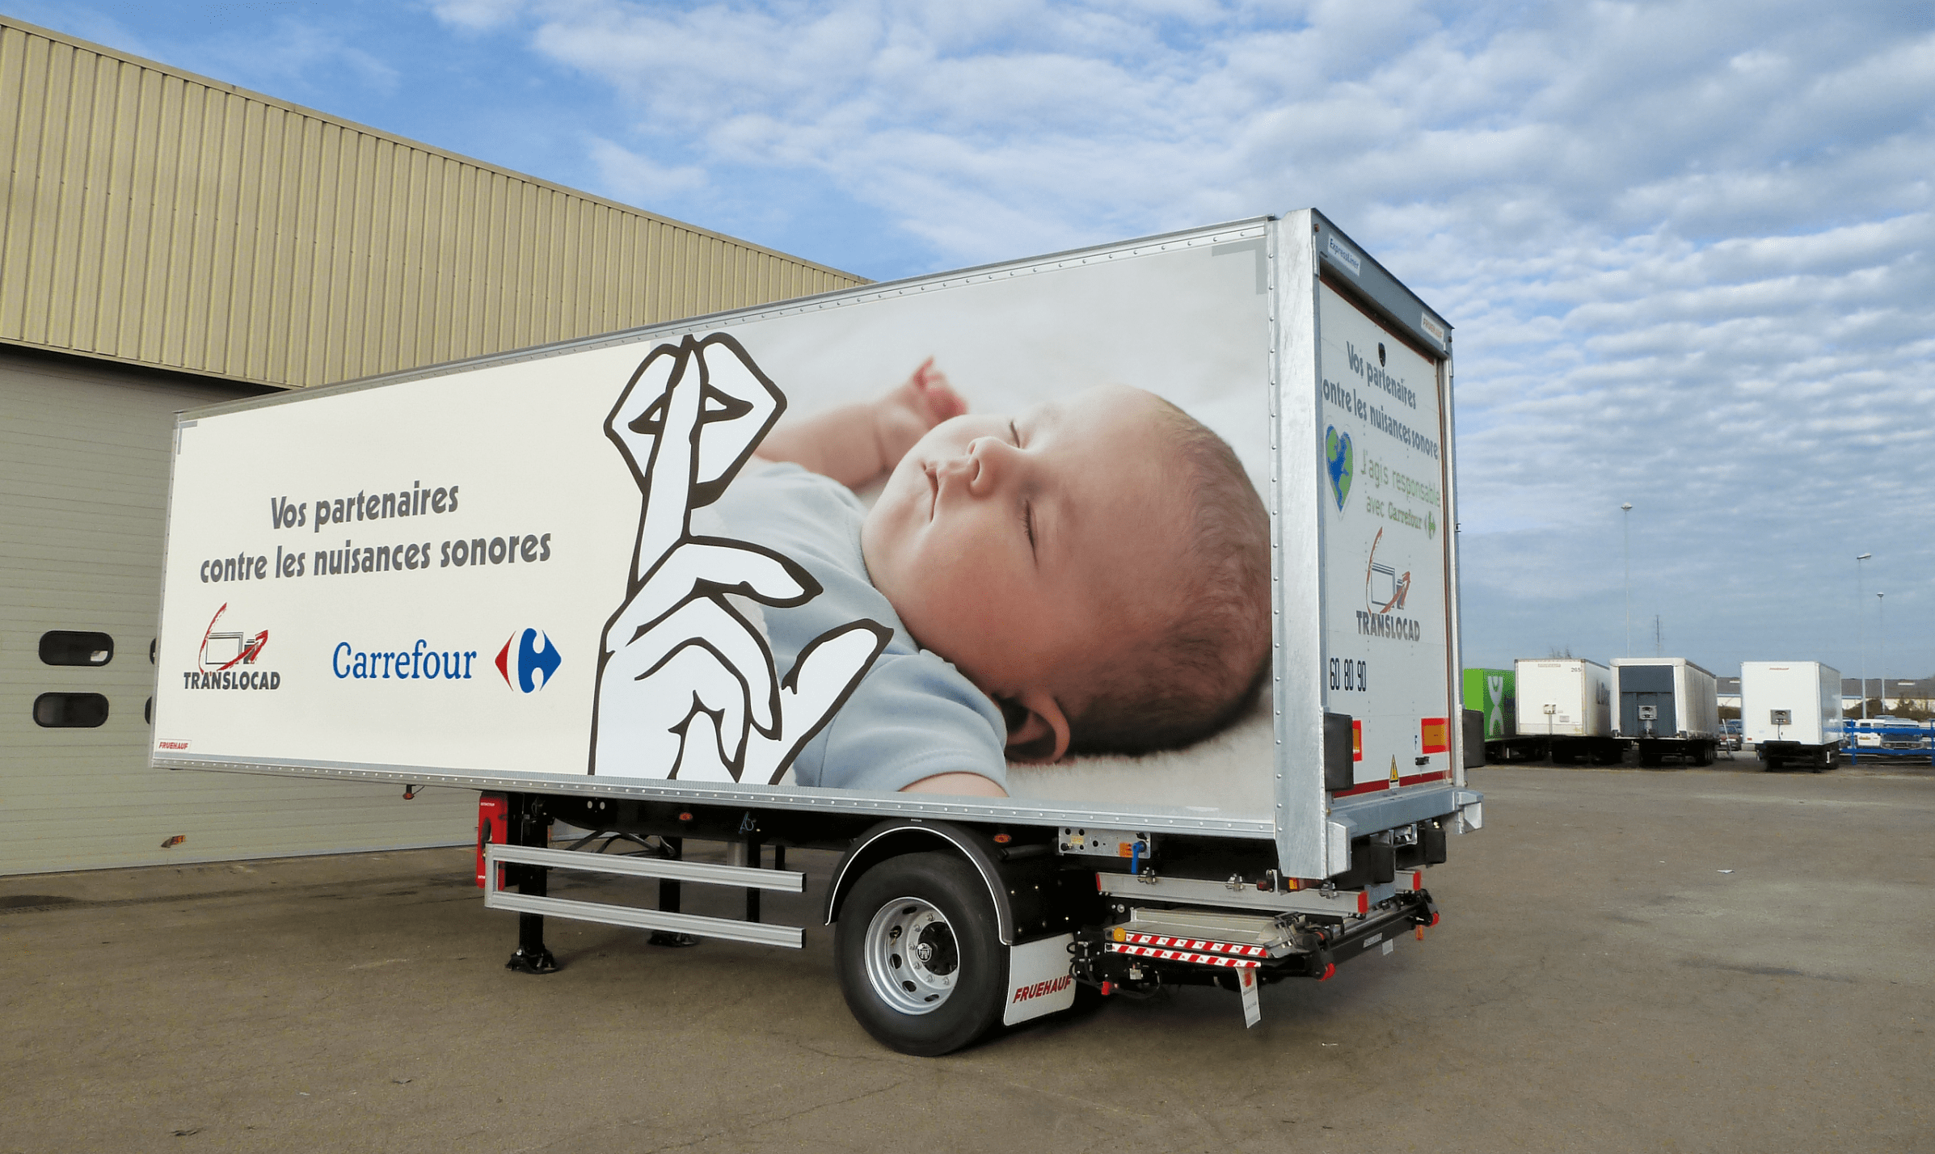
Gallery

PIEK certification (option)
Fourgons - Innovations, Innovations - Easy UP
EASY up®Guillaume Calviac2021-03-04T10:35:57+01:00
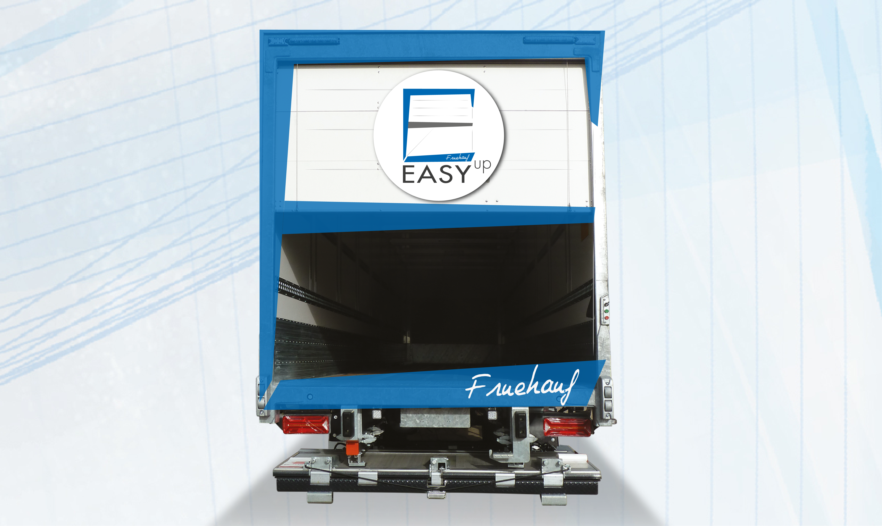
Gallery

EASY up®
City Innovations EN, Fourgons - Innovations, Innovations - Easy UP
Documentation
Demo Videos
More Innovations

Metadata
pyre_slider_type | no
pyre_slider | 0
pyre_wooslider
pyre_revslider | 0
pyre_elasticslider | 0
pyre_slider_position | default
pyre_avada_rev_styles | default
pyre_fallback
pyre_fallback_id
pyre_demo_slider
pyre_main_top_padding
pyre_main_bottom_padding
pyre_hundredp_padding
pyre_show_first_featured_image | no
pyre_display_header | yes
pyre_header_100_width | default
pyre_combined_header_bg_color
pyre_mobile_header_bg_color
pyre_header_bg
pyre_header_bg_id
pyre_header_bg_full | no
pyre_header_bg_repeat | repeat
pyre_displayed_menu | default
pyre_display_footer | default
pyre_display_copyright | default
pyre_footer_100_width | default
pyre_sidebar_position | default
pyre_responsive_sidebar_order
pyre_sidebar_sticky | default
pyre_sidebar_bg_color
pyre_page_bg_layout | default
pyre_page_bg_color
pyre_page_bg
pyre_page_bg_id
pyre_page_bg_full | default
pyre_page_bg_repeat | default
pyre_wide_page_bg_color
pyre_wide_page_bg
pyre_wide_page_bg_id
pyre_wide_page_bg_full | default
pyre_wide_page_bg_repeat | default
pyre_page_title | default
pyre_page_title_breadcrumbs_search_bar | default
pyre_page_title_text | default
pyre_page_title_text_alignment | default
pyre_page_title_custom_text
pyre_page_title_text_size
pyre_page_title_line_height
pyre_page_title_font_color
pyre_page_title_custom_subheader
pyre_page_title_custom_subheader_text_size
pyre_page_title_subheader_font_color
pyre_page_title_100_width | default
pyre_page_title_height
pyre_page_title_mobile_height
pyre_page_title_bar_bg_color
pyre_page_title_bar_borders_color
pyre_page_title_bar_bg
pyre_page_title_bar_bg_id
pyre_page_title_bar_bg_retina
pyre_page_title_bar_bg_retina_id
pyre_page_title_bar_bg_full | default
pyre_page_title_bg_parallax | default
fusion_builder_status | active
kd_featured-image-2_page_id
kd_featured-image-3_page_id
kd_featured-image-4_page_id
kd_featured-image-5_page_id
sbg_selected_sidebar | Array
sbg_selected_sidebar_replacement | Array
sbg_selected_sidebar_2 | Array
sbg_selected_sidebar_2_replacement | Array
avada_post_views_count | 281
avada_today_post_views_count | 1
avada_post_views_count_today_date | 13-12-2023

