Trailers
Author | Guillaume Calviac
Date | 2021-06-03 14:48:31
Categories

TRAILERS

The Range

Sturdy and reliable
FRUEHAUF has always designed and manufactured equipment that is recognised by the market for its sturdiness and reliability. Our trailers, with their reinforced mechanically welded chassis, are perfectly suited to intensive, harsh and very long-term applications.
They are available in Tandem (GVW 18 and 19 t) and in Tridem (GVW 26 t).

Safety
Our vehicles are designed for maximum safety :
- Safe road behaviour with integrated, latest-generation undercarriage and electronic driver assistance systems improving the vehicle's passive and active safety
- User safety through perfectly ergonomic forms, parts and equipment
Lowered Booms
High Booms
Specialists

Lowered Booms

For hooks positioned towards the undercarriage, under the chassis

Ring height 380 to 460 mm
With undercarriage 19.5" or 22.5" and single or twin rear wheels, lowered boom trailers are fully configurable in terms of length (from 7.05 to 8.45 m) and floor height.
With their reinforced mechanically welded chassis, they are perfectly suited to harsh and intensive applications.
- Adaptability
- Reliability
- Sturdiness
Tandem 22.5″ – Single rear wheel and twin rear wheelGuillaume Calviac2021-03-29T09:03:30+02:00
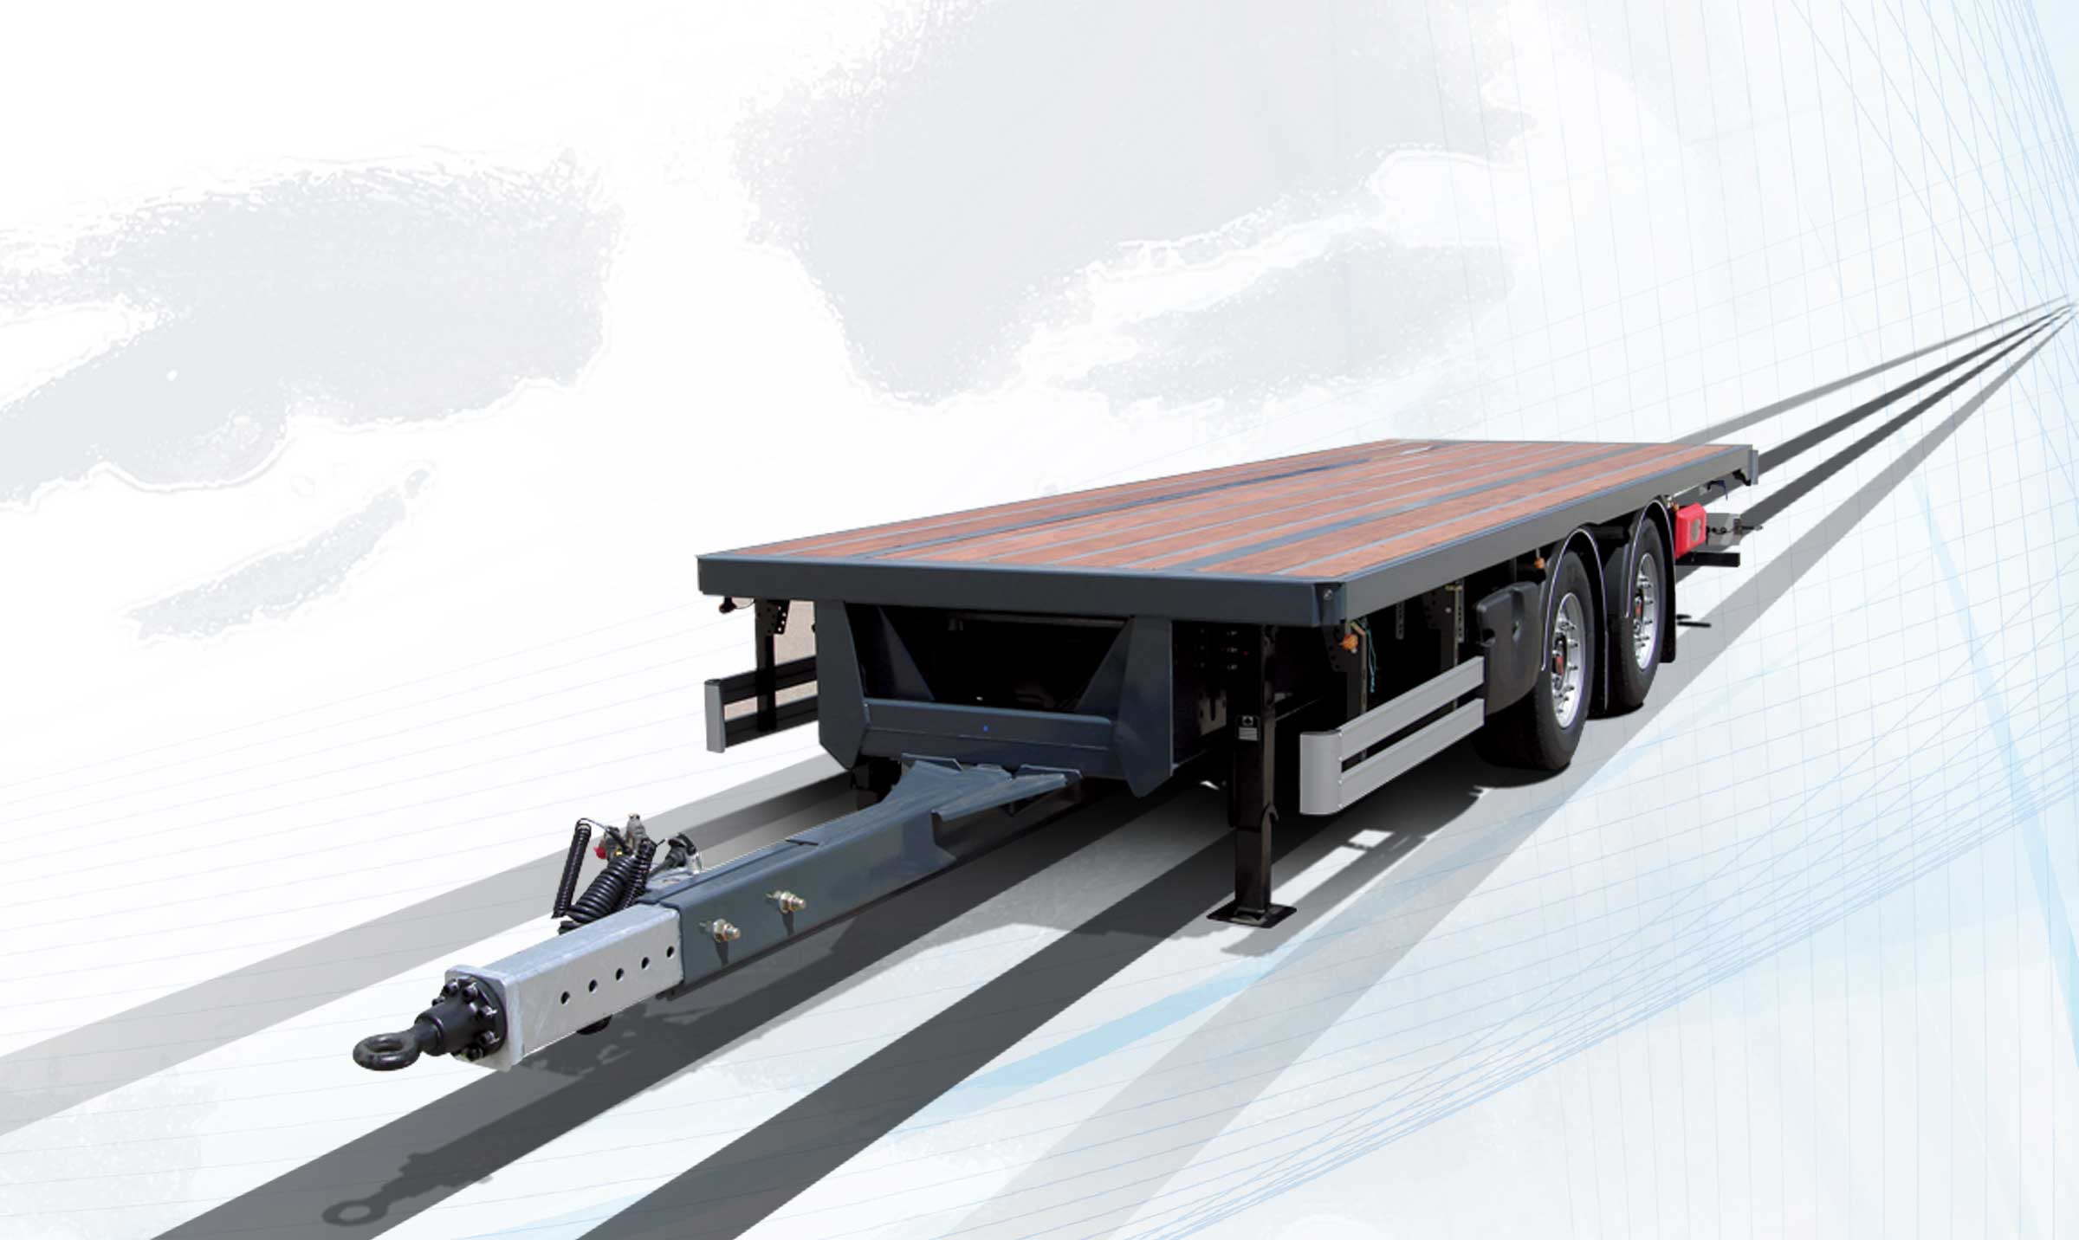
Gallery

Tandem 22.5″ – Single rear wheel and twin rear wheel
Remorque Flèche Surbaissée, Remorques Tandems
Tandem 19.5″ – Single rear wheel and twin rear wheelGuillaume Calviac2021-03-29T09:02:54+02:00
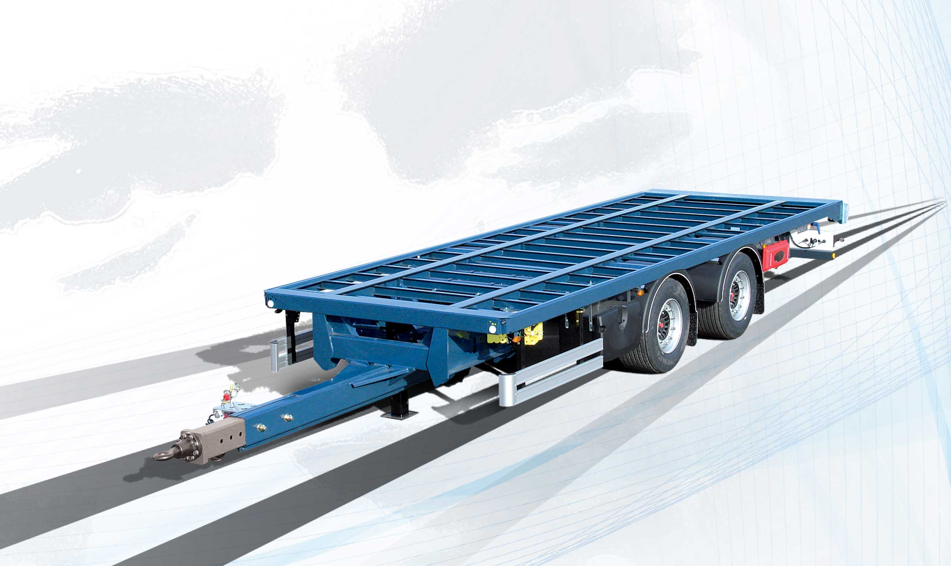
Gallery

Tandem 19.5″ – Single rear wheel and twin rear wheel
Remorque Flèche Surbaissée, Remorques Tandems
Average tonnage – GVW 18 t and 19 tGuillaume Calviac2021-03-29T09:01:34+02:00
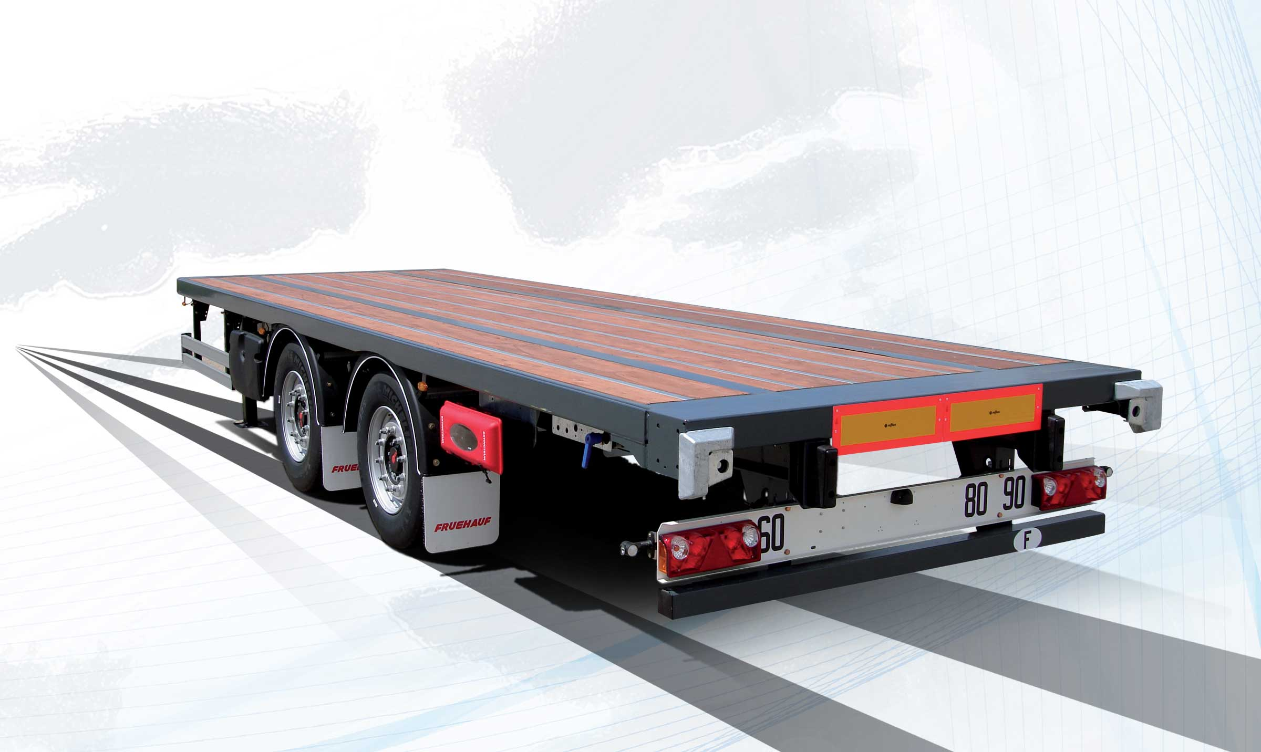
Gallery

Average tonnage – GVW 18 t and 19 t
Remorque Flèche Surbaissée, Remorques Tandems
Tridem 19.5″ – Single rear wheel and twin rear wheelGuillaume Calviac2021-03-29T09:04:39+02:00
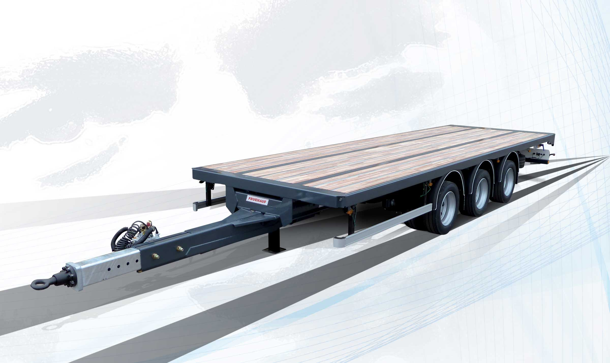
Gallery

Tridem 19.5″ – Single rear wheel and twin rear wheel
Remorque Flèche Surbaissée, Remorques Tridems
Average tonnage – GVW 26 tGuillaume Calviac2021-03-29T09:00:43+02:00
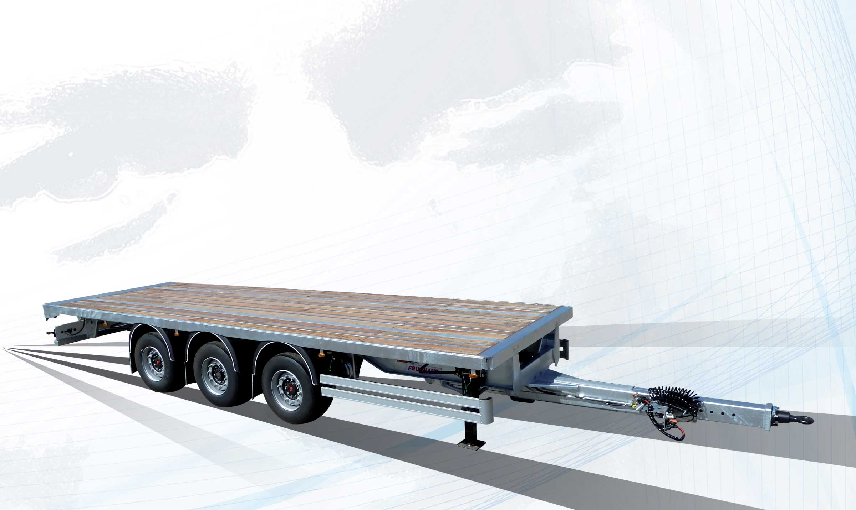
Gallery

Average tonnage – GVW 26 t
Remorque Flèche Surbaissée, Remorques Tridems
Documentation

High Booms

For hook positioned at the end of the chassis

Ring height 750 to 950 mm
With undercarriage 19.5" or 22.5" and single or twin rear wheels, high boom trailers are fully configurable in terms of length (from 6.20 to 8.10 m) and floor height.
With their reinforced mechanically welded chassis, they are perfectly suited to harsh and intensive applications.
- Sturdiness
- Adaptability
- Reliability
Twin rear wheel 19.5″Guillaume Calviac2021-03-29T09:10:17+02:00
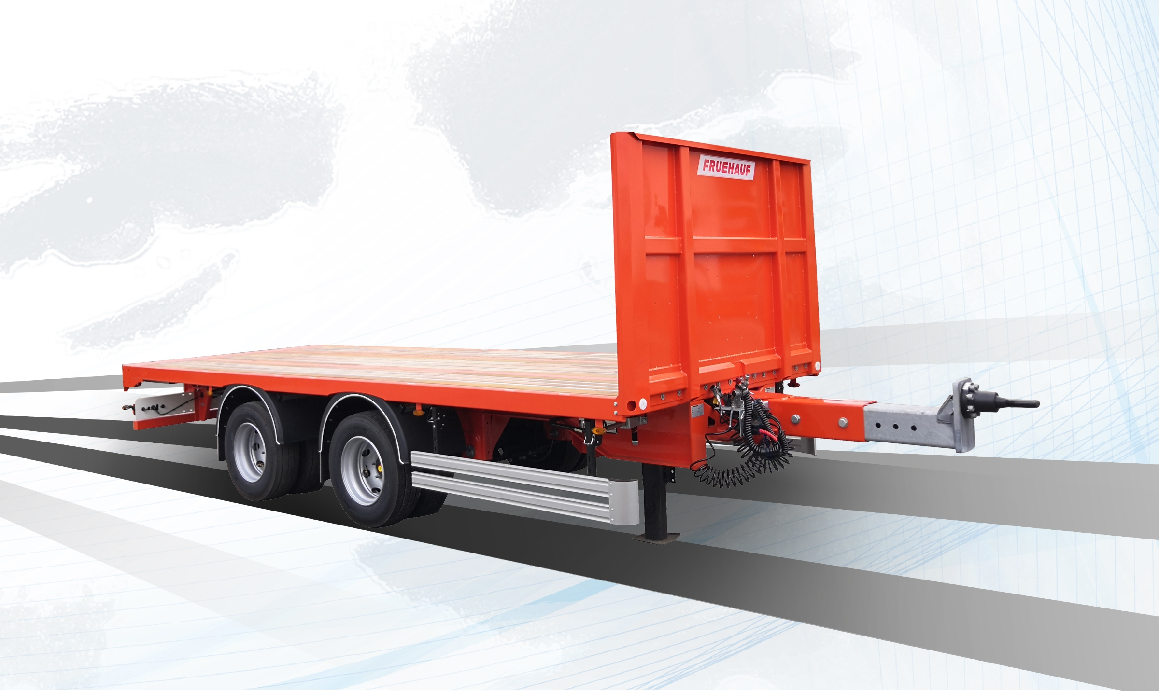
Gallery

Twin rear wheel 19.5″
Remorque Flèche Haute
Boom adjustable in 100 mm incrementsGuillaume Calviac2021-03-29T09:09:31+02:00
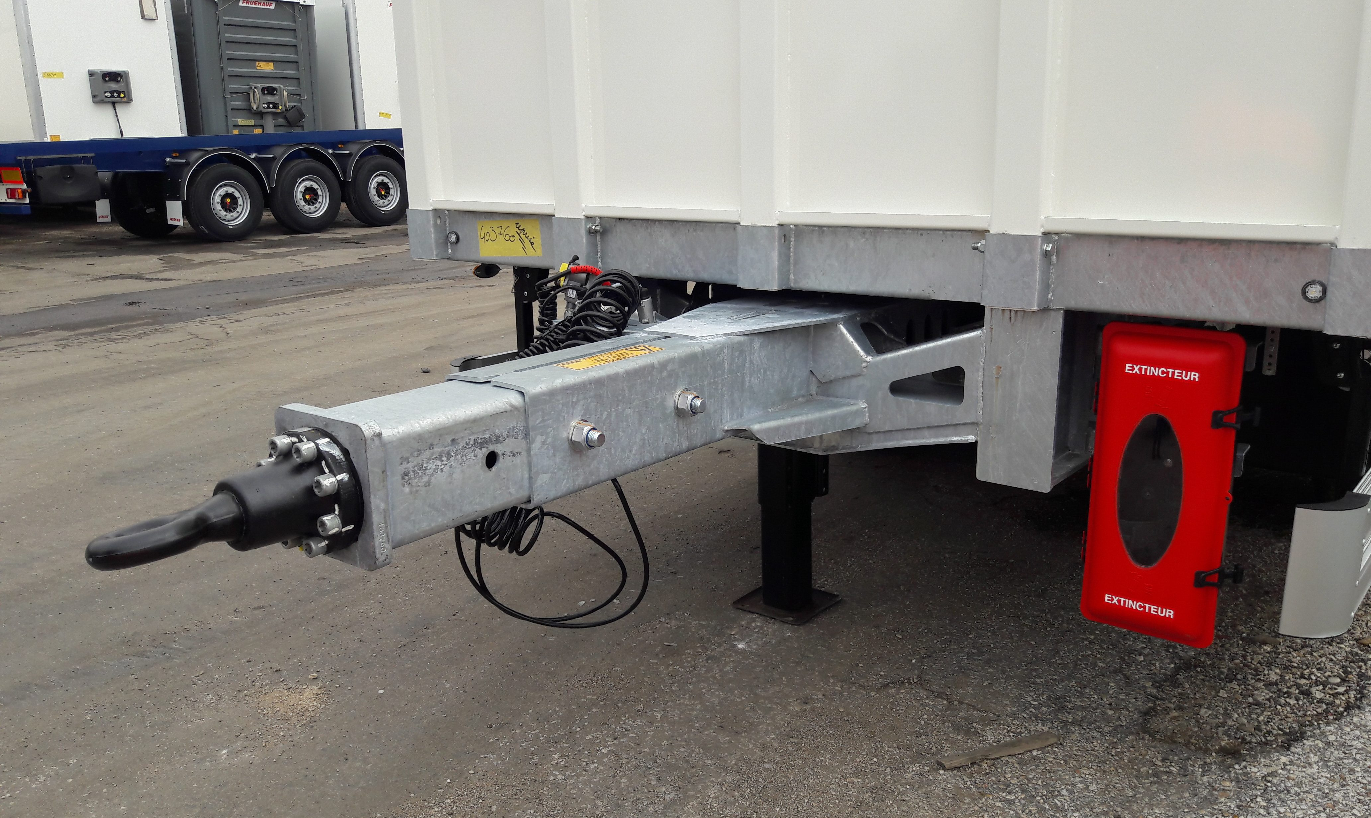
Gallery

Boom adjustable in 100 mm increments
Remorque Flèche Haute
Single rear wheel 22.5″Guillaume Calviac2021-03-29T09:08:48+02:00
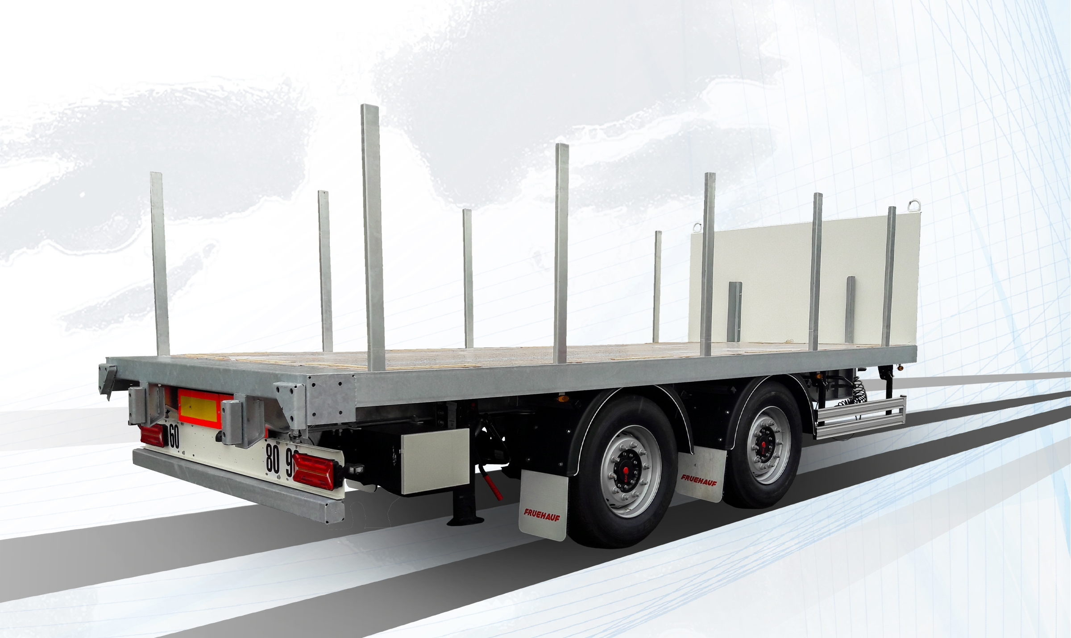
Gallery

Single rear wheel 22.5″
Remorque Flèche Haute
Documentation

Specialists

Mobile Swap Bodies & bare chassis
With their reinforced mechanically welded chassis, FRUEHAUF trailers meet the most specialised transport needs.
From the transport of mobile swap bodies for delivery companies and specialist flows through to specific adaptations, they are designed to withstand the harshest applications.
- Sturdiness
- Adaptability
- Reliability
Mobile swap bodiesGuillaume Calviac2021-03-29T09:44:23+02:00
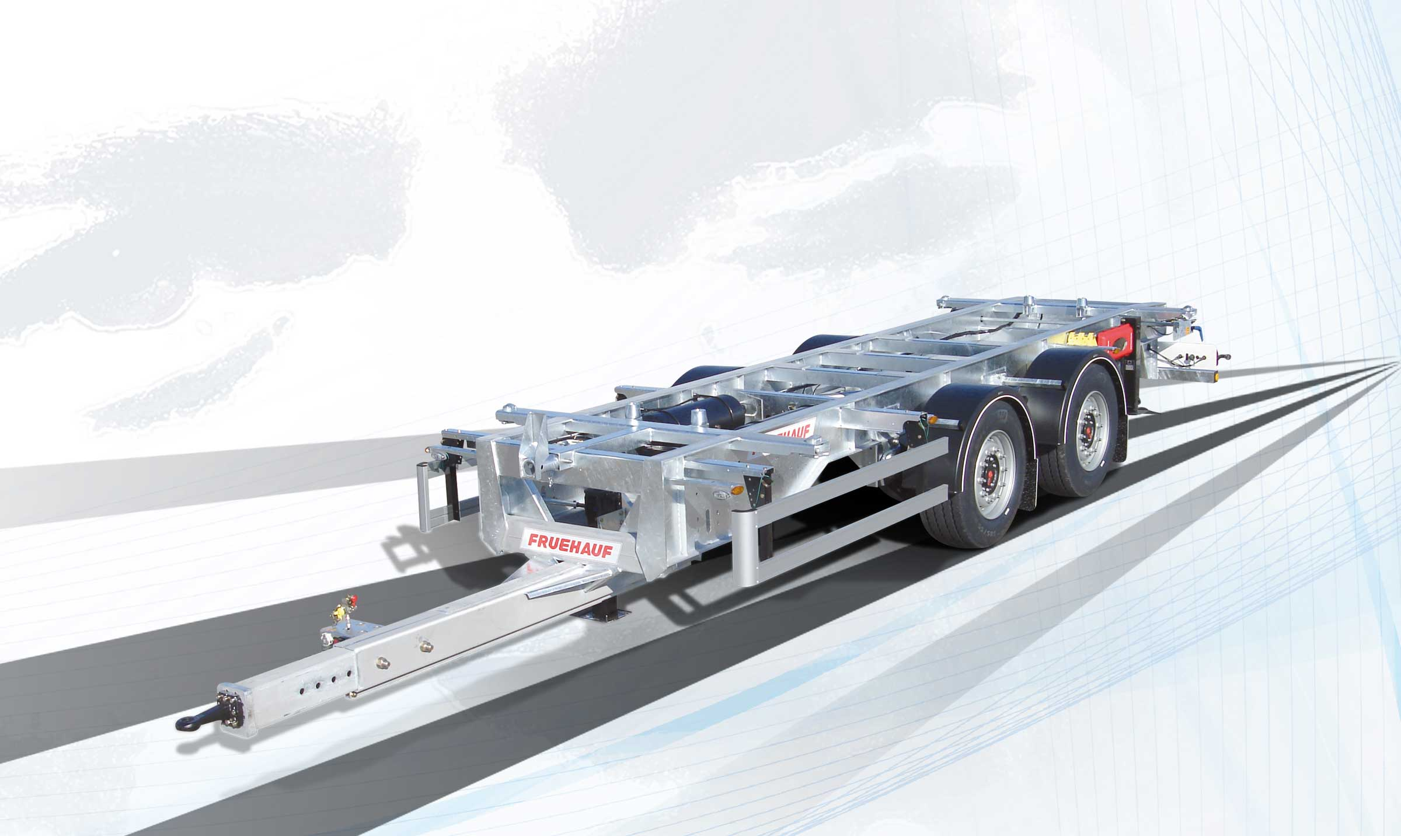
Gallery

Mobile swap bodies
Remorques Spécialisées
Bare chassisGuillaume Calviac2021-03-29T09:43:56+02:00
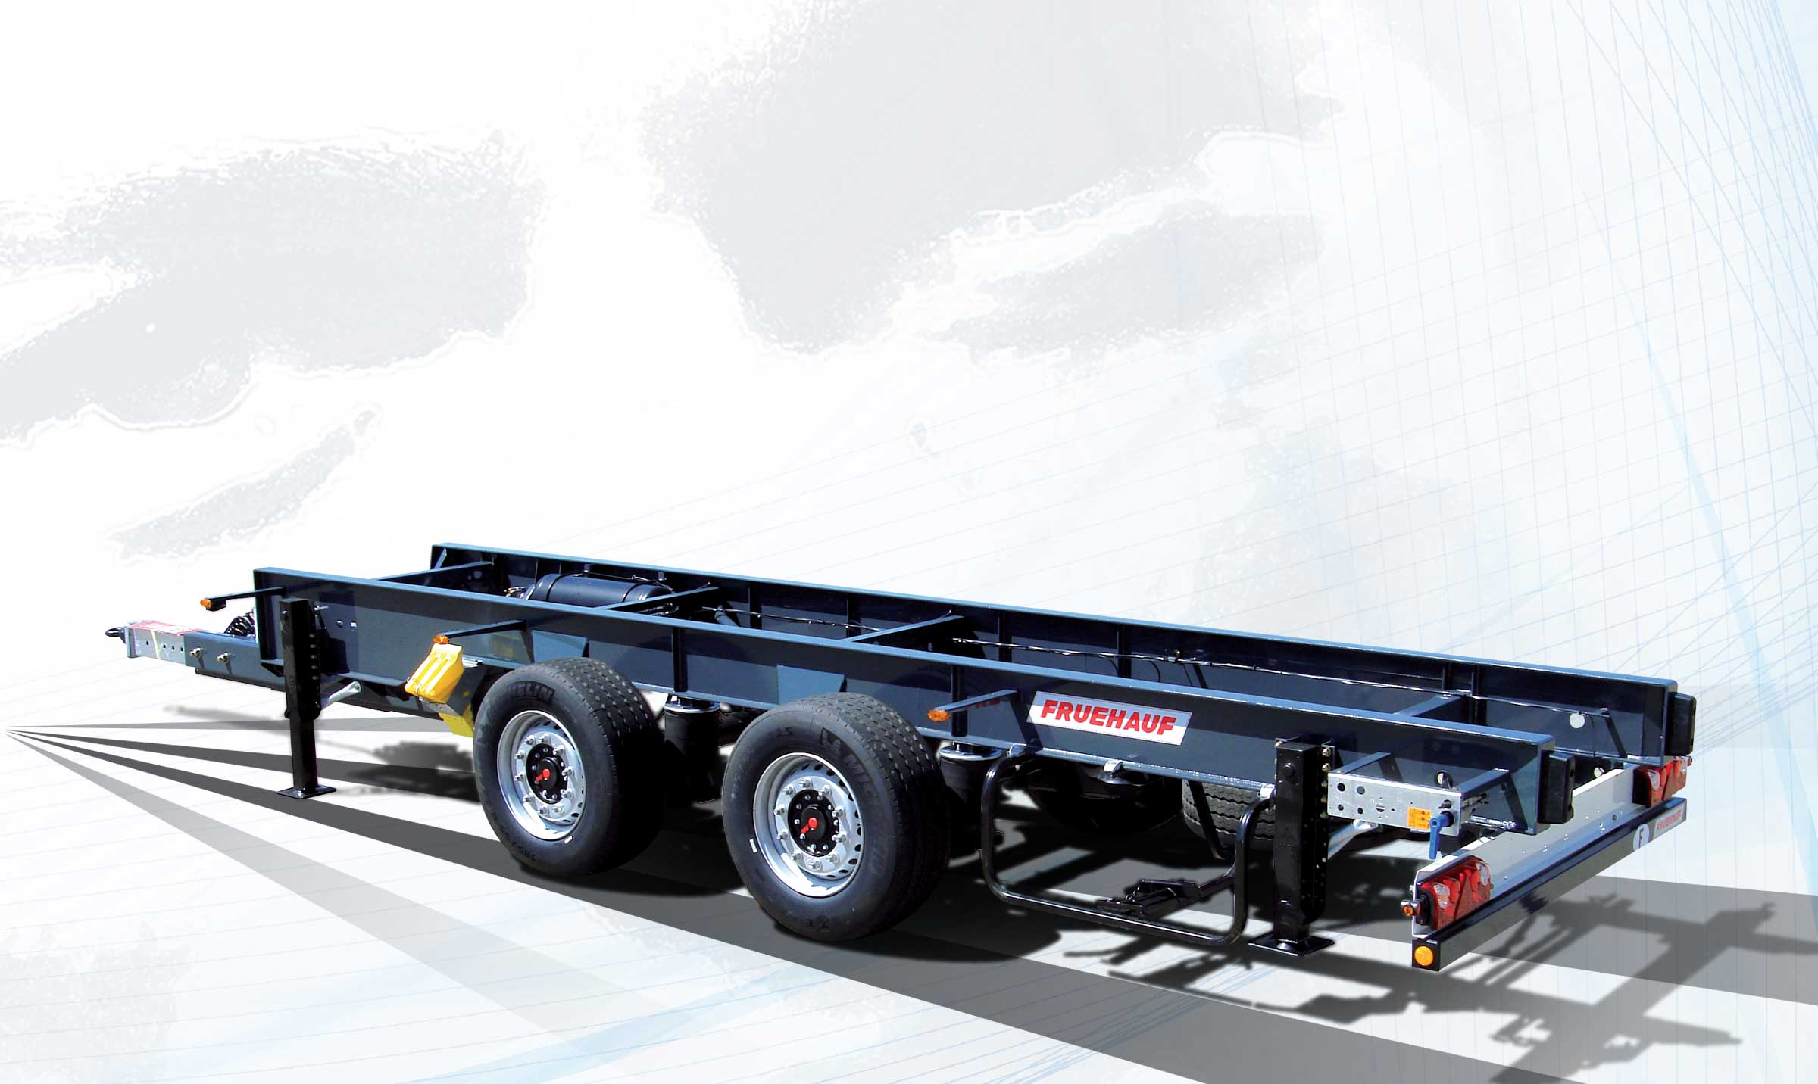
Gallery

Bare chassis
Remorques Spécialisées
Documentation

Innovations
By listening to its customers and users, FRUEHAUF is able to continuously design new innovative and high-performance equipment for increased savings, productivity and safety.
Protection of personnel and equipment, reduced fuel consumption, anticipation of new requirements.
- Economy
- Productivity
- Safety
SafeParkingGuillaume Calviac2021-01-15T11:41:43+01:00
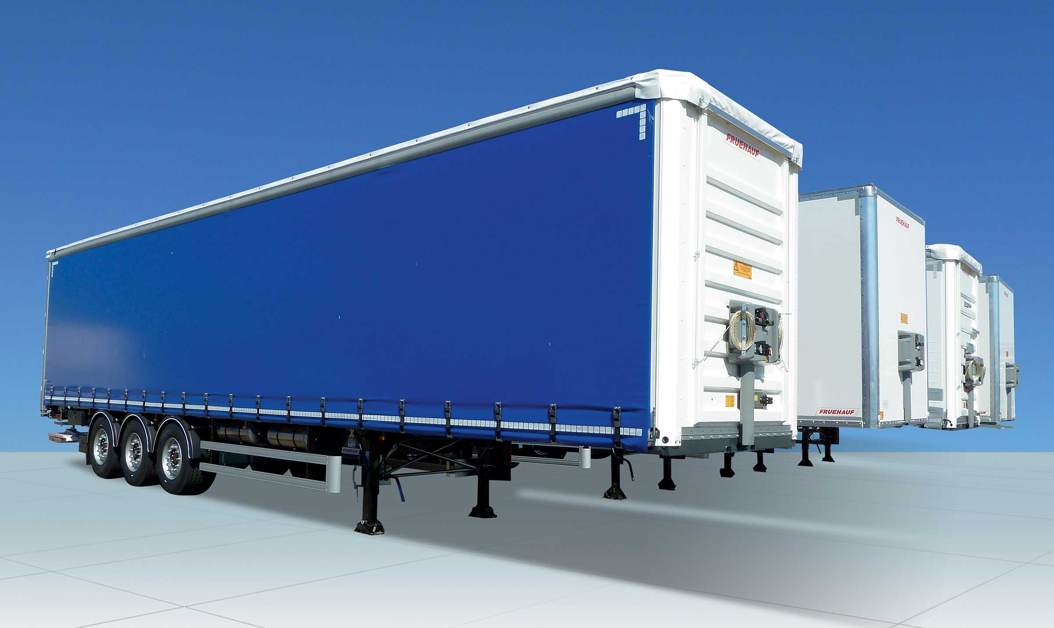
Gallery

SafeParking
Innovations - SafeParking, Innovations Base EN
TelematicsGuillaume Calviac2021-01-29T13:44:33+01:00

Gallery

Telematics
Innovations - Télématique, Innovations Base EN
RCPGuillaume Calviac2021-01-15T11:33:18+01:00
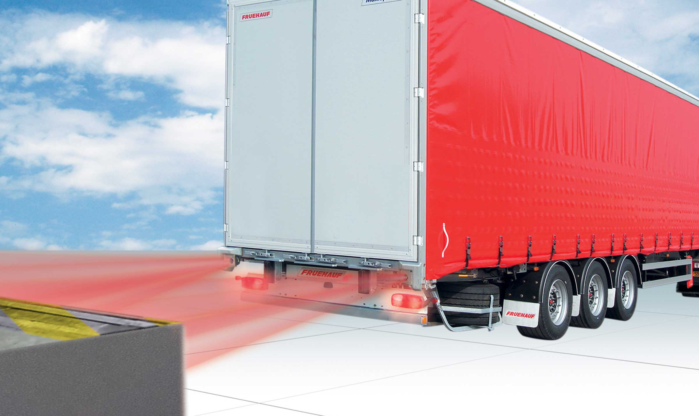
Gallery

RCP
Innovations - RCP, Innovations Base EN
APCSGuillaume Calviac2021-01-15T11:24:21+01:00
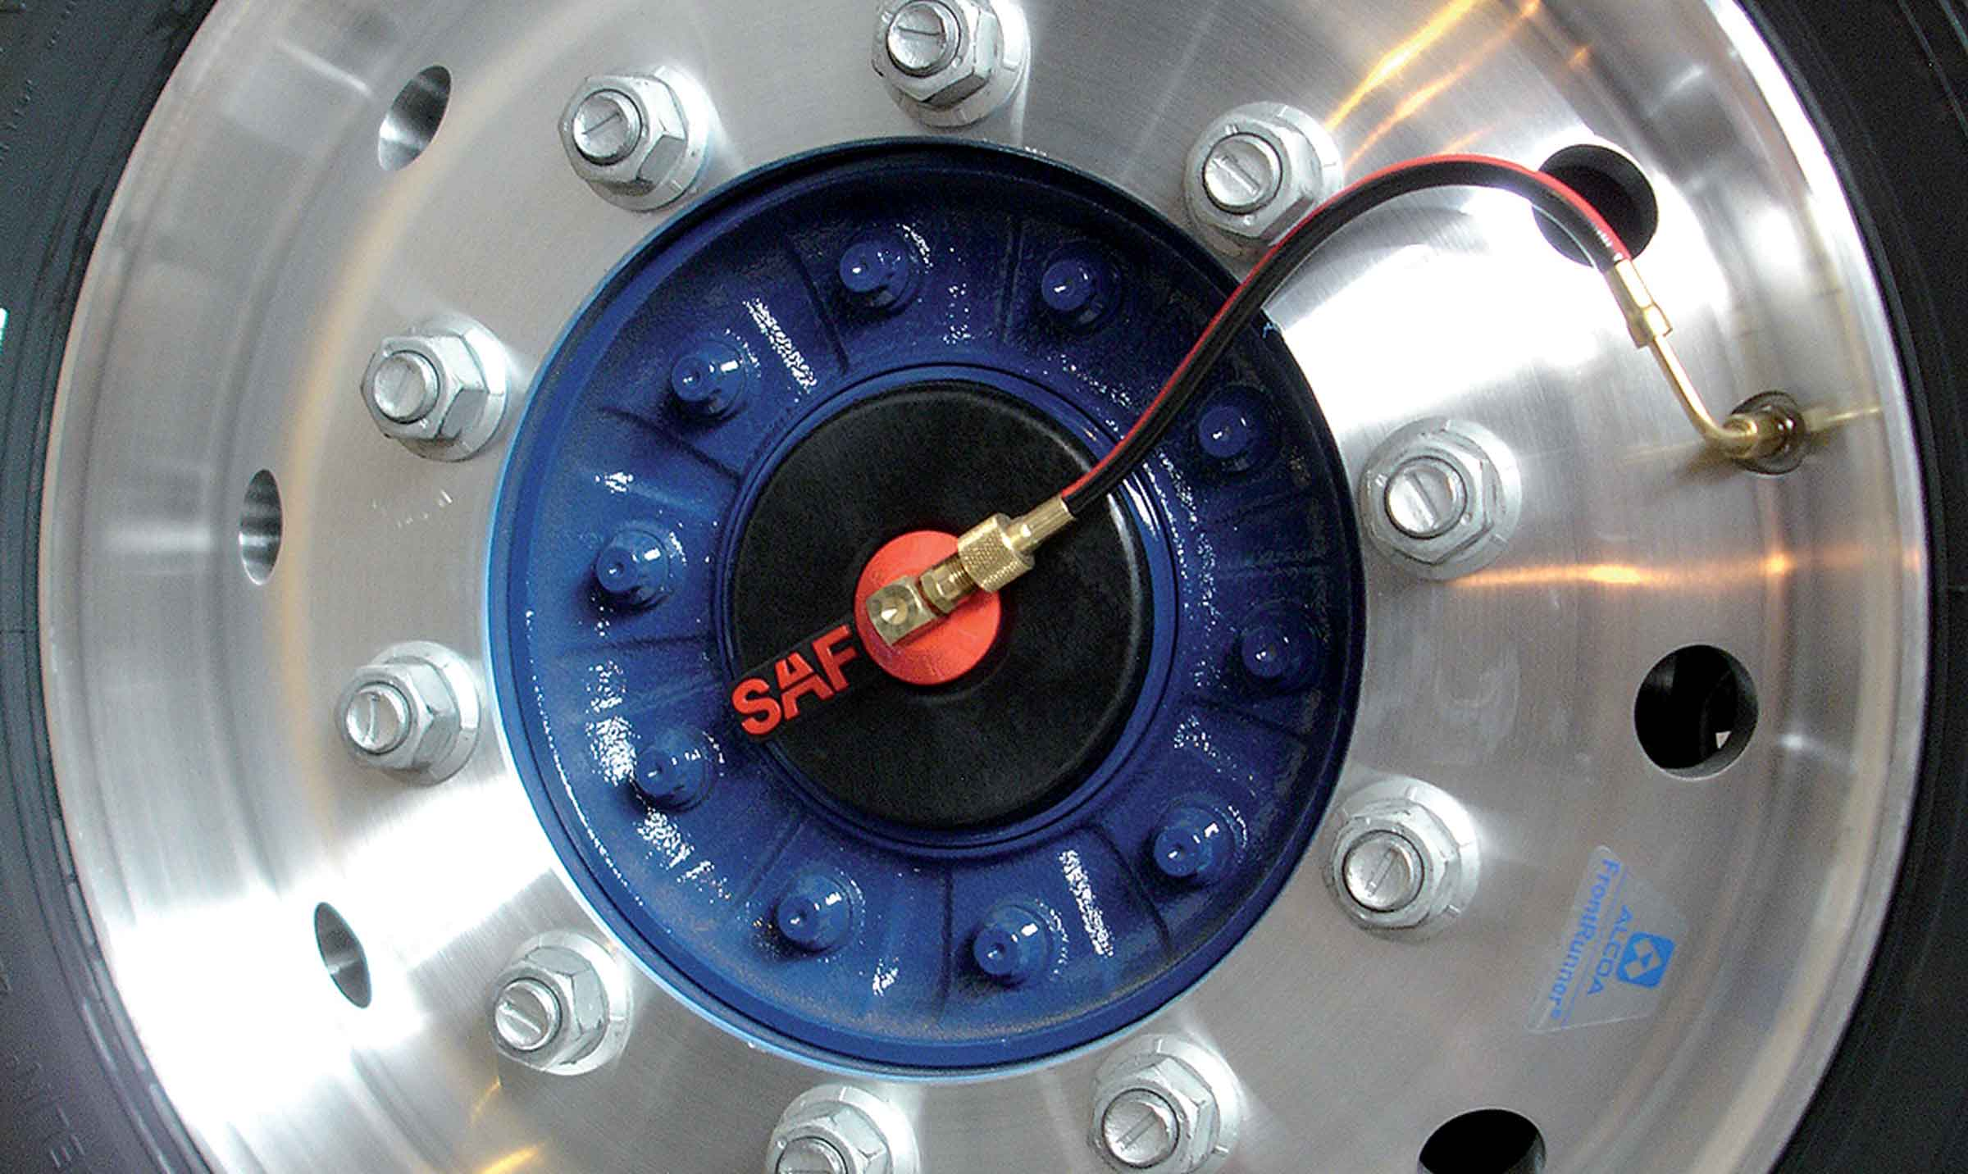
Gallery

APCS
Innovations APCS, Innovations Base EN
EBSGuillaume Calviac2021-01-15T11:24:12+01:00
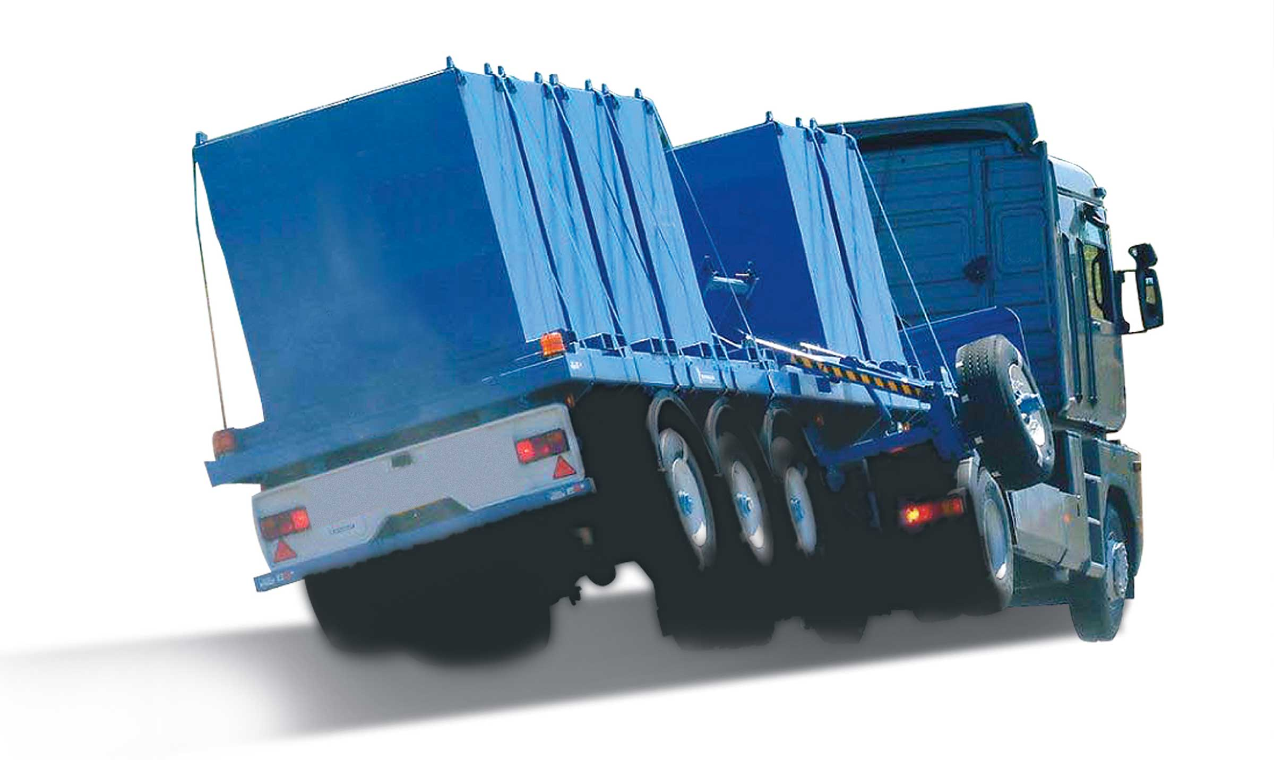
Gallery

EBS
Innovations Base EN
TPMSGuillaume Calviac2021-01-29T08:34:38+01:00
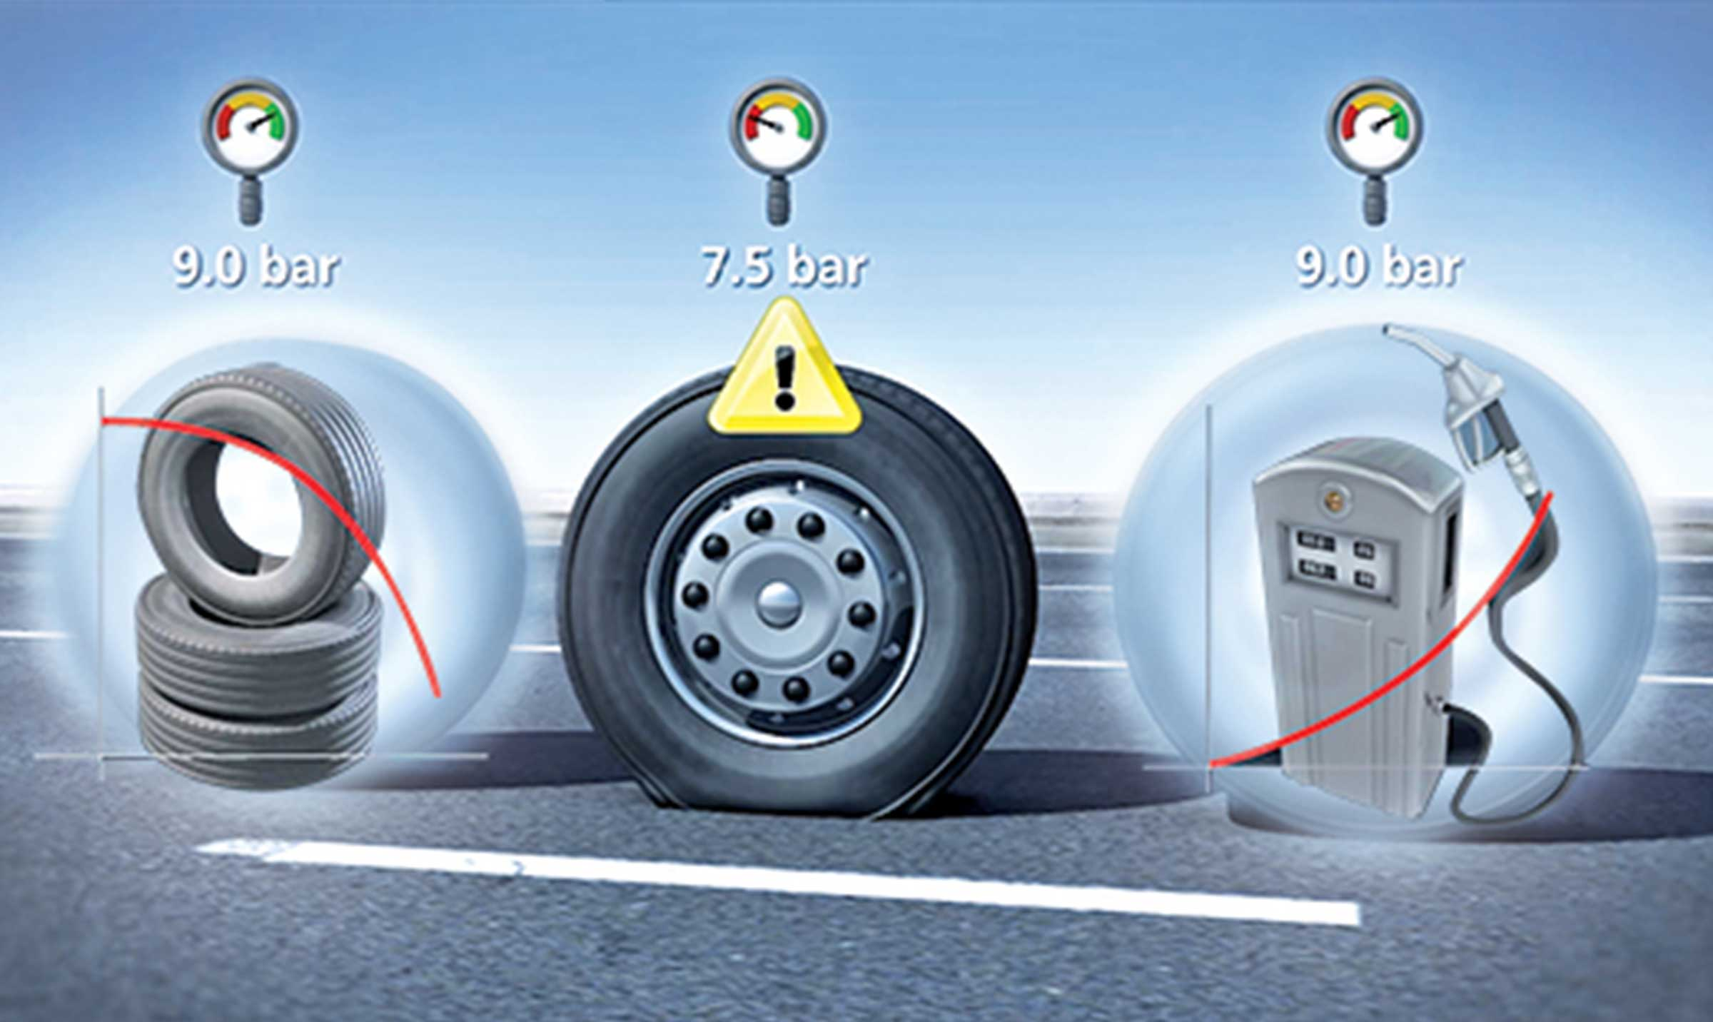
Gallery

TPMS
Innovations - TPMS, Innovations Base EN
Documentation
Demo Videos

Metadata
fusion_builder_status | active
avada_post_views_count | 498
avada_today_post_views_count | 9
avada_post_views_count_today_date | 12-12-2023

