Public Works Tippers
Author | Guillaume Calviac
Date | 2021-06-01 11:55:00
Categories

PUBLIC WORKS TIPPERS

The range
Developed closely with users and customers who are experts in their respective fields, FRUEHAUF Public Works Tippers are perfectly suited to each transport need: standard construction products, raw material, site supplies and asphalt through to the most difficult work such as demolition and rock filling.
Made from special "ENDUR-AL®" aluminium or special HARDOX® steel, FRUEHAUF tippers offer the best value for money, minimising the cost of ownership.
Site supplies
Raw materials - Abrasive materials
Asphalt - Earthwork
Demolition - Rock filling
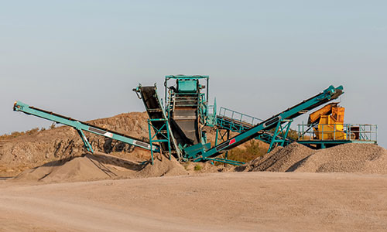
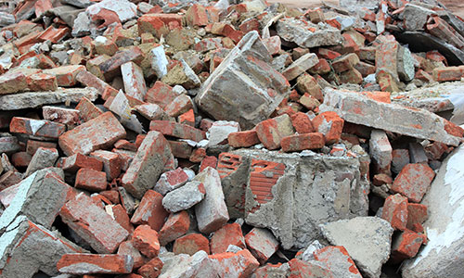
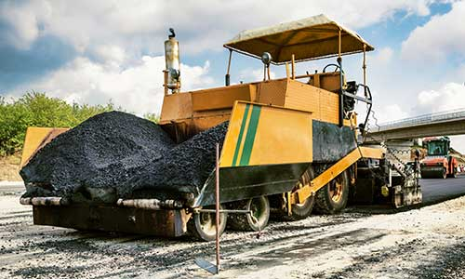
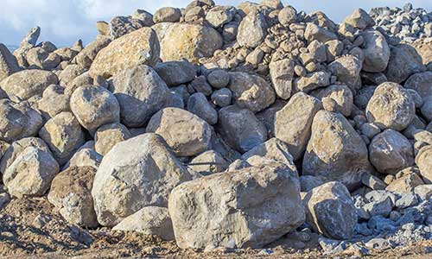
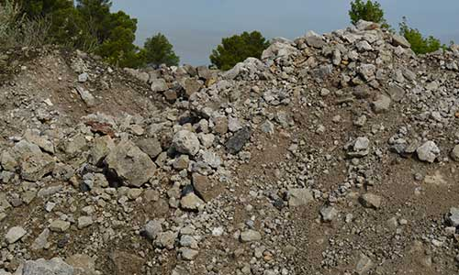

Transport - Supply
Designed especially for maximum payload, FRUEHAUF Public Works Tippers meet all transport and site supply requirements and offer the best value for money.

OptiMum

Maximum Payload

From 24 to 34 m³
The tapered shape of its body and its mechanically welded chassis made from special steel ensures the best compromise between ease of flow and maximum volume.
Made entirely from special "ENDUR-AL®" aluminium, the bottom and sides offer unrivalled abrasion resistance, minimising the cost of ownership.
- Unrivalled abrasion resistance
- Long service life
- Sturdy and lightweight
Tapered, reinforced bodyGuillaume Calviac2021-01-15T14:45:11+01:00
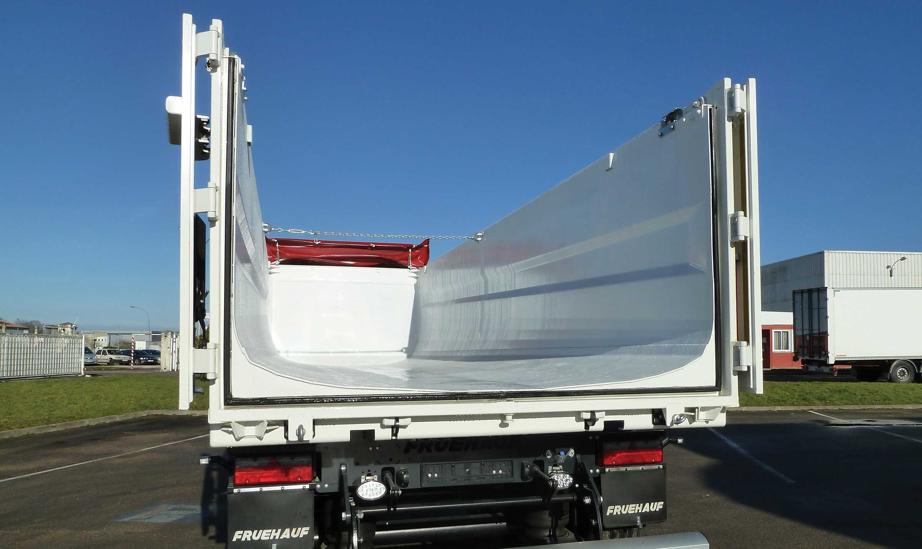
Gallery

Tapered, reinforced body
Bennes TP Optimum
Universal rear gateGuillaume Calviac2021-02-09T14:48:26+01:00
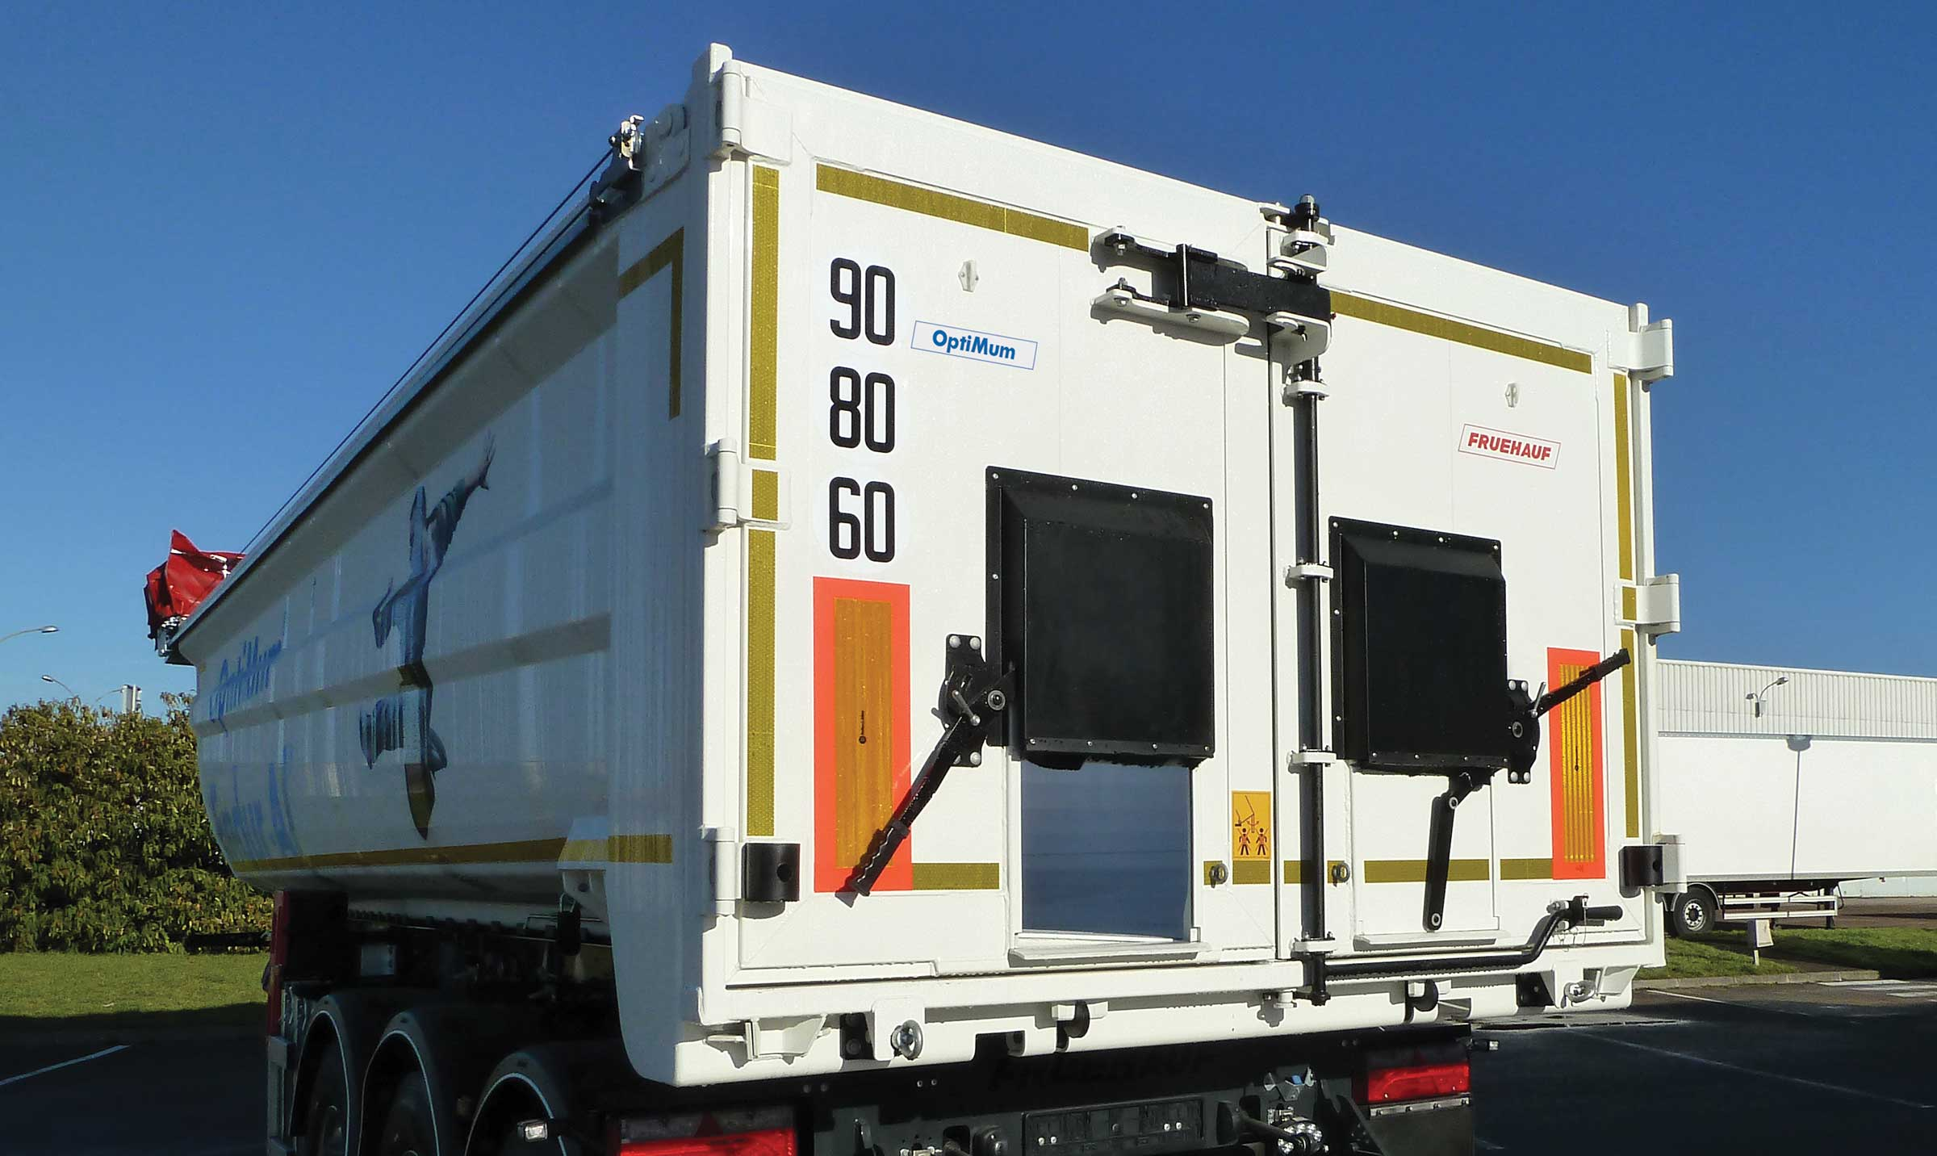
Gallery

Universal rear gate
Bennes TP Optimum
Top hinged rear gateGuillaume Calviac2021-02-09T14:48:16+01:00
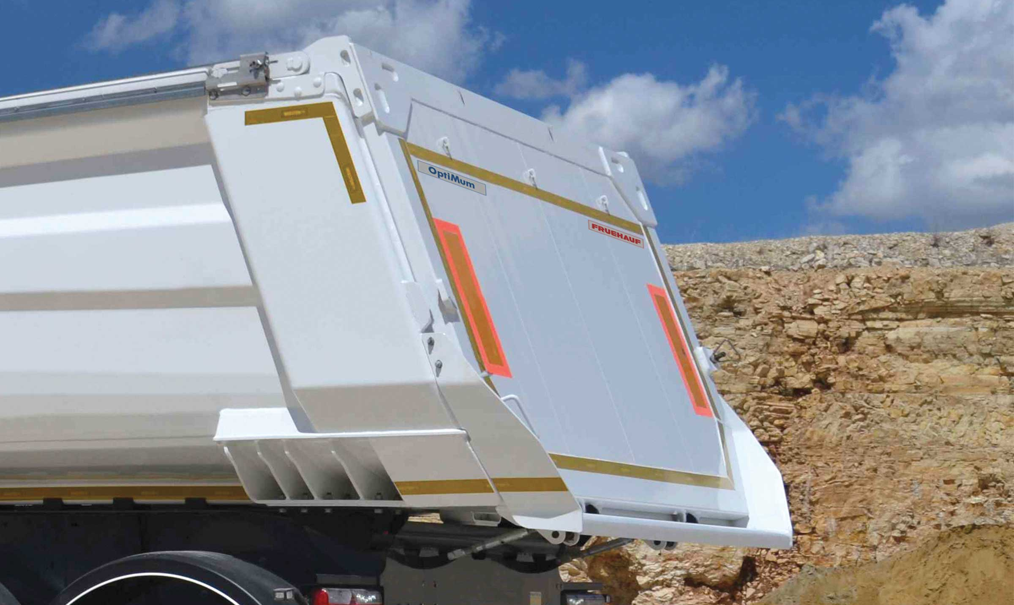
Gallery

Top hinged rear gate
Bennes TP Optimum
OptiMumGuillaume Calviac2021-01-15T14:42:47+01:00
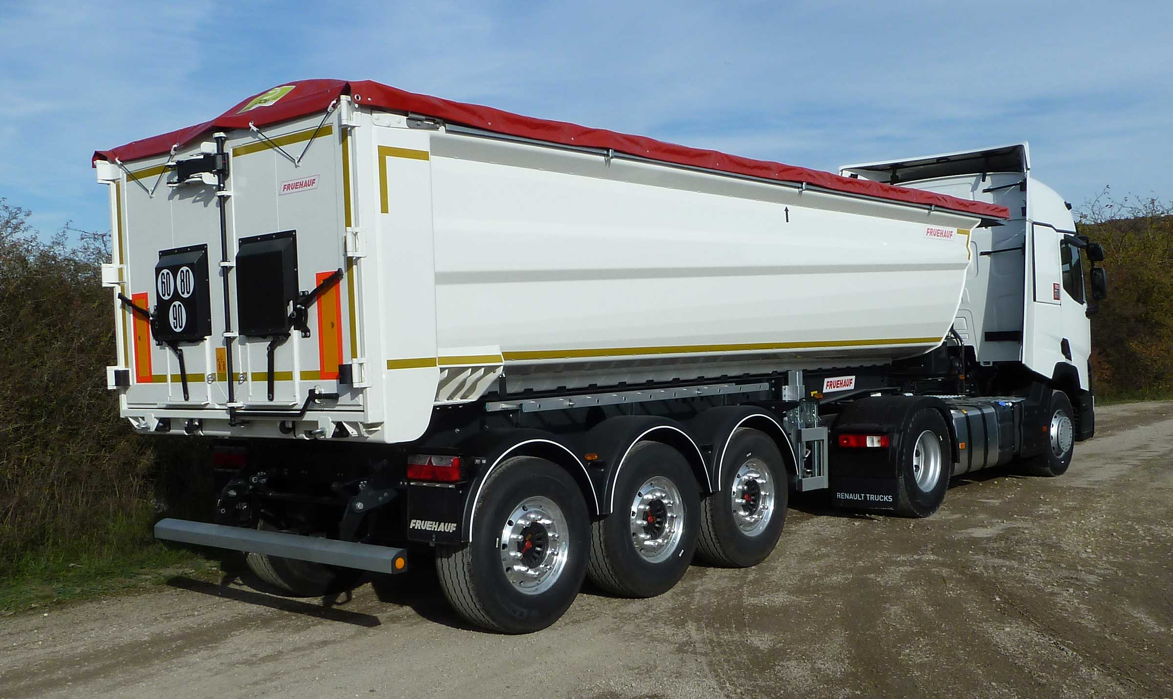
Gallery

OptiMum
Bennes TP Optimum
OptiMumGuillaume Calviac2021-01-15T14:40:51+01:00
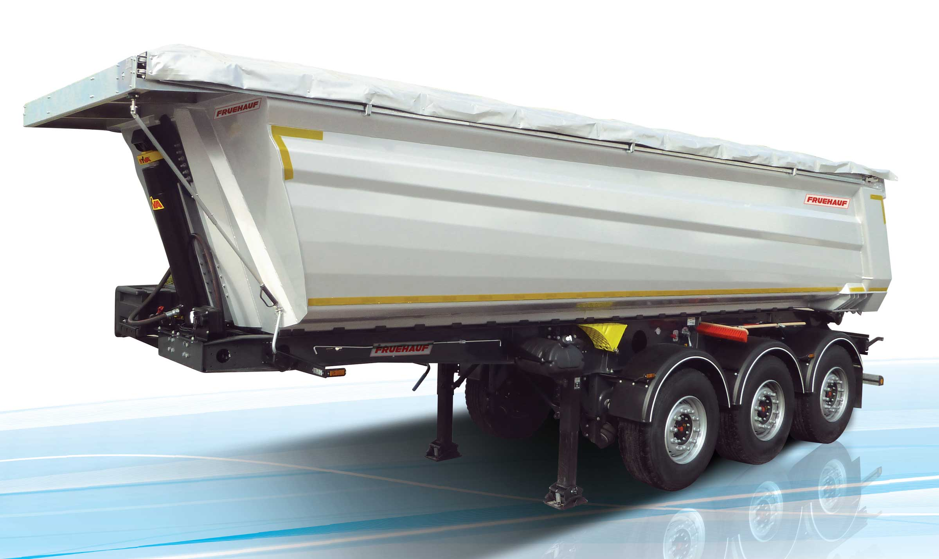
Gallery

OptiMum
Bennes TP Optimum
Documentation

OptiMax

Variable Volume

From 23 to 40 m³
Its modular construction with smooth surfaces of the box enables huge variability of volumes with lengths and heights adapted to all needs.
Its special "ENDUR-AL®" aluminium bottom offers unrivalled abrasion resistance, and the thickness and number of crossmembers can be adapted.
- Body with reinforced smooth walls
- Adaptable bottom
- Versatile use
OptiMaxGuillaume Calviac2021-01-15T14:51:36+01:00
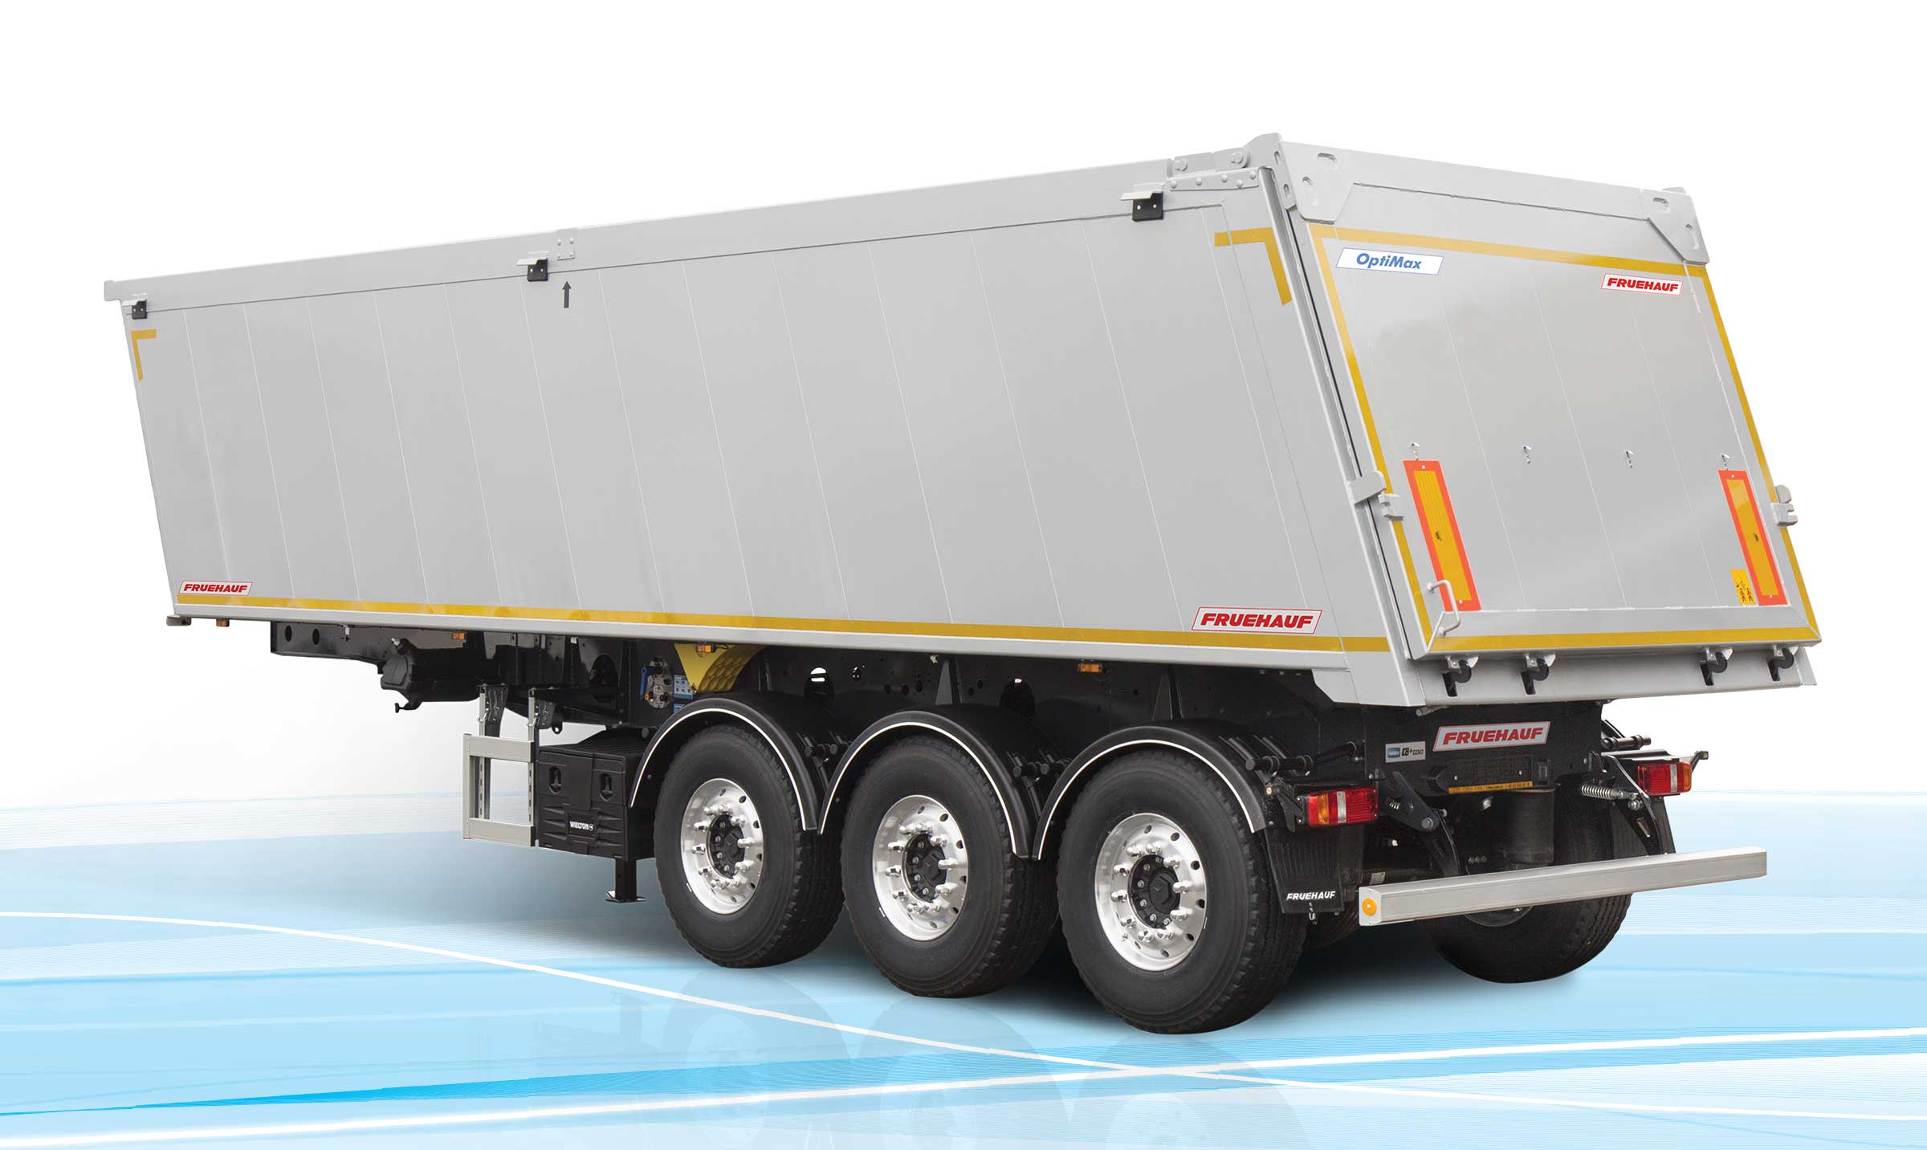
Gallery

OptiMax
Bennes TP OptiMax
OptiMaxGuillaume Calviac2021-01-15T14:51:13+01:00
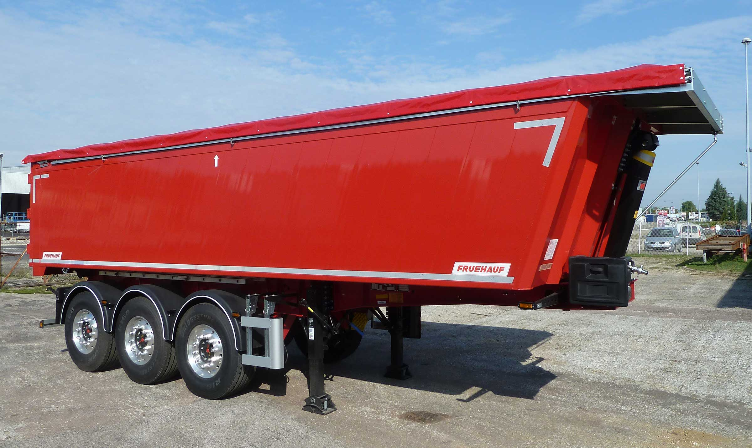
Gallery

OptiMax
Bennes TP OptiMax
Modular body with smooth side wallsGuillaume Calviac2021-02-09T14:51:49+01:00
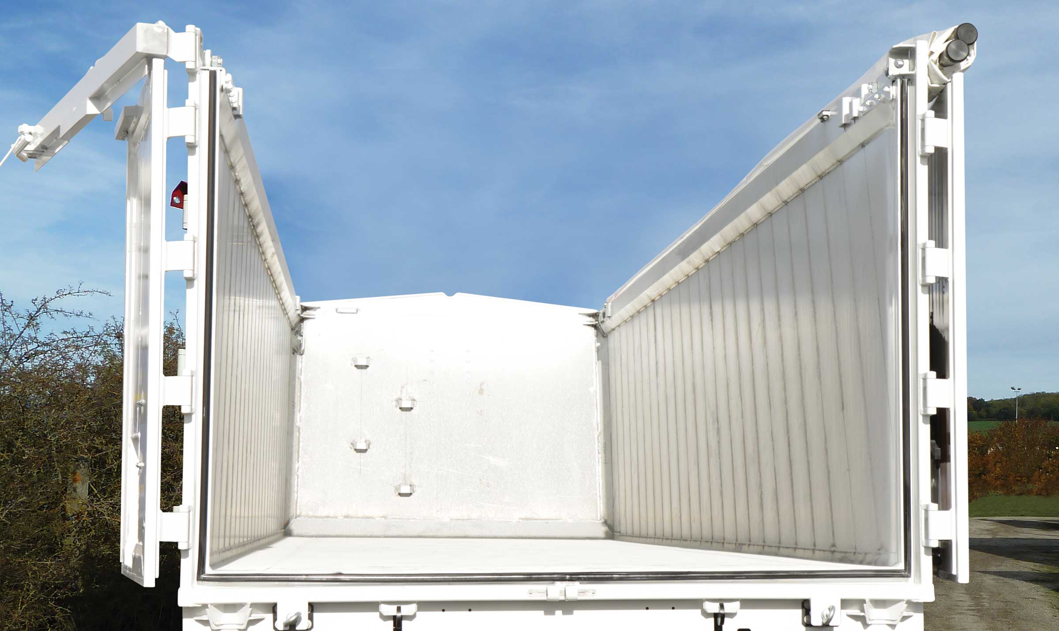
Gallery

Modular body with smooth side walls
Bennes TP OptiMax
Tapered doubling of the side wallsGuillaume Calviac2021-02-09T14:52:40+01:00
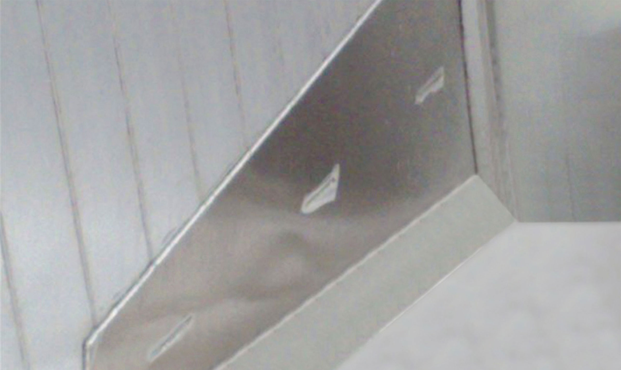
Gallery

Tapered doubling of the side walls
Bennes TP OptiMax
Documentation

OptiSteel

Abrasion Resistance

From 22 to 27 m³
The result of our expertise as a leader in the manufacture of steel tippers, its body is made from special HARDOX® steel and offers the greatest abrasion resistance while preserving maximum payload.
Its single-piece bottom with side risers guarantees unrivalled service life, without renovation of the bottoms and sides, making it particularly economical.
- High abrasion resistance
- Long service life
- Sturdy and lightweight
OptiSteelGuillaume Calviac2021-01-15T15:00:21+01:00
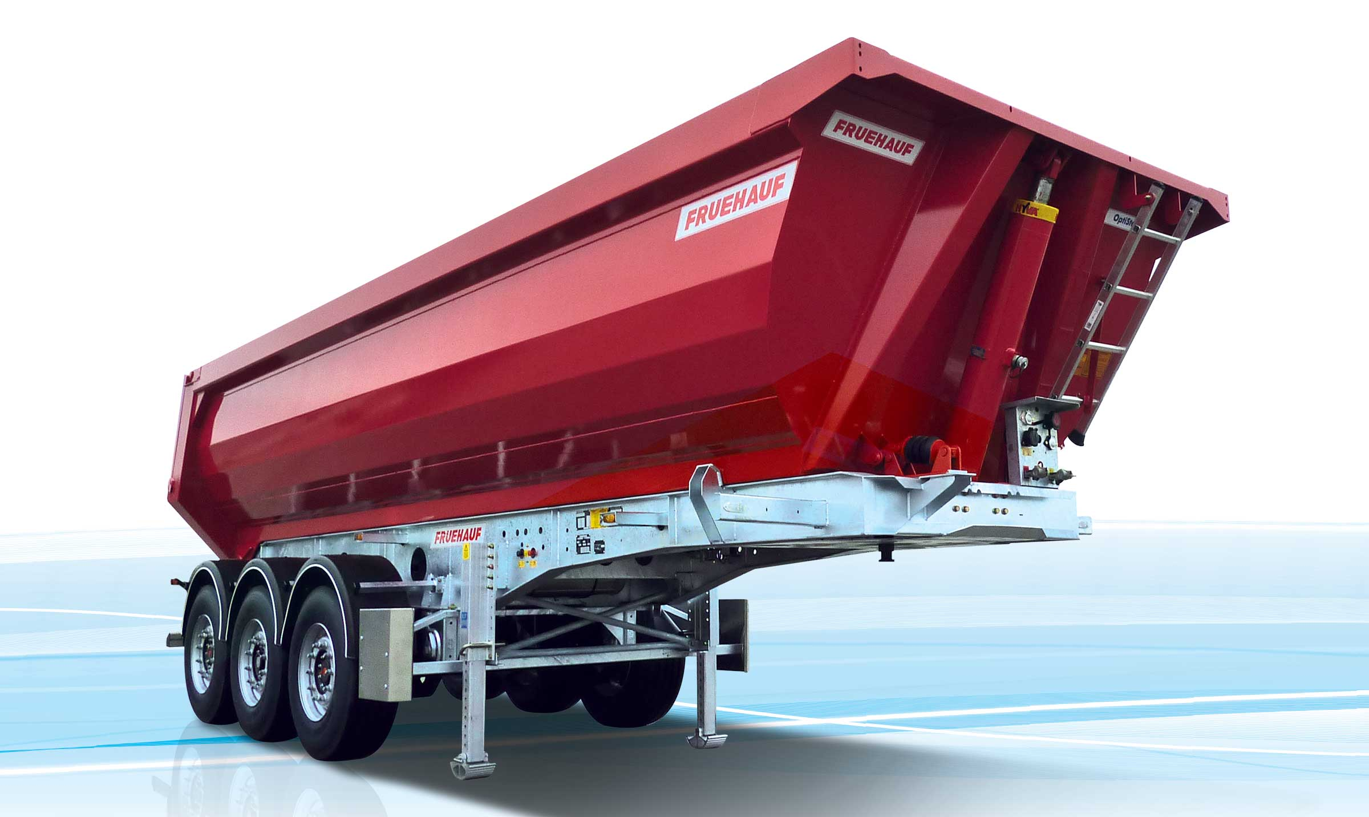
Gallery

OptiSteel
Bennes TP OptiSteel
OptiSteelGuillaume Calviac2021-01-15T14:59:49+01:00
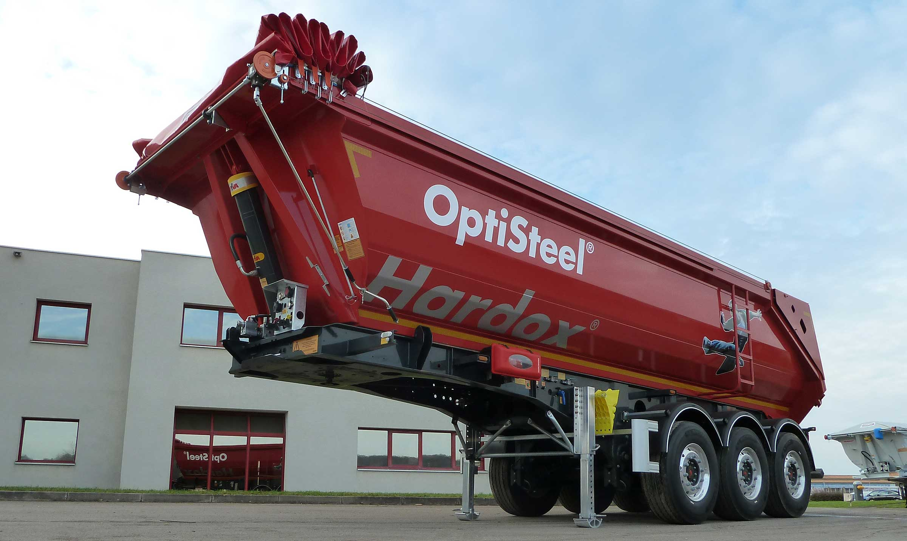
Gallery

OptiSteel
Bennes TP OptiSteel
Hydraulic tailgateGuillaume Calviac2021-01-15T14:59:27+01:00
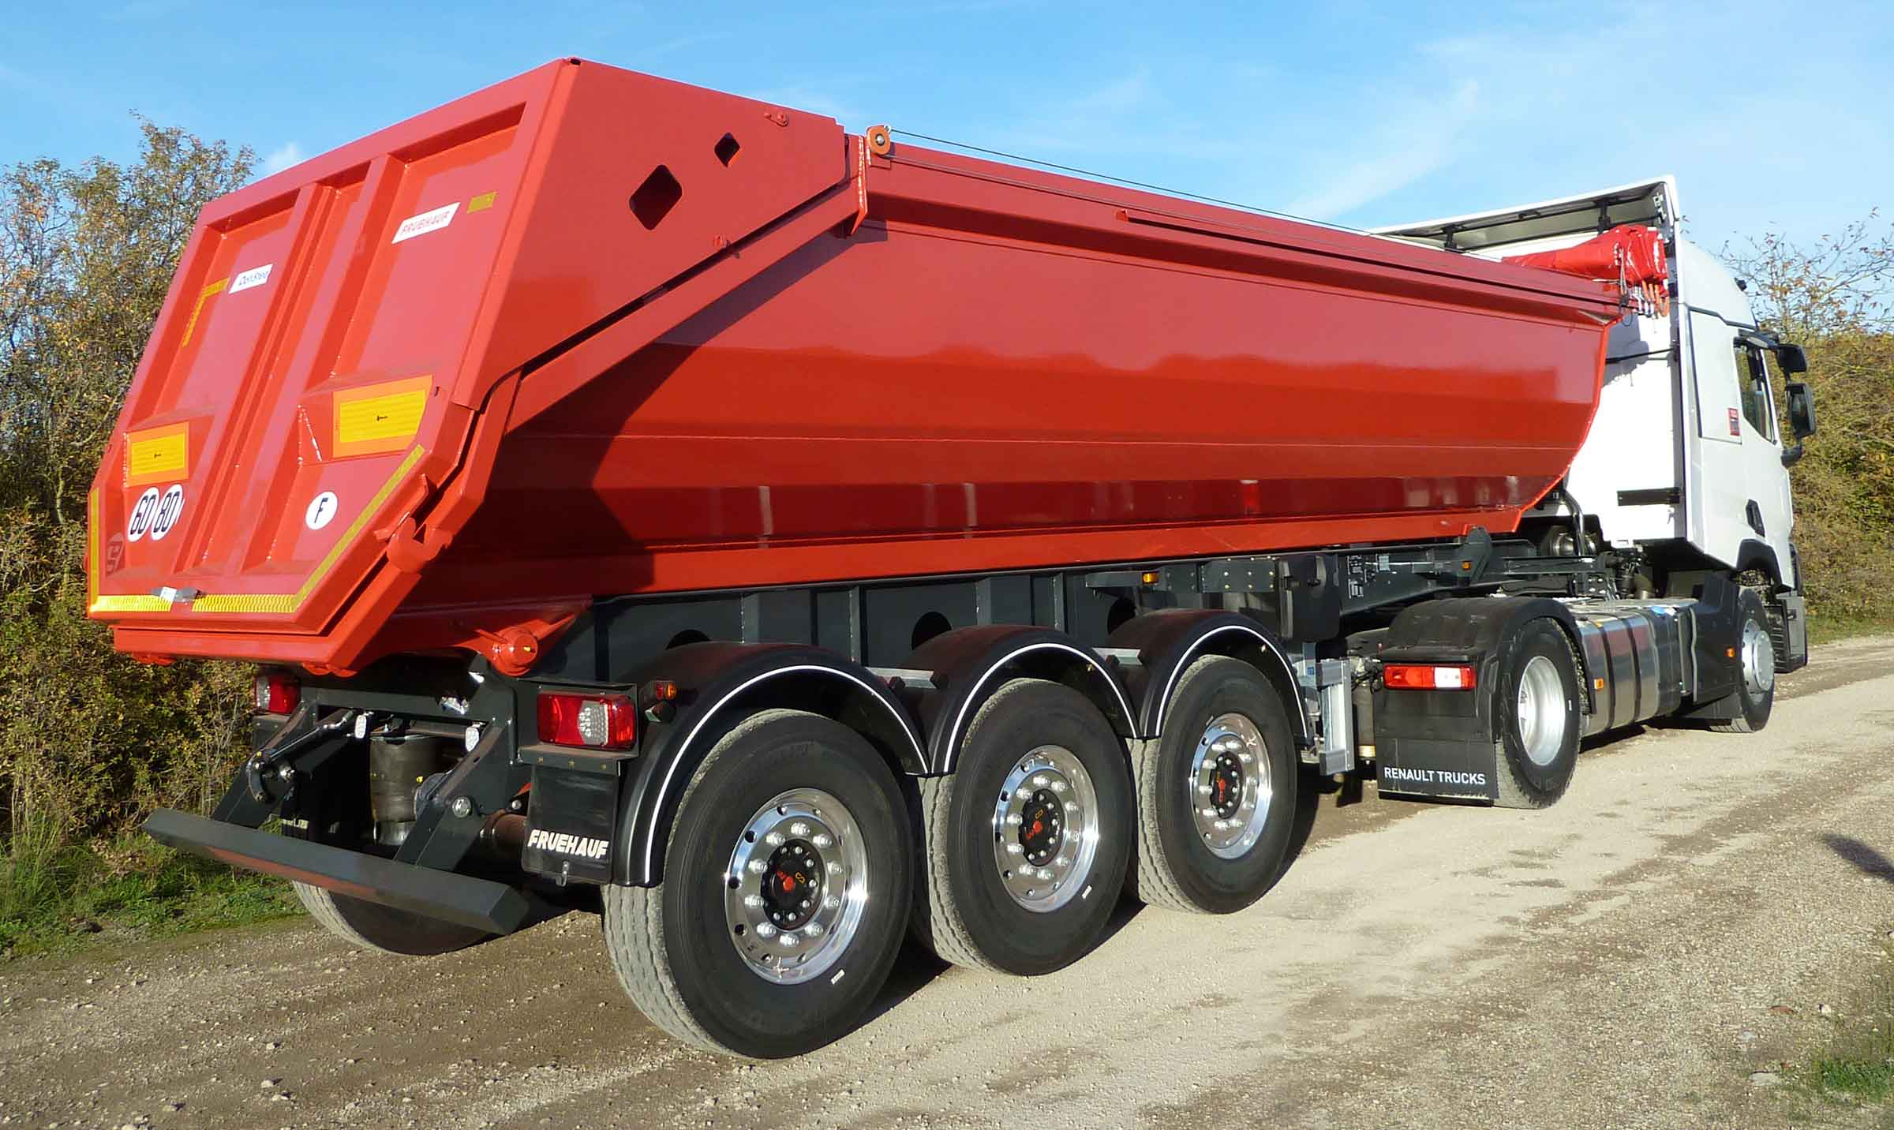
Gallery

Hydraulic tailgate
Bennes TP OptiSteel
Lifting bumper when tippingGuillaume Calviac2021-02-09T14:56:59+01:00
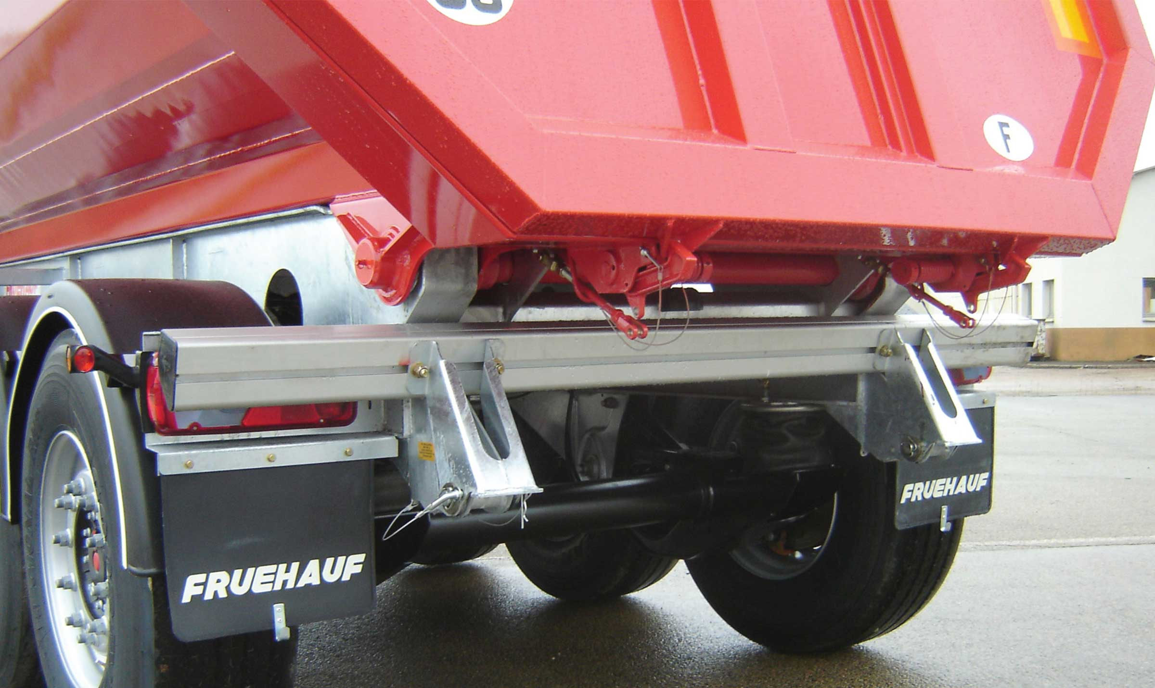
Gallery

Lifting bumper when tipping
Bennes TP OptiSteel
Universal rear doorGuillaume Calviac2021-01-15T14:58:11+01:00
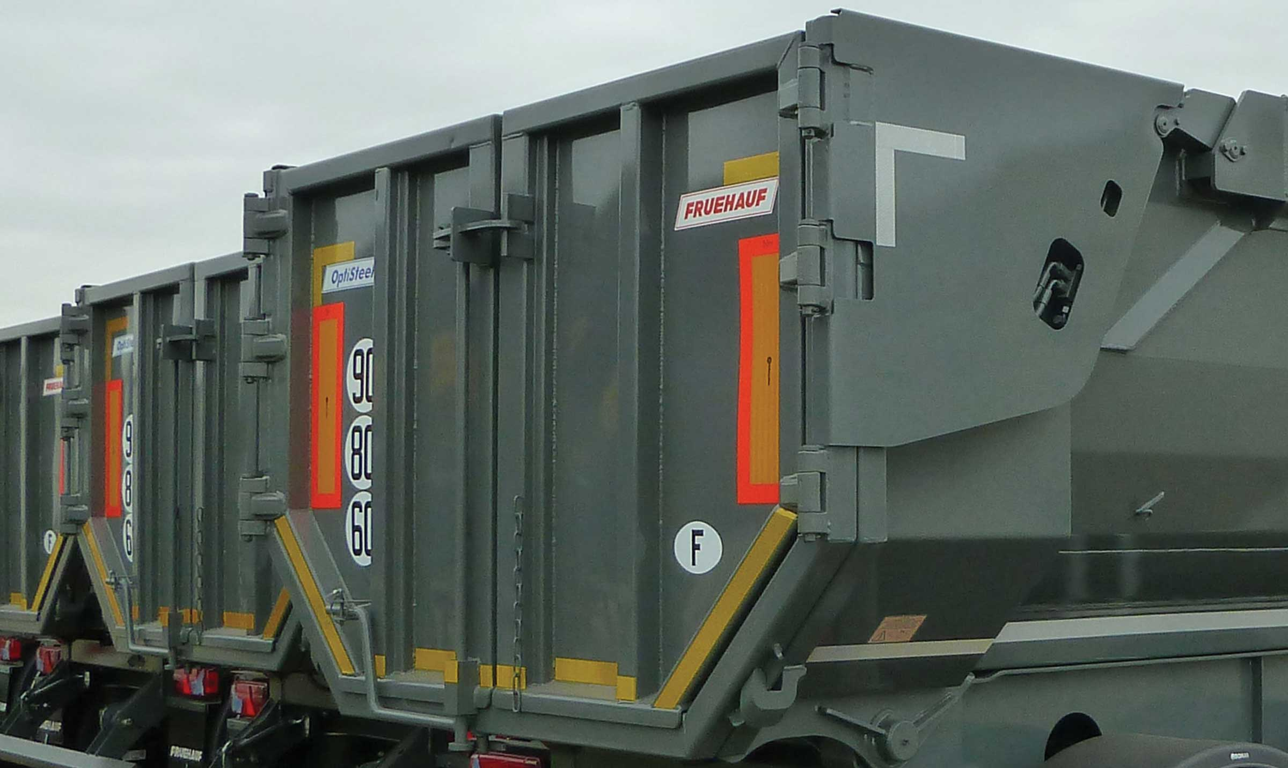
Gallery

Universal rear door
Bennes TP OptiSteel
Aluminium landing gearGuillaume Calviac2021-01-15T14:57:27+01:00
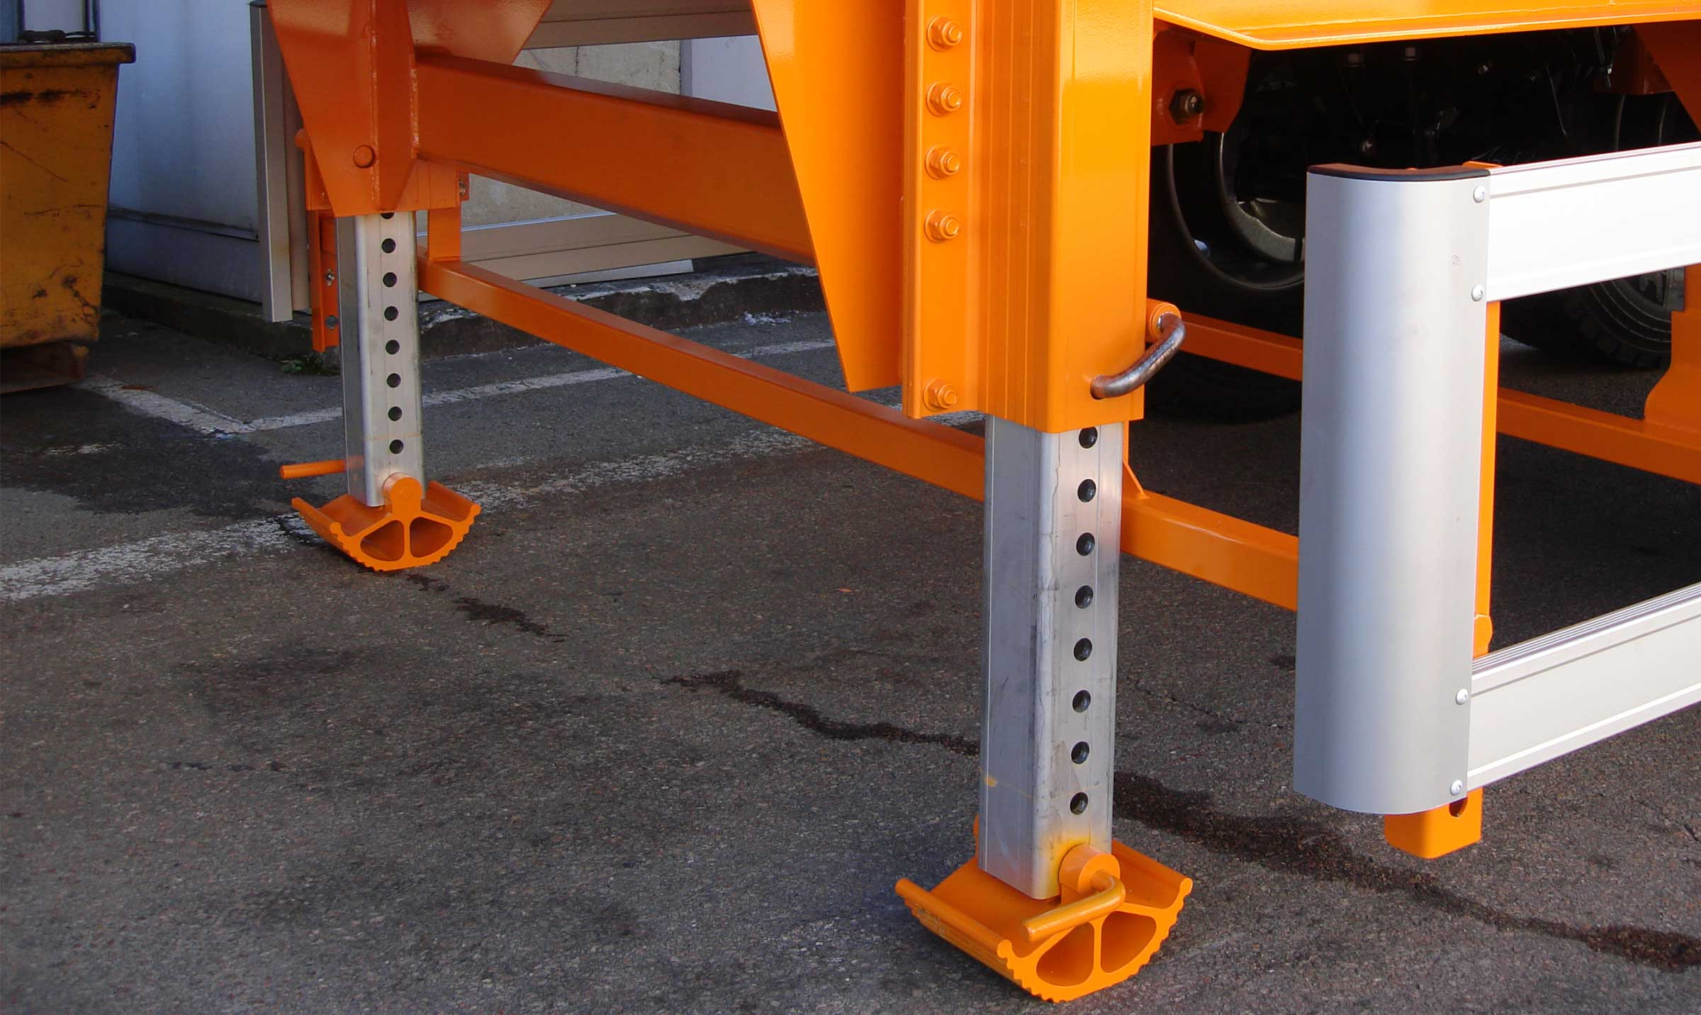
Gallery

Aluminium landing gear
Bennes TP OptiSteel
Documentation

Earthwork – Demolition – Rock filling
FRUEHAUF reinforced Public Works Tippers are designed for intensive or harsh applications. Their sturdiness is recognised on the market.

Intensive

Performance

From 22 to 27 m³
Specially designed for intensive earthworks, central or site supplies and small demolitions.
The seamless, single-piece bottom of the body with its side and front walls made from special HARDOX® steel offer unrivalled abrasion resistance.
- Unrivalled abrasion resistance
- Versatile use
- Sturdiness
IntensiveGuillaume Calviac2021-01-15T15:18:08+01:00
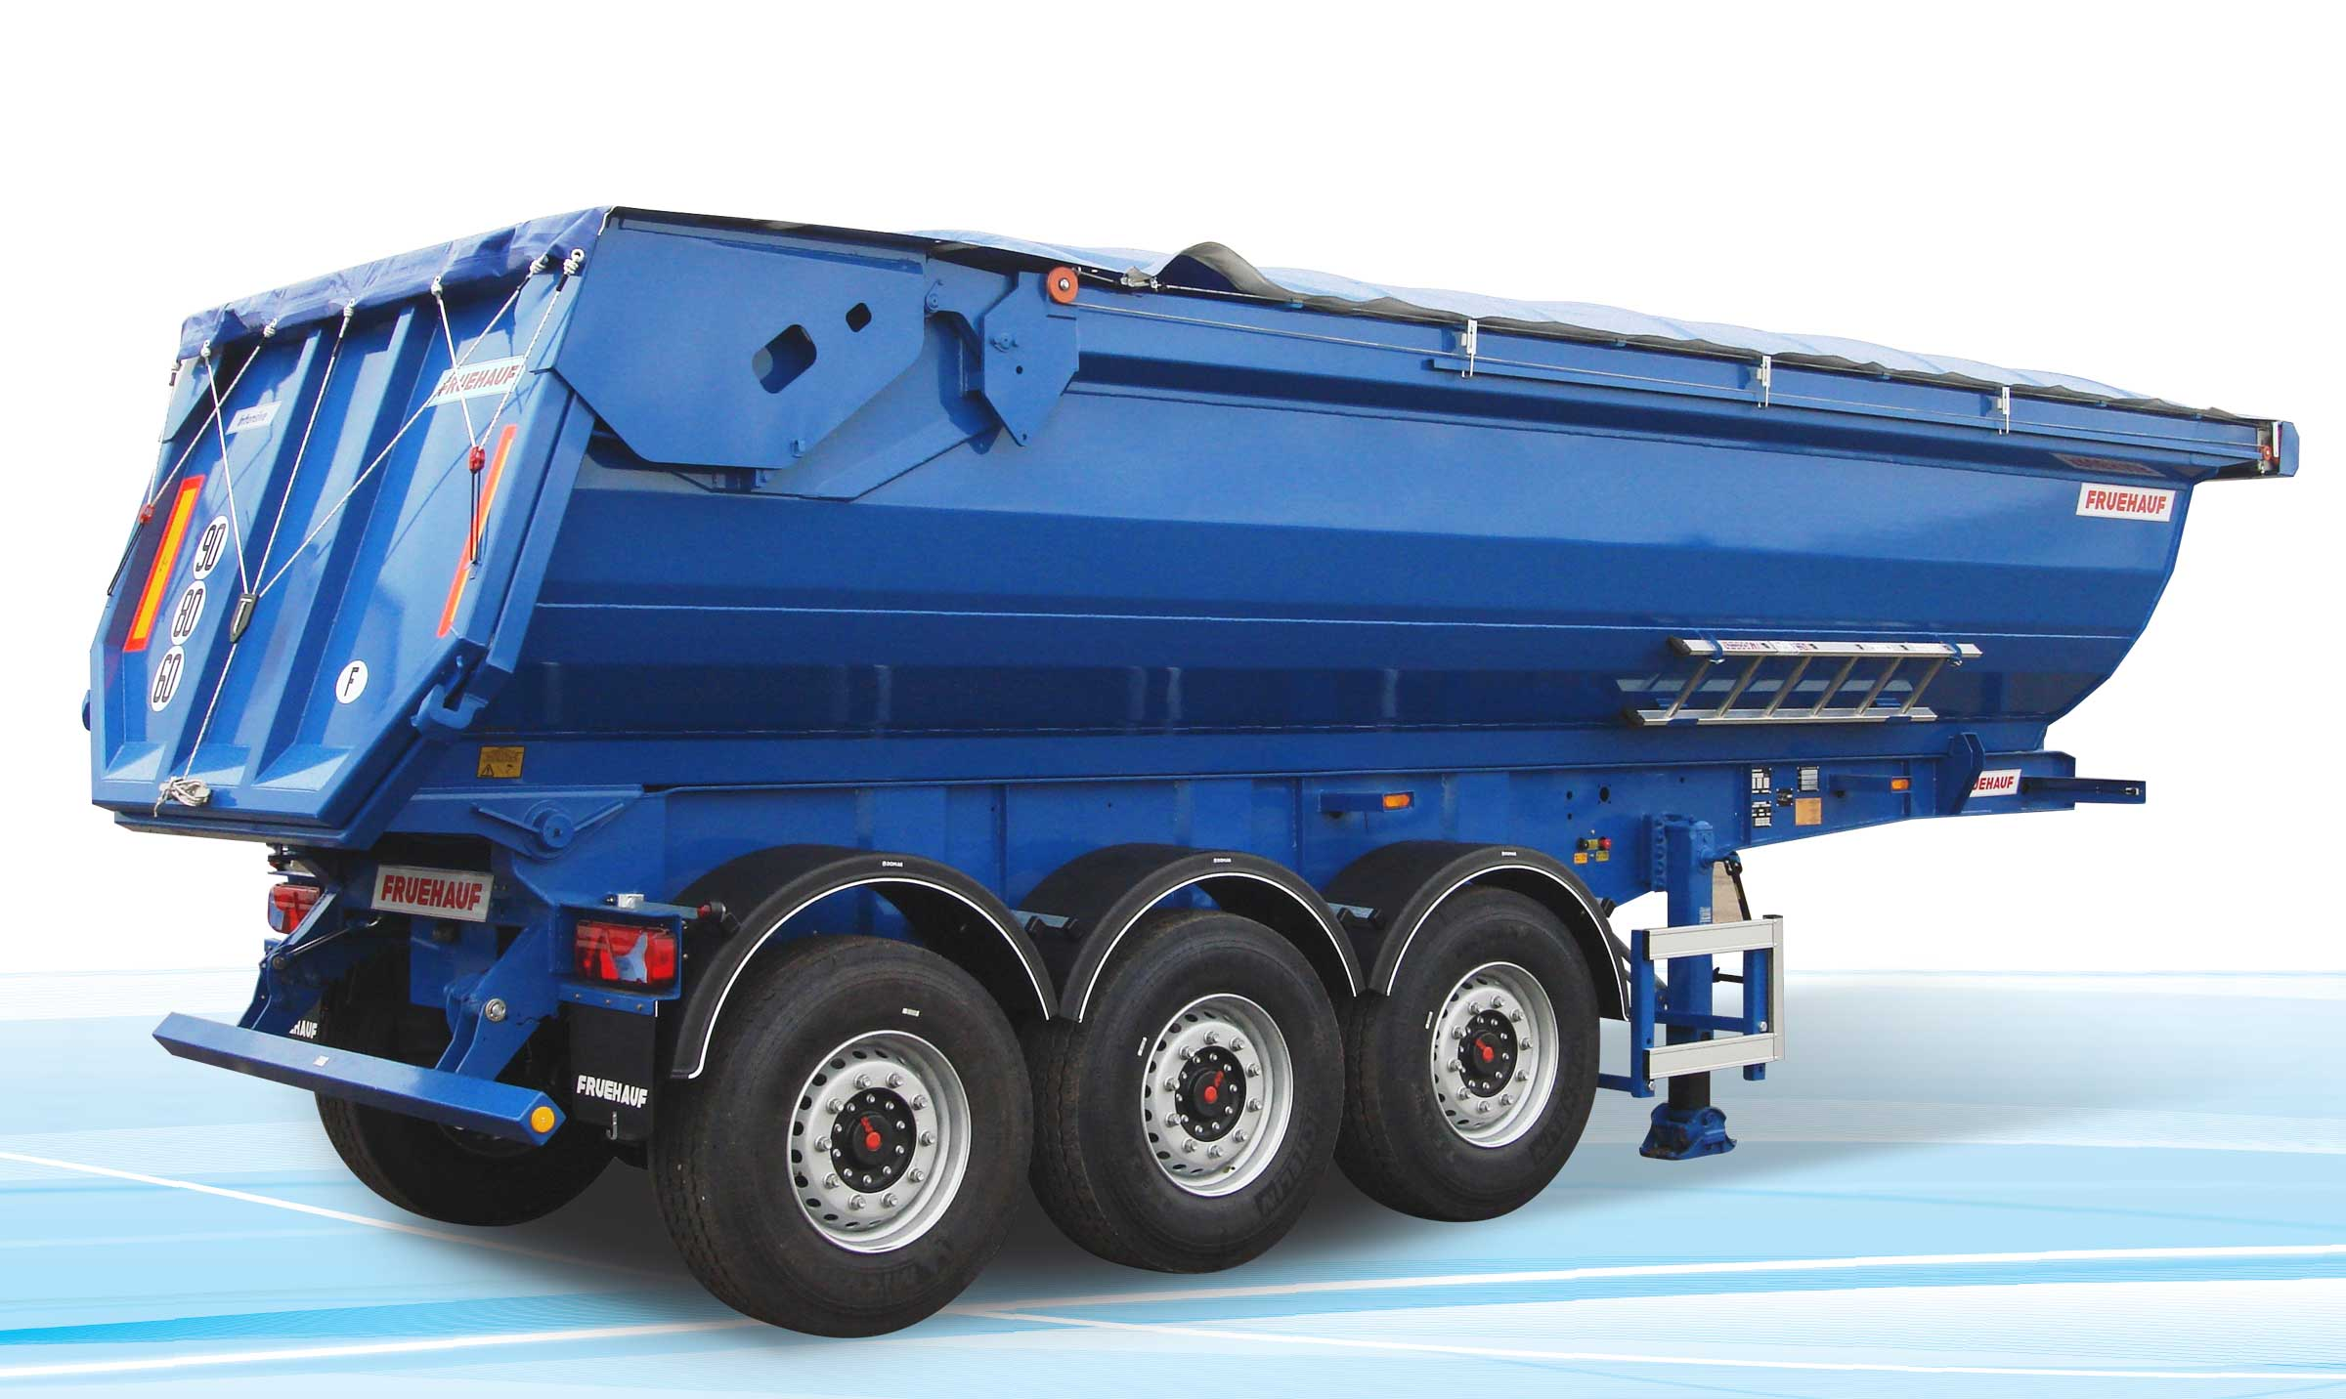
Gallery

Intensive
Bennes TP Intensive
IntensiveGuillaume Calviac2021-01-15T15:17:53+01:00
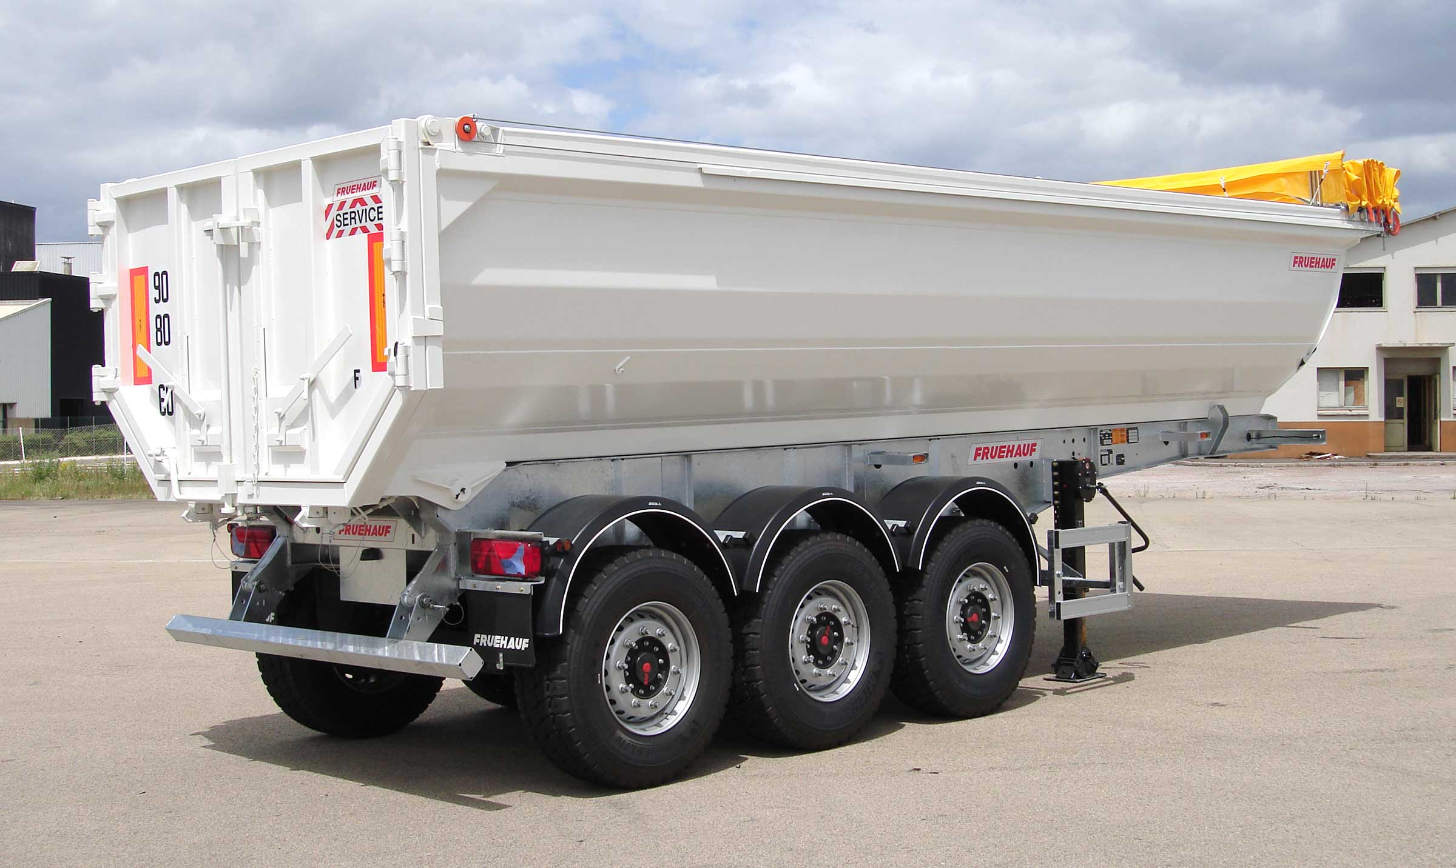
Gallery

Intensive
Bennes TP Intensive
IntensiveGuillaume Calviac2021-01-15T15:17:38+01:00
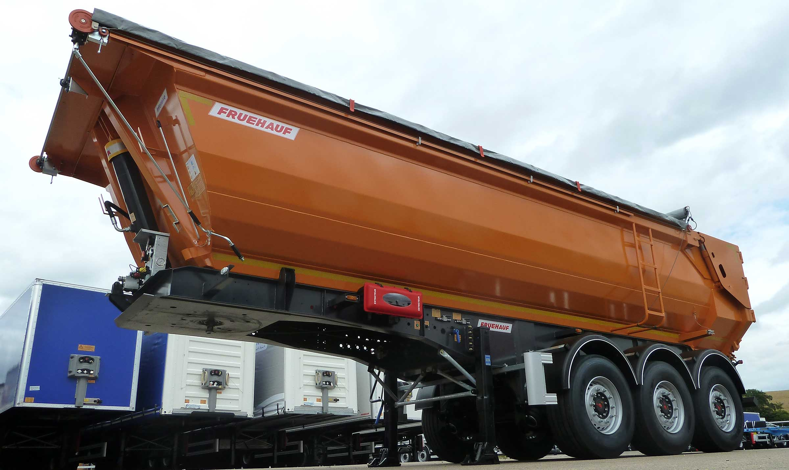
Gallery

Intensive
Bennes TP Intensive
Hydraulic tailgateGuillaume Calviac2021-01-15T15:16:57+01:00
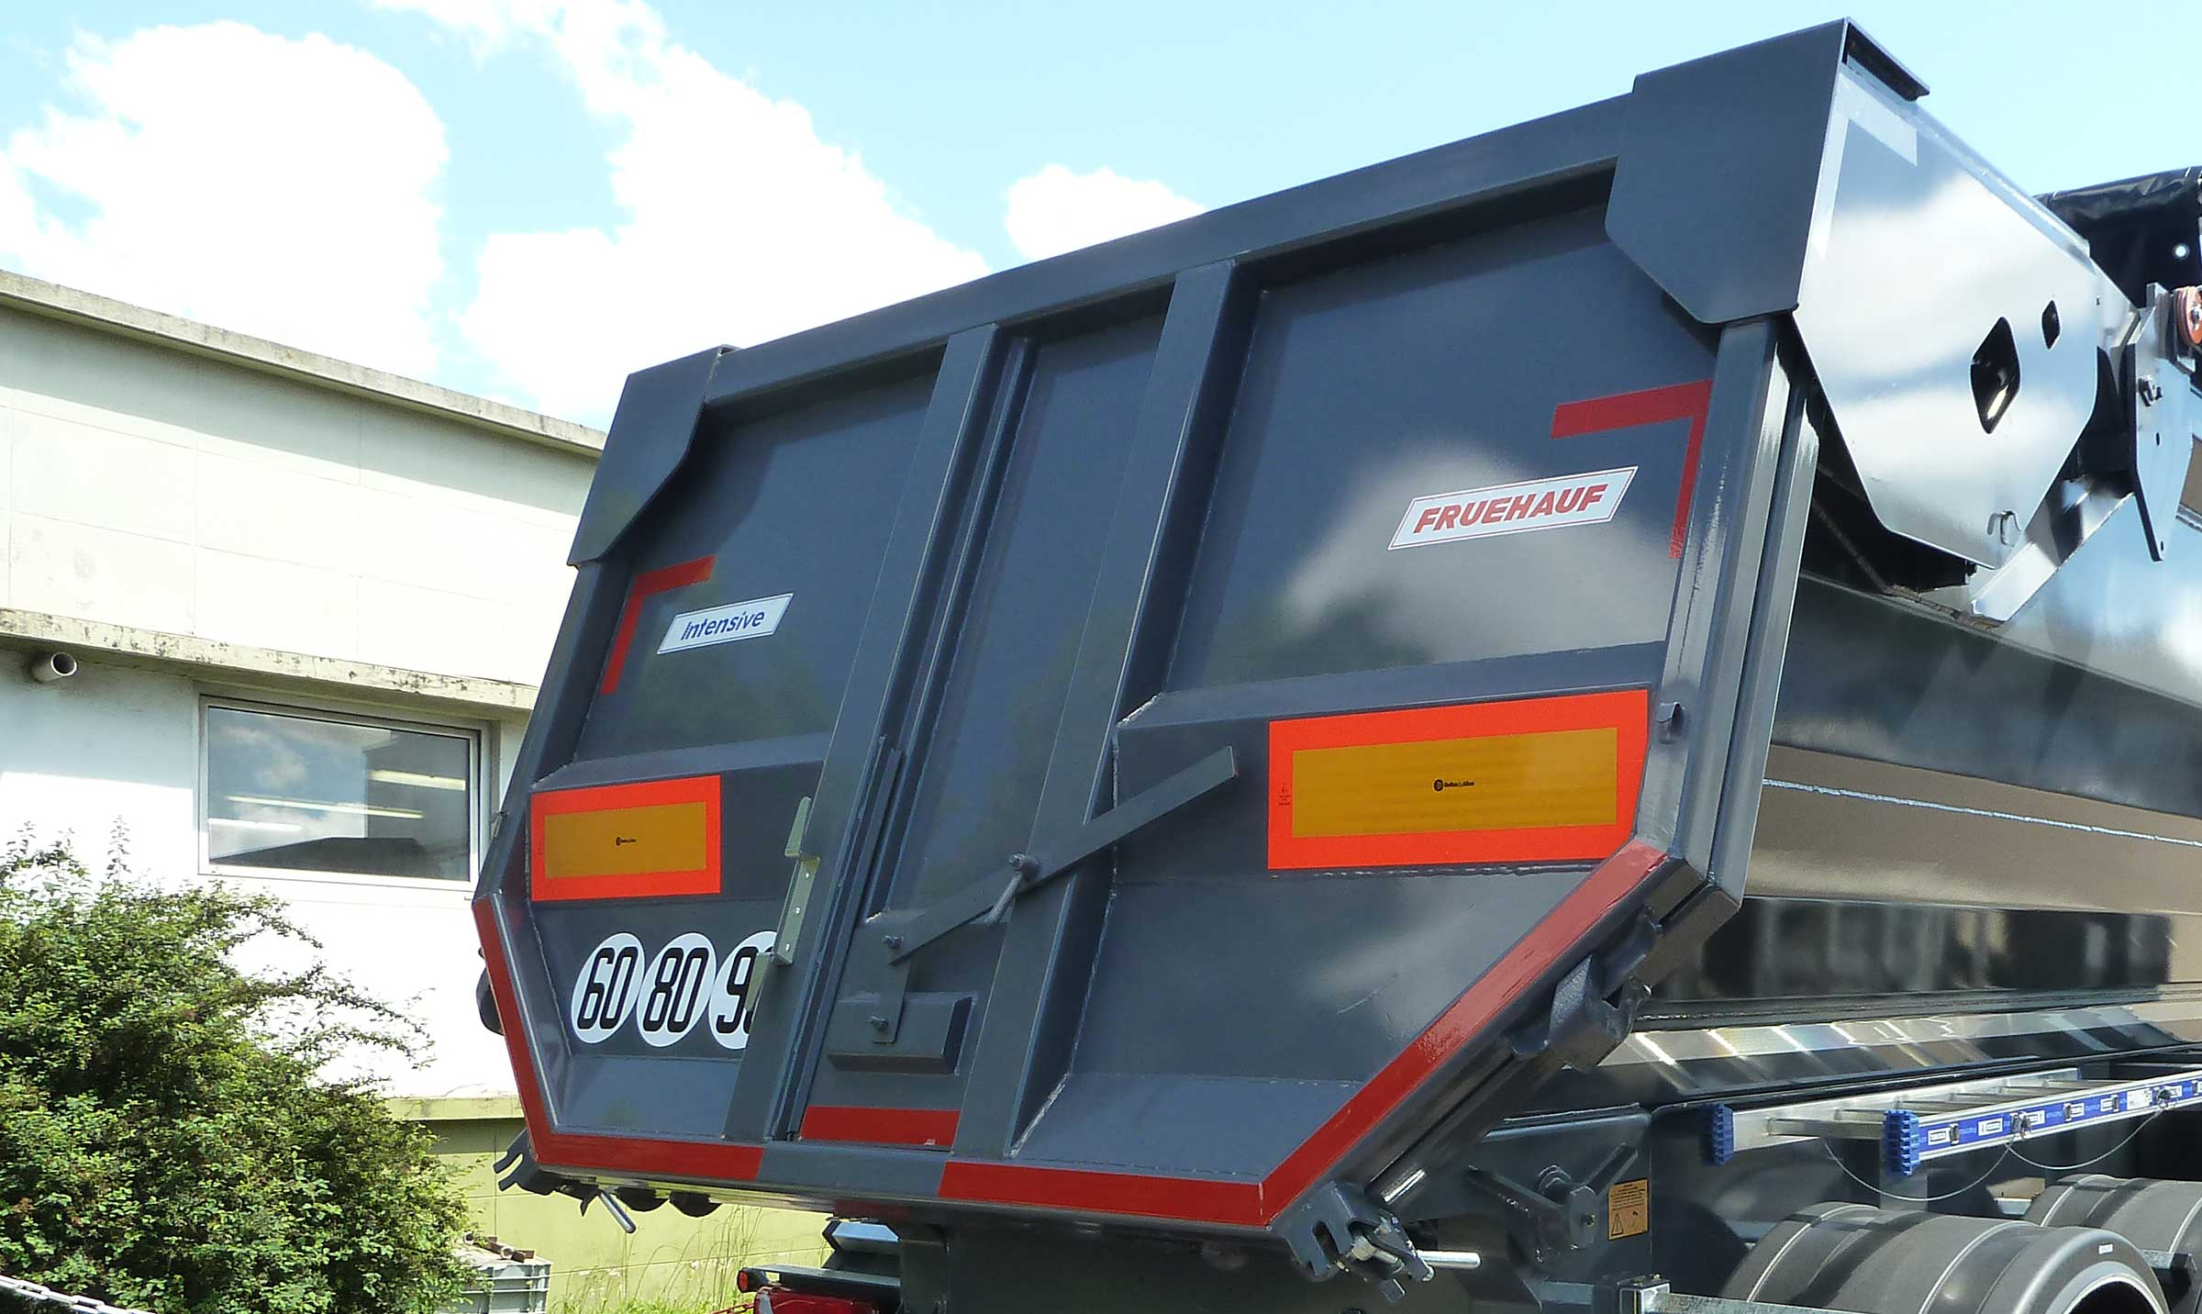
Gallery

Hydraulic tailgate
Bennes TP Intensive
Universal rear doorGuillaume Calviac2021-01-15T15:15:20+01:00
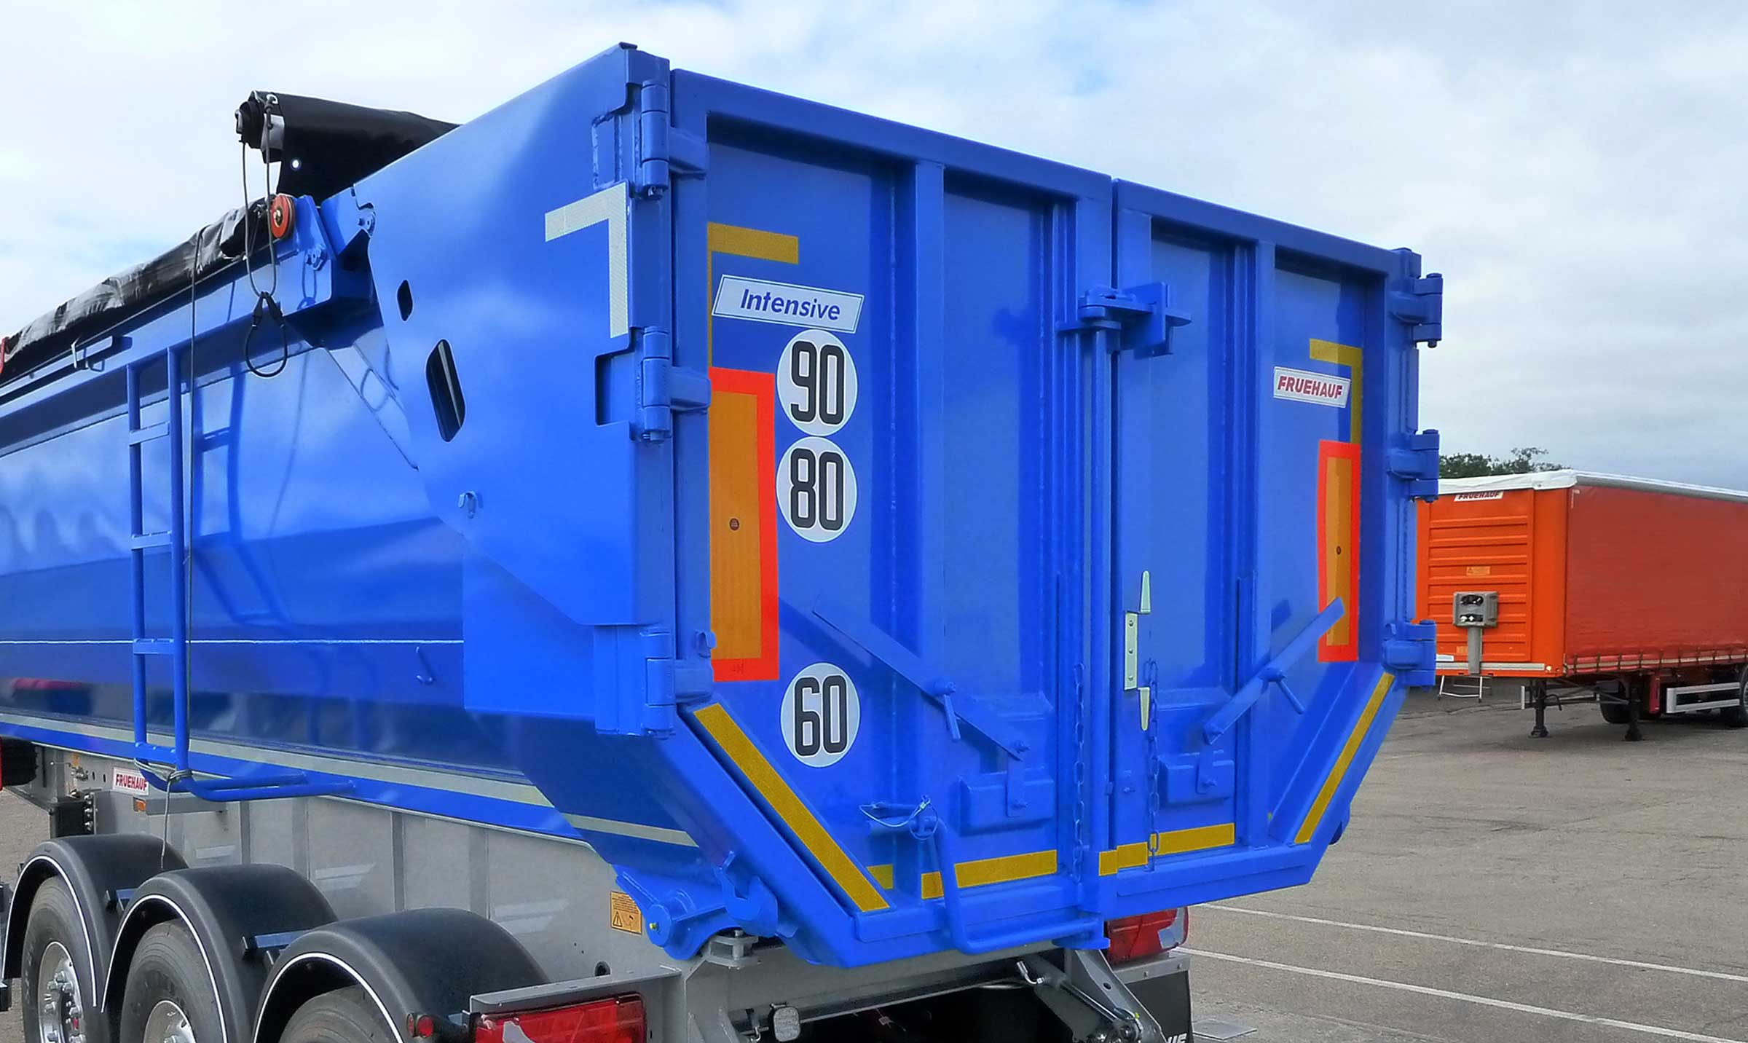
Gallery

Universal rear door
Bennes TP Intensive
Finisher-compatible reinforced axlesGuillaume Calviac2021-01-15T15:14:38+01:00
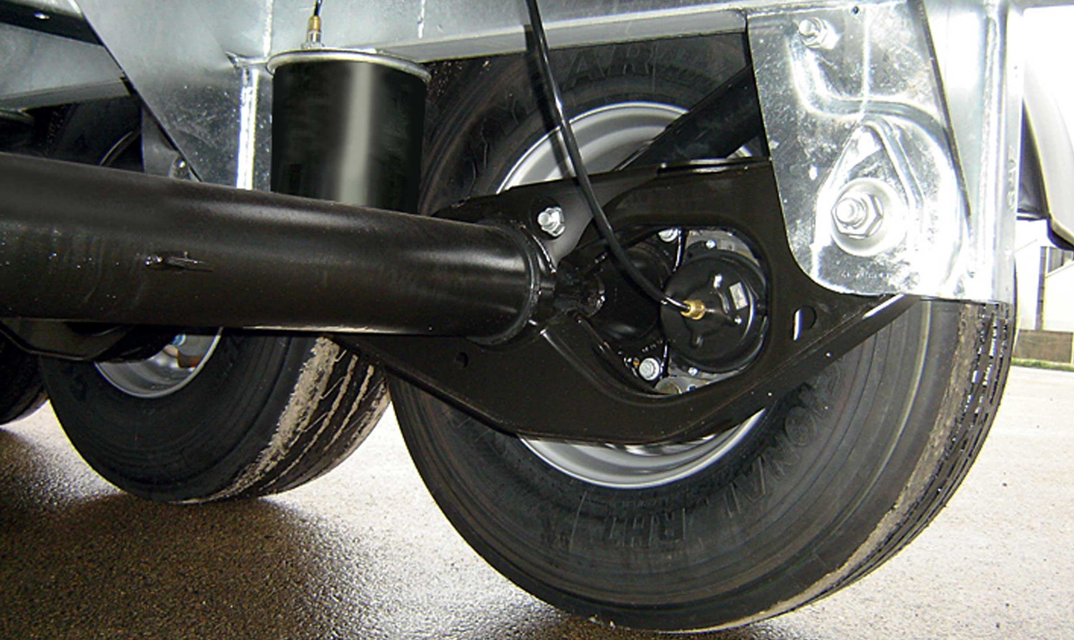
Gallery

Finisher-compatible reinforced axles
Bennes TP Intensive

Extreme

Sturdiness

From 22 to 27 m³
Model intended for the harshest demolition and rock filling applications, its body is made from thick HARDOX® steel.
Its side walls, which are lined at the bottom by the side lifts of the bottom sheet, guarantee extreme impact resistance.
- Unrivalled abrasion resistance
- Long service life
- Extreme sturdiness
ExtremeGuillaume Calviac2021-01-15T15:25:11+01:00
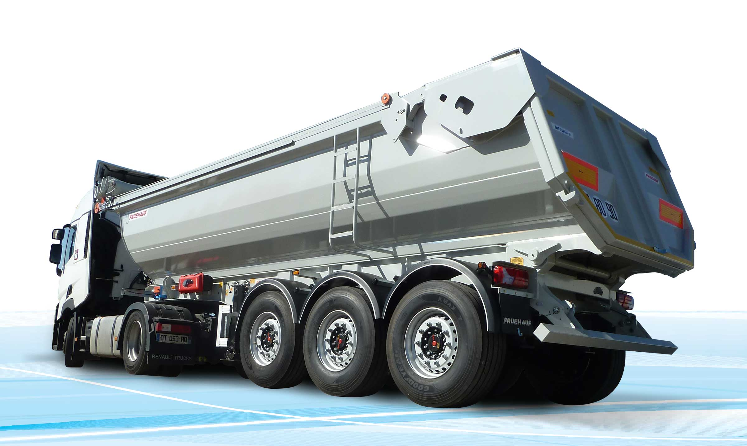
Gallery

Extreme
Bennes TP Extreme
Hydraulic tailgateGuillaume Calviac2021-01-15T15:24:40+01:00
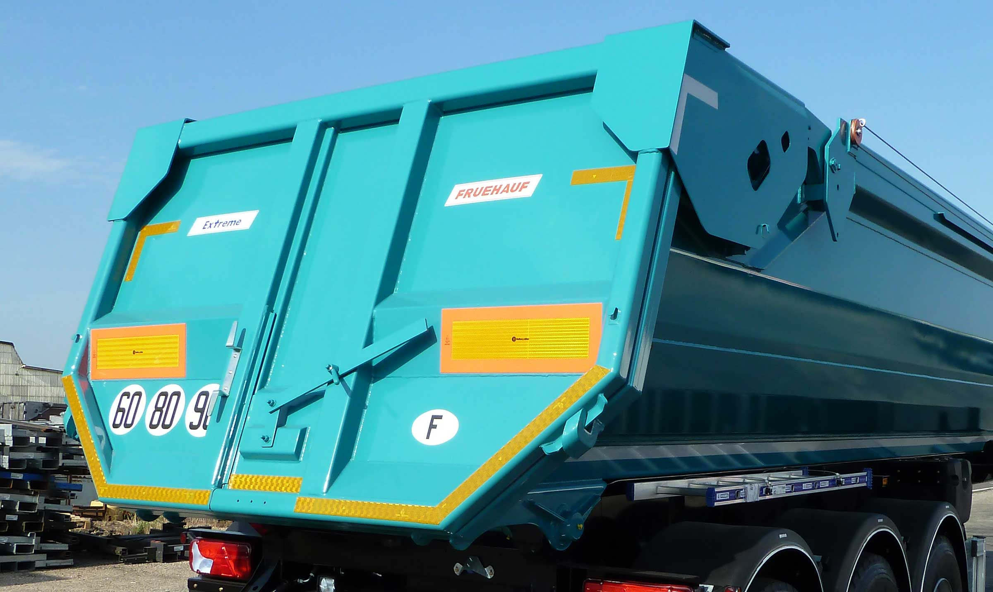
Gallery

Hydraulic tailgate
Bennes TP Extreme
Rear self-steering axleGuillaume Calviac2021-01-15T15:23:47+01:00
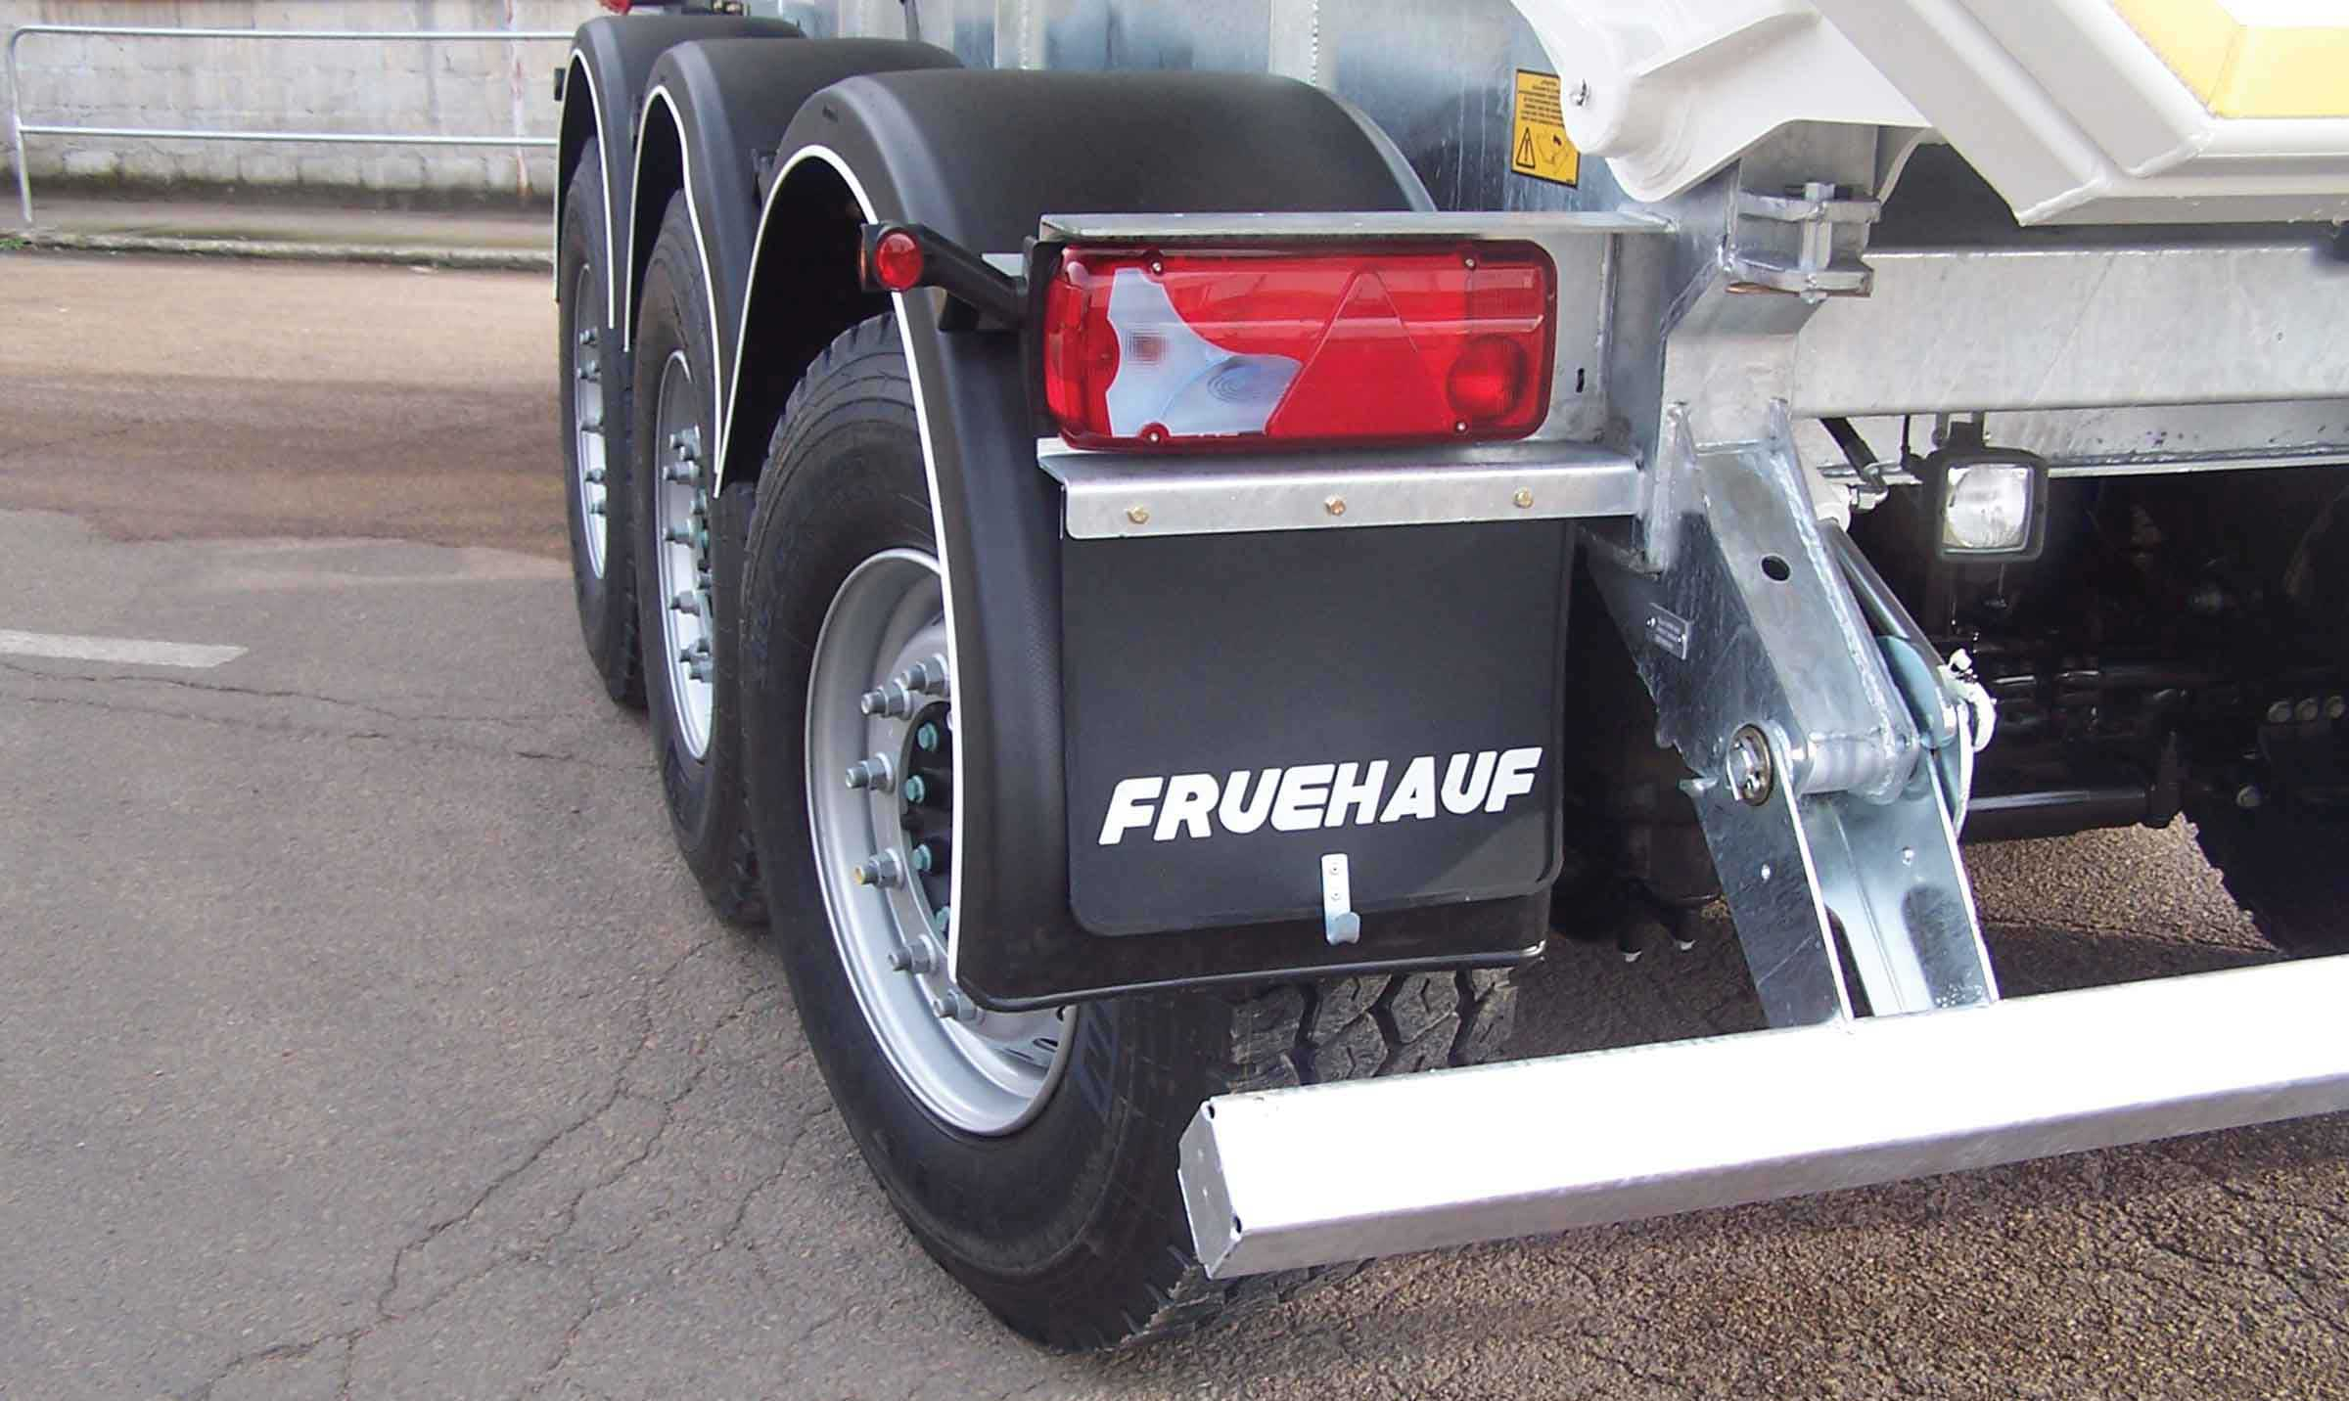
Gallery

Rear self-steering axle
Bennes TP Extreme
MudguardGuillaume Calviac2021-01-15T15:23:07+01:00
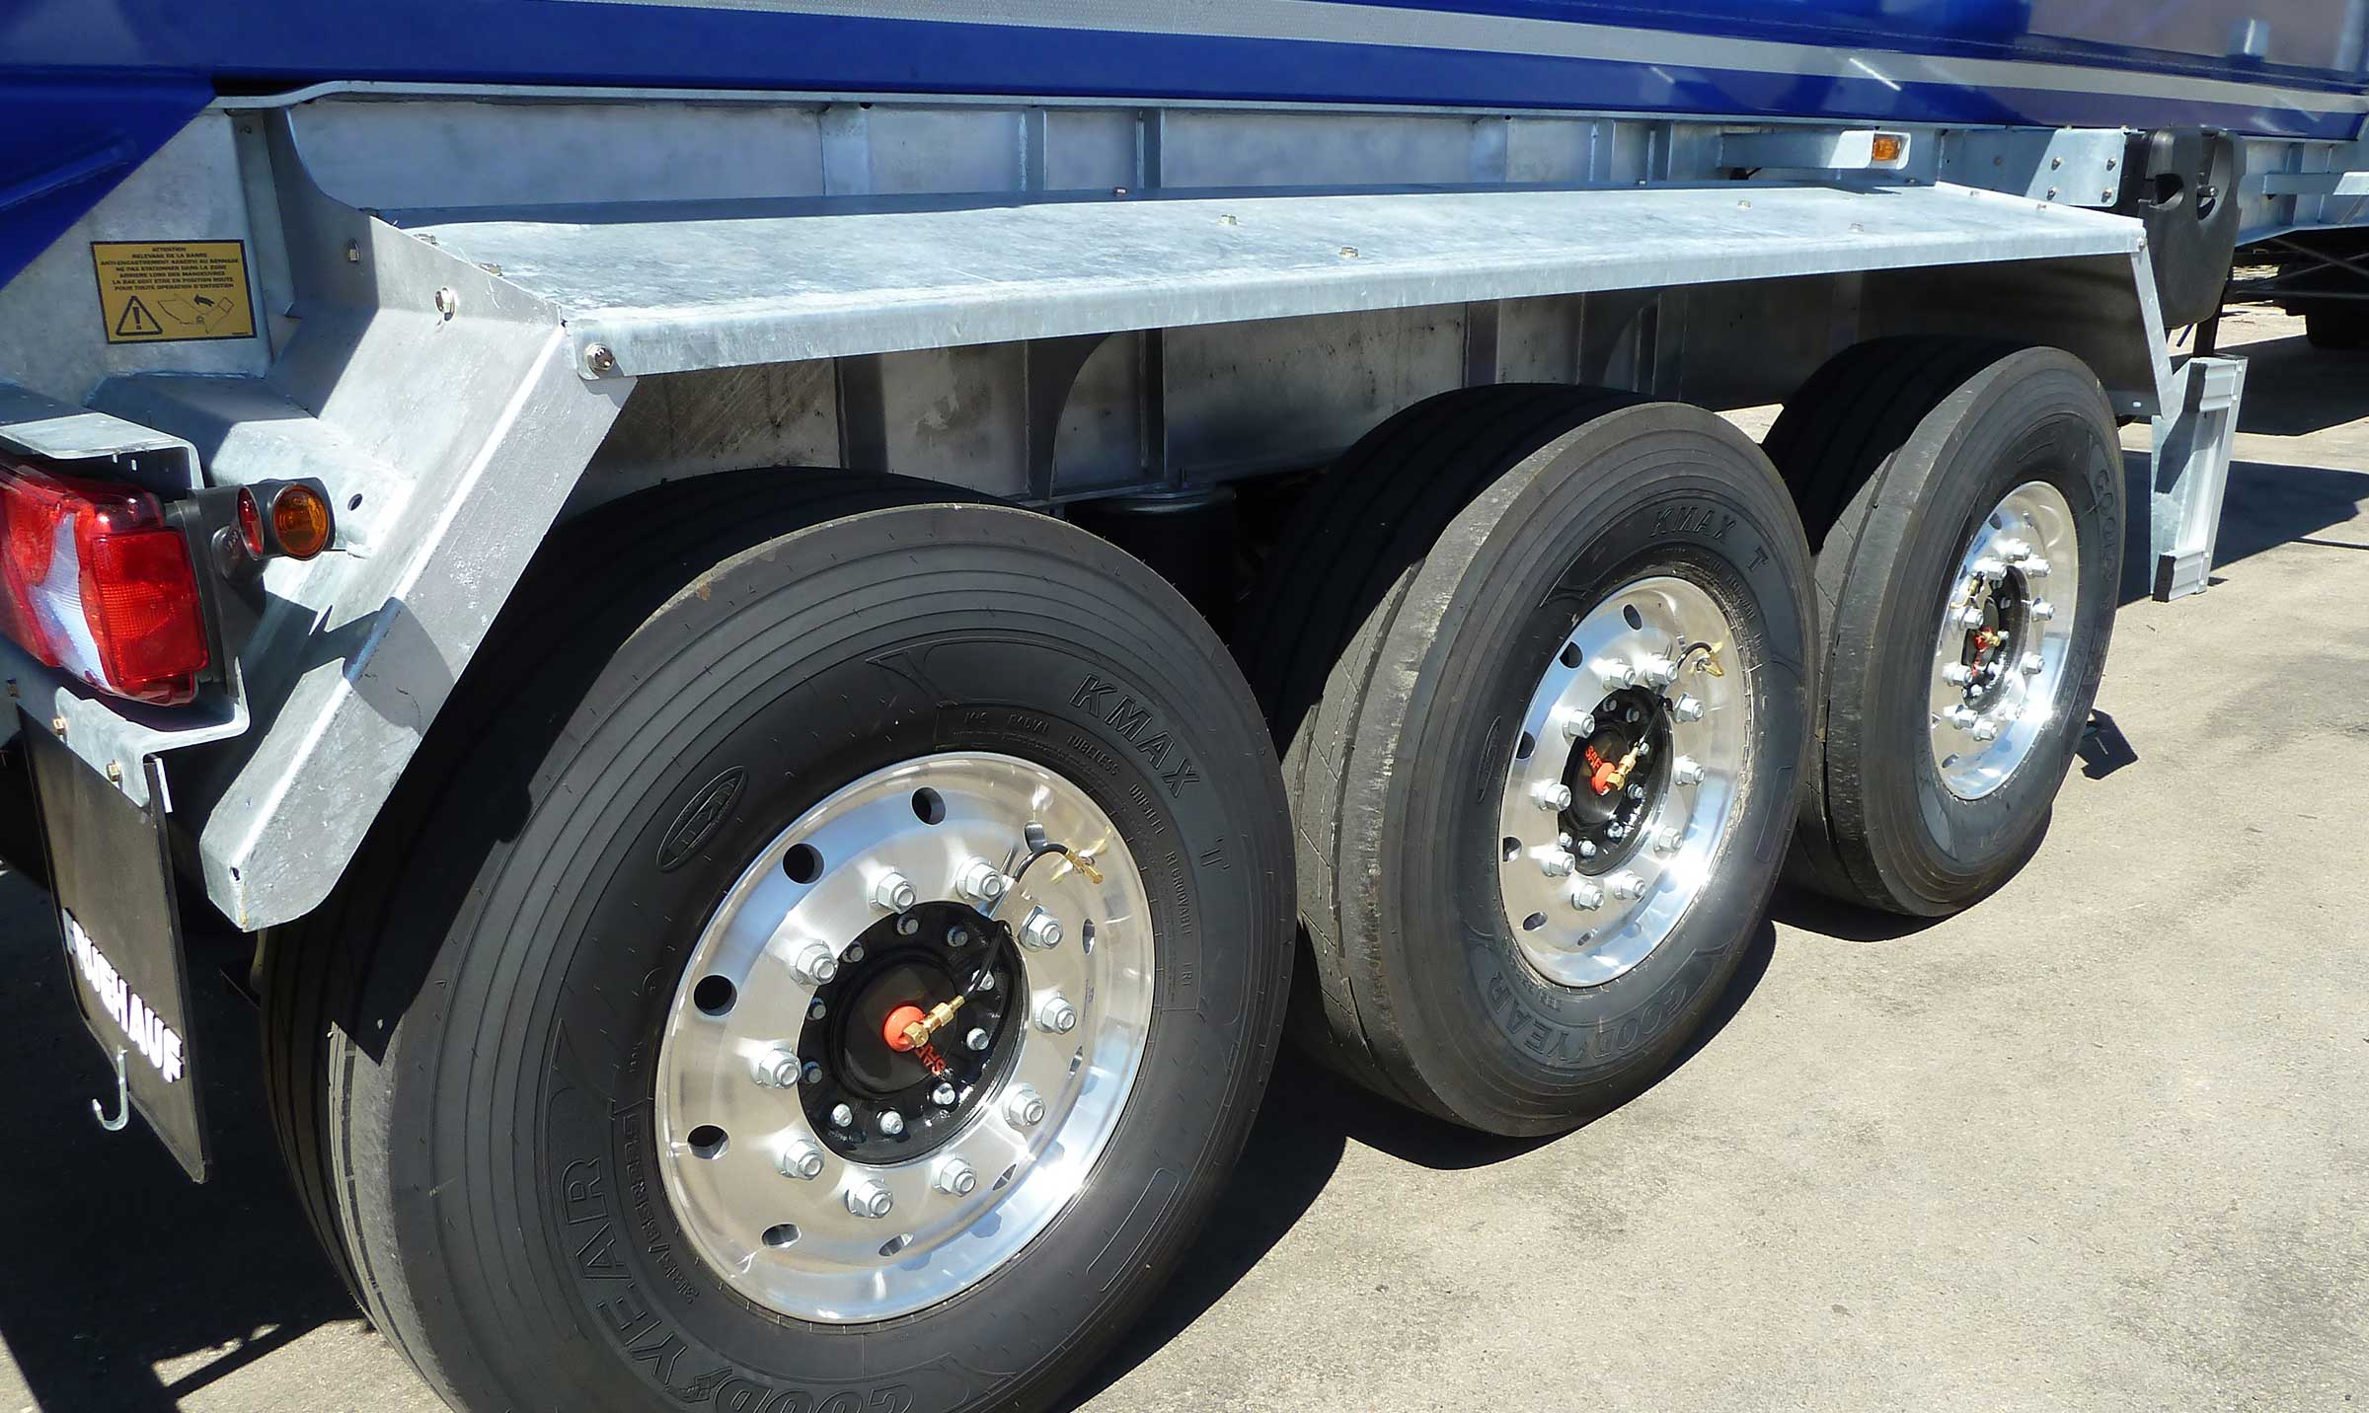
Gallery

Mudguard
Bennes TP Extreme

Innovations
FRUEHAUF Public Works Tippers are designed for maximum safety, focusing on two key aspects:
Safety of users in contact with the vehicle, through ergonomically shaped parts and adapted equipment for ease of use.
Safe road behaviour with integrated electronic driver assistance systems improving the vehicle's passive and active safety.
- Ergonomics and aesthetics
- Adapted equipment
- Driver assistance
SafeParkingGuillaume Calviac2021-01-15T11:41:43+01:00
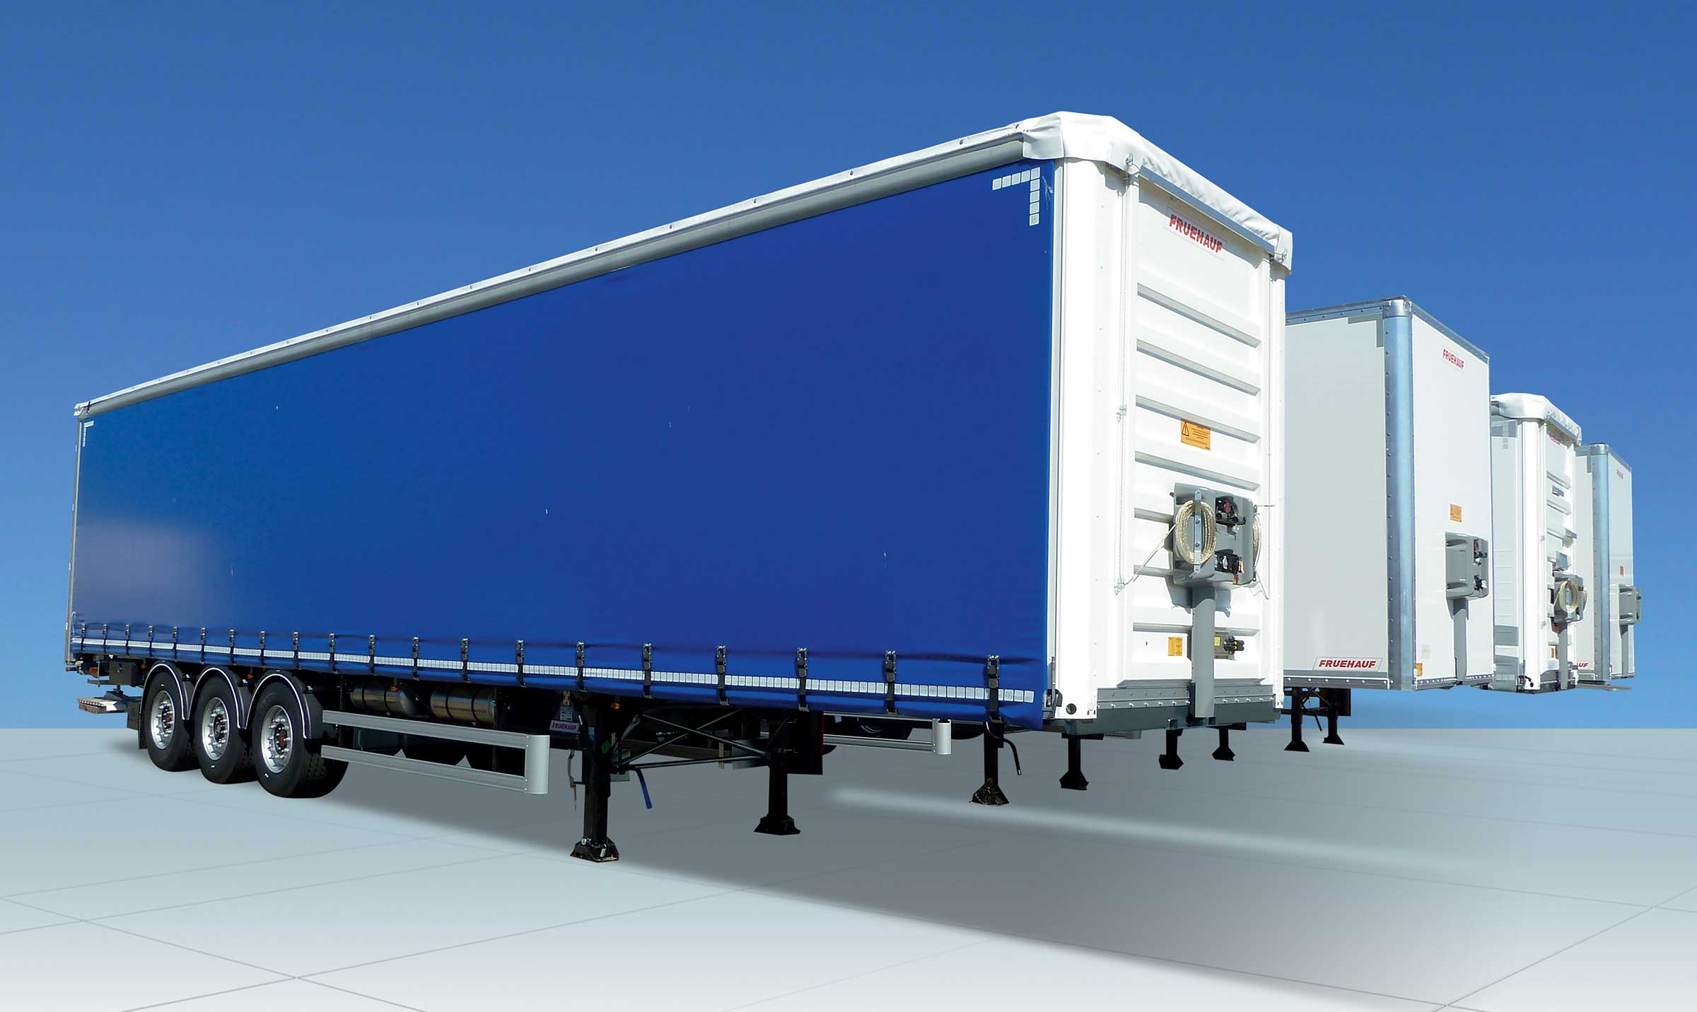
Gallery

SafeParking
Innovations - SafeParking, Innovations Base EN
TelematicsGuillaume Calviac2021-01-29T13:44:33+01:00
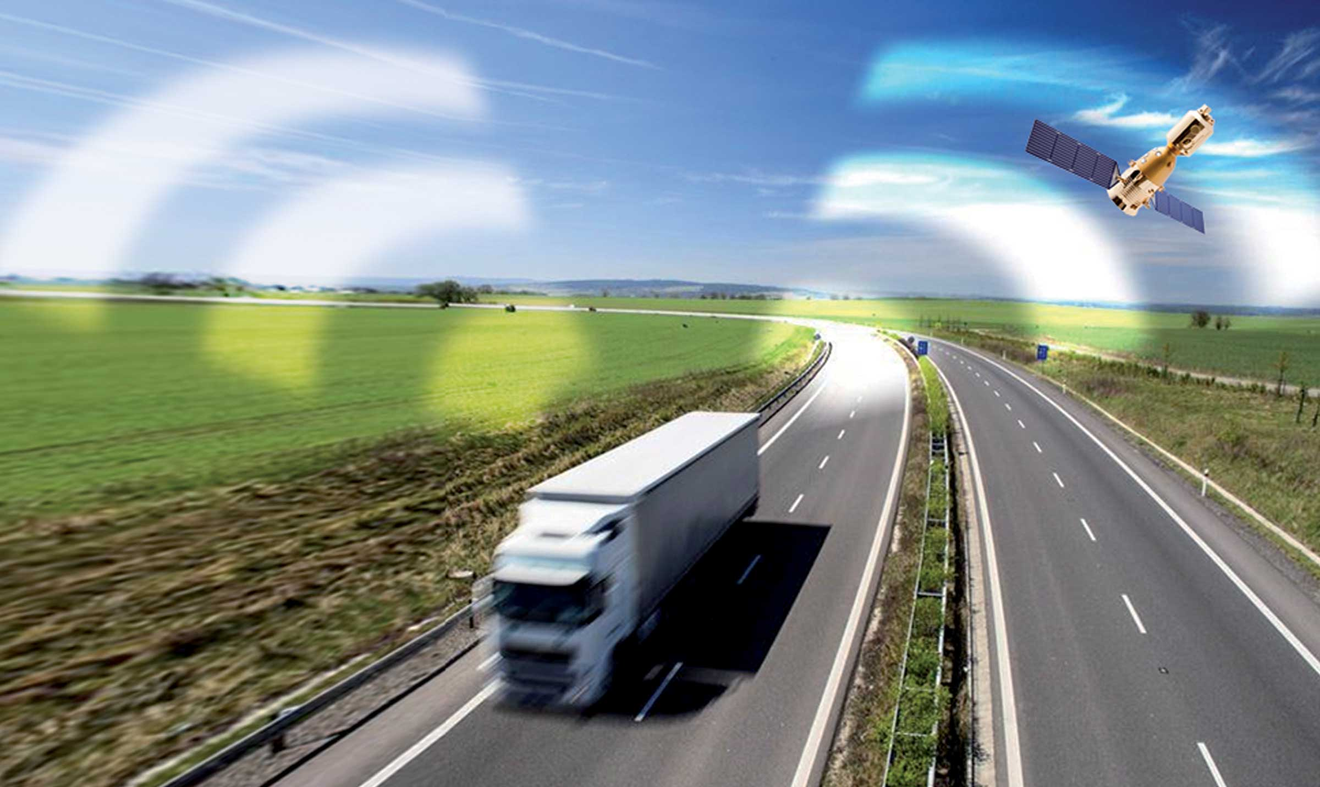
Gallery

Telematics
Innovations - Télématique, Innovations Base EN
RCPGuillaume Calviac2021-01-15T11:33:18+01:00
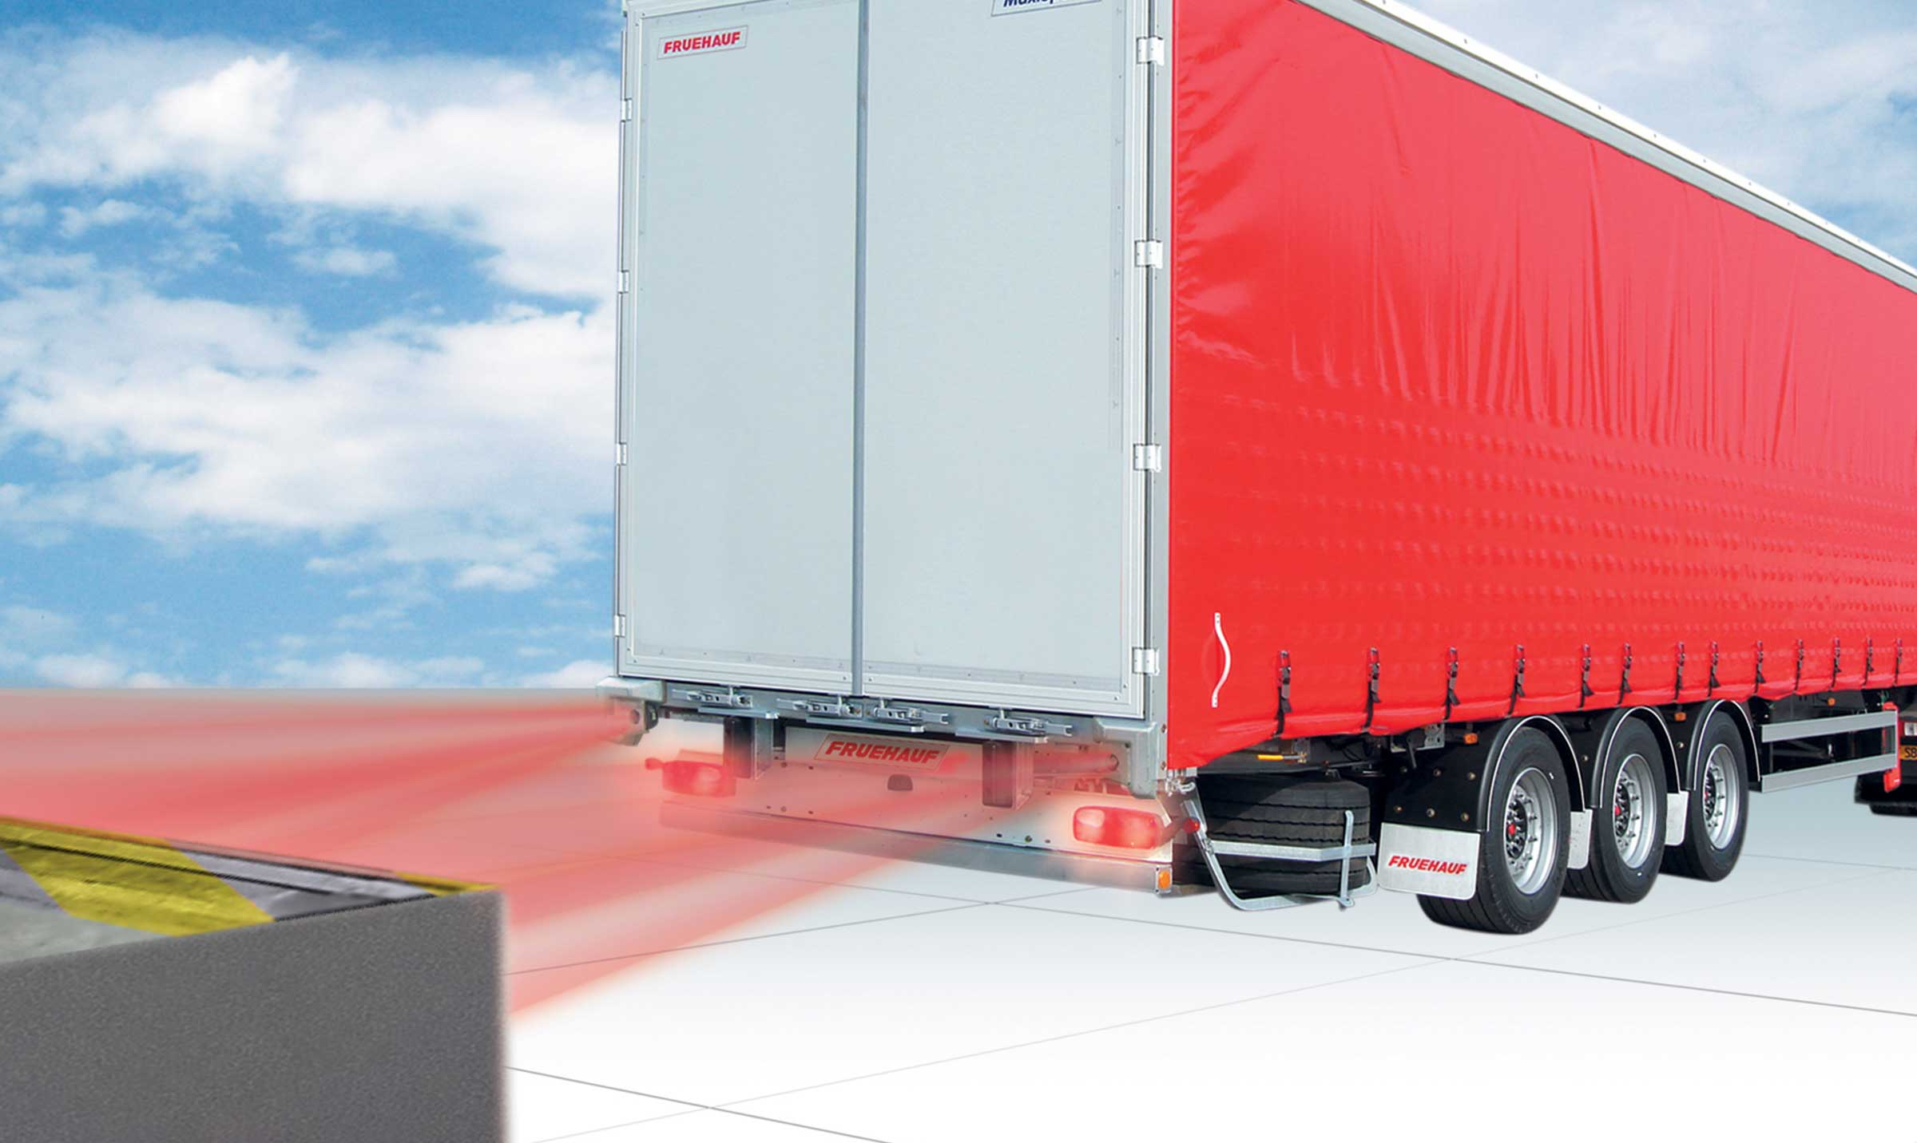
Gallery

RCP
Innovations - RCP, Innovations Base EN
APCSGuillaume Calviac2021-01-15T11:24:21+01:00
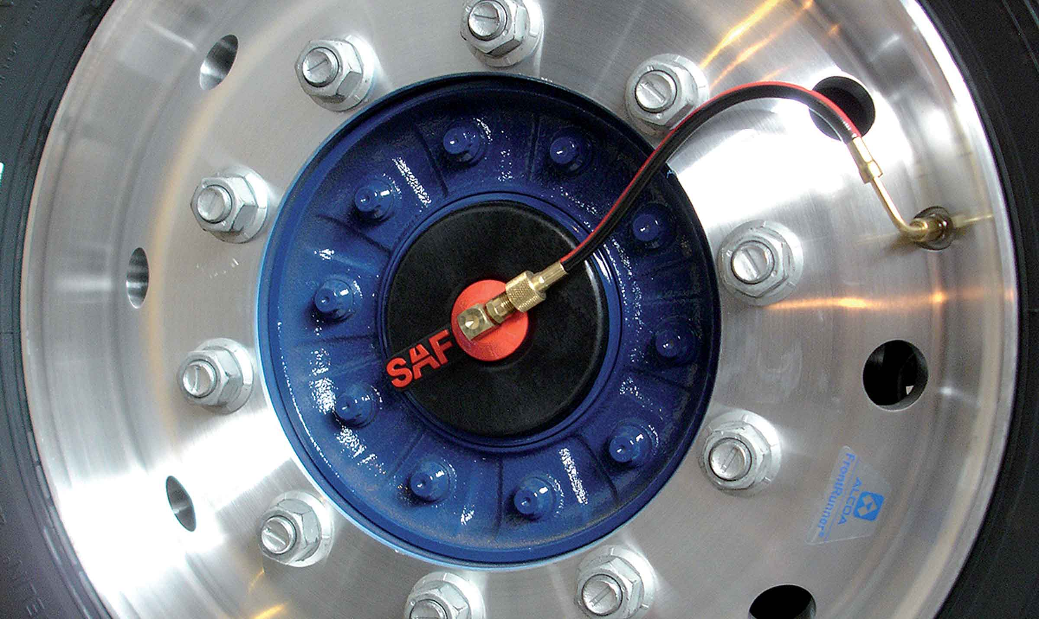
Gallery

APCS
Innovations APCS, Innovations Base EN
EBSGuillaume Calviac2021-01-15T11:24:12+01:00
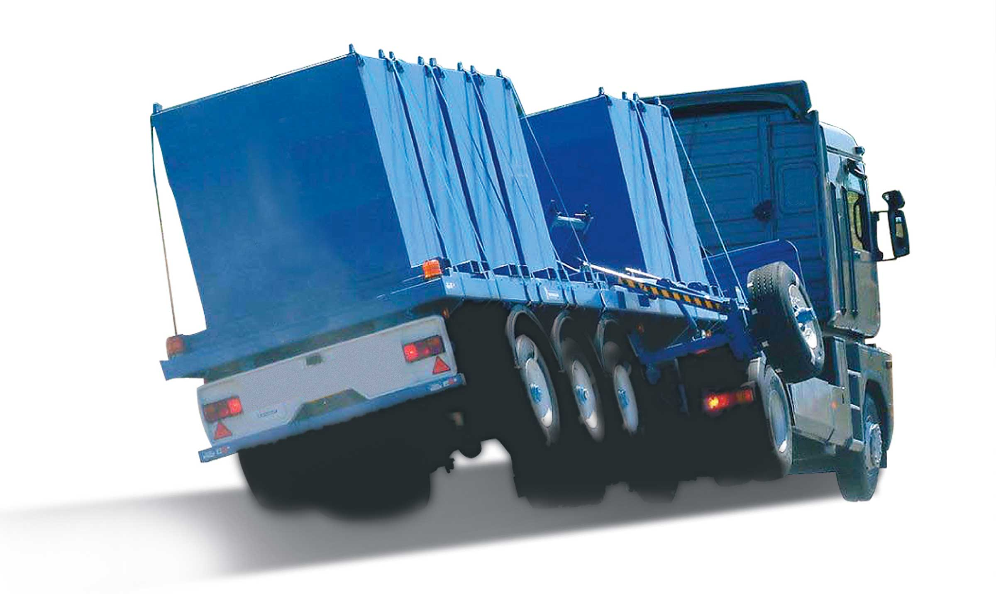
Gallery

EBS
Innovations Base EN
TPMSGuillaume Calviac2021-01-29T08:34:38+01:00
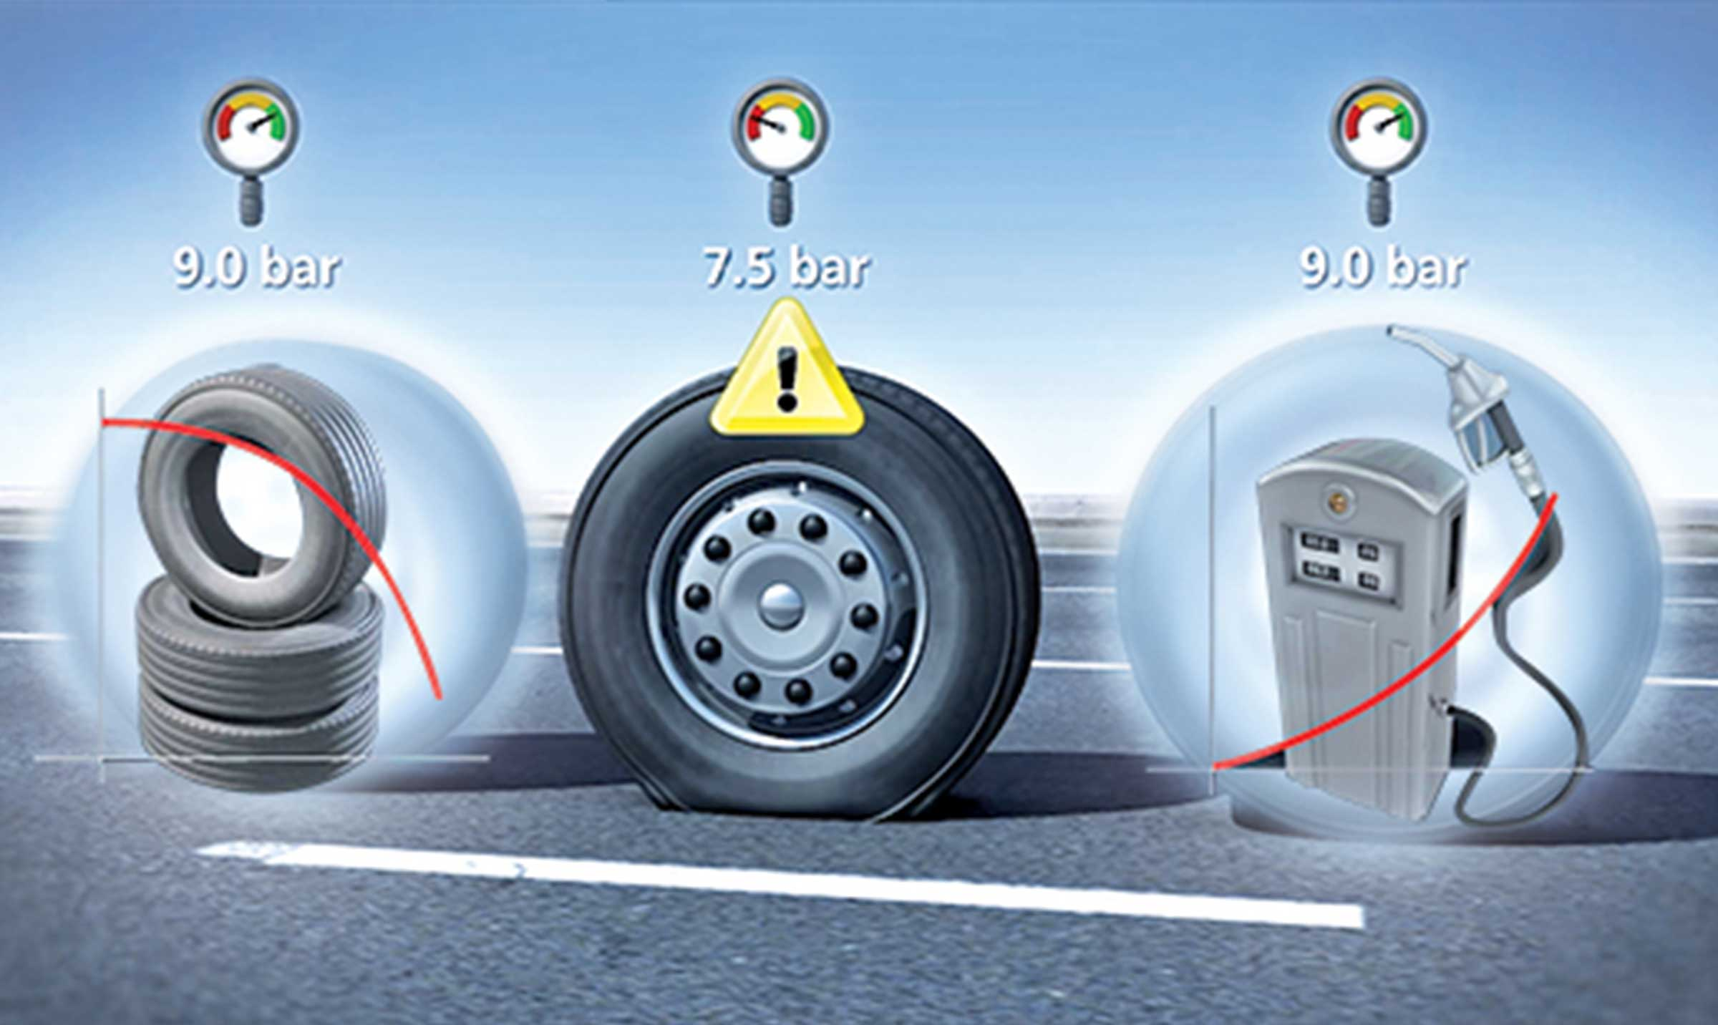
Gallery

TPMS
Innovations - TPMS, Innovations Base EN
Documentation
Demo Videos

Metadata
pyre_slider_type | no
pyre_slider | 0
pyre_wooslider
pyre_revslider | 0
pyre_elasticslider | 0
pyre_slider_position | default
pyre_avada_rev_styles | default
pyre_fallback
pyre_fallback_id
pyre_demo_slider
pyre_main_top_padding
pyre_main_bottom_padding
pyre_hundredp_padding
pyre_show_first_featured_image | no
pyre_display_header | yes
pyre_header_100_width | default
pyre_combined_header_bg_color
pyre_mobile_header_bg_color
pyre_header_bg
pyre_header_bg_id
pyre_header_bg_full | no
pyre_header_bg_repeat | repeat
pyre_displayed_menu | default
pyre_display_footer | default
pyre_display_copyright | default
pyre_footer_100_width | default
pyre_sidebar_position | default
pyre_responsive_sidebar_order
pyre_sidebar_sticky | default
pyre_sidebar_bg_color
pyre_page_bg_layout | default
pyre_page_bg_color
pyre_page_bg
pyre_page_bg_id
pyre_page_bg_full | default
pyre_page_bg_repeat | default
pyre_wide_page_bg_color
pyre_wide_page_bg
pyre_wide_page_bg_id
pyre_wide_page_bg_full | default
pyre_wide_page_bg_repeat | default
pyre_page_title | default
pyre_page_title_breadcrumbs_search_bar | default
pyre_page_title_text | default
pyre_page_title_text_alignment | default
pyre_page_title_custom_text
pyre_page_title_text_size
pyre_page_title_line_height
pyre_page_title_font_color
pyre_page_title_custom_subheader
pyre_page_title_custom_subheader_text_size
pyre_page_title_subheader_font_color
pyre_page_title_100_width | default
pyre_page_title_height
pyre_page_title_mobile_height
pyre_page_title_bar_bg_color
pyre_page_title_bar_borders_color
pyre_page_title_bar_bg
pyre_page_title_bar_bg_id
pyre_page_title_bar_bg_retina
pyre_page_title_bar_bg_retina_id
pyre_page_title_bar_bg_full | default
pyre_page_title_bg_parallax | default
fusion_builder_status | active
kd_featured-image-2_page_id
kd_featured-image-3_page_id
kd_featured-image-4_page_id
kd_featured-image-5_page_id
sbg_selected_sidebar | Array
sbg_selected_sidebar_replacement | Array
sbg_selected_sidebar_2 | Array
sbg_selected_sidebar_2_replacement | Array
avada_post_views_count | 342
avada_today_post_views_count | 3
avada_post_views_count_today_date | 12-12-2023

