Platforms
Author | Guillaume Calviac
Date | 2021-06-01 09:37:40
Categories

PLATFORMS

The Range
Fruehauf Platforms semitrailers meet all transport needs, from standard use to more specialist use, thanks to their reinforced mechanically welded chassis perfectly suited to intensive, harsh, long-term applications.

City

CITY Platform Rear steering axle
The CITY platform is perfect for supplying construction sites in an urban environment where there is little room to manoeuvre.
As some materials require specific equipment, CITY platforms are suitable for low drop side, iron carrier, crane, removable racks and other layouts.
- Manoeuvrability
- Adaptability
- Productivity
Iron carrier layoutGuillaume Calviac2021-01-14T10:37:54+01:00
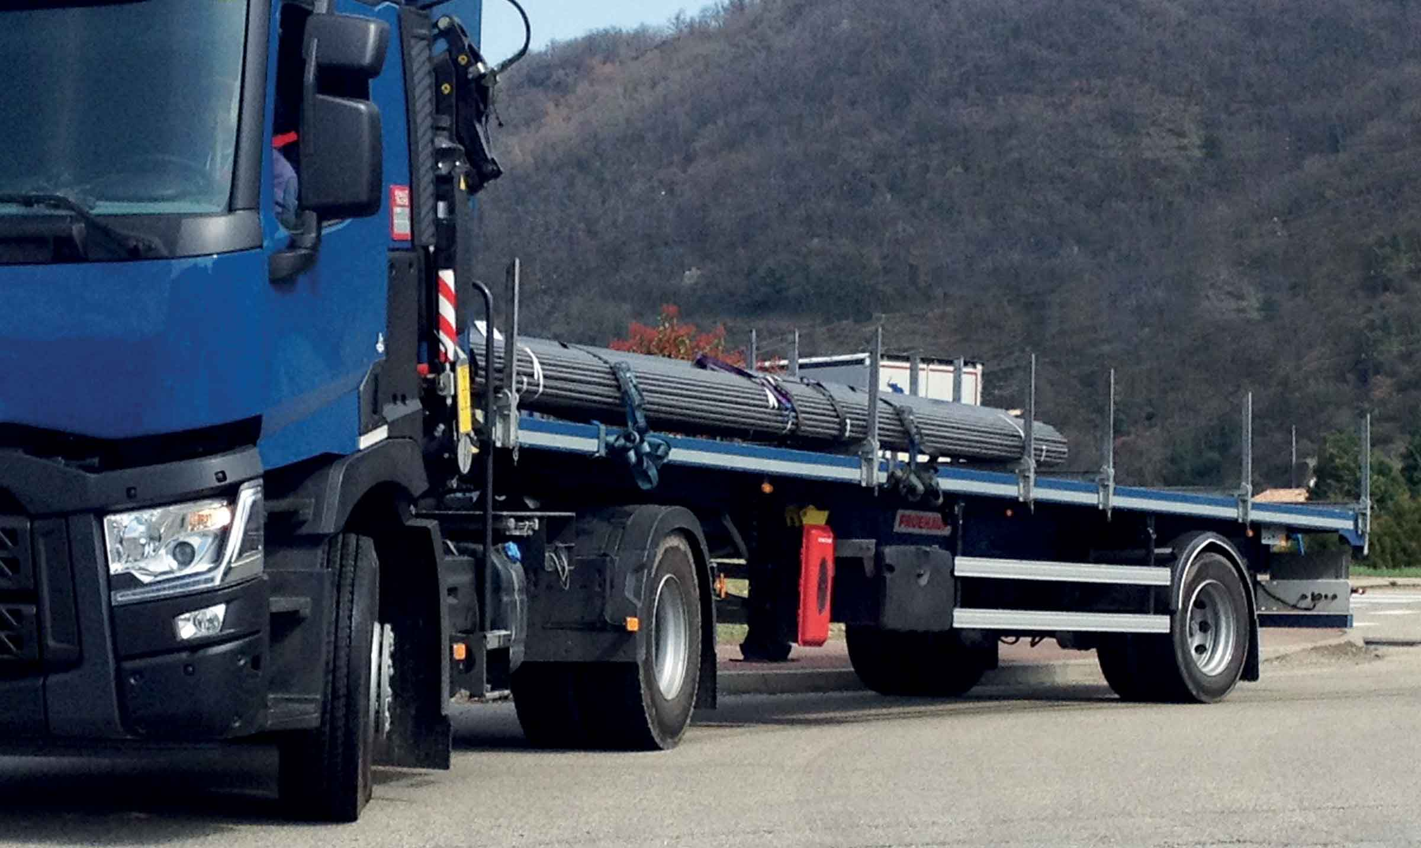
Gallery

Iron carrier layout
City plateaux EN
Crane platformGuillaume Calviac2021-02-10T09:49:13+01:00
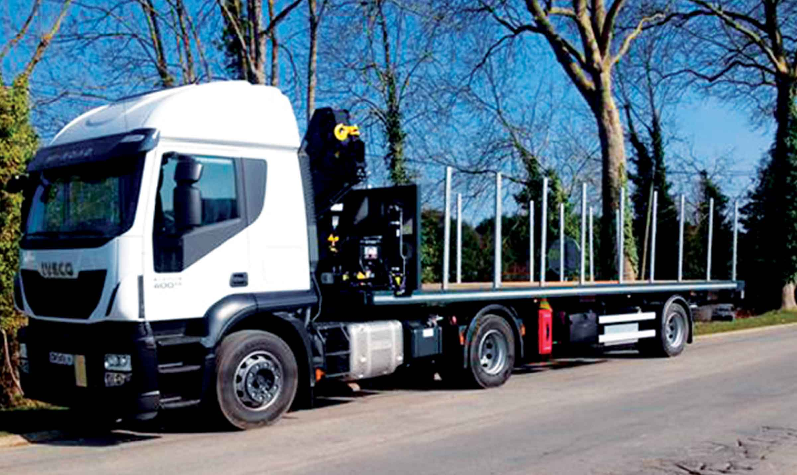
Gallery

Crane platform
City plateaux EN
Removable racksGuillaume Calviac2021-01-14T10:29:02+01:00
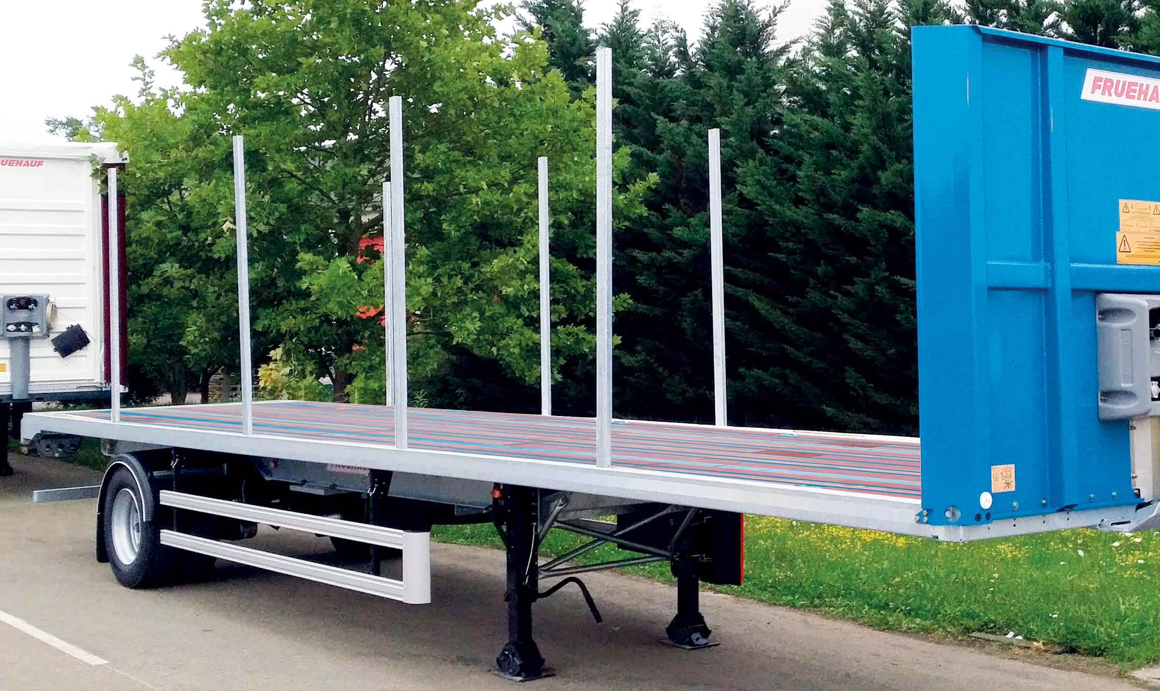
Gallery

Removable racks
City plateaux EN
PlatformGuillaume Calviac2021-01-14T10:27:01+01:00
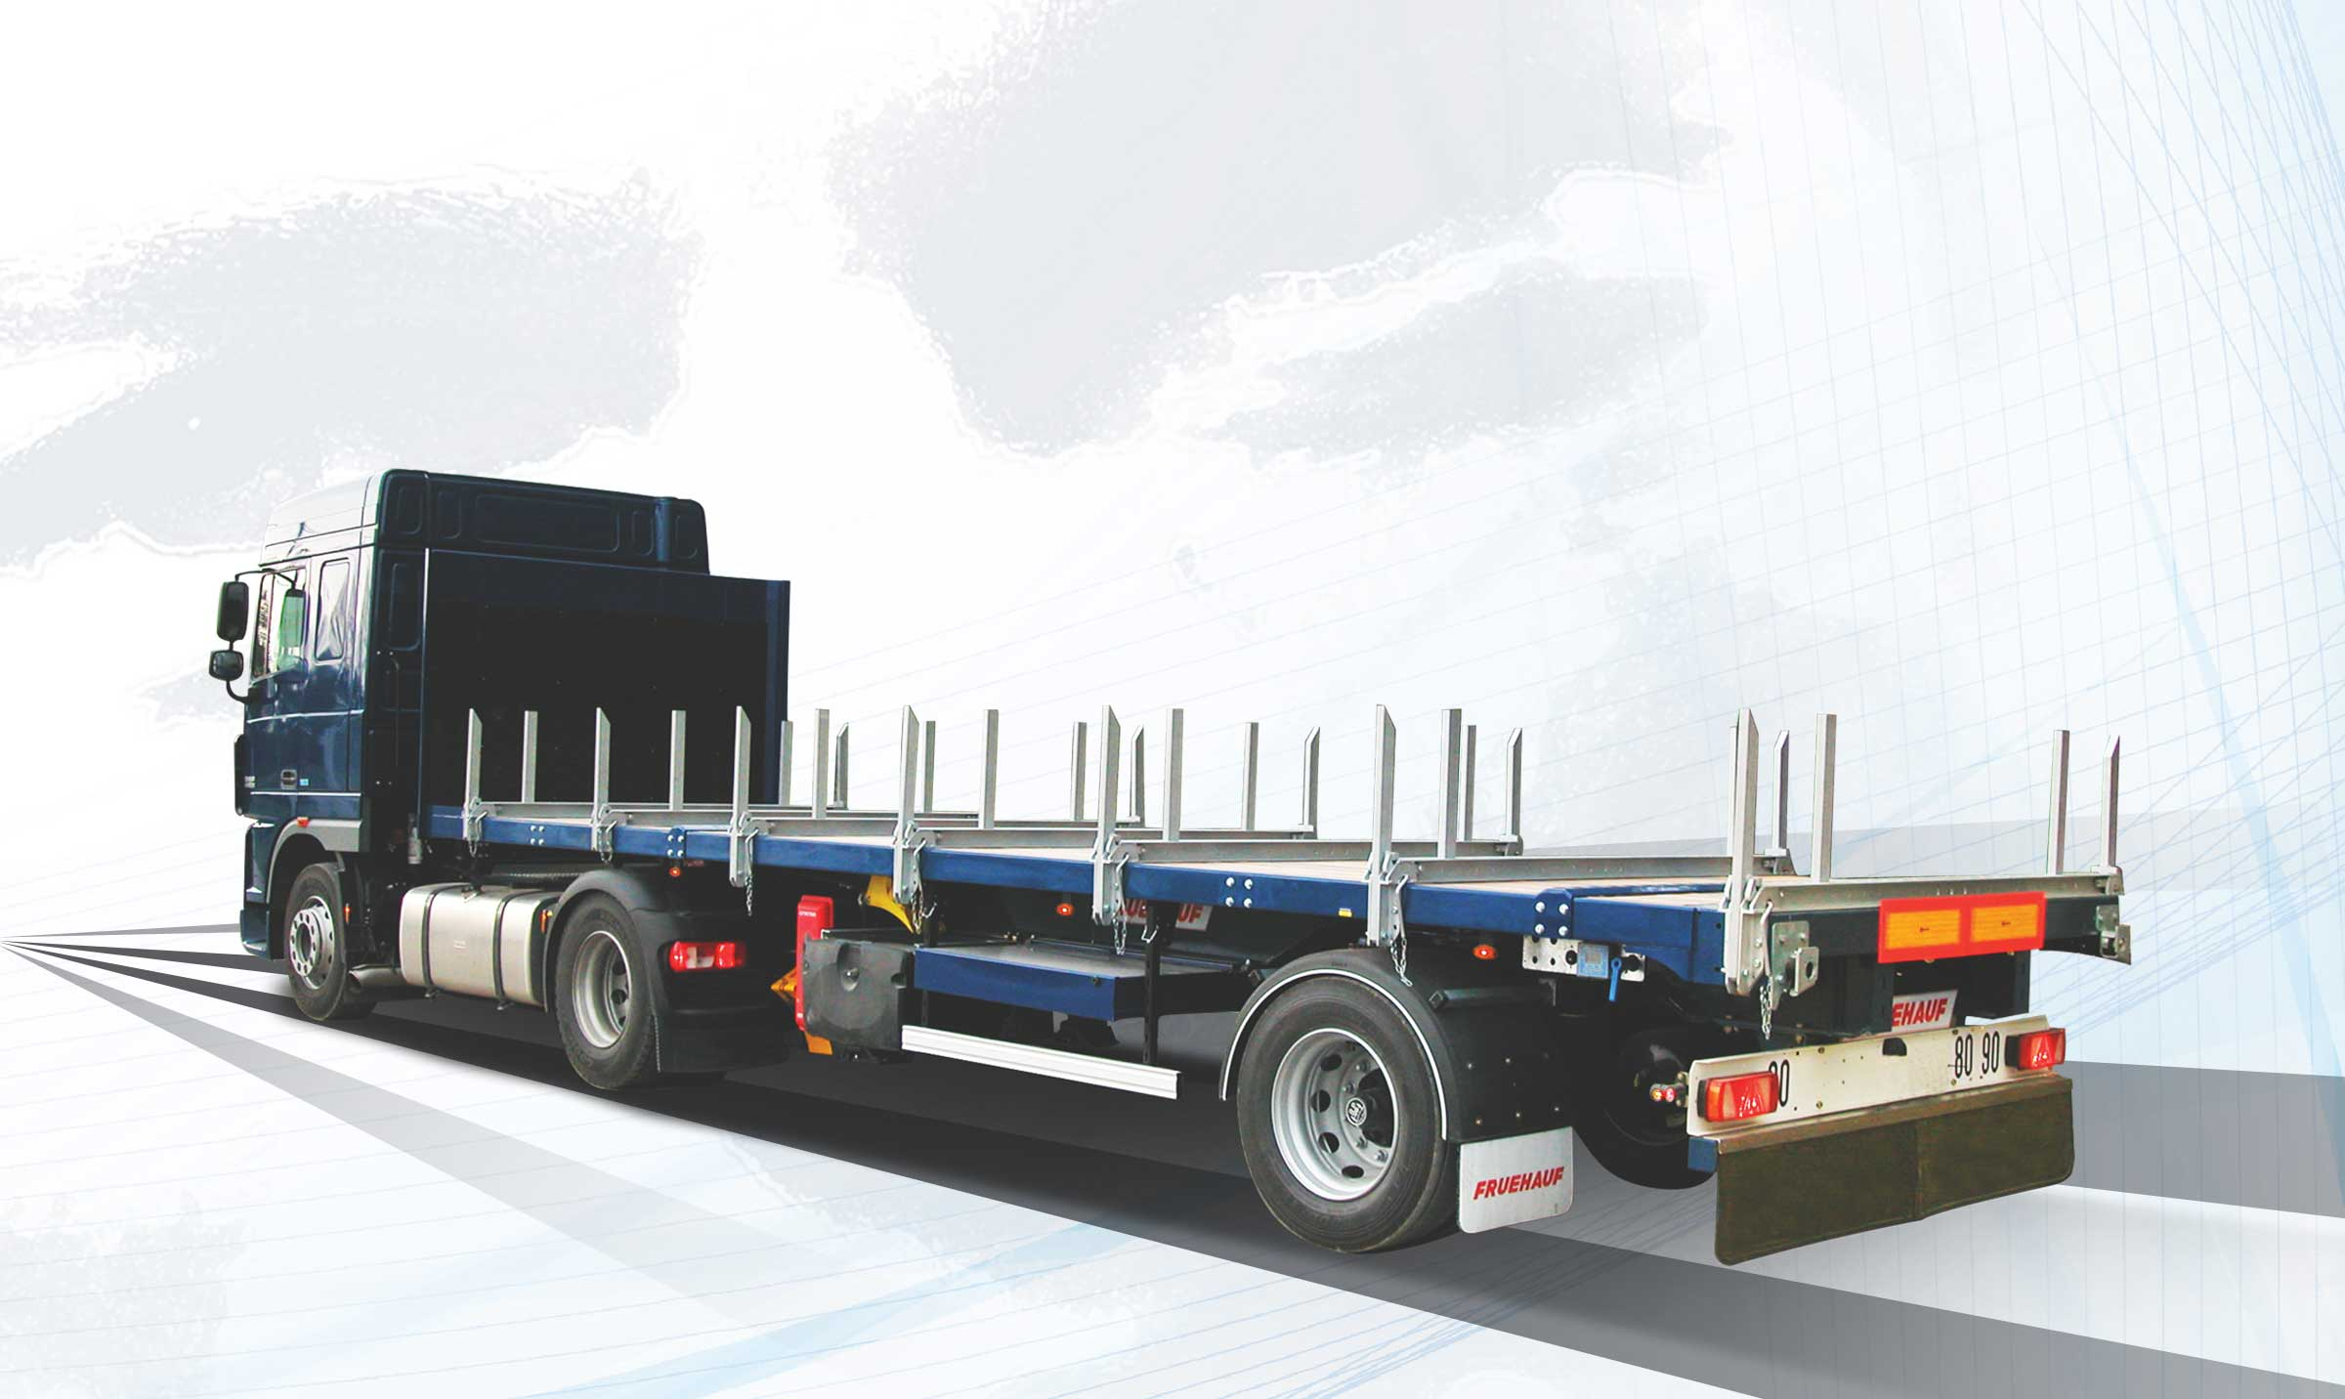
Gallery

Platform
City plateaux EN, Innovations - City
PlatformGuillaume Calviac2021-01-14T10:26:39+01:00
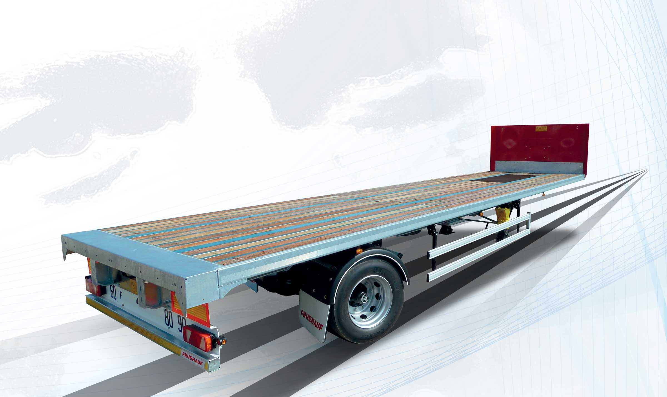
Gallery

Platform
City plateaux EN
Documentation
Demo Videos

Classic

Straight Platform - 90, 120, 150 mm

22,5″ Simple assembly
CLASSIC MultiLoader platforms meet the needs of transport of materials on a platform with or without sides.
They can be adapted to suit all requirements with a variety of equipment: front end, posts, boxes, lashing systems, etc.
- Sturdiness
- Reliability
- Adaptability
Iron carrier layoutGuillaume Calviac2021-01-15T12:16:59+01:00
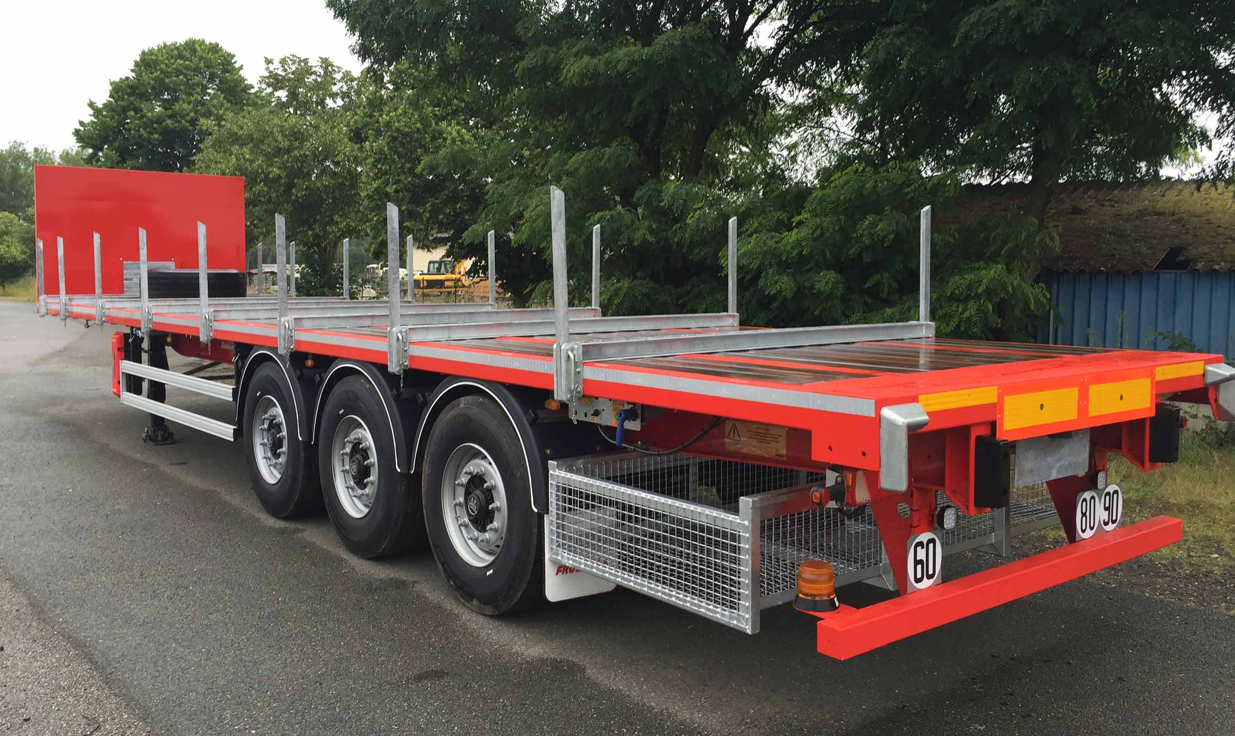
Gallery

Iron carrier layout
Plateaux Classic EN
Reinforced mechanically welded chassisGuillaume Calviac2021-01-15T12:13:44+01:00
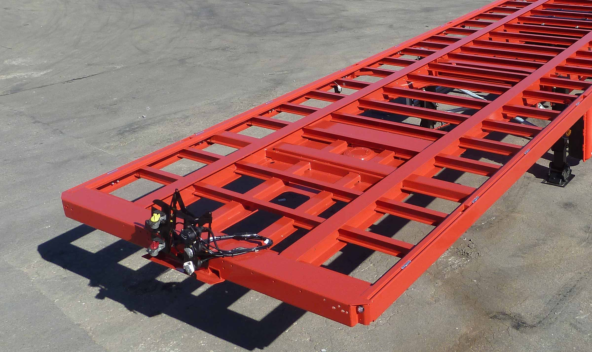
Gallery

Reinforced mechanically welded chassis
Plateaux Classic EN
Bodywork with low drop sidesGuillaume Calviac2021-01-15T12:10:25+01:00
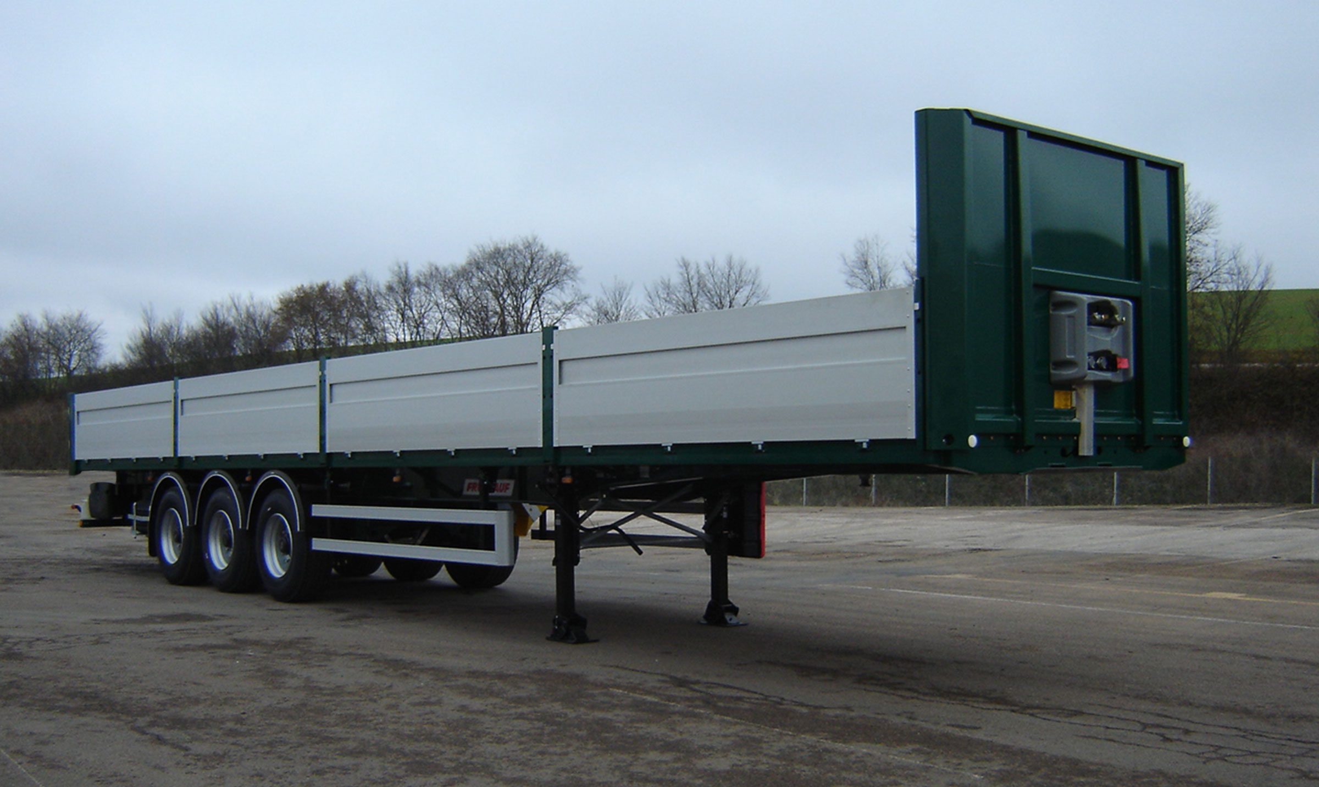
Gallery

Bodywork with low drop sides
Plateaux Classic EN
Naked PlatformGuillaume Calviac2021-02-10T10:23:30+01:00
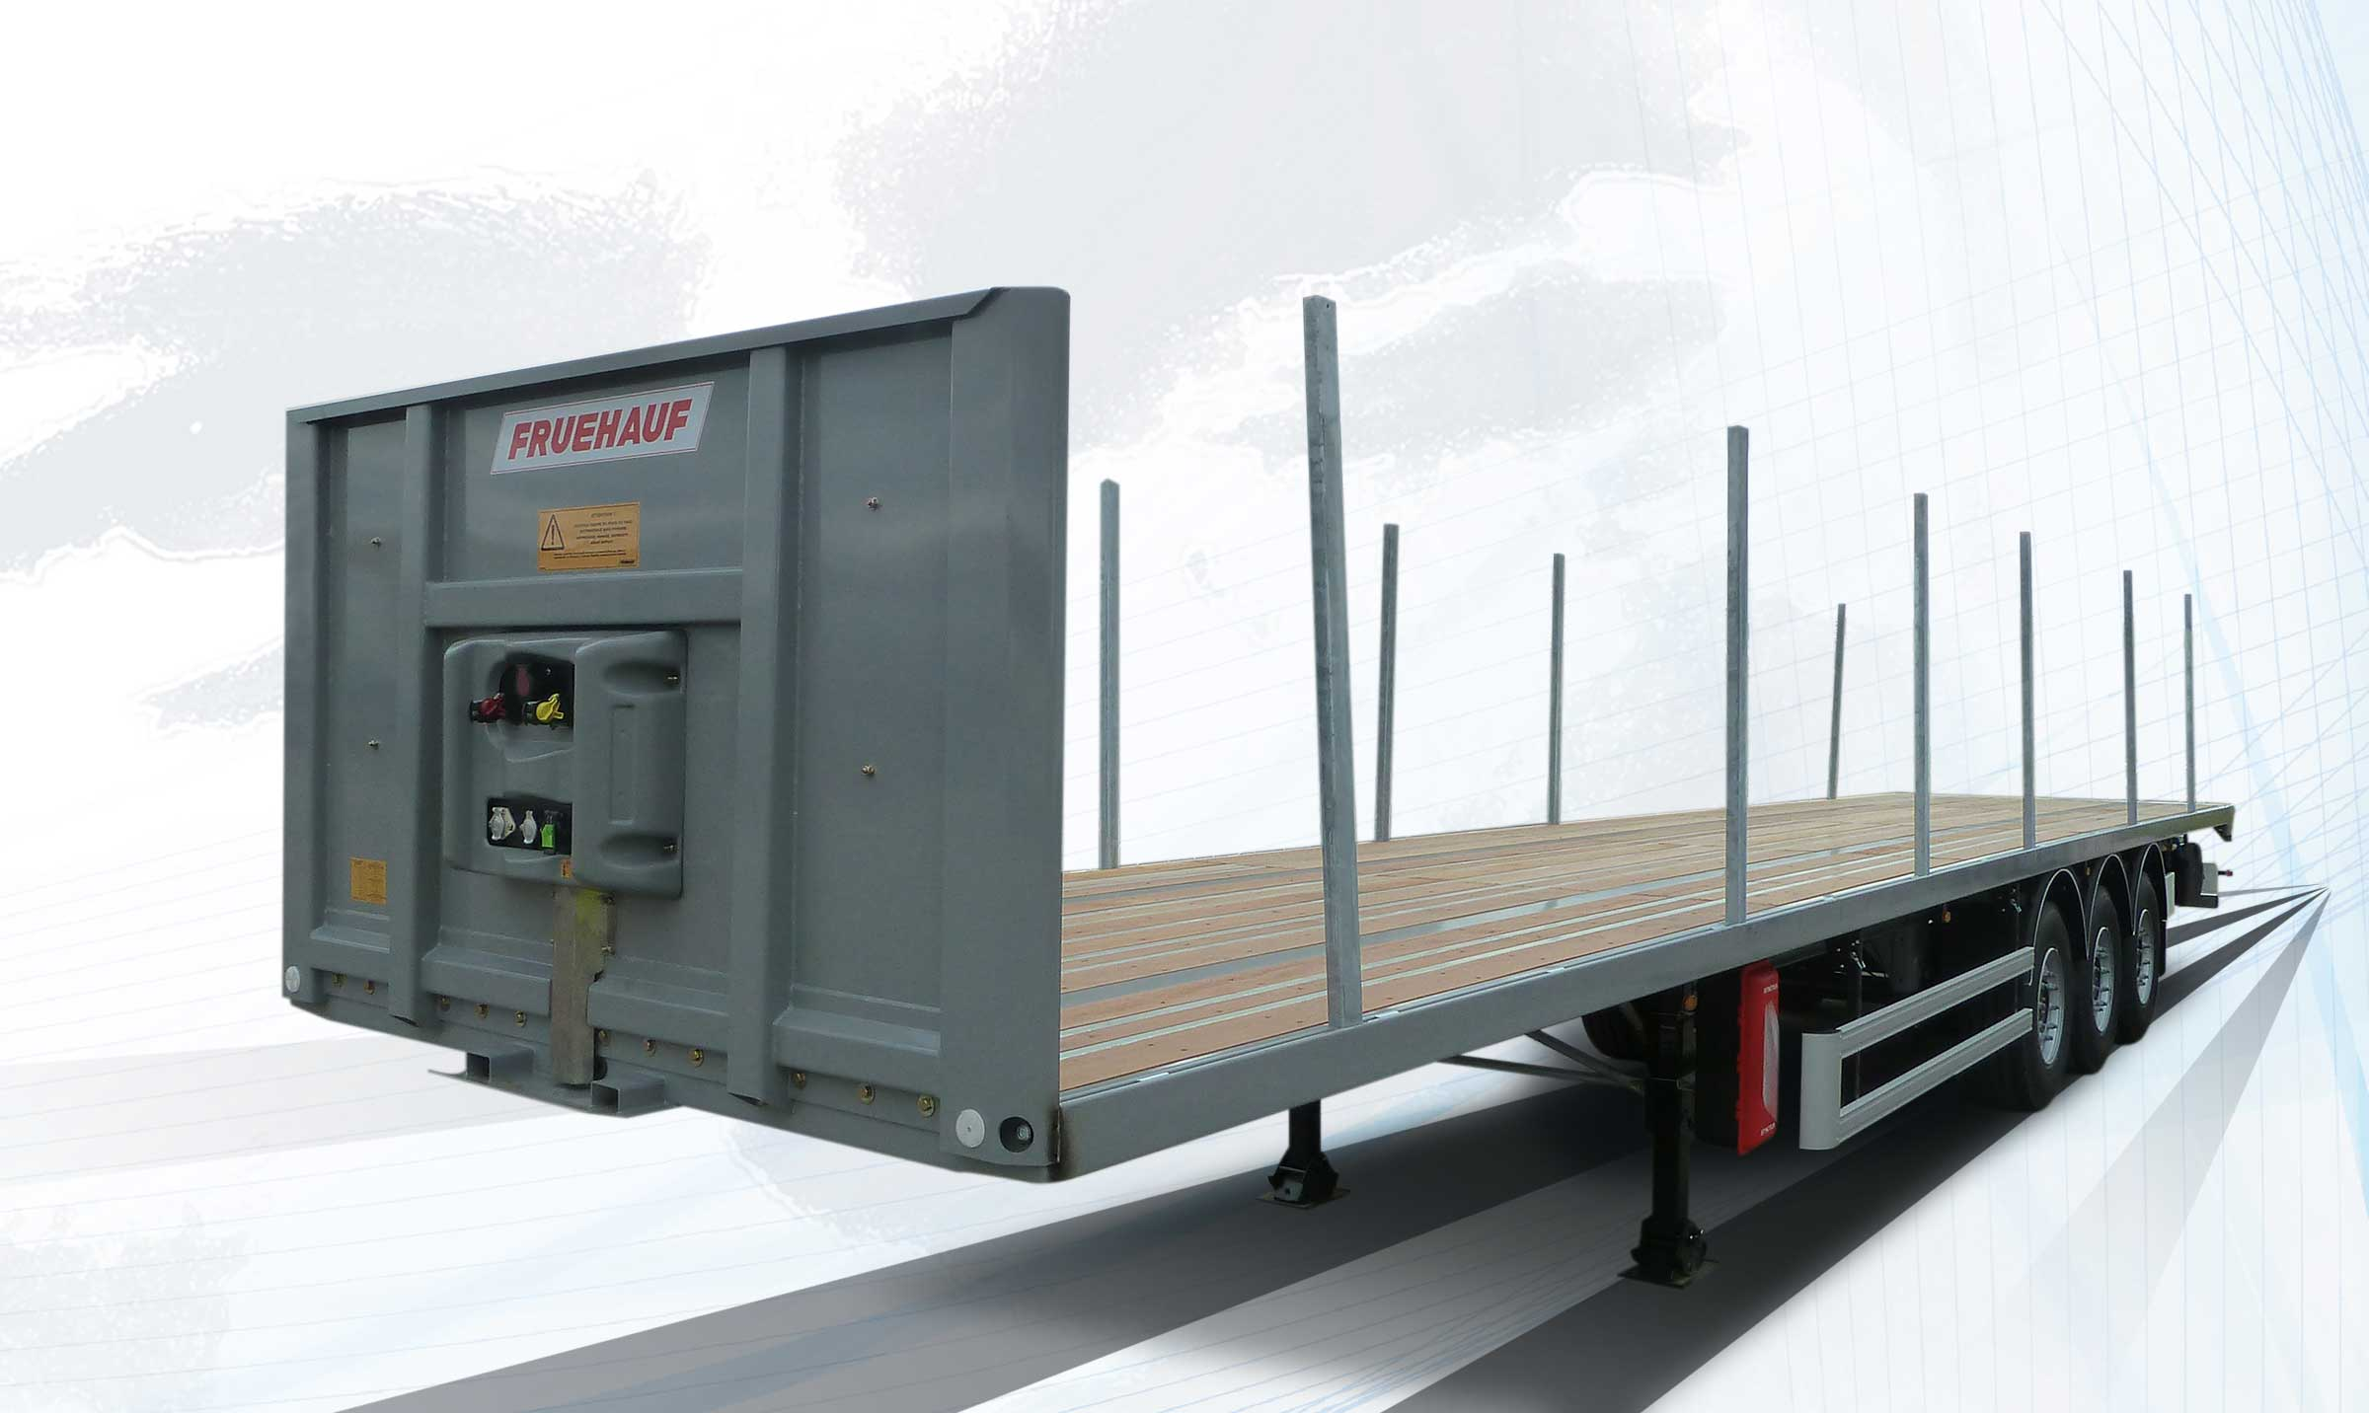
Gallery

Naked Platform
Plateaux Classic EN

Midweight Heavy Duty

Midweight platform 170 mm

Tridem 22,5″
Its reinforced mechanically welded structure is perfect for harsh applications and for transporting localised loads.
Available with or without sides, with various equipment.
- Sturdiness
- Reliability
- Adaptability
Reinforced deckGuillaume Calviac2021-01-15T12:25:09+01:00
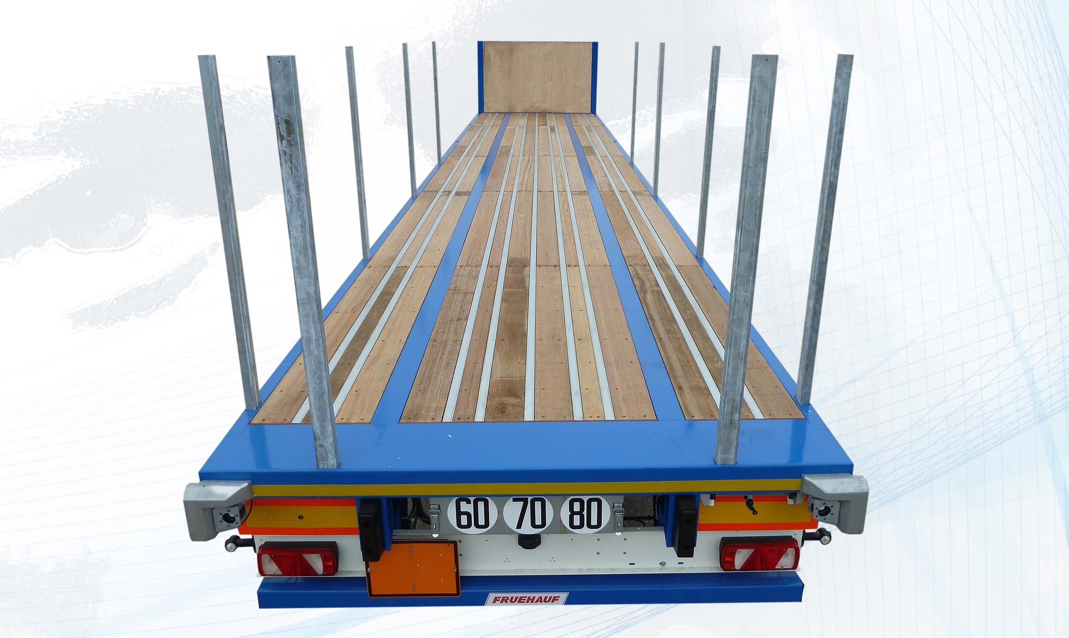
Gallery

Reinforced deck
Plateaux Heavy Duty Mi-lourd EN
Midweight PlatformGuillaume Calviac2021-01-15T12:24:33+01:00
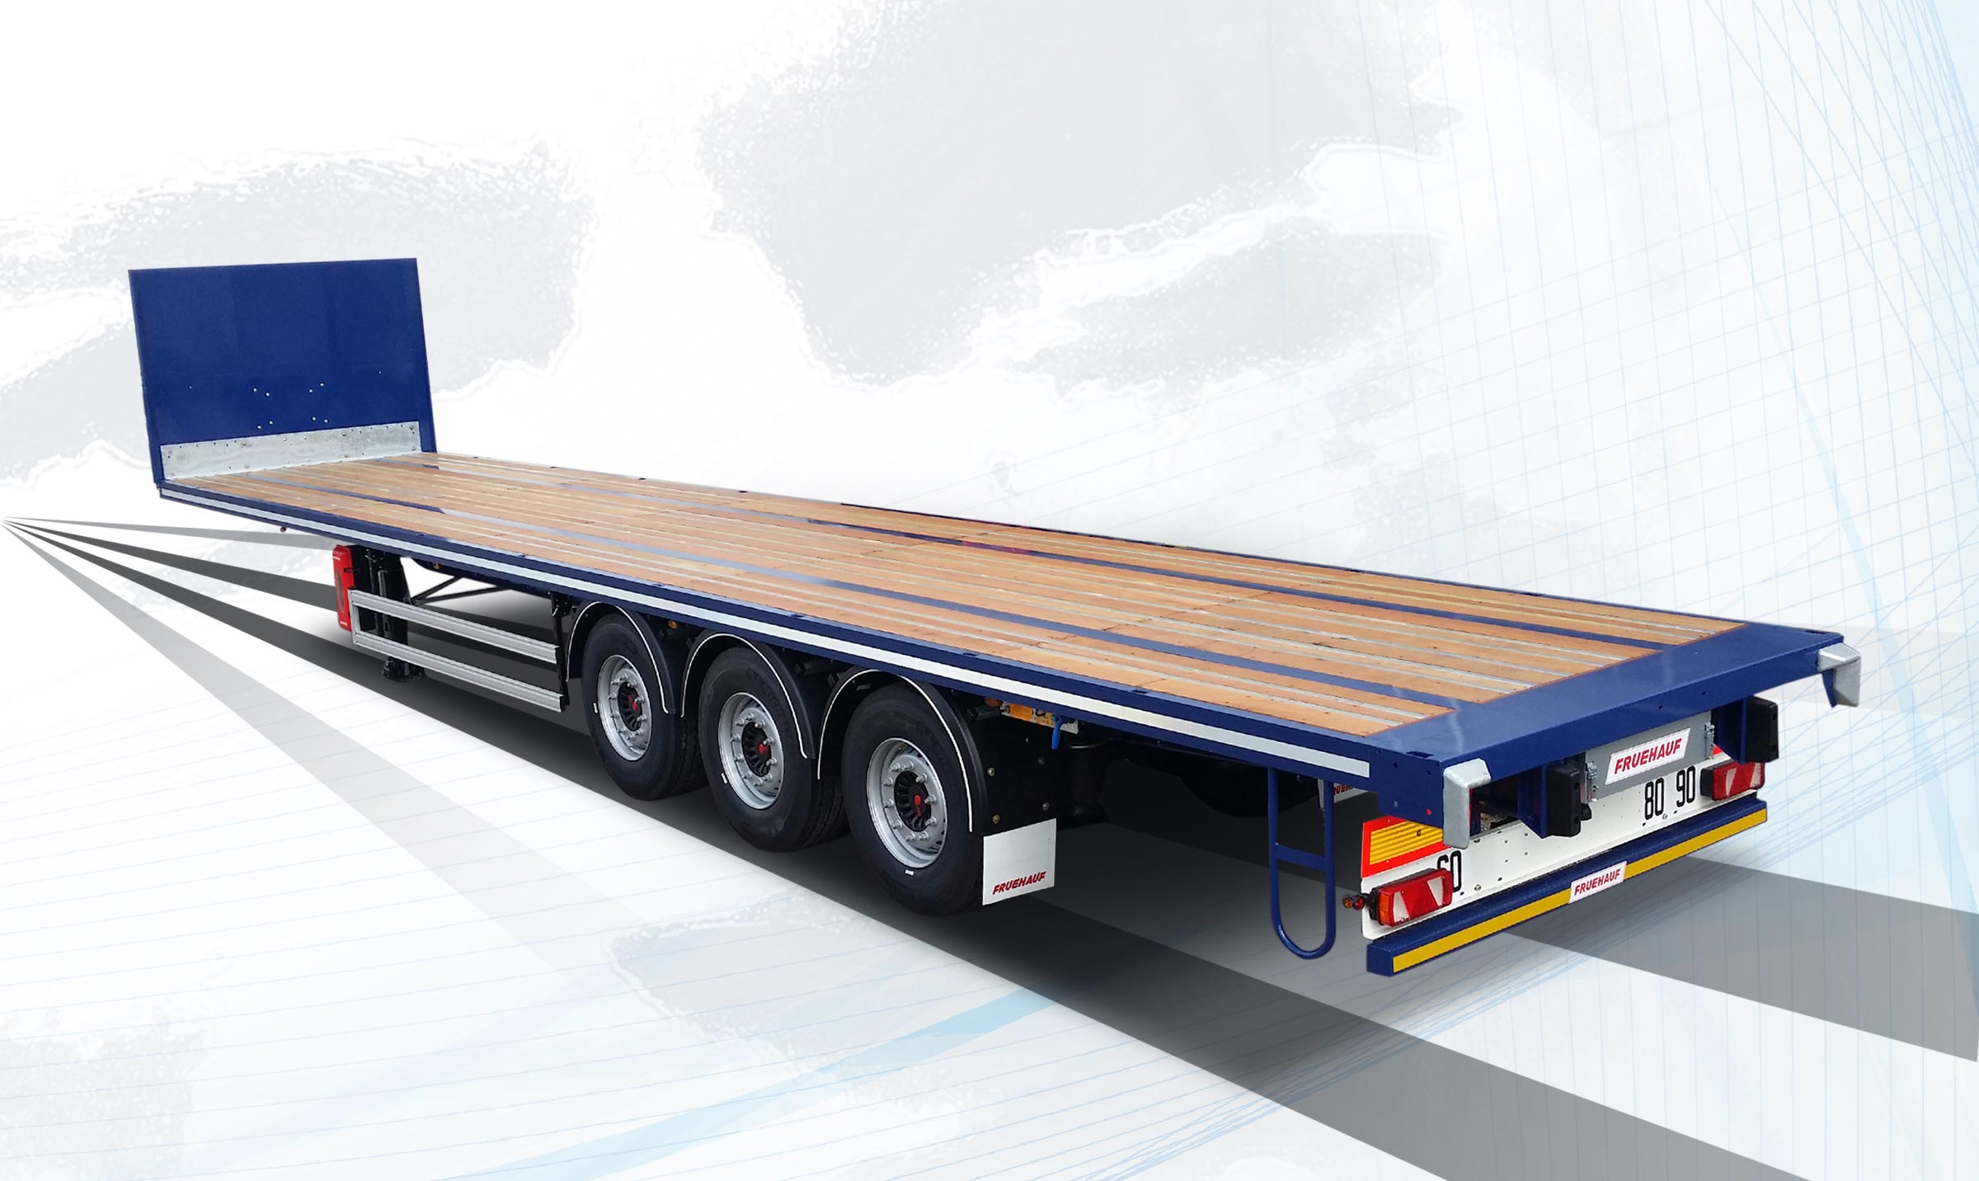
Gallery

Midweight Platform
Plateaux Heavy Duty Mi-lourd EN
Midweight PlatformGuillaume Calviac2021-01-15T12:23:59+01:00
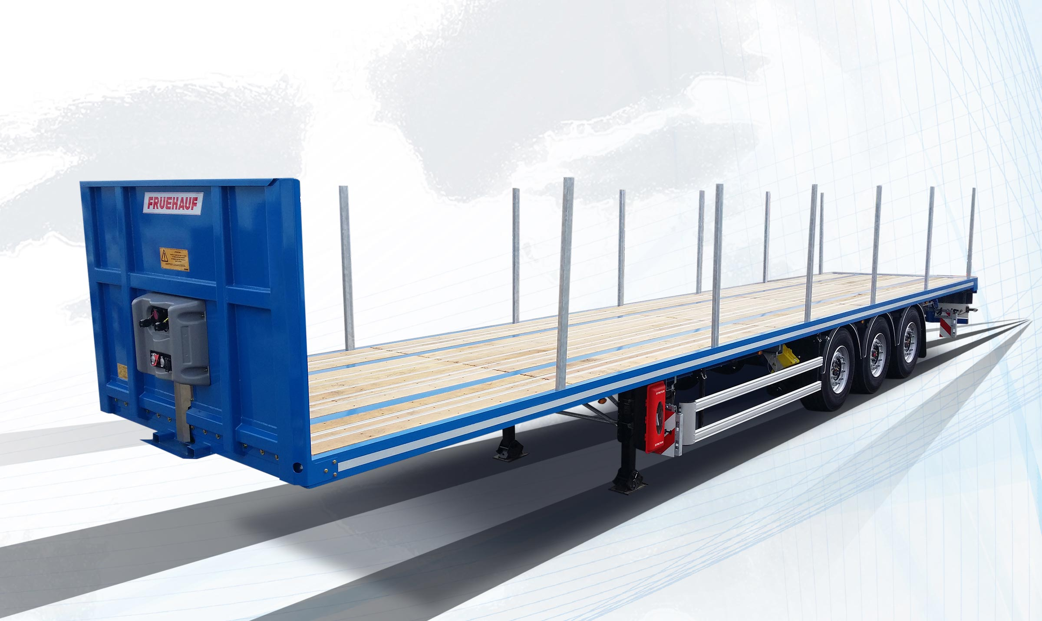
Gallery

Midweight Platform
Plateaux Heavy Duty Mi-lourd EN

Heavyweight Heavy Duty

Heavyweight Platform 240 mm
This hyper reinforced platform offers very high concentrated load capacity.
Available as a platform with or without drop sides or a crane platform.
- Sturdiness
- Reliability
- Adaptability
Bodywork with low drop sidesGuillaume Calviac2021-01-15T12:31:05+01:00
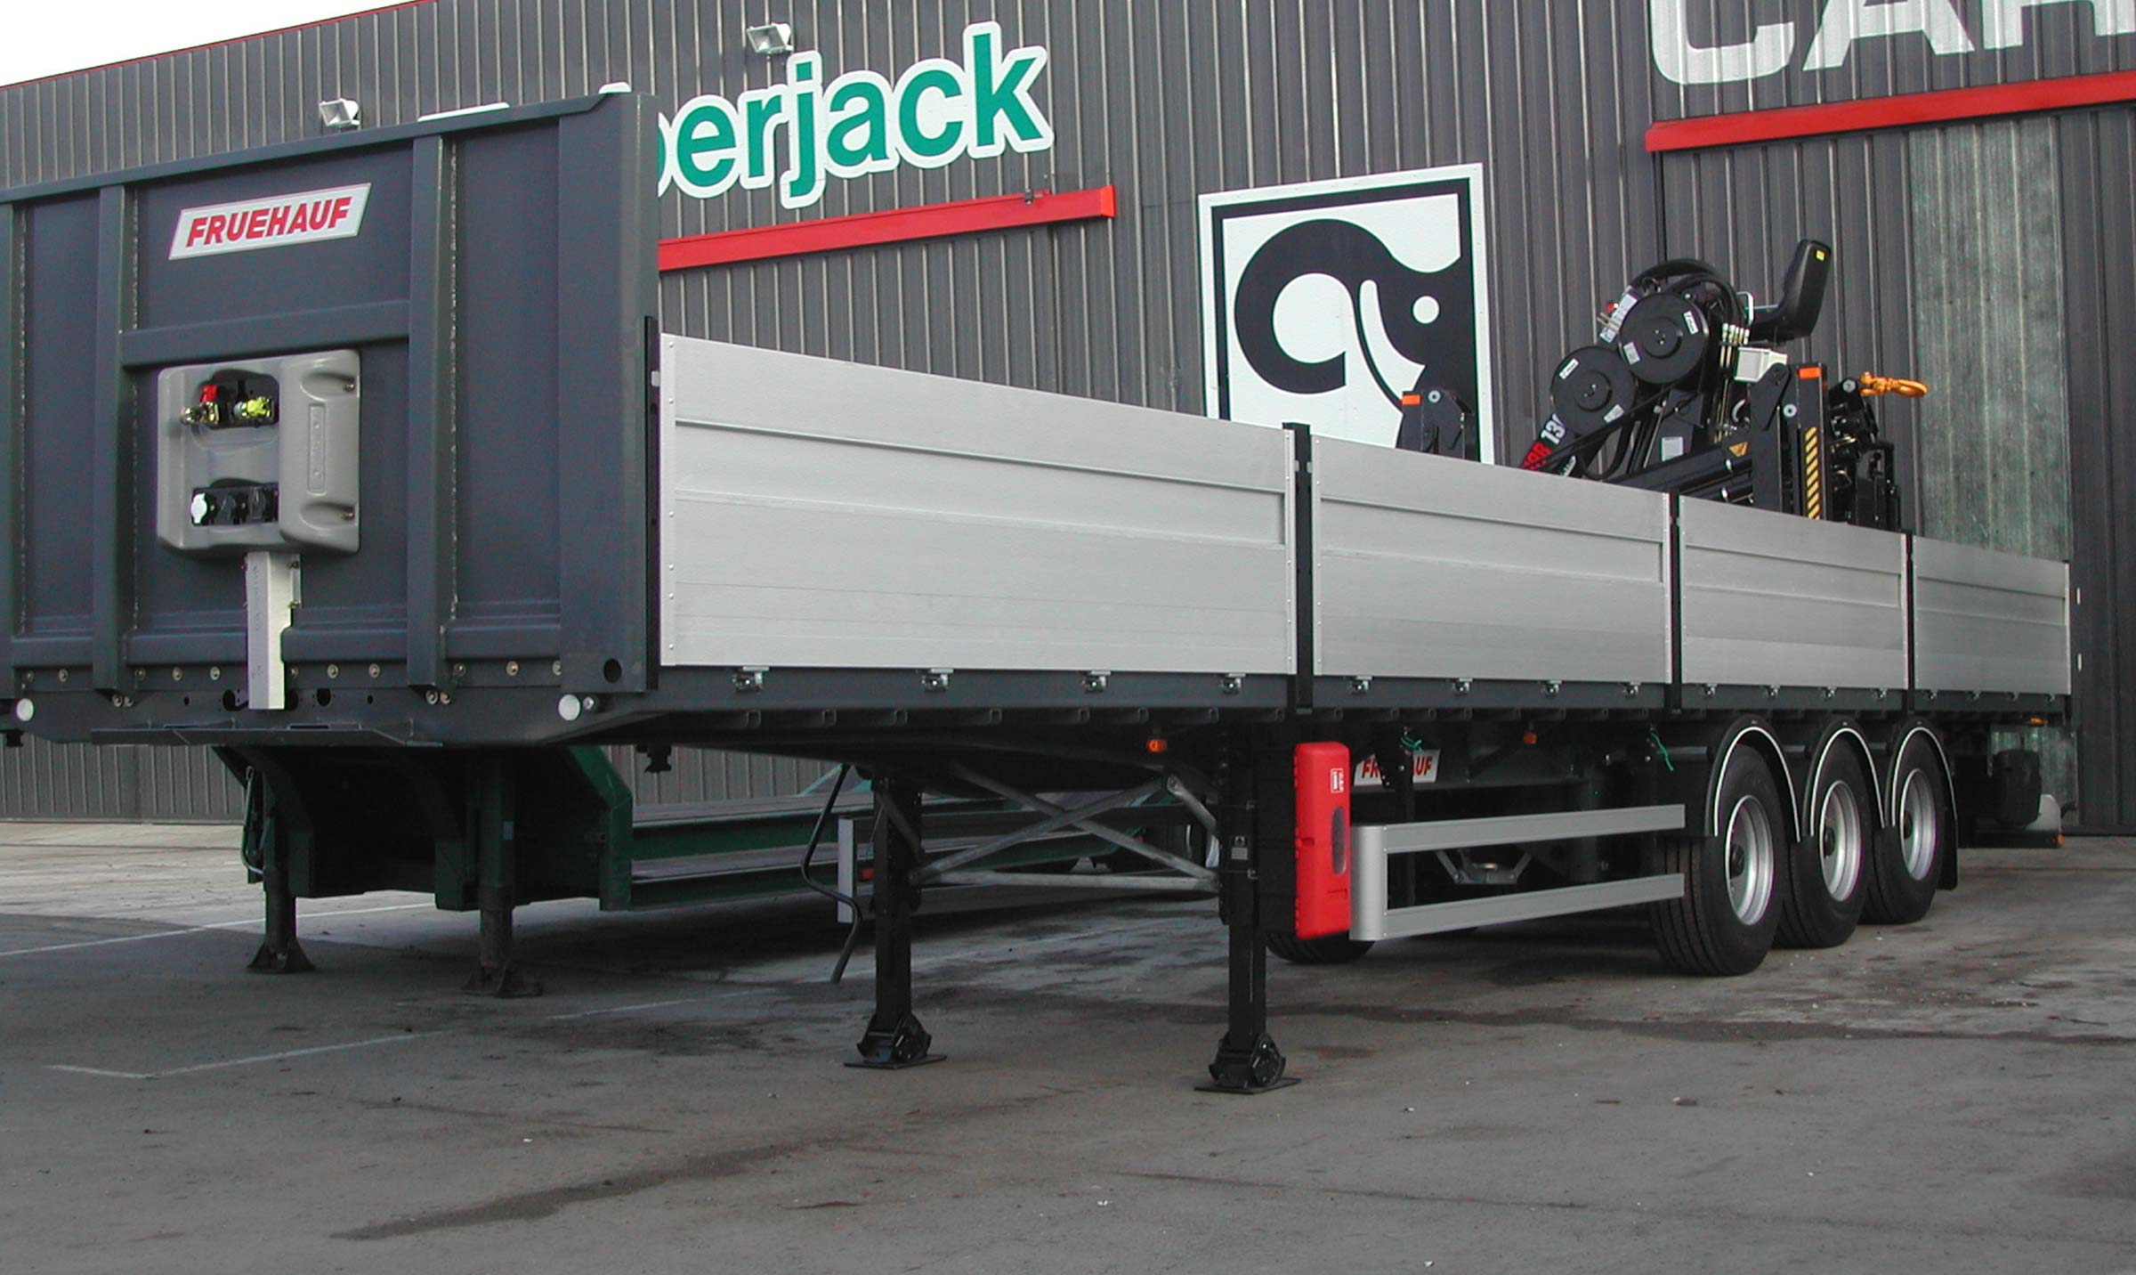
Gallery

Bodywork with low drop sides
Plateaux Heavy Duty Lourd EN
Reinforced chassisGuillaume Calviac2021-01-15T12:31:15+01:00
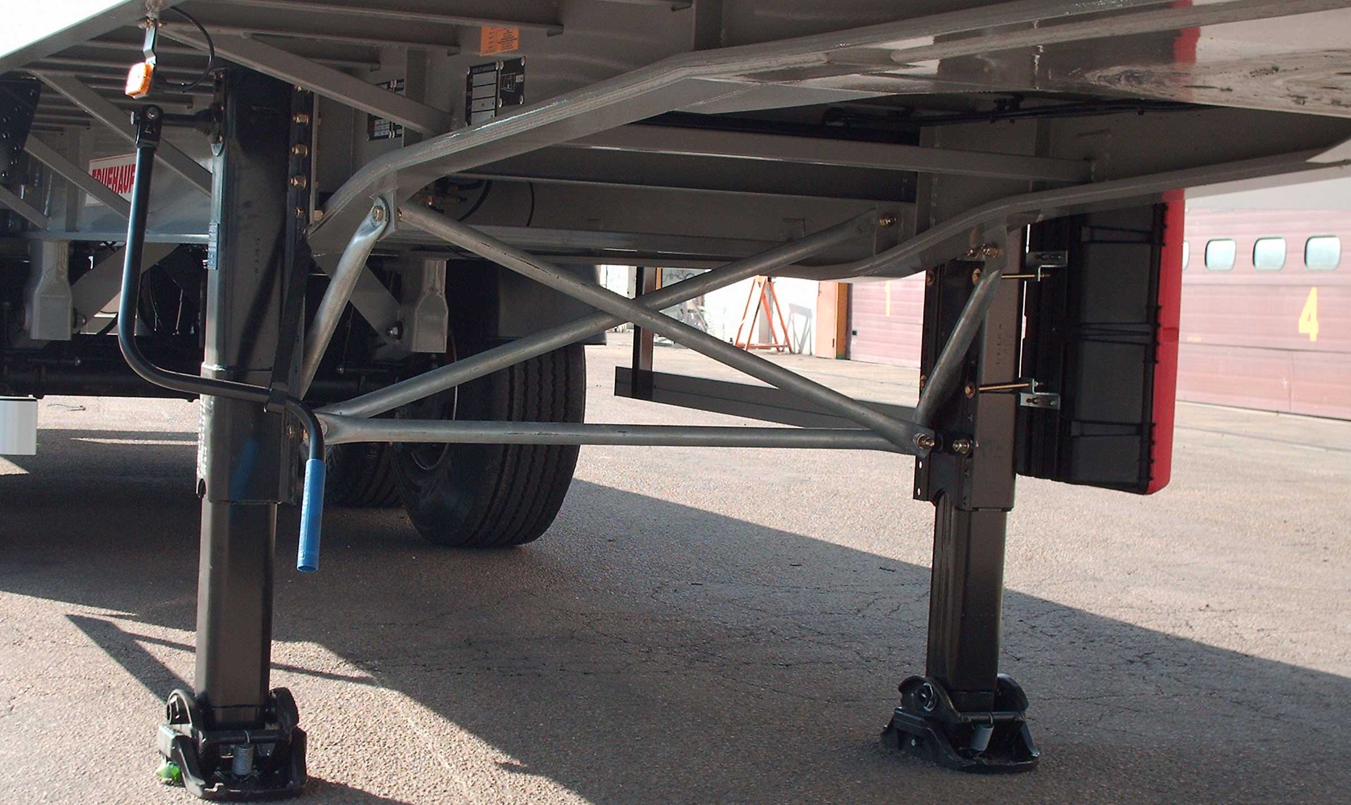
Gallery

Reinforced chassis
Plateaux Heavy Duty Lourd EN
Heavyweight PlatformGuillaume Calviac2021-01-15T12:31:24+01:00
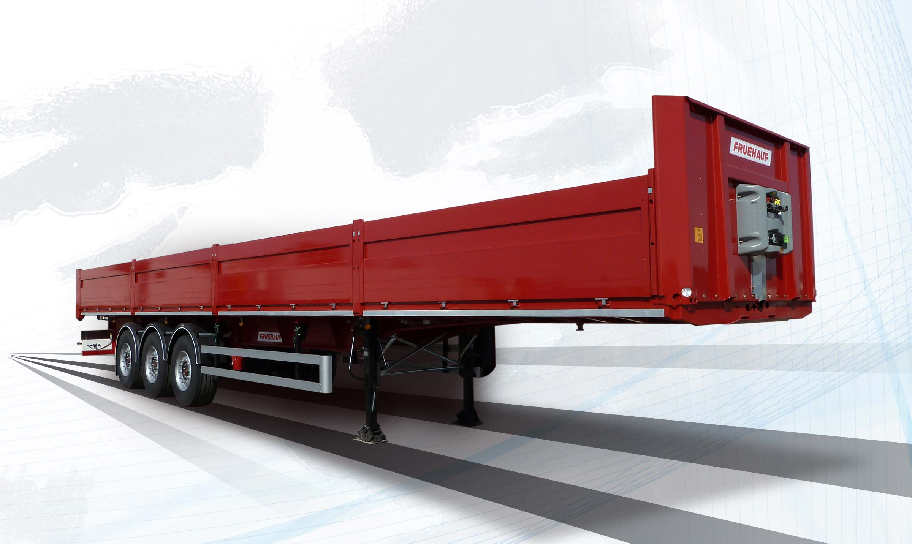
Gallery

Heavyweight Platform
Plateaux Heavy Duty Lourd EN

Container chassis

20' centred - 2 x 20'

40' - 45' - A1360 swap body
This chassis has crossmembers with retractable twist locks to transport containers or swap bodies.
Its equipment variants are suitable for multifunctional uses, either as a traditional platform or as a container chassis.
- Sturdiness
- Reliability
- Adaptability
10 t capacity wooden deckGuillaume Calviac2021-01-15T13:54:33+01:00
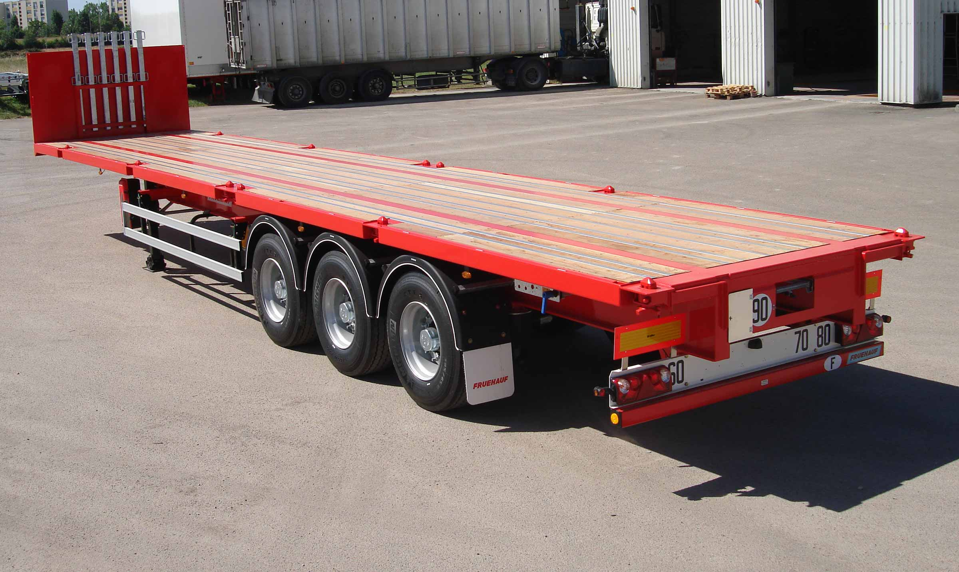
Gallery

10 t capacity wooden deck
Plateaux Porte Conteneurs EN
Removable front endGuillaume Calviac2021-01-15T10:34:21+01:00
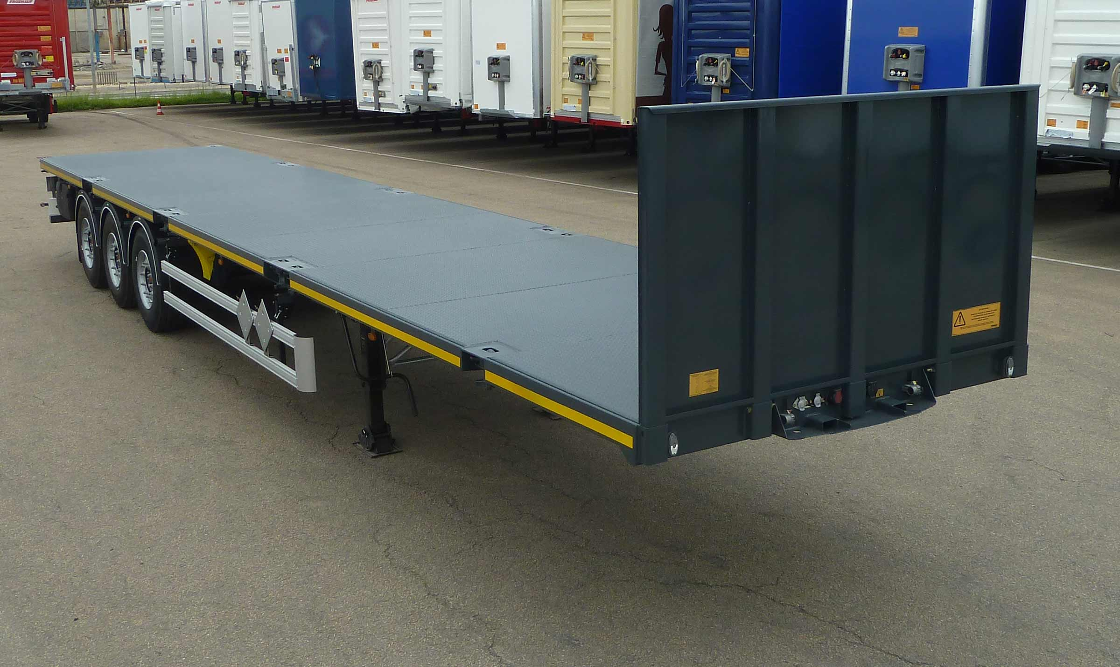
Gallery

Removable front end
Plateaux Porte Conteneurs EN
Metal deckGuillaume Calviac2021-06-01T13:50:12+02:00
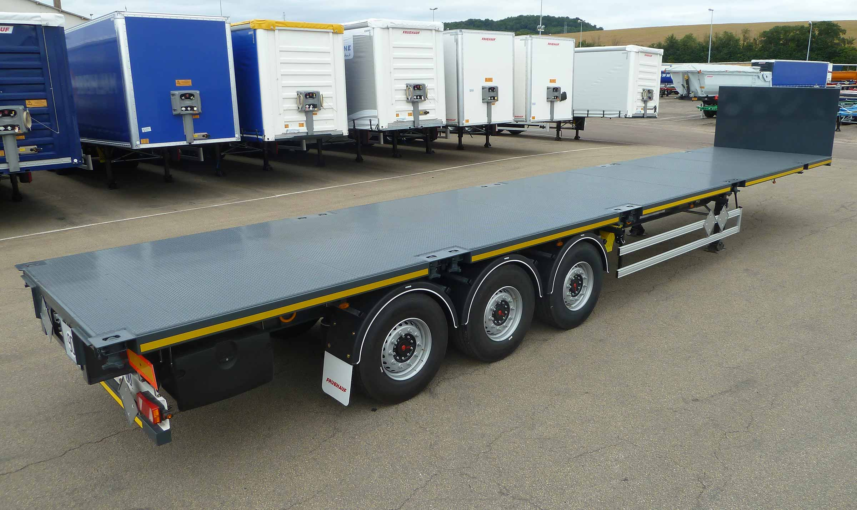
Gallery

Metal deck
Plateaux Porte Conteneurs EN
Container chassis platformGuillaume Calviac2021-01-15T10:28:50+01:00
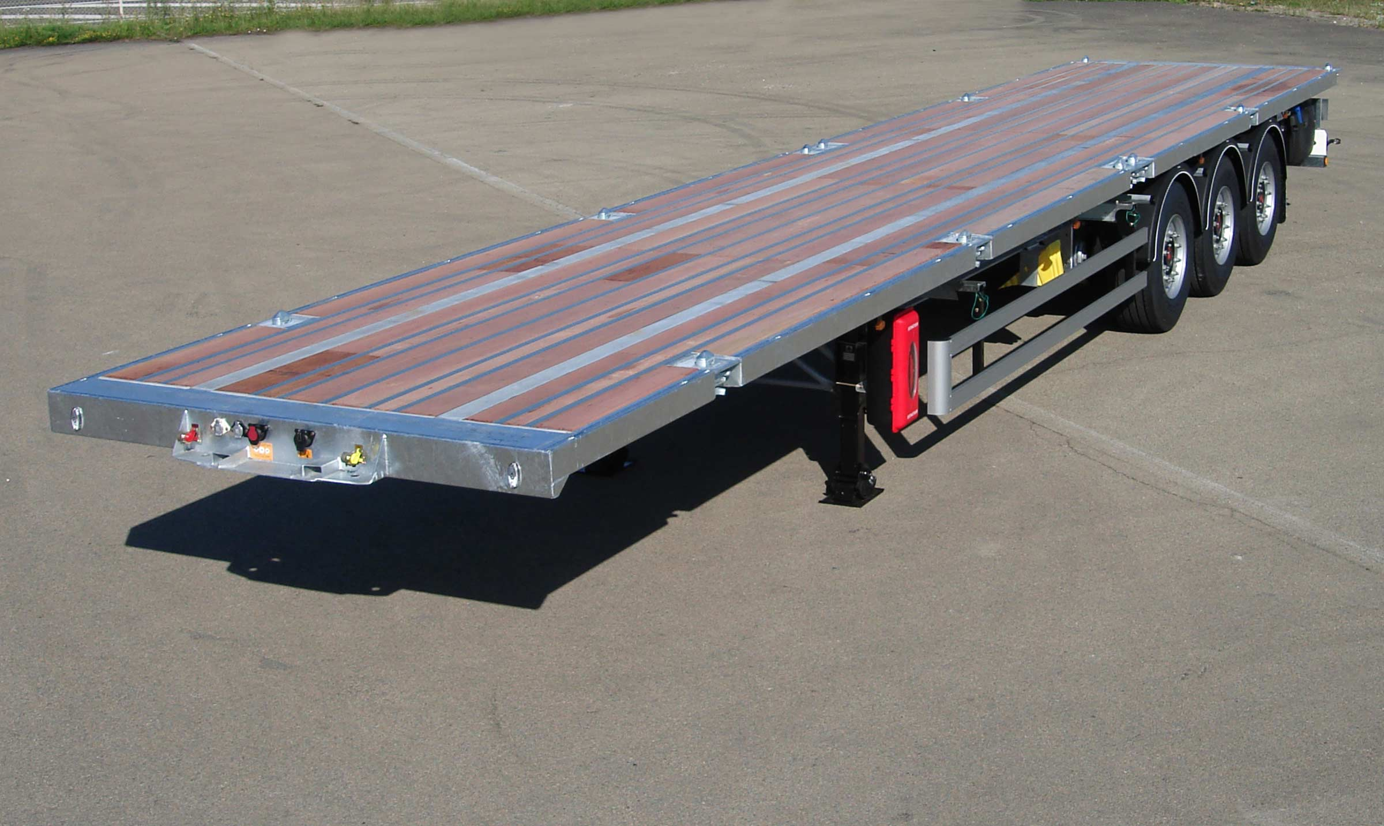
Gallery

Container chassis platform
Plateaux Porte Conteneurs EN
Container chassis platformGuillaume Calviac2021-01-15T10:28:19+01:00
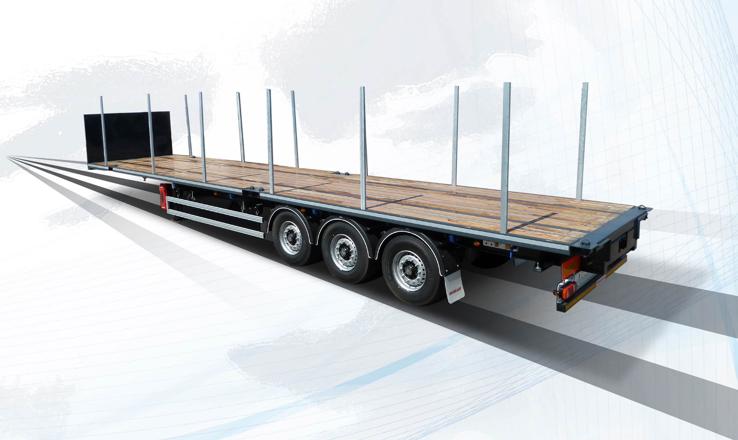
Gallery

Container chassis platform
Plateaux Porte Conteneurs EN
Documentation

Mega

Straight platform

Tridem 19,5″
FRUEHAUF MEGA straight platforms, with tapered gooseneck, are perfect for meeting bulky transport needs.
With their reinforced mechanically welded chassis, they are perfectly suited to harsh and very long-term applications.
- Sturdiness
- Reliability
- Adaptability
19,5′ axlesGuillaume Calviac2021-01-15T14:05:20+01:00
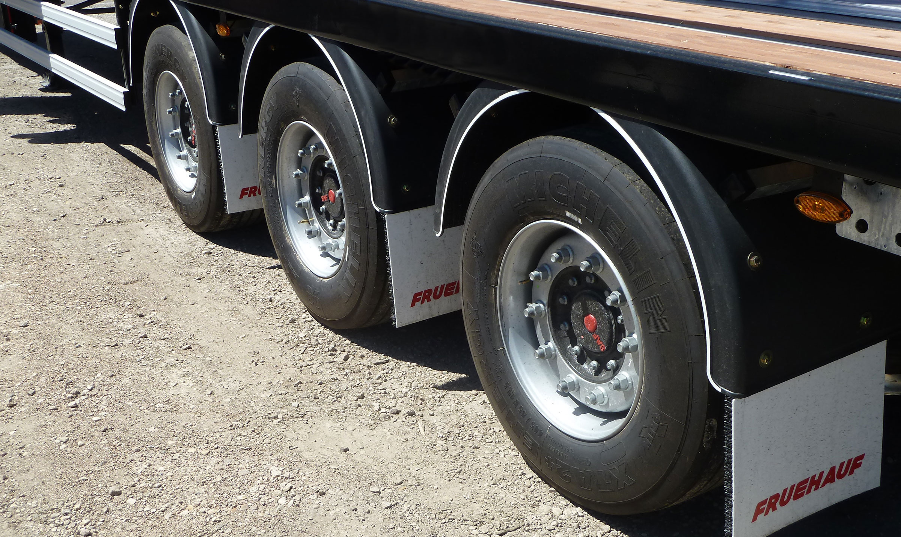
Gallery

19,5′ axles
Plateaux Mega EN
90 mm gooseneckGuillaume Calviac2021-01-15T14:04:46+01:00
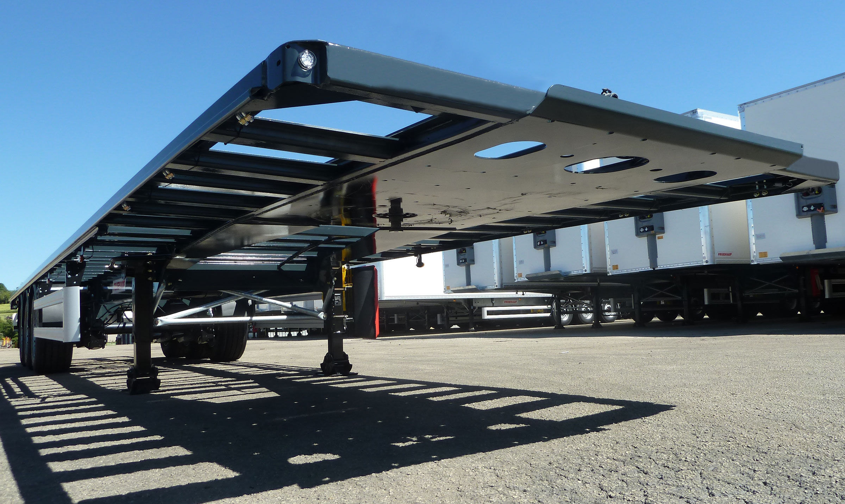
Gallery

90 mm gooseneck
Plateaux Mega EN

Innovations
By listening to its customers and users, Fruehauf is able to continuously design new innovative and high-performance equipment for increased savings, productivity and safety.
Protection of personnel and equipment, reduced fuel consumption, anticipation of new requirements.
- Economy
- Productivity
- Safety
SafeParkingGuillaume Calviac2021-01-15T11:41:43+01:00
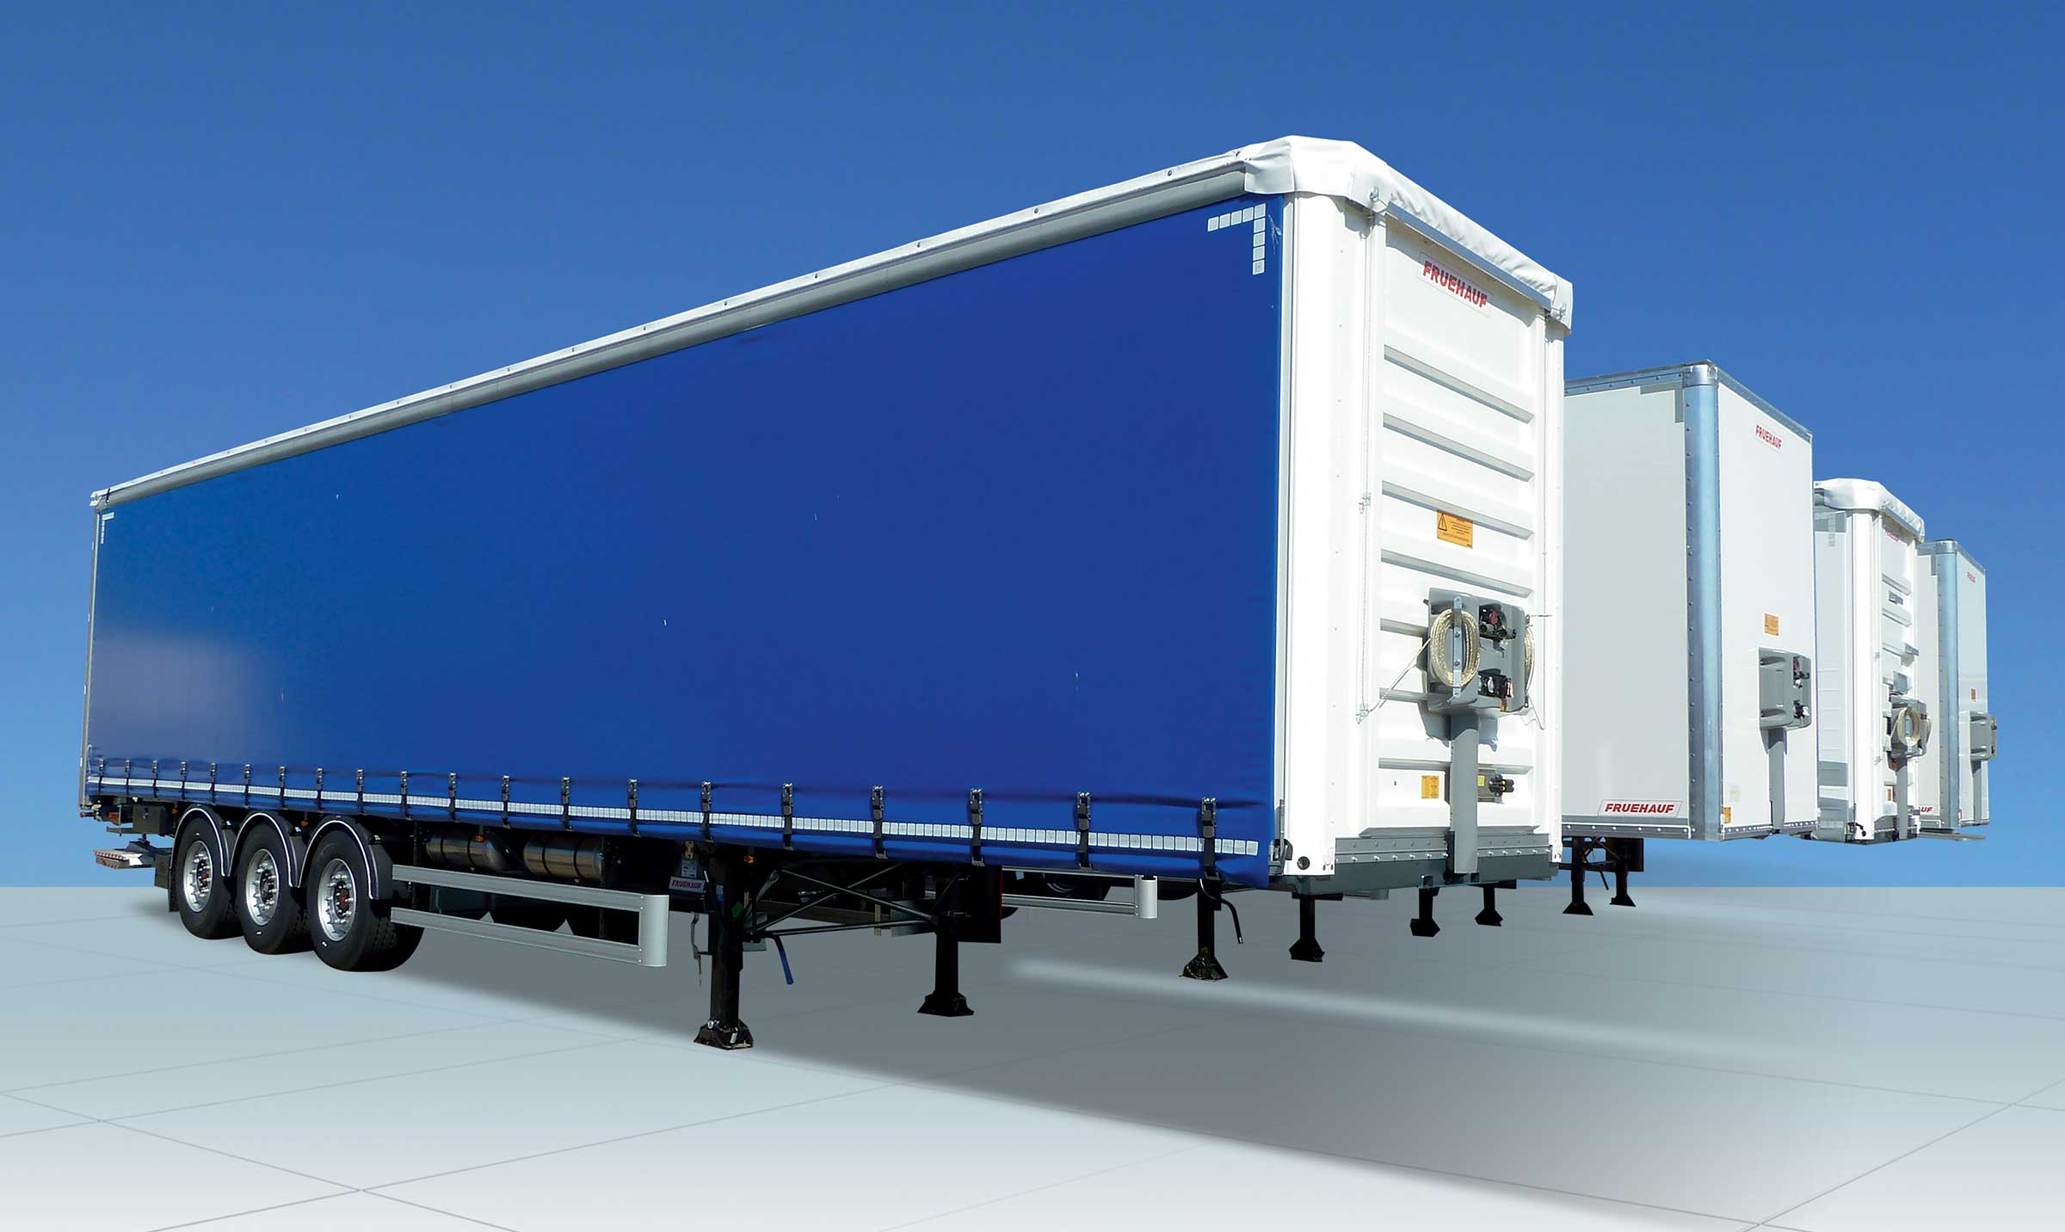
Gallery

SafeParking
Innovations - SafeParking, Innovations Base EN
TelematicsGuillaume Calviac2021-01-29T13:44:33+01:00

Gallery

Telematics
Innovations - Télématique, Innovations Base EN
RCPGuillaume Calviac2021-01-15T11:33:18+01:00
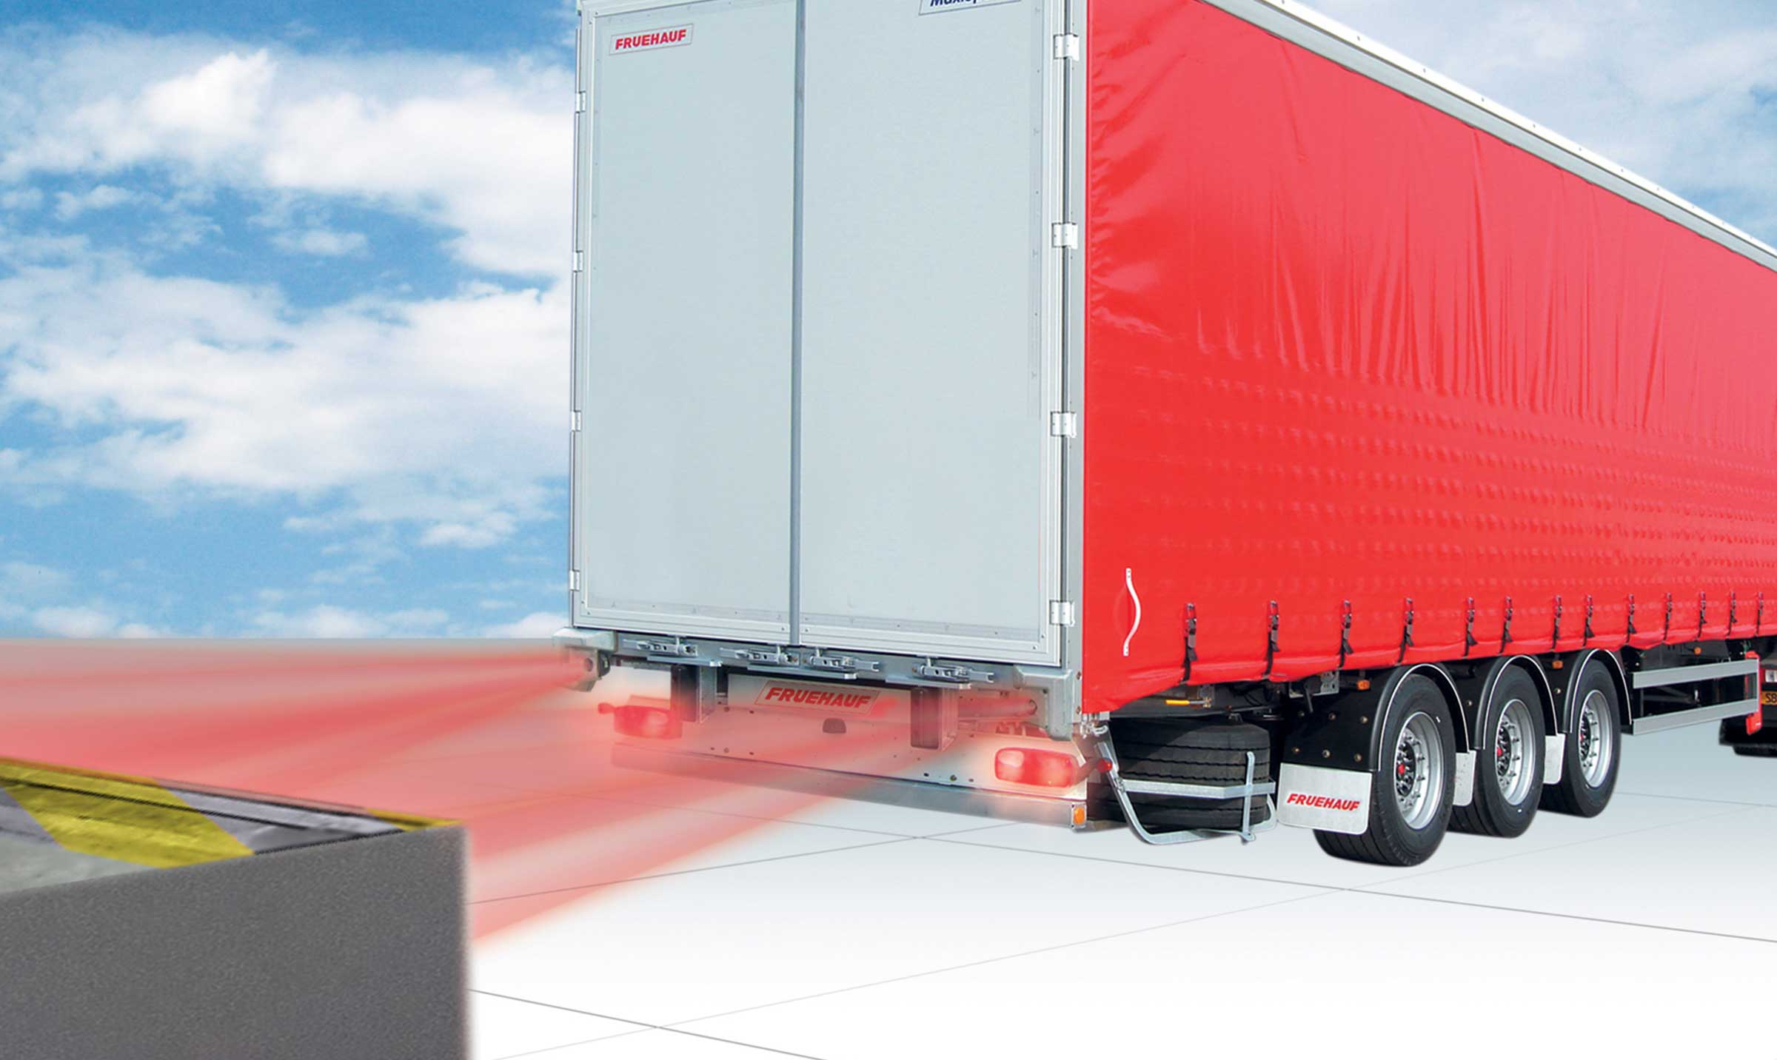
Gallery

RCP
Innovations - RCP, Innovations Base EN
APCSGuillaume Calviac2021-01-15T11:24:21+01:00
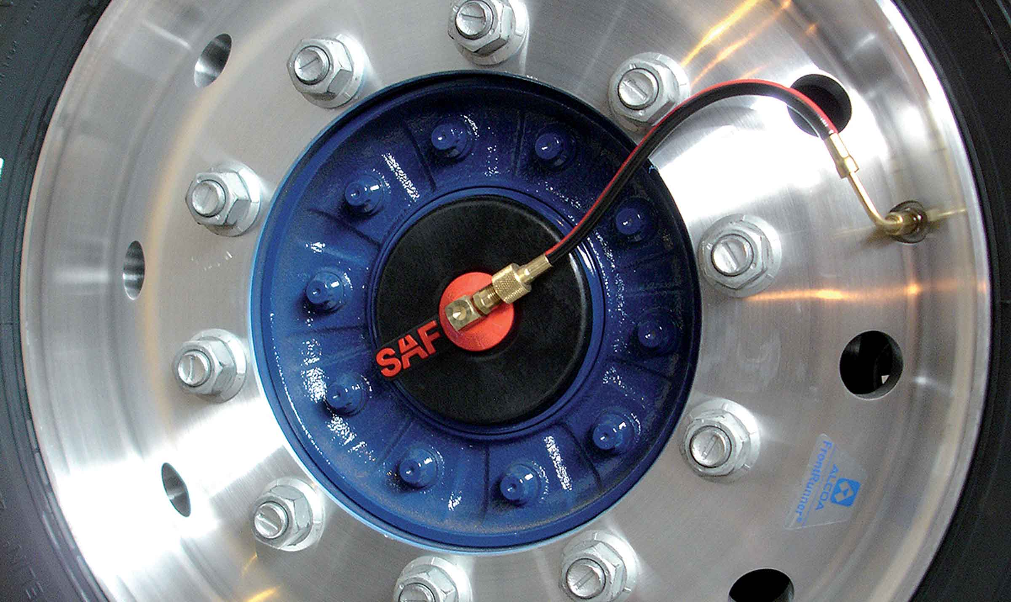
Gallery

APCS
Innovations APCS, Innovations Base EN
EBSGuillaume Calviac2021-01-15T11:24:12+01:00
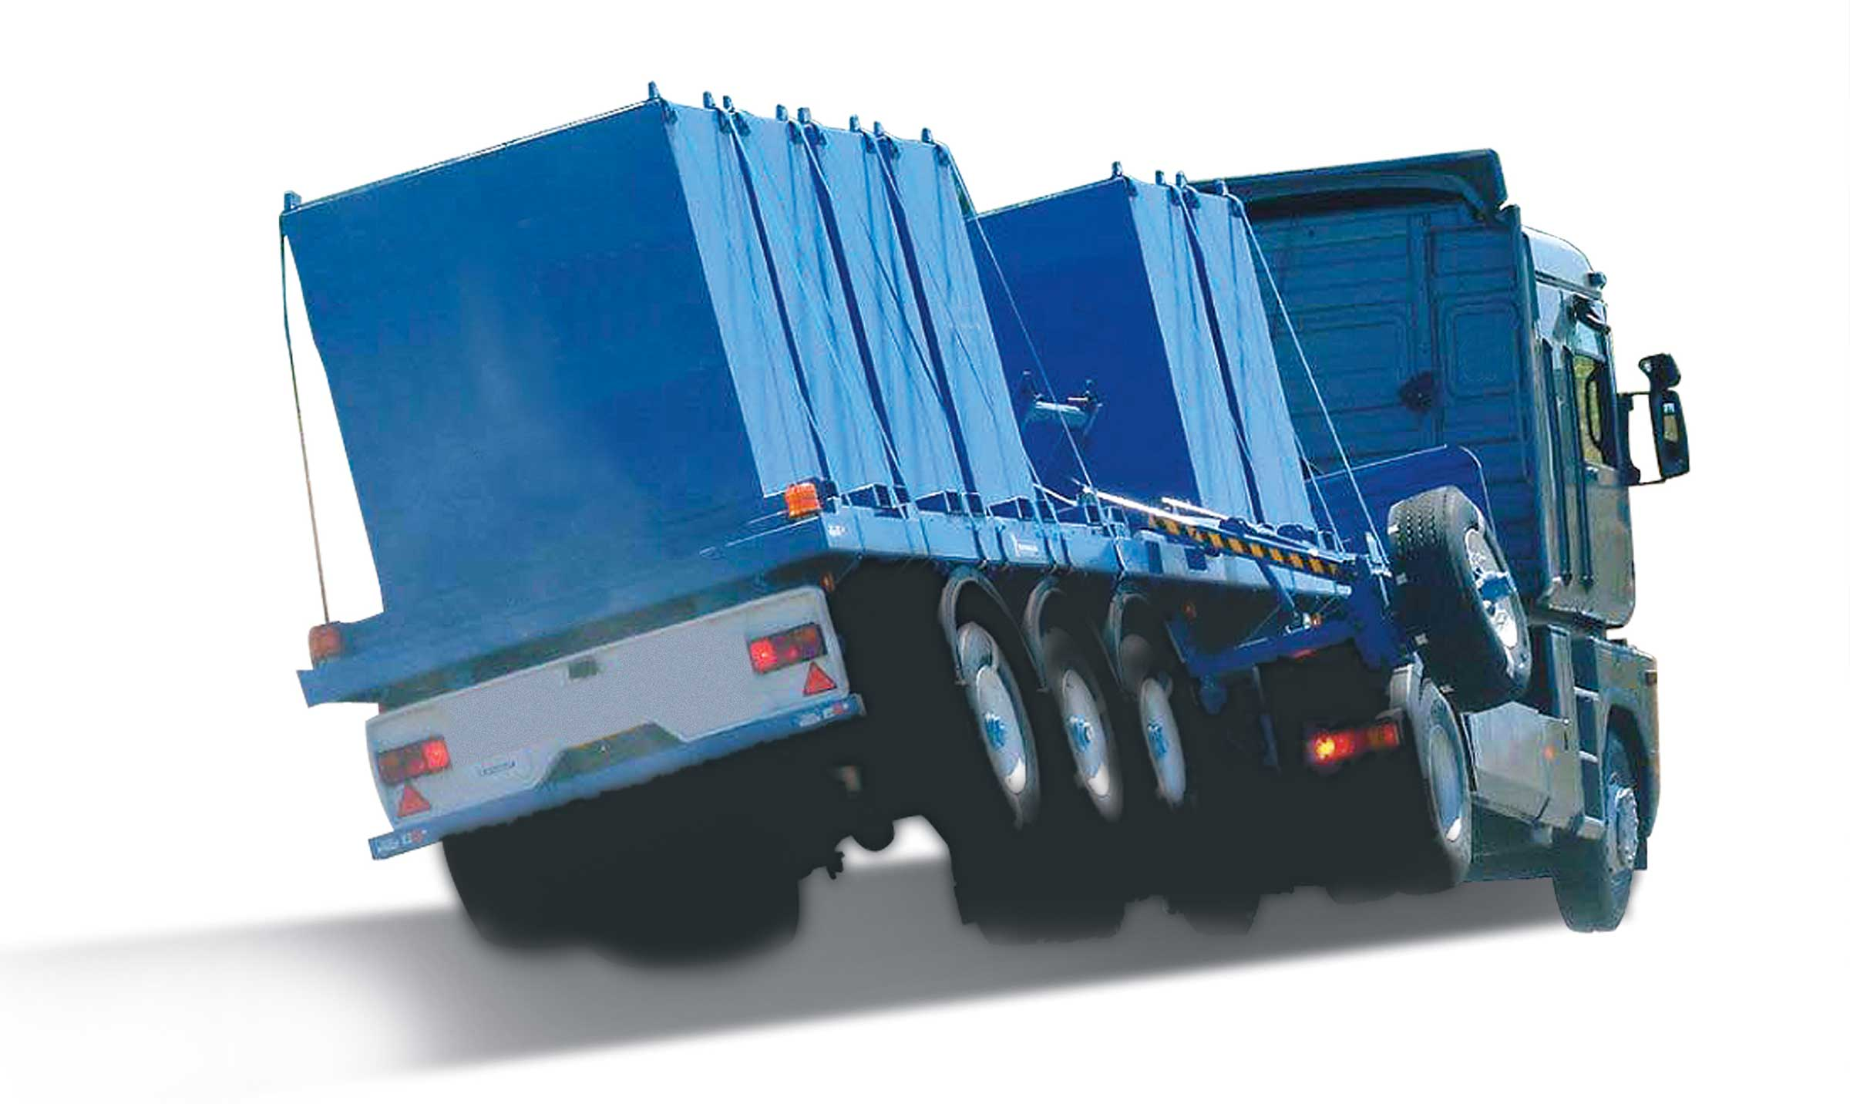
Gallery

EBS
Innovations Base EN
TPMSGuillaume Calviac2021-01-29T08:34:38+01:00
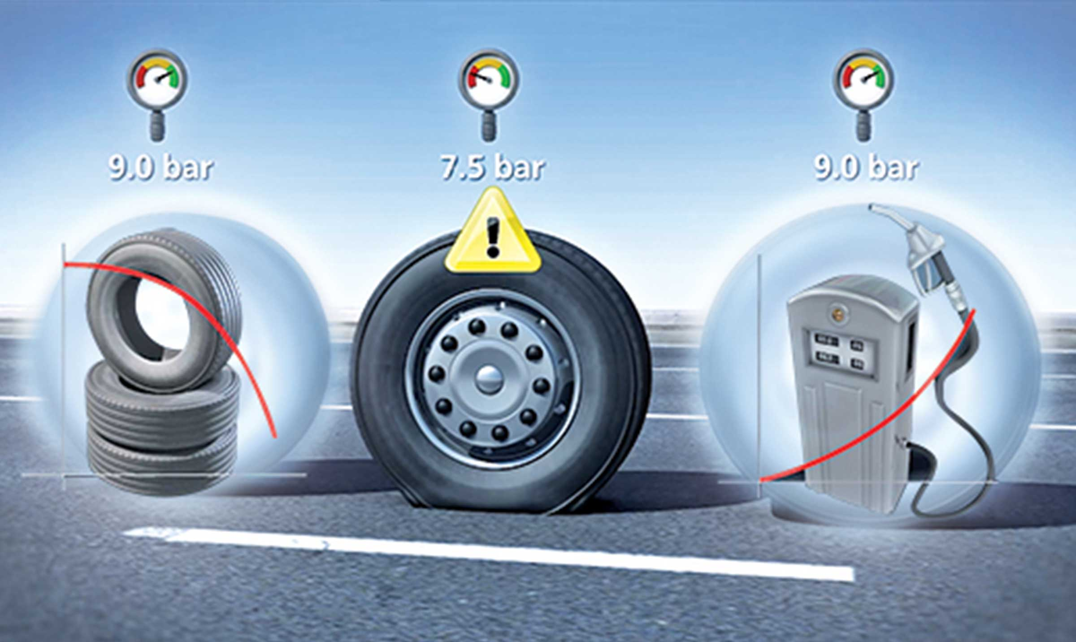
Gallery

TPMS
Innovations - TPMS, Innovations Base EN
Documentation
Demo Videos

Metadata
pyre_slider_type | no
pyre_slider | 0
pyre_wooslider
pyre_revslider | 0
pyre_elasticslider | 0
pyre_slider_position | default
pyre_avada_rev_styles | default
pyre_fallback
pyre_fallback_id
pyre_demo_slider
pyre_main_top_padding
pyre_main_bottom_padding
pyre_hundredp_padding
pyre_show_first_featured_image | no
pyre_display_header | yes
pyre_header_100_width | default
pyre_combined_header_bg_color
pyre_mobile_header_bg_color
pyre_header_bg
pyre_header_bg_id
pyre_header_bg_full | no
pyre_header_bg_repeat | repeat
pyre_displayed_menu | default
pyre_display_footer | default
pyre_display_copyright | default
pyre_footer_100_width | default
pyre_sidebar_position | default
pyre_responsive_sidebar_order
pyre_sidebar_sticky | default
pyre_sidebar_bg_color
pyre_page_bg_layout | default
pyre_page_bg_color
pyre_page_bg
pyre_page_bg_id
pyre_page_bg_full | default
pyre_page_bg_repeat | default
pyre_wide_page_bg_color
pyre_wide_page_bg
pyre_wide_page_bg_id
pyre_wide_page_bg_full | default
pyre_wide_page_bg_repeat | default
pyre_page_title | default
pyre_page_title_breadcrumbs_search_bar | default
pyre_page_title_text | default
pyre_page_title_text_alignment | default
pyre_page_title_custom_text
pyre_page_title_text_size
pyre_page_title_line_height
pyre_page_title_font_color
pyre_page_title_custom_subheader
pyre_page_title_custom_subheader_text_size
pyre_page_title_subheader_font_color
pyre_page_title_100_width | default
pyre_page_title_height
pyre_page_title_mobile_height
pyre_page_title_bar_bg_color
pyre_page_title_bar_borders_color
pyre_page_title_bar_bg
pyre_page_title_bar_bg_id
pyre_page_title_bar_bg_retina
pyre_page_title_bar_bg_retina_id
pyre_page_title_bar_bg_full | default
pyre_page_title_bg_parallax | default
fusion_builder_status | active
kd_featured-image-2_page_id
kd_featured-image-3_page_id
kd_featured-image-4_page_id
kd_featured-image-5_page_id
sbg_selected_sidebar | Array
sbg_selected_sidebar_replacement | Array
sbg_selected_sidebar_2 | Array
sbg_selected_sidebar_2_replacement | Array
avada_post_views_count | 312
avada_today_post_views_count | 1
avada_post_views_count_today_date | 13-12-2023

