Innovations
Author | Guillaume Calviac
Date | 2021-06-03 14:59:11
Categories

INNOVATIONS

Continuous innovation
By listening to its operators, Fruehauf is able to continuously design new innovative and high-performance equipment for increased savings, productivity and safety :
- Protection of people and equipment
- Tyre pressure and temperature monitoring
- Reduced fuel consumption
- Anticipation of new transport needs
These new equipments has certain advantages for their users over the competition.

FALCON : the future at work

Advanced research project
FRUEHAUF is involved in the "FALCON" project, an advanced research programme on the vehicle of the future, at the cutting edge in terms of innovation, aimed at improving the energy efficiency of road trains and therefore reducing fuel consumption and CO₂ emissions.
- Fuel savings
- Reduced CO₂ emissions
- Flexible and aerodynamic
Falcon : Flexible & Aerodynamic Truck for Low CONsumptionGuillaume Calviac2021-01-28T14:56:40+01:00
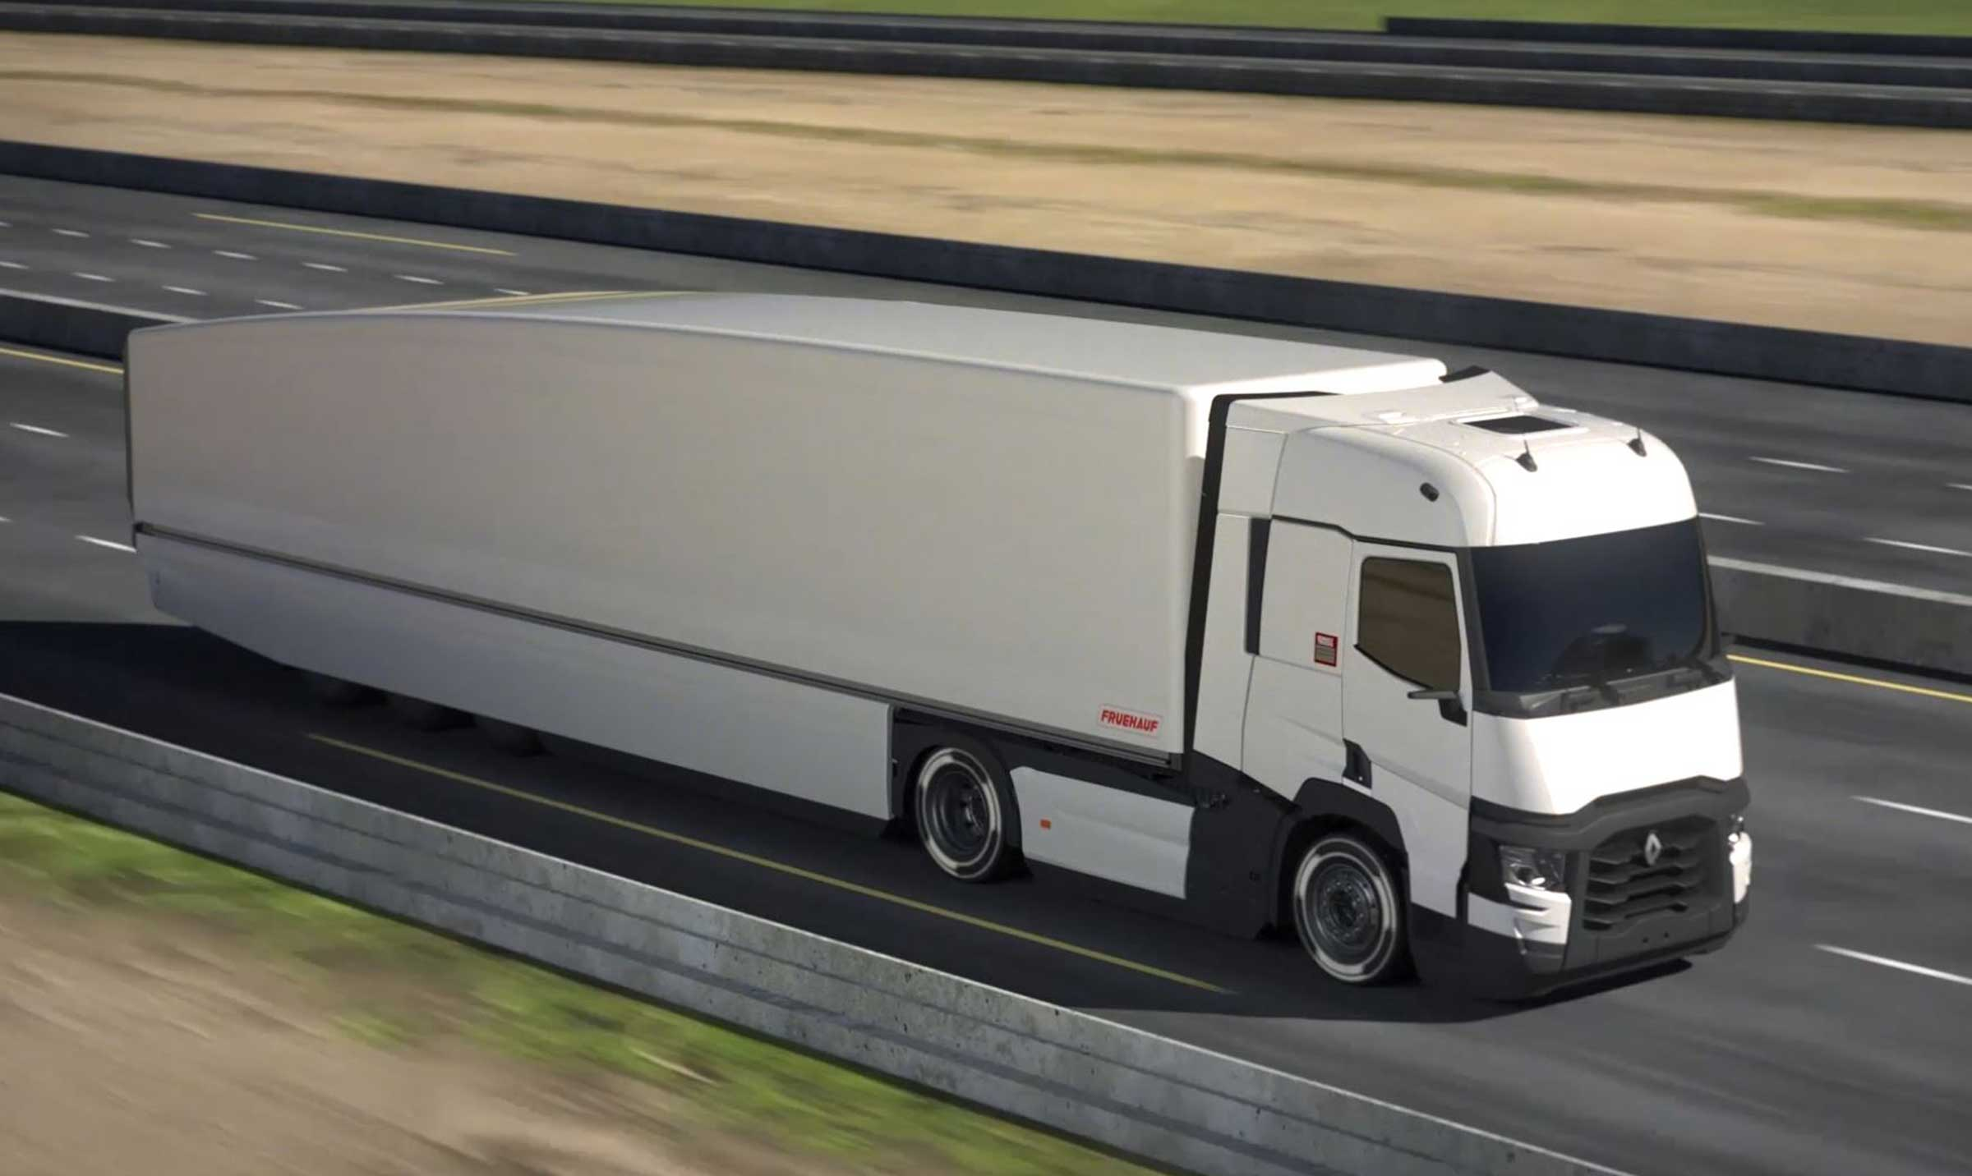
Gallery

Falcon : Flexible & Aerodynamic Truck for Low CONsumption
Falcon
Falcon : Flexible & Aerodynamic Truck for Low CONsumptionGuillaume Calviac2021-01-28T14:53:21+01:00
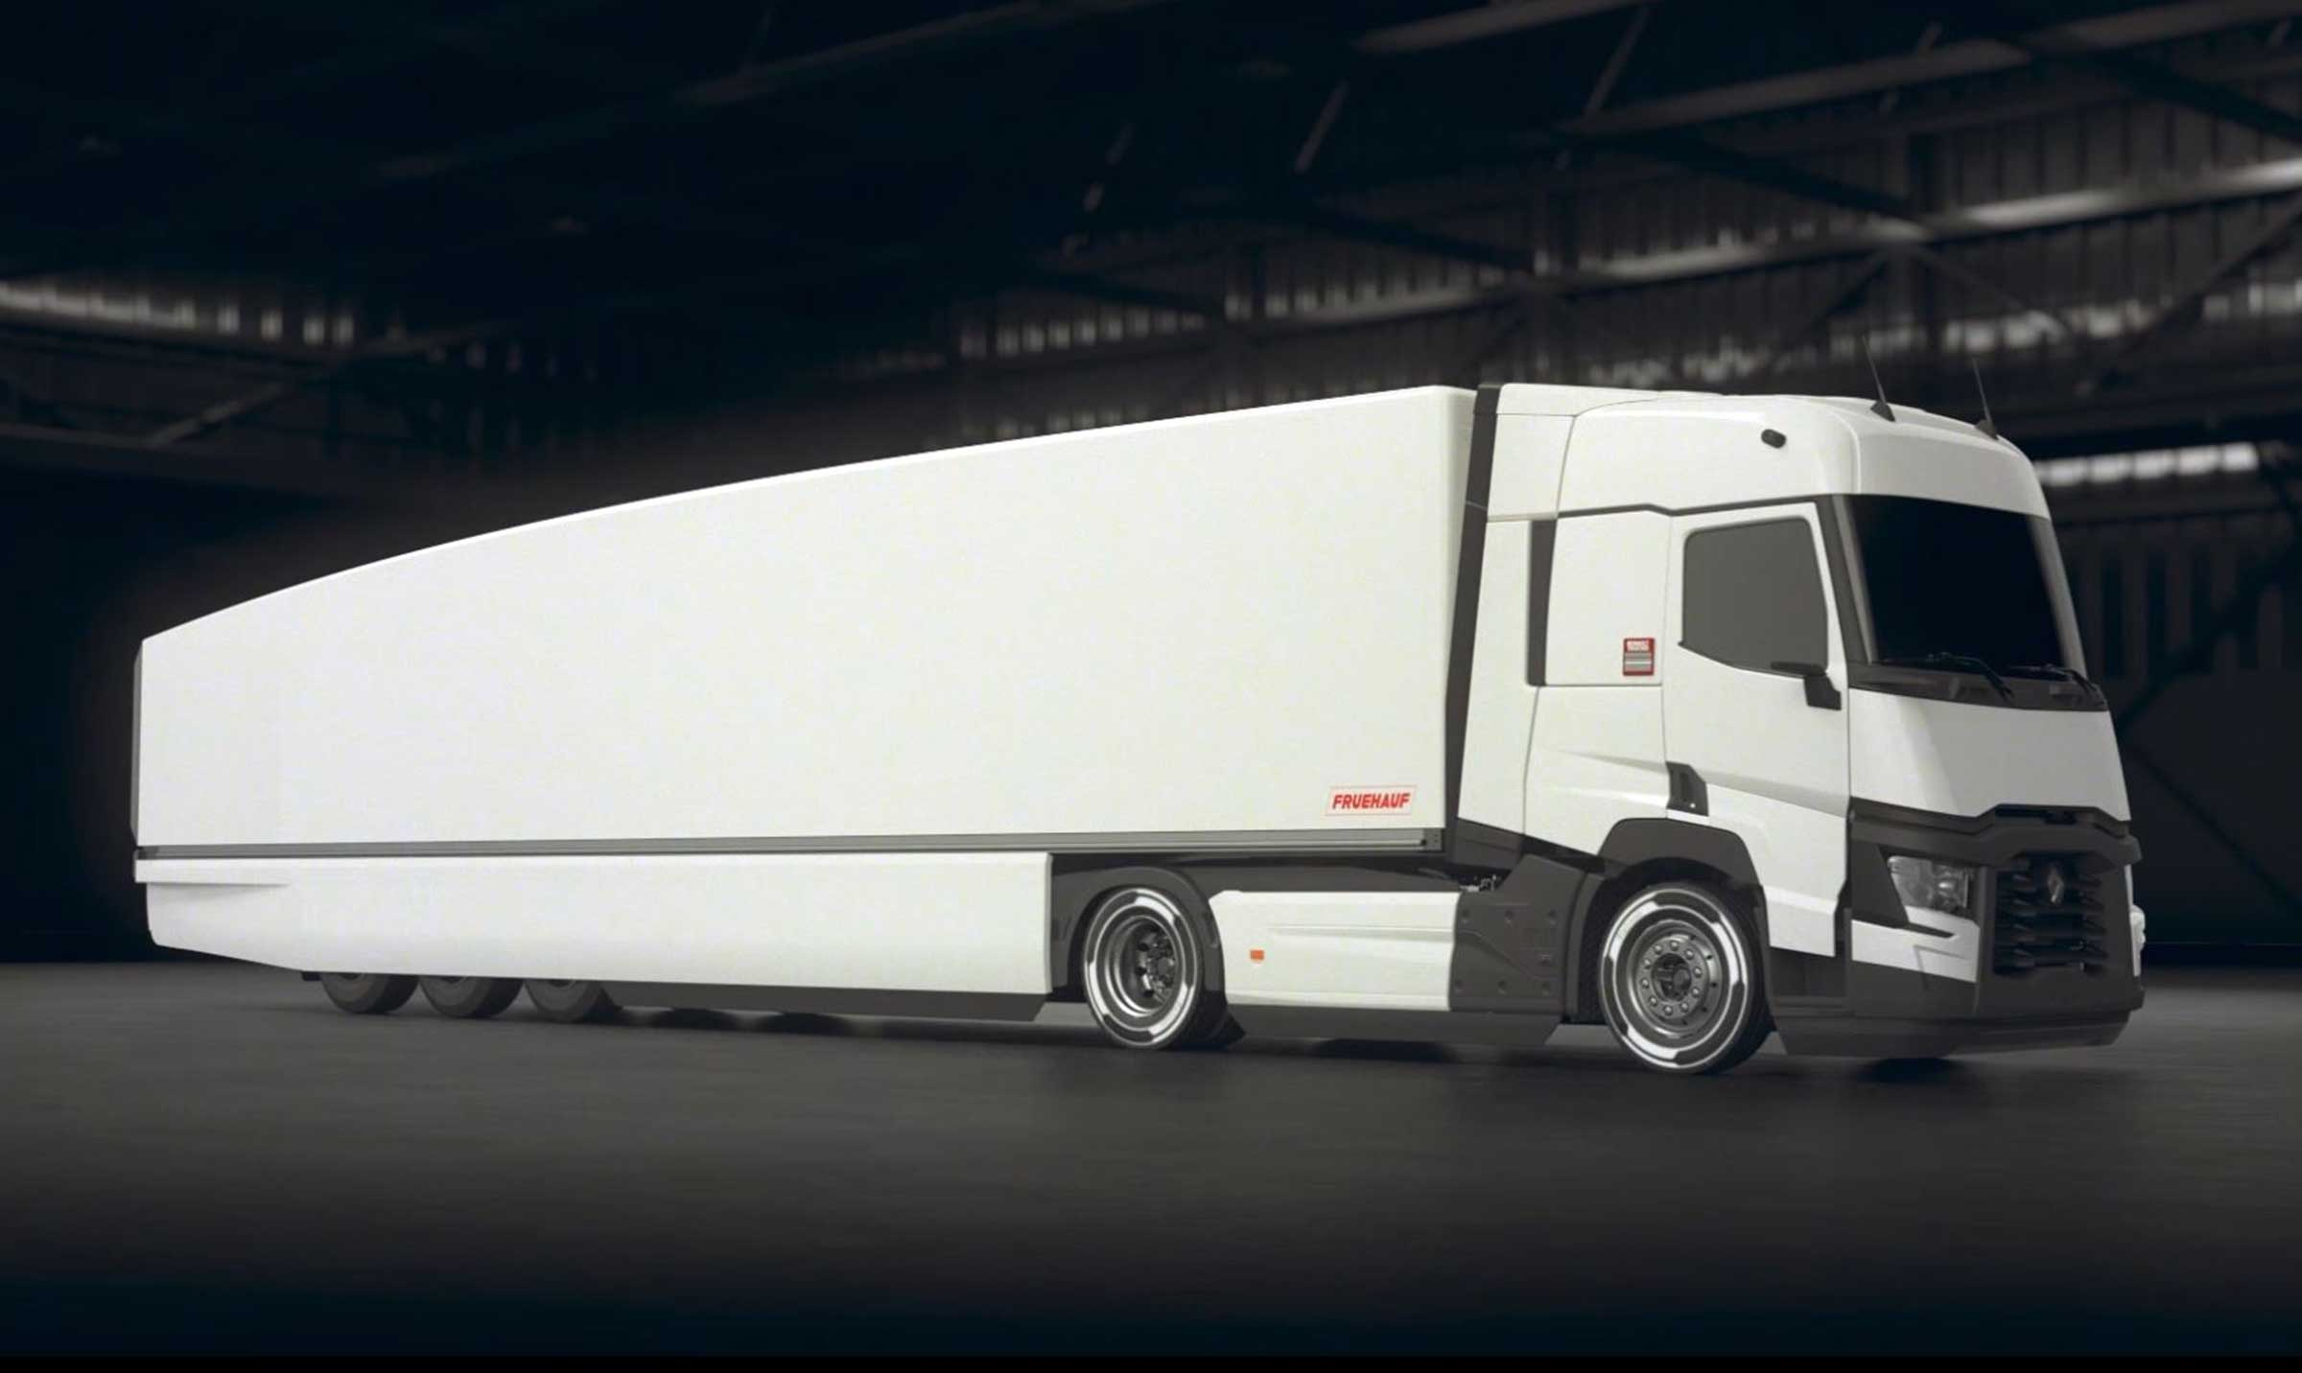
Gallery

Falcon : Flexible & Aerodynamic Truck for Low CONsumption
Falcon
Falcon : Flexible & Aerodynamic Truck for Low CONsumptionGuillaume Calviac2021-01-28T14:52:59+01:00
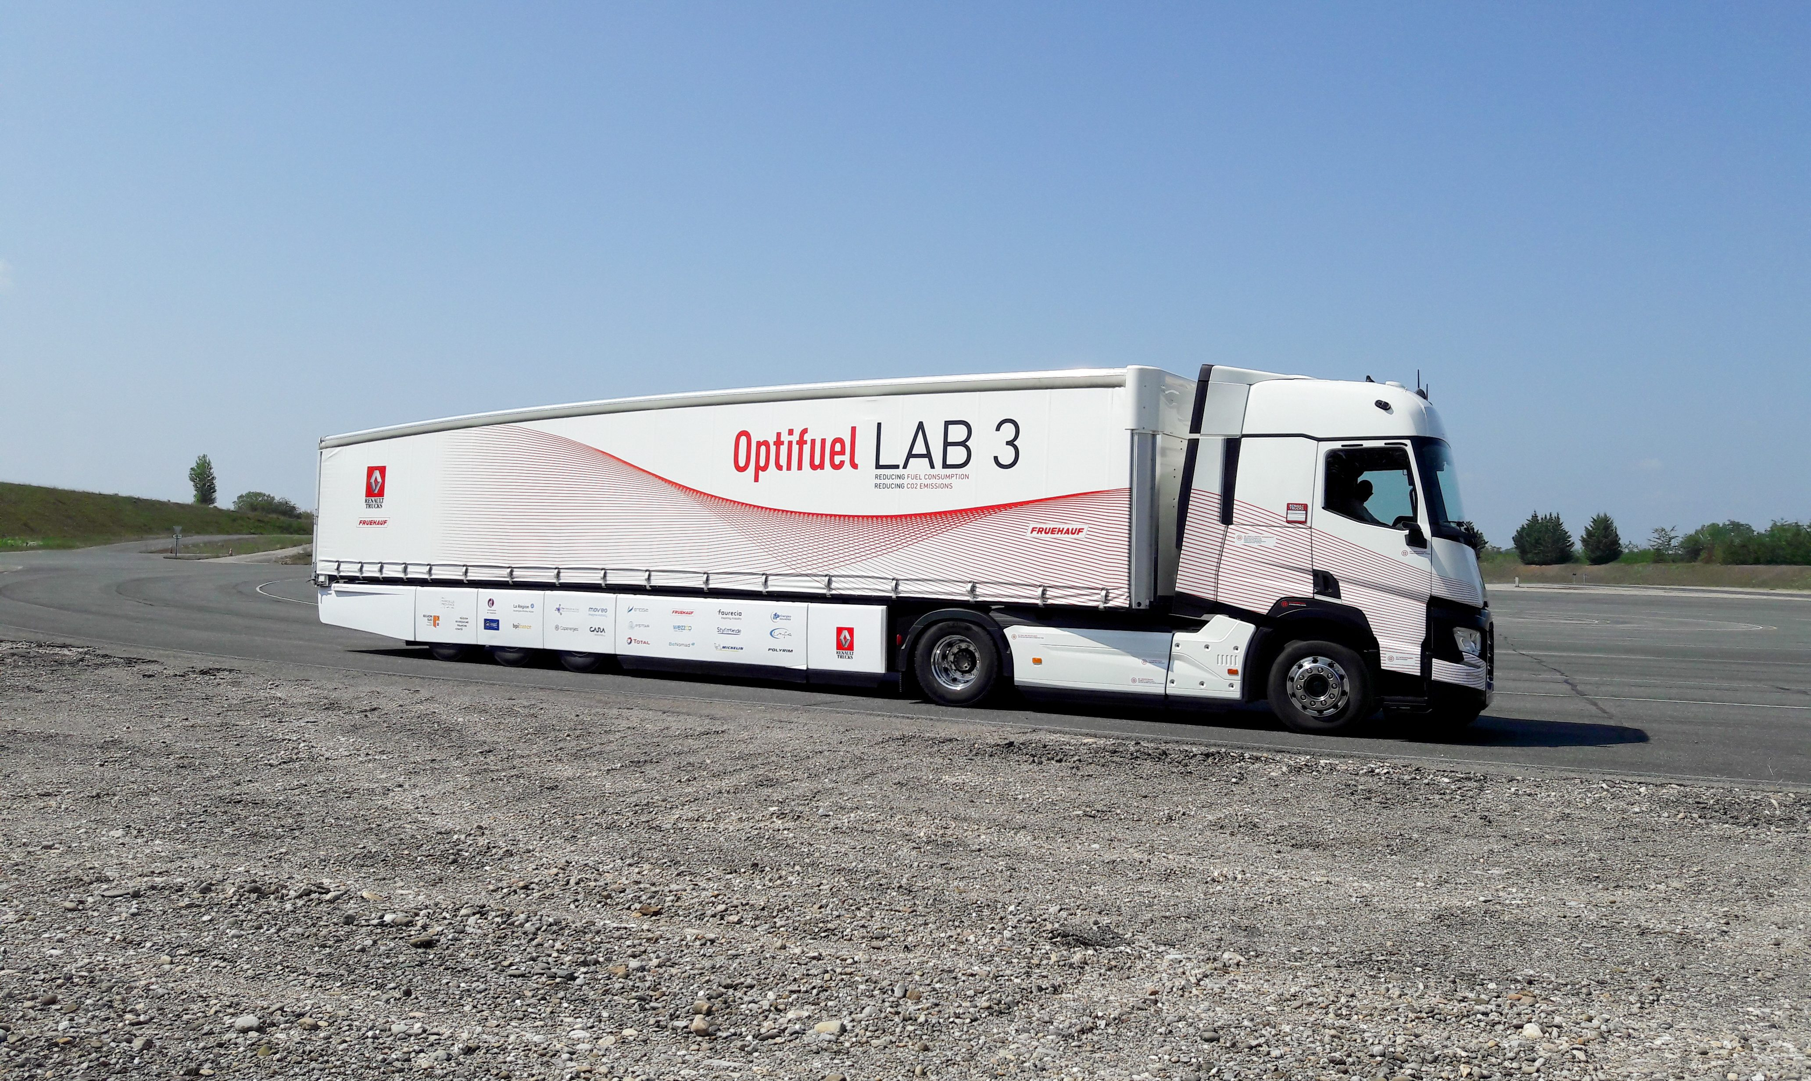
Gallery

Falcon : Flexible & Aerodynamic Truck for Low CONsumption
Falcon
Documentation
Demo Videos

Protection of people and equipment

EASY^{UP®}

Roller shutter door with pneumatic assistance

Simplicity and Reliability
The new roller shutter door with pneumatic assistance EASY ^{UP ®} is FRUEHAUF's brand-new innovation. It allows to securely eliminate any repetitive efforts.
It is compatible with all hights of vehicles and its commands are accessible from the ground or the loading platforms.
- Ergonomics
- Safety
- Reliability
ERGONOMICS – Accessible controlsGuillaume Calviac2021-03-29T08:42:10+02:00
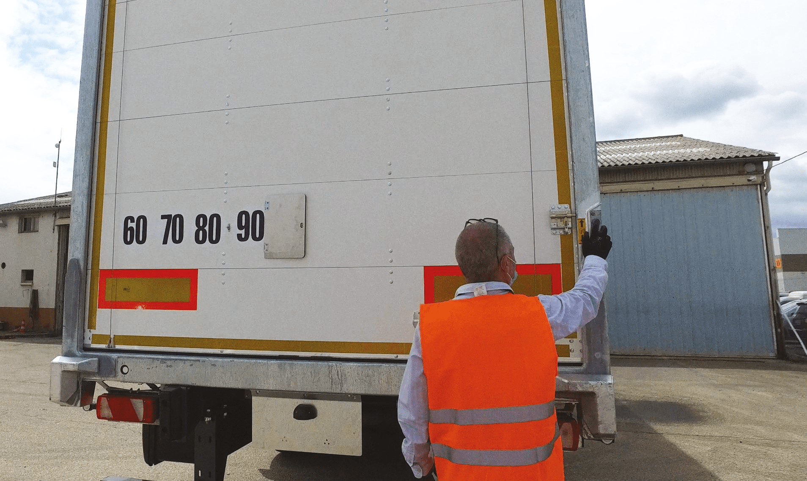
Gallery

ERGONOMICS – Accessible controls
Fourgons - Innovations, Innovations - Easy UP
Freight safetyGuillaume Calviac2021-03-29T08:41:09+02:00
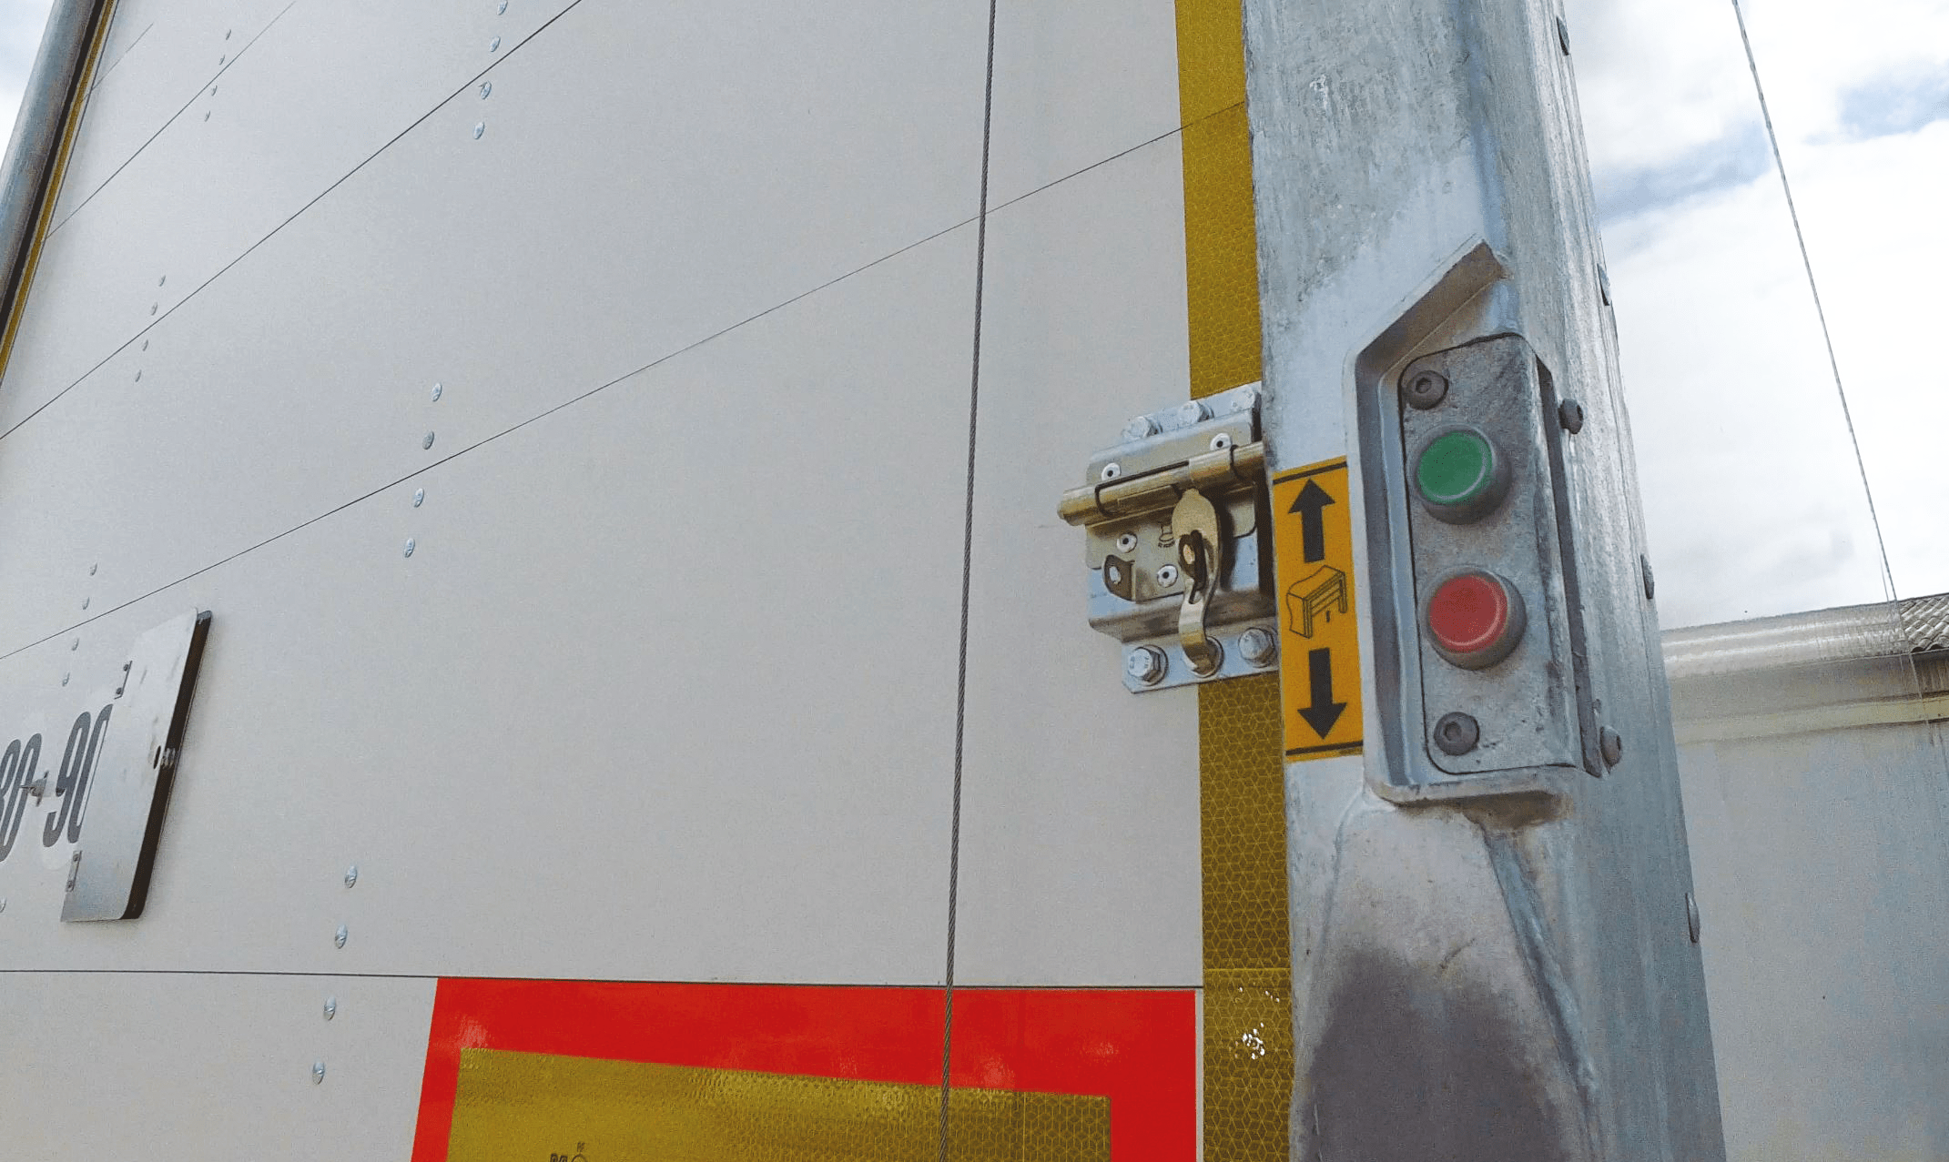
Gallery

Freight safety
Fourgons - Innovations, Innovations - Easy UP
SAFETY – Low pressure cylinderGuillaume Calviac2021-03-29T08:39:48+02:00
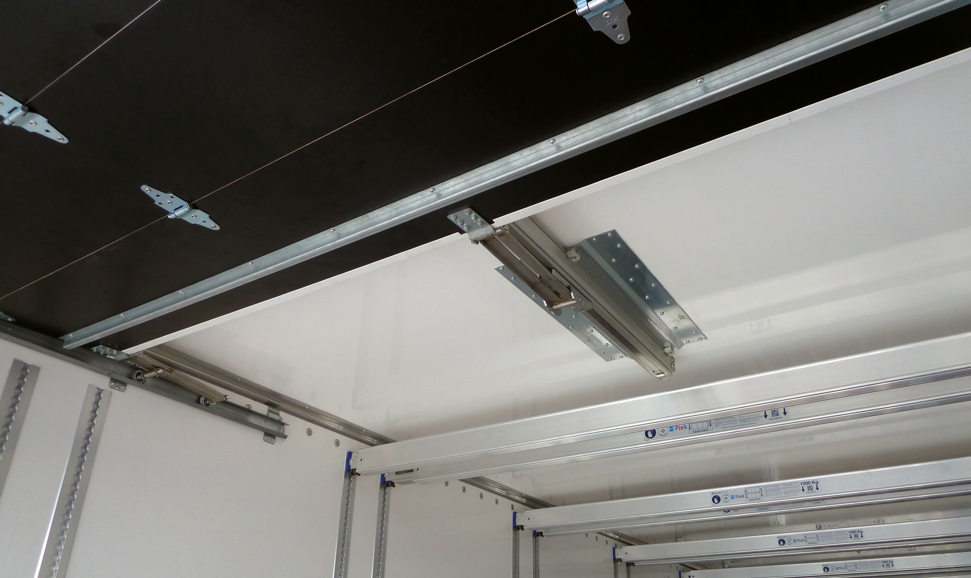
Gallery

SAFETY – Low pressure cylinder
Fourgons - Innovations, Innovations - Easy UP
Compensating spring retentionGuillaume Calviac2021-03-29T08:38:12+02:00
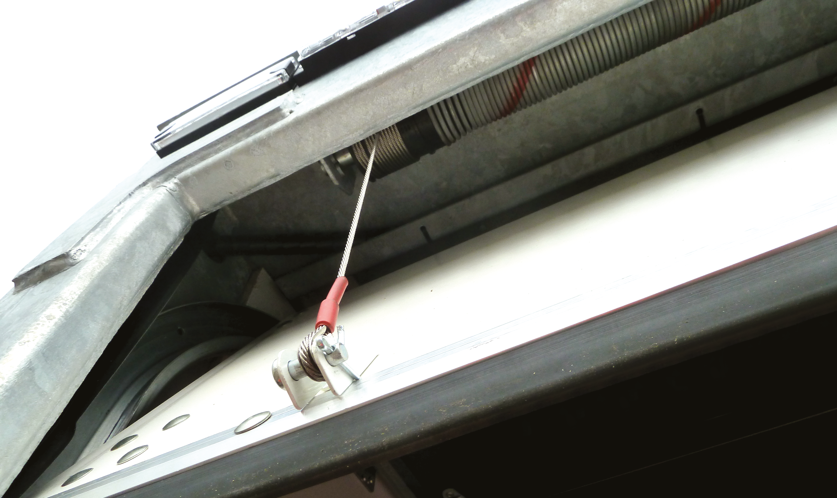
Gallery

Compensating spring retention
Fourgons - Innovations, Innovations - Easy UP
RELIABILITY – Additional air tankGuillaume Calviac2021-03-29T08:33:00+02:00
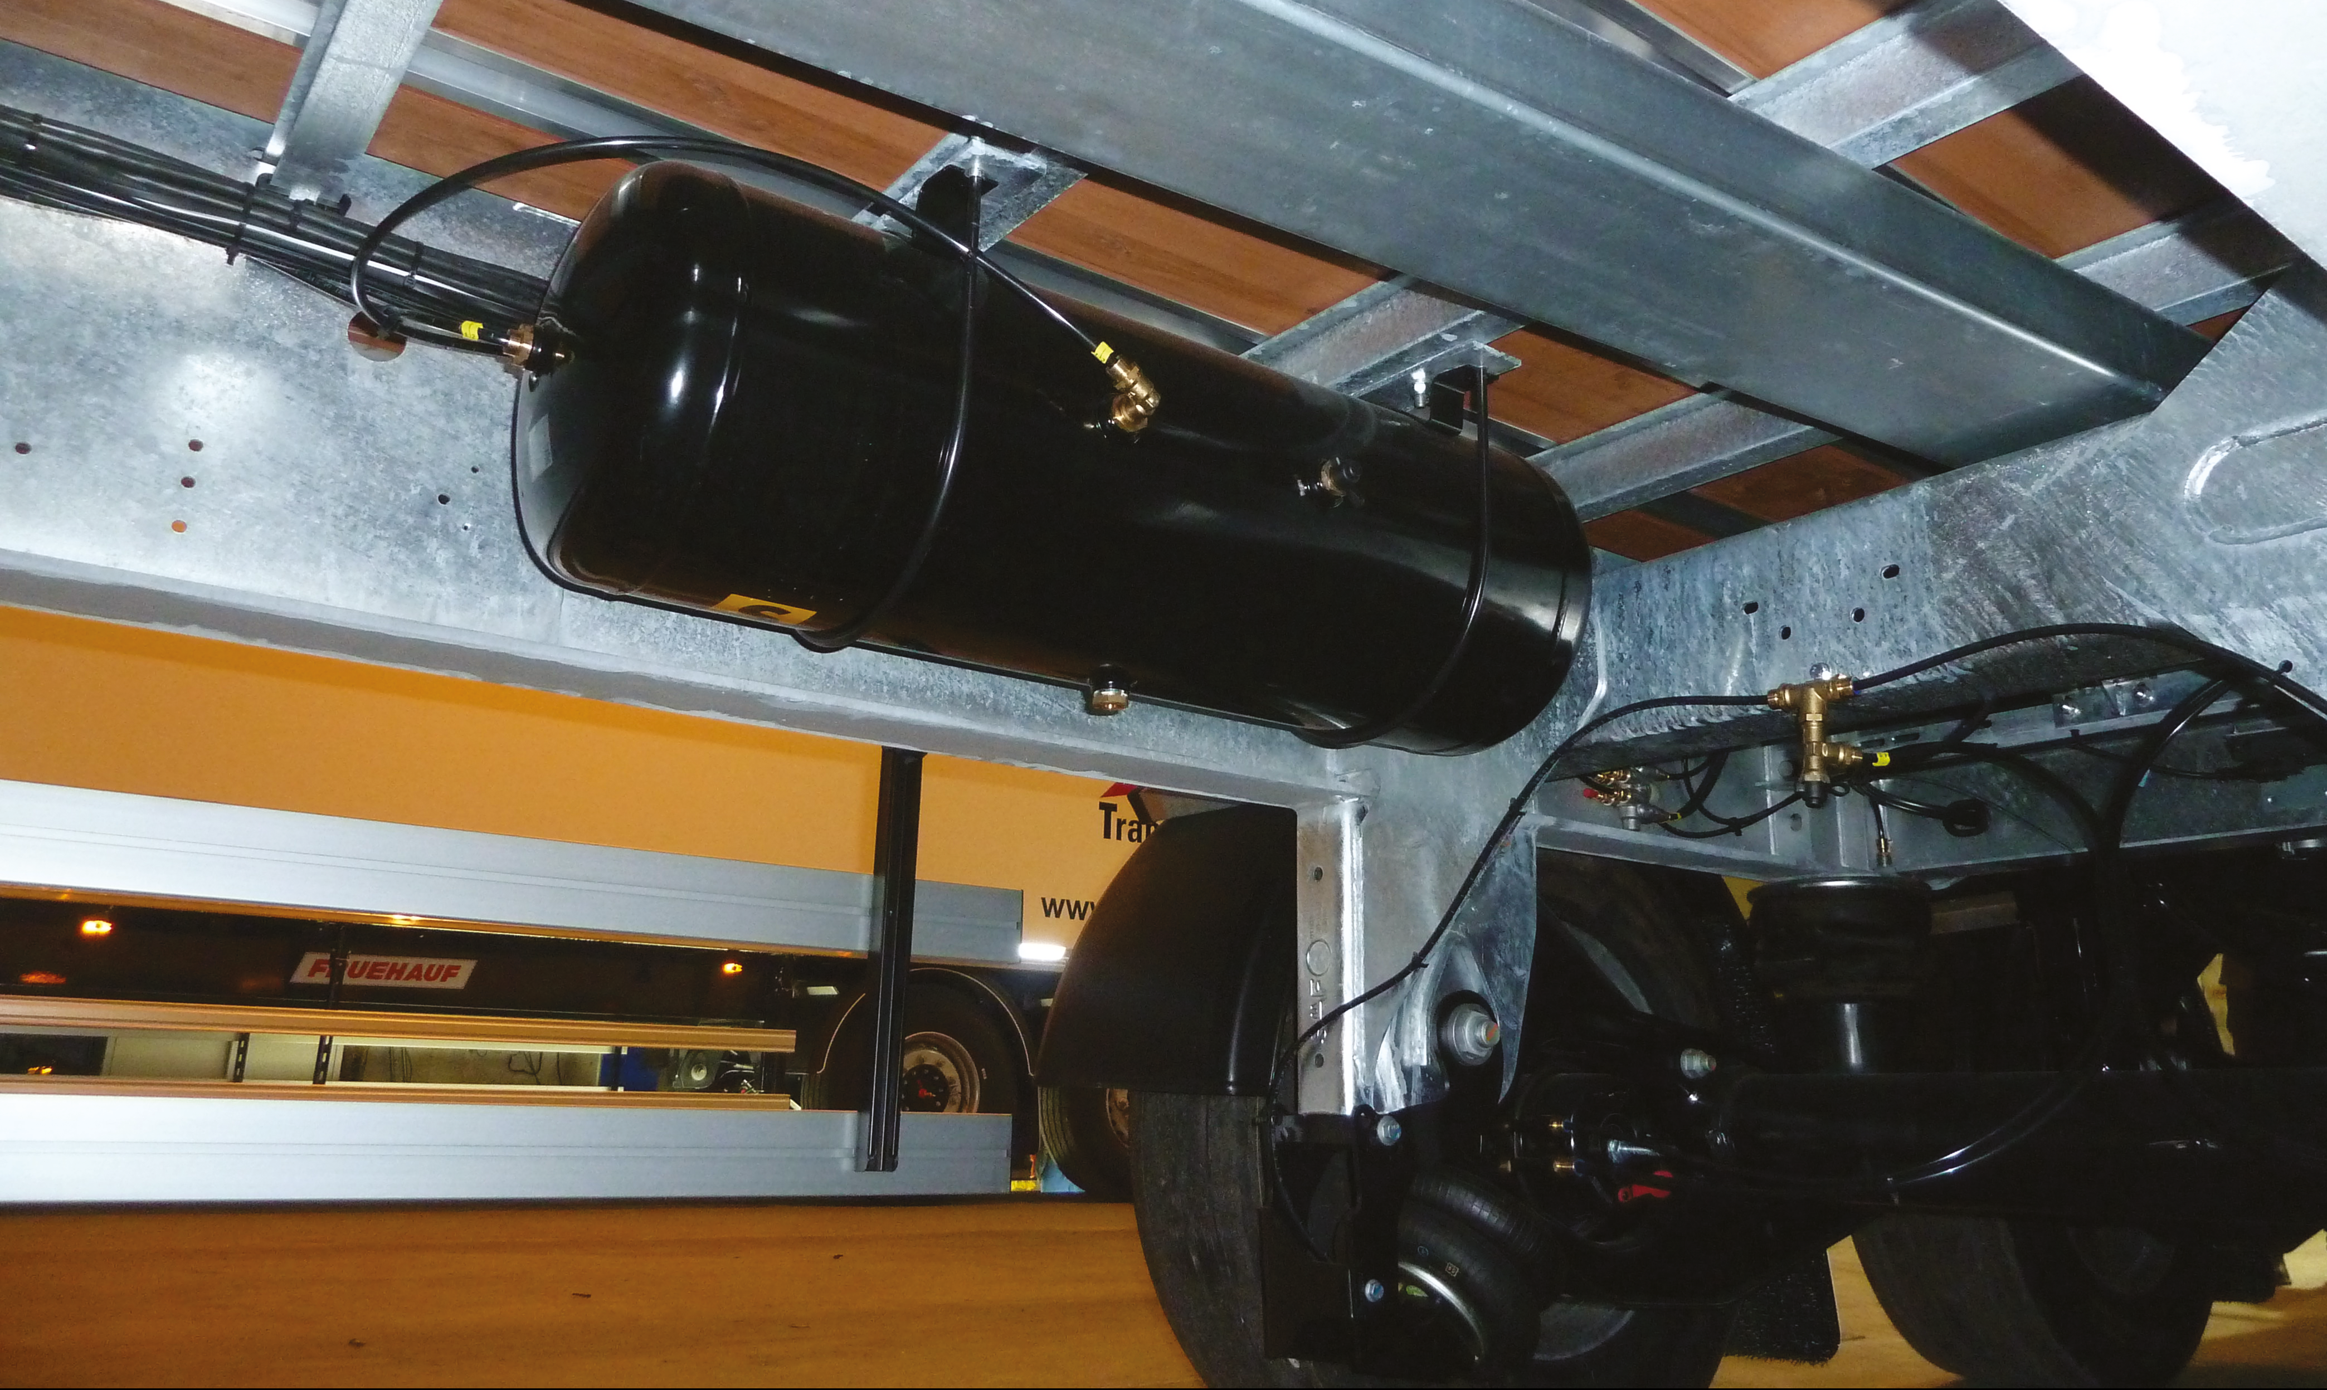
Gallery

RELIABILITY – Additional air tank
Fourgons - Innovations, Innovations - Easy UP
PIEK certification (option)Guillaume Calviac2021-02-26T09:53:19+01:00
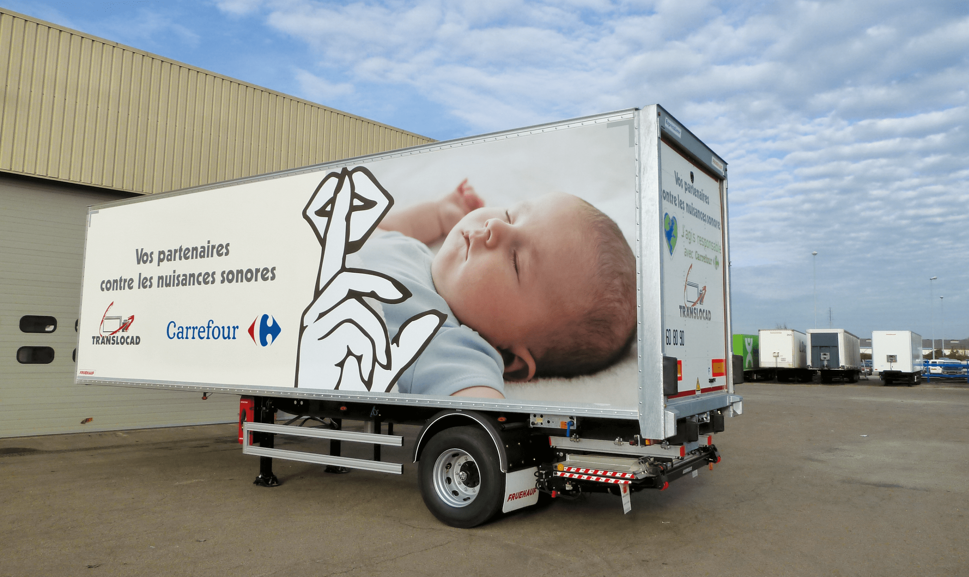
Gallery

PIEK certification (option)
Fourgons - Innovations, Innovations - Easy UP
EASY up®Guillaume Calviac2021-03-04T10:35:57+01:00
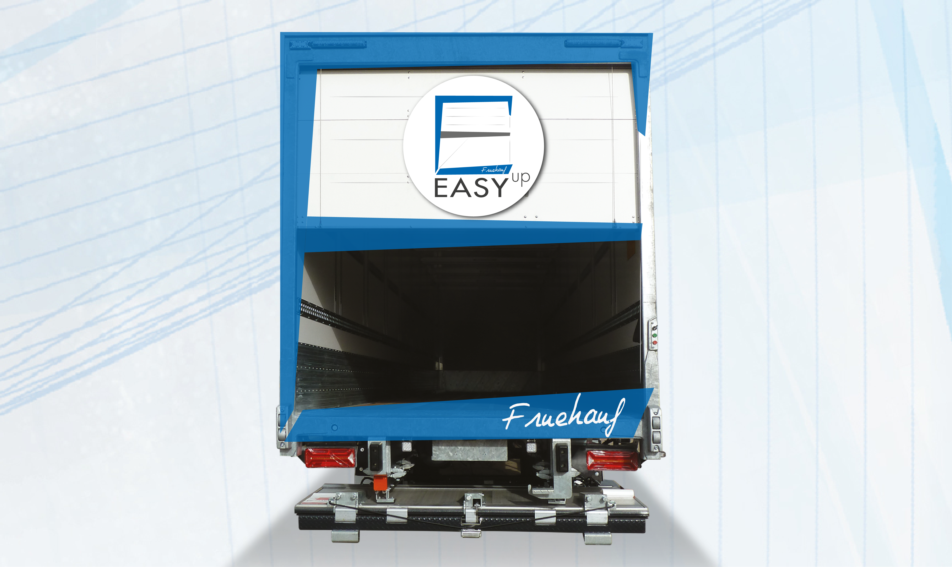
Gallery

EASY up®
City Innovations EN, Fourgons - Innovations, Innovations - Easy UP
Documentation

RCP®

Reverse Collision Protection

Active safety during reverse manoeuvres
This system automatically brakes the vehicle as soon as it detects an obstacle behind the vehicle and completely immobilises it, preventing collisions.
It actively protects the rear ends of vehicles and docks.
- Equipment security
- Safety of personnel
- Reduced maintenance costs
RCPGuillaume Calviac2021-01-28T15:24:12+01:00
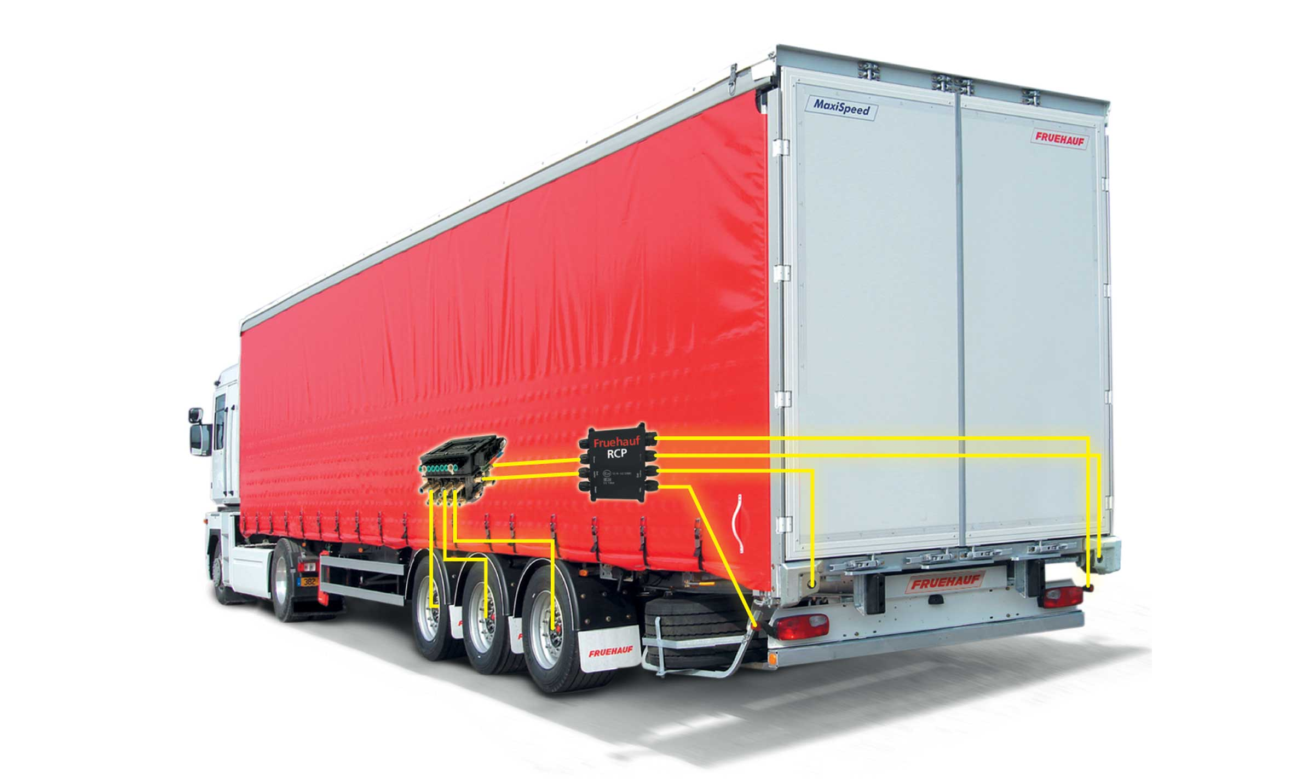
Gallery

RCP
Innovations - RCP
RCPGuillaume Calviac2021-01-28T15:23:52+01:00
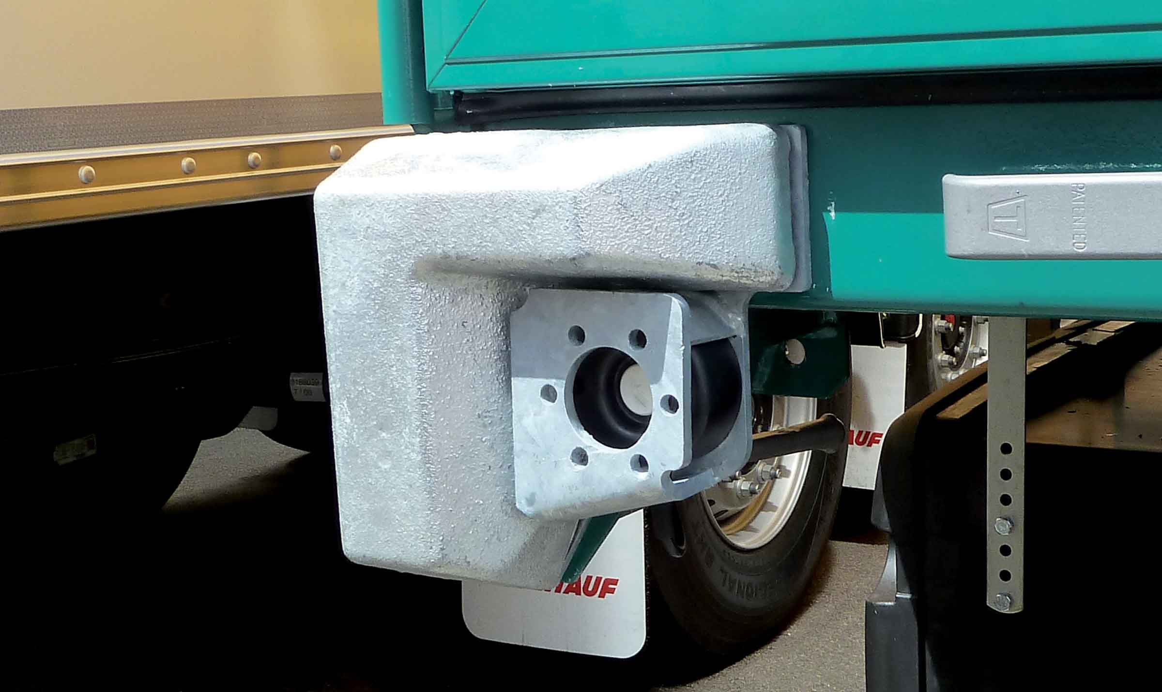
Gallery

RCP
Innovations - RCP
RCPGuillaume Calviac2021-01-28T15:22:49+01:00
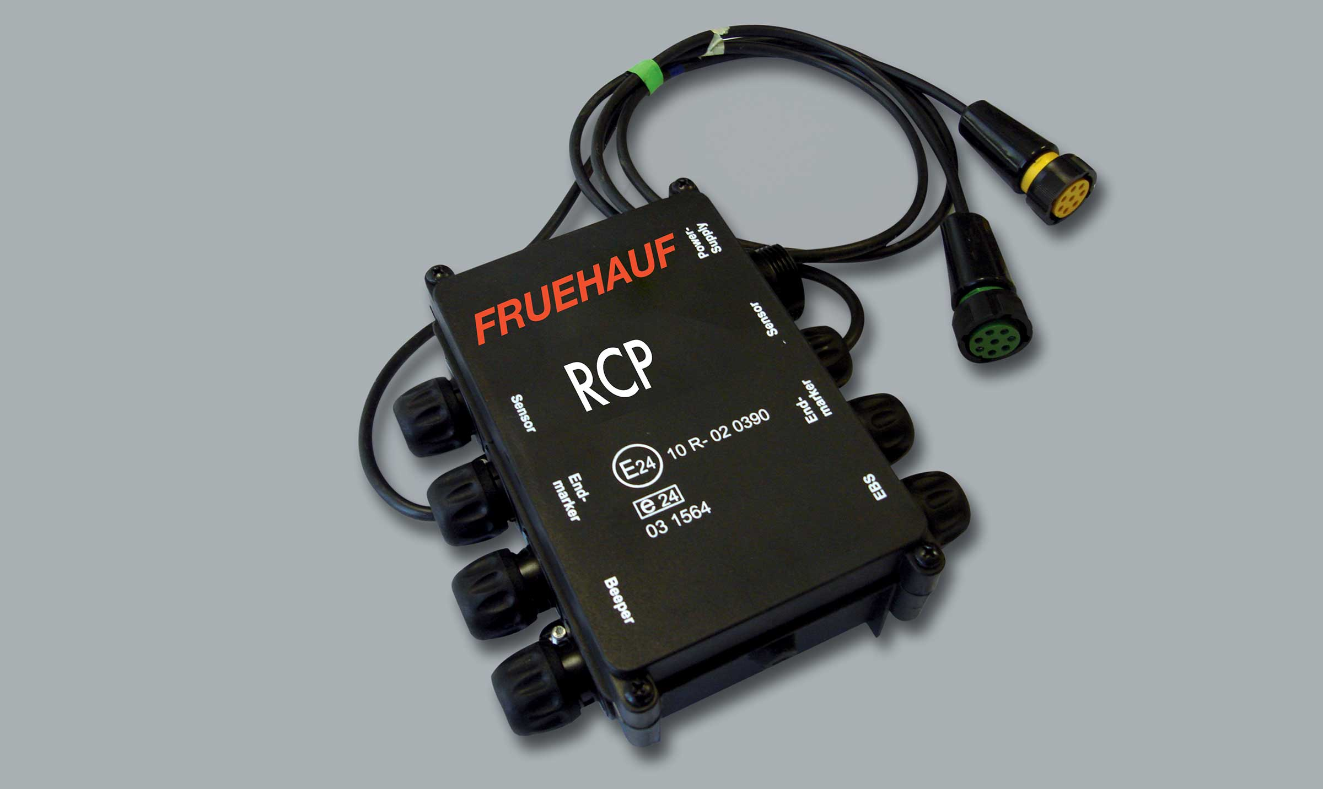
Gallery

RCP
Innovations - RCP
RCPGuillaume Calviac2021-01-28T15:22:15+01:00
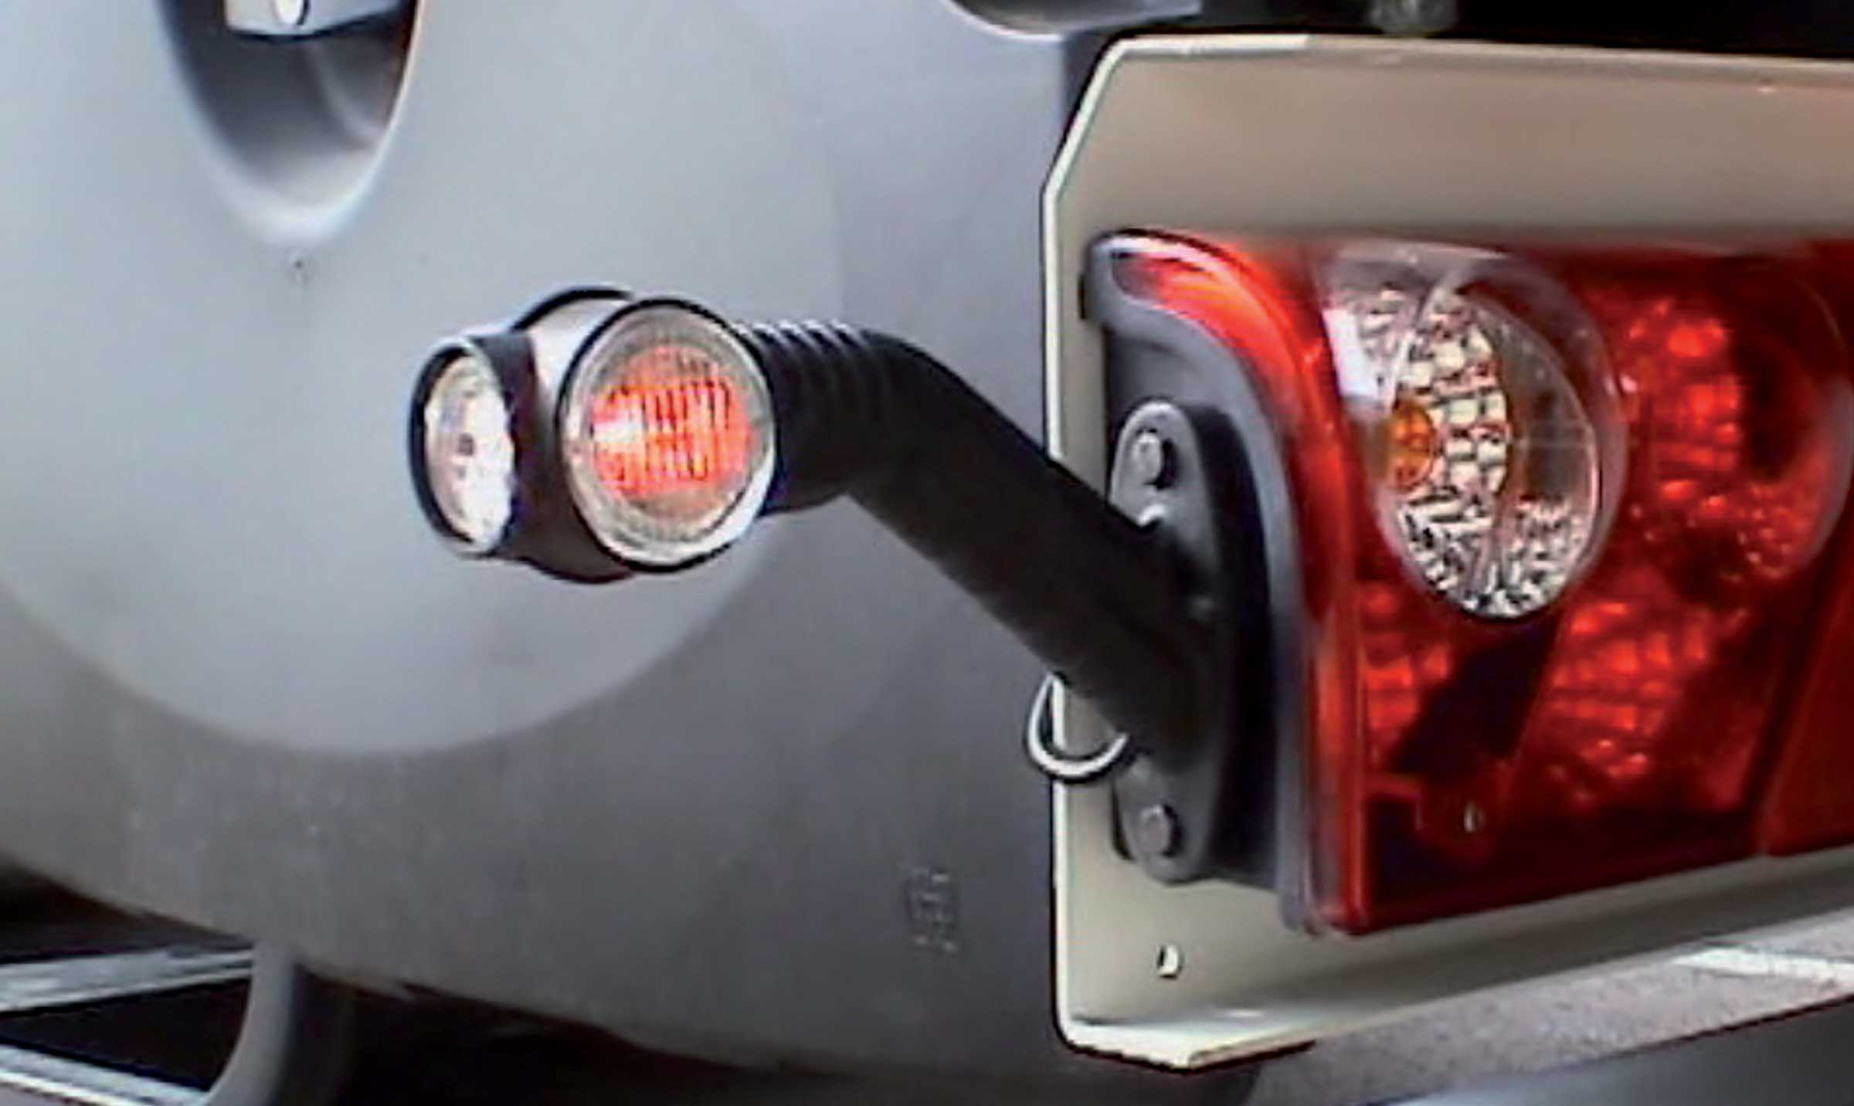
Gallery

RCP
Innovations - RCP
RCPGuillaume Calviac2021-01-15T11:33:18+01:00
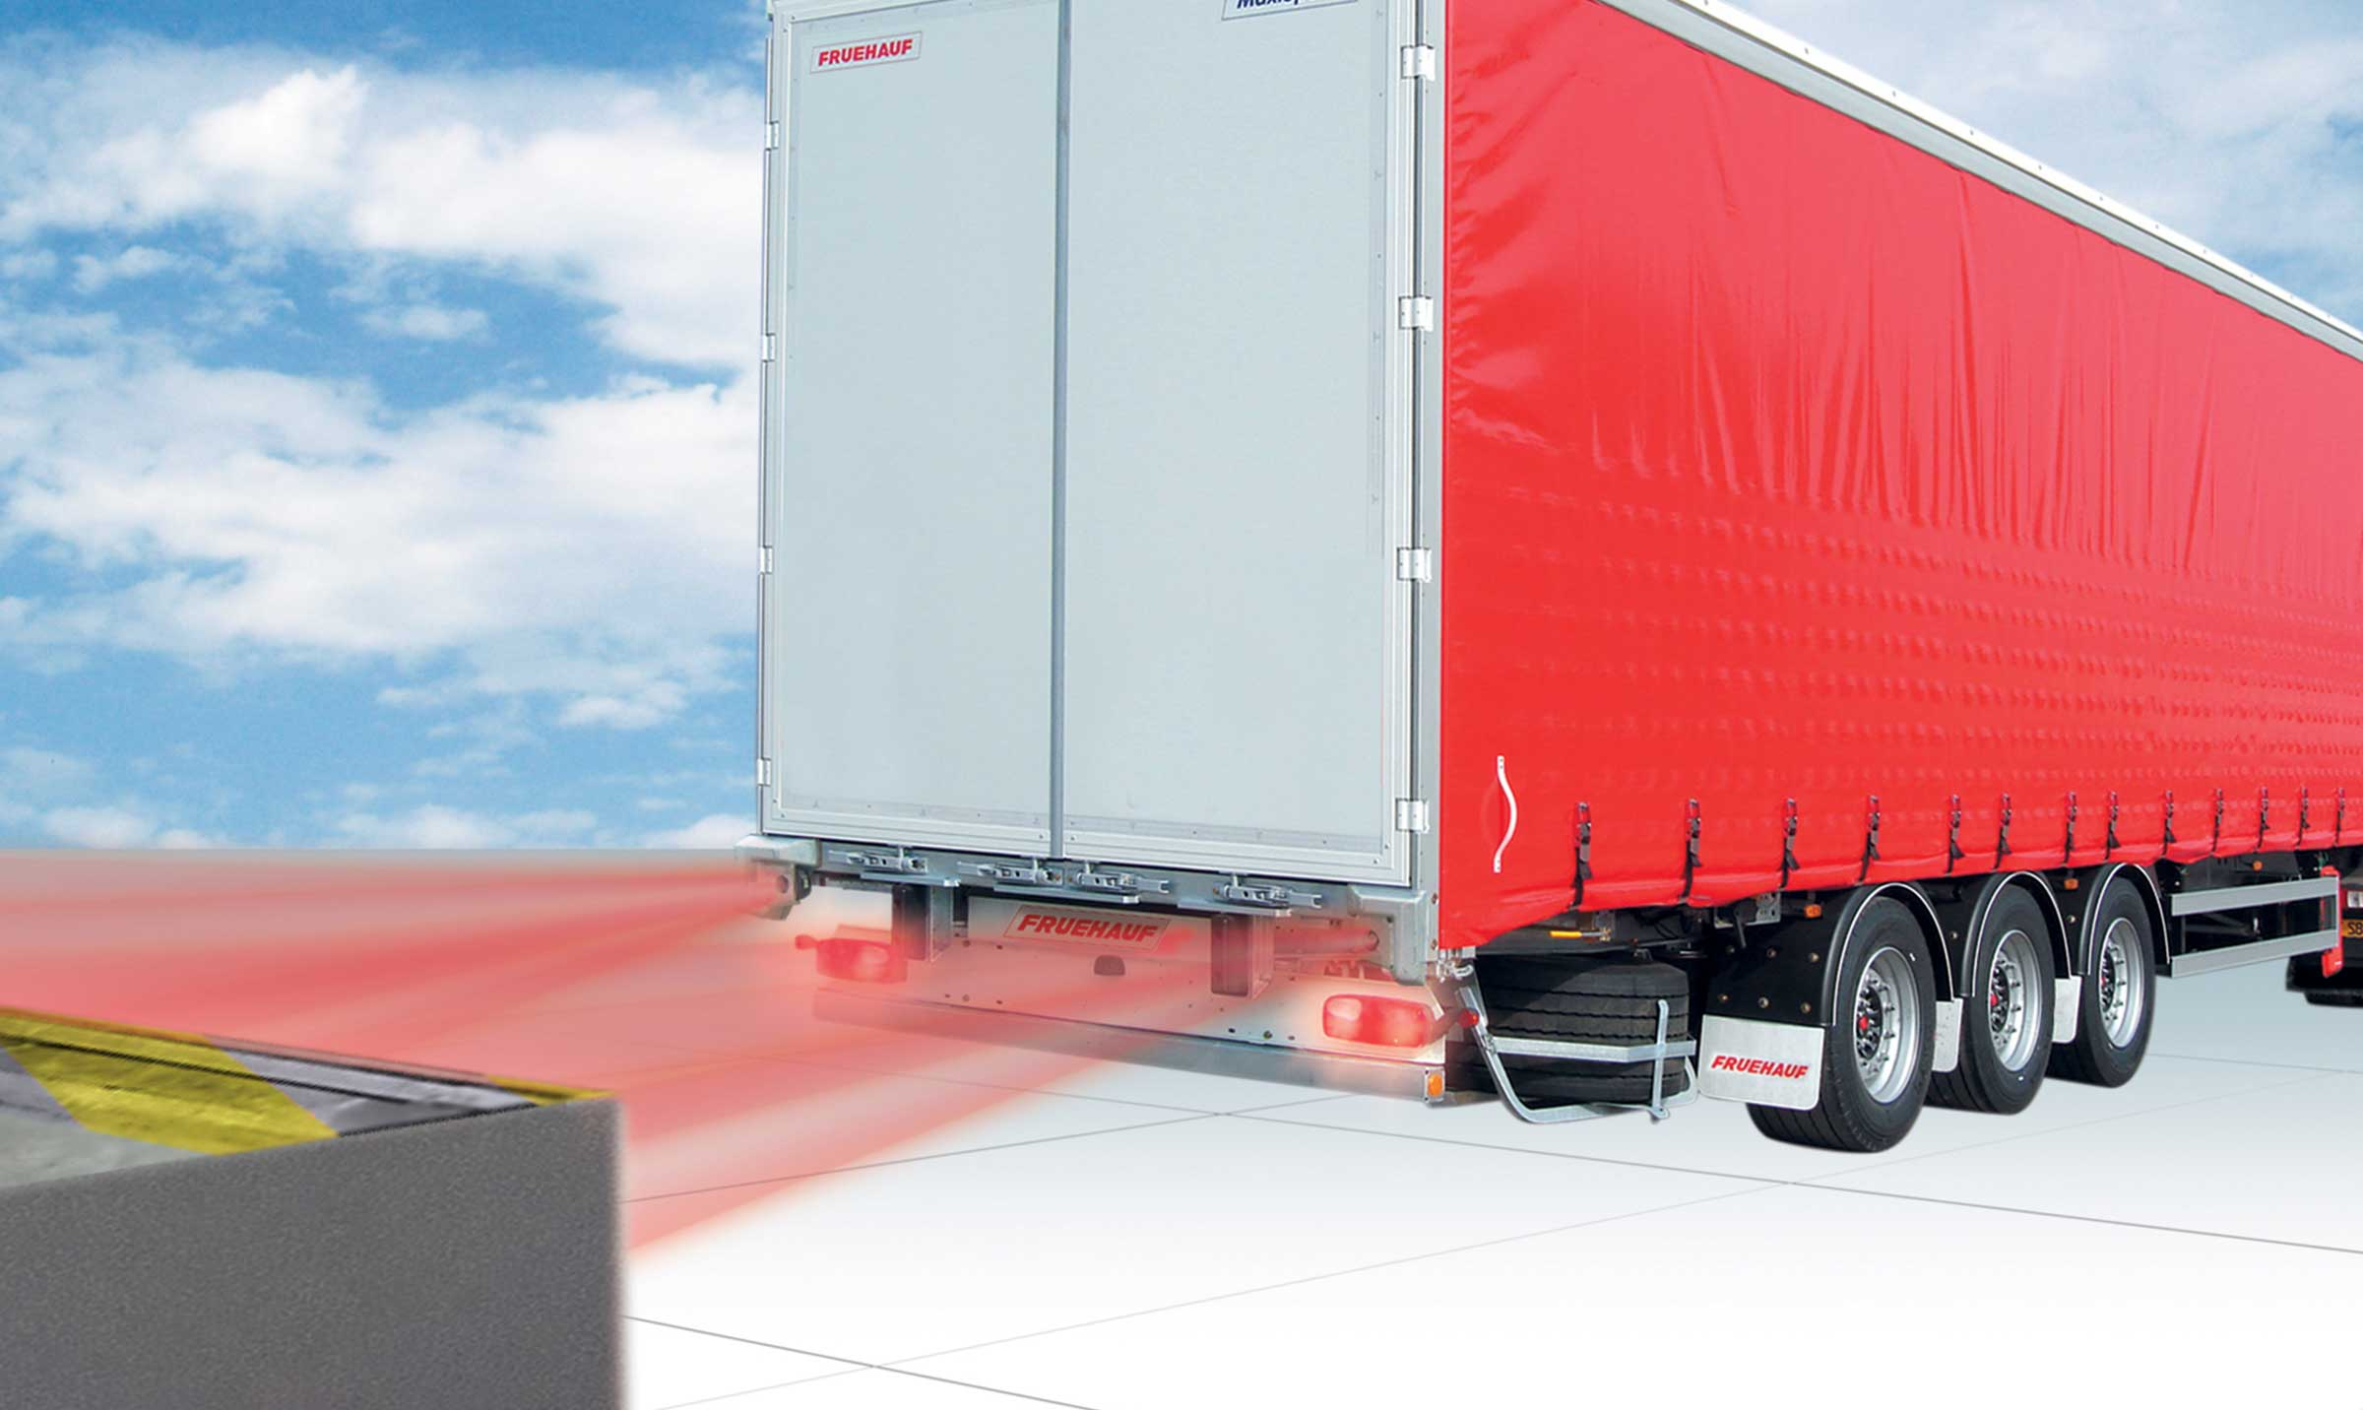
Gallery

RCP
Innovations - RCP, Innovations Base EN
Documentation
Demo Videos

SafeParking®

Automatic parking brake Automatic parking brake activation

Prevention of all brake release risks during coupling
SafeParking® is a safety device that automatically engages the parking brake on uncoupling.
It eliminates any risk of the vehicles moving during coupling.
- Safety of personnel
- Equipment security
SafeParkingGuillaume Calviac2021-01-28T15:33:00+01:00
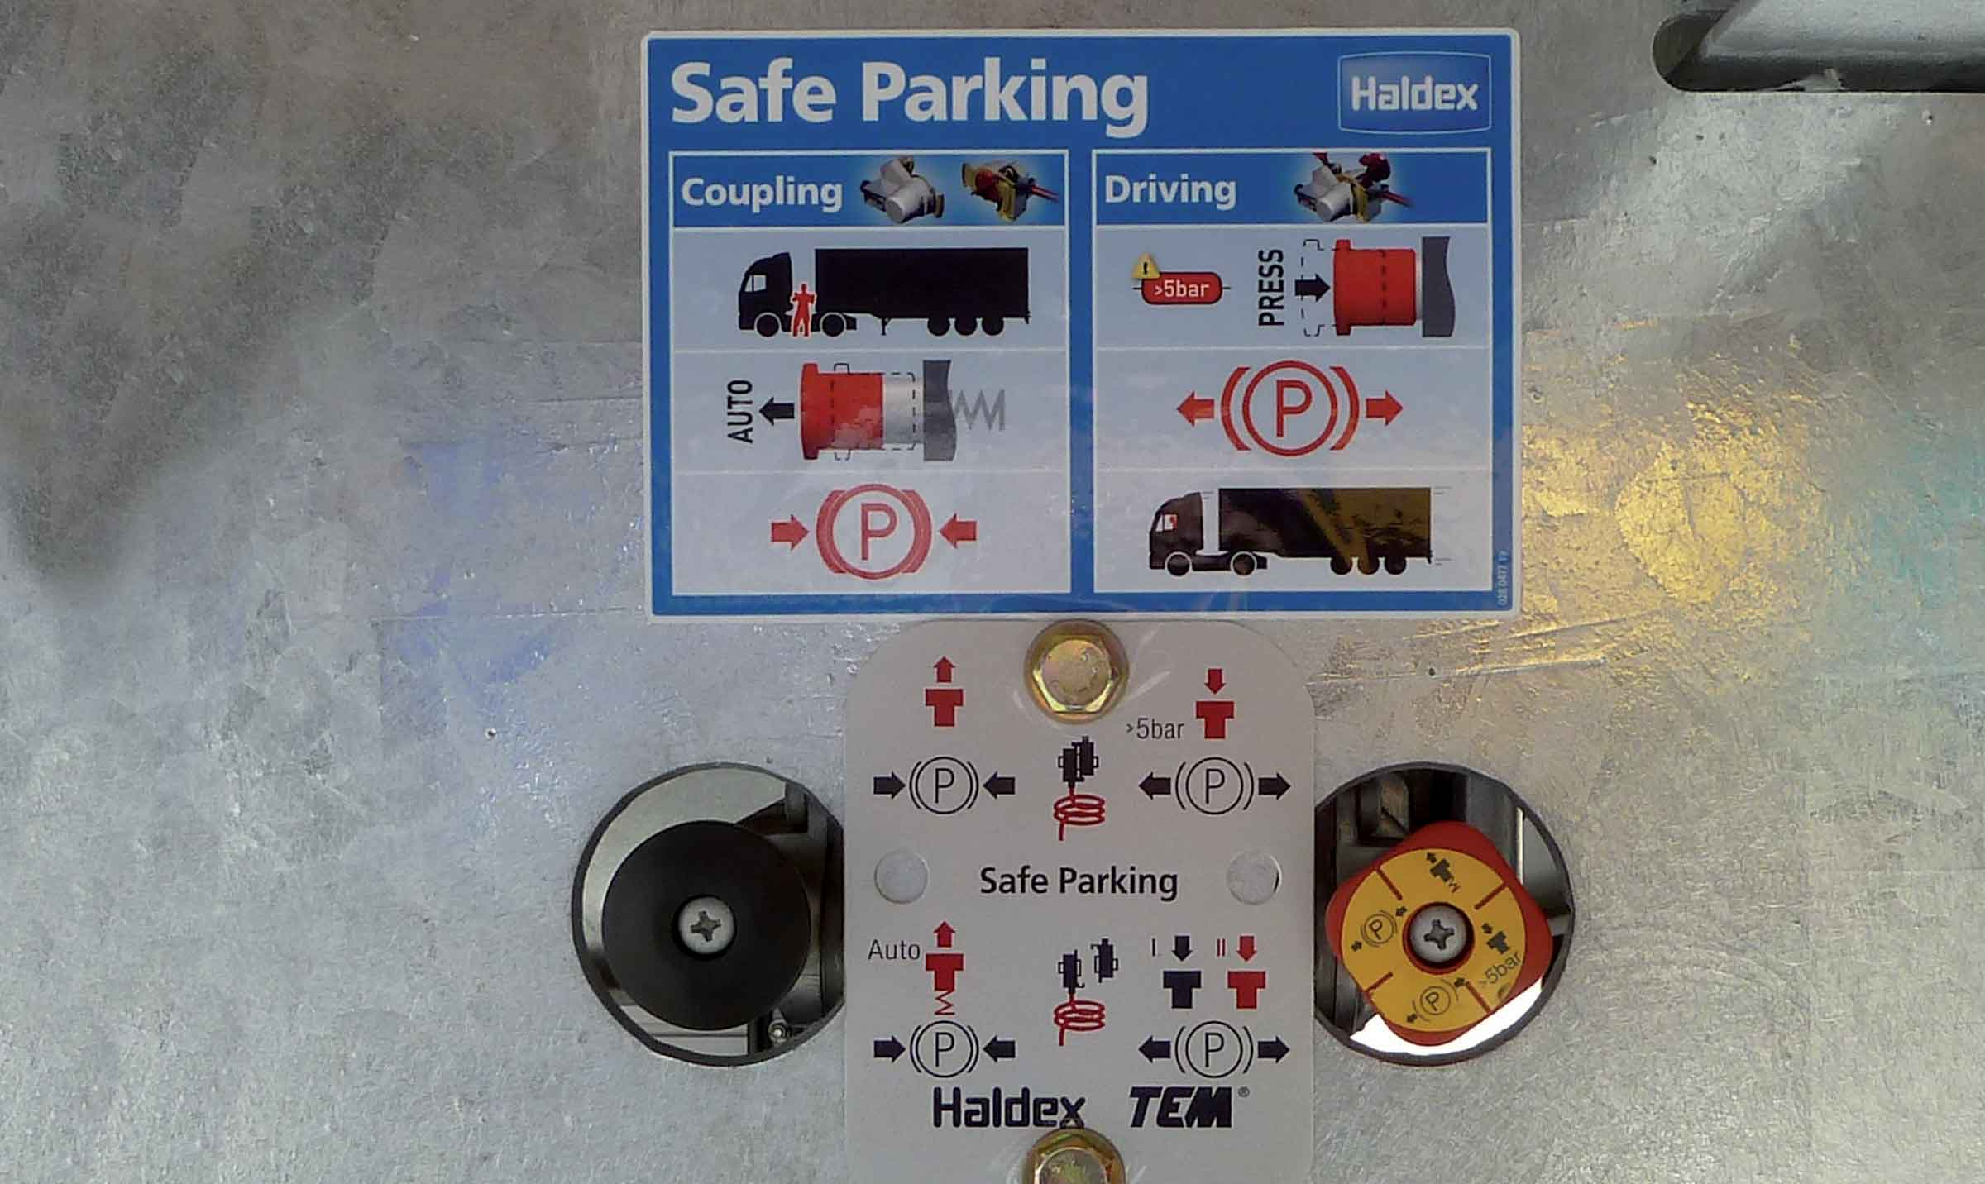
Gallery

SafeParking
Innovations - SafeParking
SafeParkingGuillaume Calviac2021-01-28T15:32:30+01:00
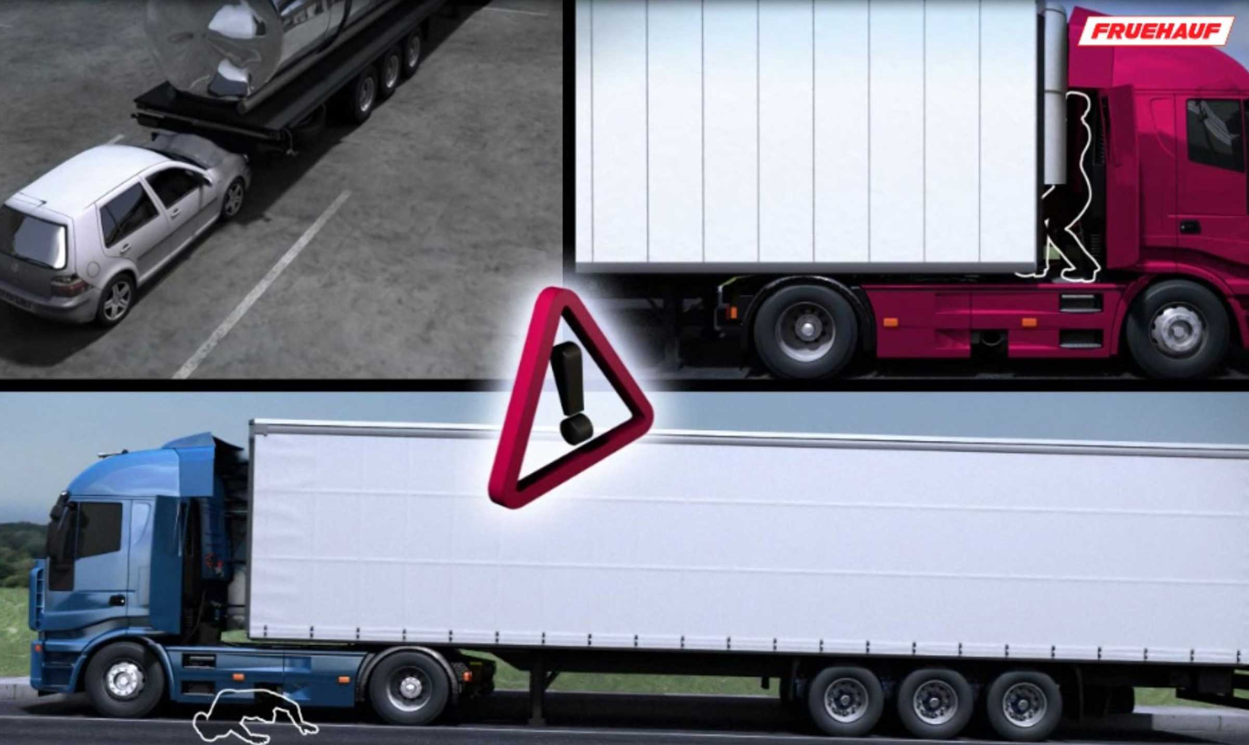
Gallery

SafeParking
Innovations - SafeParking
SafeParkingGuillaume Calviac2021-01-15T11:41:43+01:00
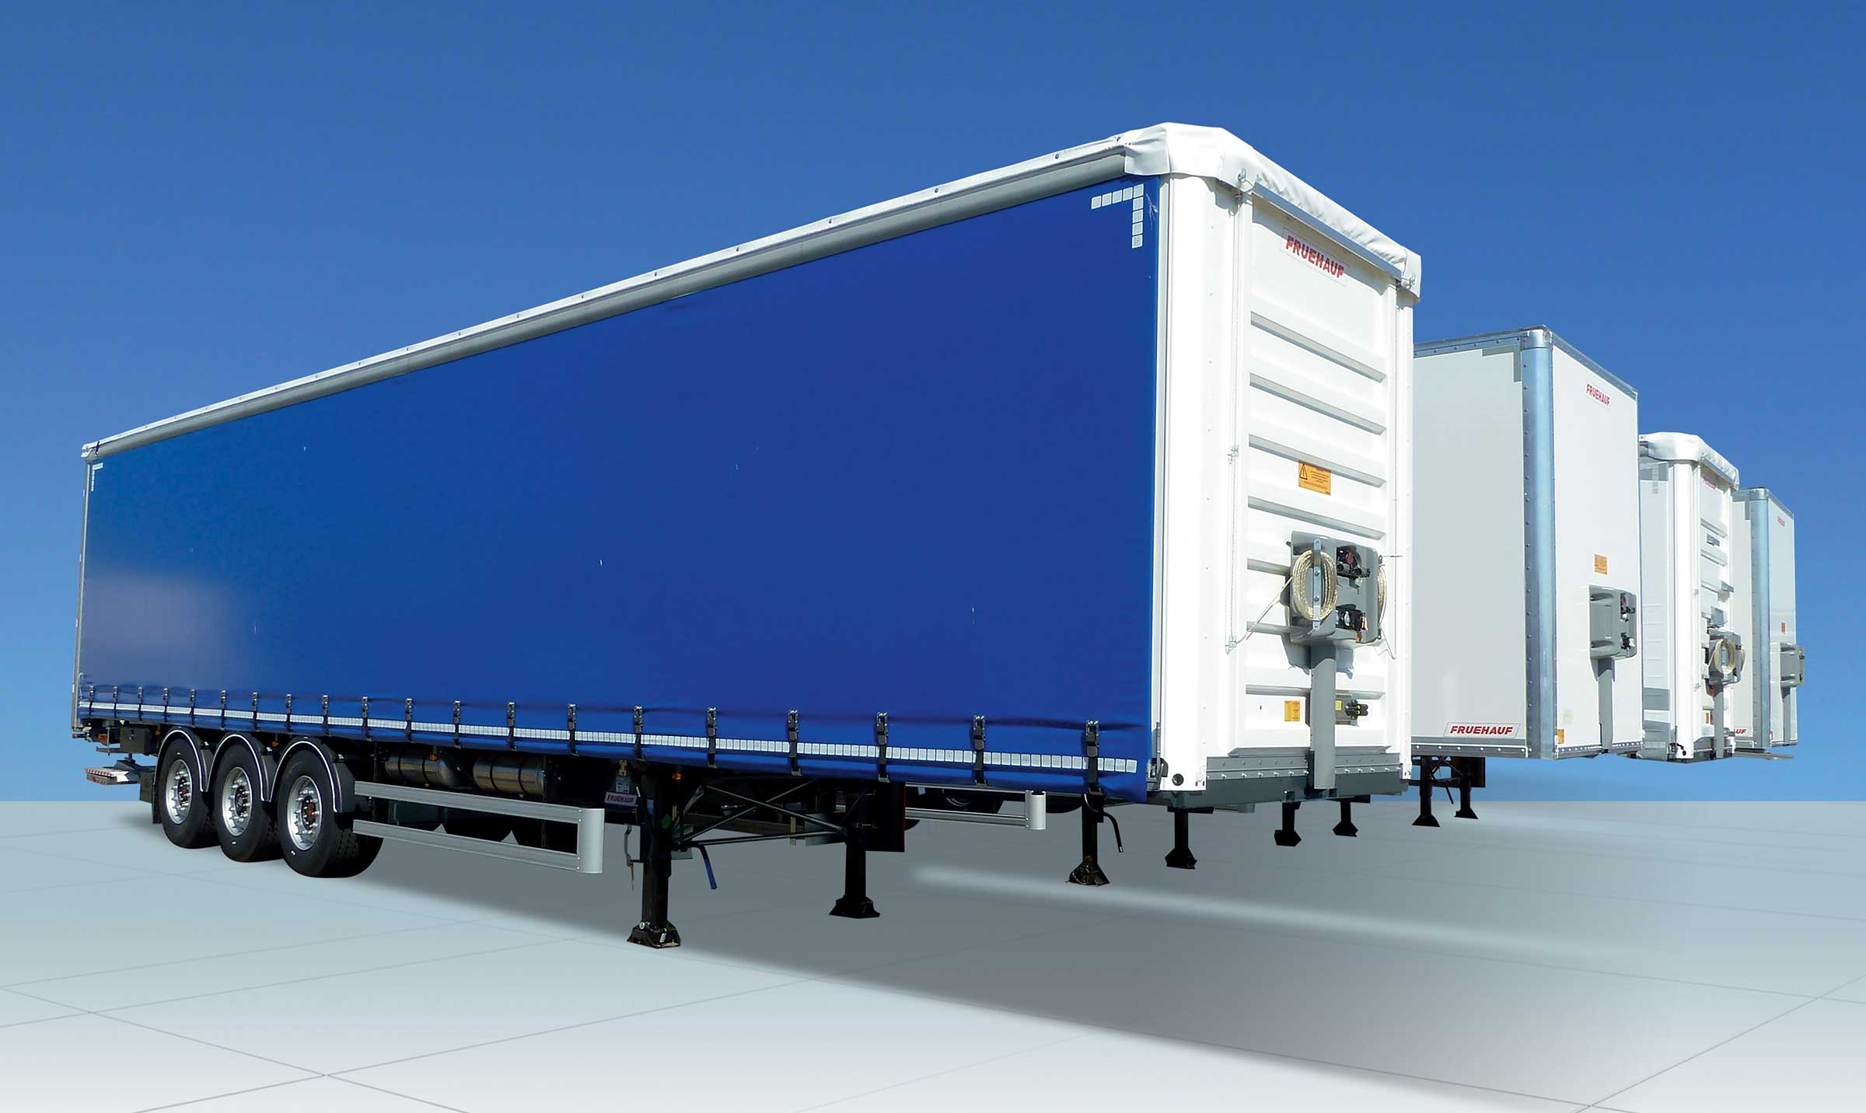
Gallery

SafeParking
Innovations - SafeParking, Innovations Base EN
Documentation
Demo Videos

M&B Inside®

Monte & Baisse (Raise & Lower command) Inside Interior docking control

Safety and easy in the adjustment to dock height
The M&B Inside® is used to easily adjust and keep the semitrailer at dock level at all times.
A special control on the rear pillar controls the vehicle's air suspension. For safety, the suspension automatically returns to road position over 15 km/h.
- Safety of personnel
- Productivity
Internal control on rear pillarGuillaume Calviac2021-01-28T15:43:36+01:00
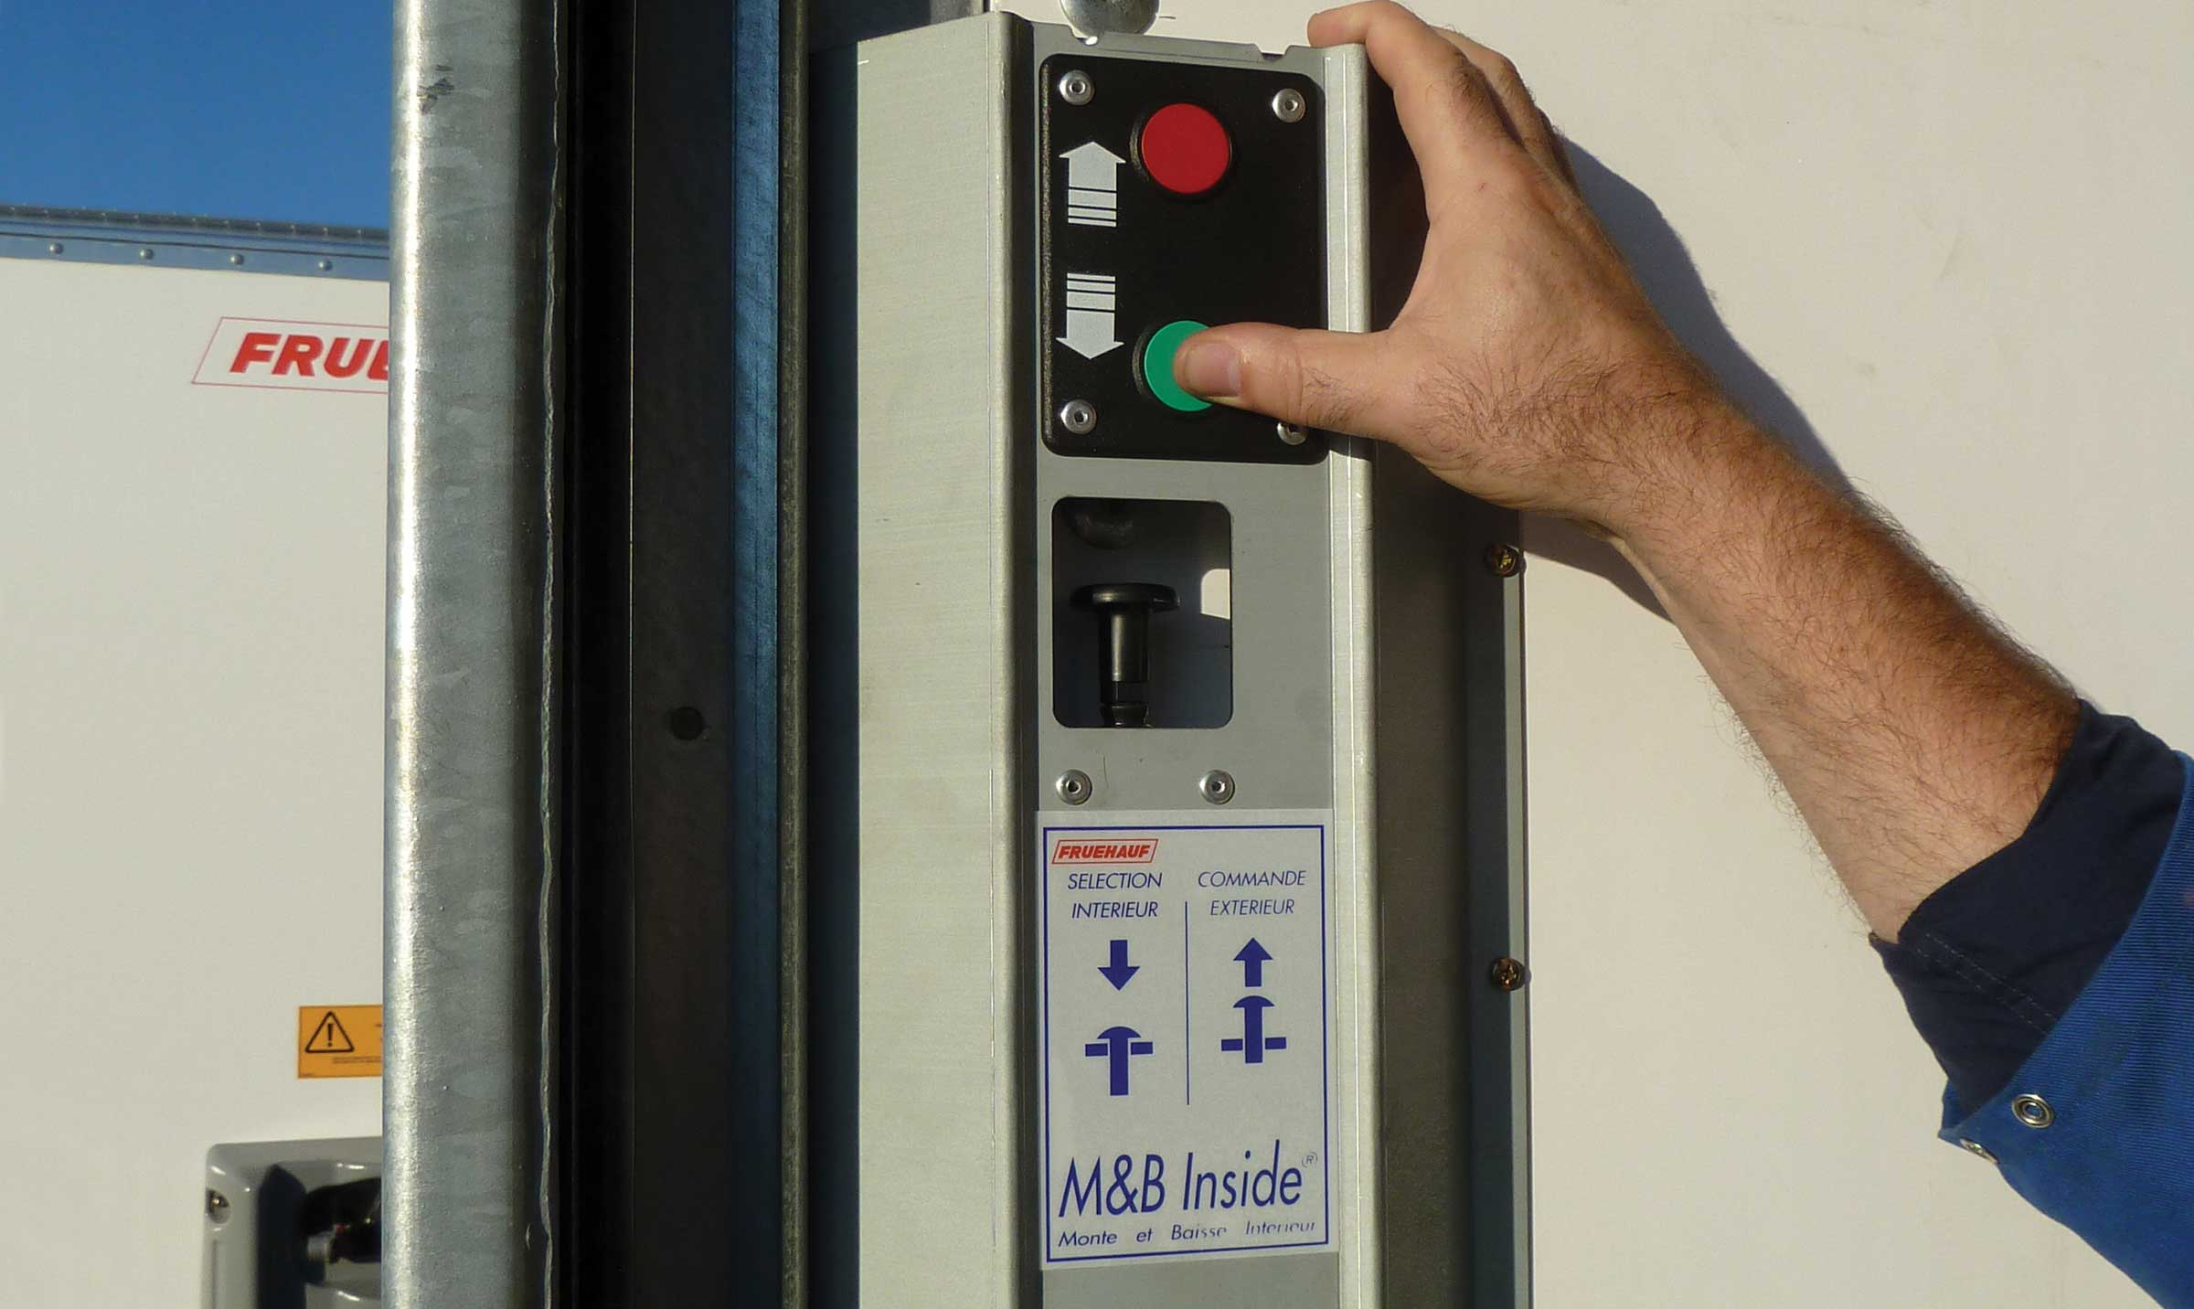
Gallery

Internal control on rear pillar
Innovations - M&B Inside
Raise & Lower command InsideGuillaume Calviac2021-02-09T08:53:58+01:00
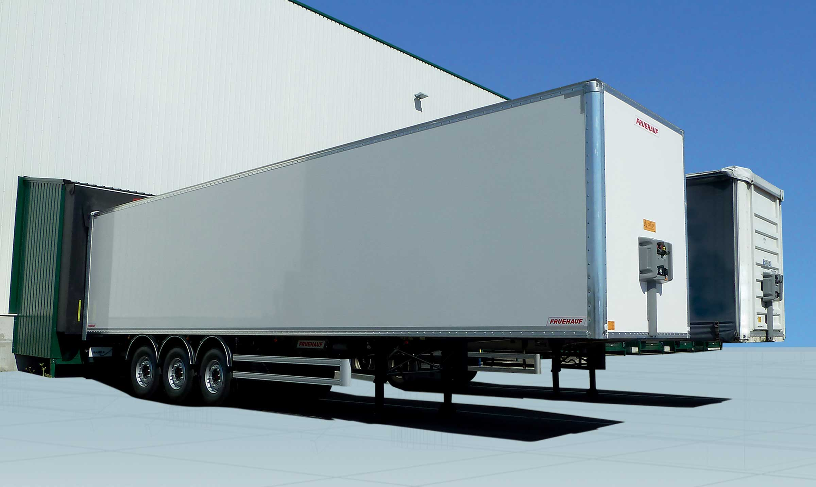
Gallery

Raise & Lower command Inside
ExpressLiner Innovations EN, Innovations - M&B Inside
Documentation
Demo Videos

Automatic Centralised Lubrication

Secure automatic lubrication of the entire CITY steering axle
Fruehauf automatic Centralised Lubrication, specially developed for City vehicles, enables optimum lubrication of the coupling and the steering axle.
- Equipment security
- Reduced lubricant consumption
- Reduced downtime
8 lubricators on steering rear axleGuillaume Calviac2021-06-01T15:53:32+02:00
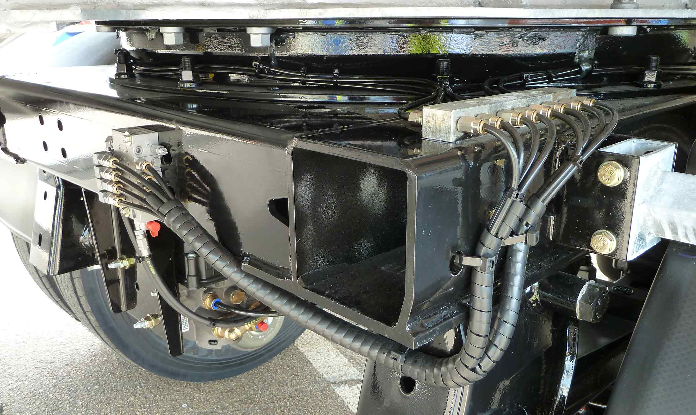
Gallery

8 lubricators on steering rear axle
Innovations - Graissage centralisé
4 lubricators on coupling plateGuillaume Calviac2021-06-01T15:53:53+02:00
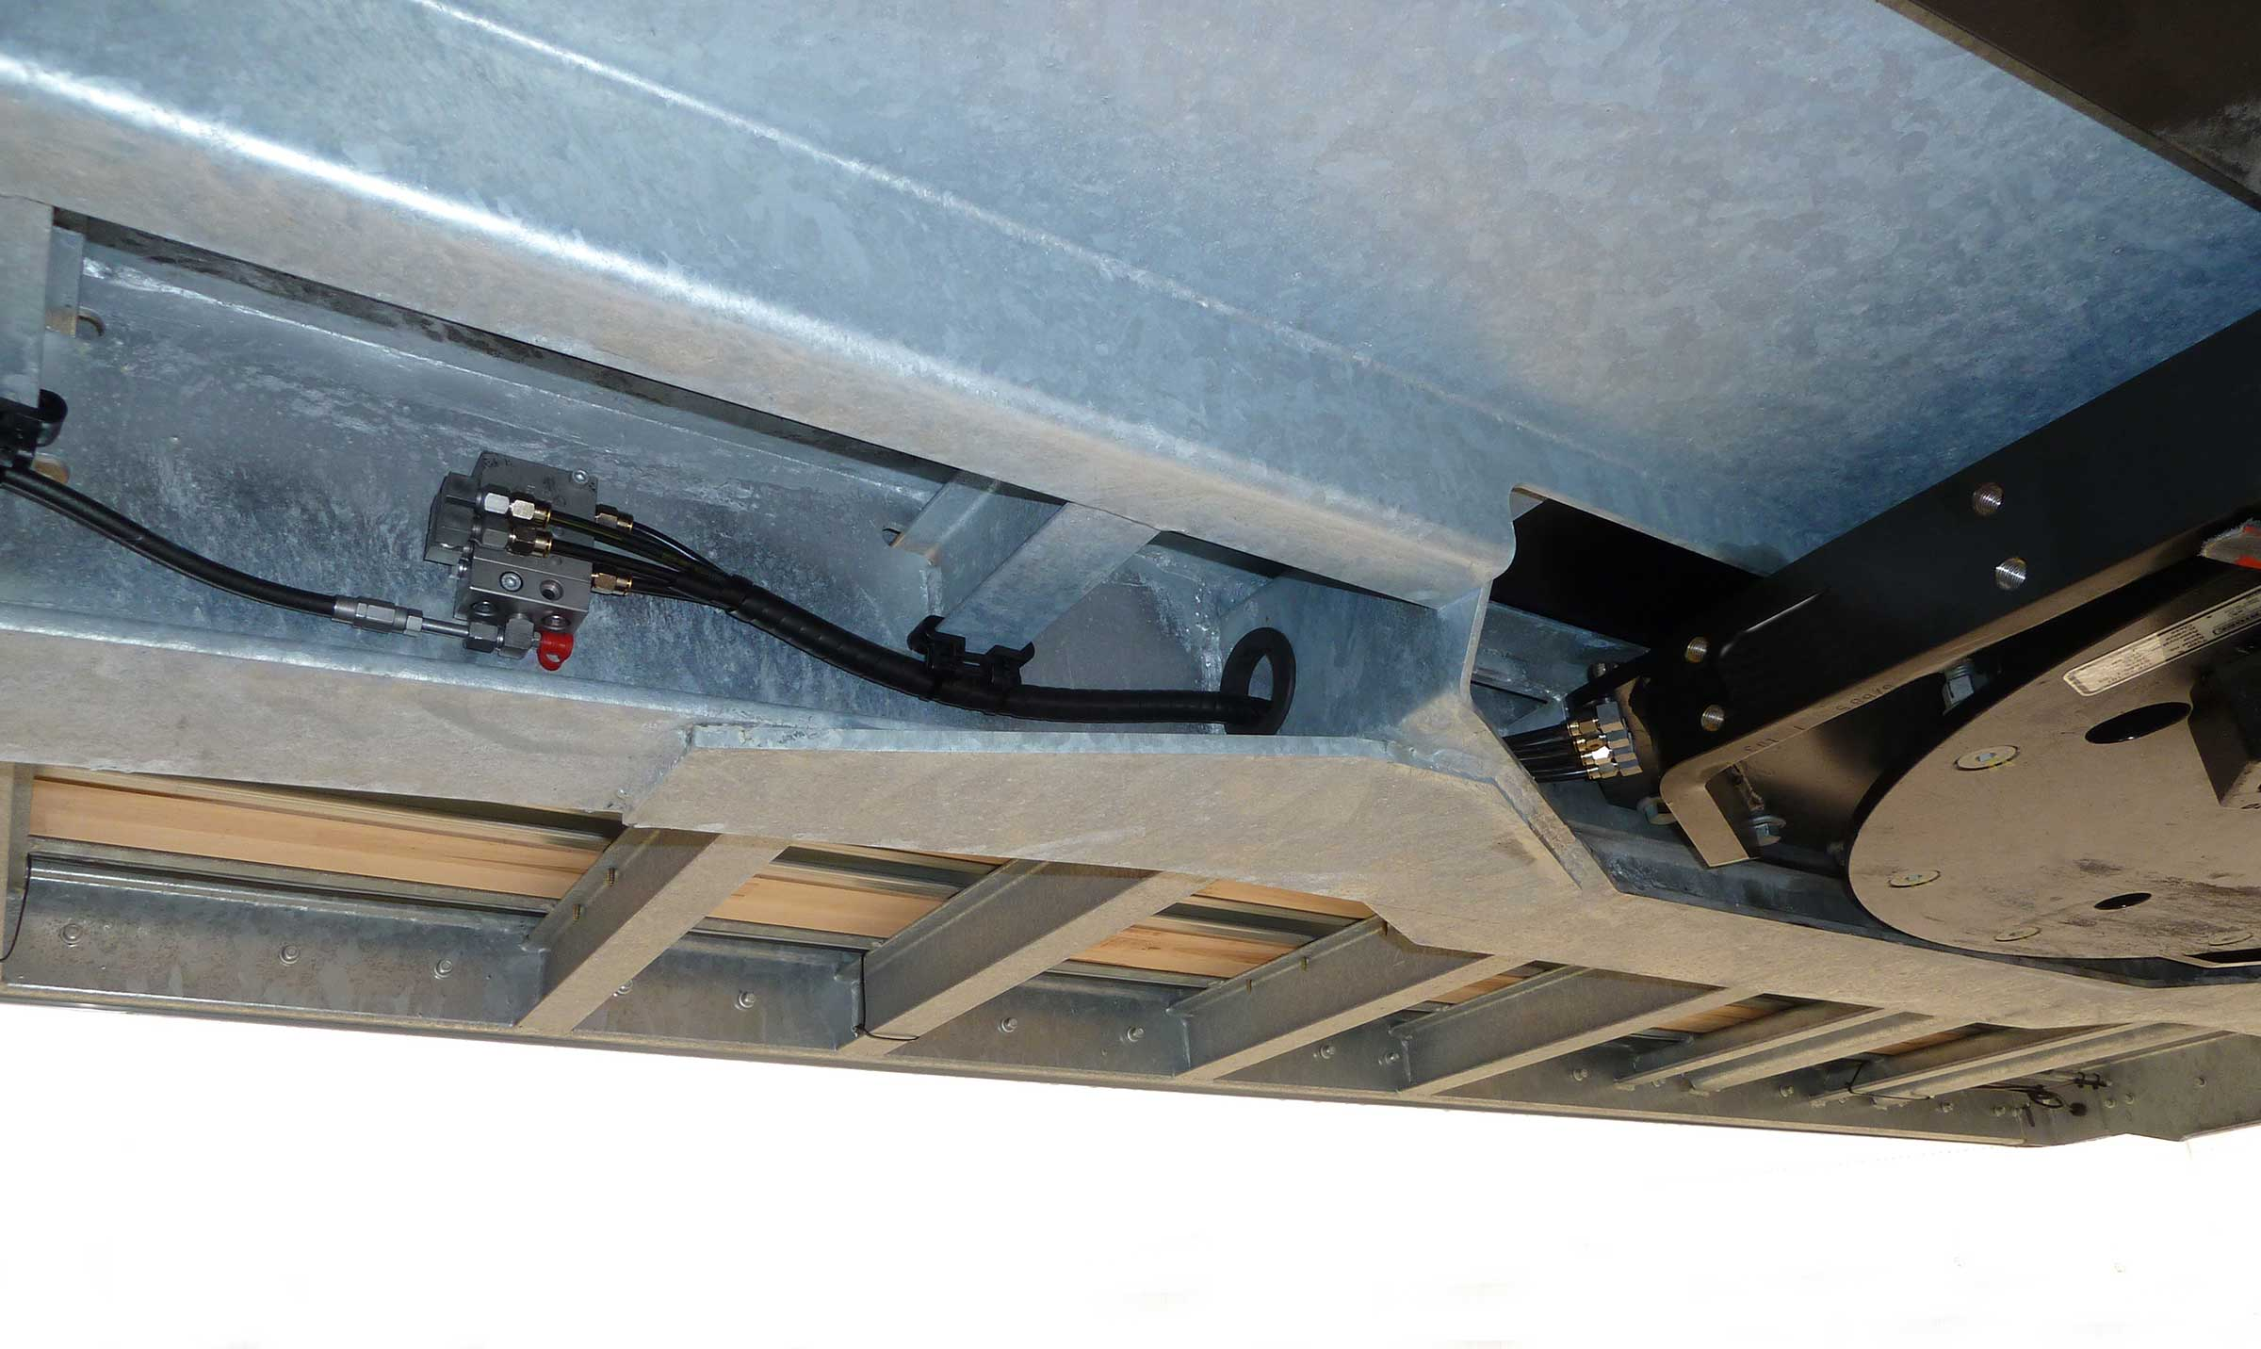
Gallery

4 lubricators on coupling plate
Innovations - Graissage centralisé
Rear steering axle on swivelling reinforced frameGuillaume Calviac2021-01-13T15:38:29+01:00
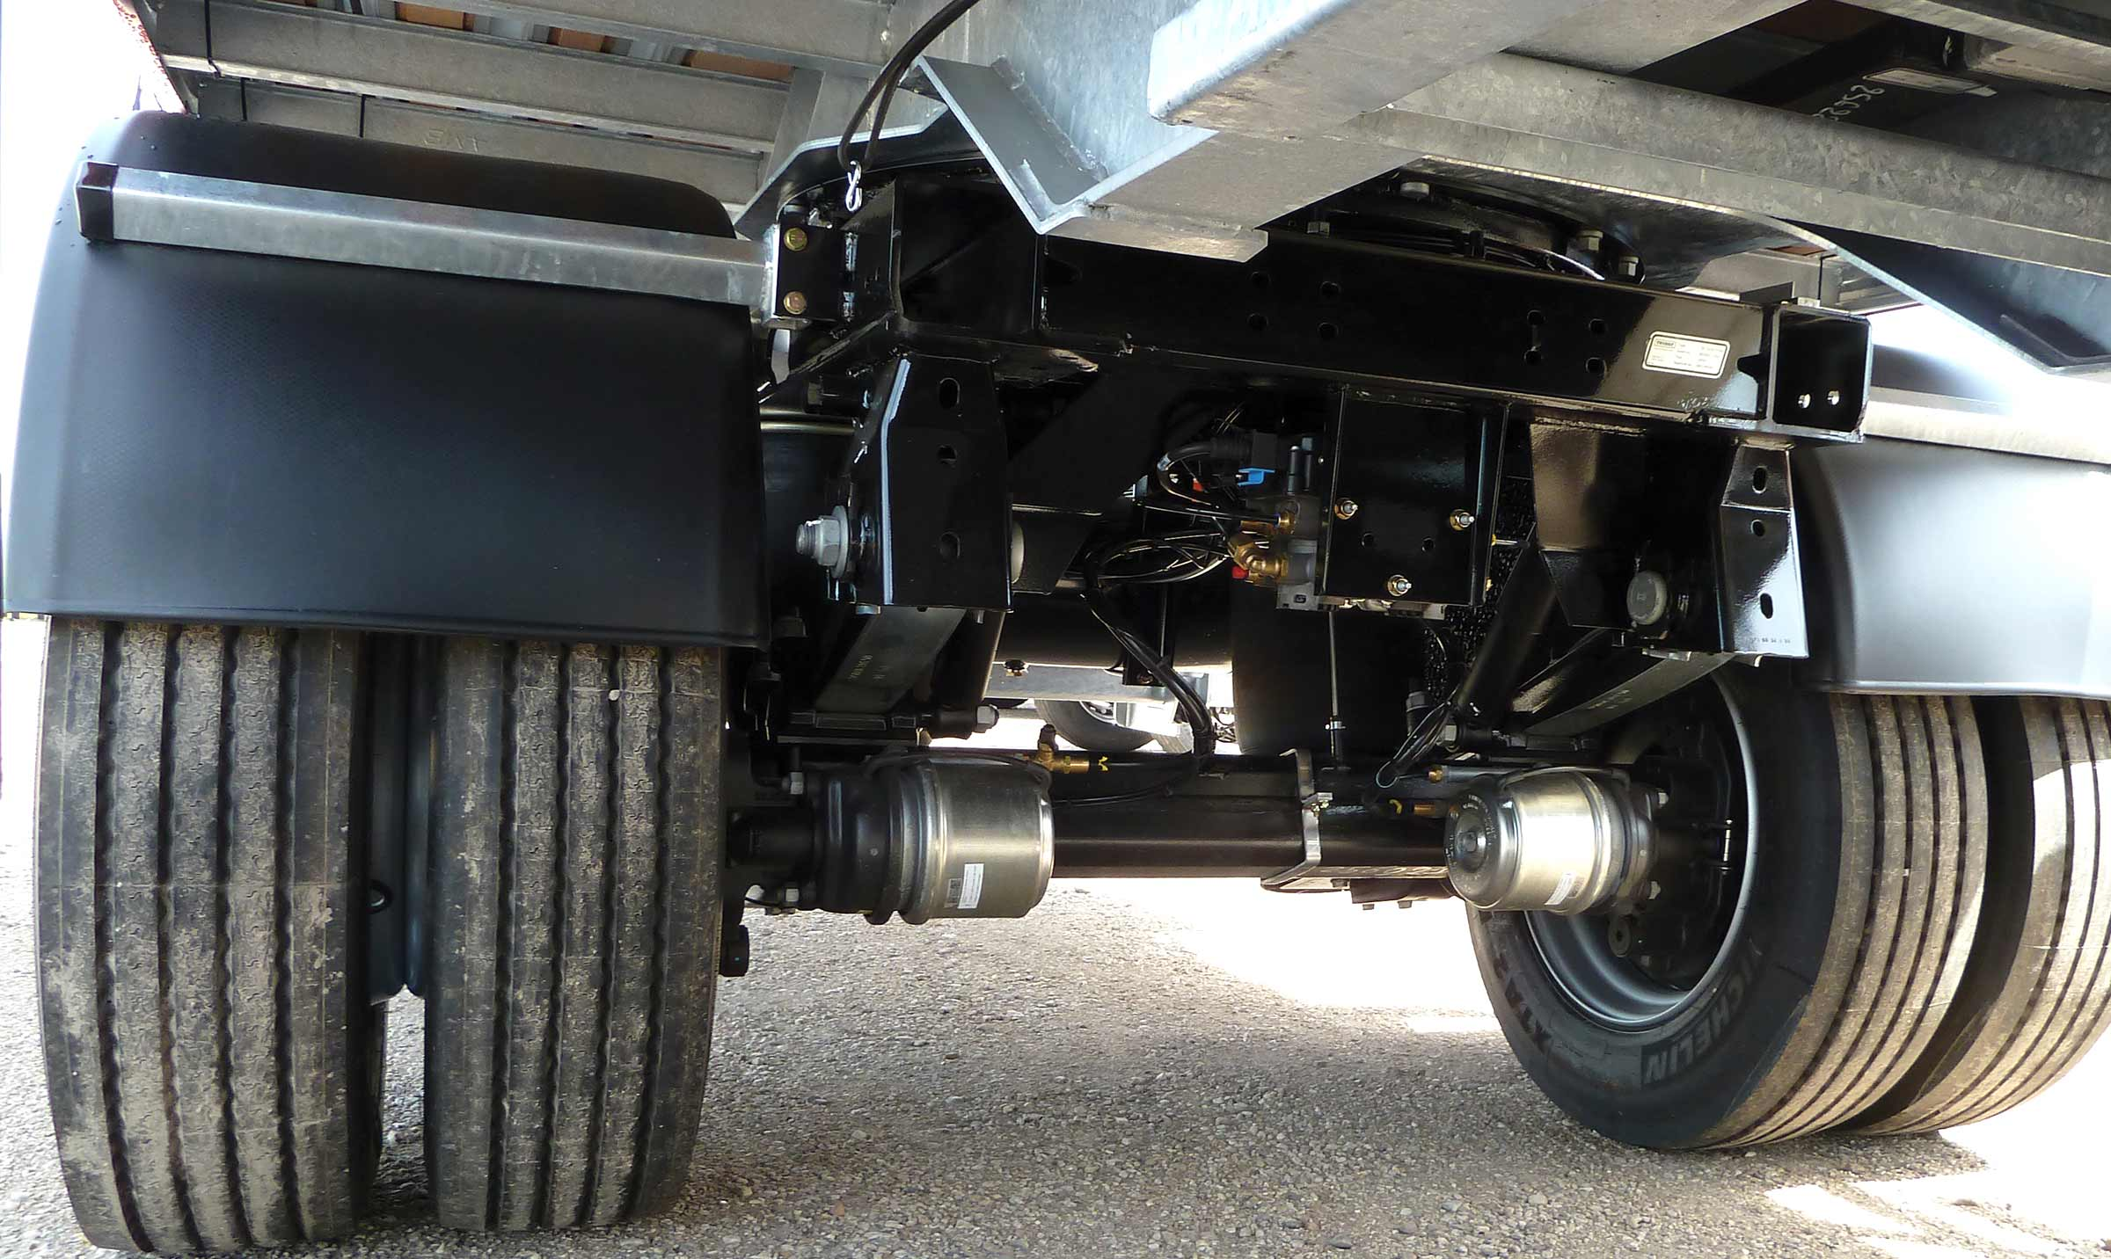
Gallery

Rear steering axle on swivelling reinforced frame
City - Urban - Rear steering axle, Innovations - Graissage centralisé
Automatic centralised lubricationGuillaume Calviac2021-02-12T12:09:09+01:00
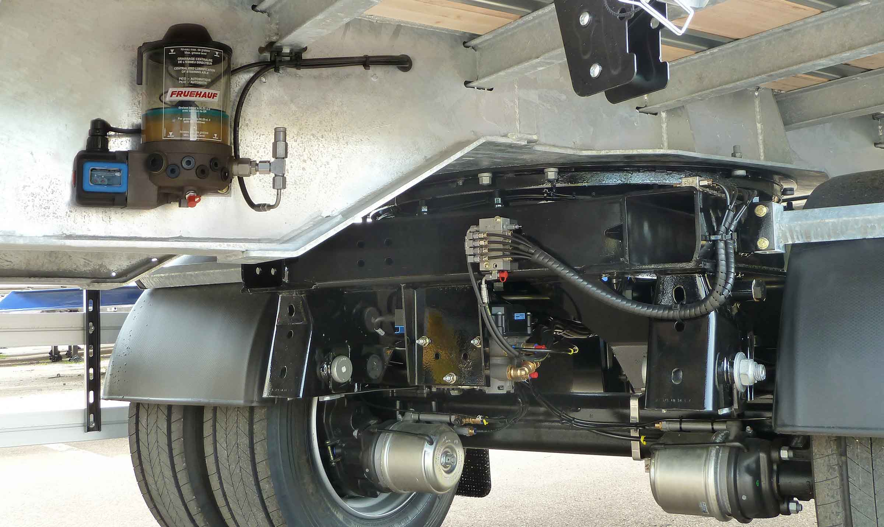
Gallery

Automatic centralised lubrication
Innovations - Graissage centralisé
Documentation

Tyre monitoring

APCS®

Automatic Pressure Control System

Optimal tyre pressure for more economy and safety
1.5 bar of underinflation means +2 L/100 km of fuel consumption, +30% tyre wear and 85% blowout causes.
The APCS® system automatically maintains the optimum tyre pressure using a booster that continuously controls and compensates for pressure drops.
- Safety of personnel
- Equipment security
- Reduced costs
APCSGuillaume Calviac2021-01-28T16:28:39+01:00
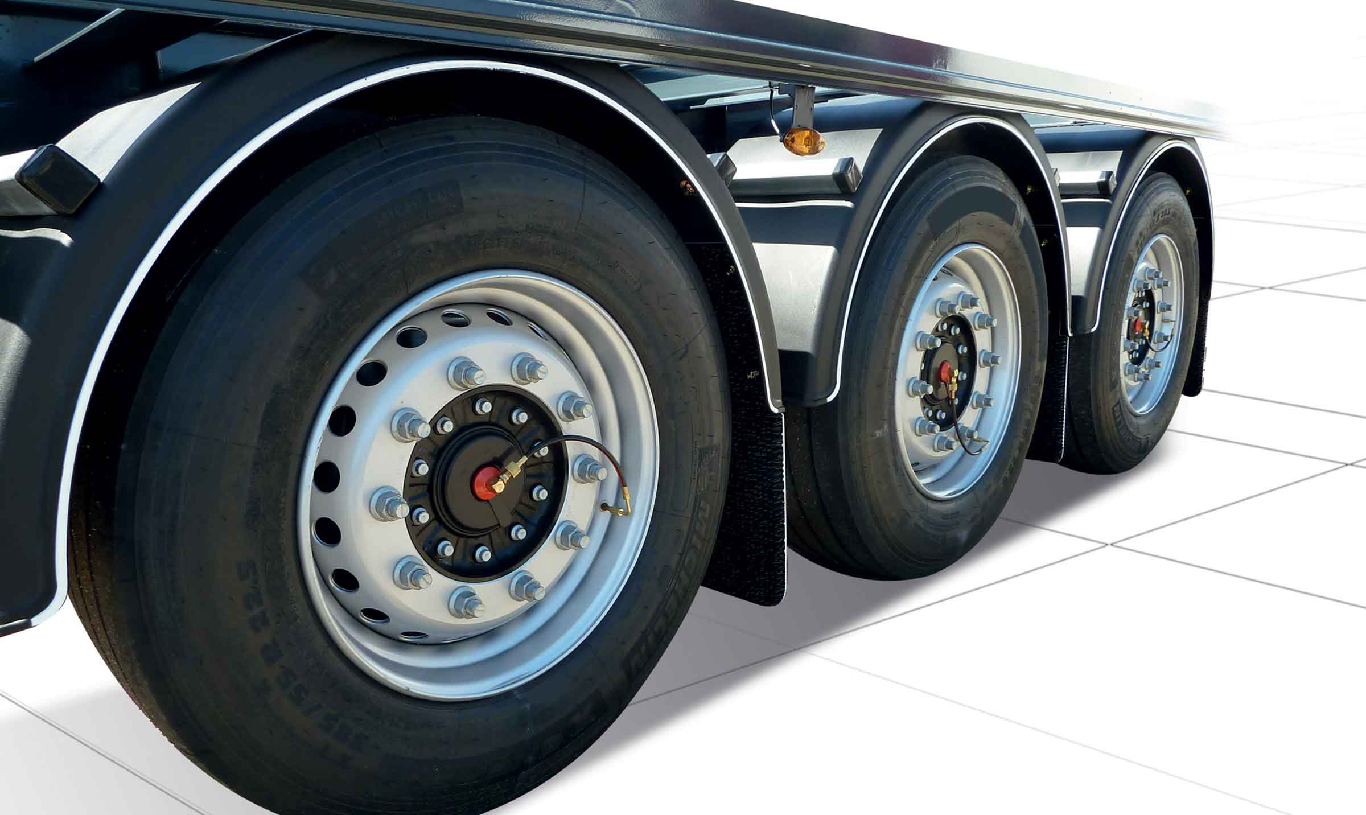
Gallery

APCS
Innovations APCS
APCSGuillaume Calviac2021-01-28T16:28:16+01:00
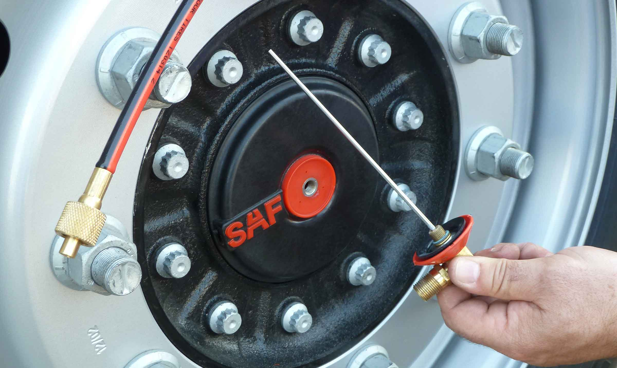
Gallery

APCS
Innovations APCS
APCSGuillaume Calviac2021-01-28T16:27:45+01:00
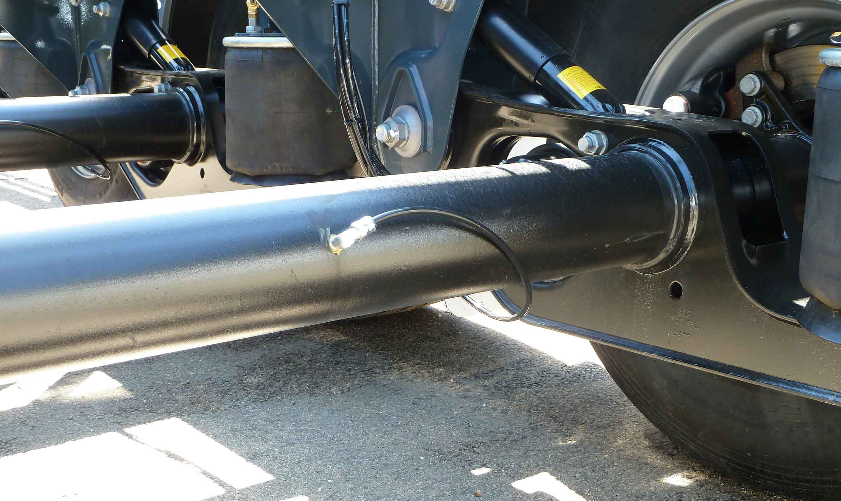
Gallery

APCS
Innovations APCS
APCSGuillaume Calviac2021-01-28T16:27:26+01:00
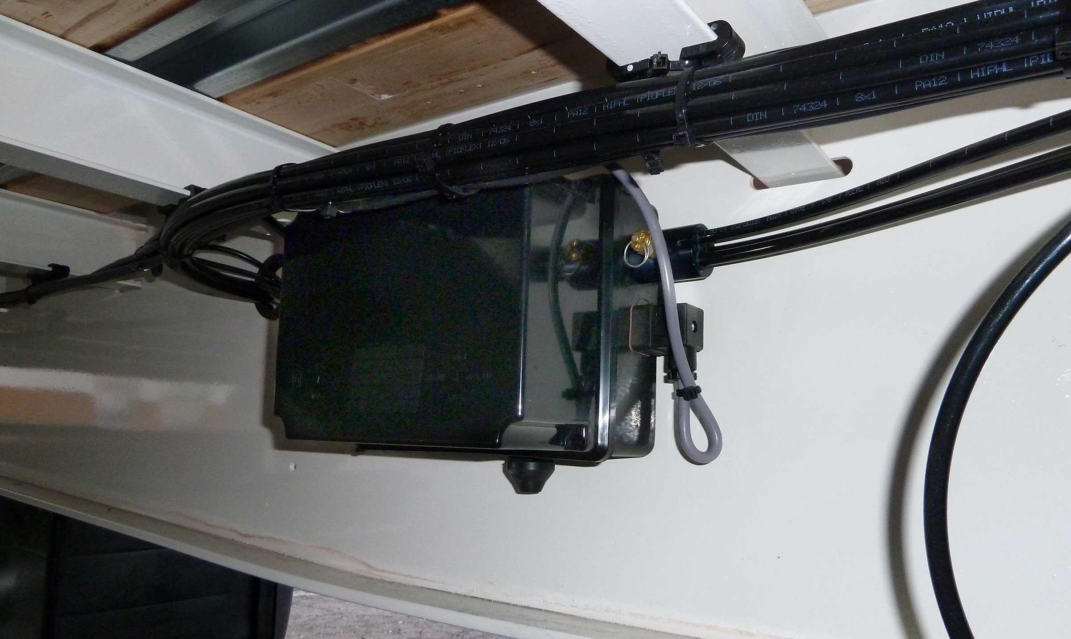
Gallery

APCS
Innovations APCS
APCSGuillaume Calviac2021-01-15T11:24:21+01:00
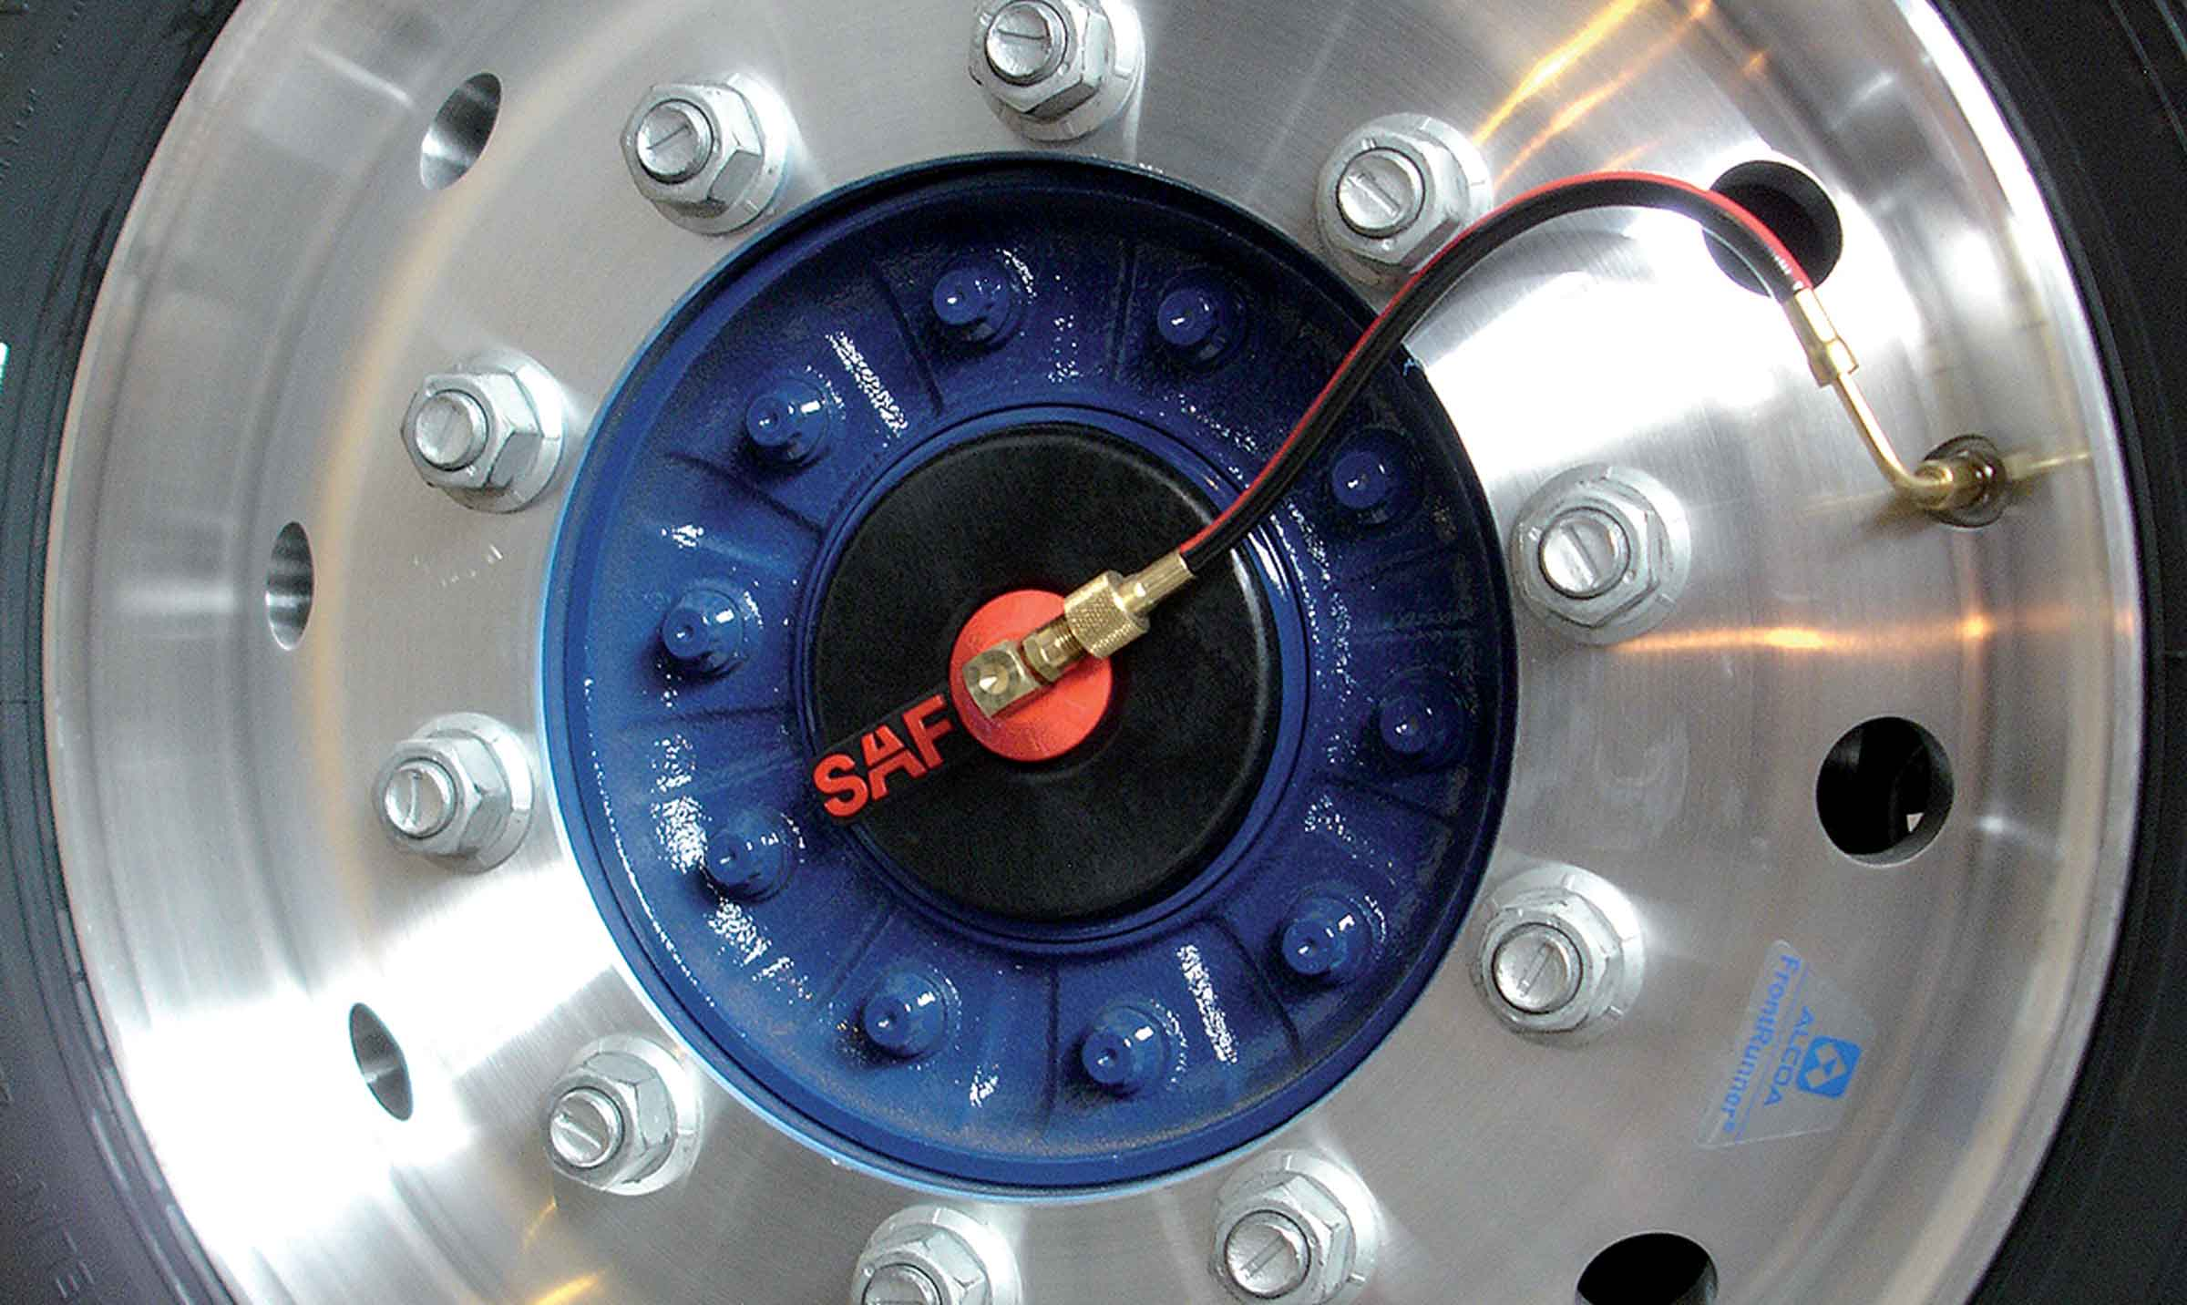
Gallery

APCS
Innovations APCS, Innovations Base EN
Documentation
Demo Videos

TPMS

Tire Pressure Monitoring System Tire pressure and temperature Monitoring System

Just-in-time transport with no risk of immobilising breakdown
The TPMS sensors continuously monitor and detect any pressure drops or temperature increases caused by mechanical failure.
The system feeds information back to the tractor dashboard to alert the driver. It can also transmit it by telematics to anticipate servicing before breakdown.
- Safety of personnel
- Equipment security
- Reduced costs
TPMSGuillaume Calviac2021-01-29T08:36:21+01:00
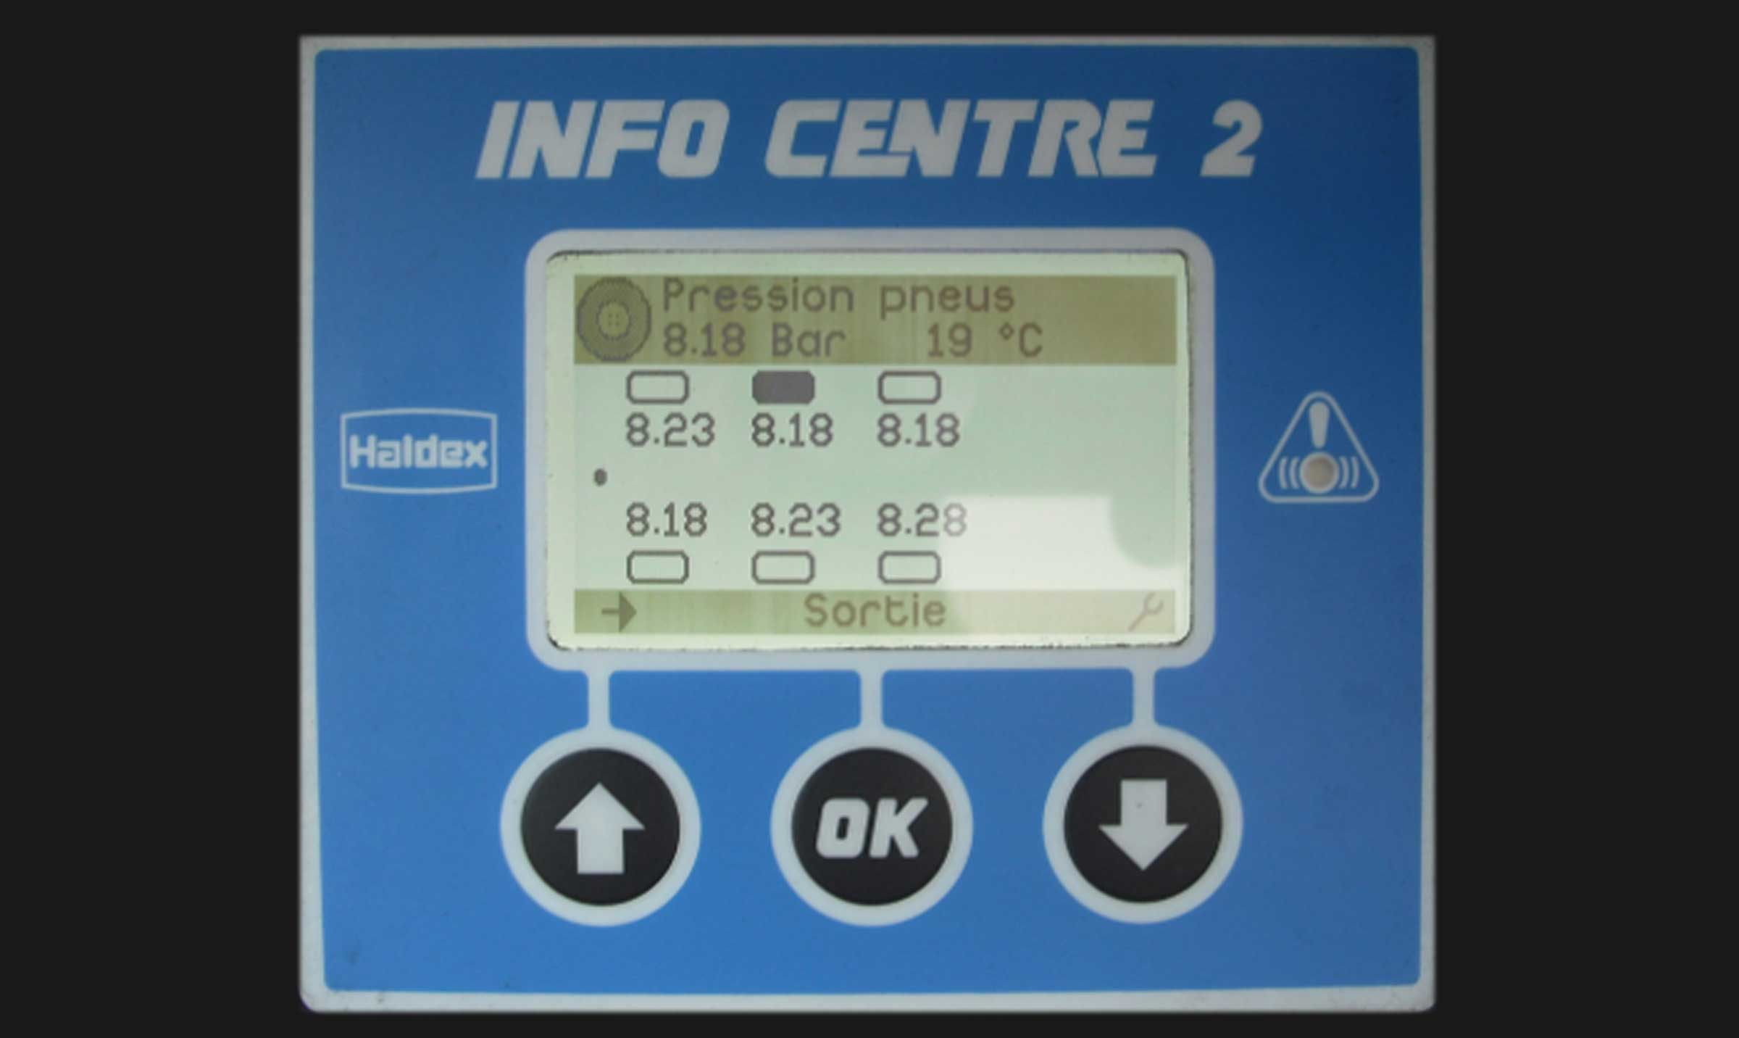
Gallery

TPMS
Innovations - TPMS
TPMSGuillaume Calviac2021-01-29T08:36:15+01:00
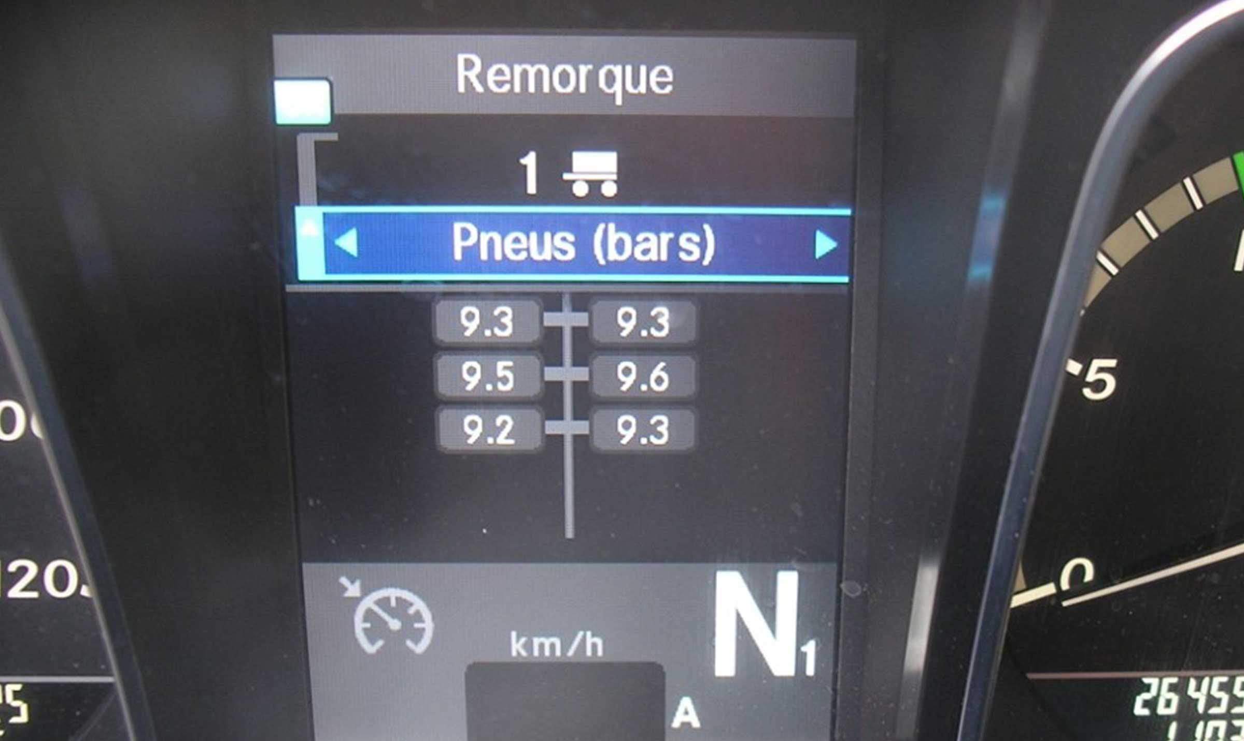
Gallery

TPMS
Innovations - TPMS
TPMSGuillaume Calviac2021-01-29T08:36:08+01:00
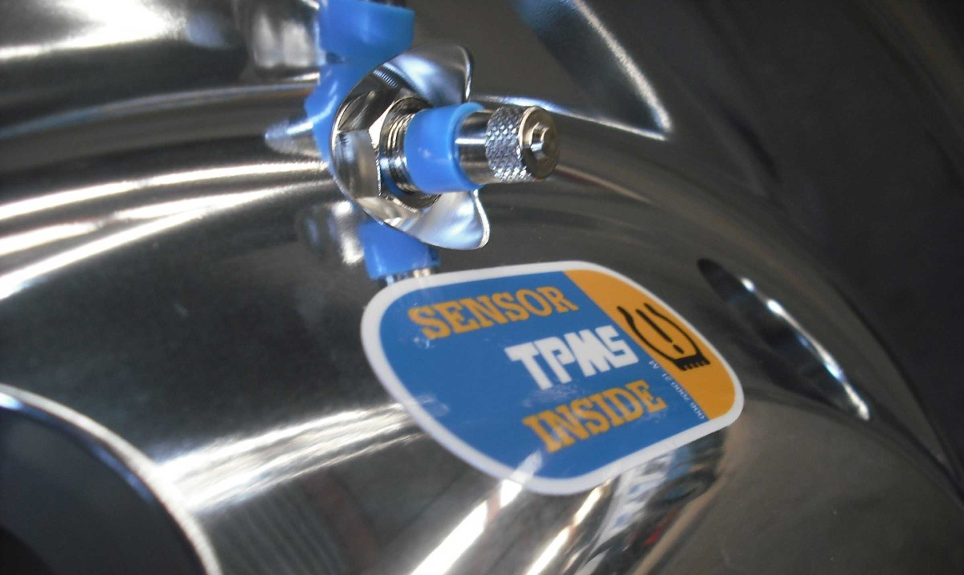
Gallery

TPMS
Innovations - TPMS
TPMSGuillaume Calviac2021-01-29T08:35:16+01:00
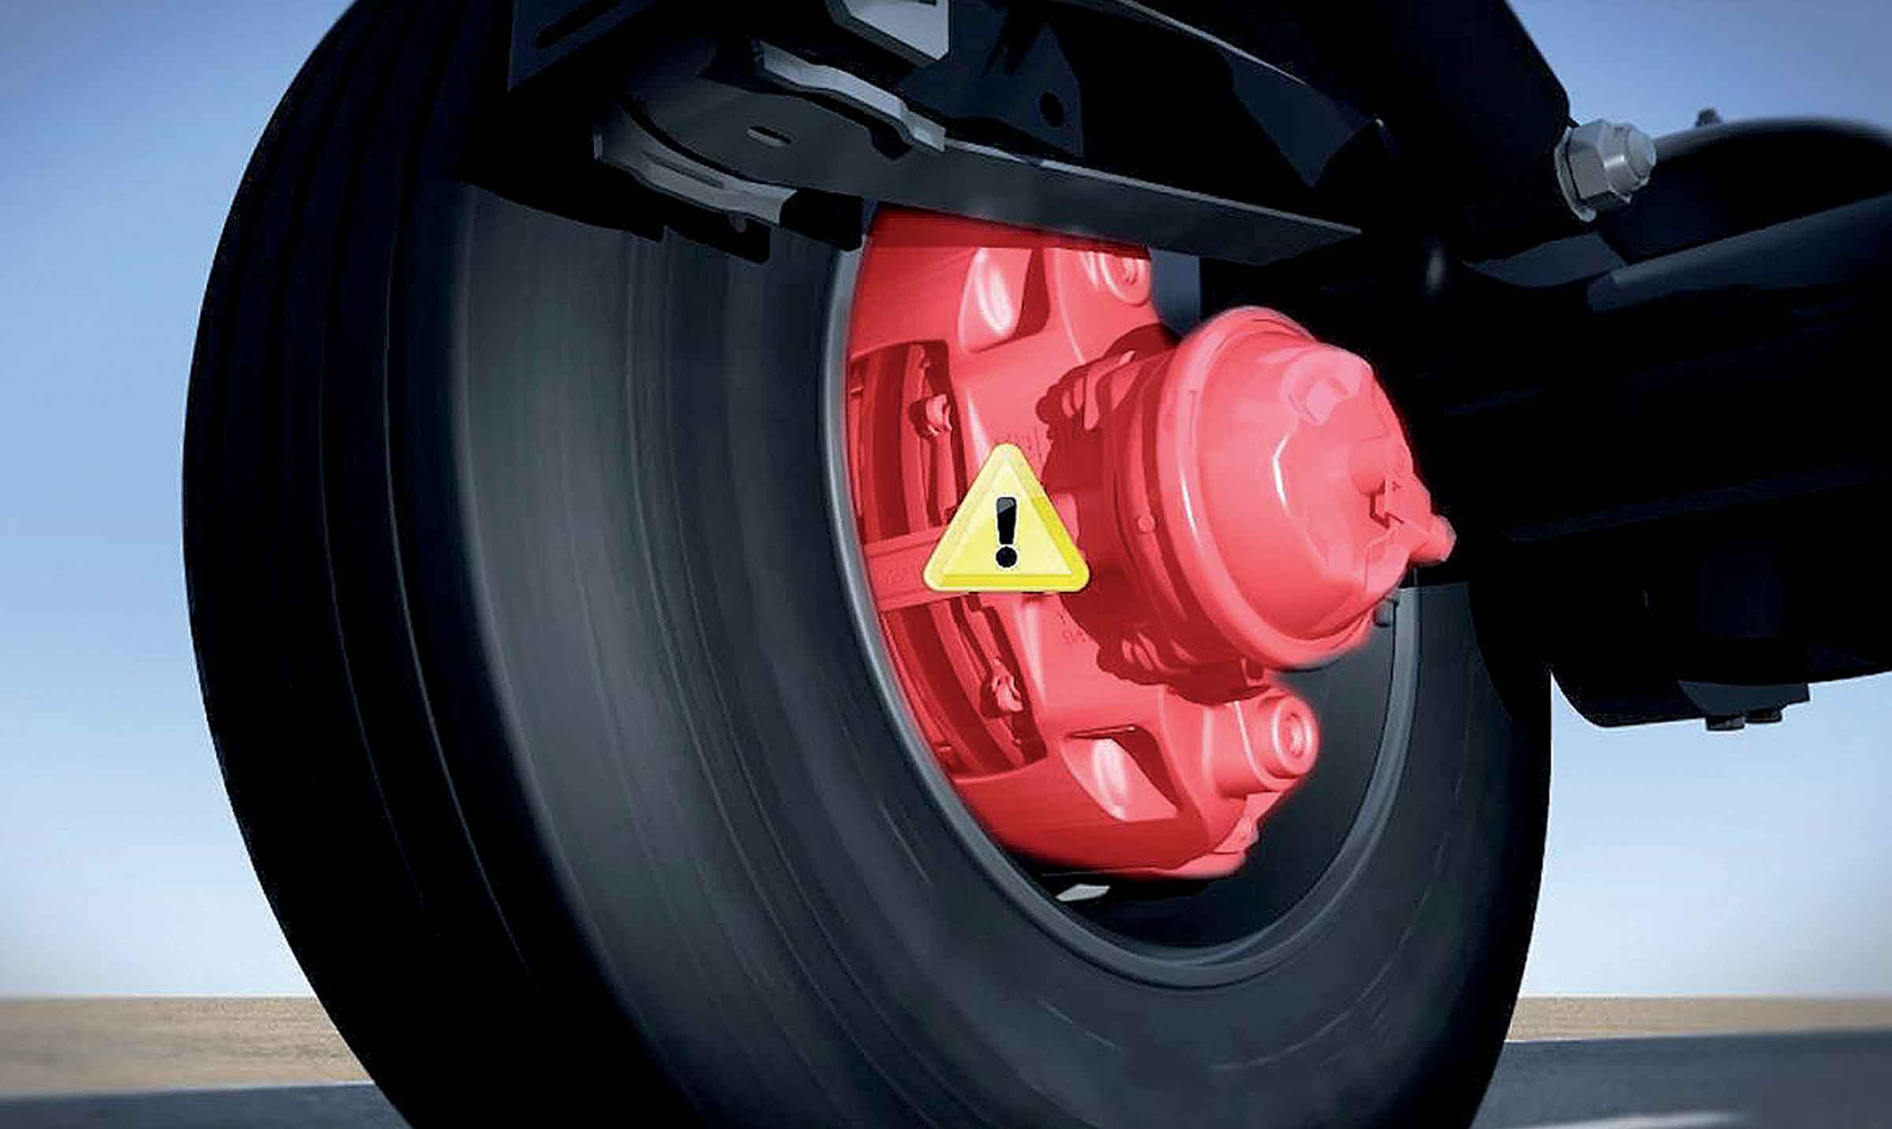
Gallery

TPMS
Innovations - TPMS
TPMSGuillaume Calviac2021-01-29T08:34:38+01:00
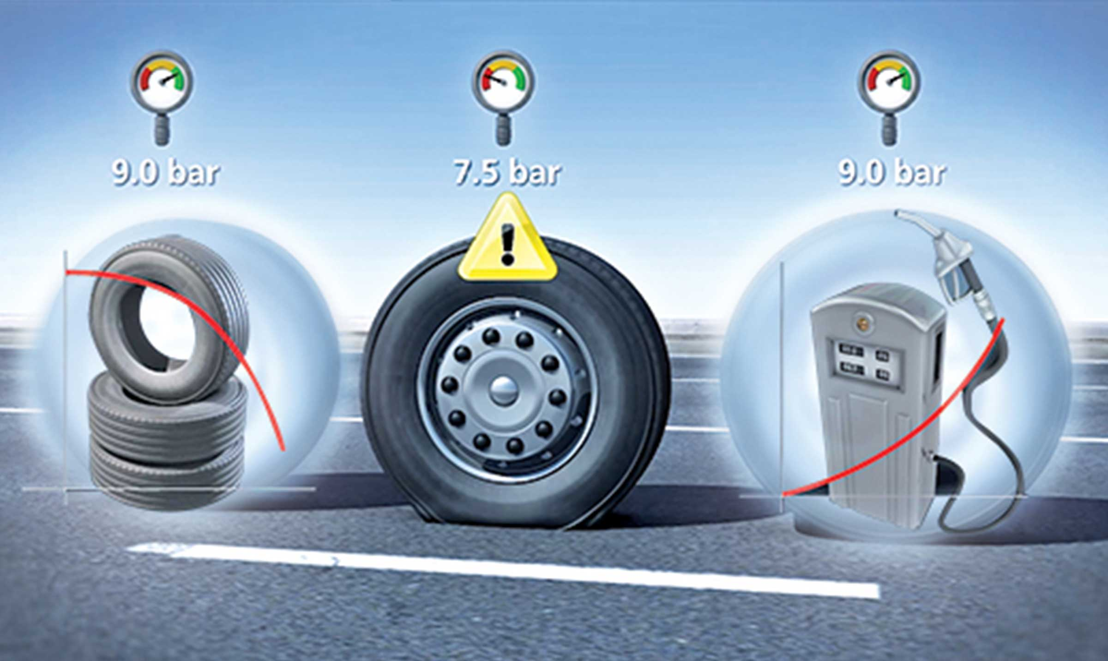
Gallery

TPMS
Innovations - TPMS, Innovations Base EN
Documentation
Demo Videos

A solution of every need

Quick'Slide

Speed and security
The Quick Slide curtainsider enables an optimum unloading time. The immobilisation time of the vehicle is thus reduced. It also offers better ergonomics for the drivers during manipulation phases.
Equiped with 3 spanbands instead of 18, this curtainsiders without side planks enables a fast opening and closing of the curtain. Less than 2 minutes is necessary, versus more than 10 minutes for a standard curtain.
- Economy
- Productivity
- Ergonomy
Documentation
Demo Videos
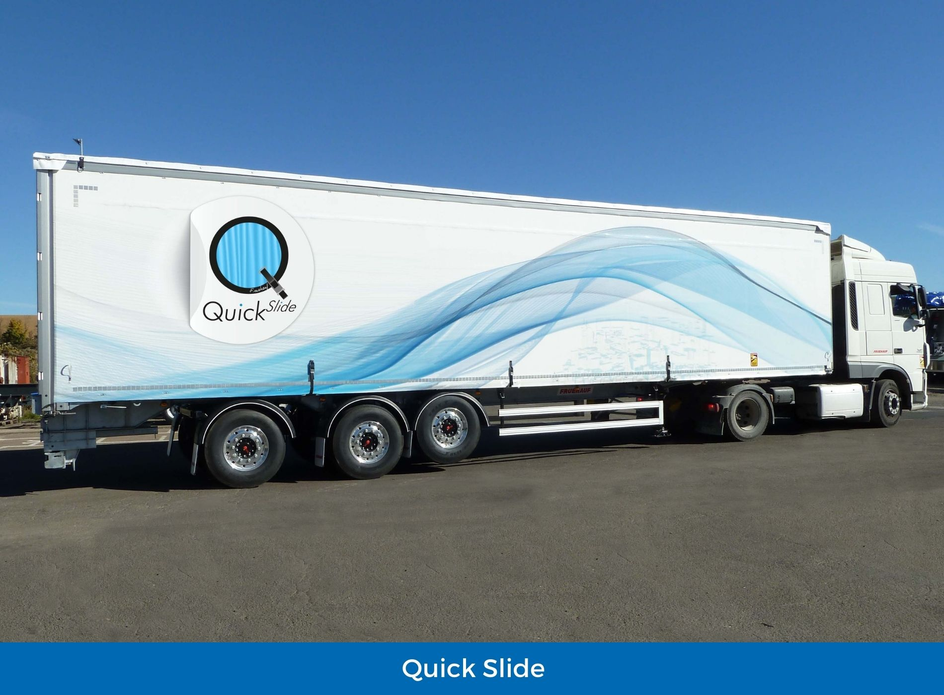

City

The best solution for distribution

Rear steering axle
With their rear steering axle, Fruehauf CITY vehicles offer superior payload and manoeuvrability performance compared to traditional distribution carriers.
Available for 21, 24, 27 or 34 pallets, they feature bodywork and equipment identical to 13.60 m semitrailers, enabling full adaptation to the diversity of needs.
- Manoeuvrability
- Working load
- Ease of use
VanGuillaume Calviac2021-01-27T15:01:36+01:00
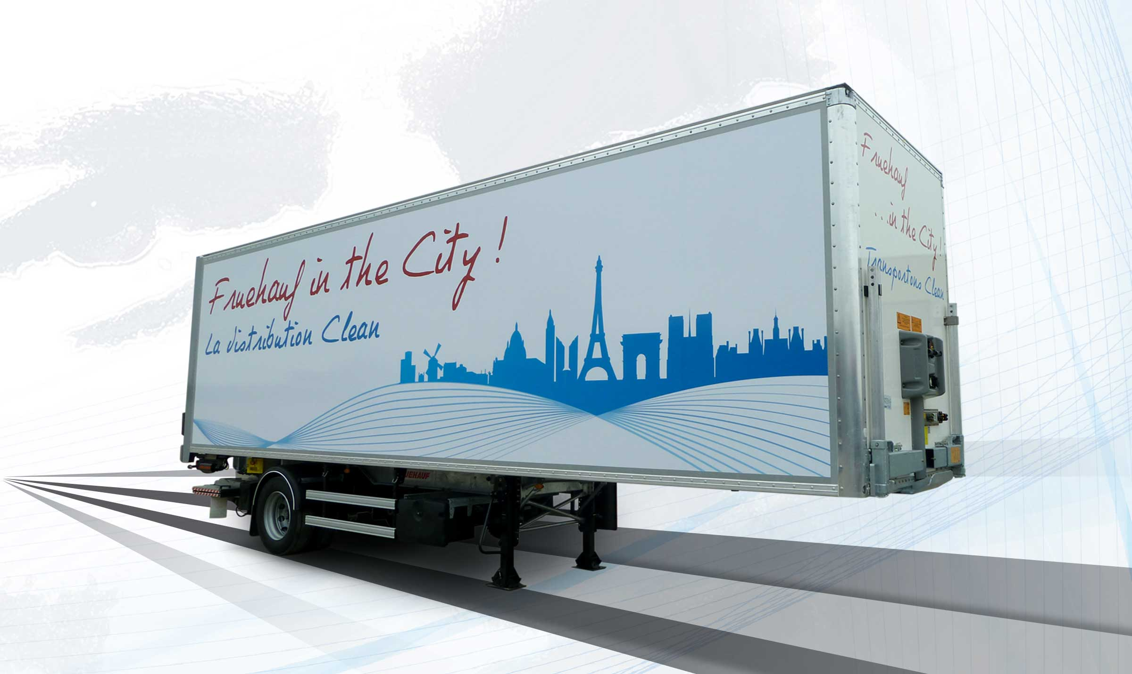
Gallery

Van
City Fourgon, Innovations - City
Refrigerated unit on pre-fitted chassisGuillaume Calviac2021-01-14T10:55:22+01:00
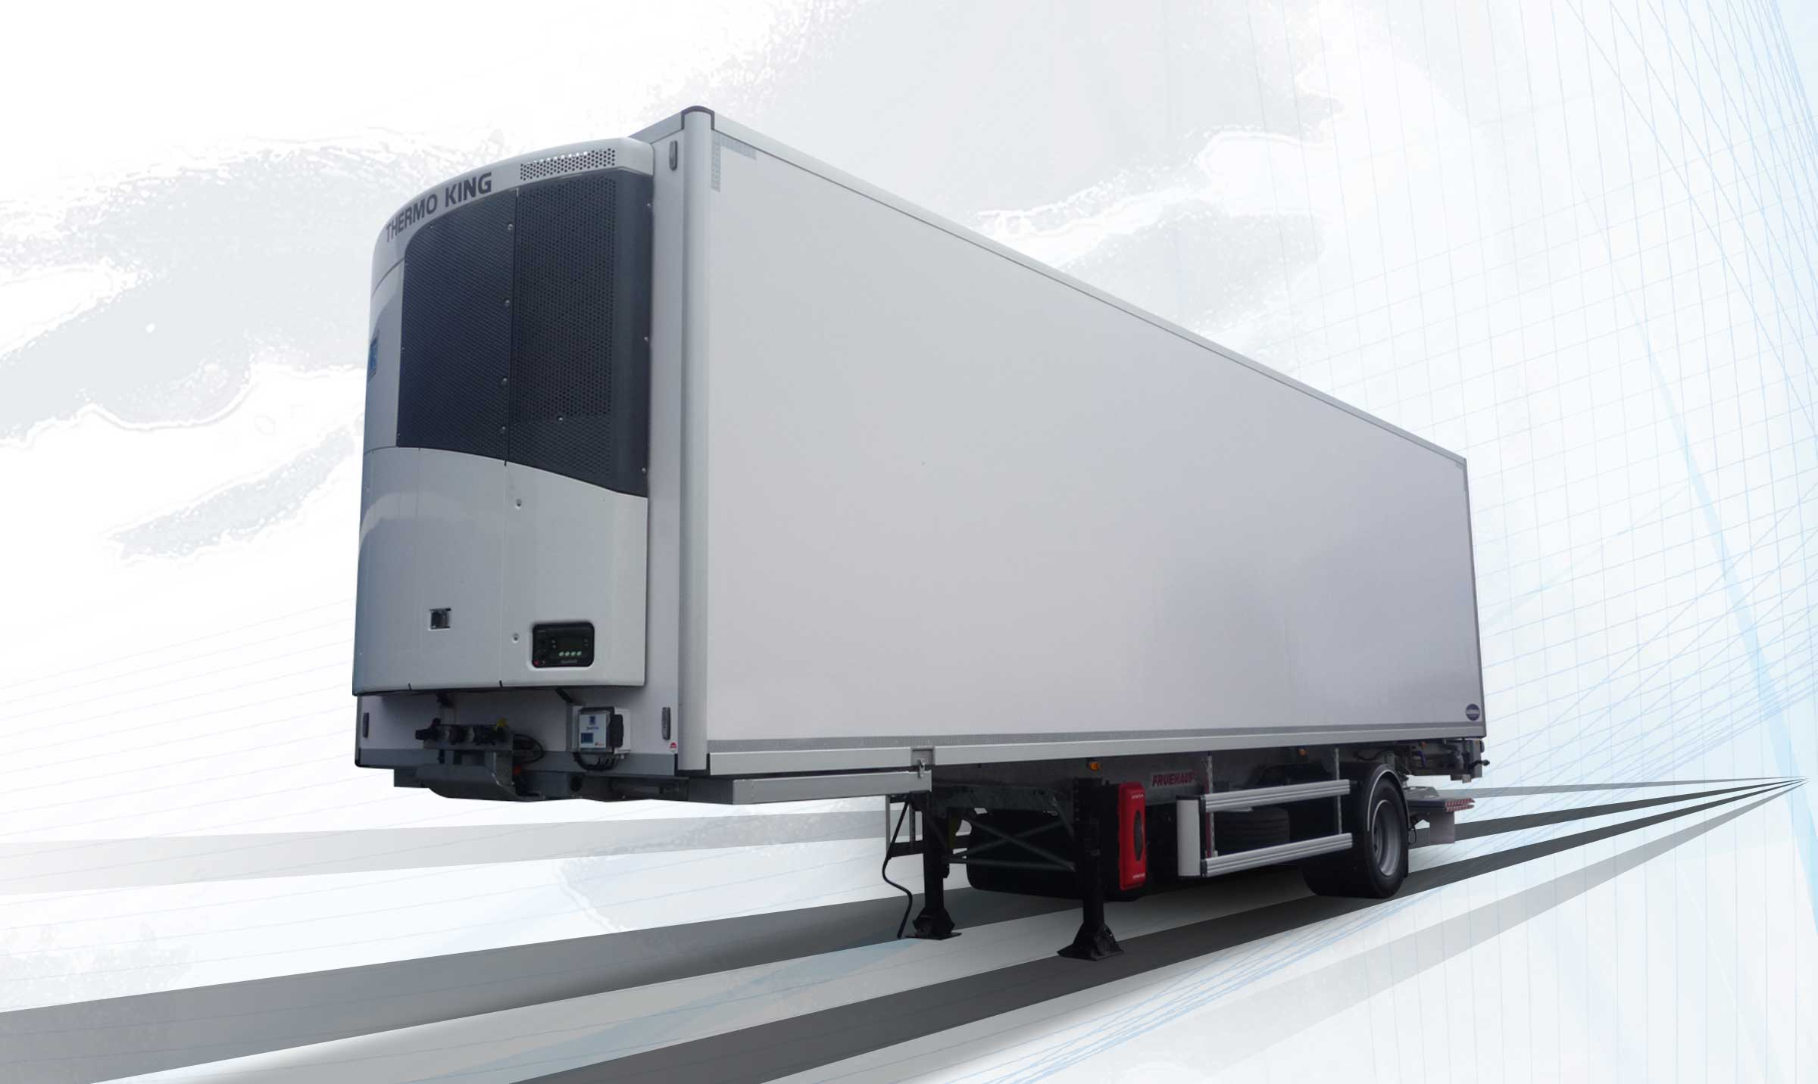
Gallery

Refrigerated unit on pre-fitted chassis
City frigo EN, Innovations - City
PlatformGuillaume Calviac2021-01-14T10:27:01+01:00
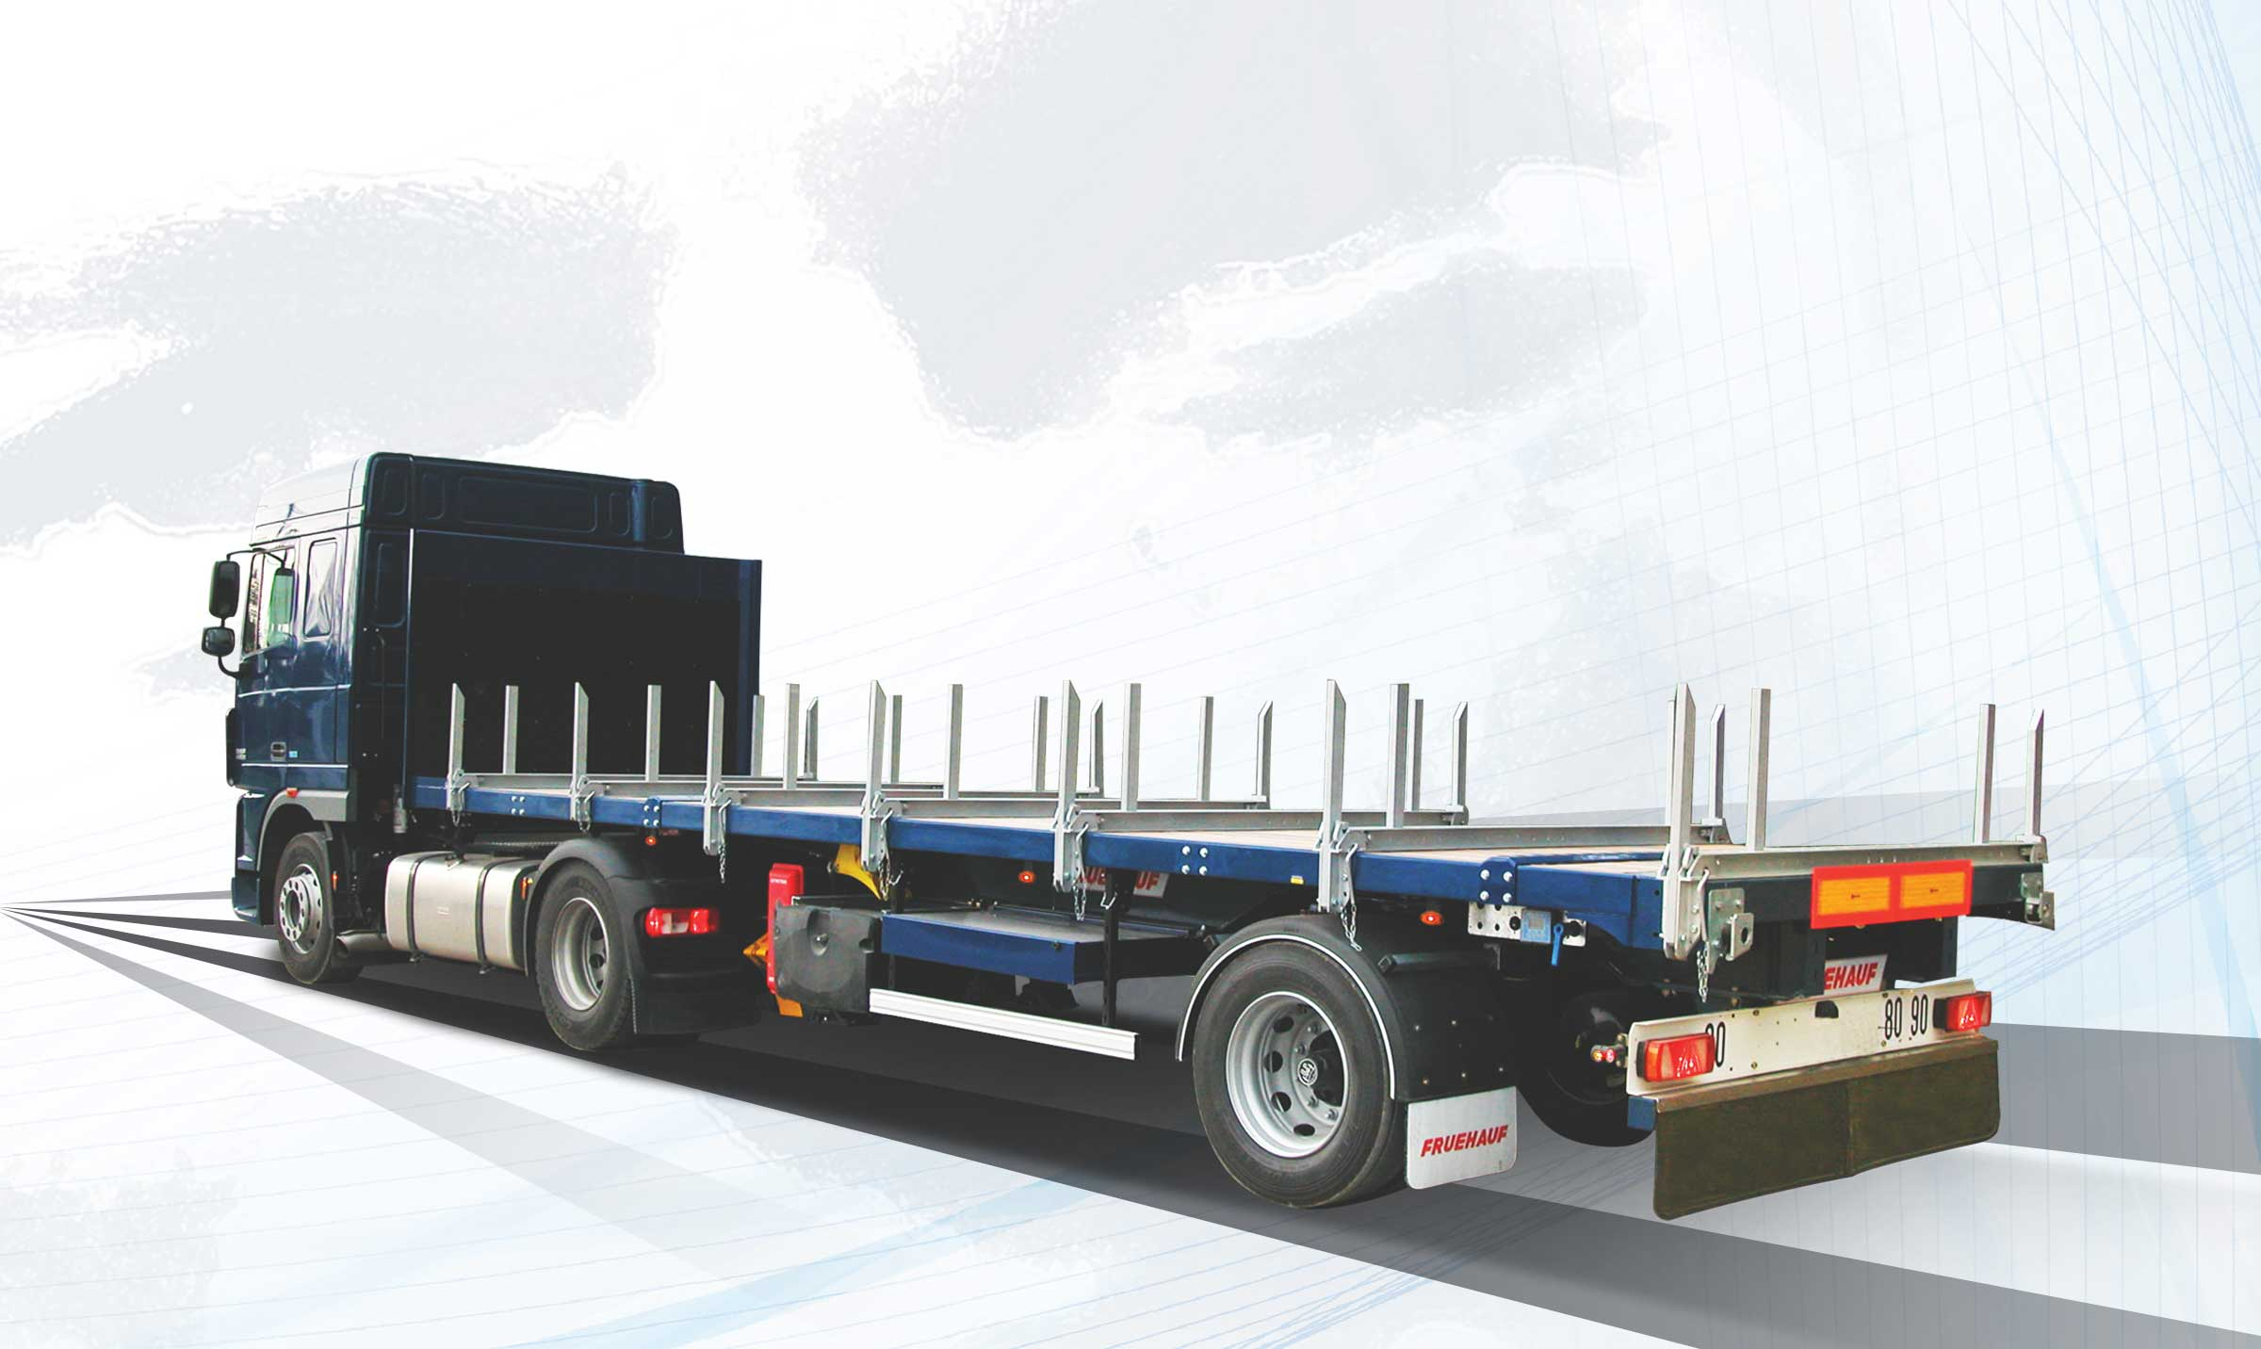
Gallery

Platform
City plateaux EN, Innovations - City
Steering axleGuillaume Calviac2021-01-13T15:37:02+01:00
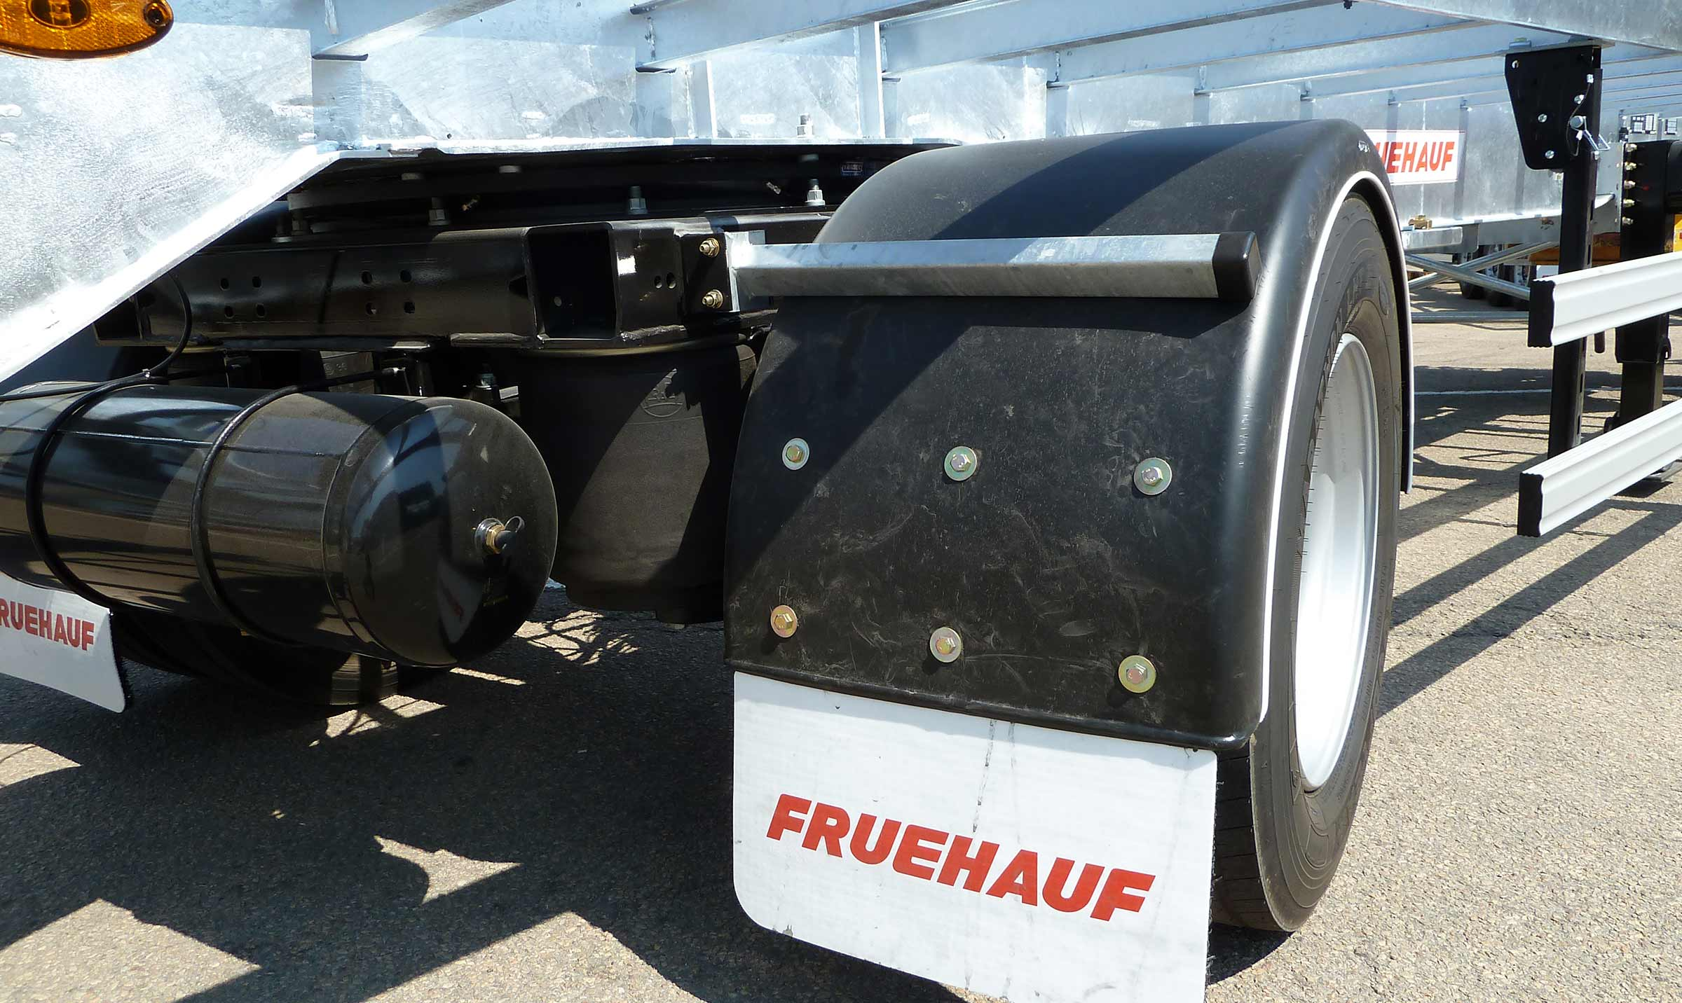
Gallery

Steering axle
City - Urban - Rear steering axle, Innovations - City
MaxiSpeed CityFrançoise Bernerd2021-01-14T09:08:12+01:00
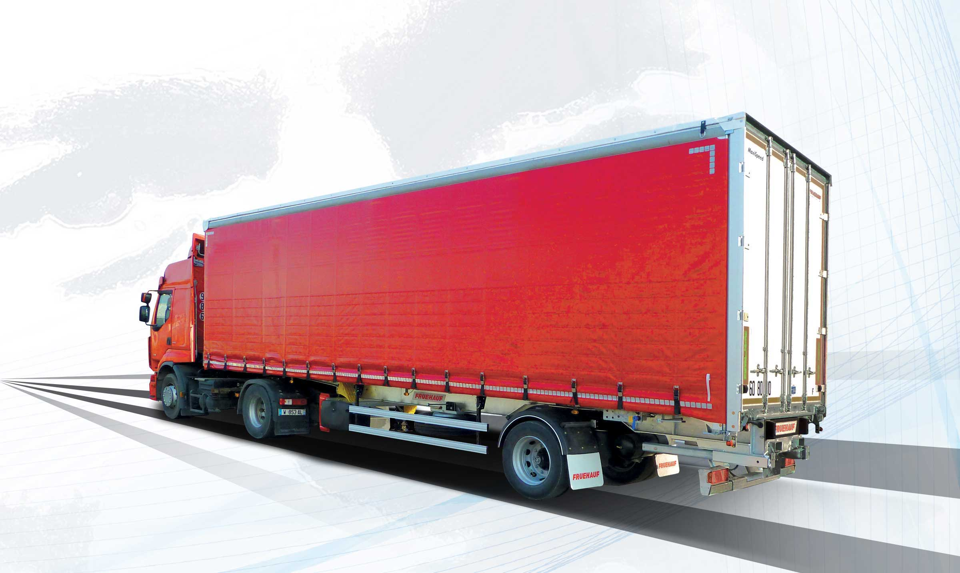
Gallery

MaxiSpeed City
City - Urban - MaxiSpeed, Innovations - City, MaxiSpeed City
Documentation
Demo Videos

MaxiSpeed Easy

Versatility

Extendible for loading and driving
The MaxiSpeed EASY is the answer to the wide variety of flows, from maximum volume for the automotive industry to maximum load for full loads.
Variable hitch from 950 mm MEGA to the traditional 1,100 mm, retaining 22.5″ wheels. Extendible roof for loading and driving, adjustable from 2.75 m to 3.05 m within the European 4-metre height limit.
- Versatile use
- Productivity
- MEGA 22.5″ coupling
Hydropneumatic pumpGuillaume Calviac2021-01-27T11:11:17+01:00
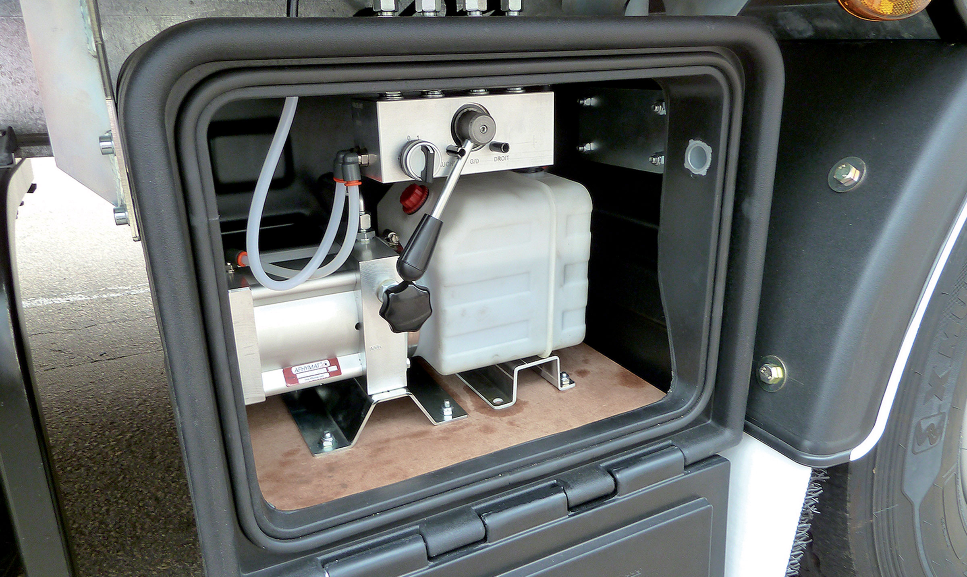
Gallery

Hydropneumatic pump
MaxiSpeed Easy
Fixed height aluminium doorsGuillaume Calviac2021-02-09T16:03:27+01:00
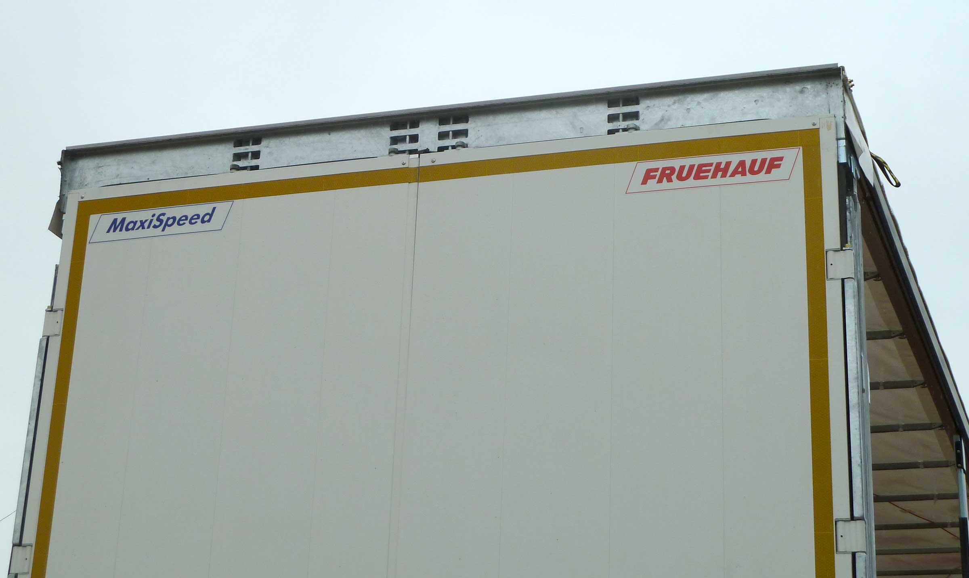
Gallery

Fixed height aluminium doors
MaxiSpeed Easy
Liftable roof for loading and drivingGuillaume Calviac2021-02-09T16:03:03+01:00
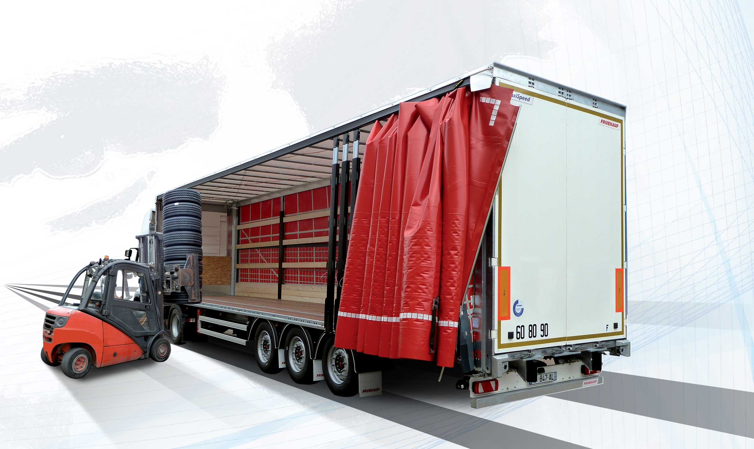
Gallery

Liftable roof for loading and driving
MaxiSpeed Easy, MaxiSpeed Innovations
Long-travel suspensionGuillaume Calviac2021-01-27T11:09:01+01:00
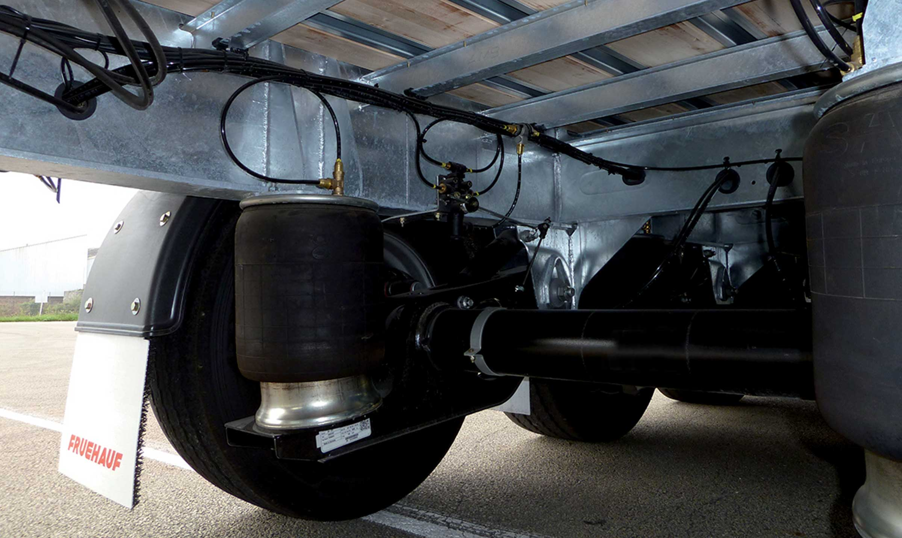
Gallery

Long-travel suspension
MaxiSpeed Easy
Liftable roofGuillaume Calviac2021-04-12T09:42:01+02:00
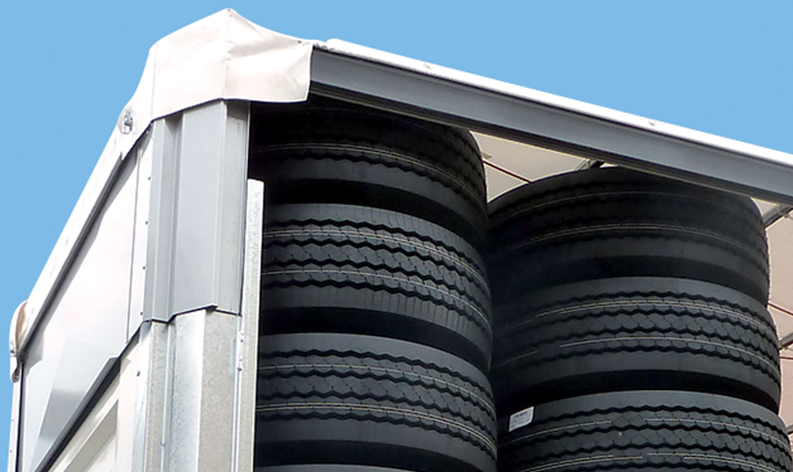
Gallery

Liftable roof
MaxiSpeed Easy
Documentation
Demo Videos

Telematics

Real-time tracking

Remote transmission of data from the on-board computer
Immediate or alert-based access to all data on geolocation, technical faults, tyre temperatures and pressures and slow puncture before blowout enables activity and the main expenditure items to be controlled in real time.
- Equipment security
- Productivity
- Reduced costs
TelematicsGuillaume Calviac2021-01-29T13:44:33+01:00
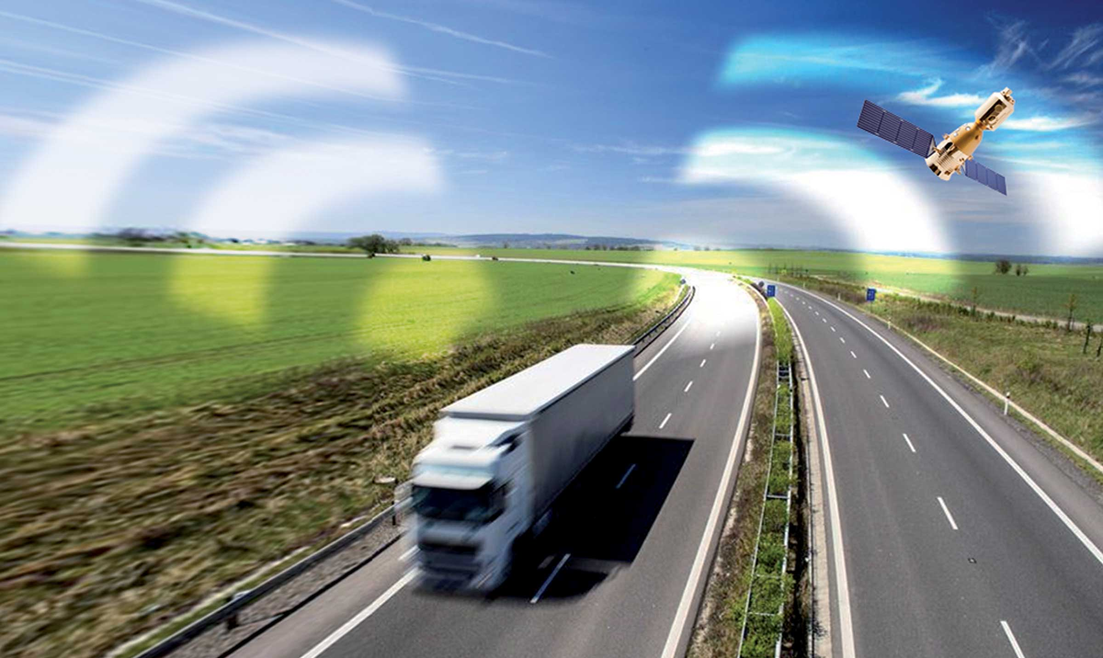
Gallery

Telematics
Innovations - Télématique, Innovations Base EN
Documentation

Aerodynamics

Transport better, consume less
FRUEHAUF has made aerodynamics research a strategic focus.
Aerodynamic equipment that can make a real difference to fuel economy will gradually be fitted to most vehicles. Side deflectors or even rear flow channels will soon be making an appearance and will effectively help to reduce fuel consumption and CO2 emissions.
- Reduced fuel consumption
- Reduced costs
AerodynamicsGuillaume Calviac2021-01-29T13:52:11+01:00

Gallery

Aerodynamics
Innovations - Aérodynamisme
Documentation

Metadata
fusion_builder_status | active
pyre_displayed_menu | default
pyre_display_copyright | default
pyre_display_footer | default
pyre_display_header | yes
pyre_elasticslider | 0
pyre_fallback
pyre_header_bg
pyre_header_bg_color
pyre_header_bg_full | no
pyre_header_bg_repeat | repeat
pyre_hundredp_padding
pyre_main_bottom_padding
pyre_main_top_padding
pyre_page_bg
pyre_page_bg_color
pyre_page_bg_full | no
pyre_page_bg_layout | default
pyre_page_bg_repeat | repeat
pyre_page_title | default
pyre_page_title_bar_bg
pyre_page_title_bar_bg_color
pyre_page_title_bar_bg_full | default
pyre_page_title_bar_bg_retina
pyre_page_title_bg_parallax | default
pyre_page_title_custom_subheader
pyre_page_title_text | default
pyre_revslider | 0
pyre_show_first_featured_image | no
pyre_sidebar_position | default
pyre_slider | 0
pyre_slider_position | default
pyre_slider_type | no
pyre_wide_page_bg
pyre_wide_page_bg_color
pyre_wide_page_bg_full | no
pyre_wide_page_bg_repeat | repeat
pyre_wooslider | final_fixed_width
sbg_selected_sidebar | Array
sbg_selected_sidebar_replacement | Array
sbg_selected_sidebar_2 | Array
sbg_selected_sidebar_2_replacement | Array
pyre_avada_rev_styles | default
pyre_footer_100_width | default
pyre_header_100_width | default
pyre_page_title_100_width | default
pyre_page_title_breadcrumbs_search_bar | default
pyre_page_title_text_alignment | default
pyre_header_bg_opacity
pyre_sidebar_sticky | default
pyre_sidebar_bg_color
pyre_page_title_text_size
pyre_page_title_line_height
pyre_page_title_custom_subheader_text_size
pyre_page_title_font_color
pyre_page_title_height
pyre_page_title_mobile_height
pyre_page_title_bar_borders_color
avada_post_views_count | 286
avada_today_post_views_count | 1
avada_post_views_count_today_date | 13-12-2023

