Large Volume Tippers
Author | Guillaume Calviac
Date | 2021-06-01 15:45:53
Categories

LARGE VOLUME TIPPERS

The range
Special "ENDUR-AL®" Aluminium
As a result of its lamination and treatment process, the special "ENDUR-AL®" aluminium offers 20% more resistance than the alloys normally used.
The Fruehauf Aluminium Large Volume Tipper is exclusively made from this new, very high quality alloy for maximum payload.
Special Hardox® Steel
Intended for the harshest applications, the special HARDOX® steel is the result of a high-tech production process that hardens the sheet metal for a longer life.
The Fruehauf steel Large Volume Tipper made from this special steel is therefore particularly well suited to the transport of highly aggressive products.

Cereals - Food Products - Chemicals
Designed especially for maximum payload, Fruehauf AgroMax® aluminium Large Volume Tippers meet the needs of transport of food products, chemicals, recyclables or loose, low-density product, with the best value for money.
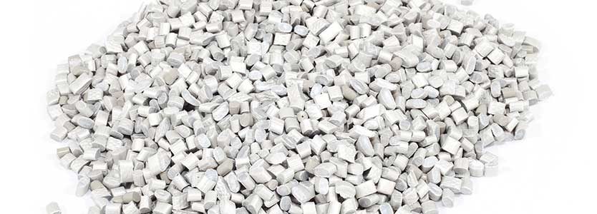
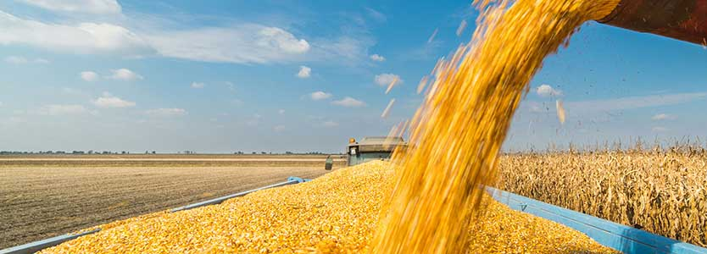
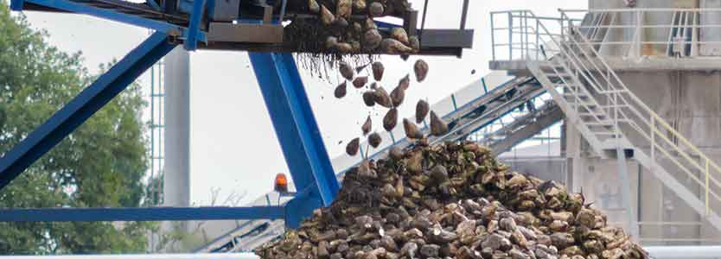

AgroMax

Maximum Payload

From 37 to 64 m³
Its modular construction with smooth surfaces of the box enables huge variability of volumes with lengths and heights adapted to all needs.
Its special "ENDUR-AL®" aluminium bottom and continuously welded, slanted sides offer unrivalled abrasion resistance and sturdiness.
- Unrivalled abrasion resistance
- Long service life
- Sturdy and lightweight
Reinforced bodyGuillaume Calviac2021-01-25T11:38:29+01:00
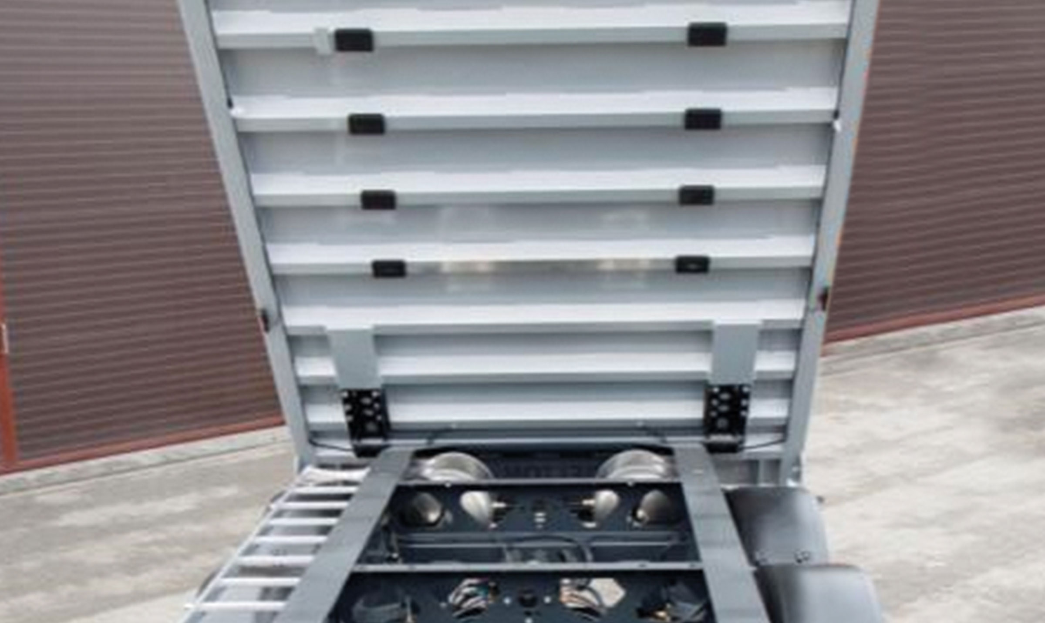
Gallery

Reinforced body
Bennes GV AgroMax
Aluminium bumpersGuillaume Calviac2021-01-25T11:18:55+01:00
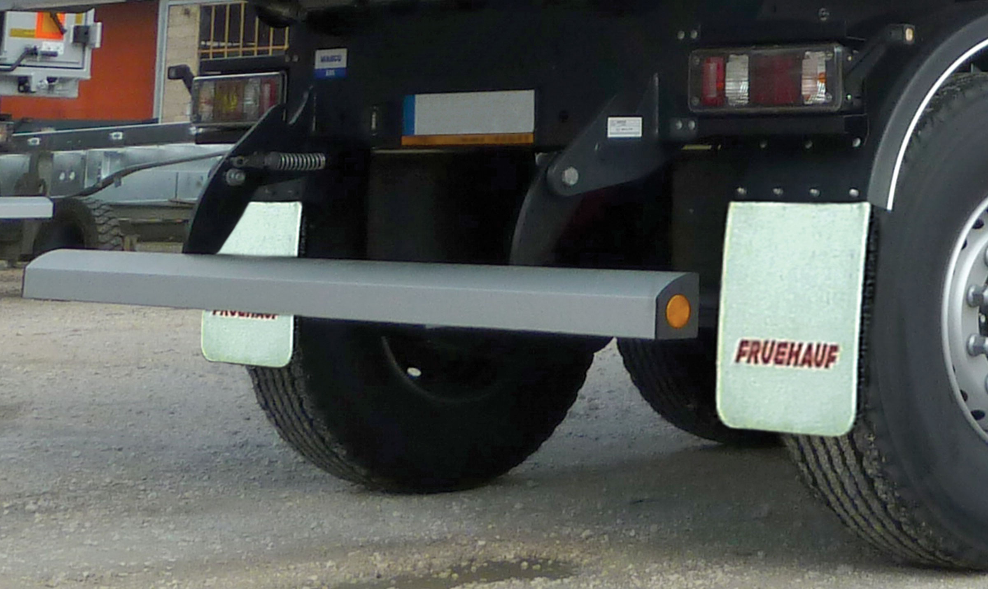
Gallery

Aluminium bumpers
Bennes GV AgroMax
Top hinged rear gateGuillaume Calviac2021-02-09T09:26:38+01:00
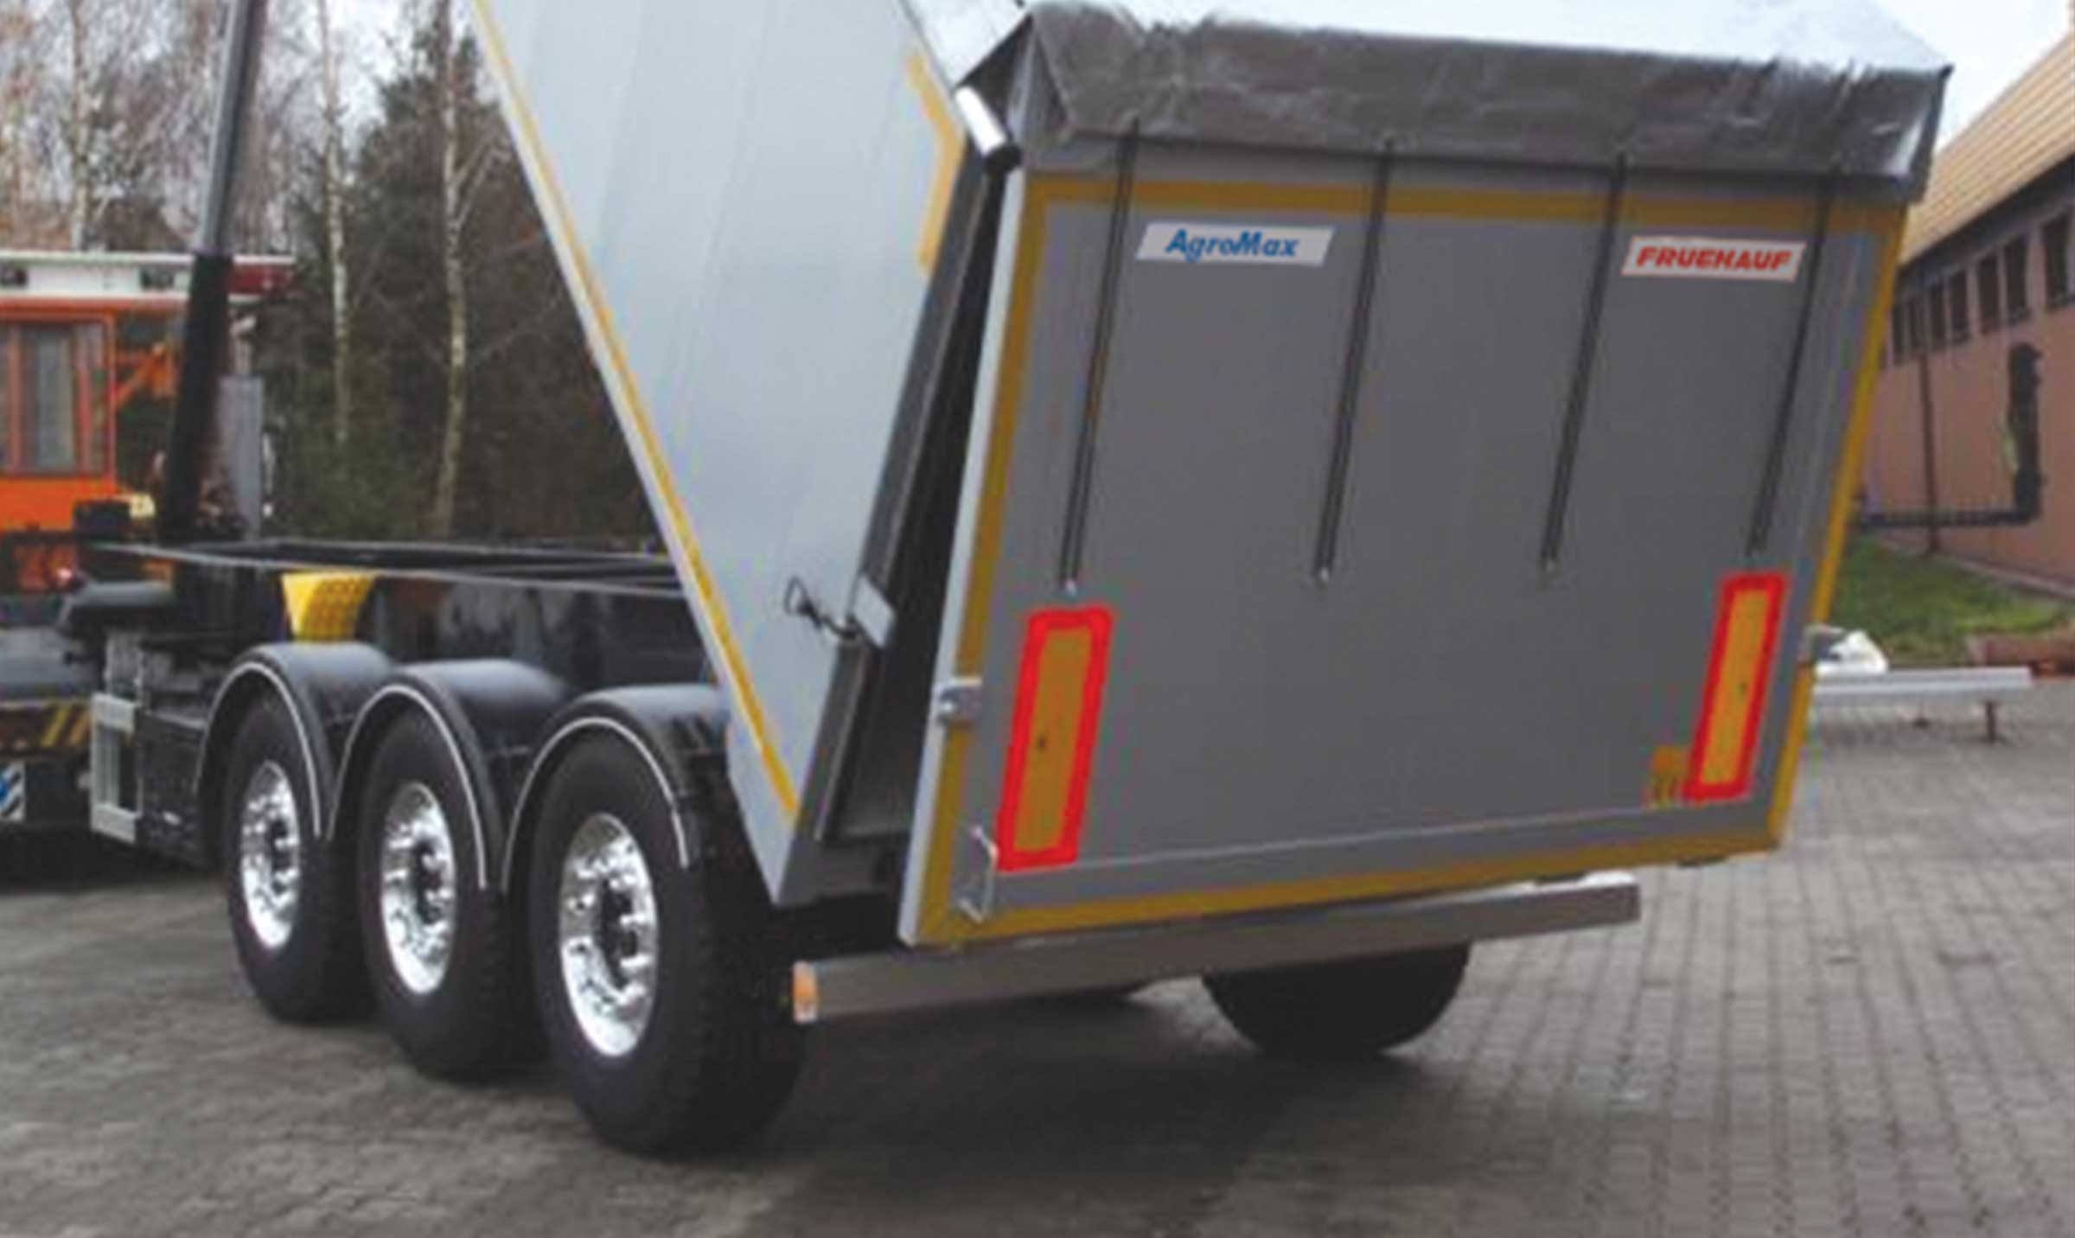
Gallery

Top hinged rear gate
Bennes GV AgroMax
AgroMaxGuillaume Calviac2021-01-25T11:16:38+01:00
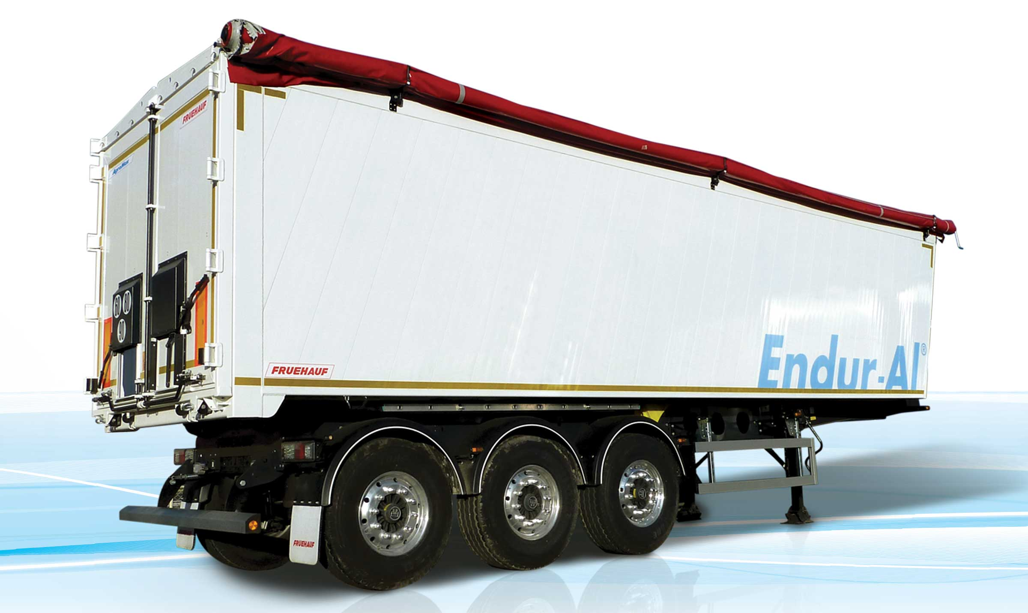
Gallery

AgroMax
Bennes GV AgroMax
Modular body with smooth faceGuillaume Calviac2021-01-25T11:34:28+01:00
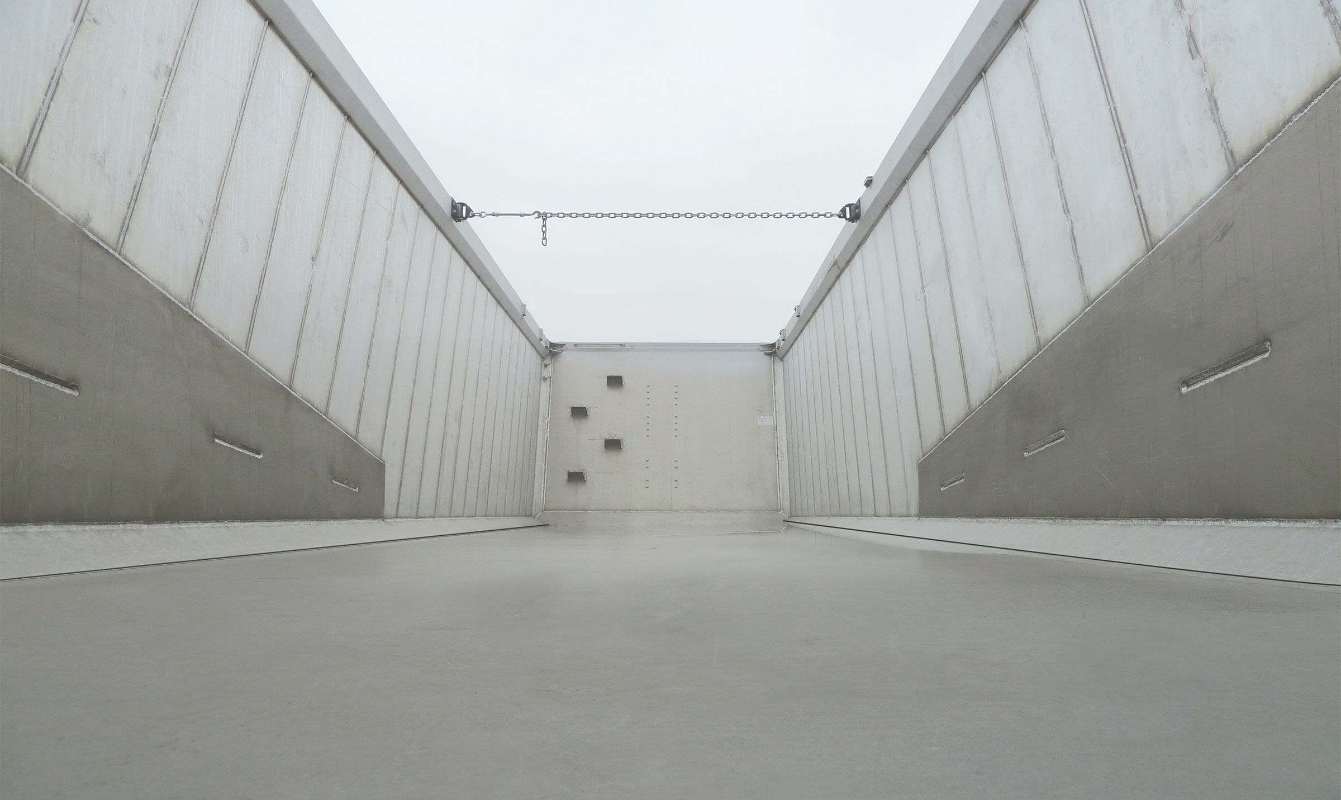
Gallery

Modular body with smooth face
Bennes GV AgroMax
Documentation

Recycling products - Scrap metal
The result of our expertise as leader in the manufacture of steel tippers, the FRUEHAUF Scrap Large Volume Tipper is particularly suited to the transport of bulky, highly aggressive products: scrap metal, broken glass, recycling products.
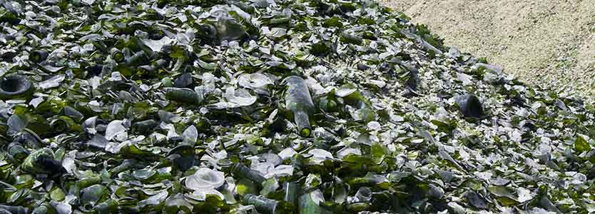
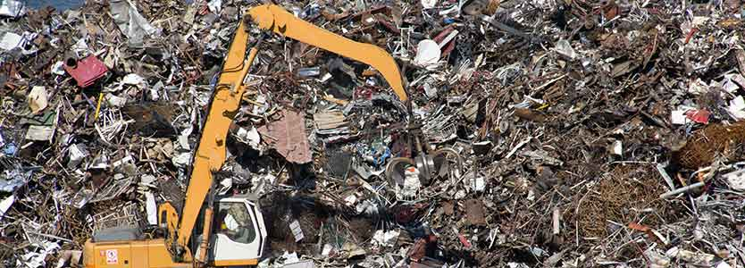
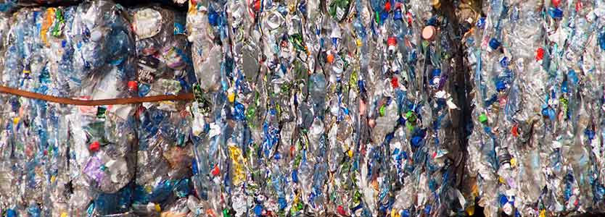

Scrap

Impact and abrasion resistance

From 51 to 55 m³
Equipped with a special HARDOX® steel body, it has the highest abrasion and impact resistance.
Thanks to the design of its body and its optimised steel chassis, it offers a particularly high payload.
- Abrasion resistance
- Impact resistance
- Sturdy and lightweight
Secure side openingGuillaume Calviac2021-01-25T11:47:45+01:00
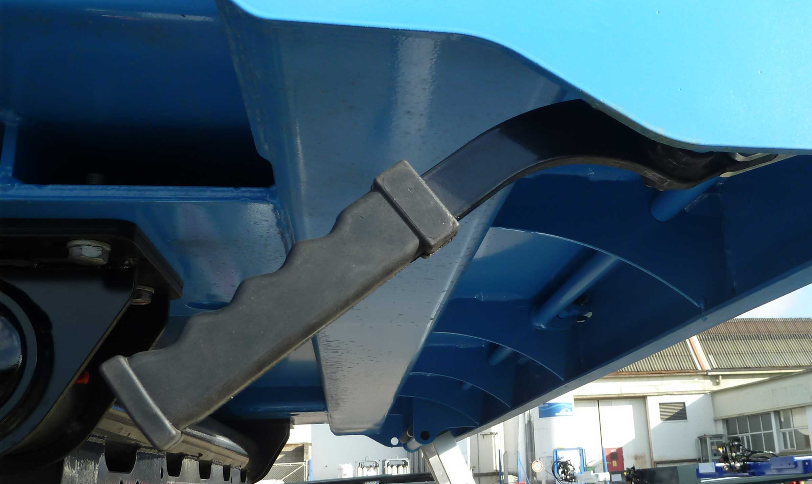
Gallery

Secure side opening
Bennes GV Scrap
Reinforced bottom by crossbearersGuillaume Calviac2021-02-09T09:37:56+01:00
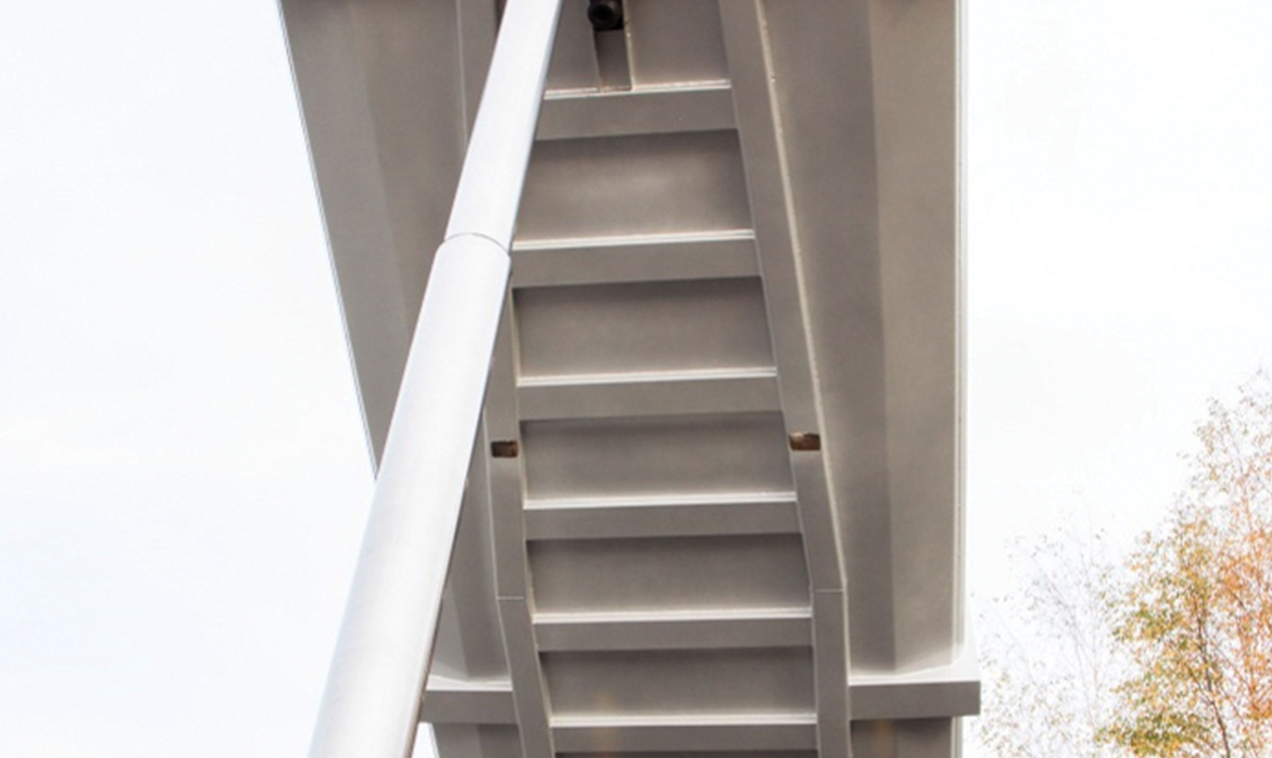
Gallery

Reinforced bottom by crossbearers
Bennes GV Scrap
ScrapGuillaume Calviac2021-01-25T11:40:37+01:00
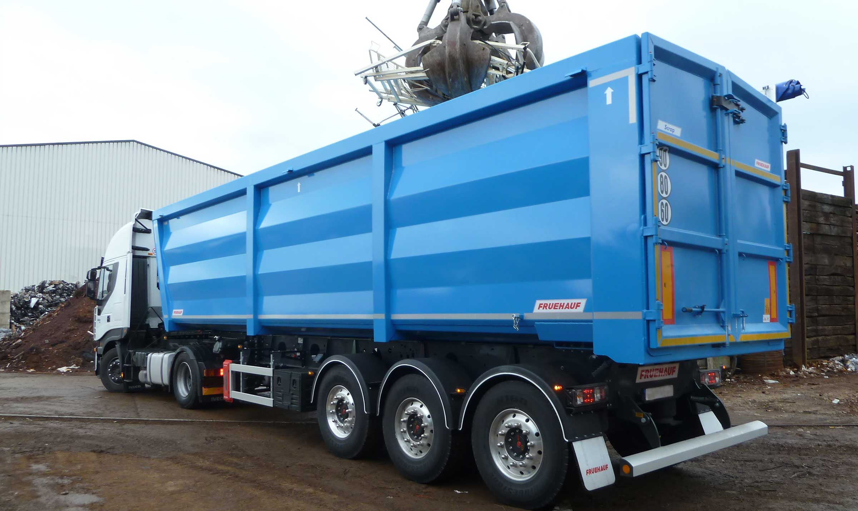
Gallery

Scrap
Bennes GV Scrap
ScrapGuillaume Calviac2021-01-25T11:40:35+01:00
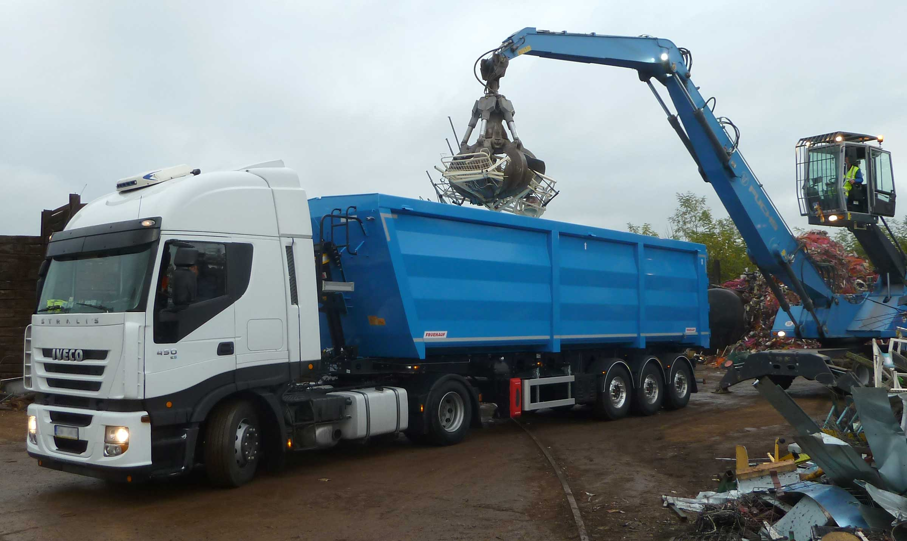
Gallery

Scrap
Bennes GV Scrap
ScrapGuillaume Calviac2021-01-25T11:40:41+01:00
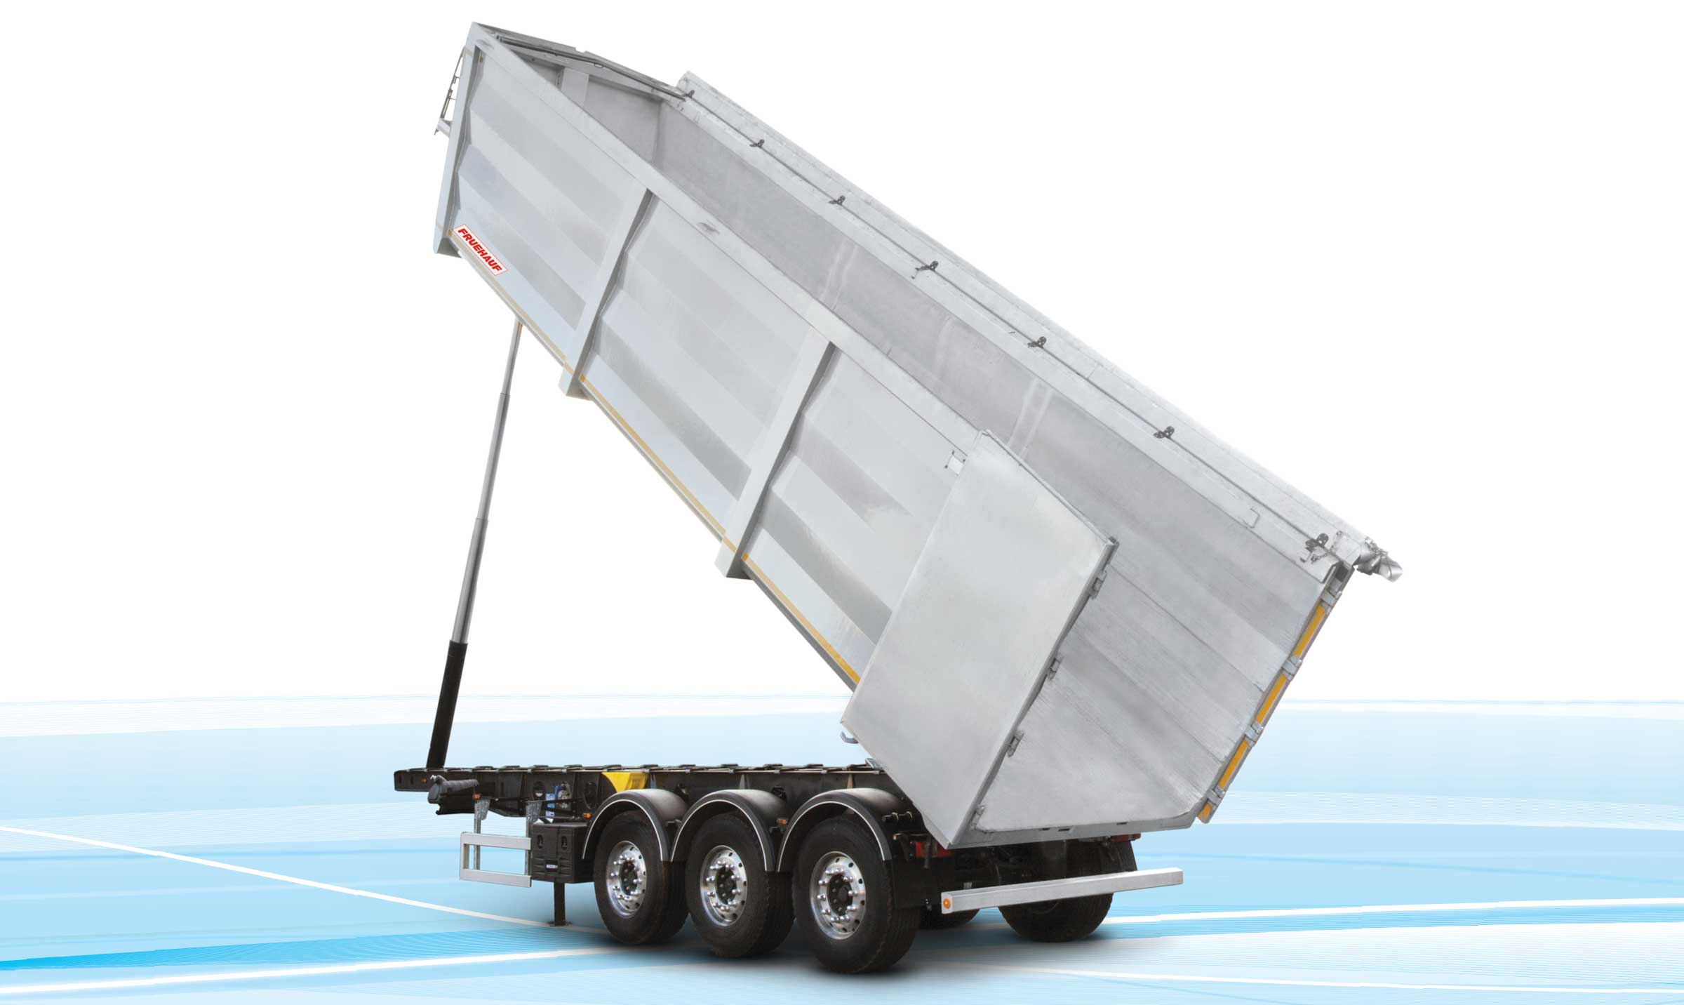
Gallery

Scrap
Bennes GV Scrap
Single-piece side wallsGuillaume Calviac2021-01-25T11:48:41+01:00
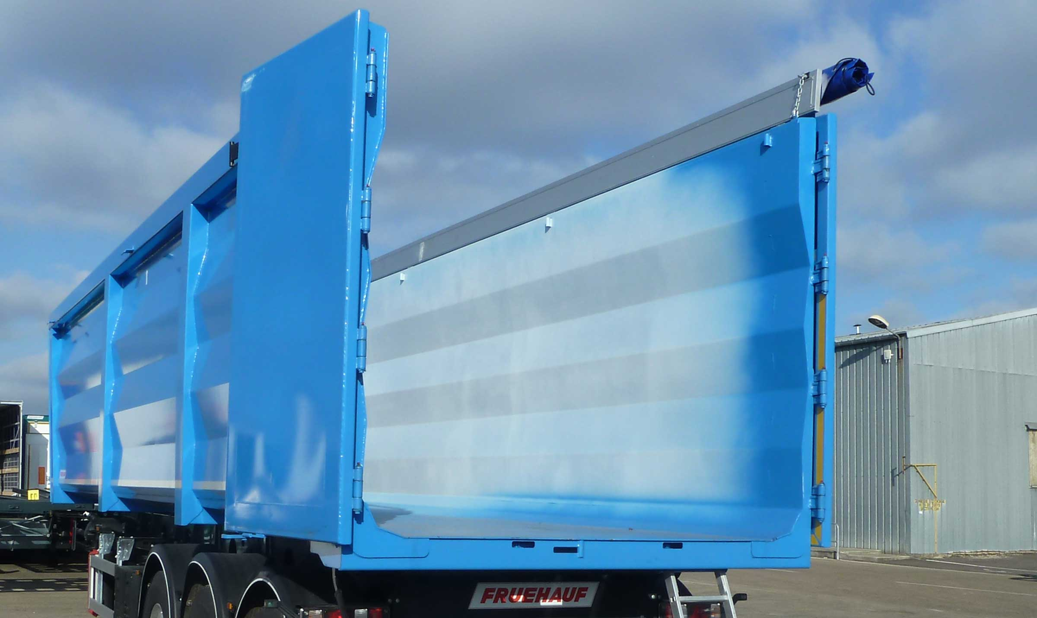
Gallery

Single-piece side walls
Bennes GV Scrap
Aluminium sheeting protection battenGuillaume Calviac2021-01-25T11:49:10+01:00
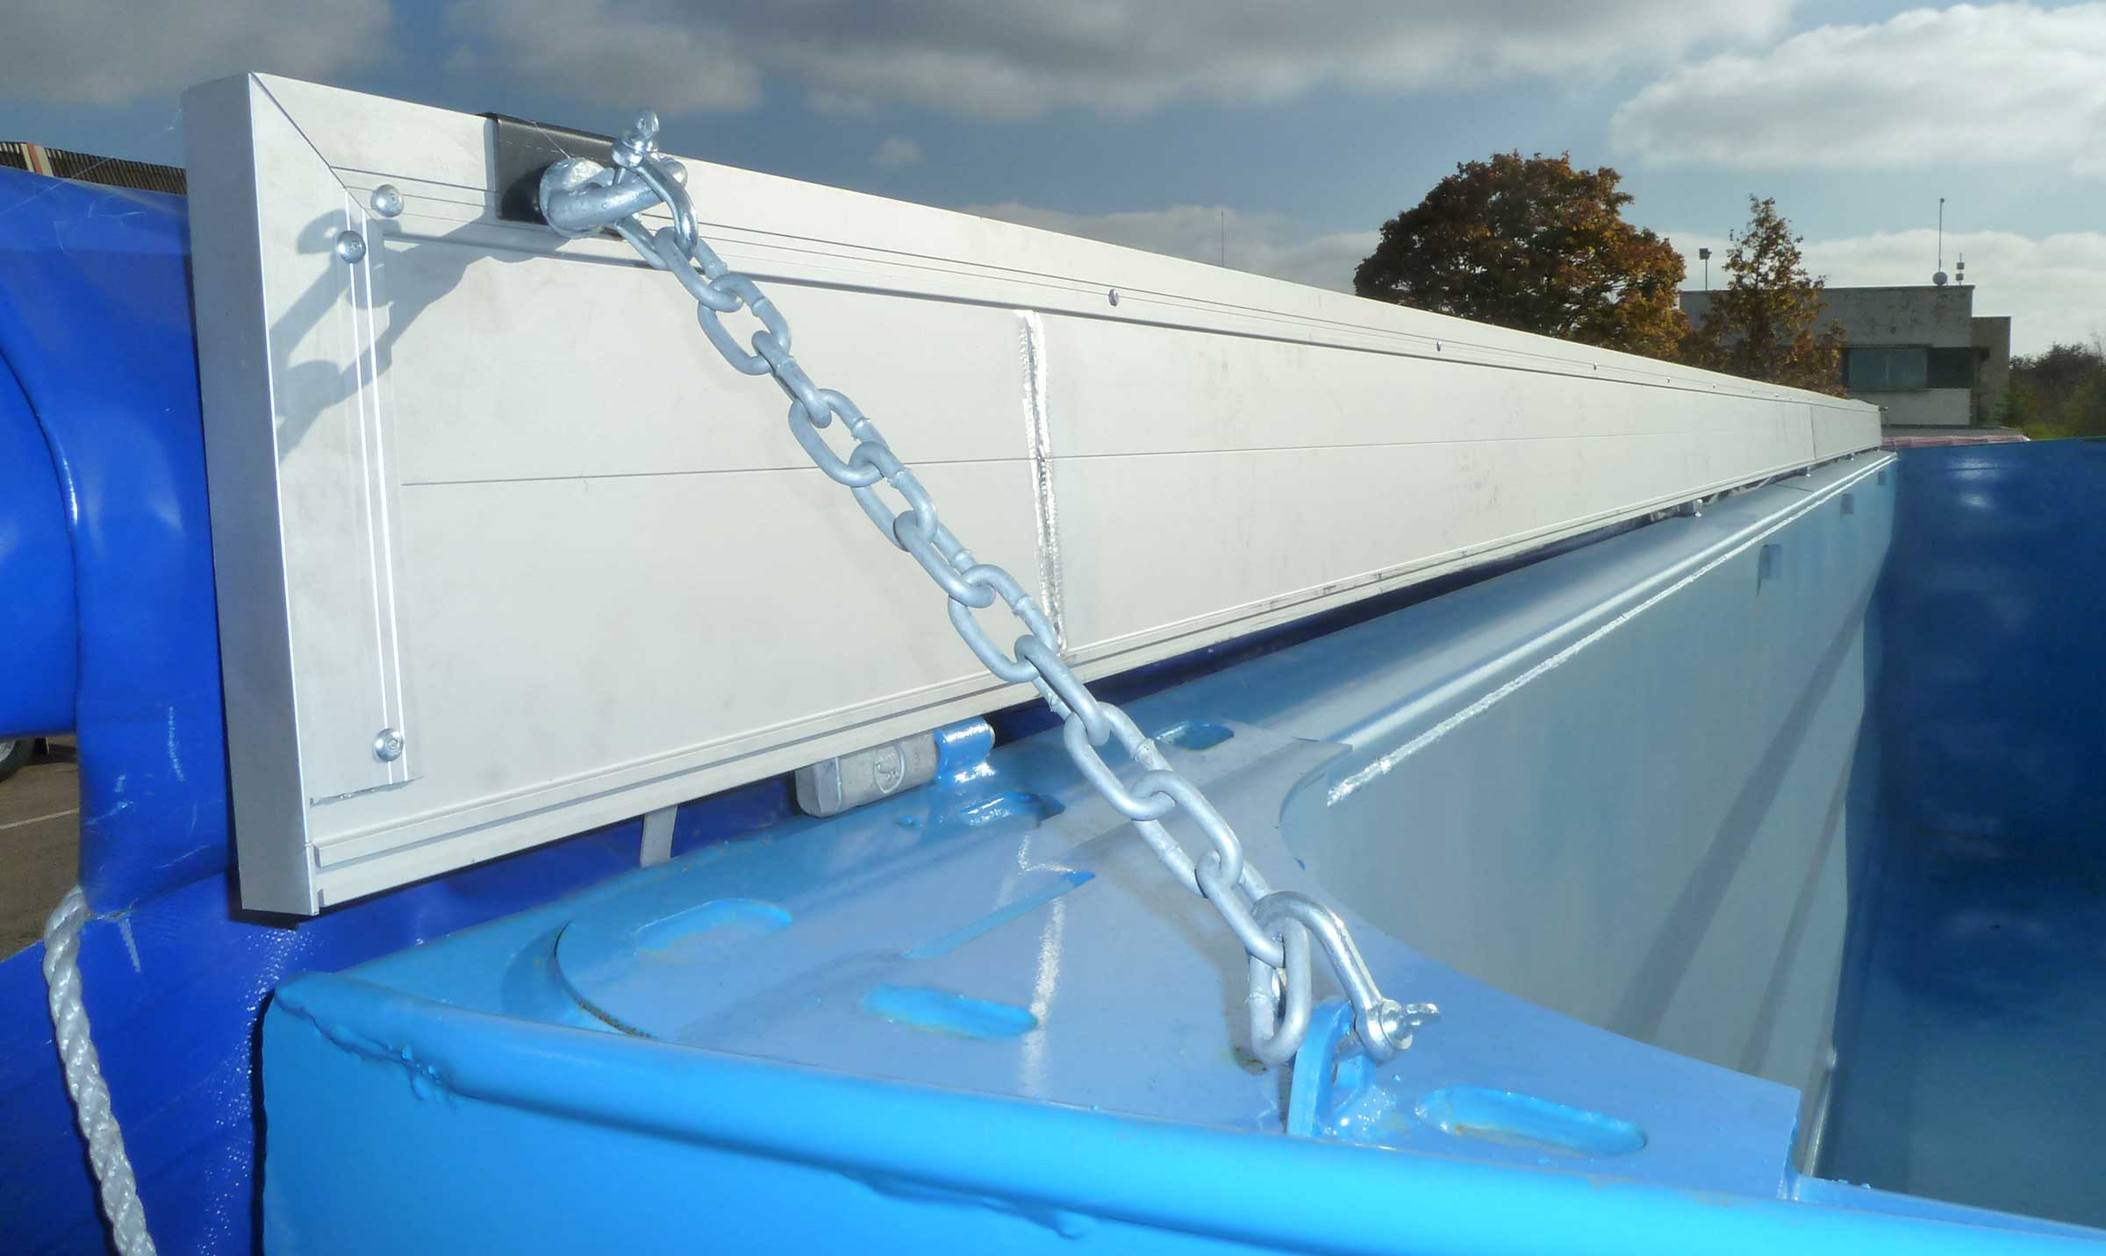
Gallery

Aluminium sheeting protection batten
Bennes GV Scrap
Documentation

Innovations
Fruehauf Large Volume Tippers are designed for maximum safety, focusing on two key aspects:
Safety of users in contact with the vehicle, through ergonomically shaped parts and adapted equipment for ease of use.
Safe road behavior with integrated electronic driver assistance systems improving the vehicle's passive and active safety.
- Ergonomics and aesthetics
- Adapted equipment
- Driver assistance
SafeParkingGuillaume Calviac2021-01-15T11:41:43+01:00
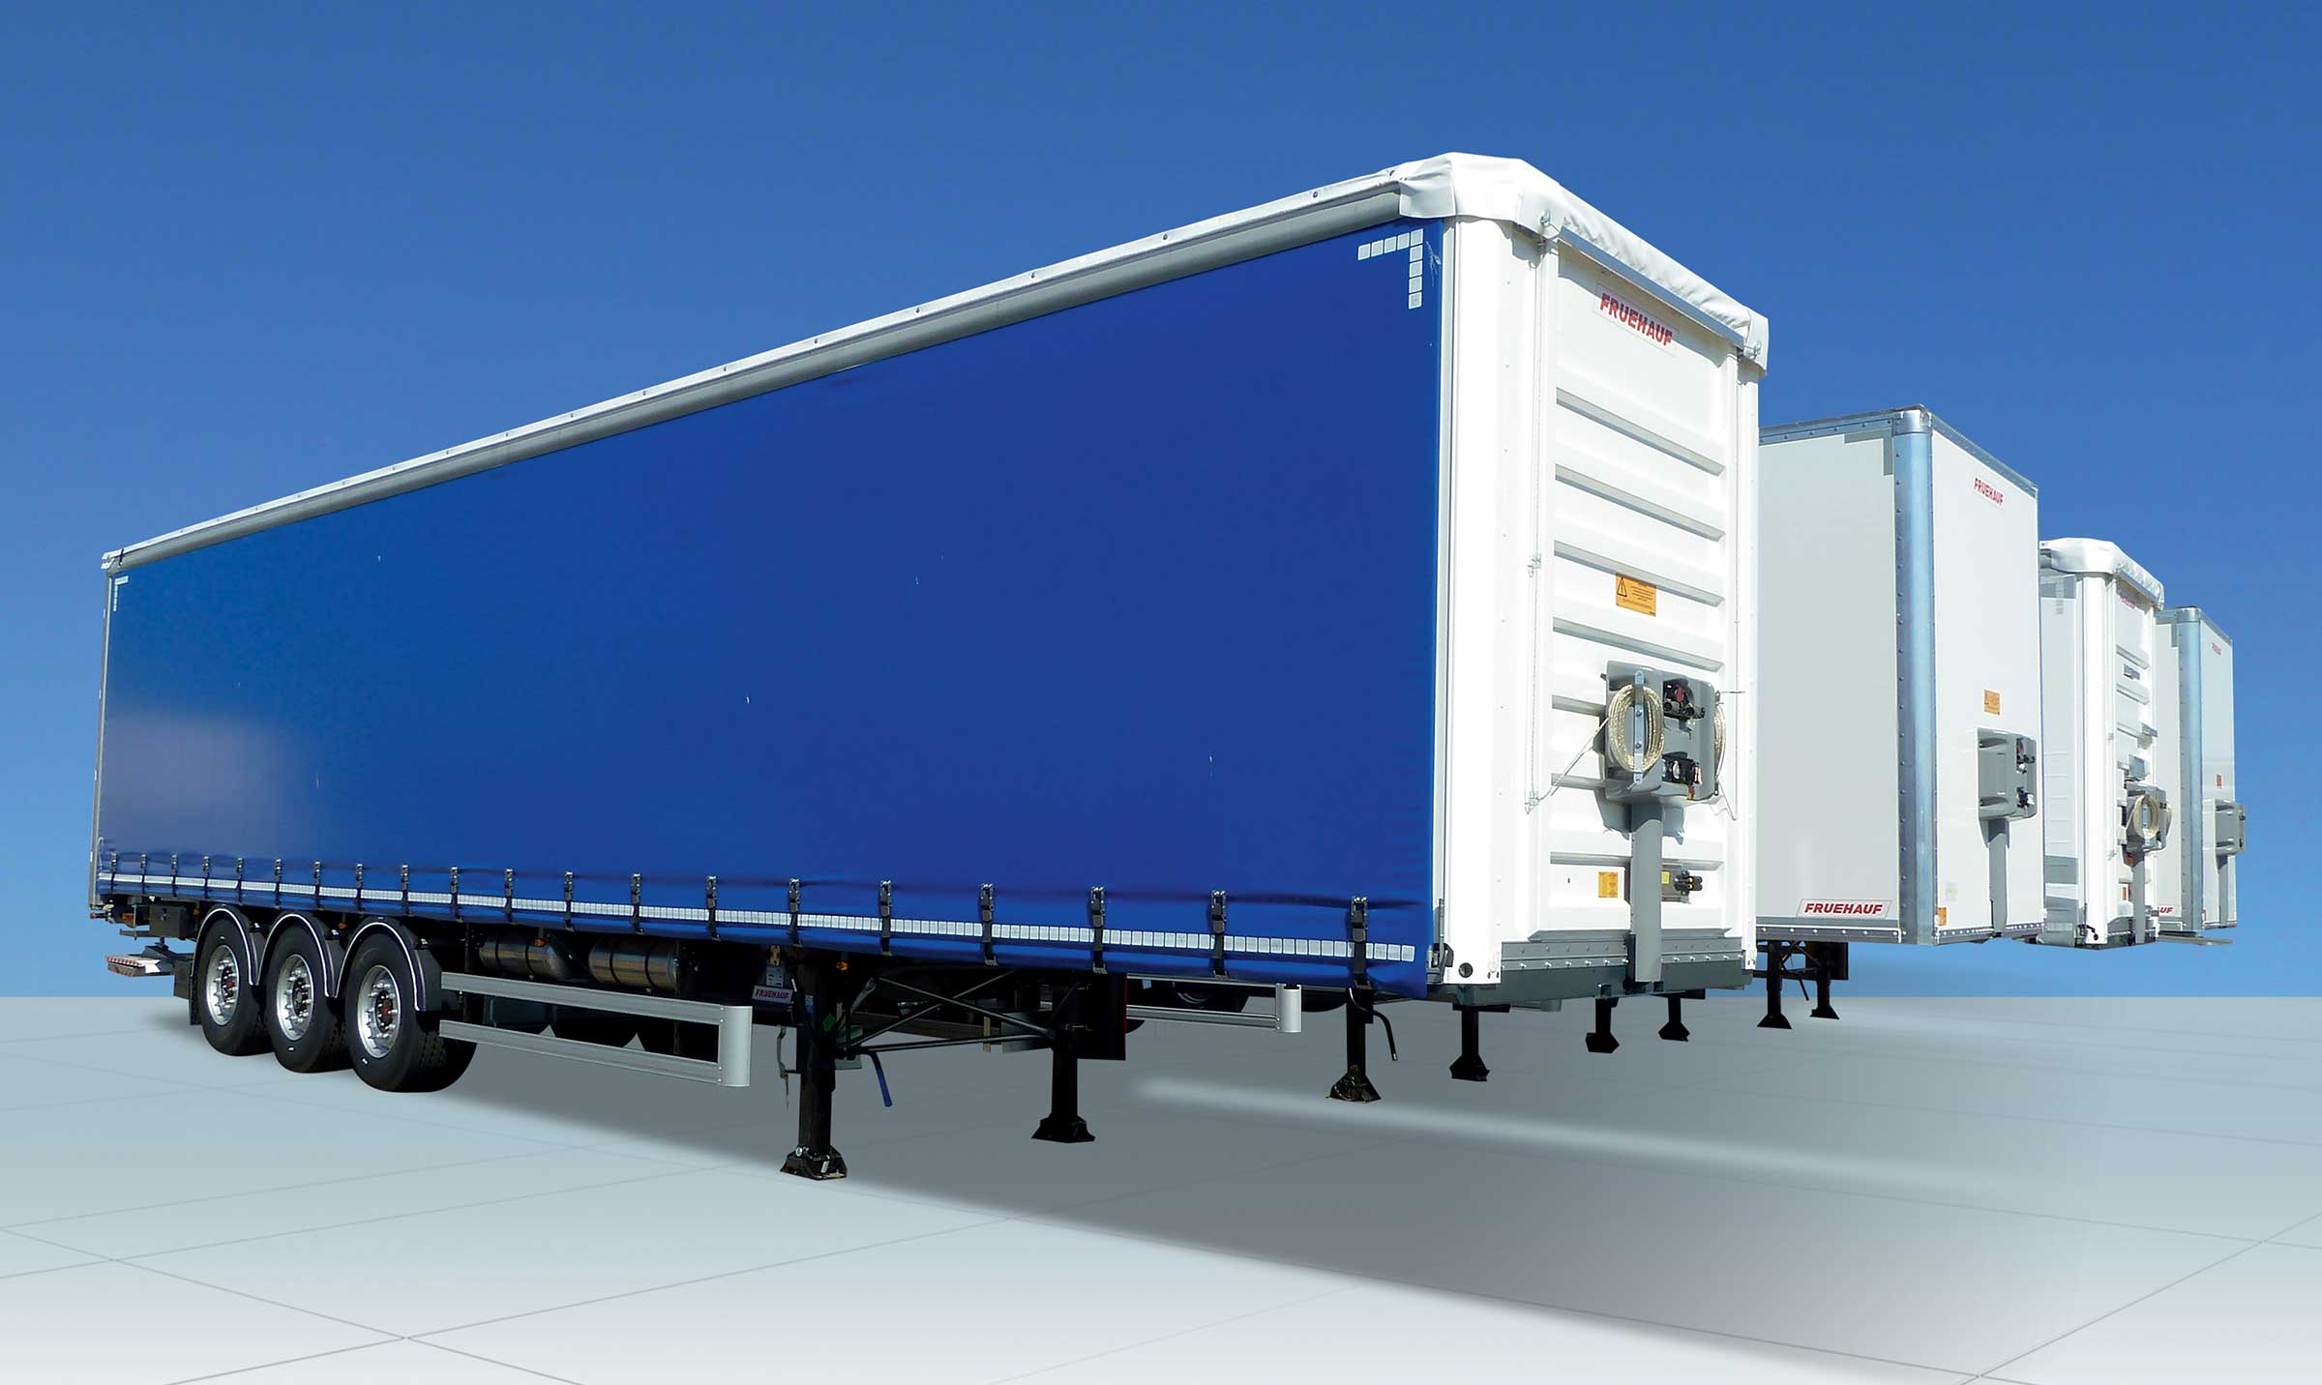
Gallery

SafeParking
Innovations - SafeParking, Innovations Base EN
TelematicsGuillaume Calviac2021-01-29T13:44:33+01:00
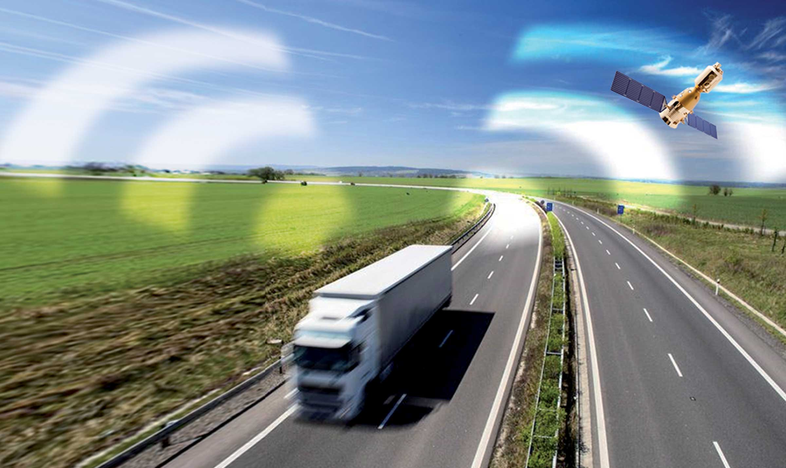
Gallery

Telematics
Innovations - Télématique, Innovations Base EN
RCPGuillaume Calviac2021-01-15T11:33:18+01:00
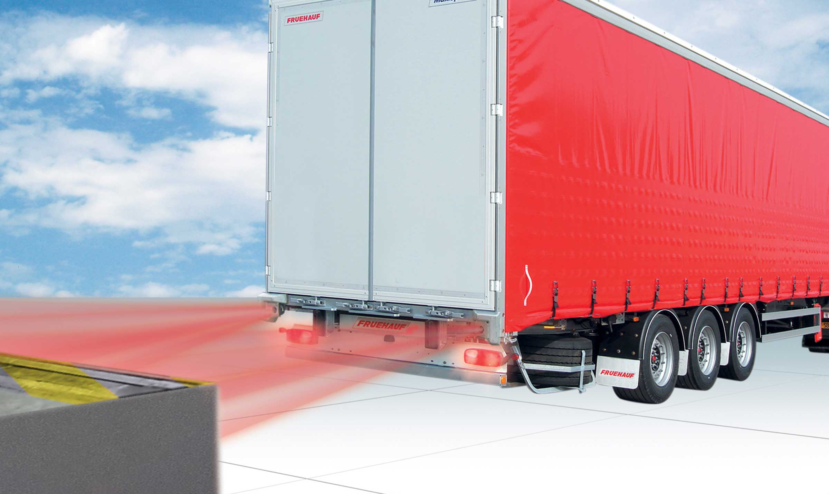
Gallery

RCP
Innovations - RCP, Innovations Base EN
APCSGuillaume Calviac2021-01-15T11:24:21+01:00
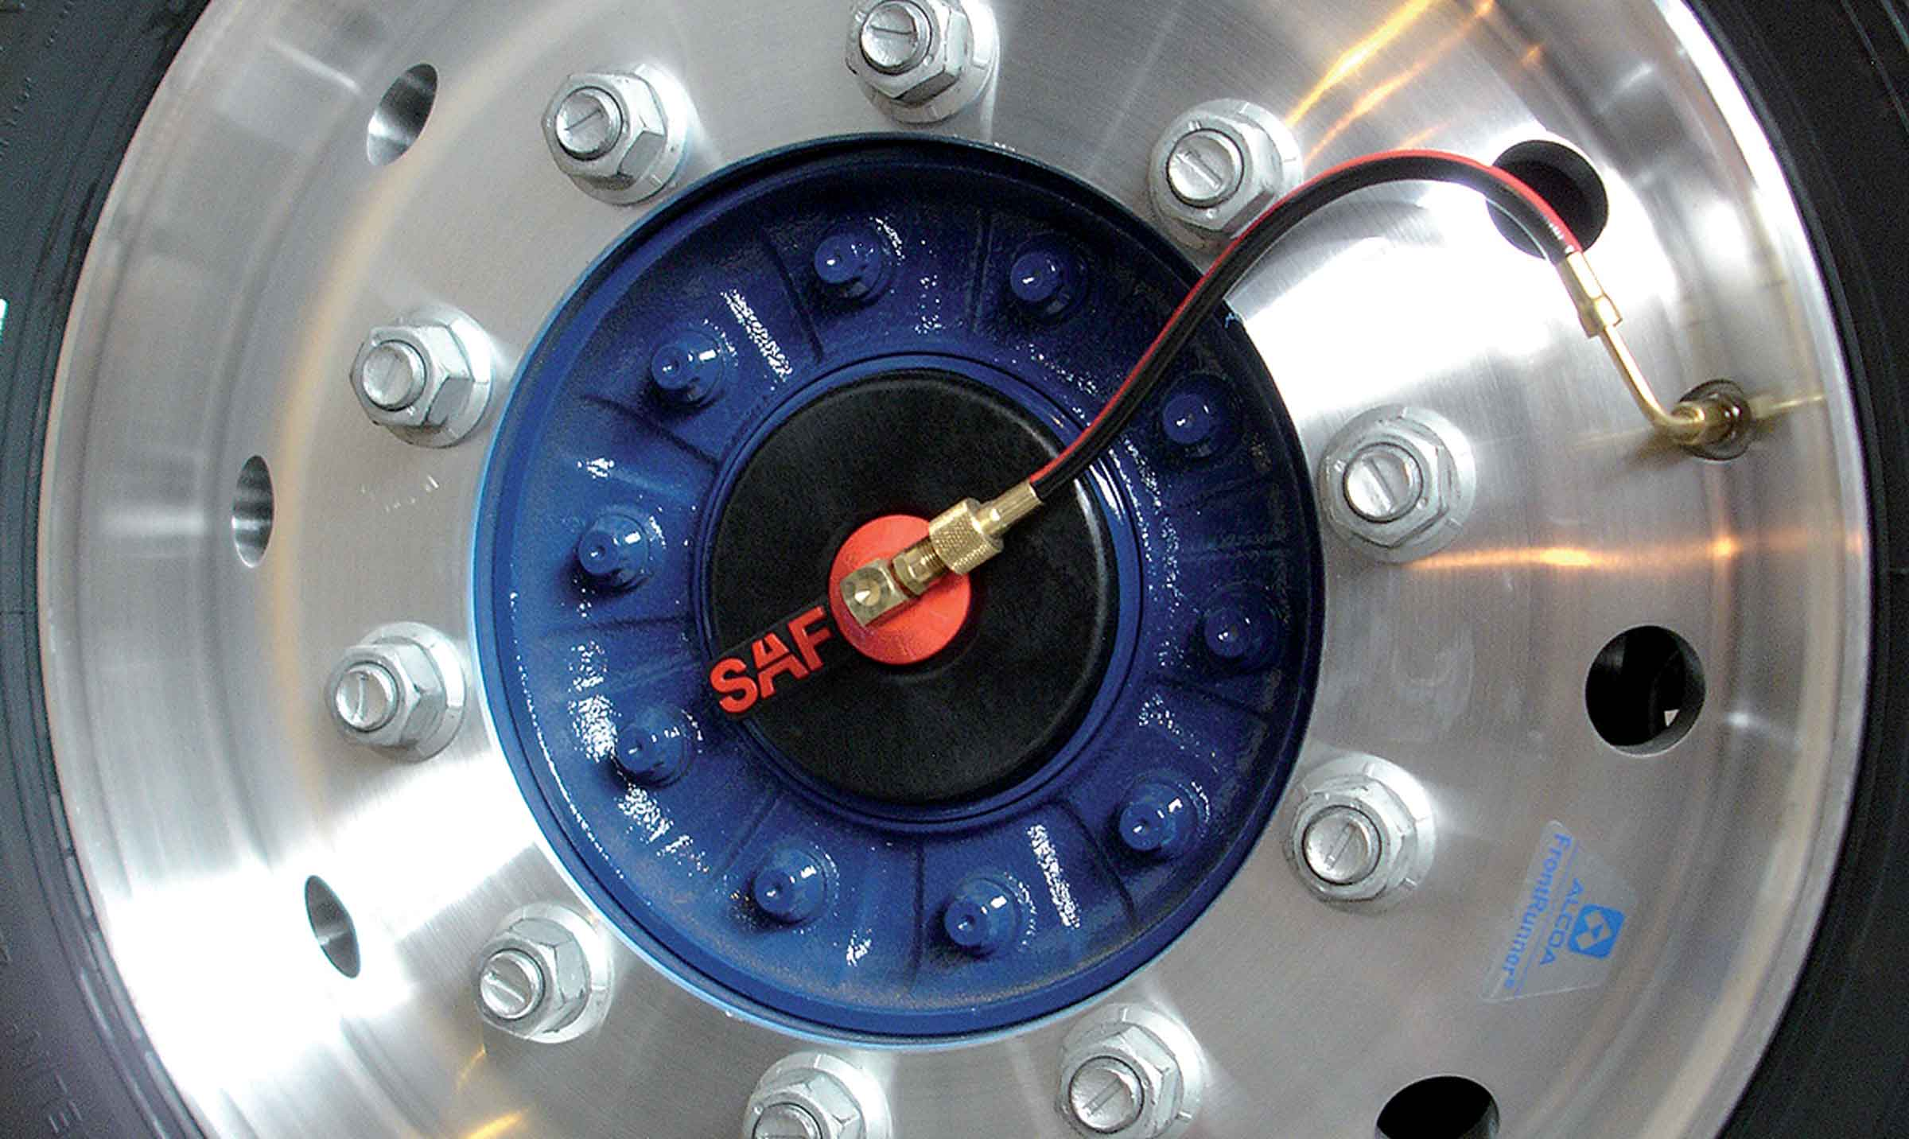
Gallery

APCS
Innovations APCS, Innovations Base EN
EBSGuillaume Calviac2021-01-15T11:24:12+01:00
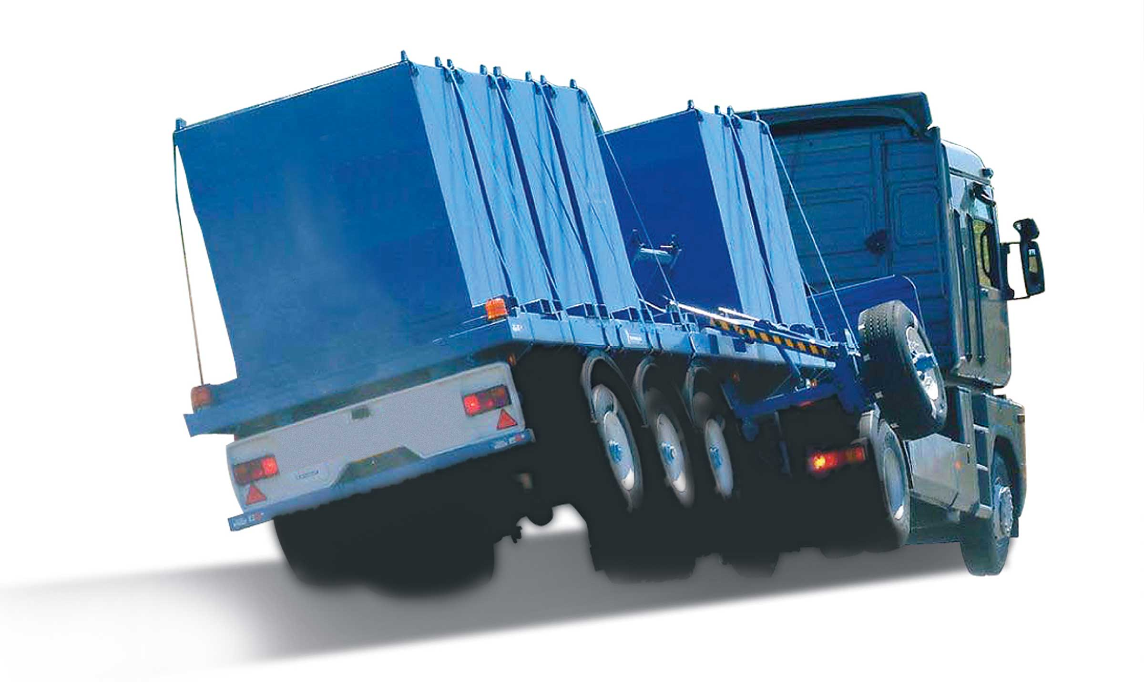
Gallery

EBS
Innovations Base EN
TPMSGuillaume Calviac2021-01-29T08:34:38+01:00
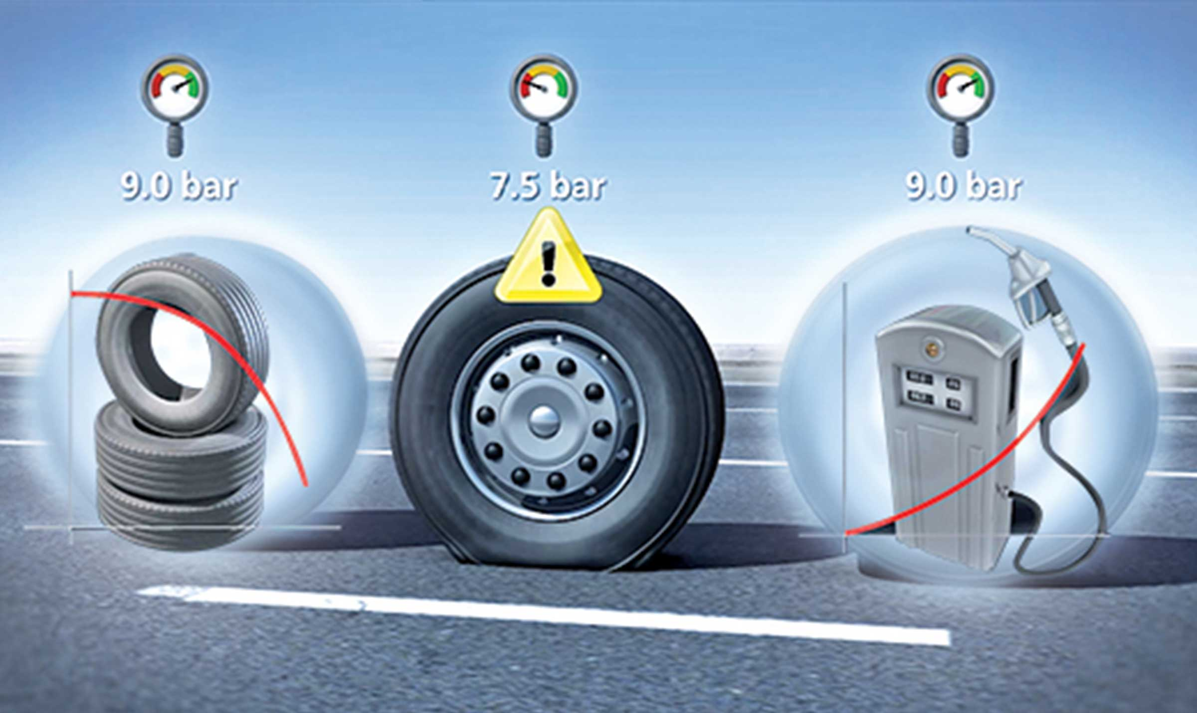
Gallery

TPMS
Innovations - TPMS, Innovations Base EN
Documentation
Demo Videos

Metadata
pyre_slider_type | no
pyre_slider | 0
pyre_wooslider
pyre_revslider | 0
pyre_elasticslider | 0
pyre_slider_position | default
pyre_avada_rev_styles | default
pyre_fallback
pyre_fallback_id
pyre_demo_slider
pyre_main_top_padding
pyre_main_bottom_padding
pyre_hundredp_padding
pyre_show_first_featured_image | no
pyre_display_header | yes
pyre_header_100_width | default
pyre_combined_header_bg_color
pyre_mobile_header_bg_color
pyre_header_bg
pyre_header_bg_id
pyre_header_bg_full | no
pyre_header_bg_repeat | repeat
pyre_displayed_menu | default
pyre_display_footer | default
pyre_display_copyright | default
pyre_footer_100_width | default
pyre_sidebar_position | default
pyre_responsive_sidebar_order
pyre_sidebar_sticky | default
pyre_sidebar_bg_color
pyre_page_bg_layout | default
pyre_page_bg_color
pyre_page_bg
pyre_page_bg_id
pyre_page_bg_full | default
pyre_page_bg_repeat | default
pyre_wide_page_bg_color
pyre_wide_page_bg
pyre_wide_page_bg_id
pyre_wide_page_bg_full | default
pyre_wide_page_bg_repeat | default
pyre_page_title | default
pyre_page_title_breadcrumbs_search_bar | default
pyre_page_title_text | default
pyre_page_title_text_alignment | default
pyre_page_title_custom_text
pyre_page_title_text_size
pyre_page_title_line_height
pyre_page_title_font_color
pyre_page_title_custom_subheader
pyre_page_title_custom_subheader_text_size
pyre_page_title_subheader_font_color
pyre_page_title_100_width | default
pyre_page_title_height
pyre_page_title_mobile_height
pyre_page_title_bar_bg_color
pyre_page_title_bar_borders_color
pyre_page_title_bar_bg
pyre_page_title_bar_bg_id
pyre_page_title_bar_bg_retina
pyre_page_title_bar_bg_retina_id
pyre_page_title_bar_bg_full | default
pyre_page_title_bg_parallax | default
fusion_builder_status | active
kd_featured-image-2_page_id
kd_featured-image-3_page_id
kd_featured-image-4_page_id
kd_featured-image-5_page_id
sbg_selected_sidebar | Array
sbg_selected_sidebar_replacement | Array
sbg_selected_sidebar_2 | Array
sbg_selected_sidebar_2_replacement | Array
avada_post_views_count | 293
avada_today_post_views_count | 2
avada_post_views_count_today_date | 12-12-2023

