Documentations Fruehauf
Author | Françoise Bernerd
Date | 2017-03-06 07:14:06
Categories

TÉLÉCHARGEMENT DE BROCHURES
Vous pouvez maintenant cliquer sur l'image correspondant à la brochure que vous souhaitez télécharger

Rideaux coulissants

Fourgons

Gamme City et Urban
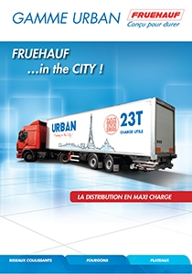
Gamme City et Urban

Porte conteneurs

Remorques

Bennes travaux publics
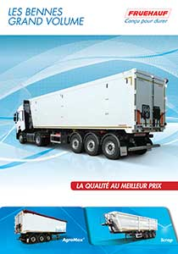
Bennes grand volume
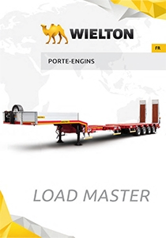
Porte-Engins

Innovations
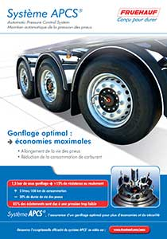
APCS
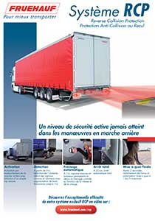
RCP

EASY UP

Metadata
fusion_builder_status | active
pyre_slider_type | no
pyre_slider | 0
pyre_wooslider
pyre_revslider | 0
pyre_elasticslider | 0
pyre_slider_position | default
pyre_avada_rev_styles | default
pyre_fallback
pyre_demo_slider
pyre_main_top_padding
pyre_main_bottom_padding
pyre_hundredp_padding
pyre_show_first_featured_image | no
pyre_display_header | yes
pyre_header_100_width | default
pyre_header_bg_color
pyre_header_bg_opacity
pyre_header_bg
pyre_header_bg_full | no
pyre_header_bg_repeat | repeat
pyre_displayed_menu | default
pyre_display_footer | default
pyre_display_copyright | default
pyre_footer_100_width | default
pyre_sidebar_position | default
pyre_sidebar_bg_color
pyre_page_bg_layout | default
pyre_page_bg_color
pyre_page_bg
pyre_page_bg_full | no
pyre_page_bg_repeat | repeat
pyre_wide_page_bg_color
pyre_wide_page_bg
pyre_wide_page_bg_full | no
pyre_wide_page_bg_repeat | repeat
pyre_page_title | default
pyre_page_title_breadcrumbs_search_bar | default
pyre_page_title_text | default
pyre_page_title_text_alignment | default
pyre_page_title_custom_text
pyre_page_title_text_size
pyre_page_title_custom_subheader
pyre_page_title_custom_subheader_text_size
pyre_page_title_font_color
pyre_page_title_100_width | default
pyre_page_title_height
pyre_page_title_mobile_height
pyre_page_title_bar_bg_color
pyre_page_title_bar_borders_color
pyre_page_title_bar_bg
pyre_page_title_bar_bg_retina
pyre_page_title_bar_bg_full | default
pyre_page_title_bg_parallax | default
pyre_sidebar_sticky | default
pyre_page_title_line_height
kd_featured-image-2_page_id
kd_featured-image-3_page_id
kd_featured-image-4_page_id
kd_featured-image-5_page_id
sbg_selected_sidebar | Array
sbg_selected_sidebar_replacement | Array
sbg_selected_sidebar_2 | Array
sbg_selected_sidebar_2_replacement | Array
avada_post_views_count | 685
avada_today_post_views_count | 6
avada_post_views_count_today_date | 12-12-2023

