Demo Videos
Author | Guillaume Calviac
Date | 2021-06-03 15:38:11
Categories

DEMO VIDEOS

FALCON : The future at work
Product details
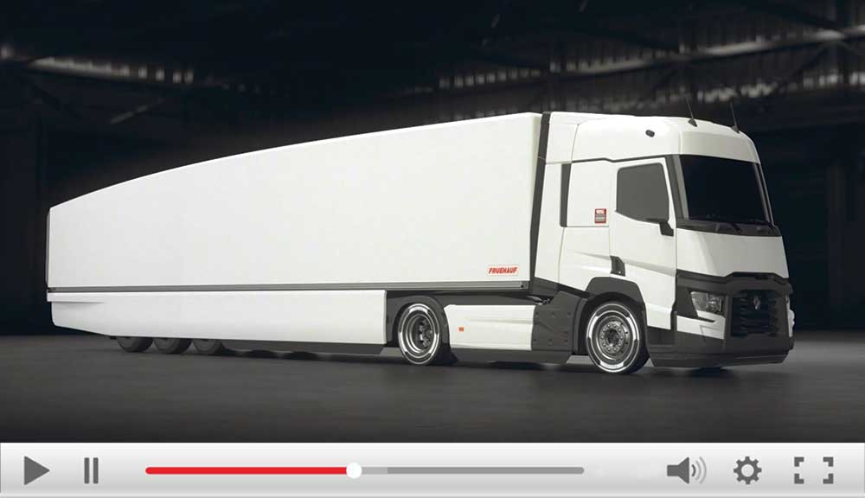
×

The future on the move
http://vod.infomaniak.com/redirect/fruehauf_vod/folder-39671/mp4-322/fruehauf-falcon-2018.mp4
Close
FALCON : The future at work

Innovations
Product details
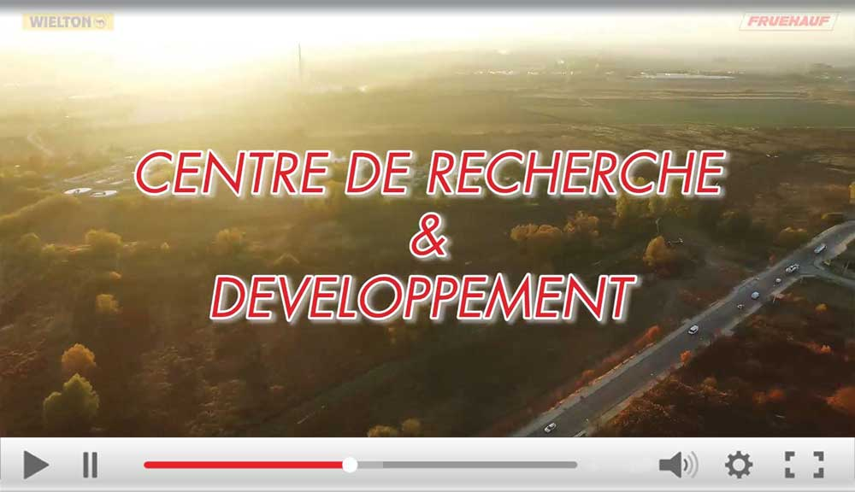
×

Search and Development Centre
http://vod.infomaniak.com/redirect/fruehauf_vod/folder-39671/mp4-322/fruehauf-centrederd-md-1920x1080p.mp4
Close
Search and Development Centre
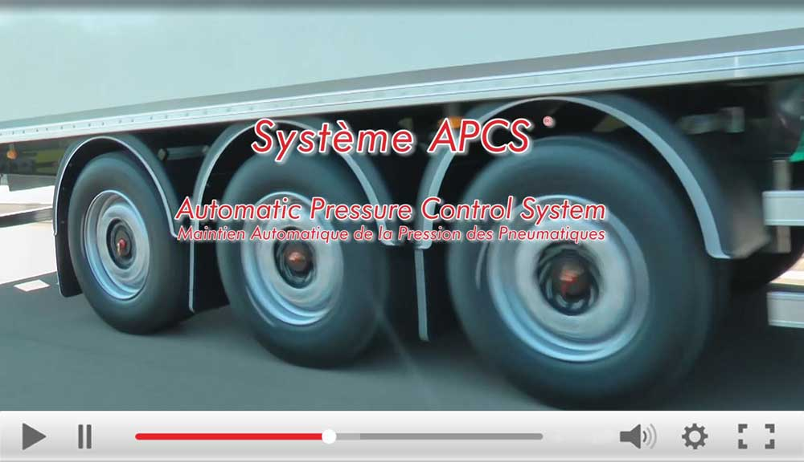
×

Innovations - APCS
http://vod.infomaniak.com/redirect/fruehauf_vod/folder-39671/mp4-226/fruehauf-apcs-hd1920x1080.mp4
Close
APCS - Automatic Pressure Control System
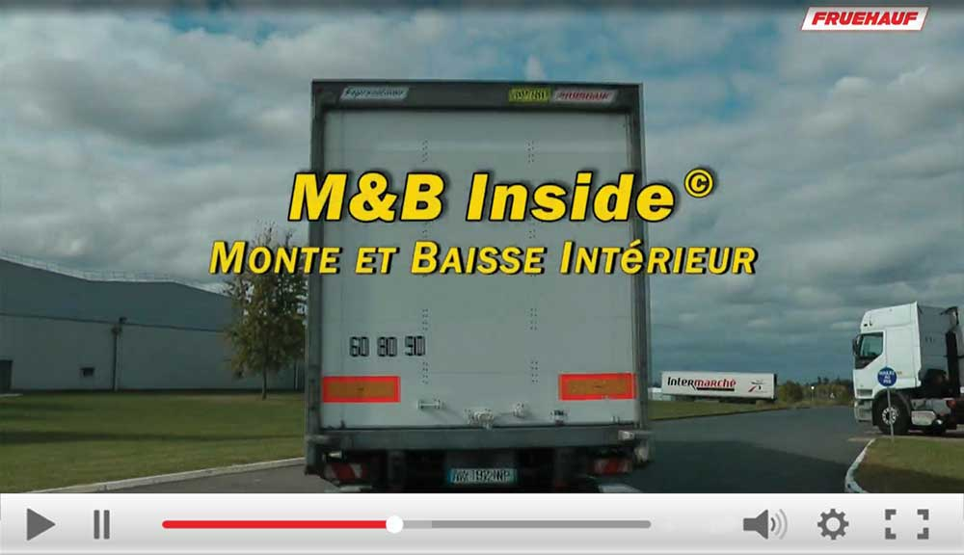
×

Raise & Lower Inside
http://vod.infomaniak.com/redirect/fruehauf_vod/folder-39671/mp4-323/mbaisseinsidev2-1920x1080xh264.mp4
Close
M&B Inside - Raise & Lower command Inside
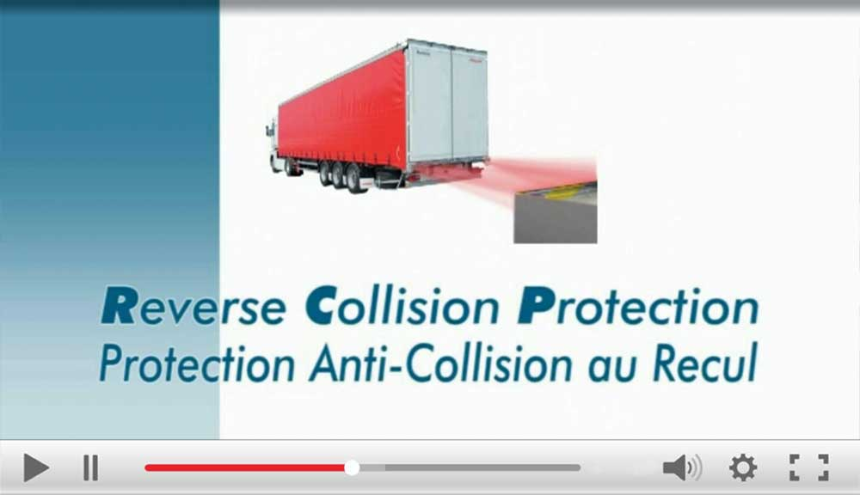
×

RCP
http://vod.infomaniak.com/redirect/fruehauf_vod/folder-39671/mp4-322/rcp_1024x576.mp4
Close
RCP - Reverse Collision Protection
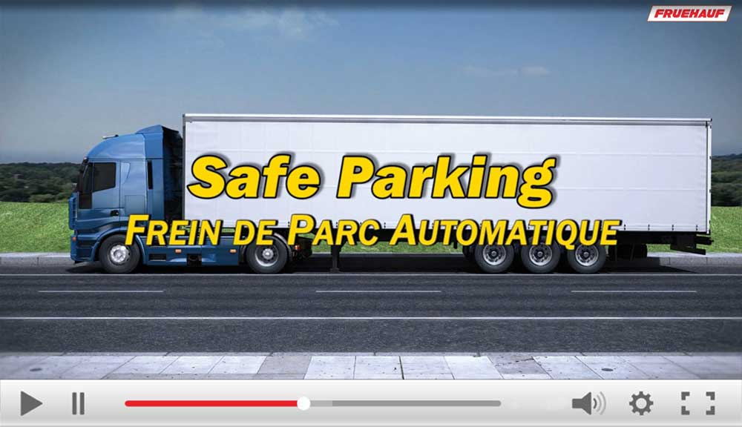
×

SafeParking
http://vod.infomaniak.com/redirect/fruehauf_vod/folder-39671/mp4-322/fruehauf-safeparking-hd1280x720.mp4
Close
SafeParking - Automatic parking brake
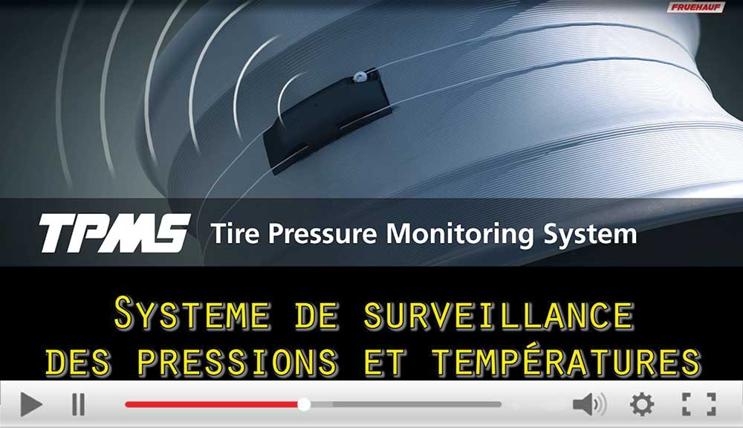
×

Innovations -TPMS
http://vod.infomaniak.com/redirect/fruehauf_vod/folder-39671/mp4-323/fruehauf-tpms-hd1920x1080.mp4
Close
TPMS - Tire Pressure Monitoring System
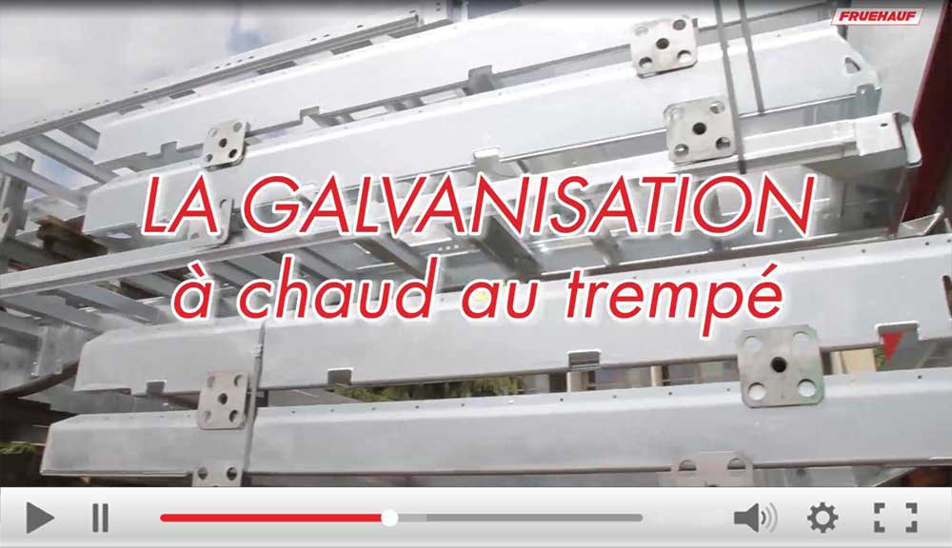
×

Innovations - Galvanisation
http://vod.infomaniak.com/redirect/fruehauf_vod/folder-39671/mp4-322/fruehauf-lanticorrosionpargalvanisationachaud-hd-1920x1080px25-mp4h264.mp4
Close
Galvanisation

The City range
Product details
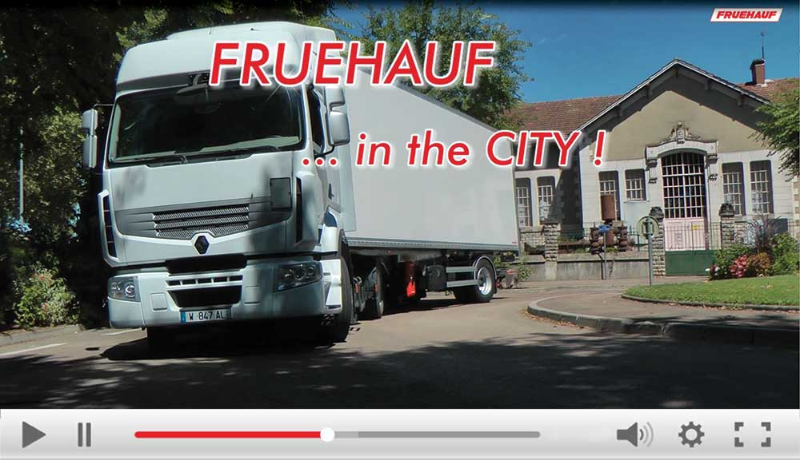
×

Innovations - Live in Auxerre
http://vod.infomaniak.com/redirect/fruehauf_vod/folder-39671/mp4-322/fruehaufinthecity-liveinauxerre-h264-1920x1080px25.mp4
Close
Live in Auxerre
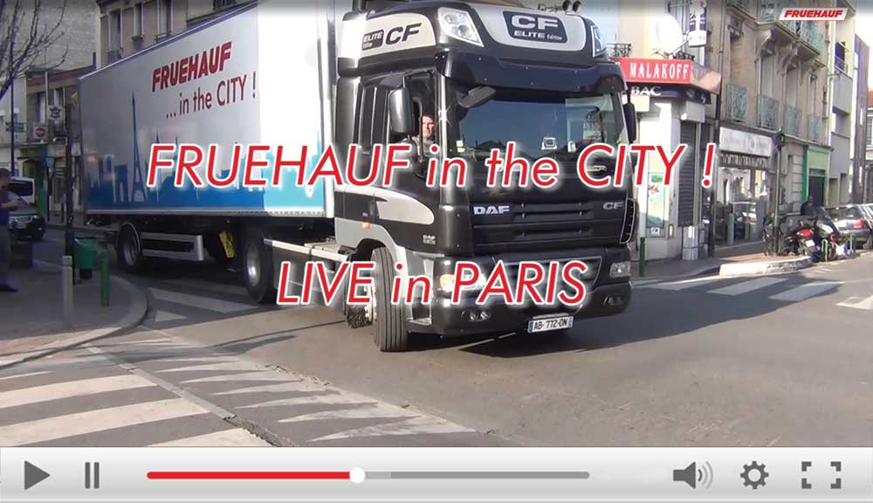
×

Innovations - Live in Paris
http://vod.infomaniak.com/redirect/fruehauf_vod/fruehauf2-39671/mp4-1072/fruehaufinthecity-liveinparis-hd1440x1080.mp4
Close
Live in Paris
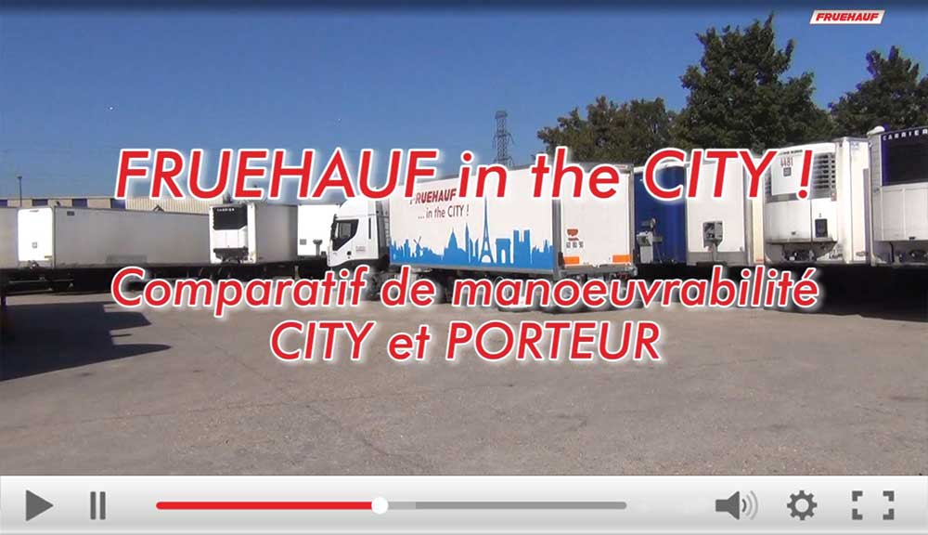
×

Innovations - City vs Porteur
http://vod.infomaniak.com/redirect/fruehauf_vod/folder-39671/mp4-323/cityfruehauf-vsporteur-hd-1920x1080px25-mp4h264.mp4
Close
Comparison of City and Carrier manoeuvrability
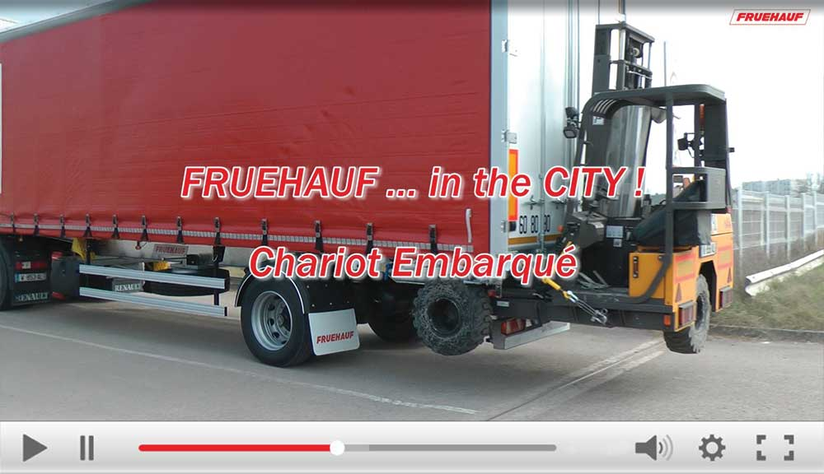
×

Innovations - Chariot embarqué
http://vod.infomaniak.com/redirect/fruehauf_vod/folder-39671/mp4-322/fruehaufinthecity-chariotembarque-1920x1080x25p.mp4
Close
City - On-board trolley
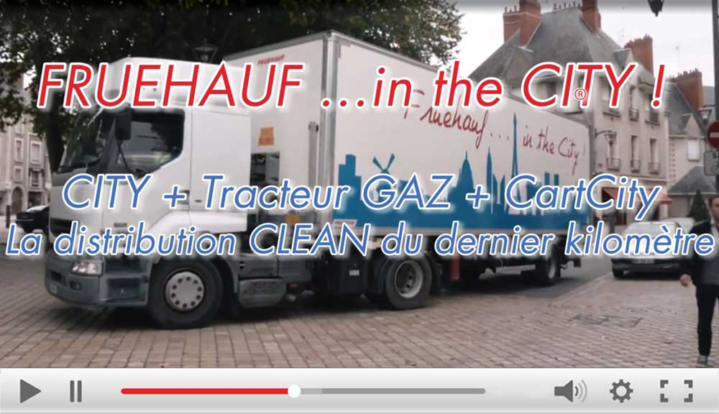
×

Innovations - La distribution Clean
http://vod.infomaniak.com/redirect/fruehauf_vod/folder-39671/mp4-226/fruehaufcity-ladistributionclean.mp4
Close
Clean distribution
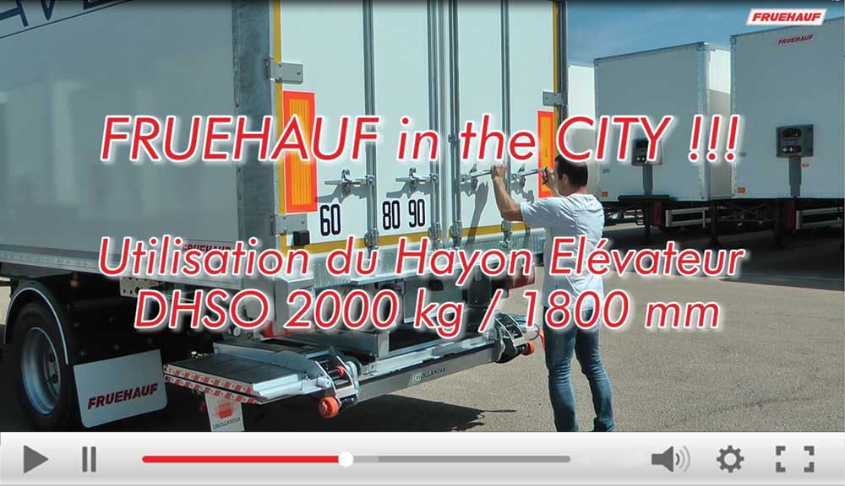
×

Innovations - Utilisation hayon DHSO
http://vod.infomaniak.com/redirect/fruehauf_vod/folder-39671/mp4-322/fruehaufcity-guideutilisationhayondhso-hd1080.mp4
Close
Using the DHSO tailgate

The curtainsiders
Product details
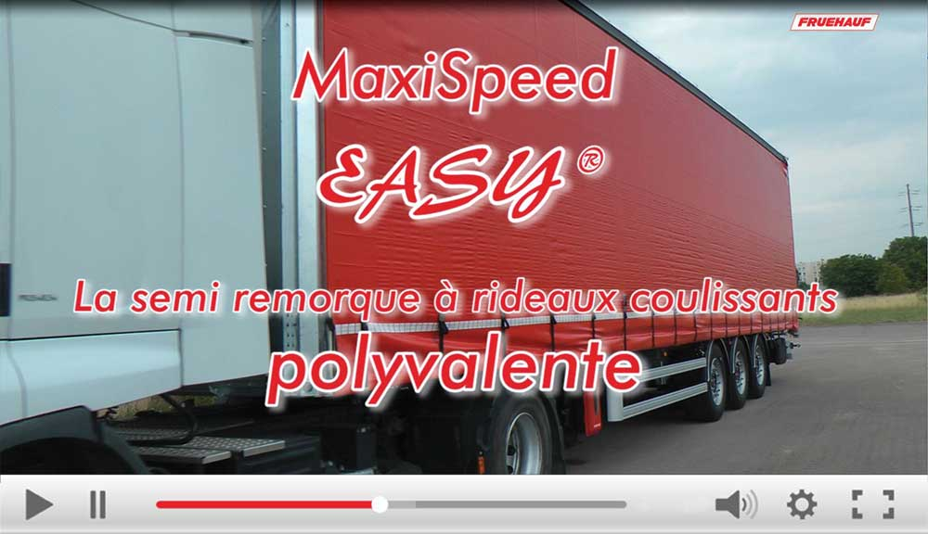
×

Innovations - Easy
http://vod.infomaniak.com/redirect/fruehauf_vod/folder-39671/mp4-323/maxispeed_easy_mp4-h264-1920x1080px25.mp4
Close
The versatile MaxiSpeed EASY
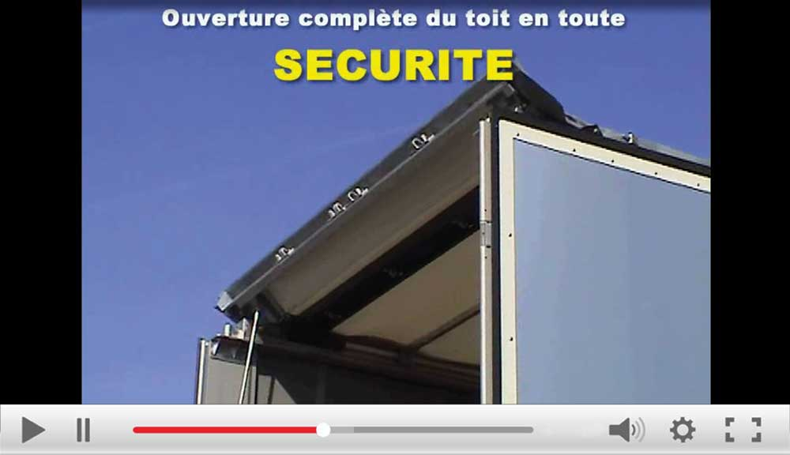
×

Innovations - Integral Open Top
http://vod.infomaniak.com/redirect/fruehauf_vod/folder-39763/mp4-29/iot_720x576.mp4
Close
Integral Open Top - Safe roof opening

The tippers
Product details
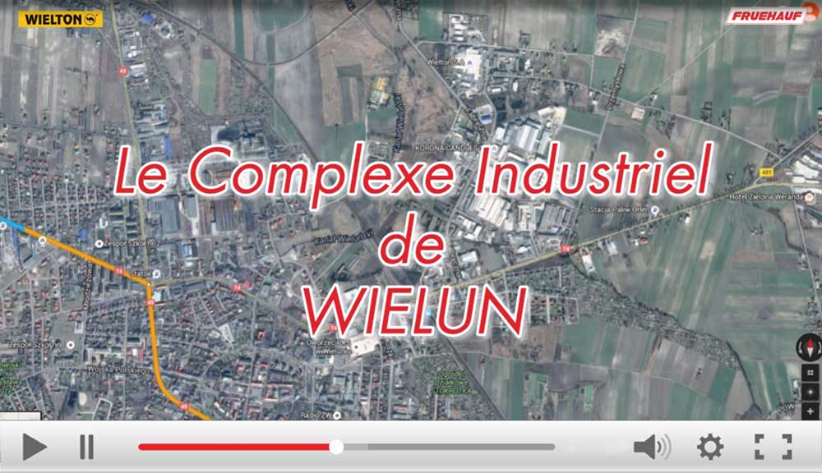
×

Complexe Wielun
http://vod.infomaniak.com/redirect/fruehauf_vod/folder-39671/mp4-322/complexe_industriel_wielun.mp4
Close
Large volume tippers - Wieluń industrial estate

×

The tipper with conveyor belt
http://vod.infomaniak.com/redirect/fruehauf_vod/folder-39671/mp4-322/complexe_industriel_wielun.mp4
Close
The Safe Tipp, the tipper with conveyor belt

Metadata
pyre_slider_type | no
pyre_slider | 0
pyre_wooslider
pyre_revslider | 0
pyre_elasticslider | 0
pyre_slider_position | default
pyre_avada_rev_styles | default
pyre_fallback
pyre_fallback_id
pyre_demo_slider
pyre_main_top_padding
pyre_main_bottom_padding
pyre_hundredp_padding
pyre_show_first_featured_image | no
pyre_display_header | yes
pyre_header_100_width | default
pyre_combined_header_bg_color
pyre_mobile_header_bg_color
pyre_header_bg
pyre_header_bg_id
pyre_header_bg_full | no
pyre_header_bg_repeat | repeat
pyre_displayed_menu | default
pyre_display_footer | default
pyre_display_copyright | default
pyre_footer_100_width | default
pyre_sidebar_position | default
pyre_responsive_sidebar_order
pyre_sidebar_sticky | default
pyre_sidebar_bg_color
pyre_page_bg_layout | default
pyre_page_bg_color
pyre_page_bg
pyre_page_bg_id
pyre_page_bg_full | default
pyre_page_bg_repeat | default
pyre_wide_page_bg_color
pyre_wide_page_bg
pyre_wide_page_bg_id
pyre_wide_page_bg_full | default
pyre_wide_page_bg_repeat | default
pyre_page_title | default
pyre_page_title_breadcrumbs_search_bar | default
pyre_page_title_text | default
pyre_page_title_text_alignment | default
pyre_page_title_custom_text
pyre_page_title_text_size
pyre_page_title_line_height
pyre_page_title_font_color
pyre_page_title_custom_subheader
pyre_page_title_custom_subheader_text_size
pyre_page_title_subheader_font_color
pyre_page_title_100_width | default
pyre_page_title_height
pyre_page_title_mobile_height
pyre_page_title_bar_bg_color
pyre_page_title_bar_borders_color
pyre_page_title_bar_bg
pyre_page_title_bar_bg_id
pyre_page_title_bar_bg_retina
pyre_page_title_bar_bg_retina_id
pyre_page_title_bar_bg_full | default
pyre_page_title_bg_parallax | default
fusion_builder_status | active
kd_featured-image-2_page_id
kd_featured-image-3_page_id
kd_featured-image-4_page_id
kd_featured-image-5_page_id
sbg_selected_sidebar | Array
sbg_selected_sidebar_replacement | Array
sbg_selected_sidebar_2 | Array
sbg_selected_sidebar_2_replacement | Array
pyre_header_bg_color
pyre_header_bg_opacity
avada_post_views_count | 894
avada_today_post_views_count | 1
avada_post_views_count_today_date | 13-12-2023

