Container chassis and swap bodies
Author | Guillaume Calviac
Date | 2021-01-29 14:49:22
Categories

CONTAINER CHASSIS AND SWAP BODIES

The MultiLiner range
Versatile vehicles for transporting all different container models or rail-road swap bodies on vehicles dedicated to a specific use. The Fruehauf MultiLiner range meets all the needs of container and swap body transport.
Each vehicle meets the requirements of intensive, continuous-flow transport: ease of use, quick implementation, optimised operating time.

Sturdiness
Fruehauf has always designed and manufactured equipment that is recognised by the market for its sturdiness. Thanks to their reinforced, mechanically welded chassis, our container chassis are perfect for intensive, harsh applications.

Safety
Our vehicles are designed for maximum safety:
- Safe road behaviour with integrated, latest-generation undercarriage and electronic driver assistance systems improving the vehicle's passive and active safety
- User safety through perfectly adapted ergonomic forms, parts and equipment
The multi purpose
The standards
The dedicated
The swap bodies

The Multiple Purpose
With its versatile vehicles, Fruehauf meets the need to handle numerous container or swap body models with a single chassis in order to optimise operating time. Their ease of use guarantees quick implementation for increased productivity.

MultiFlex

1 x 20' - 30' - 2 x 20'

40' - 45' High Cube
This super versatile model can take all models of container thanks to its wheelbase and overhang extensions and its front gooseneck.
Each of the transport configurations optimises the loads on axles in a reduced overall size.
- Sturdiness
- Reliability
- Adaptability
Reinforced front lipGuillaume Calviac2021-01-14T16:29:34+01:00
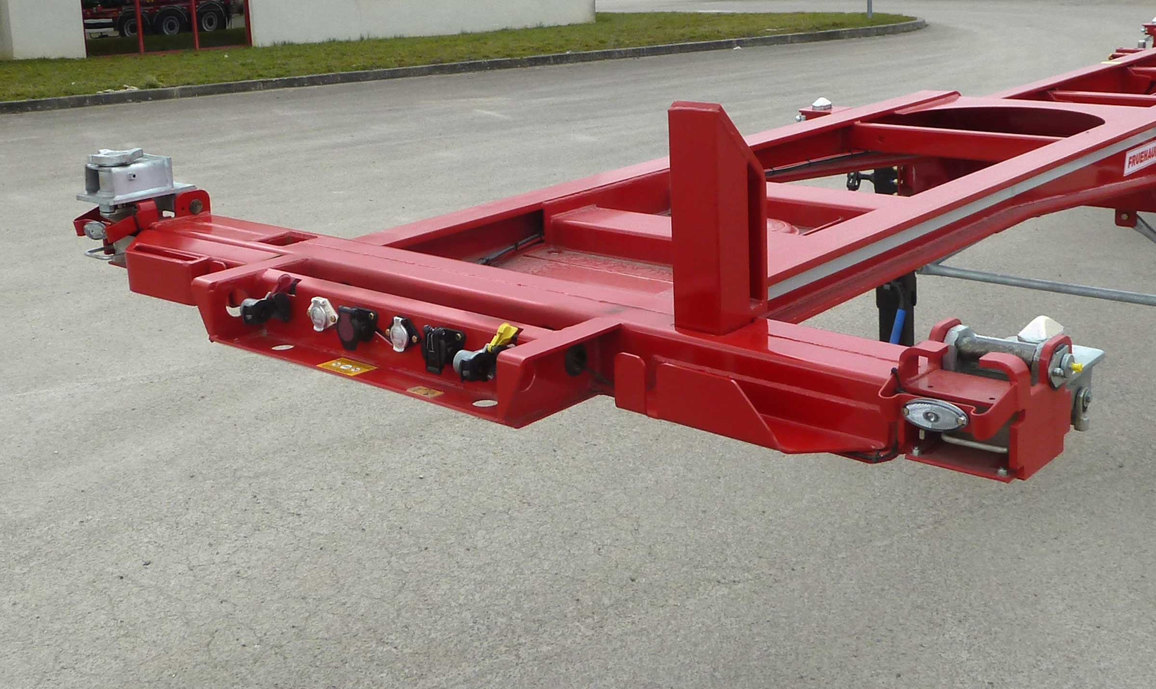
Gallery

Reinforced front lip
Porte Conteneurs Multiflex EN
Telescopic, double-extending chassisGuillaume Calviac2021-01-14T12:19:40+01:00
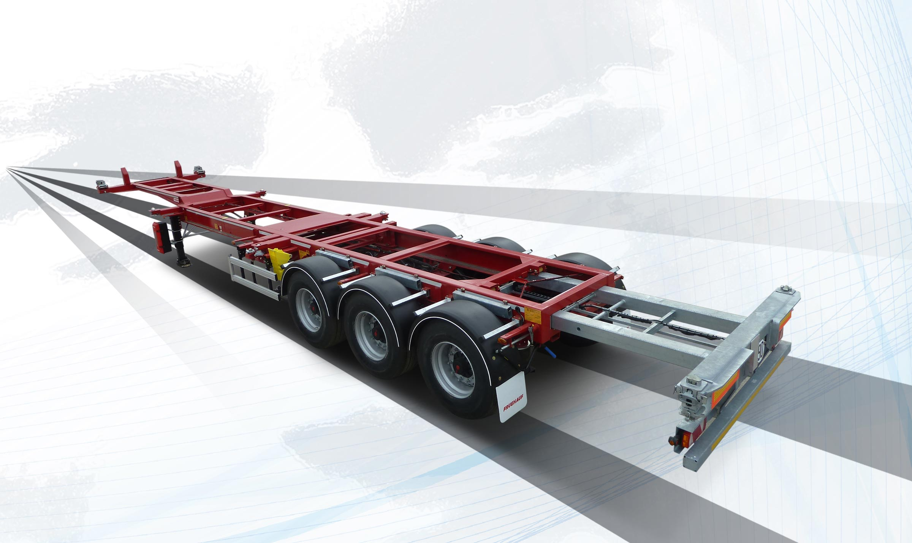
Gallery

Telescopic, double-extending chassis
Porte Conteneurs Multiflex EN
Retractable load transfer chocksGuillaume Calviac2021-01-14T12:16:41+01:00
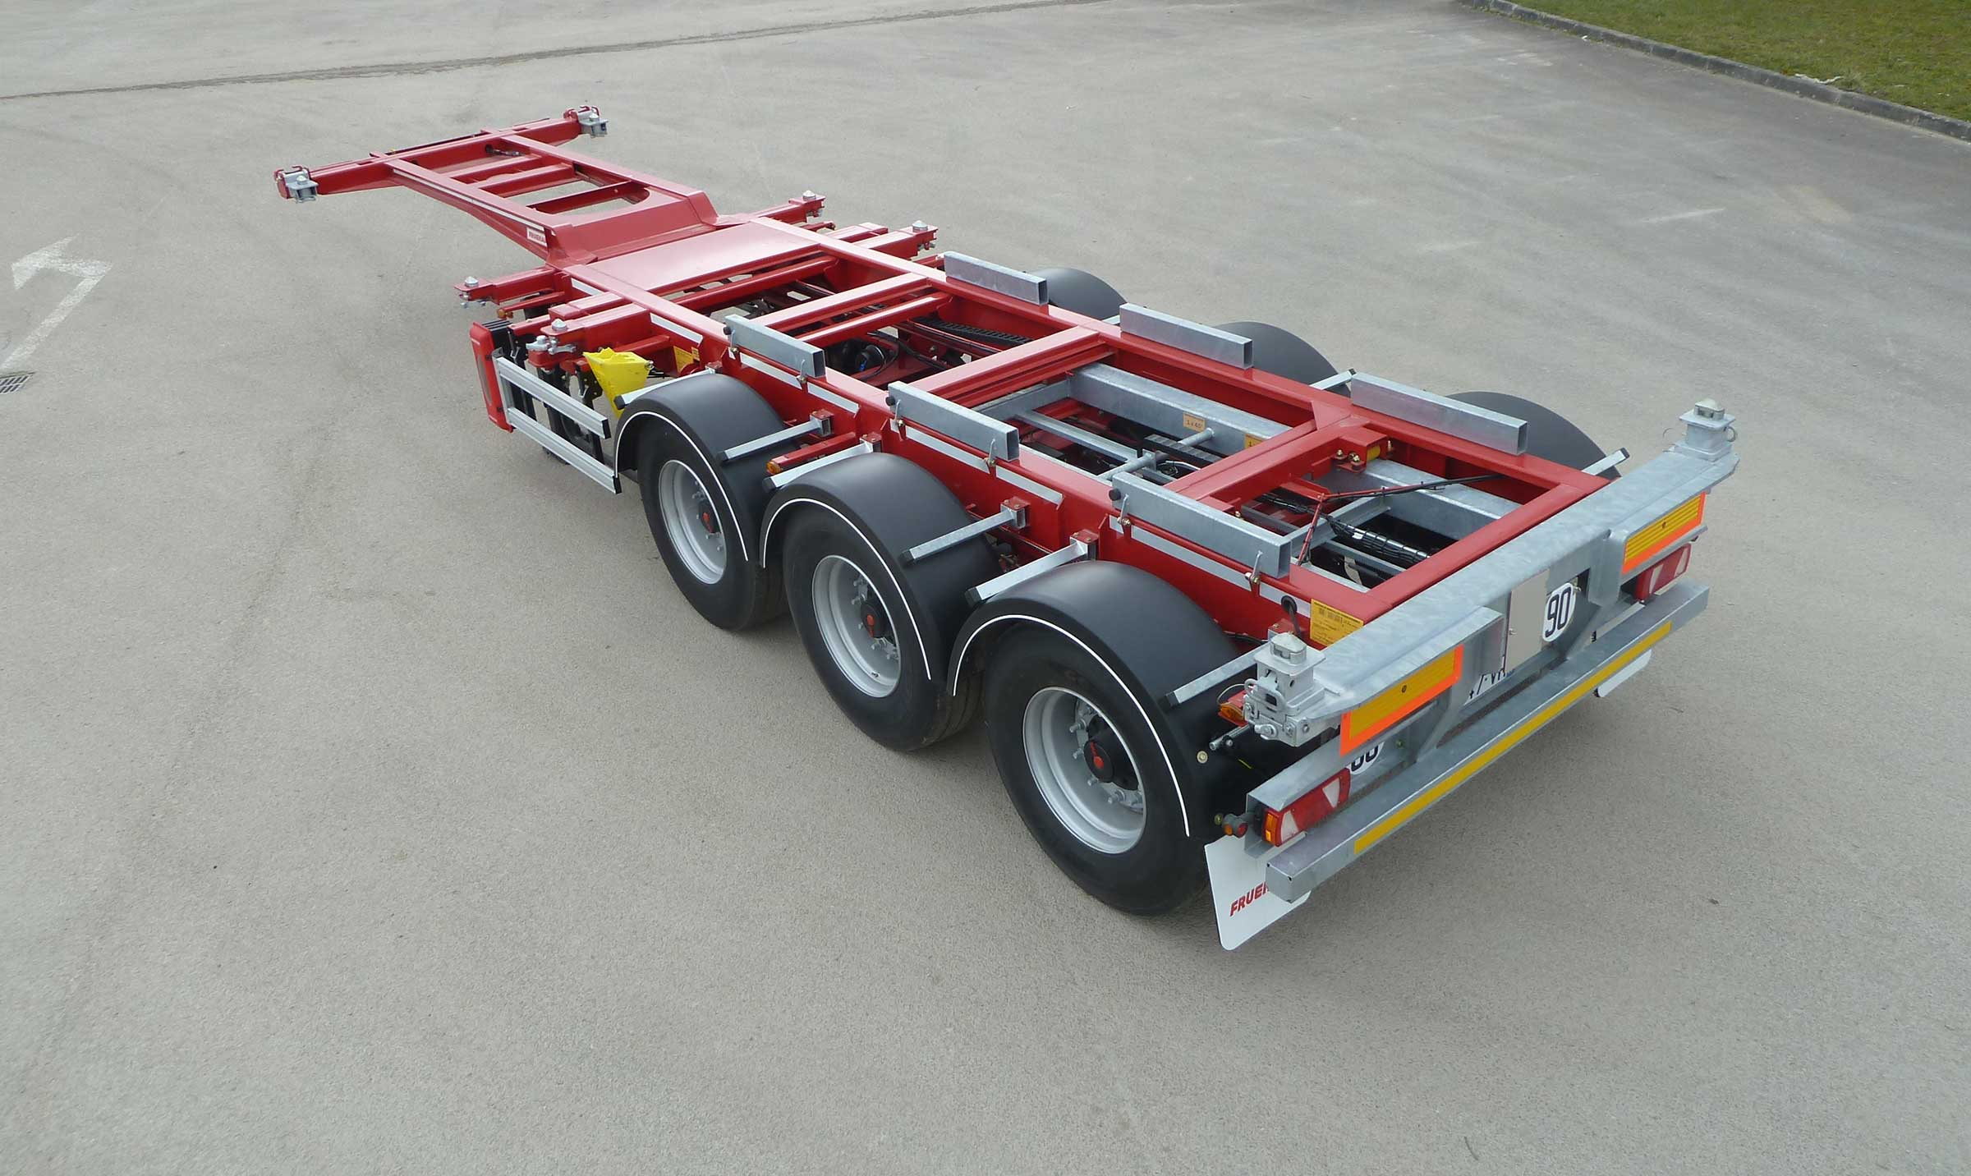
Gallery

Retractable load transfer chocks
Porte Conteneurs Multiflex EN
Sliding subframeGuillaume Calviac2021-01-14T12:15:46+01:00
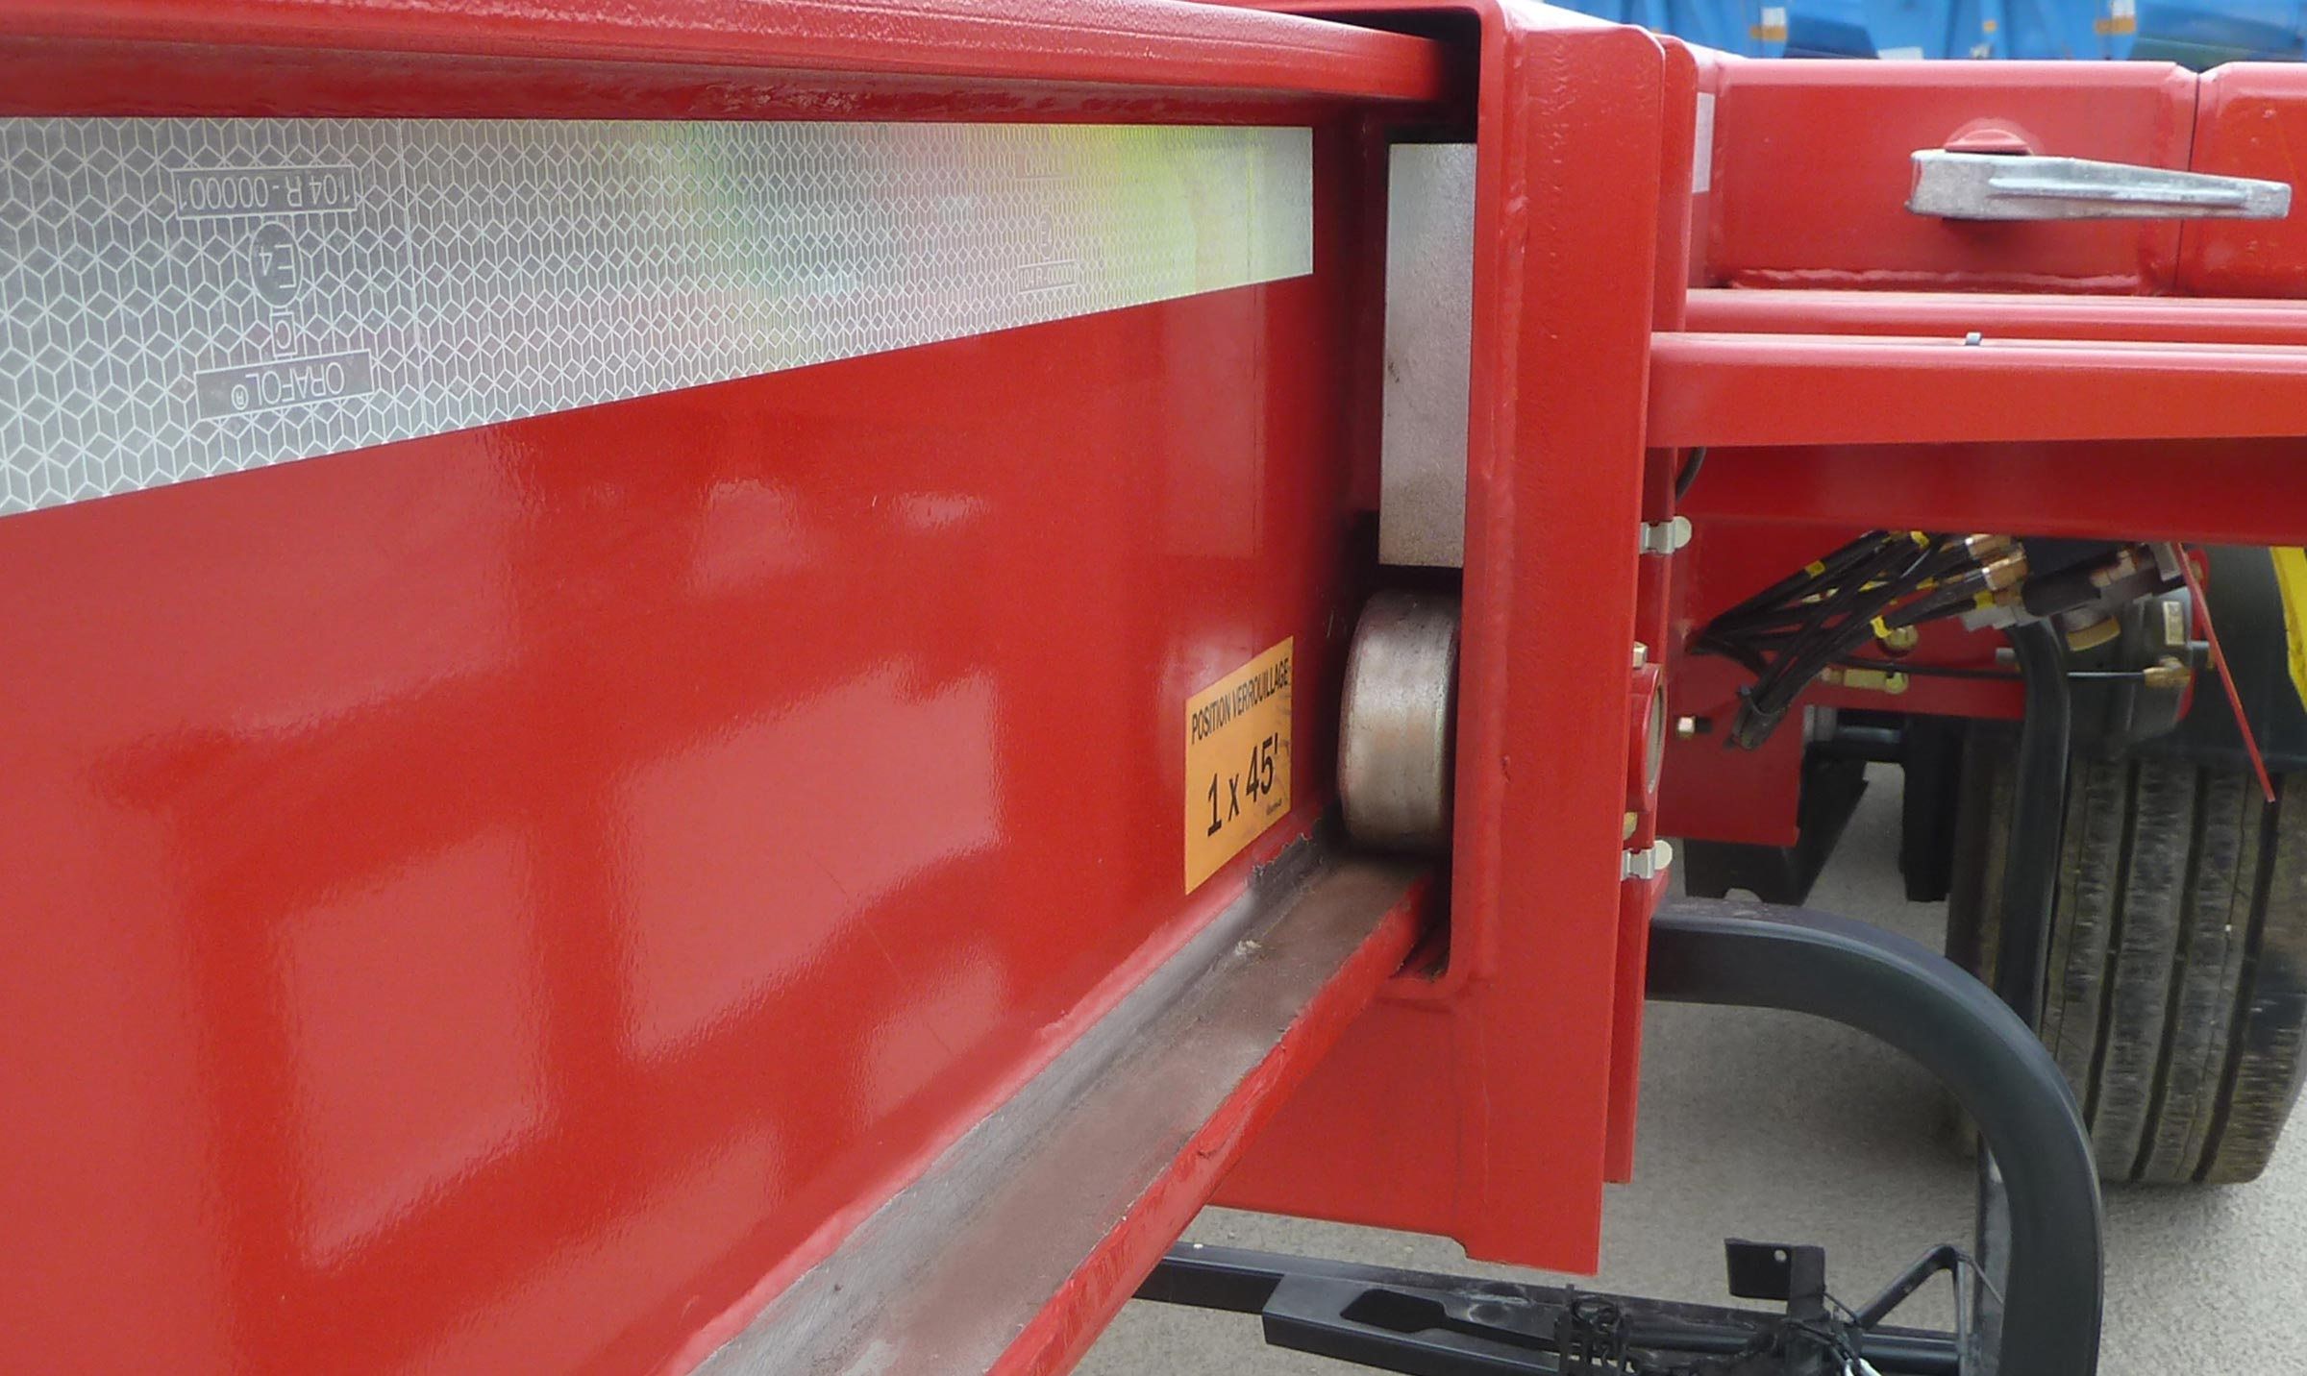
Gallery

Sliding subframe
Porte Conteneurs Multiflex EN
Teflon rollersGuillaume Calviac2021-01-14T12:14:18+01:00
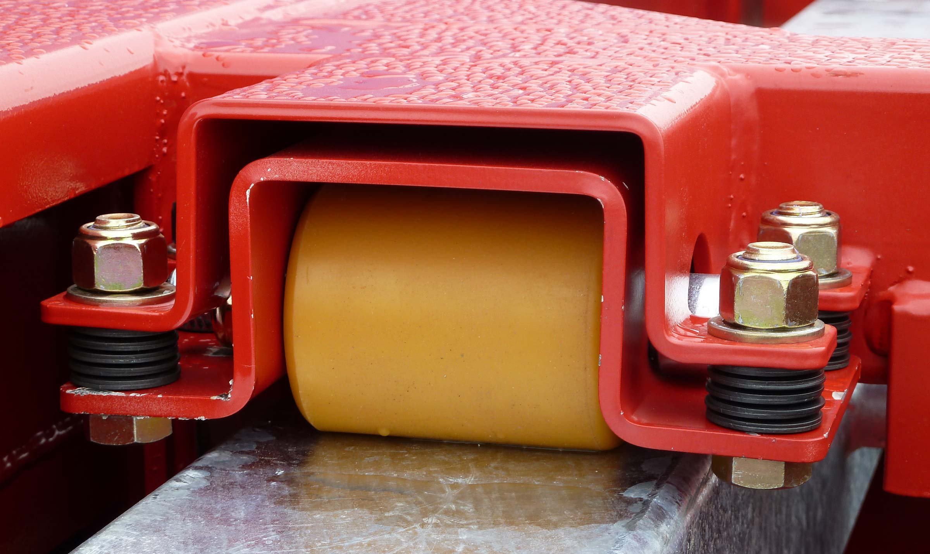
Gallery

Teflon rollers
Porte Conteneurs Multiflex EN
Documentation

Movable carriage

1 x 20' sliding - 2 x 20'

40' - 45' - Flat bottom swap body
This vehicle is equipped with a hydraulic displacement movable carriage for positioning a 20' container either in position centred for transport, or at the rear for unloading.
The vehicle can take 40' containers, 45' containers or A1360 swap bodies with a rear under-run device on slide.
- Simplicity
- Reliability
- Sturdiness
Mechanical lockingGuillaume Calviac2021-01-14T15:20:41+01:00
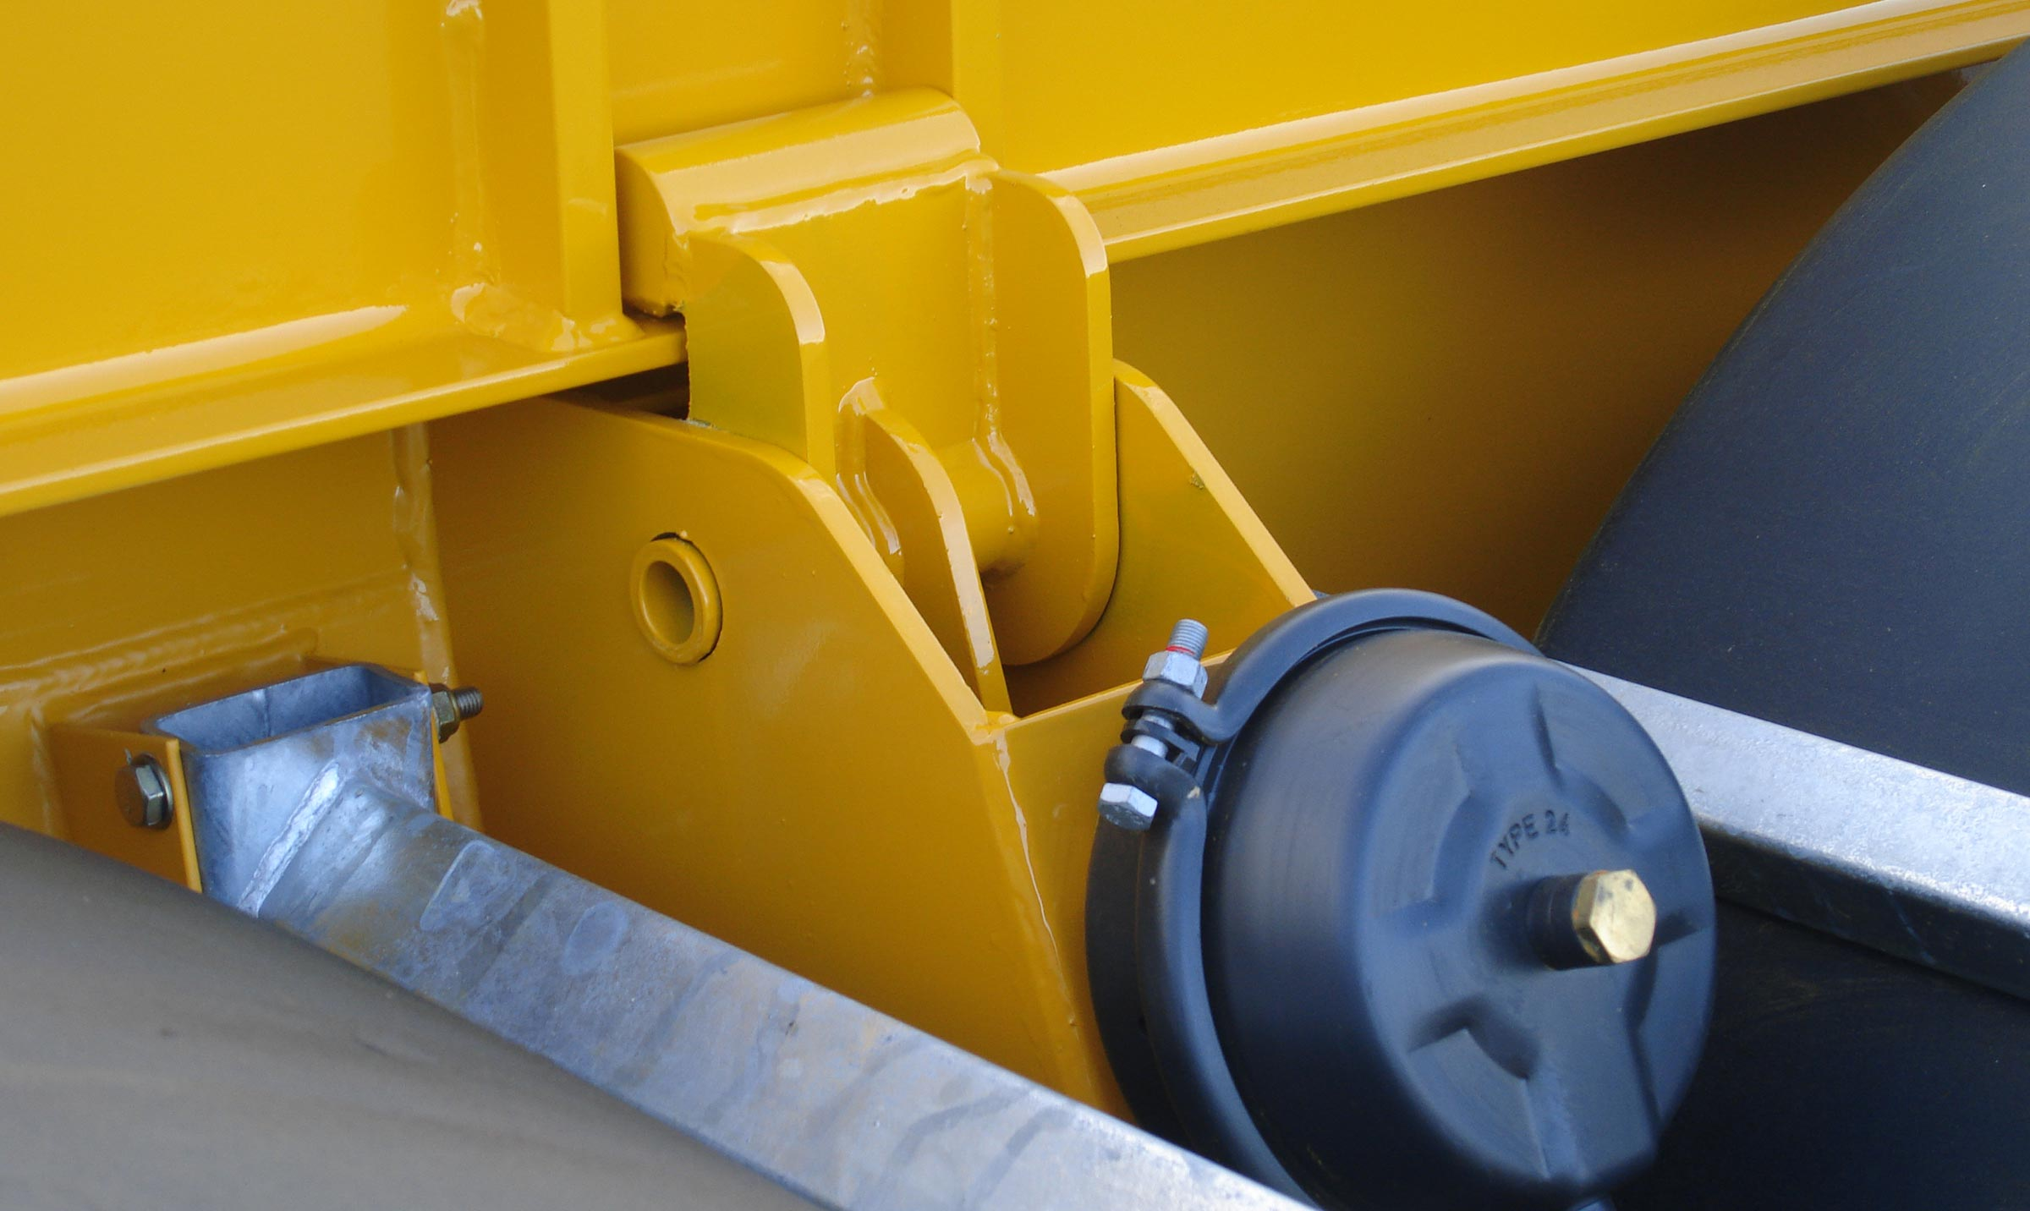
Gallery

Mechanical locking
Porte Conteneurs Chariot Mobile EN
Anti-underrun device on drawerGuillaume Calviac2021-01-14T15:19:39+01:00
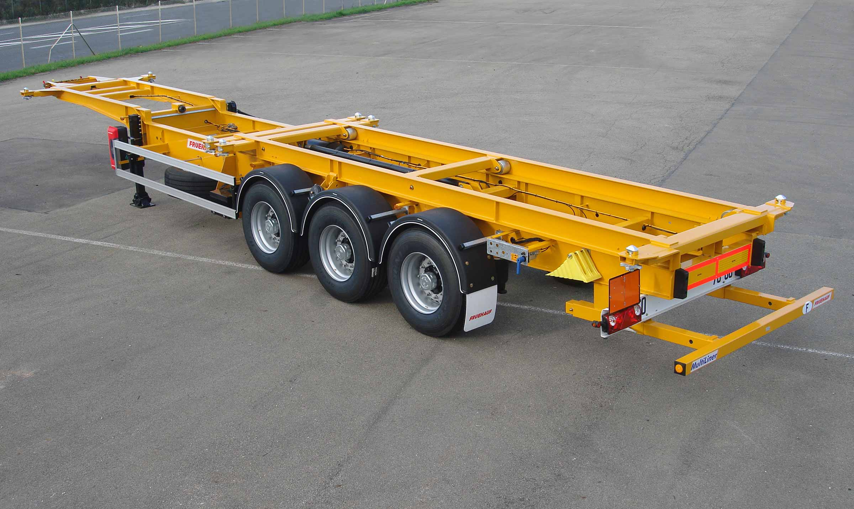
Gallery

Anti-underrun device on drawer
Porte Conteneurs Chariot Mobile EN
Movable carriage for dock unloadingGuillaume Calviac2021-01-14T15:13:34+01:00
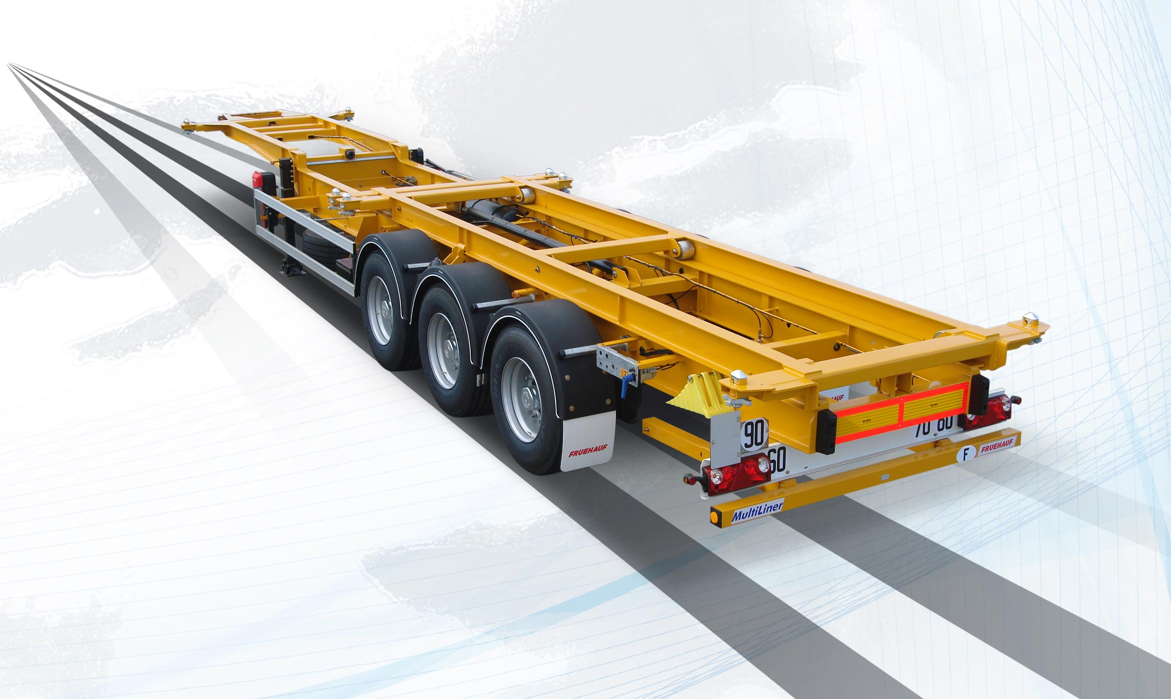
Gallery

Movable carriage for dock unloading
Porte Conteneurs Chariot Mobile EN
Layout for refrigerated unitGuillaume Calviac2021-01-14T15:12:41+01:00
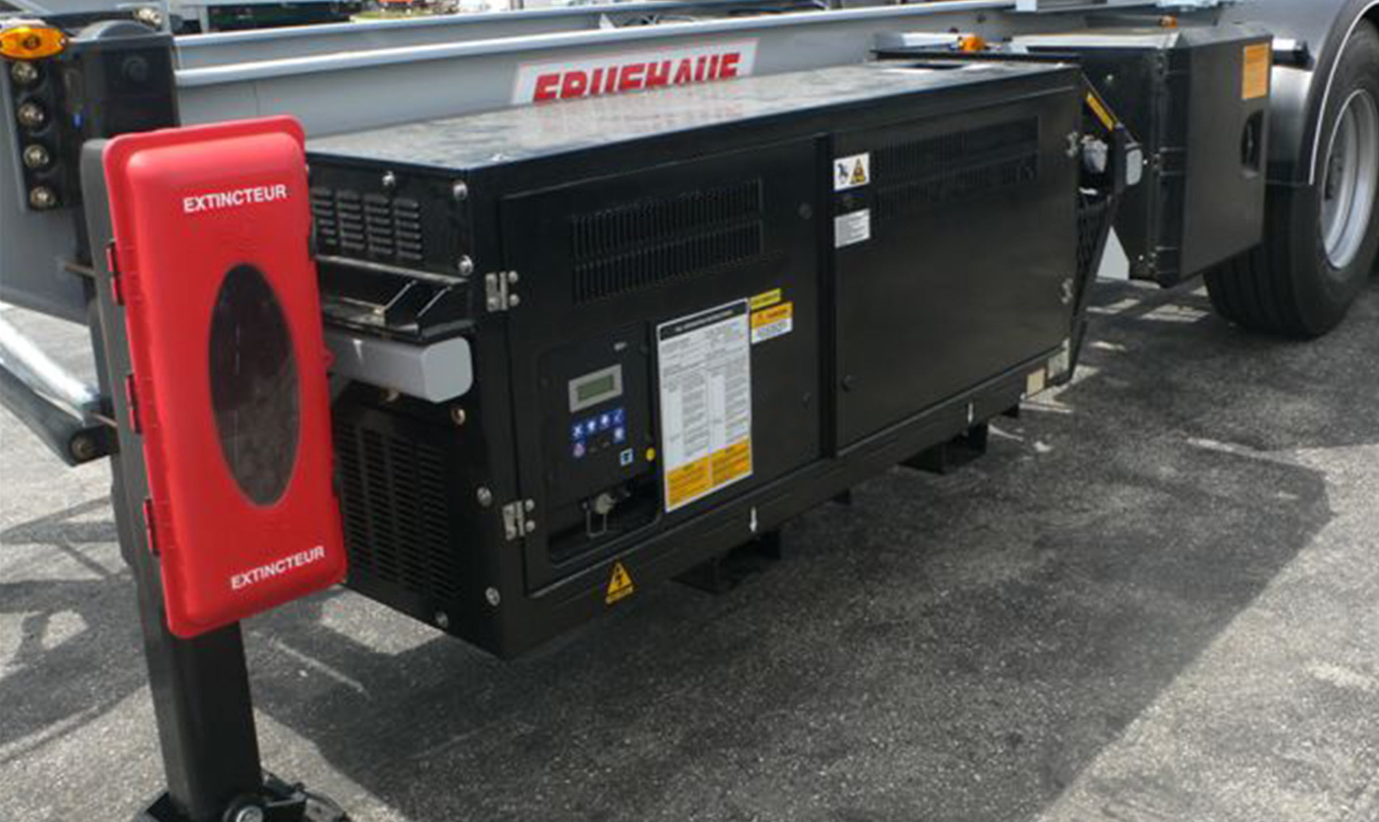
Gallery

Layout for refrigerated unit
Porte Conteneurs Chariot Mobile EN
Stainless steel rollerGuillaume Calviac2021-01-14T15:11:51+01:00
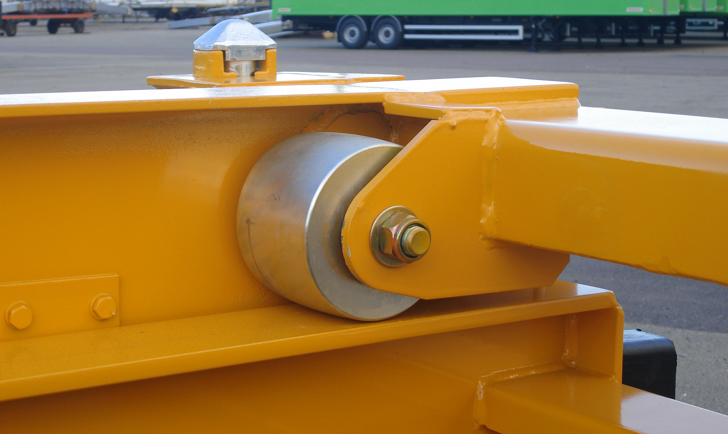
Gallery

Stainless steel roller
Porte Conteneurs Chariot Mobile EN
Documentation

Straight and gooseneck multi-position

2x20' - 20' centred - 30'

40' - 45' - A1360 swap body
Dedicated to the transport of 40' and 2 x 20' containers, its chassis is designed to take heavy containers.
Its configuration variants also make it compatible with all 20' - 30' and 45' shipping containers and A1360 swap bodies.
- Simplicity
- Reliability
- Adaptability
Rear deckingGuillaume Calviac2021-01-14T16:22:48+01:00
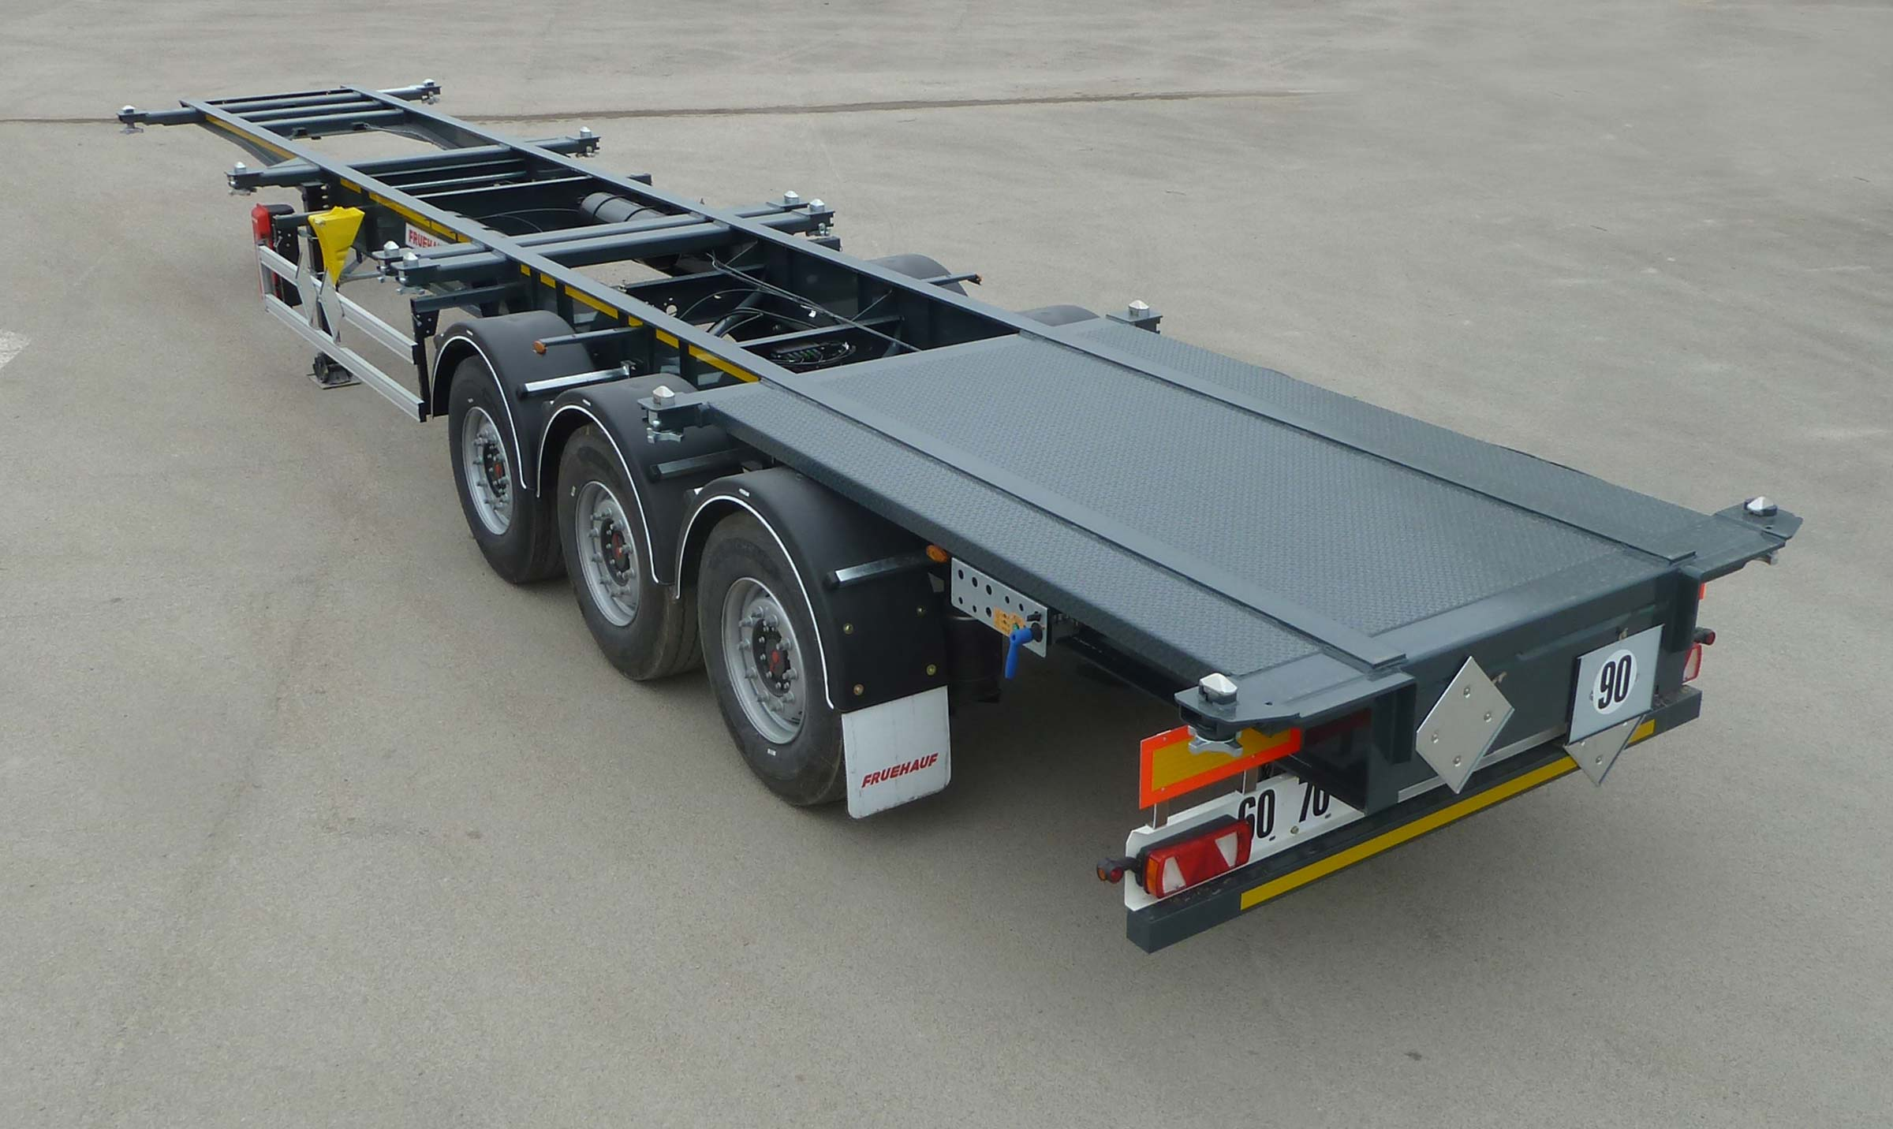
Gallery

Rear decking
Porte Conteneurs 40' EN
Container chassis – 40′ – 2×20′ – 20′ centredGuillaume Calviac2021-01-14T16:21:32+01:00
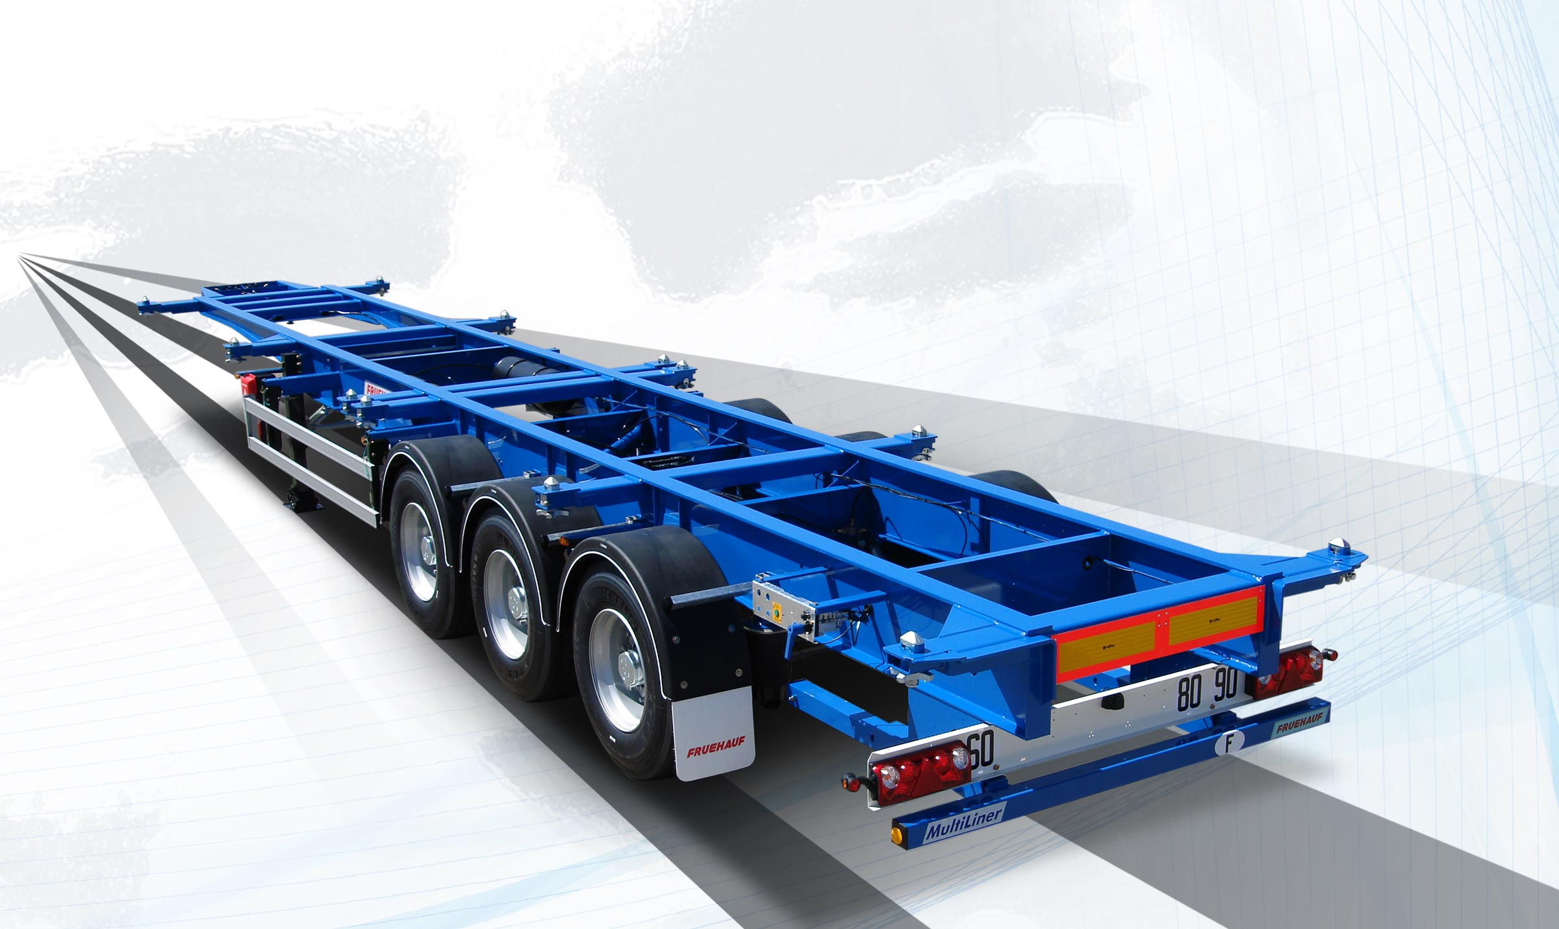
Gallery

Container chassis – 40′ – 2×20′ – 20′ centred
Porte Conteneurs 40' EN
Container chassis – 40′Guillaume Calviac2021-01-14T16:20:00+01:00
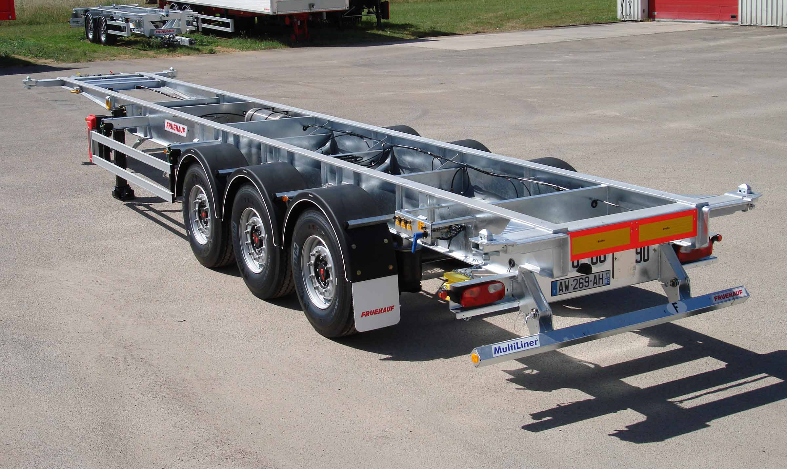
Gallery

Container chassis – 40′
Porte Conteneurs 40' EN
Reinforced front lipGuillaume Calviac2021-01-14T16:26:21+01:00
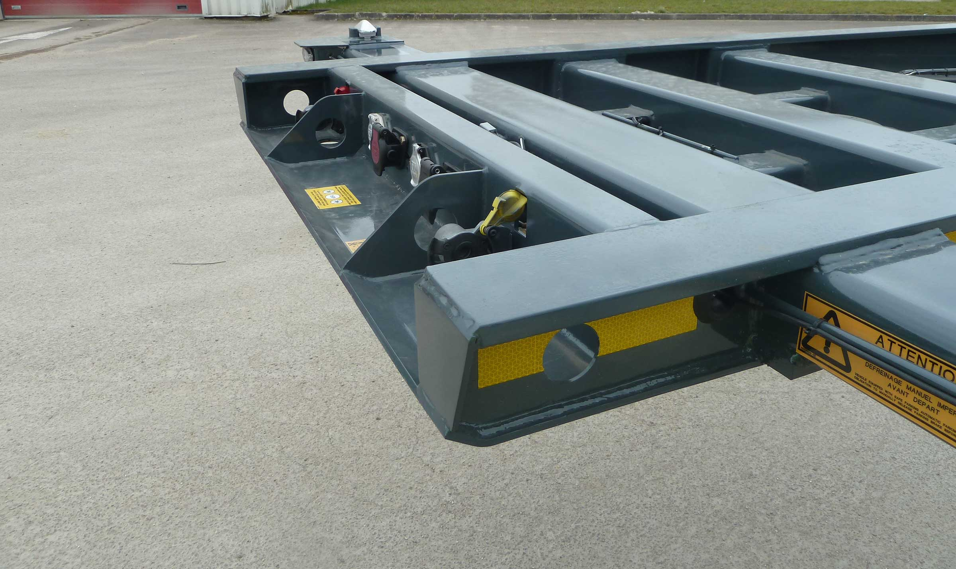
Gallery

Reinforced front lip
Porte Conteneurs 20' EN, Porte Conteneurs 40' EN
Documentation

The standards
Standard vehicles are designed for transporting a single model of container. With their reinforced, mechanically welded chassis, they are perfectly suited to transporting containers in heavy rotation.

20'
Dedicated to the transport of 20' containers, its sturdy chassis is designed to take heavy 20' containers.
Equipment variants allow it to be integrated into a double train for the simultaneous transport of twin 20' containers.
- Simplicity
- Reliability
- Sturdiness
Double train layoutGuillaume Calviac2021-01-15T08:45:17+01:00
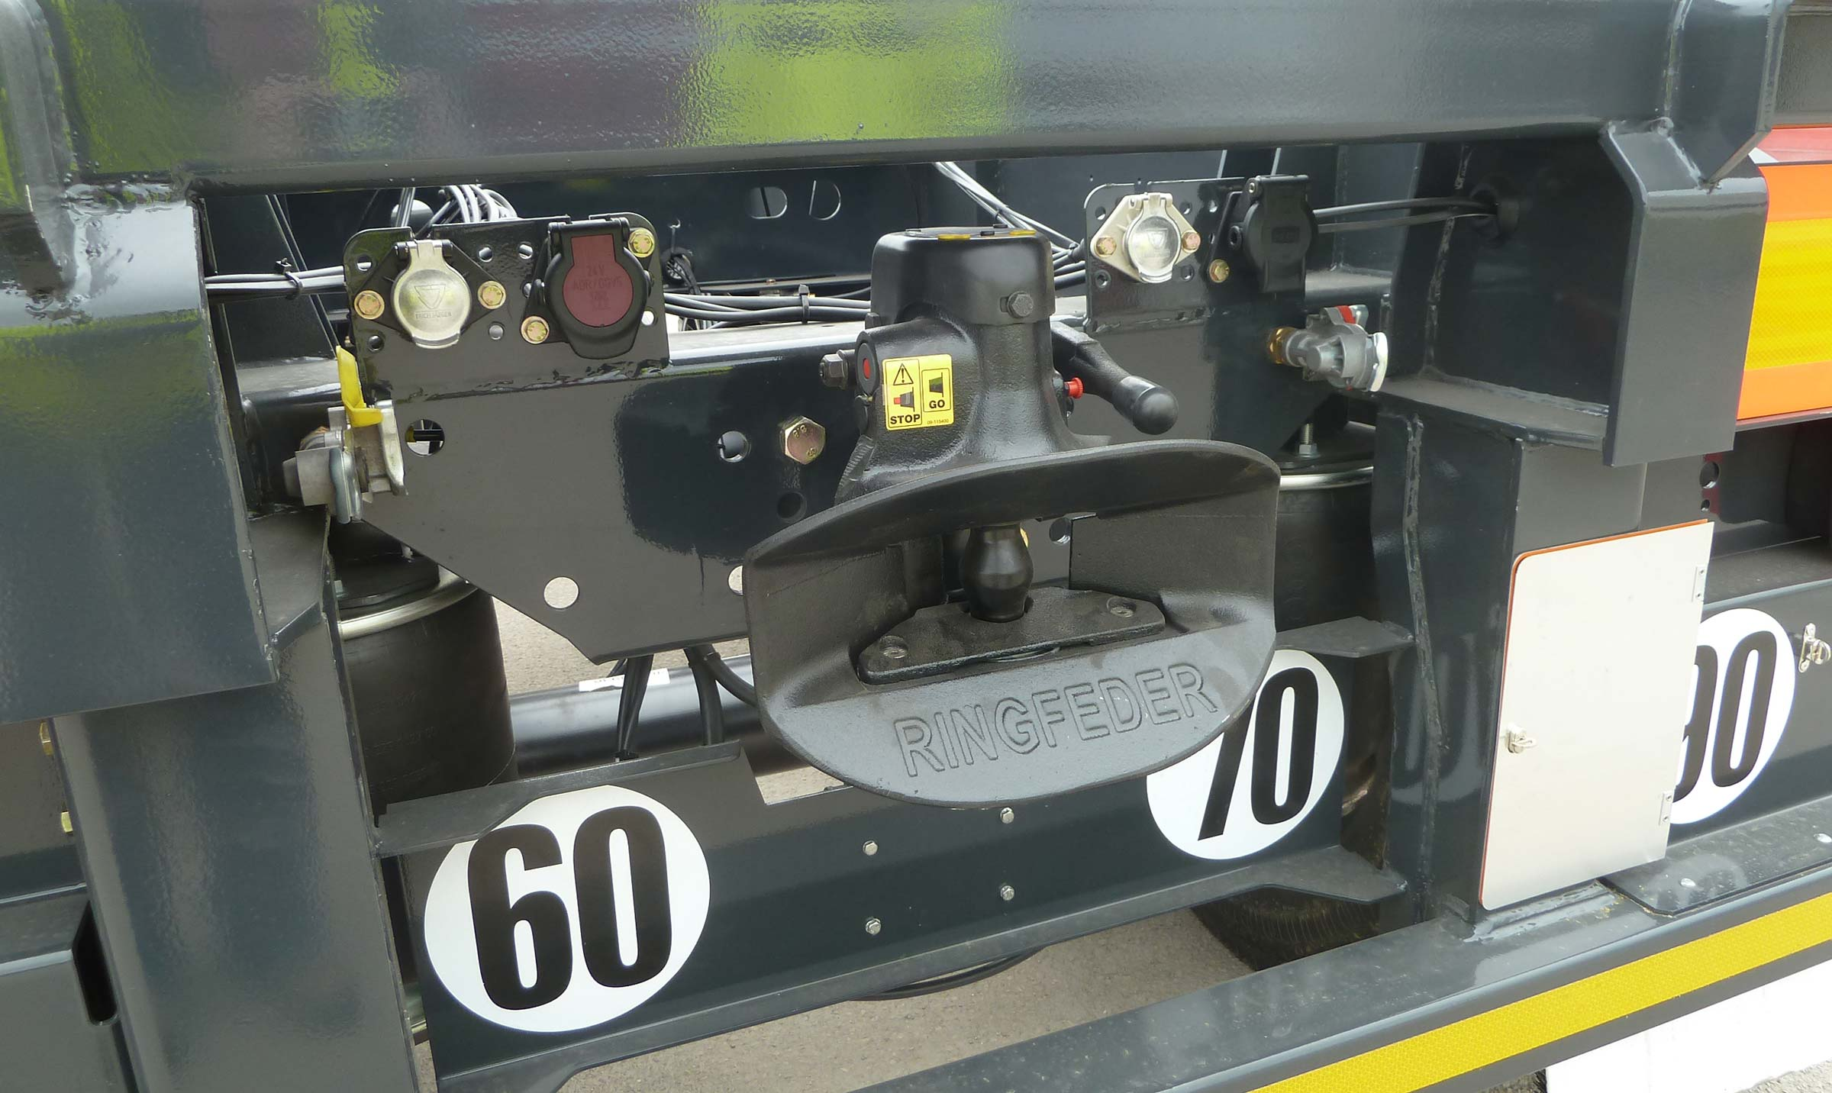
Gallery

Double train layout
Porte Conteneurs 20' EN
Container chassis – 20′Guillaume Calviac2021-01-15T08:43:04+01:00
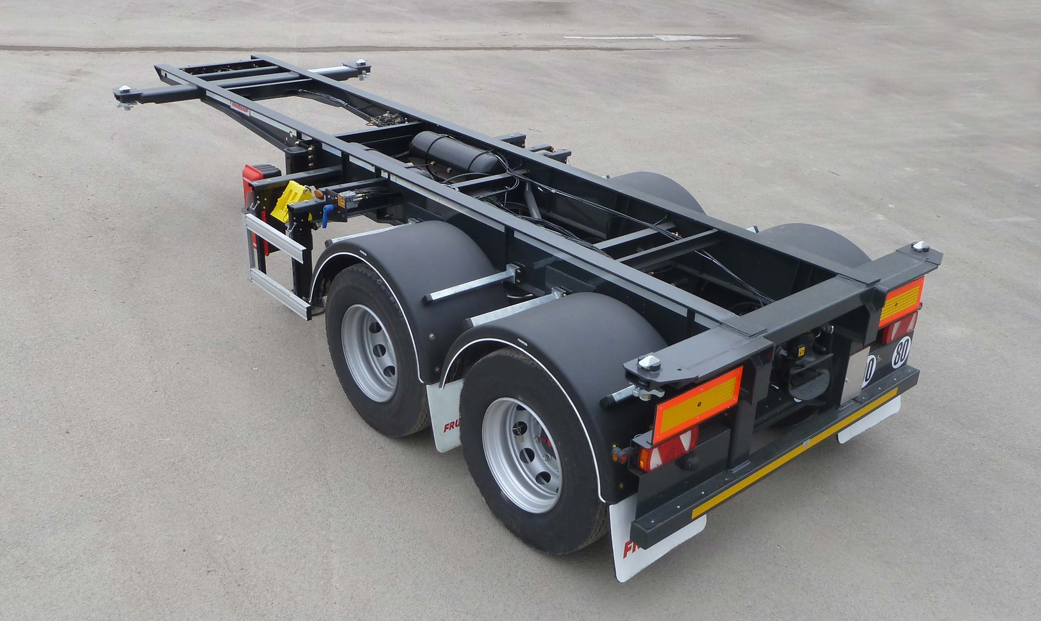
Gallery

Container chassis – 20′
Porte Conteneurs 20' EN
Container chassis – 20′Guillaume Calviac2021-01-15T08:42:32+01:00
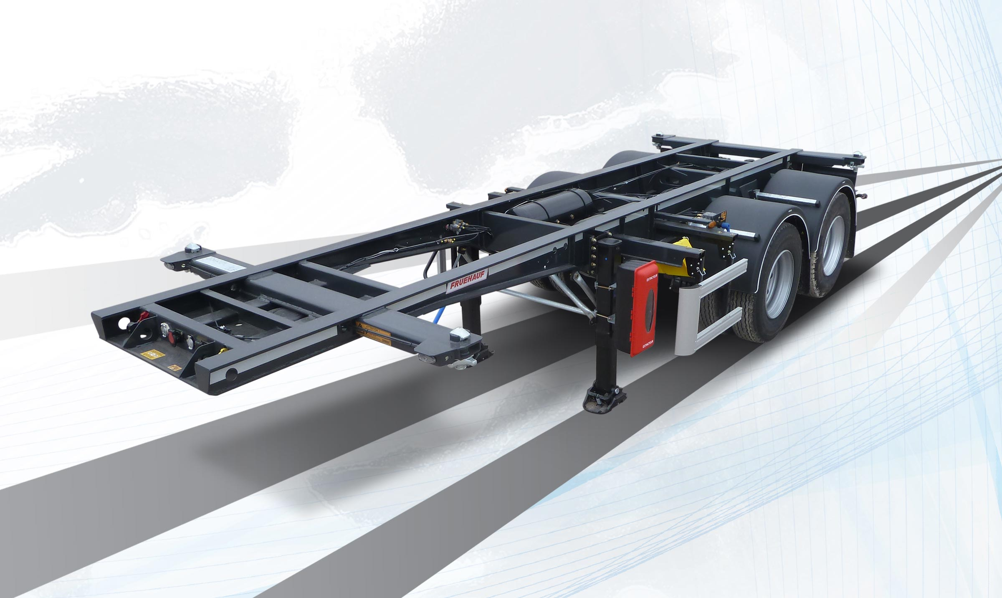
Gallery

Container chassis – 20′
Porte Conteneurs 20' EN
Reinforced front lipGuillaume Calviac2021-01-14T16:26:21+01:00
Gallery

Reinforced front lip
Porte Conteneurs 20' EN, Porte Conteneurs 40' EN
Demo Videos

DOLLY

Dolly for 20' double train
Vehicle designed to form a 20' double train with two 20' container chassis semitrailers front and rear.
- Simplicity
- Reliability
Coupling protectionGuillaume Calviac2021-01-15T09:01:19+01:00
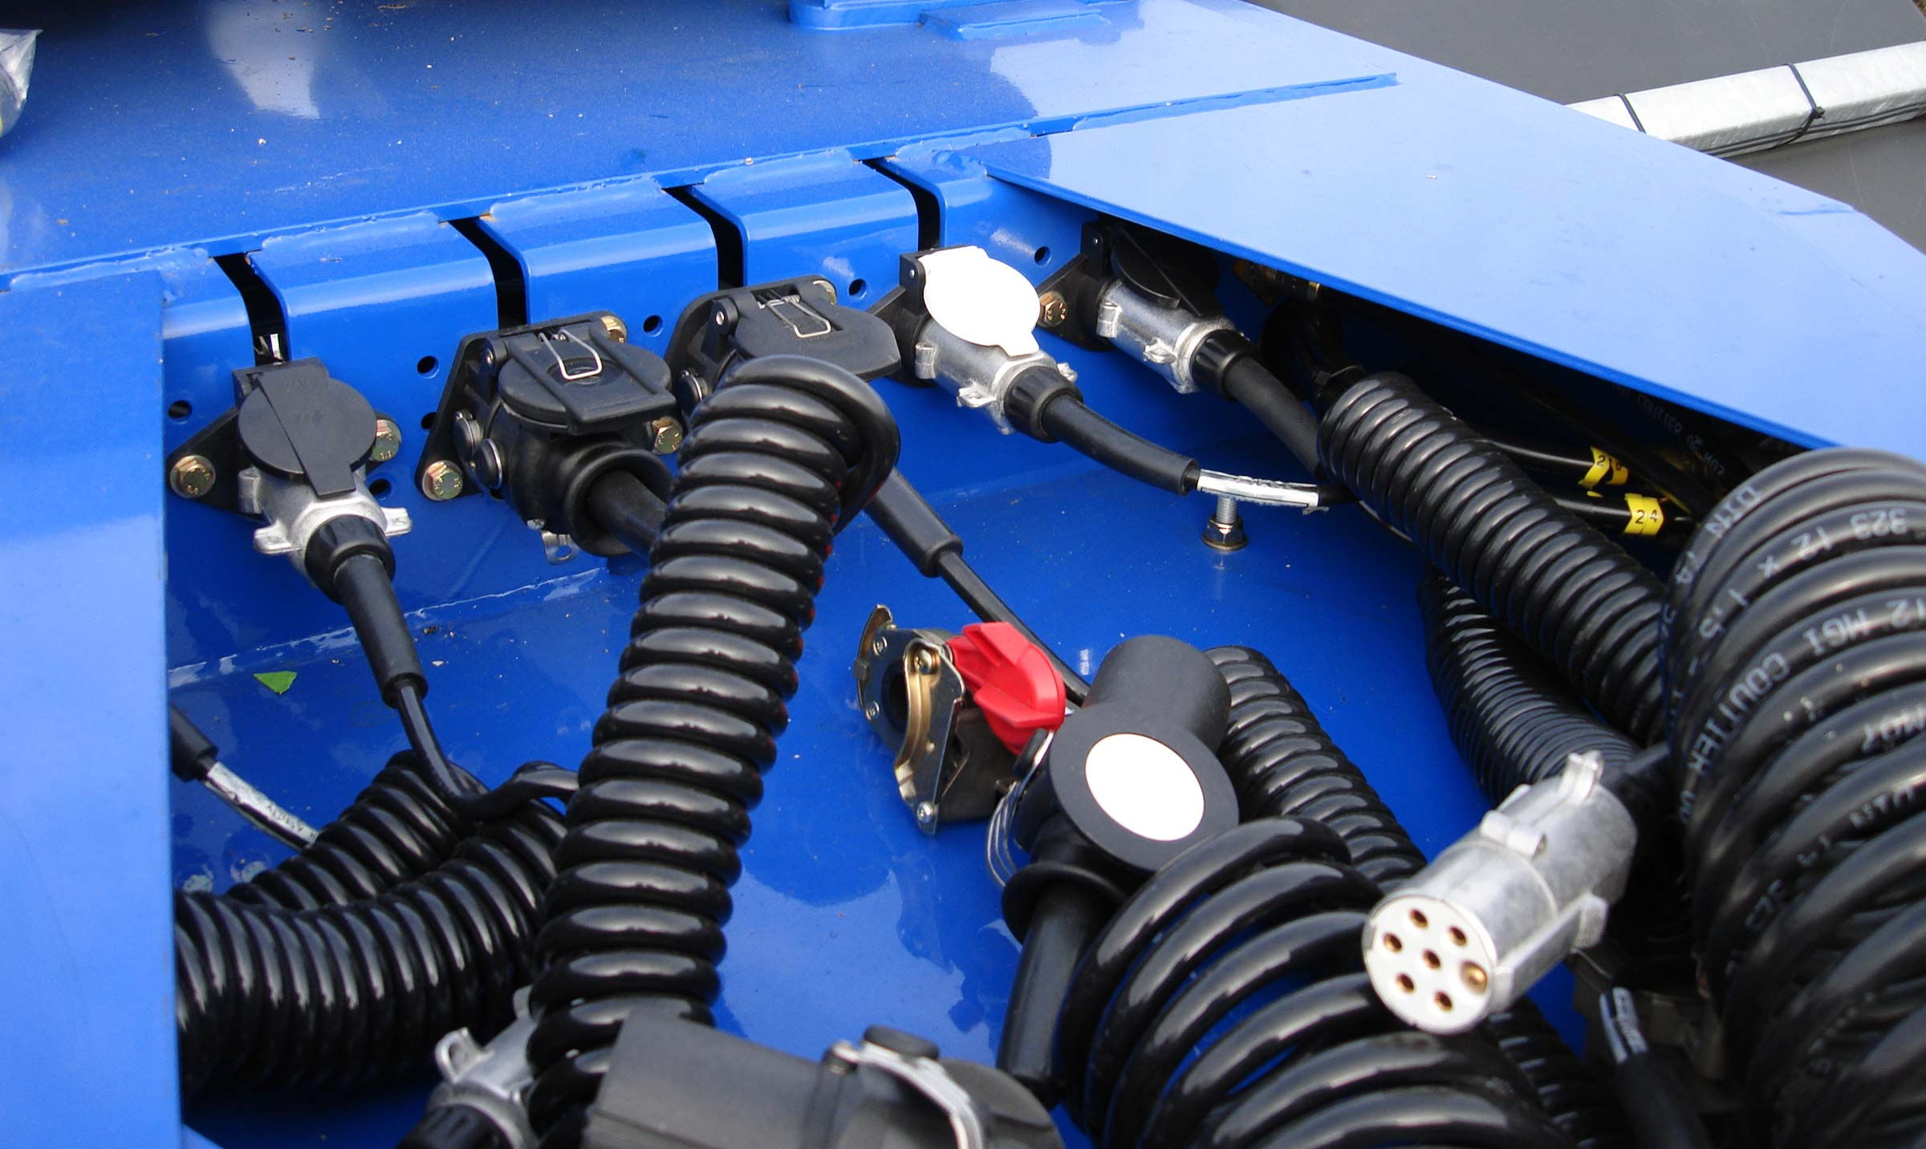
Gallery

Coupling protection
Porte Conteneurs Dolly EN
Mechanical suspensionGuillaume Calviac2021-01-15T08:54:46+01:00
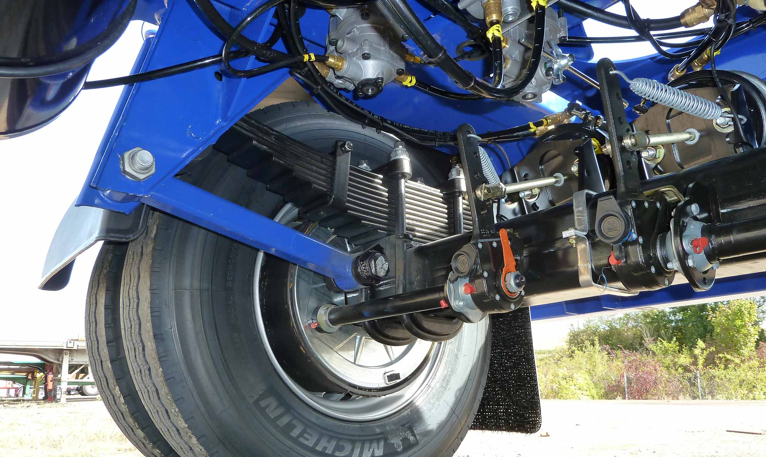
Gallery

Mechanical suspension
Porte Conteneurs Dolly EN
Fixed boomGuillaume Calviac2021-01-15T08:53:56+01:00
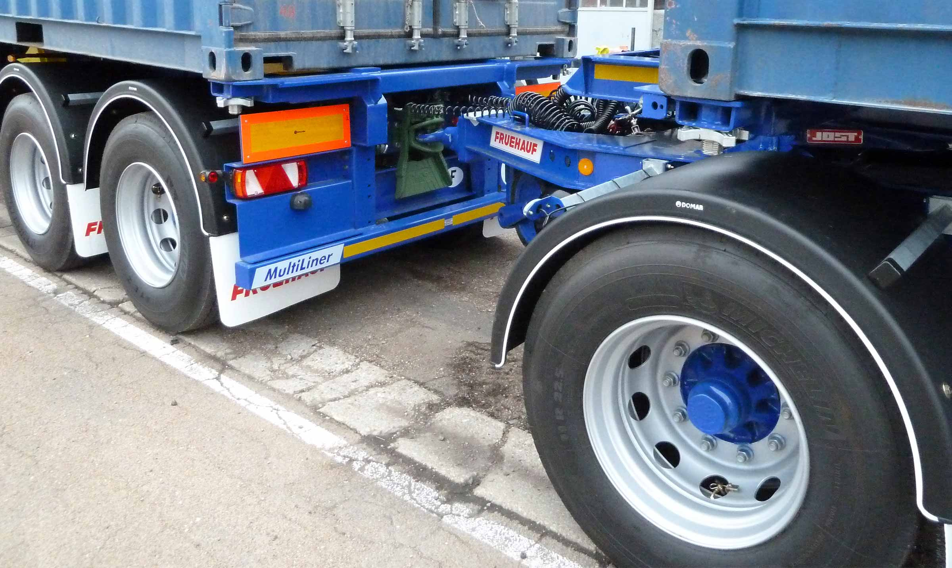
Gallery

Fixed boom
Porte Conteneurs Dolly EN
Double trainGuillaume Calviac2021-02-09T12:05:09+01:00
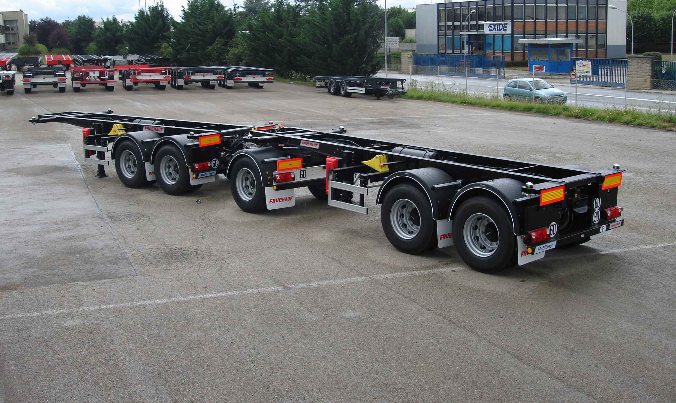
Gallery

Double train
Porte Conteneurs Dolly EN
DollyGuillaume Calviac2021-01-15T08:51:55+01:00
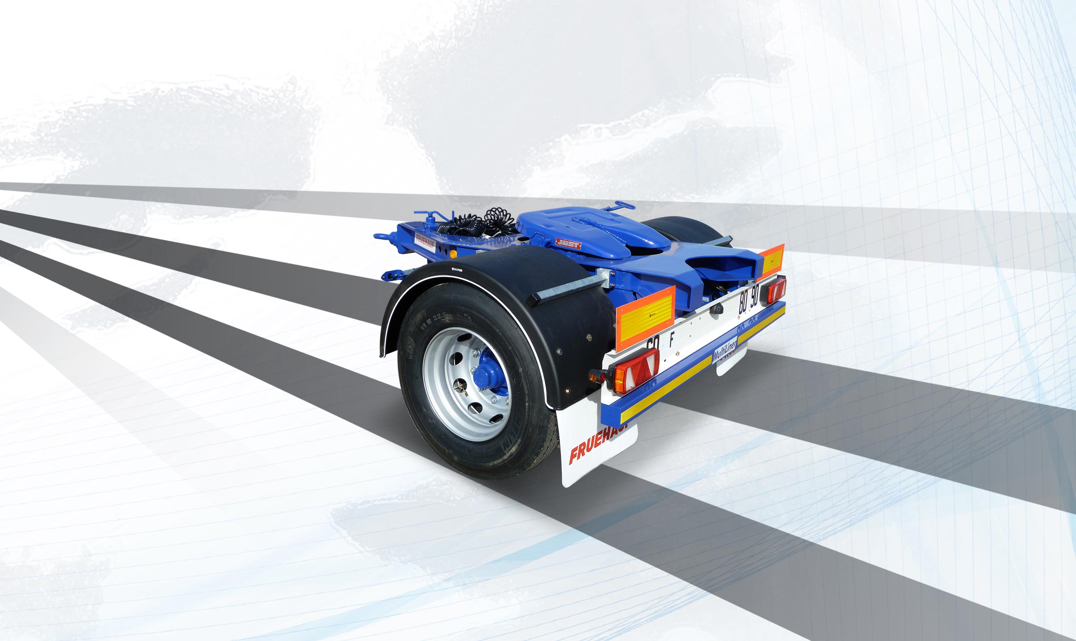
Gallery

Dolly
Porte Conteneurs Dolly EN
Dolly with 2″ Fifth-WheelGuillaume Calviac2021-01-15T09:20:02+01:00
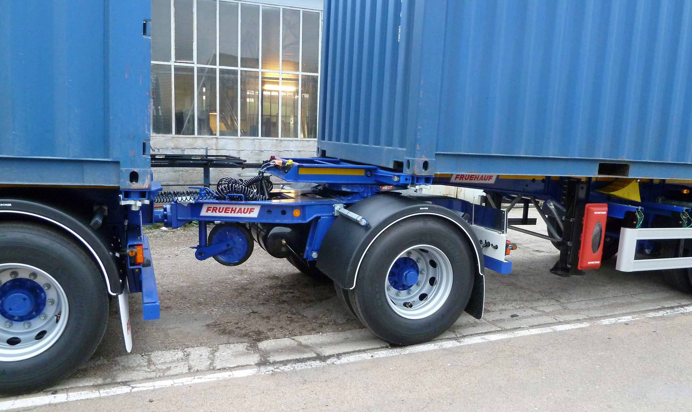
Gallery

Dolly with 2″ Fifth-Wheel
Porte Conteneurs Dolly EN
Documentation

BI-TRAIN

20'
This 20' container chassis with extendible running gear is equipped with a fifth wheel for hitching a second 20' container chassis to form a BI-TRAIN.
Fitted with a sliding subframe, it has the advantage of being usable on 20' solo.
- Simplicity
- Reliability
- Sturdiness
Protection of electrical cablesGuillaume Calviac2021-01-15T09:22:33+01:00
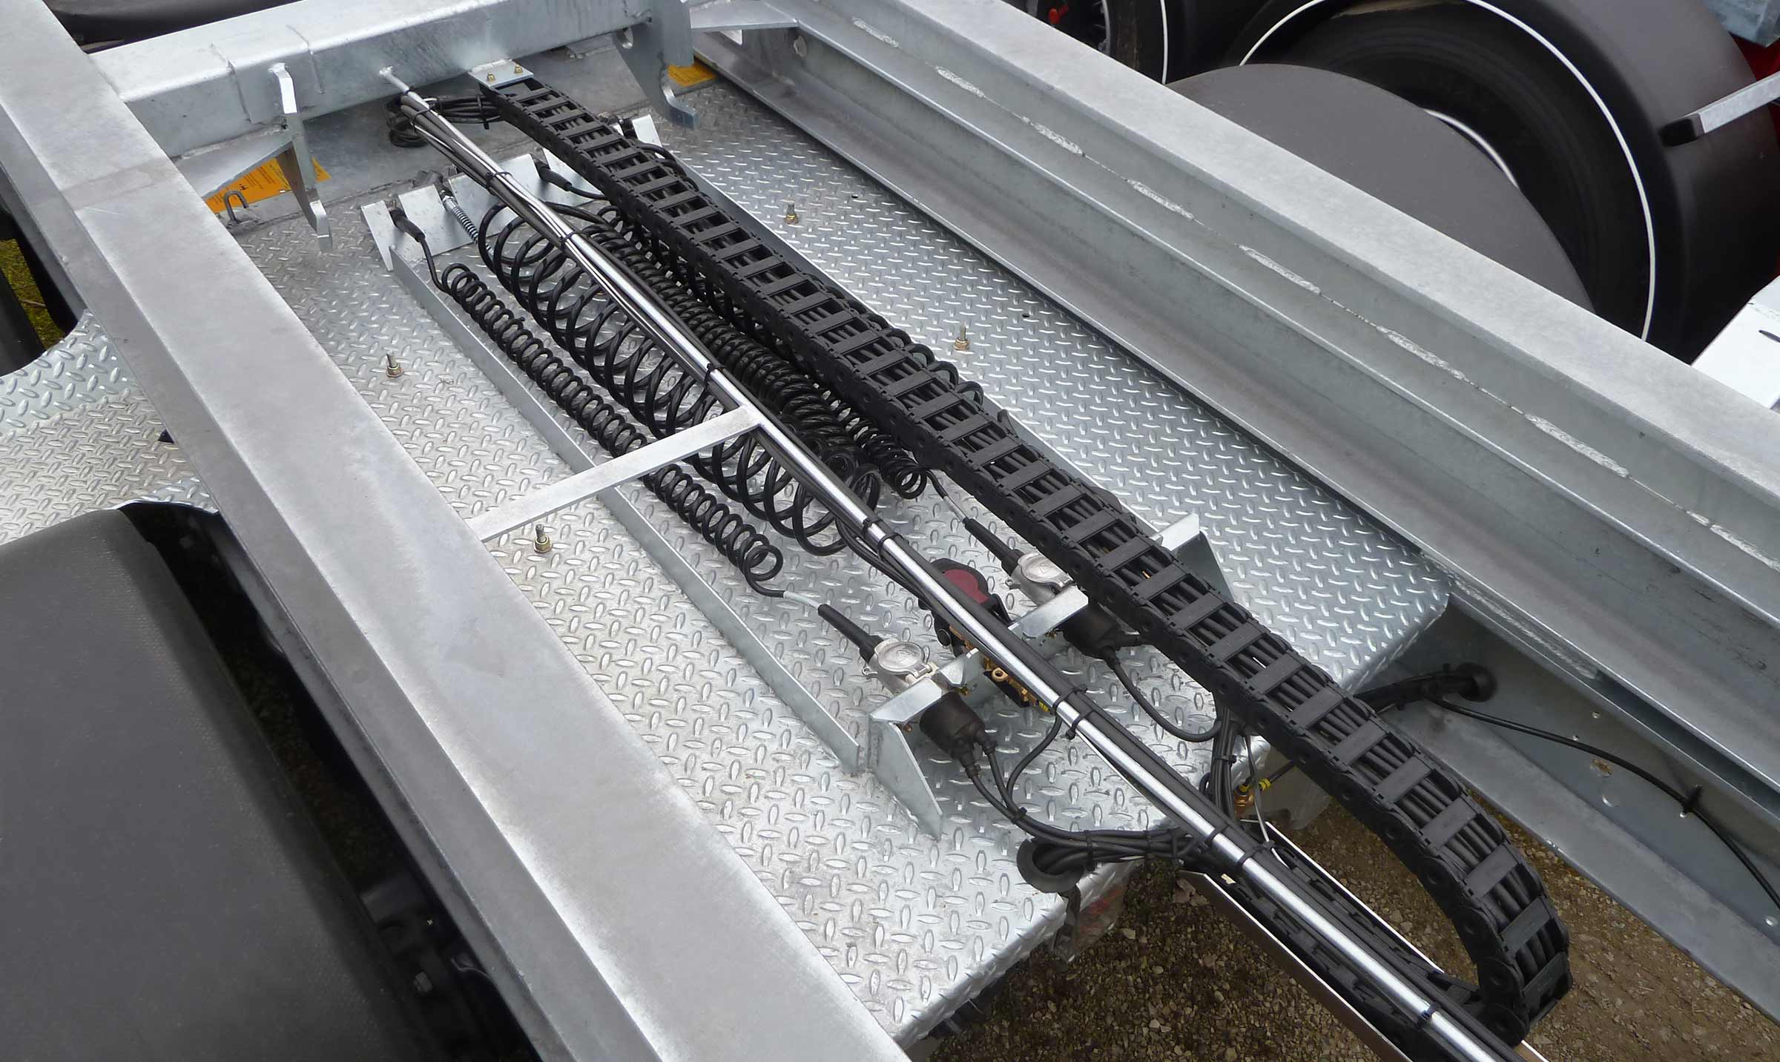
Gallery

Protection of electrical cables
Porte Conteneurs Bi-train EN
Pneumatic locking fifth wheelGuillaume Calviac2021-01-15T09:21:06+01:00
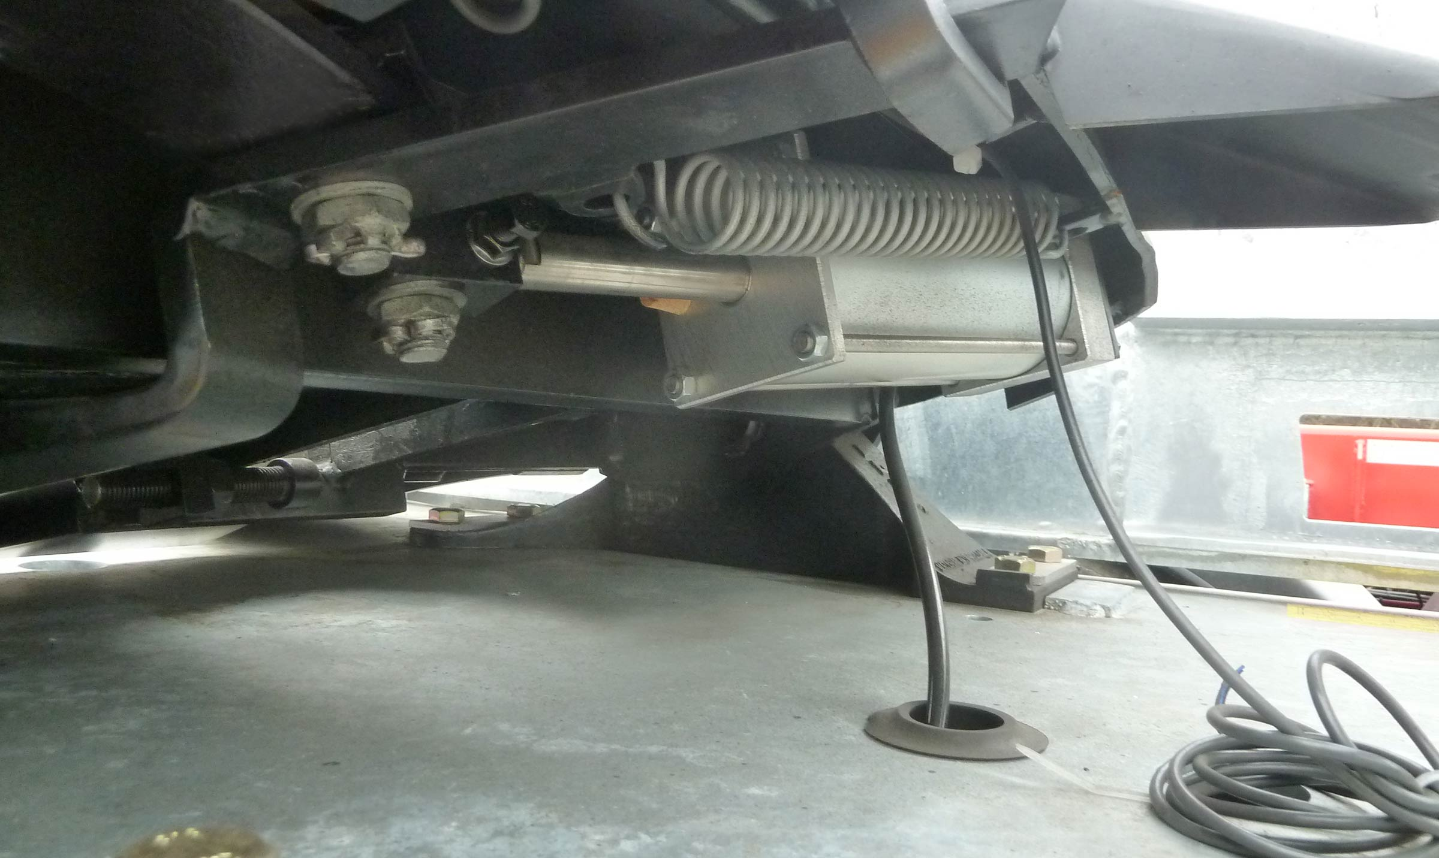
Gallery

Pneumatic locking fifth wheel
Porte Conteneurs Bi-train EN
Bi-TrainGuillaume Calviac2021-02-09T12:08:37+01:00
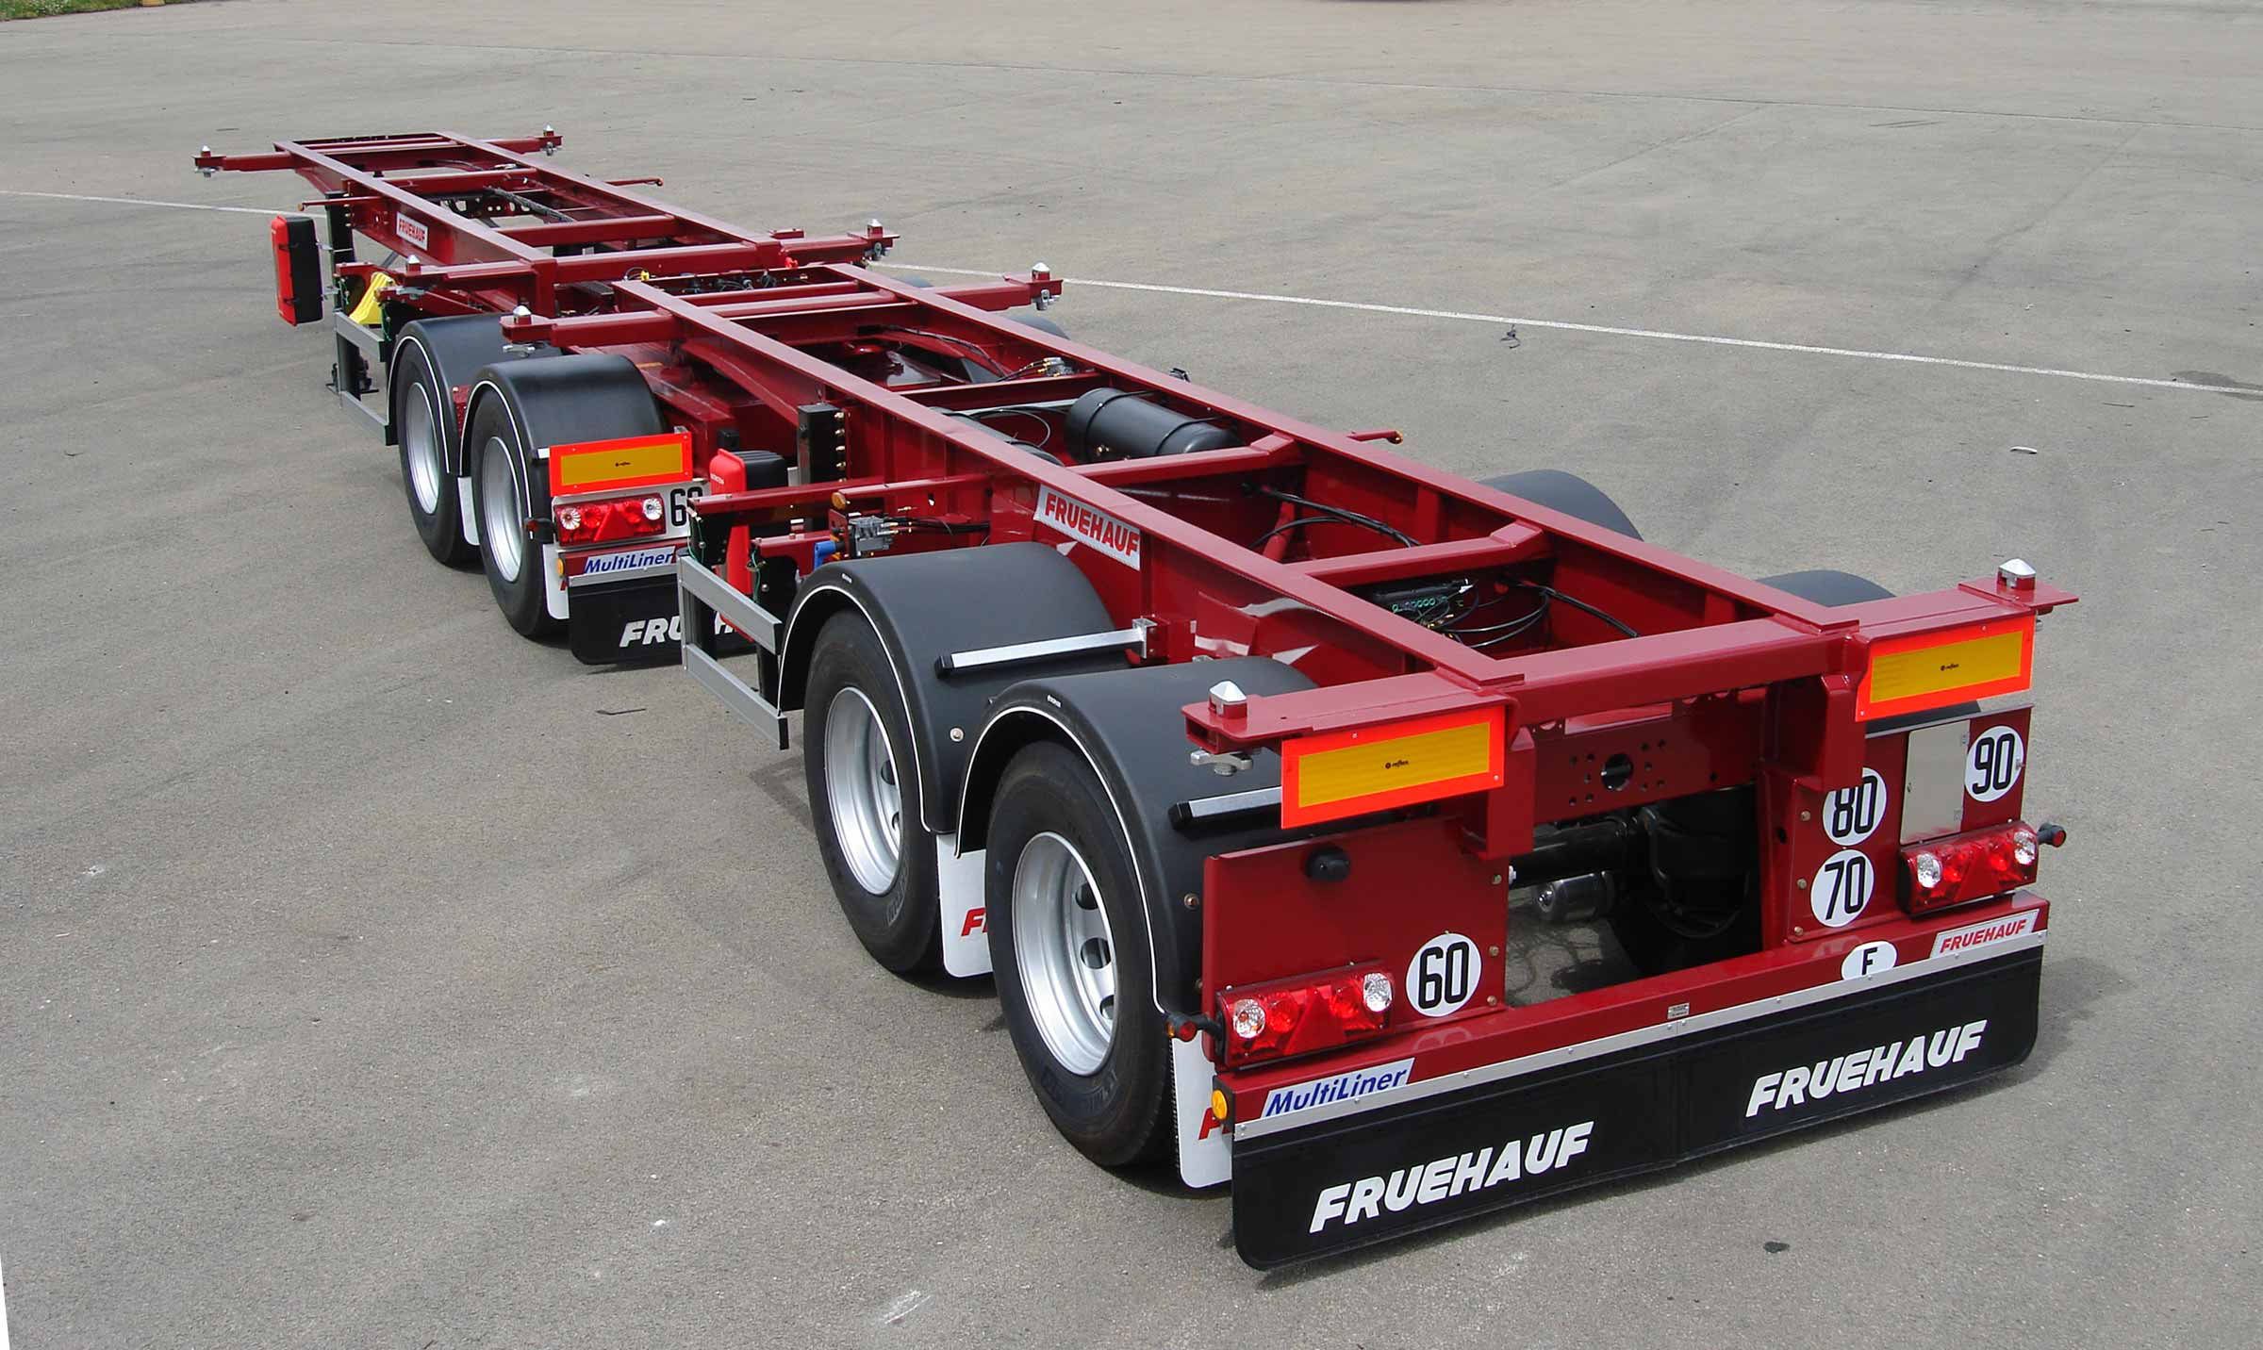
Gallery

Bi-Train
Porte Conteneurs Bi-train EN
Bi-TrainGuillaume Calviac2021-02-09T12:08:26+01:00
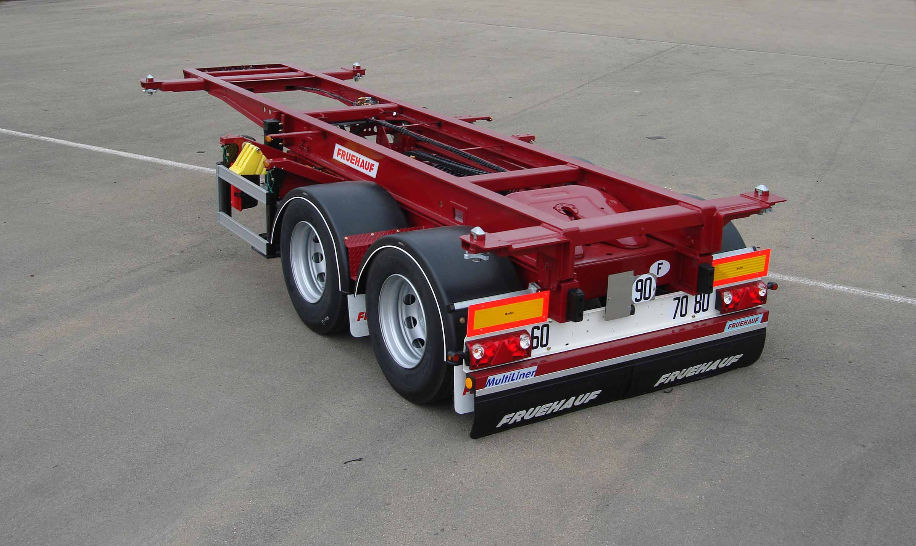
Gallery

Bi-Train
Porte Conteneurs Bi-train EN
Bi-TrainGuillaume Calviac2021-02-09T12:08:31+01:00
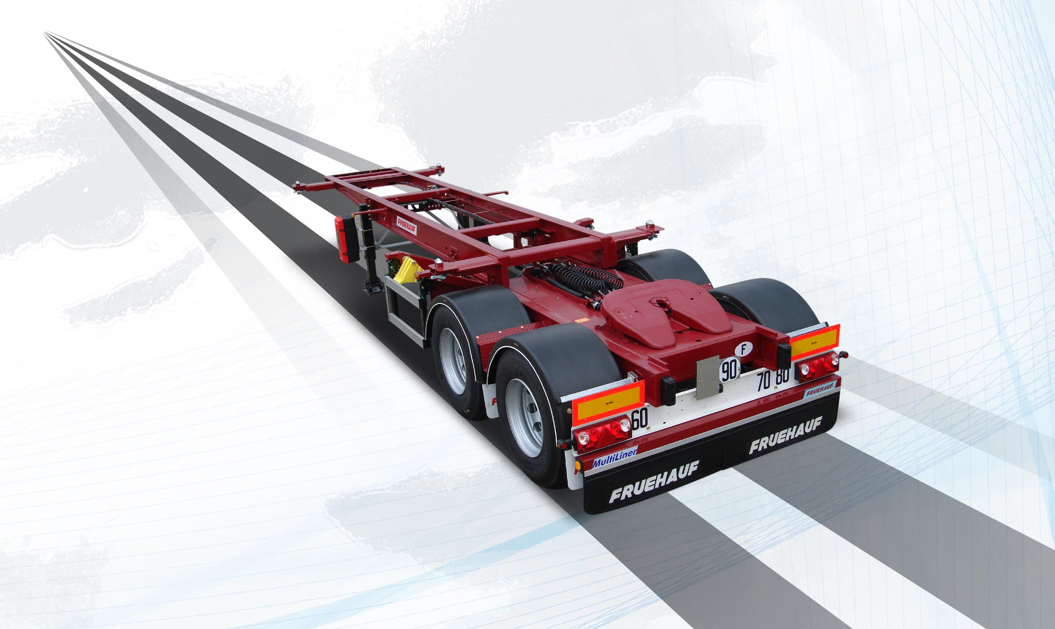
Gallery

Bi-Train
Porte Conteneurs Bi-train EN
Documentation

The Dedicated
Specially developed for transporting specialist containers or for specific uses, Fruehauf specialist container chassis optimise operating costs with adapted, safe equipment.

Chemical

20' - 30'

CHEMICAL
Dedicated to the transport of 20' centred and 30' containers, its chassis is pre-fitted for the equipment required to transport and empty chemical containers.
- Simplicity
- Lightweight
- Adaptability
Drip trayGuillaume Calviac2021-01-15T09:59:53+01:00
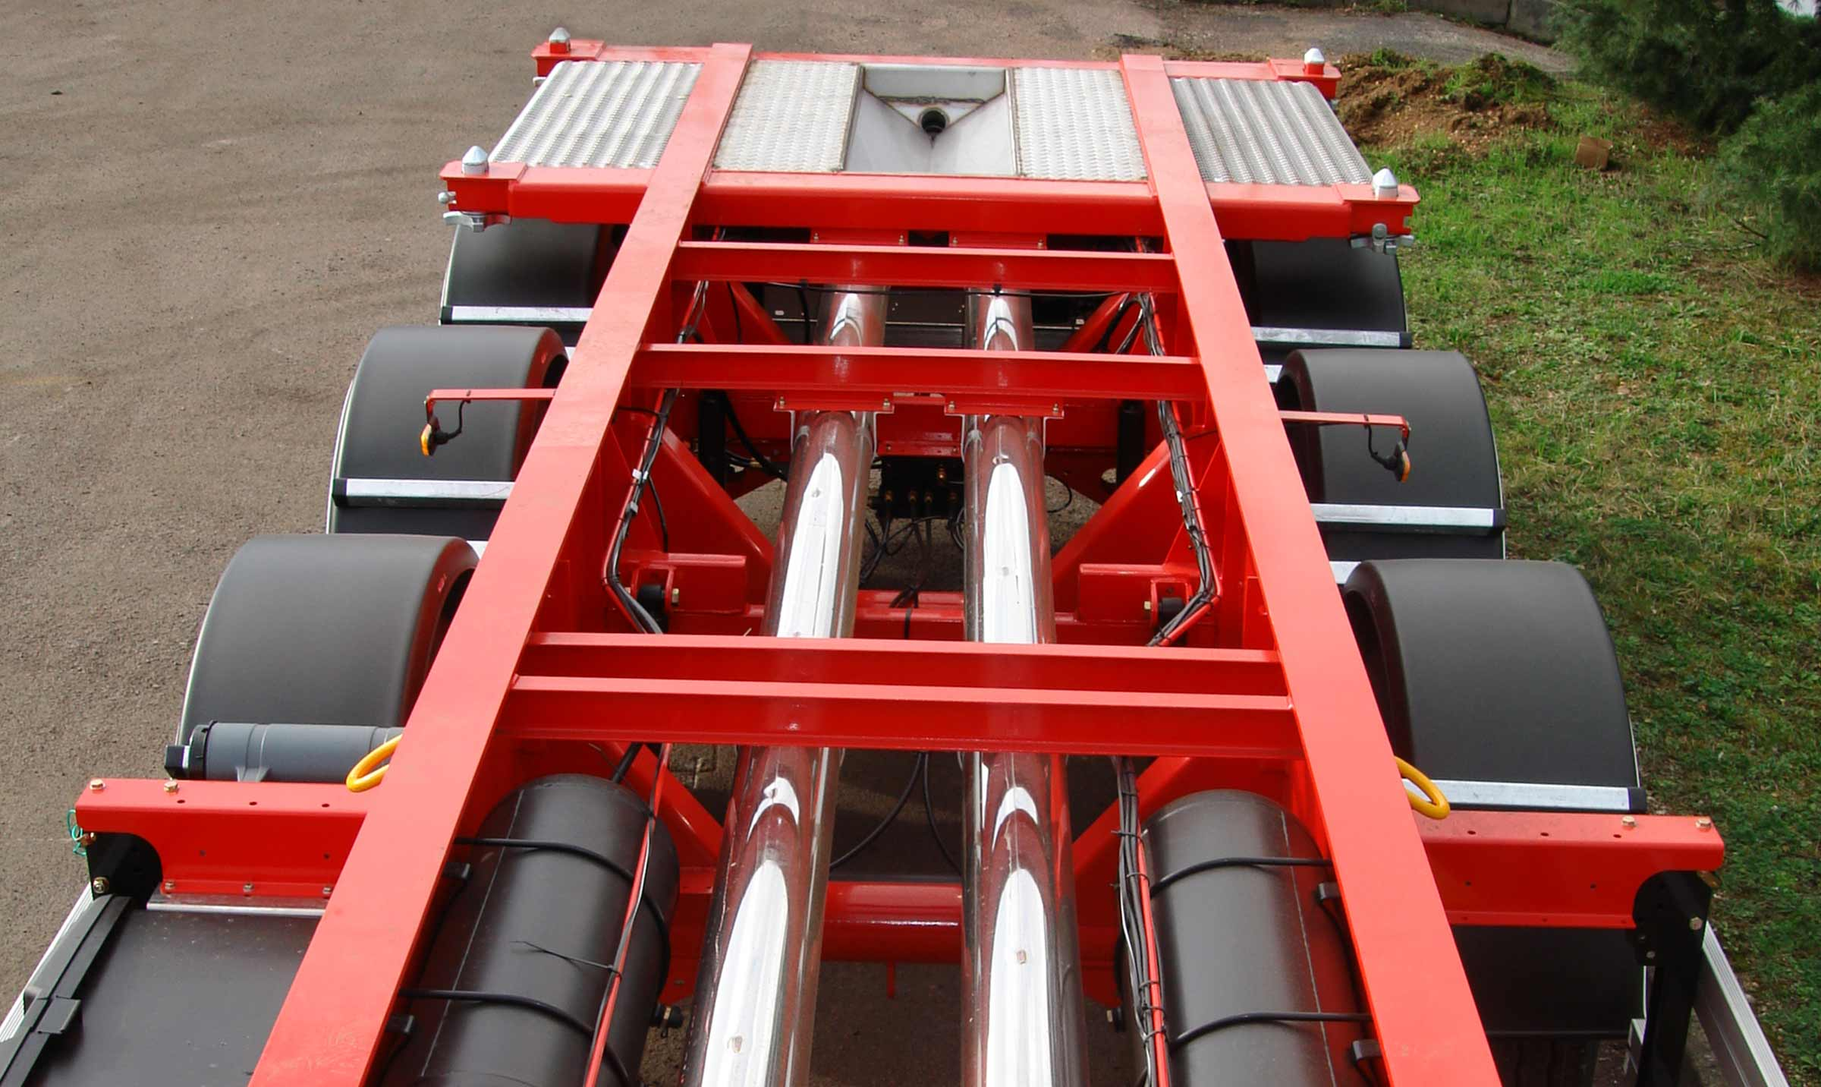
Gallery

Drip tray
Porte Conteneurs Chimique EN
Hose carrier tubeGuillaume Calviac2021-01-15T09:57:54+01:00
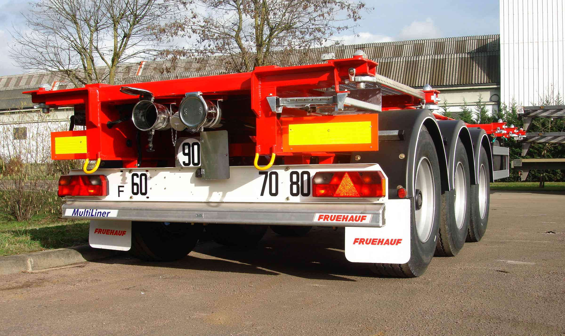
Gallery

Hose carrier tube
Porte Conteneurs Chimique EN
Rear deckingGuillaume Calviac2021-01-15T09:56:22+01:00
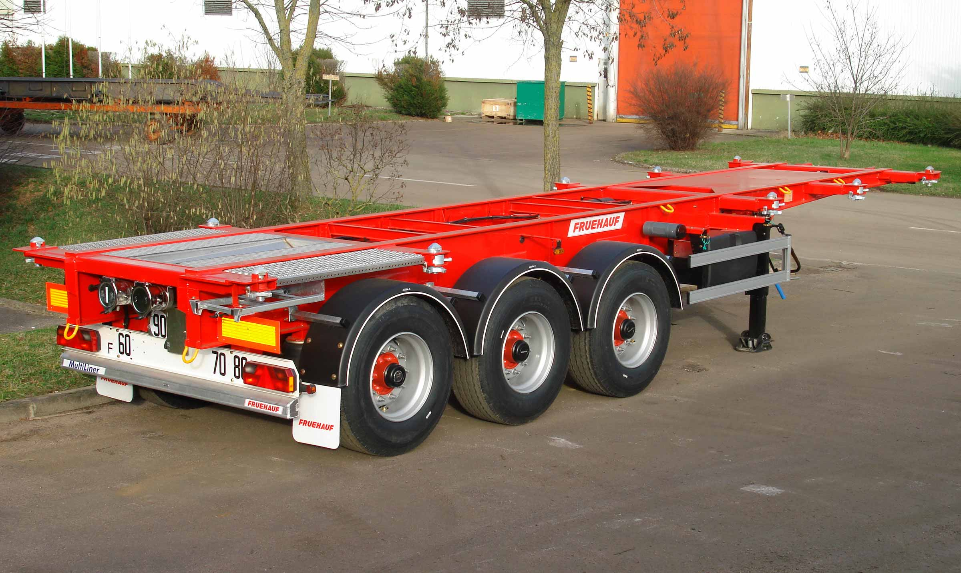
Gallery

Rear decking
Porte Conteneurs Chimique EN
Container chassis – chemicalGuillaume Calviac2021-01-15T09:55:04+01:00
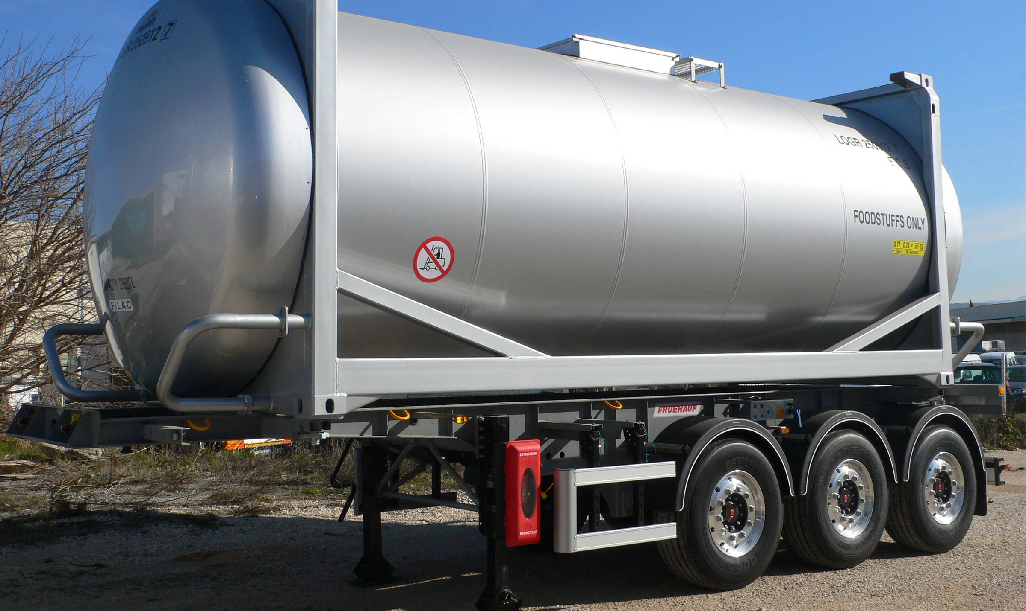
Gallery

Container chassis – chemical
Porte Conteneurs Chimique EN
Container chassis – chemicalGuillaume Calviac2021-01-15T09:54:15+01:00
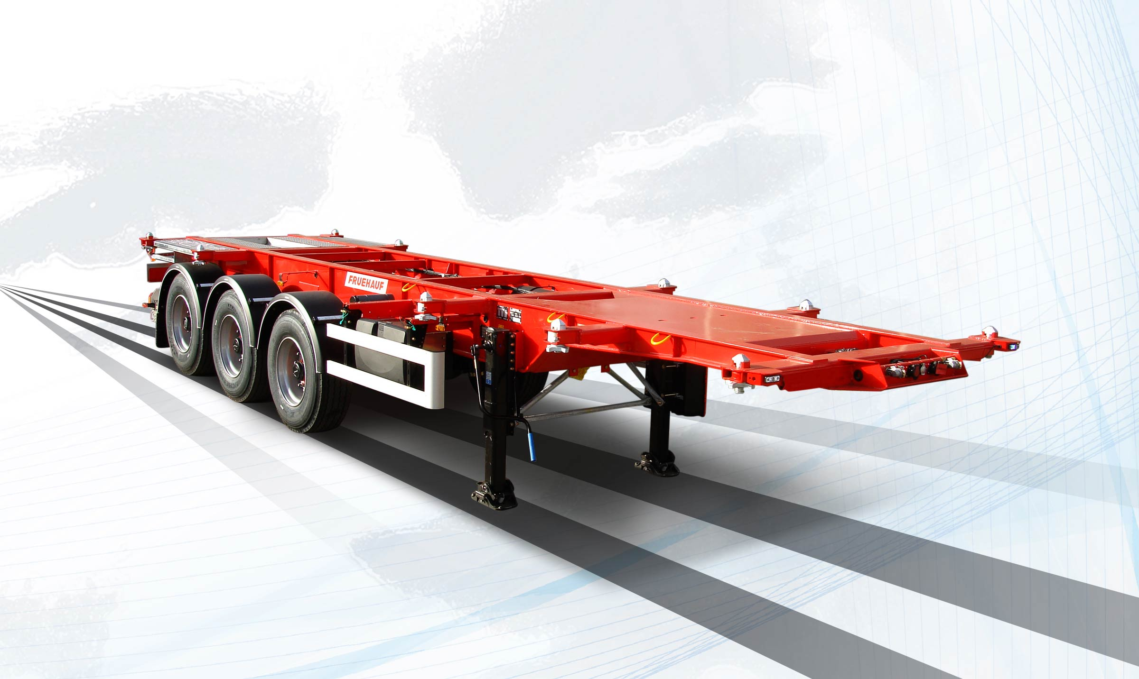
Gallery

Container chassis – chemical
Porte Conteneurs Chimique EN
Documentation

Open Box C+

20' centred - 2 x 20'

40' - 45' - A1360 swap body
This reinforced steel platform has crossmembers with retractable twist locks to transport containers and swap bodies.
Equipped with sliding bodywork that opens fully, from front to back or from back to front, it ensures multifunctional use of the vehicle, as a platform, a container chassis or a curtainsider.
- Simplicity
- Adaptability
- Sturdiness
Useful width preservedGuillaume Calviac2021-01-15T10:19:15+01:00
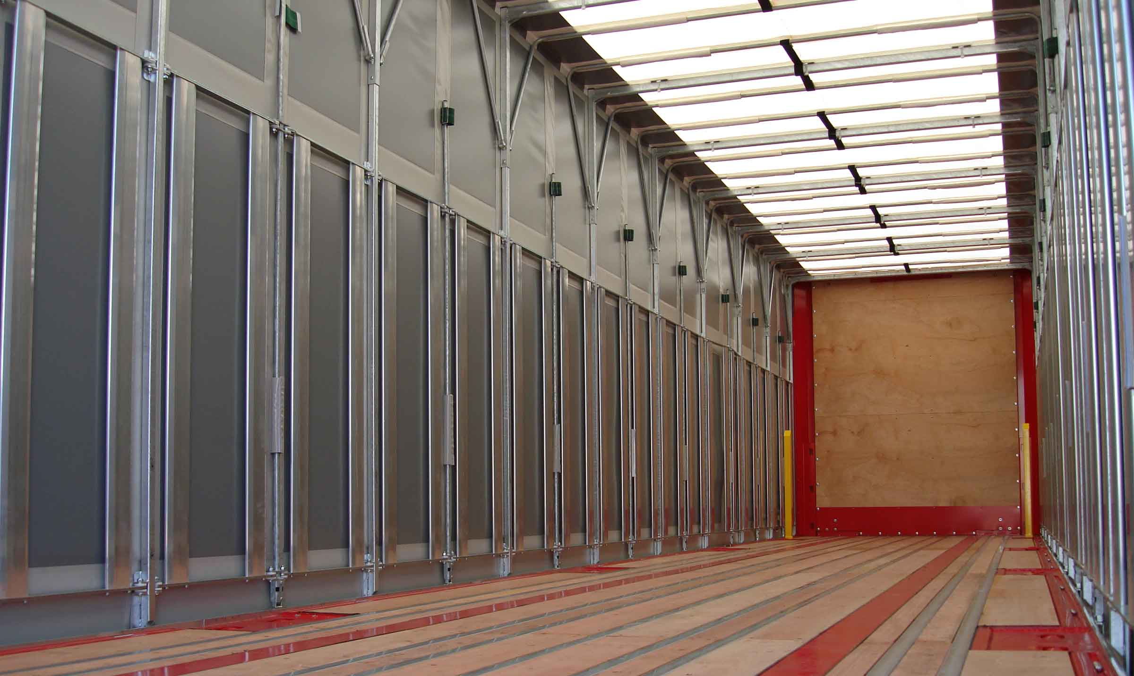
Gallery

Useful width preserved
MaxiSpeed Open Box C + EN
Integral opening for container loadingGuillaume Calviac2021-01-15T10:18:11+01:00
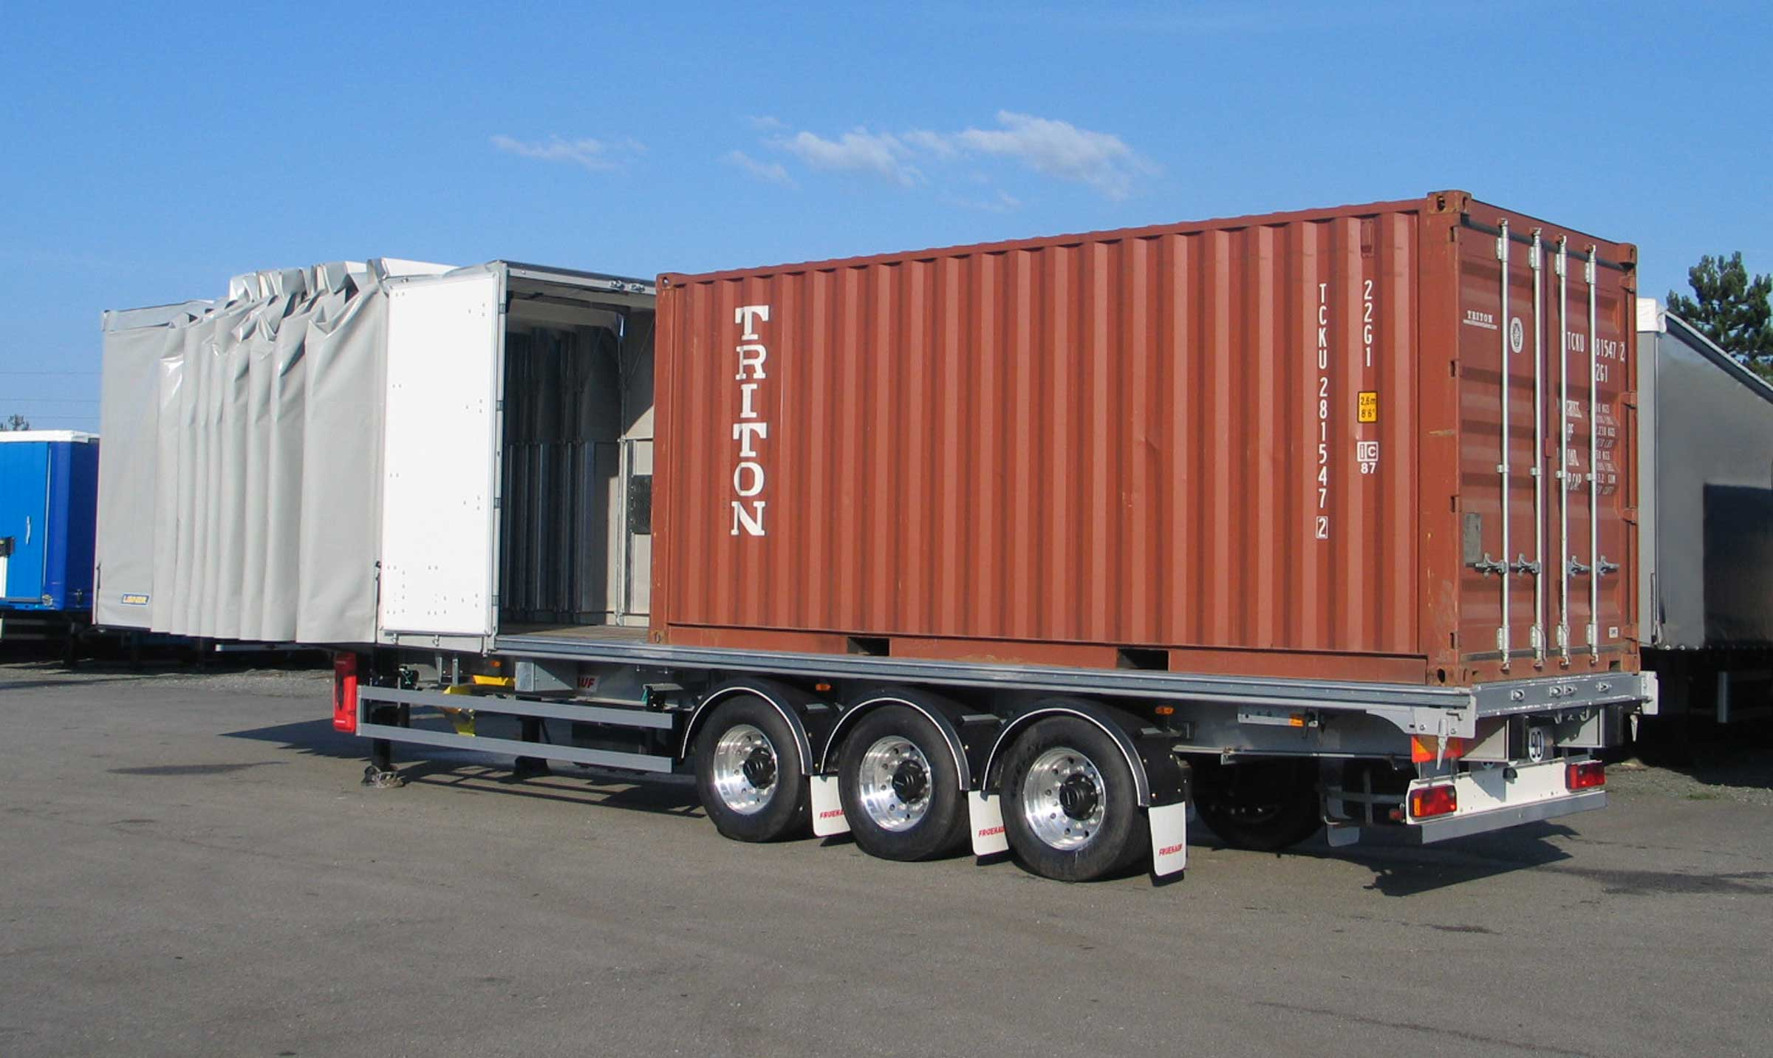
Gallery

Integral opening for container loading
MaxiSpeed Open Box C + EN
Storage of bodywork at the frontGuillaume Calviac2021-01-15T10:16:18+01:00
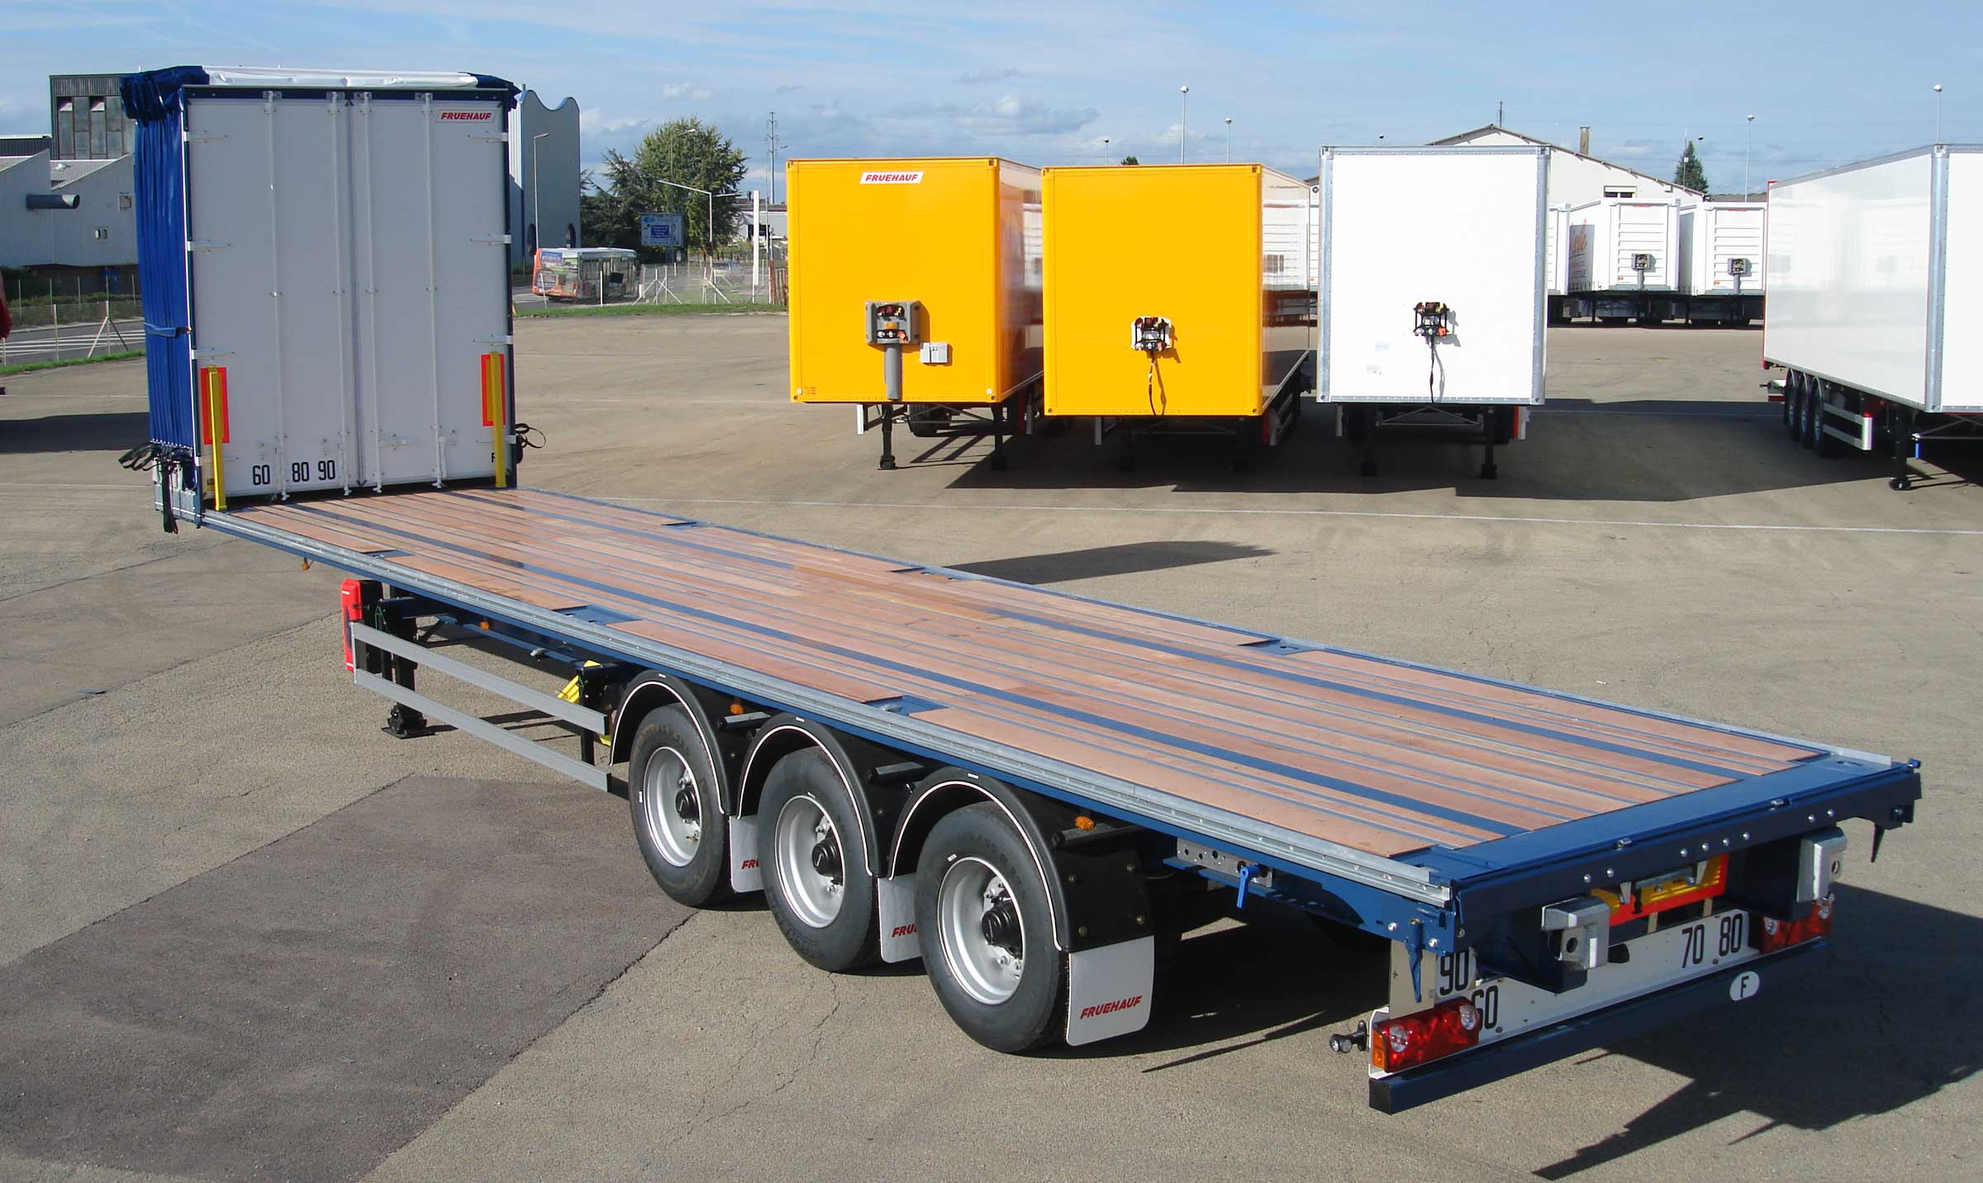
Gallery

Storage of bodywork at the front
MaxiSpeed Open Box C + EN
Sliding bodywork with integral openingGuillaume Calviac2021-01-15T10:14:03+01:00
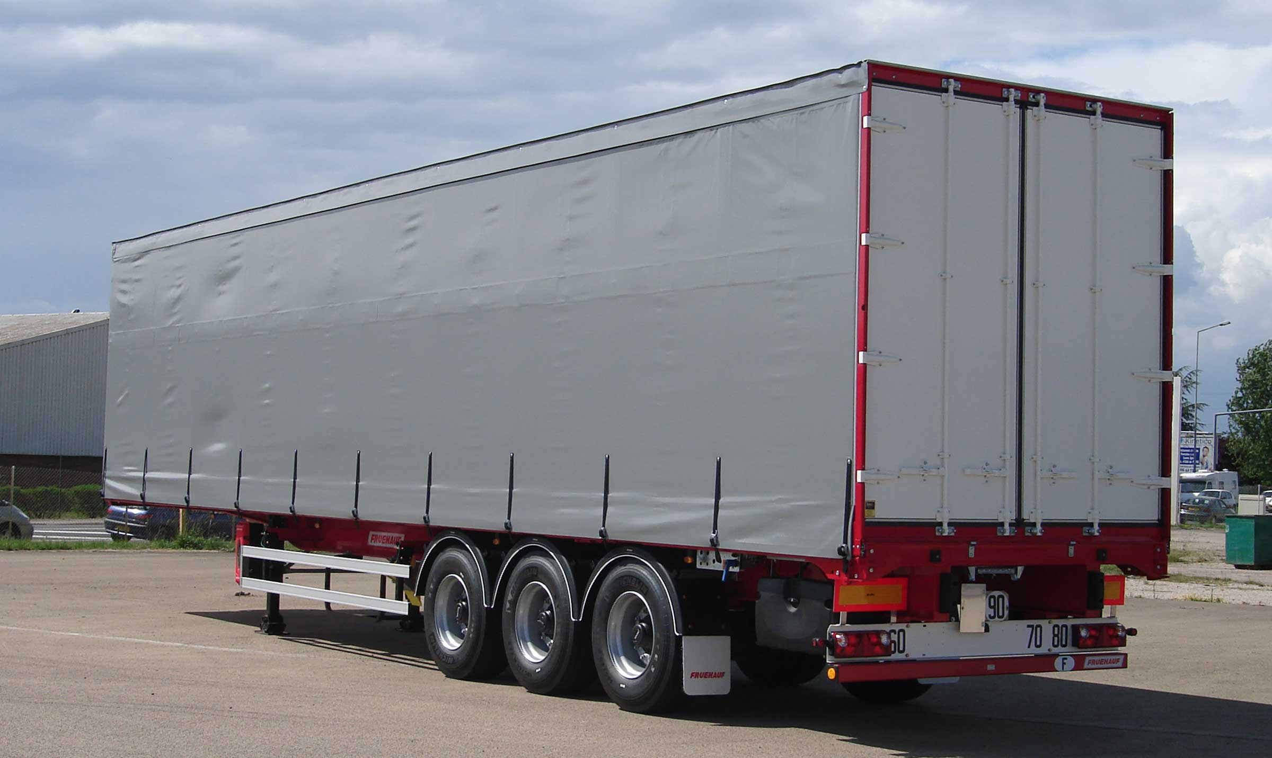
Gallery

Sliding bodywork with integral opening
MaxiSpeed Open Box C + EN

Container chassis platform

20' centred - 2 x 20'

40' - 45' - A1360 swap body
This chassis has crossmembers with retractable twist locks to transport containers.
Its equipment variants are suitable for multifunctional uses, either as a traditional platform or as a container chassis.
- Simplicity
- Reliability
- Sturdiness
10 t capacity wooden deckGuillaume Calviac2021-01-15T13:54:33+01:00
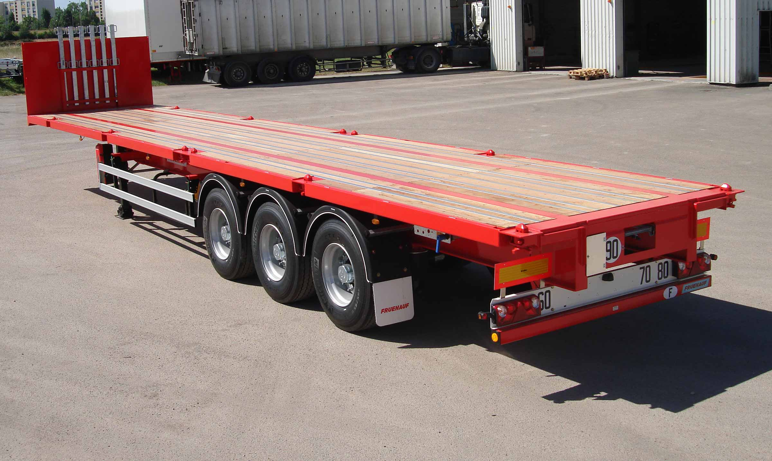
Gallery

10 t capacity wooden deck
Plateaux Porte Conteneurs EN
Removable front endGuillaume Calviac2021-01-15T10:34:21+01:00
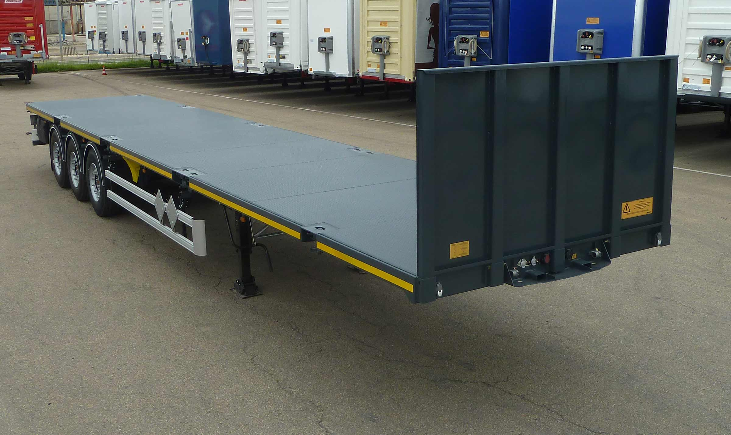
Gallery

Removable front end
Plateaux Porte Conteneurs EN
Metal deckGuillaume Calviac2021-06-01T13:50:12+02:00
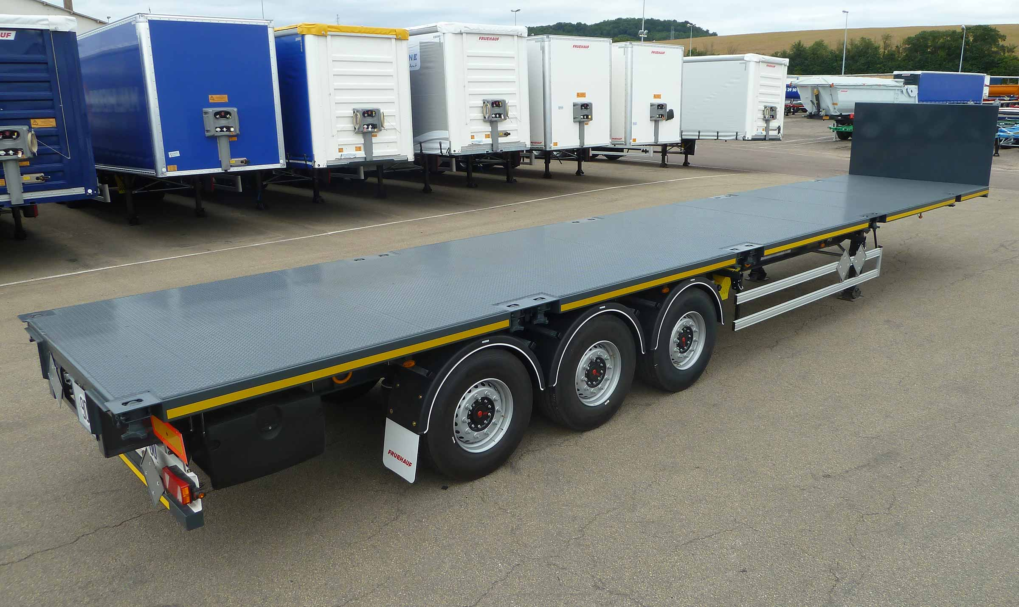
Gallery

Metal deck
Plateaux Porte Conteneurs EN
Container chassis platformGuillaume Calviac2021-01-15T10:28:50+01:00
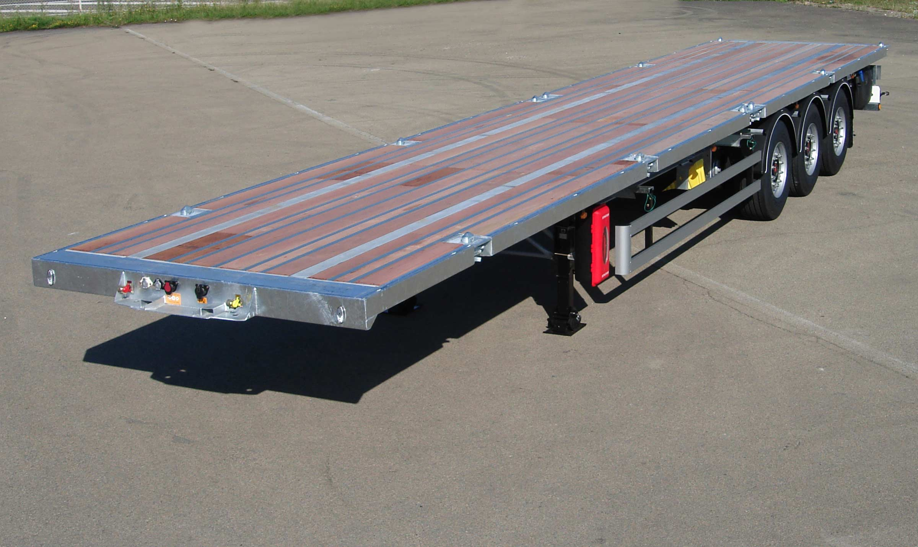
Gallery

Container chassis platform
Plateaux Porte Conteneurs EN
Container chassis platformGuillaume Calviac2021-01-15T10:28:19+01:00
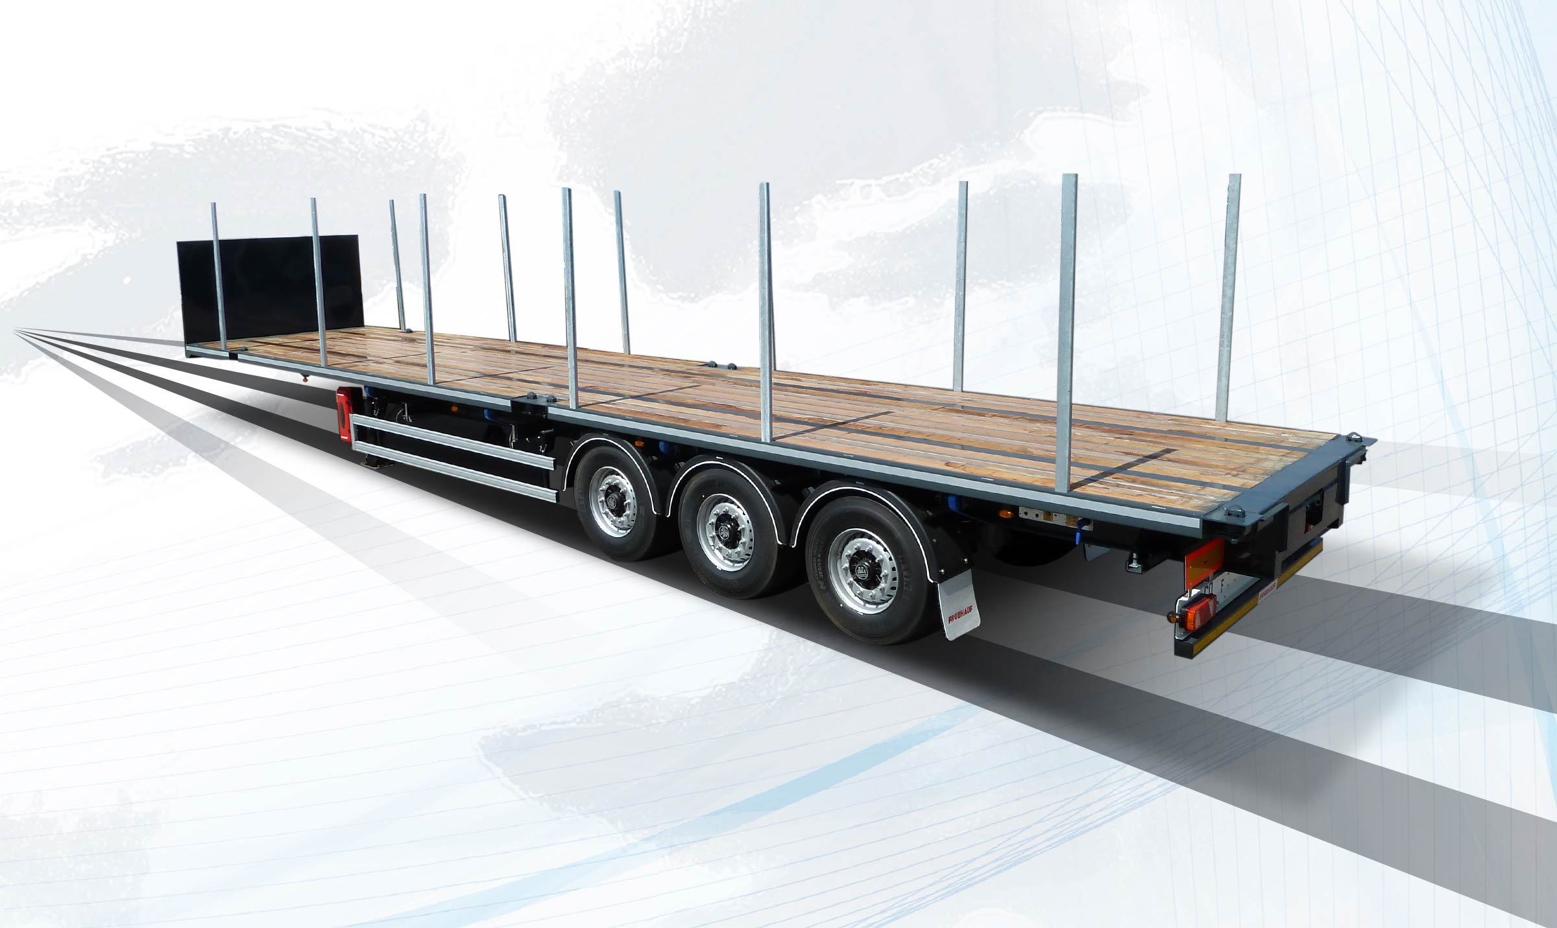
Gallery

Container chassis platform
Plateaux Porte Conteneurs EN
Documentation

The specialist vehicles for rail-road swap bodies

Straight swap body

A1360 swap body

40' - 45' euro
Dedicated to combined rail-road transport, its chassis is lightweight to carry long flat-bottom or tunnel swap bodies.
- Simplicity
- Reliability
- Sturdiness
Straight swap bodyGuillaume Calviac2021-01-15T11:06:04+01:00
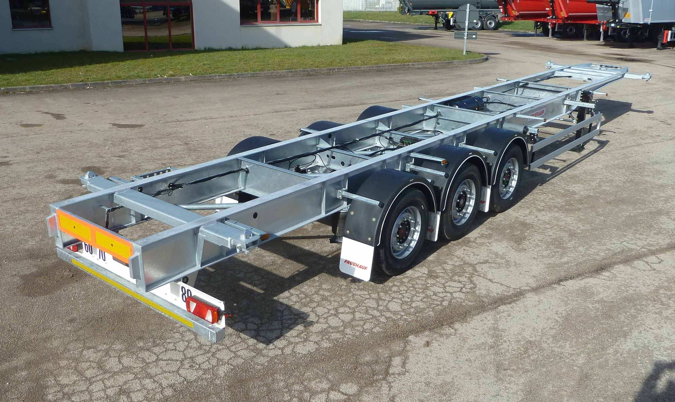
Gallery

Straight swap body
Porte Conteneurs CAMO Droit EN
Documentation

45' EURO swap body

45' swap body

Gooseneck
Vehicle specially designed to transport 45' EURO tunnel swap bodies. Its front gooseneck can carry high bodies within 4-metre height limit.
- Simplicity
- Reliability
- Sturdiness
Swap body 45′ EUROGuillaume Calviac2021-01-15T11:08:43+01:00
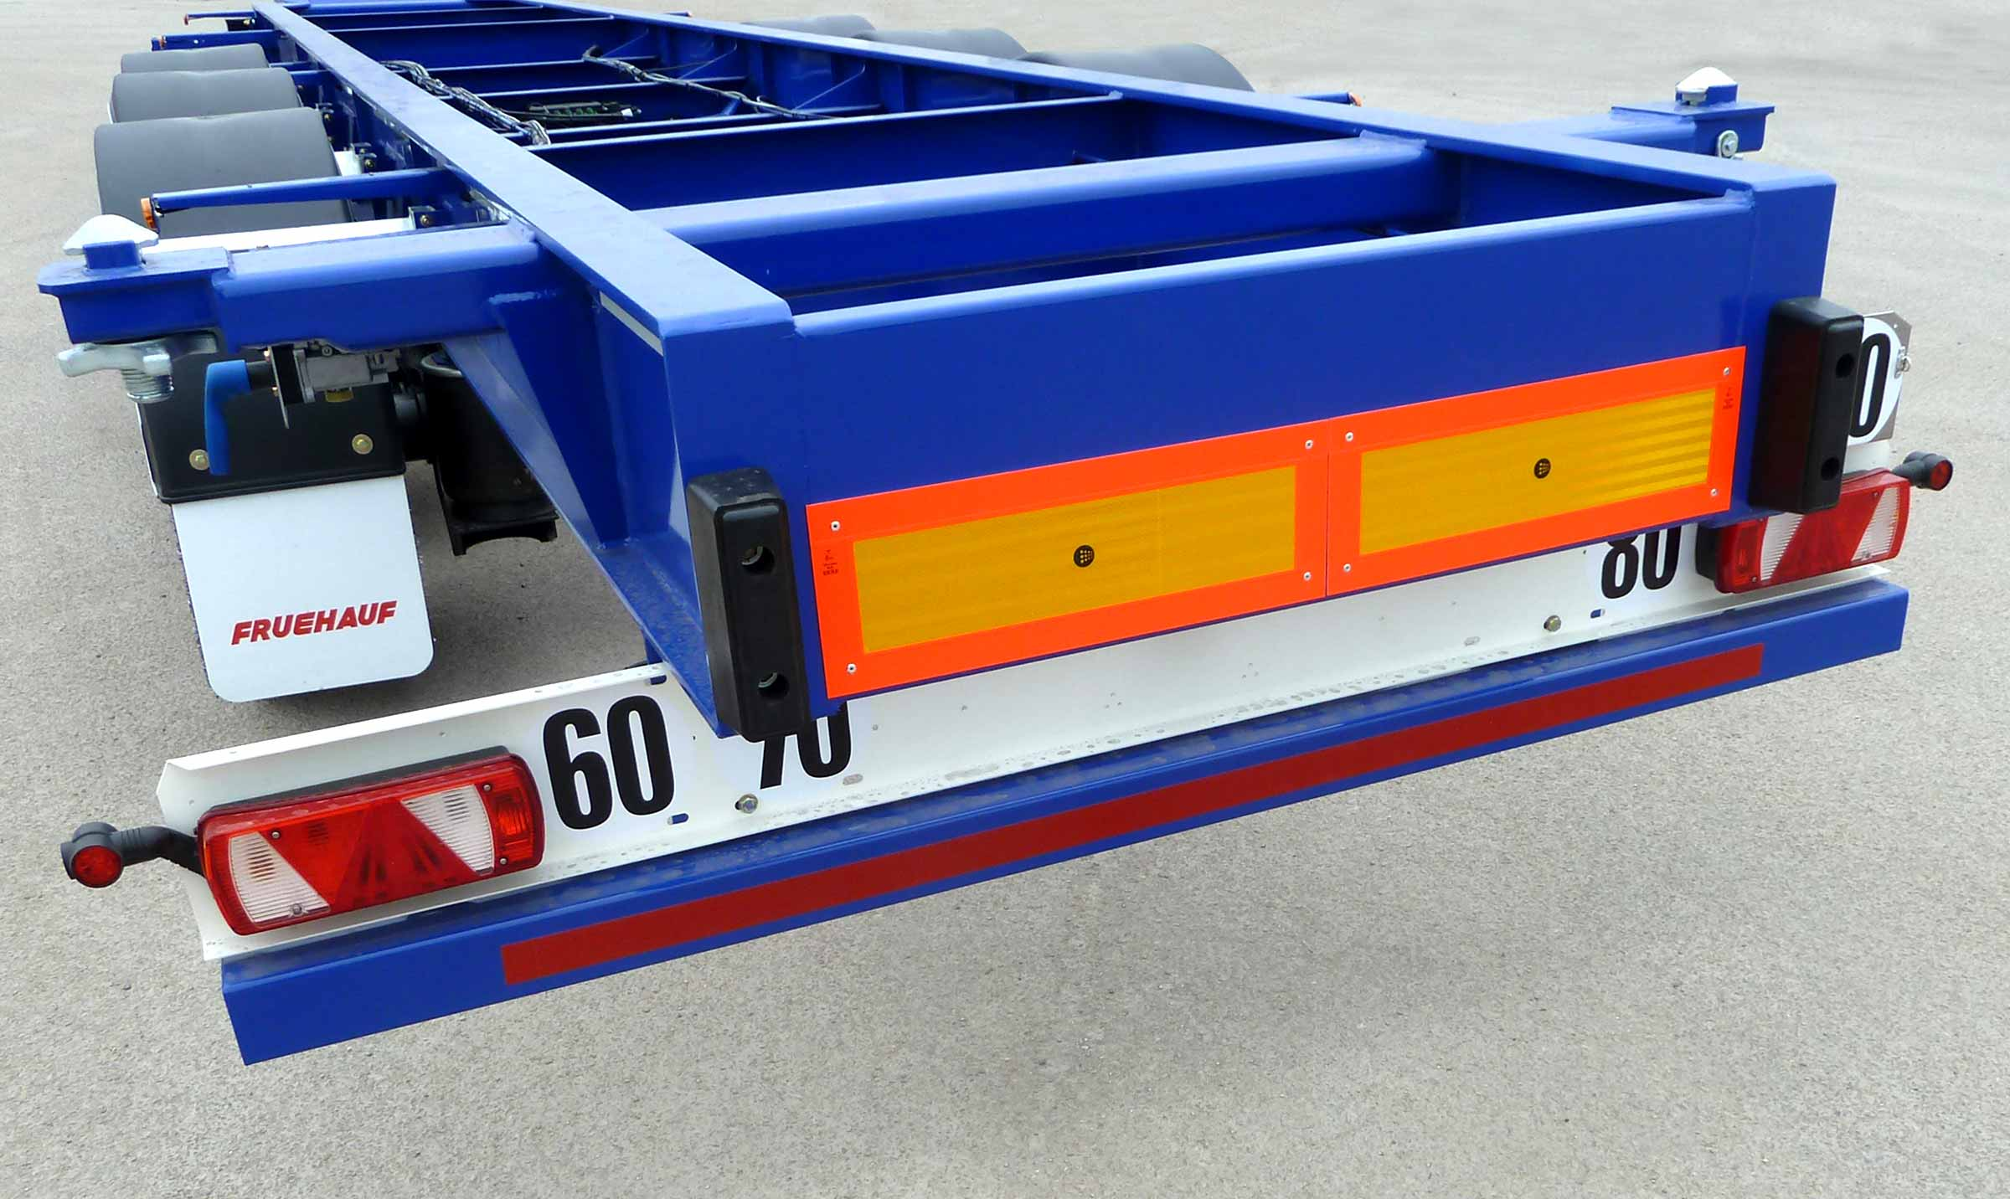
Gallery

Swap body 45′ EURO
Porte Conteneurs CAMO 45 EURO EN
Swap body 45′ EUROGuillaume Calviac2021-01-15T11:08:19+01:00
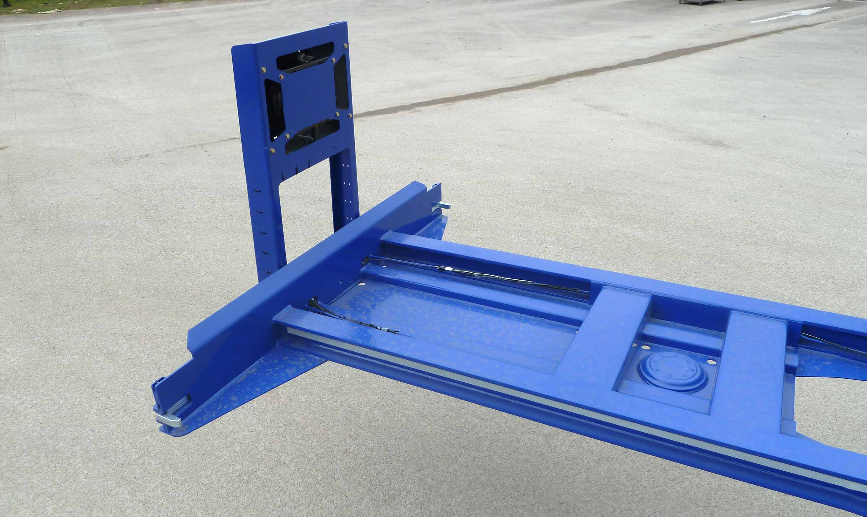
Gallery

Swap body 45′ EURO
Porte Conteneurs CAMO 45 EURO EN
Swap body 45′ EUROGuillaume Calviac2021-01-15T11:07:45+01:00
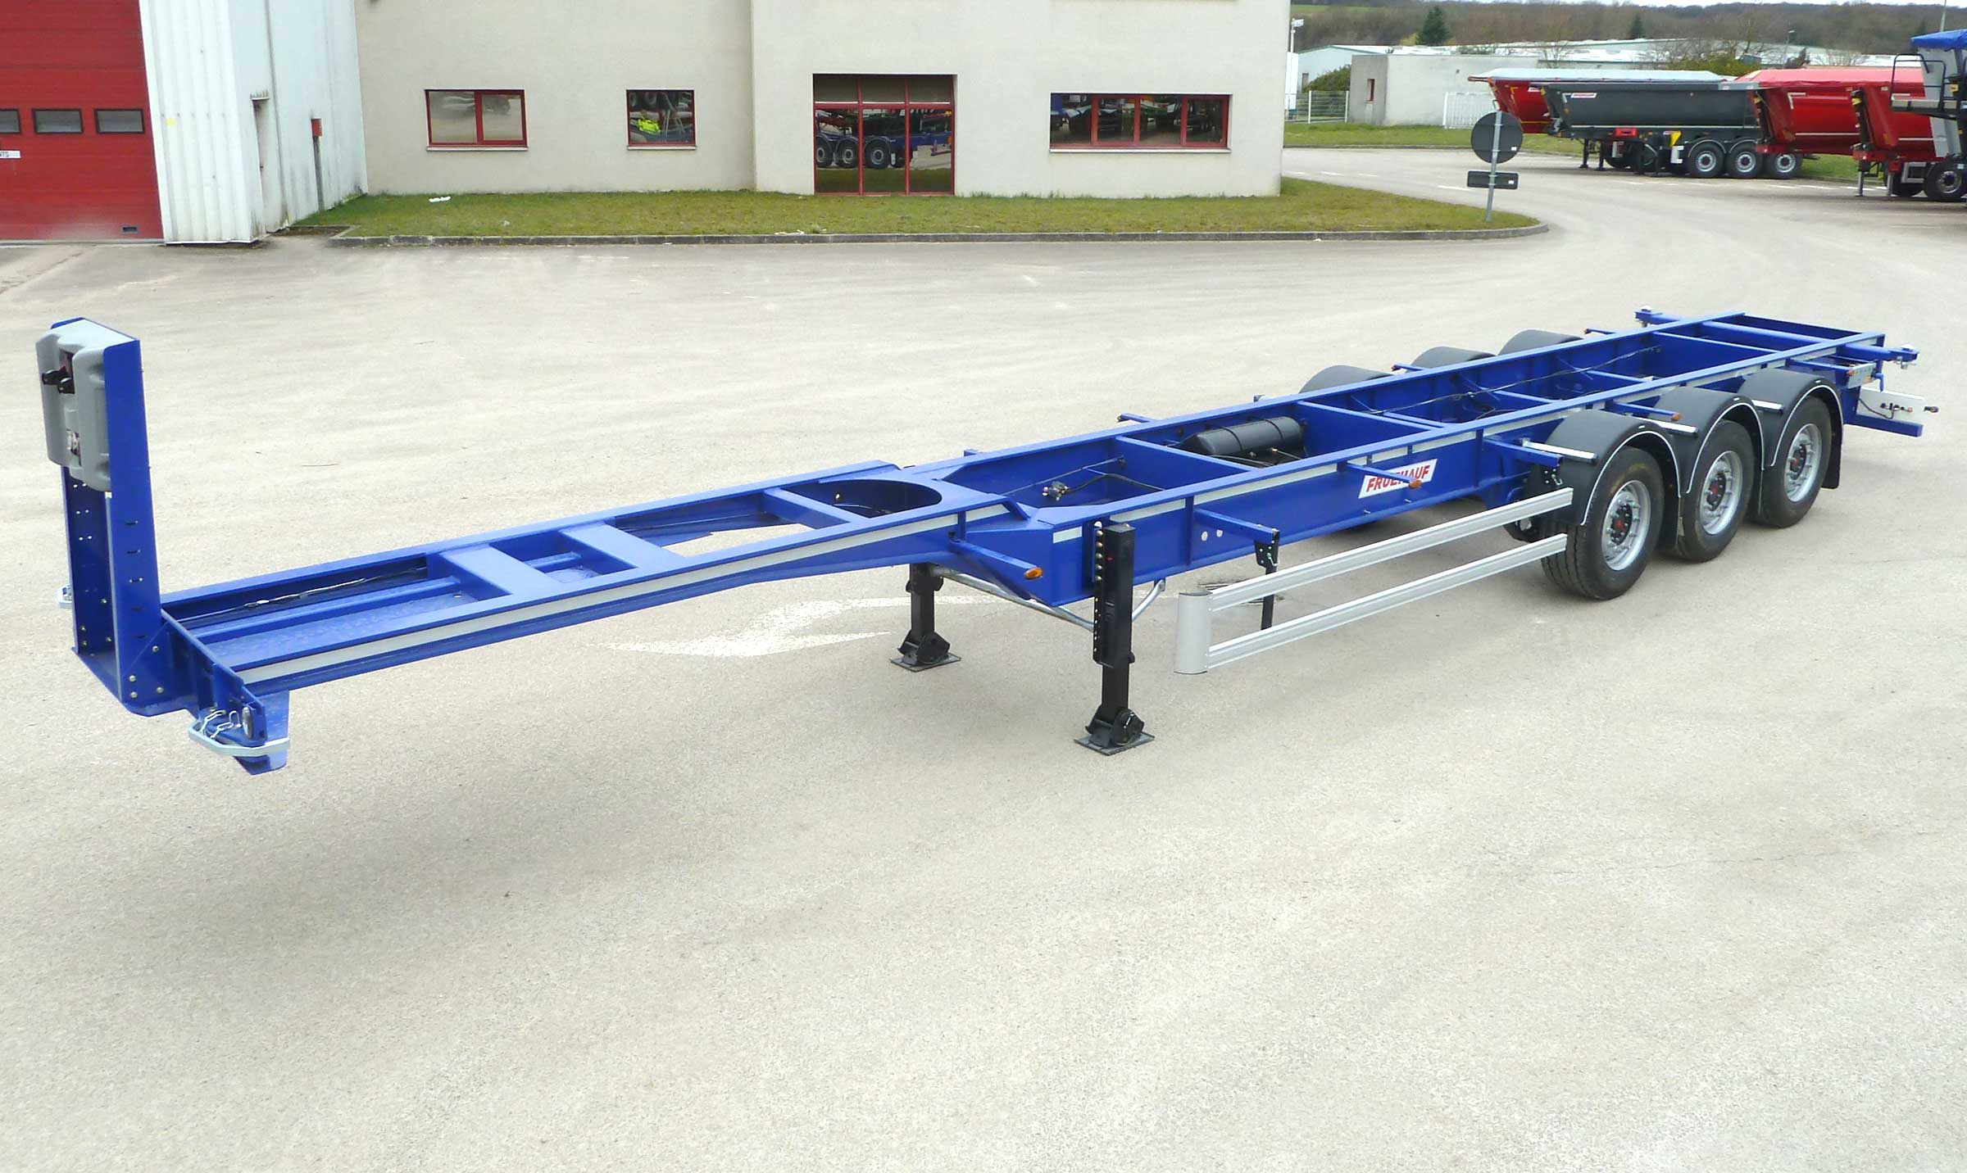
Gallery

Swap body 45′ EURO
Porte Conteneurs CAMO 45 EURO EN
Swap body 45′ EUROGuillaume Calviac2021-01-15T11:07:03+01:00
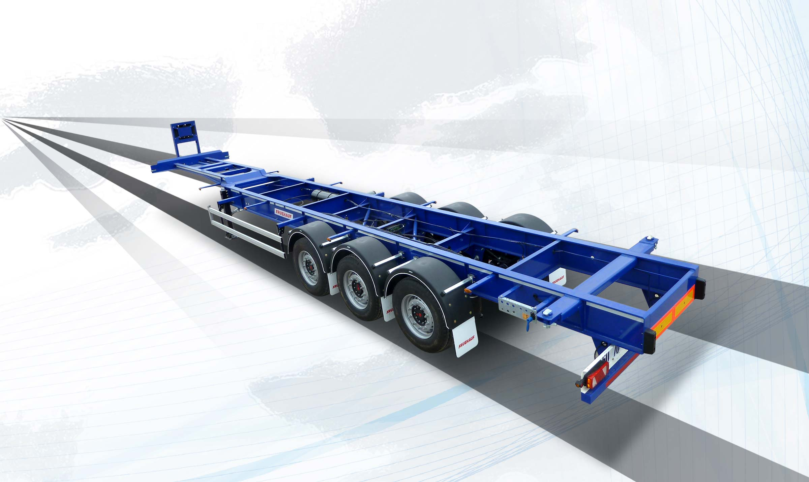
Gallery

Swap body 45′ EURO
Porte Conteneurs CAMO 45 EURO EN

Innovations
By listening to its customers and users, Fruehauf is able to continuously design new innovative and high-performance equipment for increased savings, productivity and safety.
Protection of personnel and equipment, reduced fuel consumption, anticipation of new requirements.
- Economy
- Productivity
- Safety
SafeParkingGuillaume Calviac2021-01-15T11:41:43+01:00
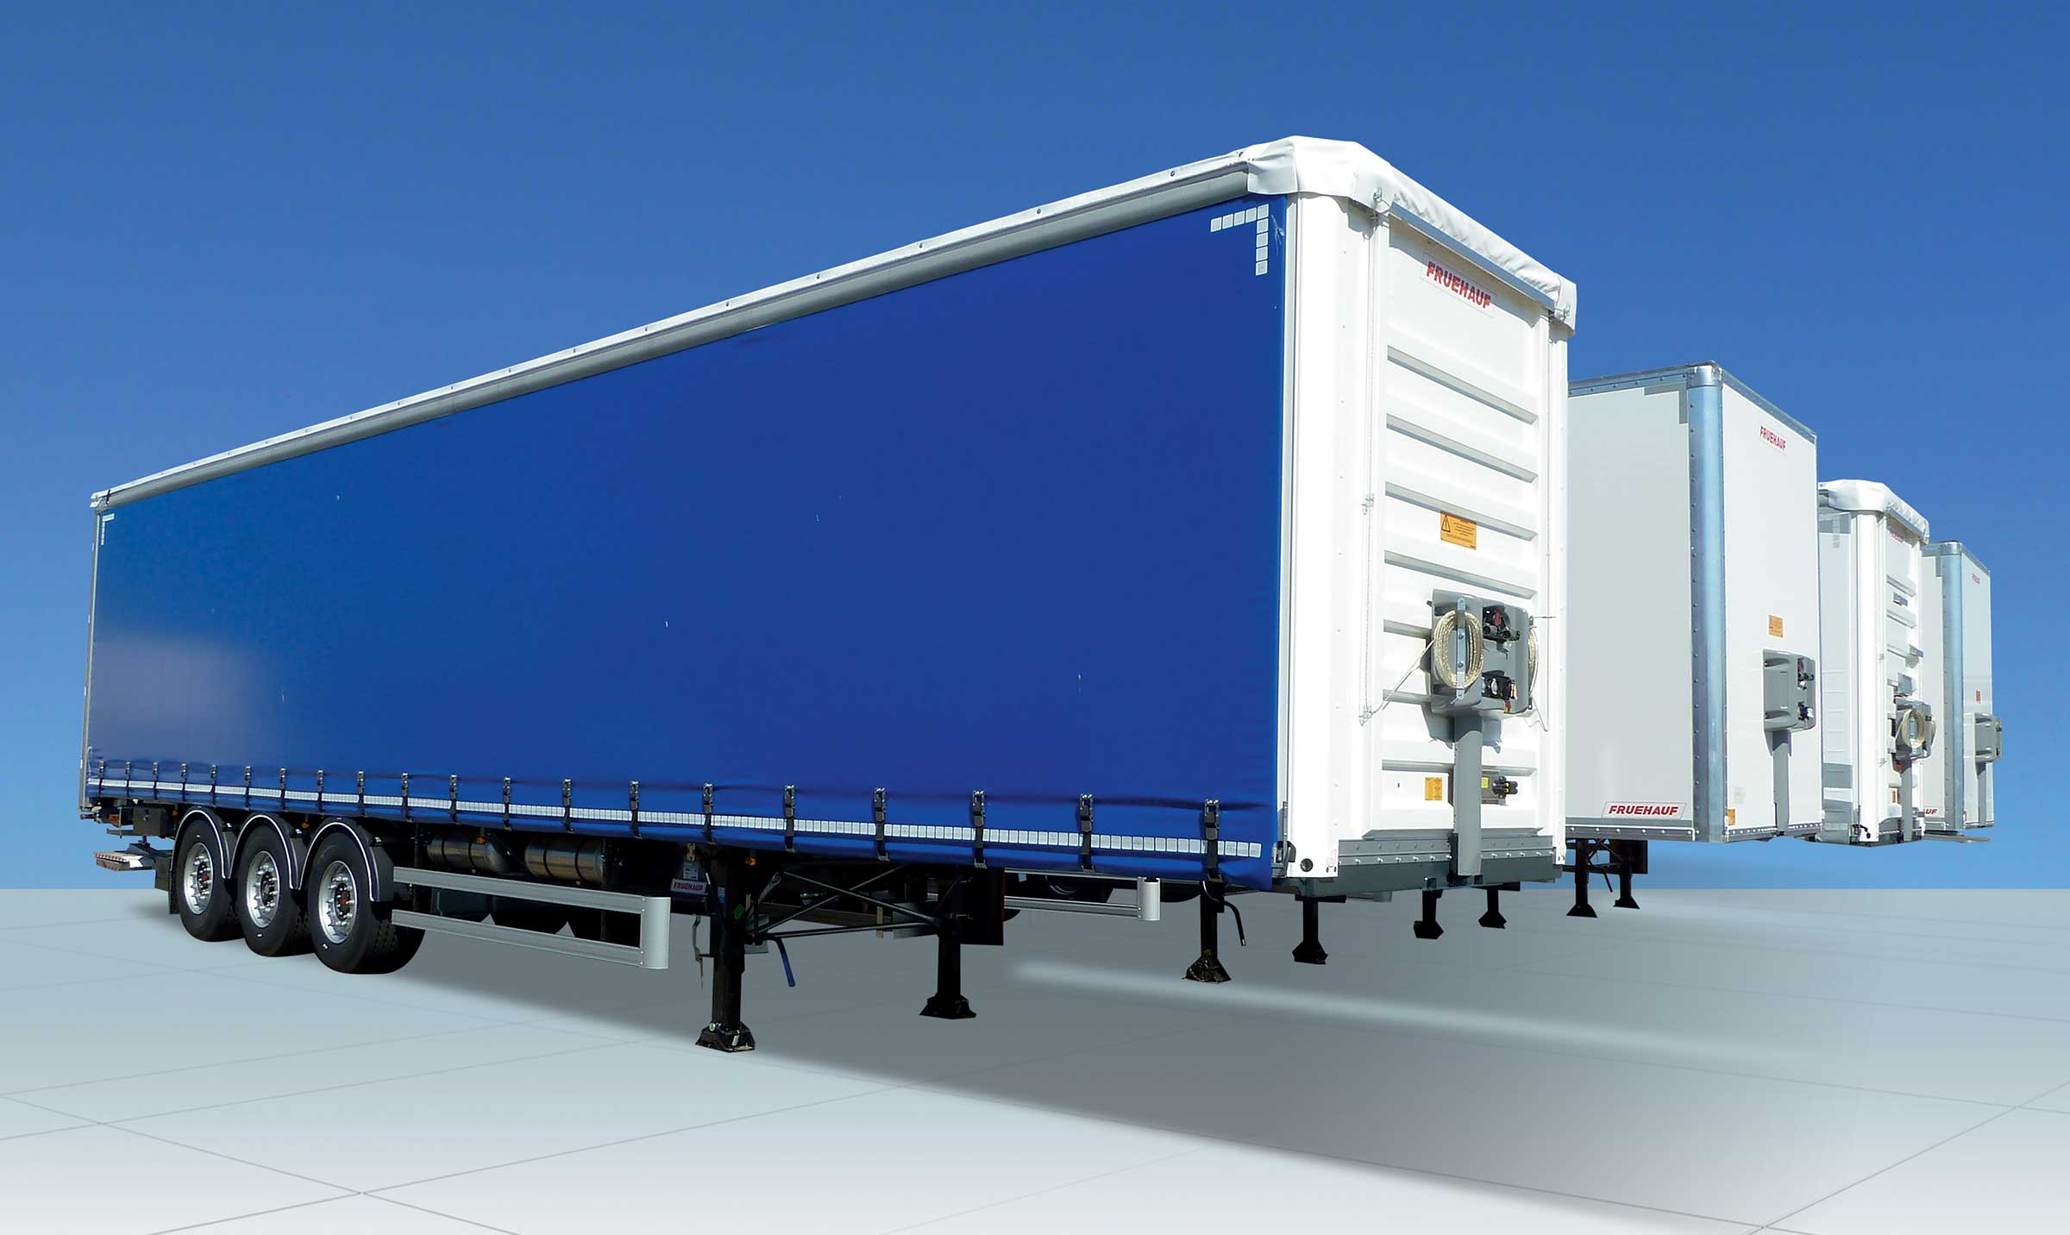
Gallery

SafeParking
Innovations - SafeParking, Innovations Base EN
TelematicsGuillaume Calviac2021-01-29T13:44:33+01:00

Gallery

Telematics
Innovations - Télématique, Innovations Base EN
RCPGuillaume Calviac2021-01-15T11:33:18+01:00
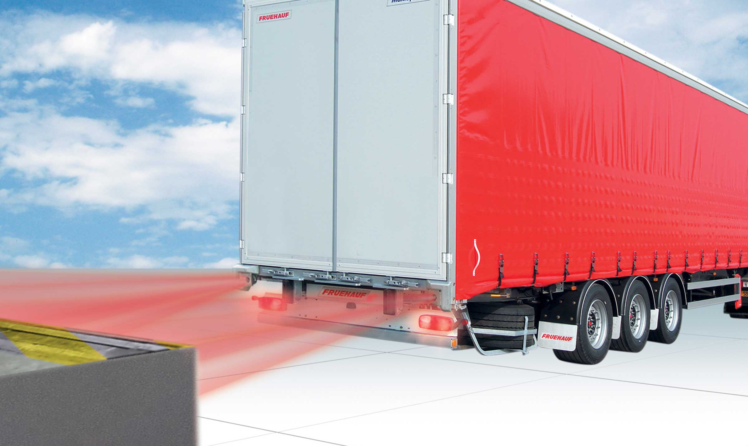
Gallery

RCP
Innovations - RCP, Innovations Base EN
APCSGuillaume Calviac2021-01-15T11:24:21+01:00
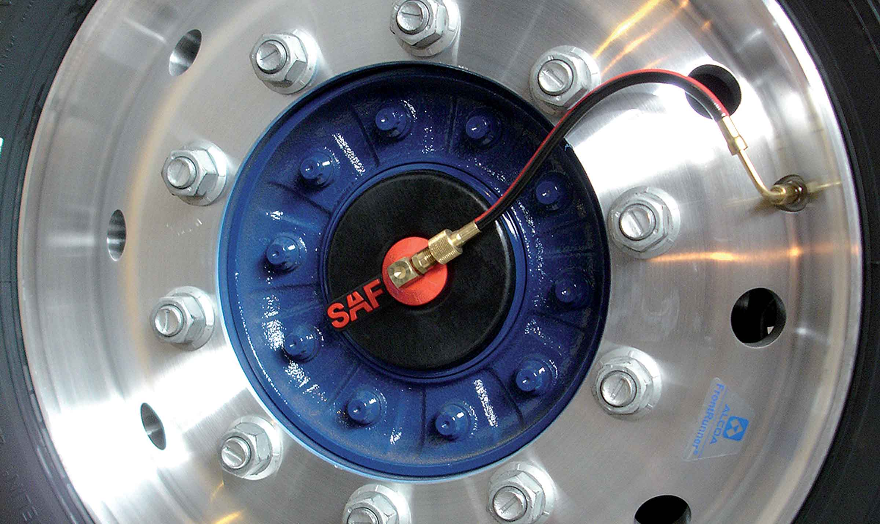
Gallery

APCS
Innovations APCS, Innovations Base EN
EBSGuillaume Calviac2021-01-15T11:24:12+01:00
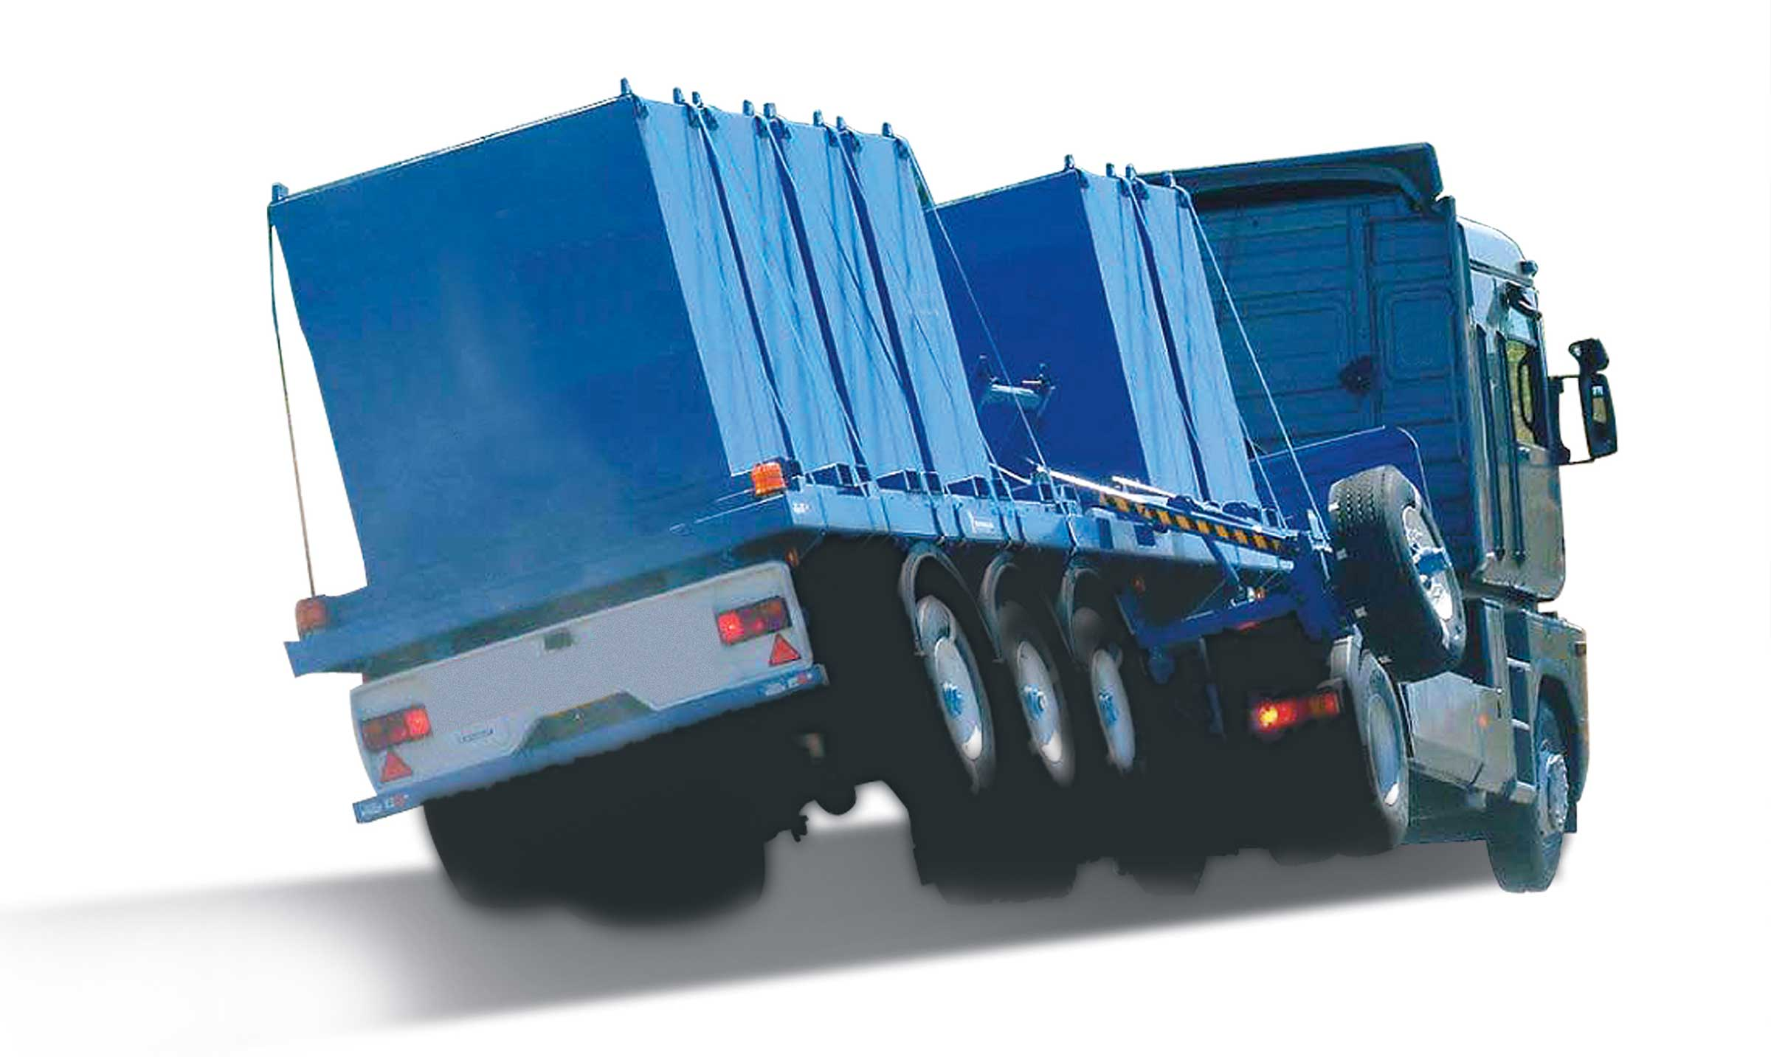
Gallery

EBS
Innovations Base EN
TPMSGuillaume Calviac2021-01-29T08:34:38+01:00
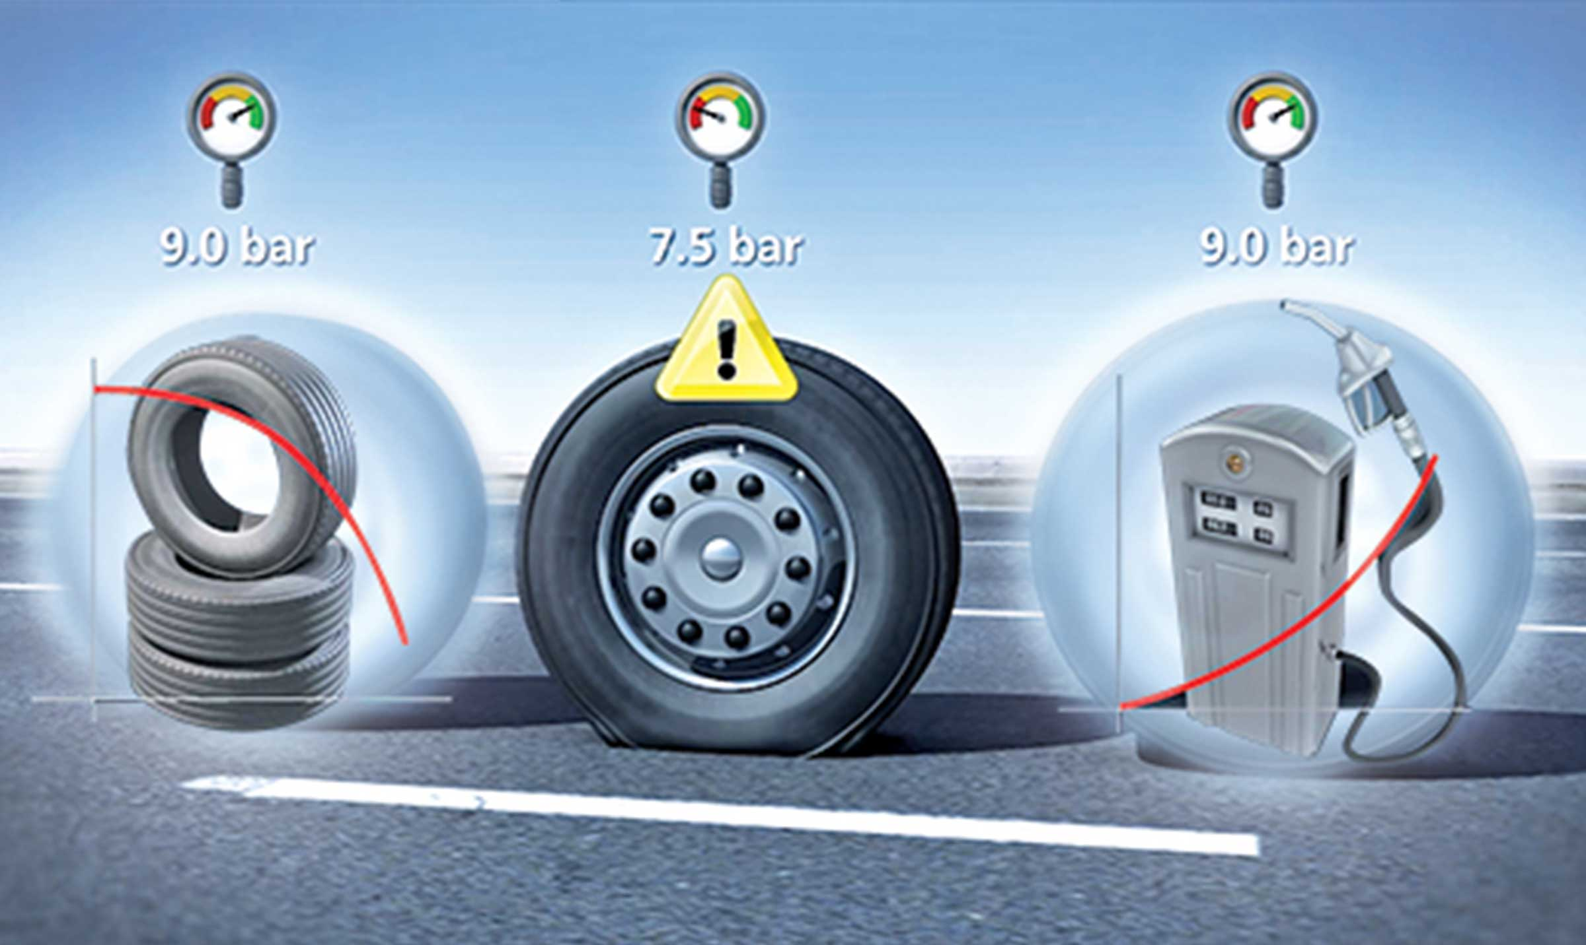
Gallery

TPMS
Innovations - TPMS, Innovations Base EN
Documentation
Demo Videos

Metadata
pyre_slider_type | no
pyre_slider | 0
pyre_wooslider
pyre_revslider | 0
pyre_elasticslider | 0
pyre_slider_position | default
pyre_avada_rev_styles | default
pyre_fallback
pyre_fallback_id
pyre_demo_slider
pyre_main_top_padding
pyre_main_bottom_padding
pyre_hundredp_padding
pyre_show_first_featured_image | no
pyre_display_header | yes
pyre_header_100_width | default
pyre_combined_header_bg_color
pyre_mobile_header_bg_color
pyre_header_bg
pyre_header_bg_id
pyre_header_bg_full | no
pyre_header_bg_repeat | repeat
pyre_displayed_menu | default
pyre_display_footer | default
pyre_display_copyright | default
pyre_footer_100_width | default
pyre_sidebar_position | default
pyre_responsive_sidebar_order
pyre_sidebar_sticky | default
pyre_sidebar_bg_color
pyre_page_bg_layout | default
pyre_page_bg_color
pyre_page_bg
pyre_page_bg_id
pyre_page_bg_full | default
pyre_page_bg_repeat | default
pyre_wide_page_bg_color
pyre_wide_page_bg
pyre_wide_page_bg_id
pyre_wide_page_bg_full | default
pyre_wide_page_bg_repeat | default
pyre_page_title | default
pyre_page_title_breadcrumbs_search_bar | default
pyre_page_title_text | default
pyre_page_title_text_alignment | default
pyre_page_title_custom_text
pyre_page_title_text_size
pyre_page_title_line_height
pyre_page_title_font_color
pyre_page_title_custom_subheader
pyre_page_title_custom_subheader_text_size
pyre_page_title_subheader_font_color
pyre_page_title_100_width | default
pyre_page_title_height
pyre_page_title_mobile_height
pyre_page_title_bar_bg_color
pyre_page_title_bar_borders_color
pyre_page_title_bar_bg
pyre_page_title_bar_bg_id
pyre_page_title_bar_bg_retina
pyre_page_title_bar_bg_retina_id
pyre_page_title_bar_bg_full | default
pyre_page_title_bg_parallax | default
fusion_builder_status | active
kd_featured-image-2_page_id
kd_featured-image-3_page_id
kd_featured-image-4_page_id
kd_featured-image-5_page_id
sbg_selected_sidebar | Array
sbg_selected_sidebar_replacement | Array
sbg_selected_sidebar_2 | Array
sbg_selected_sidebar_2_replacement | Array
avada_post_views_count | 382
avada_today_post_views_count | 4
avada_post_views_count_today_date | 12-12-2023

