CITY - URBAN - DISTRICT VEHICLES
Author | Guillaume Calviac
Date | 2021-01-25 16:29:27
Categories

CITY - URBAN - DISTRICT VEHICULES

The range
Better payload, better manoeuvrability, effective and powerful equipment, Fruehauf City and Urban offer performance much better then traditionnal 4x2 and 6x2 Distribution Trucks.
Available as curtainsiders, vans and platforms, they feature bodywork and equipment identical to 13.60 m semitraliers, enabling full adaptation to the diversity of urban distribution needs.
City range
With its 12 t on the rear axle and its 13 t on the truck driven axle, it offers an exceptionnal and unrivalled payload.
Vehicle available for 21, 24 or 27 pallets.
Urban range
Its 18 t capacity twin-axle chassis and its optimised shape give it a payload 5 t greater than the single-axle City.
Vehicle available for 27 pallets.
District range
Thanks to its 13,60m long, the District ensures a similar charging potential as the MAXISPEED CLASSIC.
Its 3rd steering axle is a real asset in manœuvres.
The combination with a forklift onboard system enables an optimum use of this semi-trailer.
Vehicule able to carry 34 pallets.
Industrial loads - Pallets
Local shops - Parcel Delivery
Site supplies
Refrigerated distribution

Rear steering axle

The best manoeuvrability

Maximum payload
Such performance called for the development of a new rear steering axle.
Directly linked to the coupling plate by a deflection arm, it enables the truck to be followed almost exactly.
Assembled on a reinforced frame and built into a hot-galvanised chassis with an optimised wheelbase, it ensures an exceptional and unrivalled payload.
- Best payload
- Better manoeuvrability
- Ease of use
Automatic centralised lubricationGuillaume Calviac2021-02-12T12:14:34+01:00
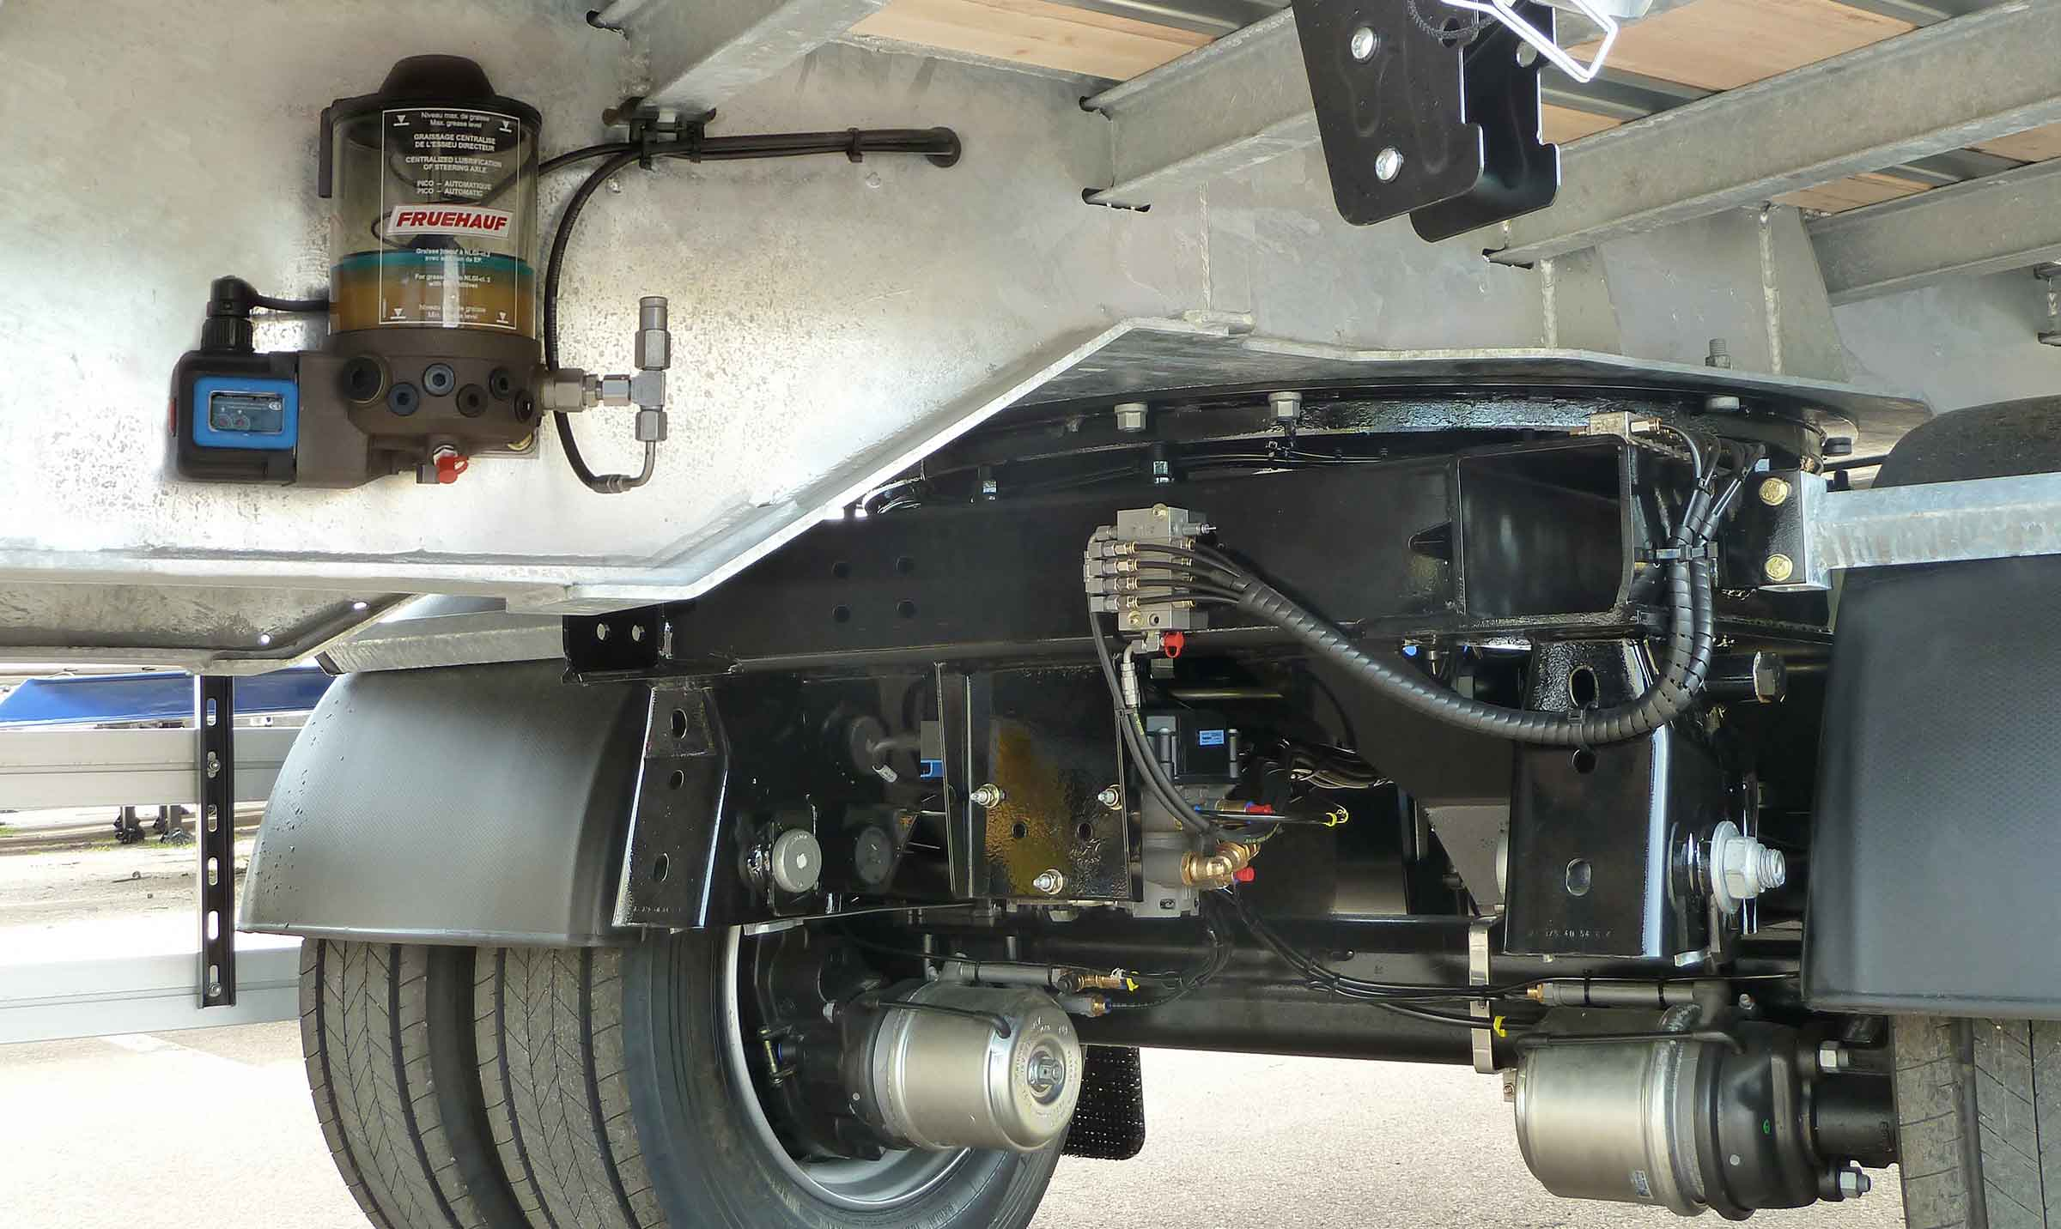
Gallery

Automatic centralised lubrication
City - Urban - Rear steering axle, City Innovations EN
Swivelling coupling plate with idler armGuillaume Calviac2021-04-12T09:24:43+02:00
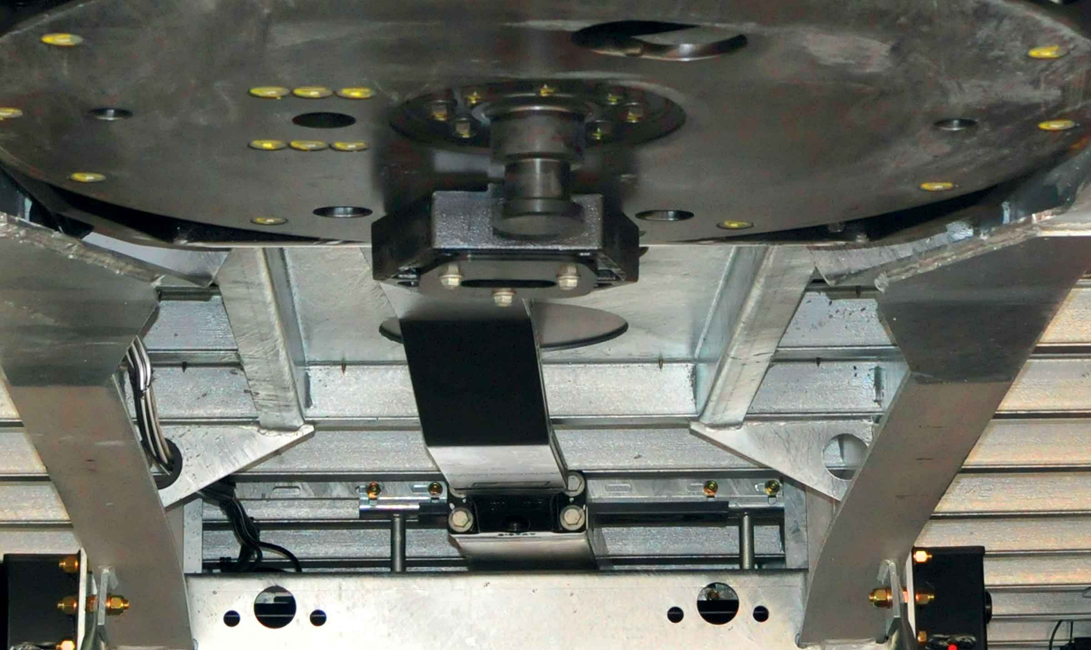
Gallery

Swivelling coupling plate with idler arm
City - Urban - Rear steering axle
URBAN rear steering axleGuillaume Calviac2021-01-13T15:39:55+01:00
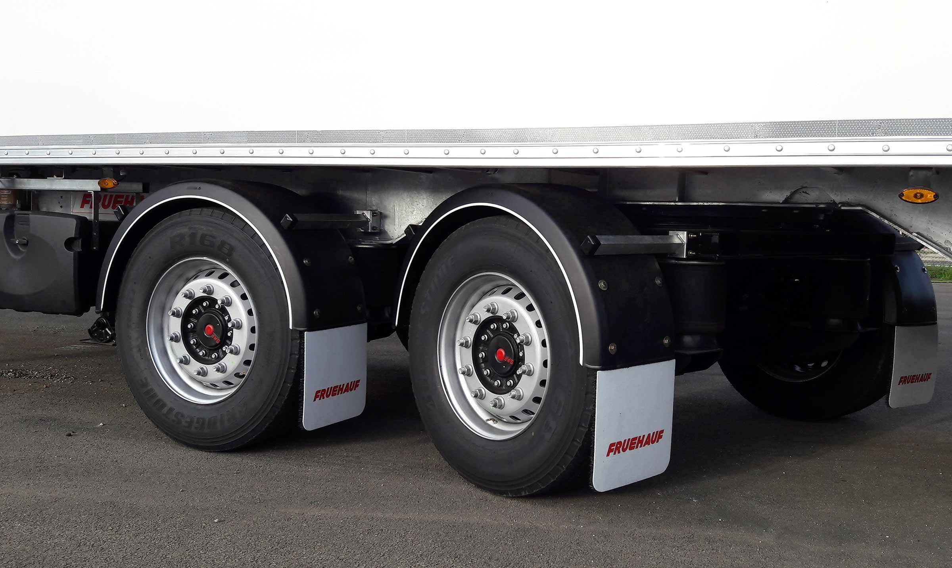
Gallery

URBAN rear steering axle
City - Urban - Rear steering axle
Rear steering axle on swivelling reinforced frameGuillaume Calviac2021-01-13T15:38:29+01:00
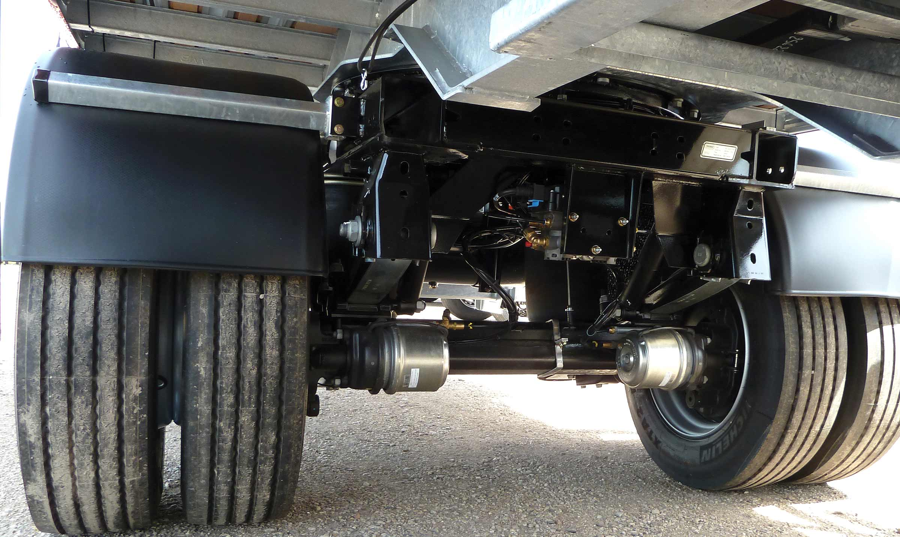
Gallery

Rear steering axle on swivelling reinforced frame
City - Urban - Rear steering axle, Innovations - Graissage centralisé
Steering axleGuillaume Calviac2021-01-13T15:37:02+01:00
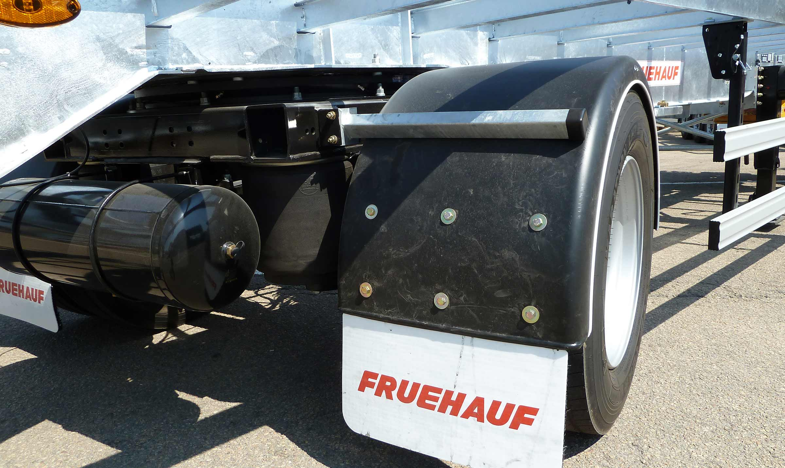
Gallery

Steering axle
City - Urban - Rear steering axle, Innovations - City
Manual centralised lubricationGuillaume Calviac2021-02-12T12:10:07+01:00
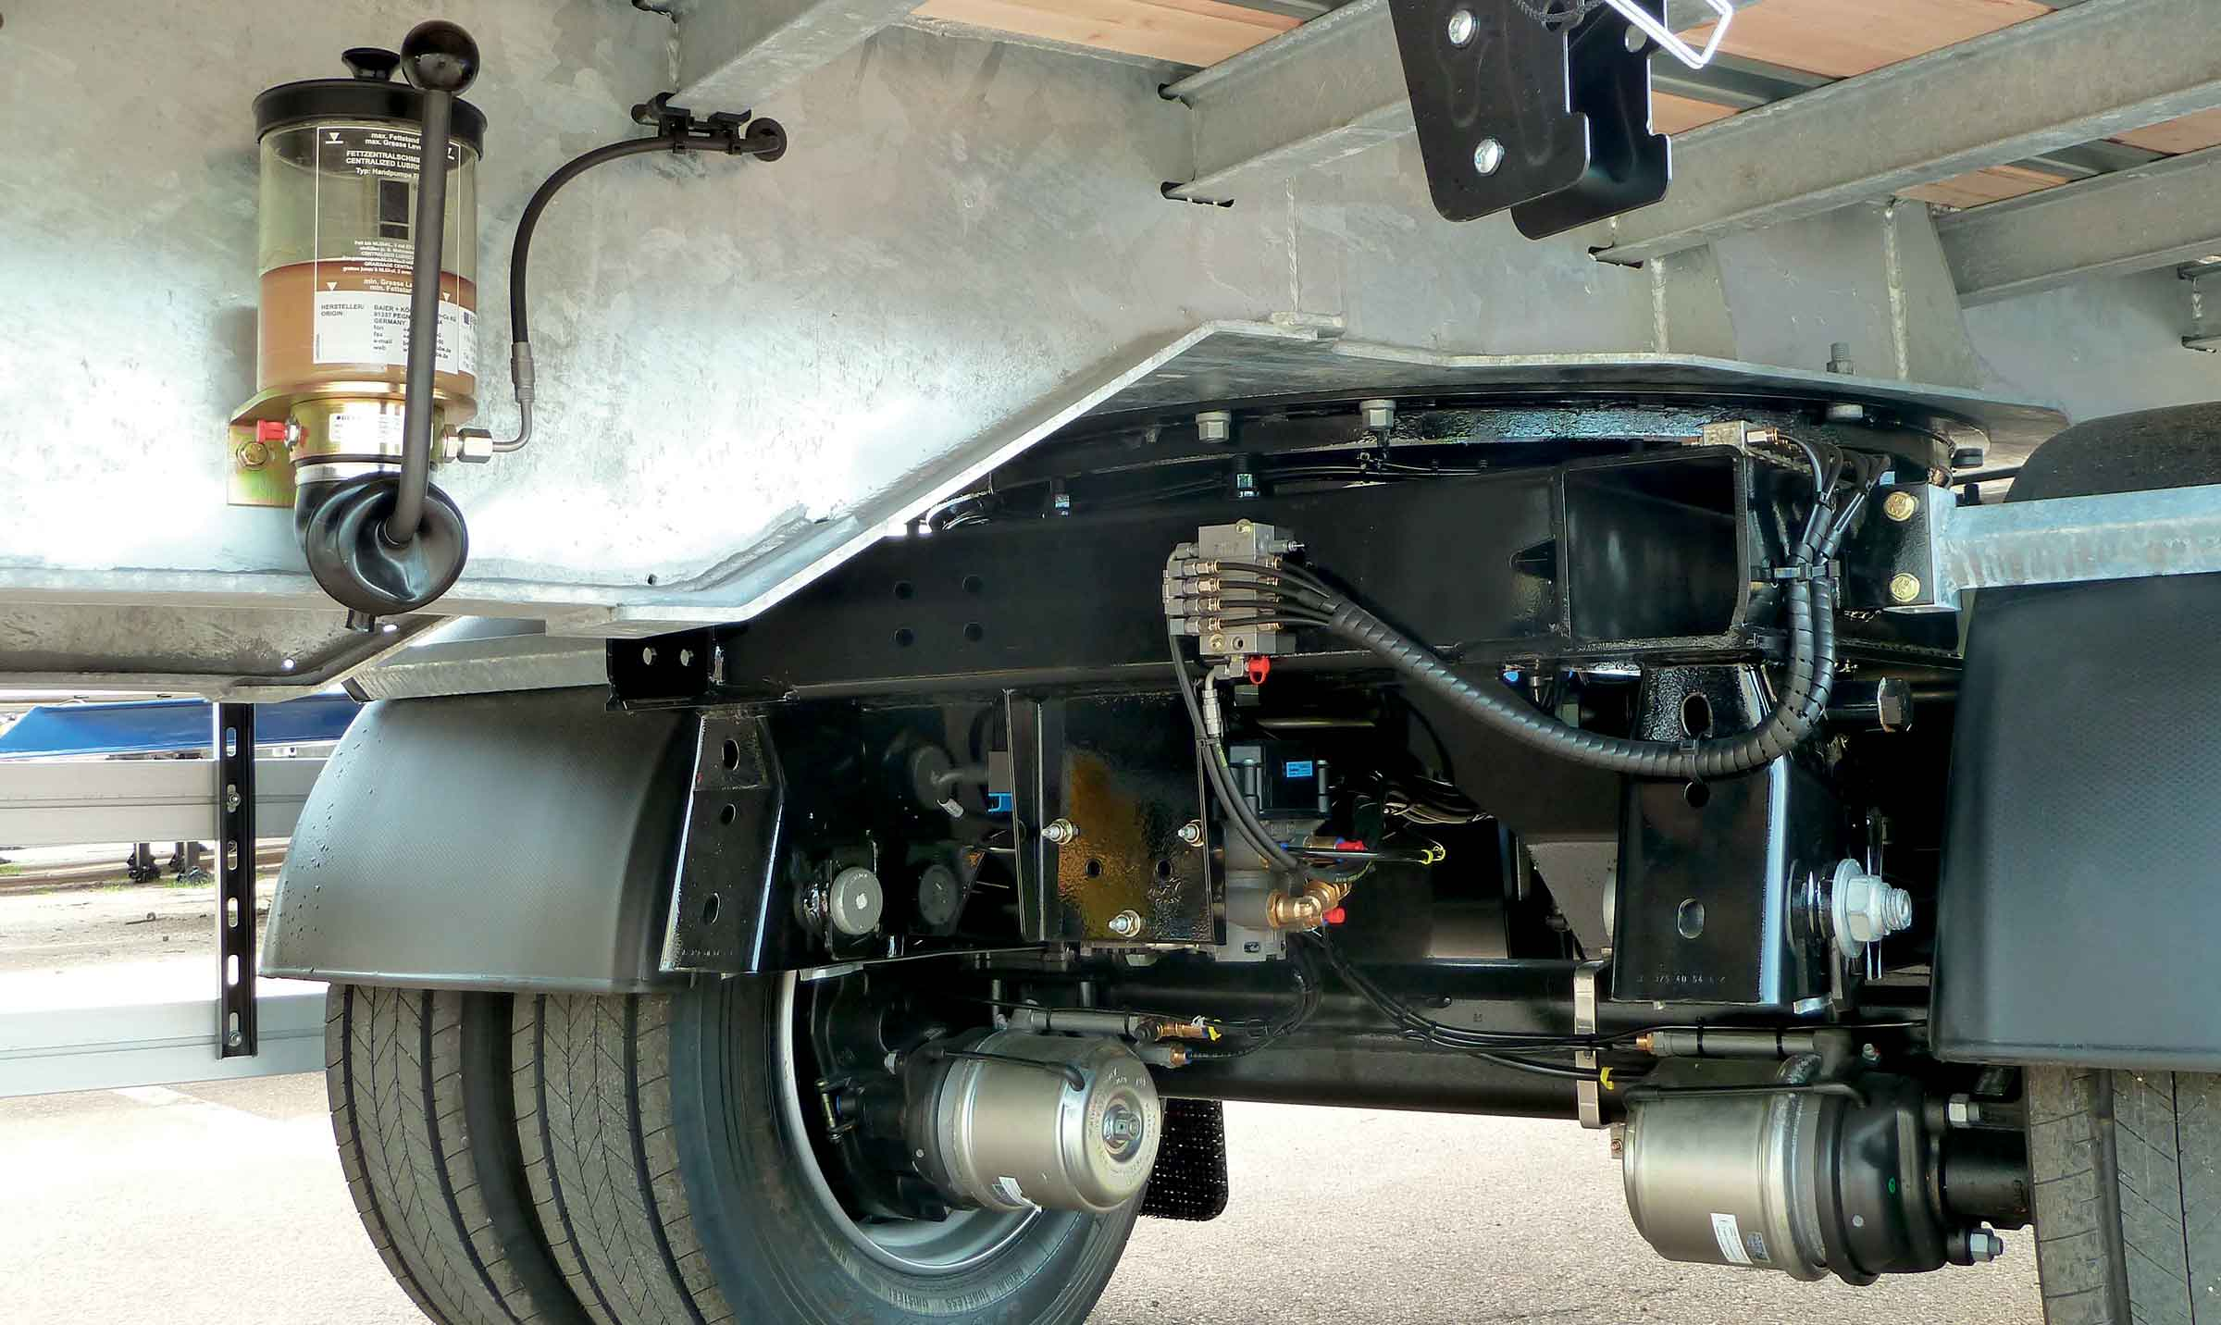
Gallery

Manual centralised lubrication
City - Urban - Rear steering axle, City Innovations EN
Documentation
Demo Videos

Industrial distribution - Pallets
The MaxiSpeed City, Urban and District curtainsiders are perfectly suited to industrial and pallet distribution.
Their machanically welded chassis, solid decks and bodywork are ideal for intensive and harsh applications.
MaxiSpeed City, Urban and District vehicles are available in several versions: Drop Sides, On-board forklift, etc.
- Versatility
- Productivity
- Adaptability
MaxiSpeed CityGuillaume Calviac2021-01-13T16:34:34+01:00
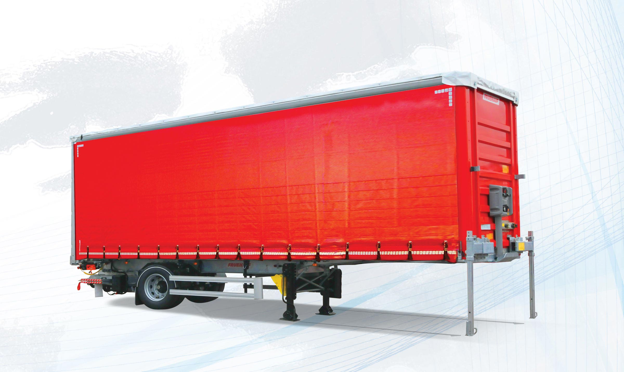
Gallery

MaxiSpeed City
City - Urban - MaxiSpeed, MaxiSpeed City
MaxiSpeed CityGuillaume Calviac2021-01-13T16:34:20+01:00
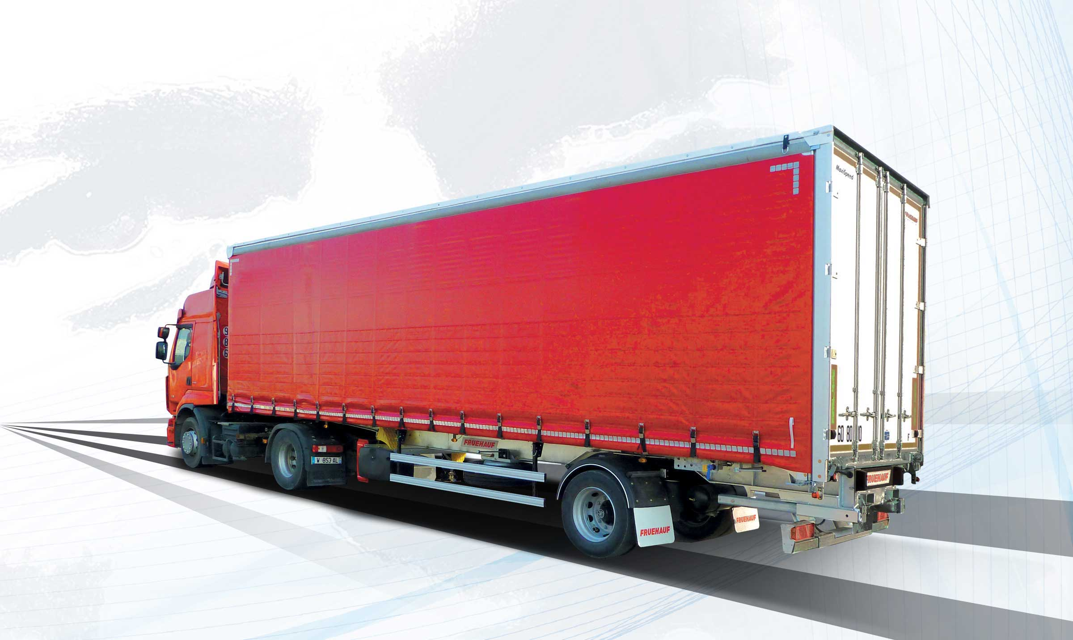
Gallery

MaxiSpeed City
City - Urban - MaxiSpeed
MaxiSpeed UrbanGuillaume Calviac2021-01-13T16:33:51+01:00
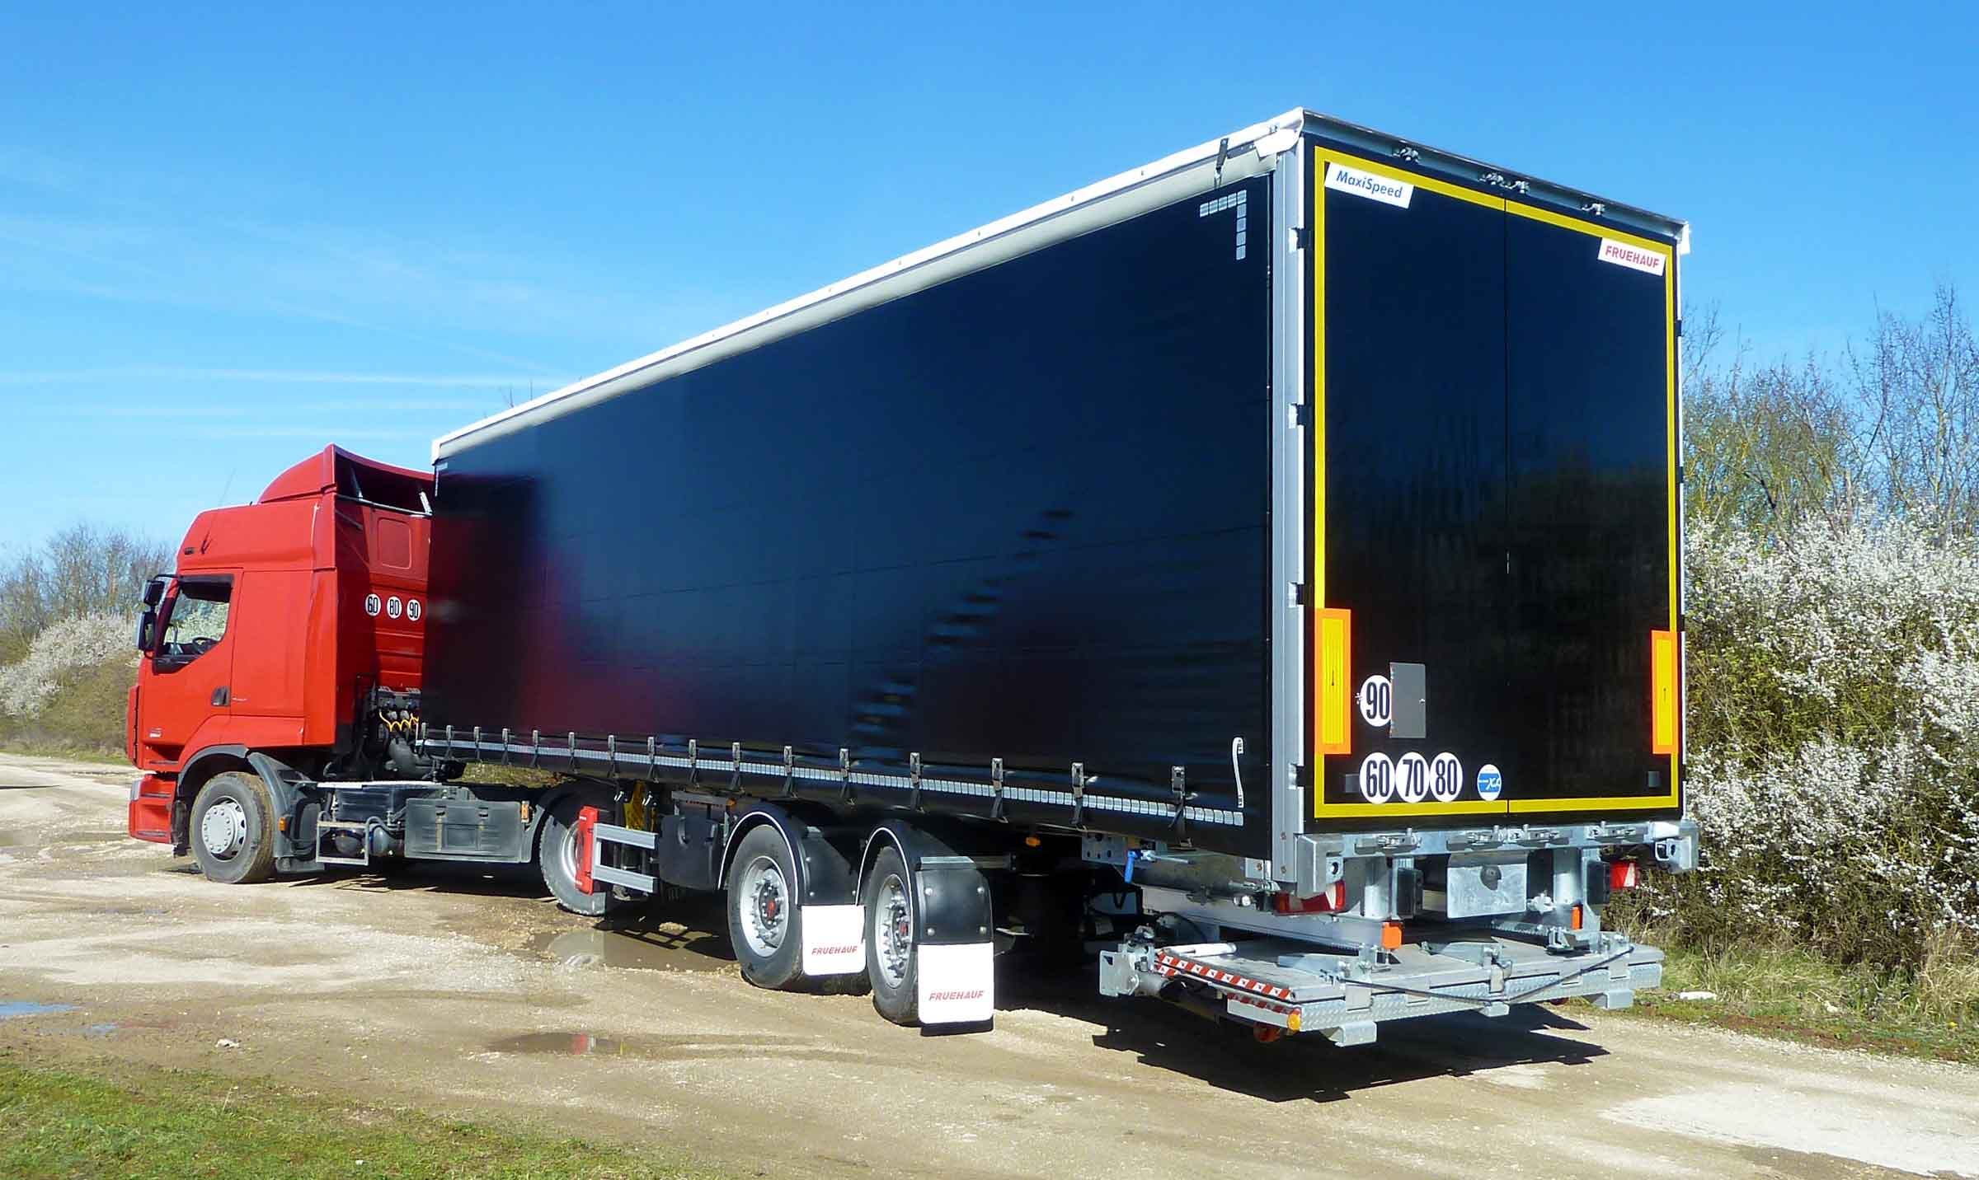
Gallery

MaxiSpeed Urban
City - Urban - MaxiSpeed
Bodywork with drop sidesGuillaume Calviac2021-01-13T16:31:16+01:00
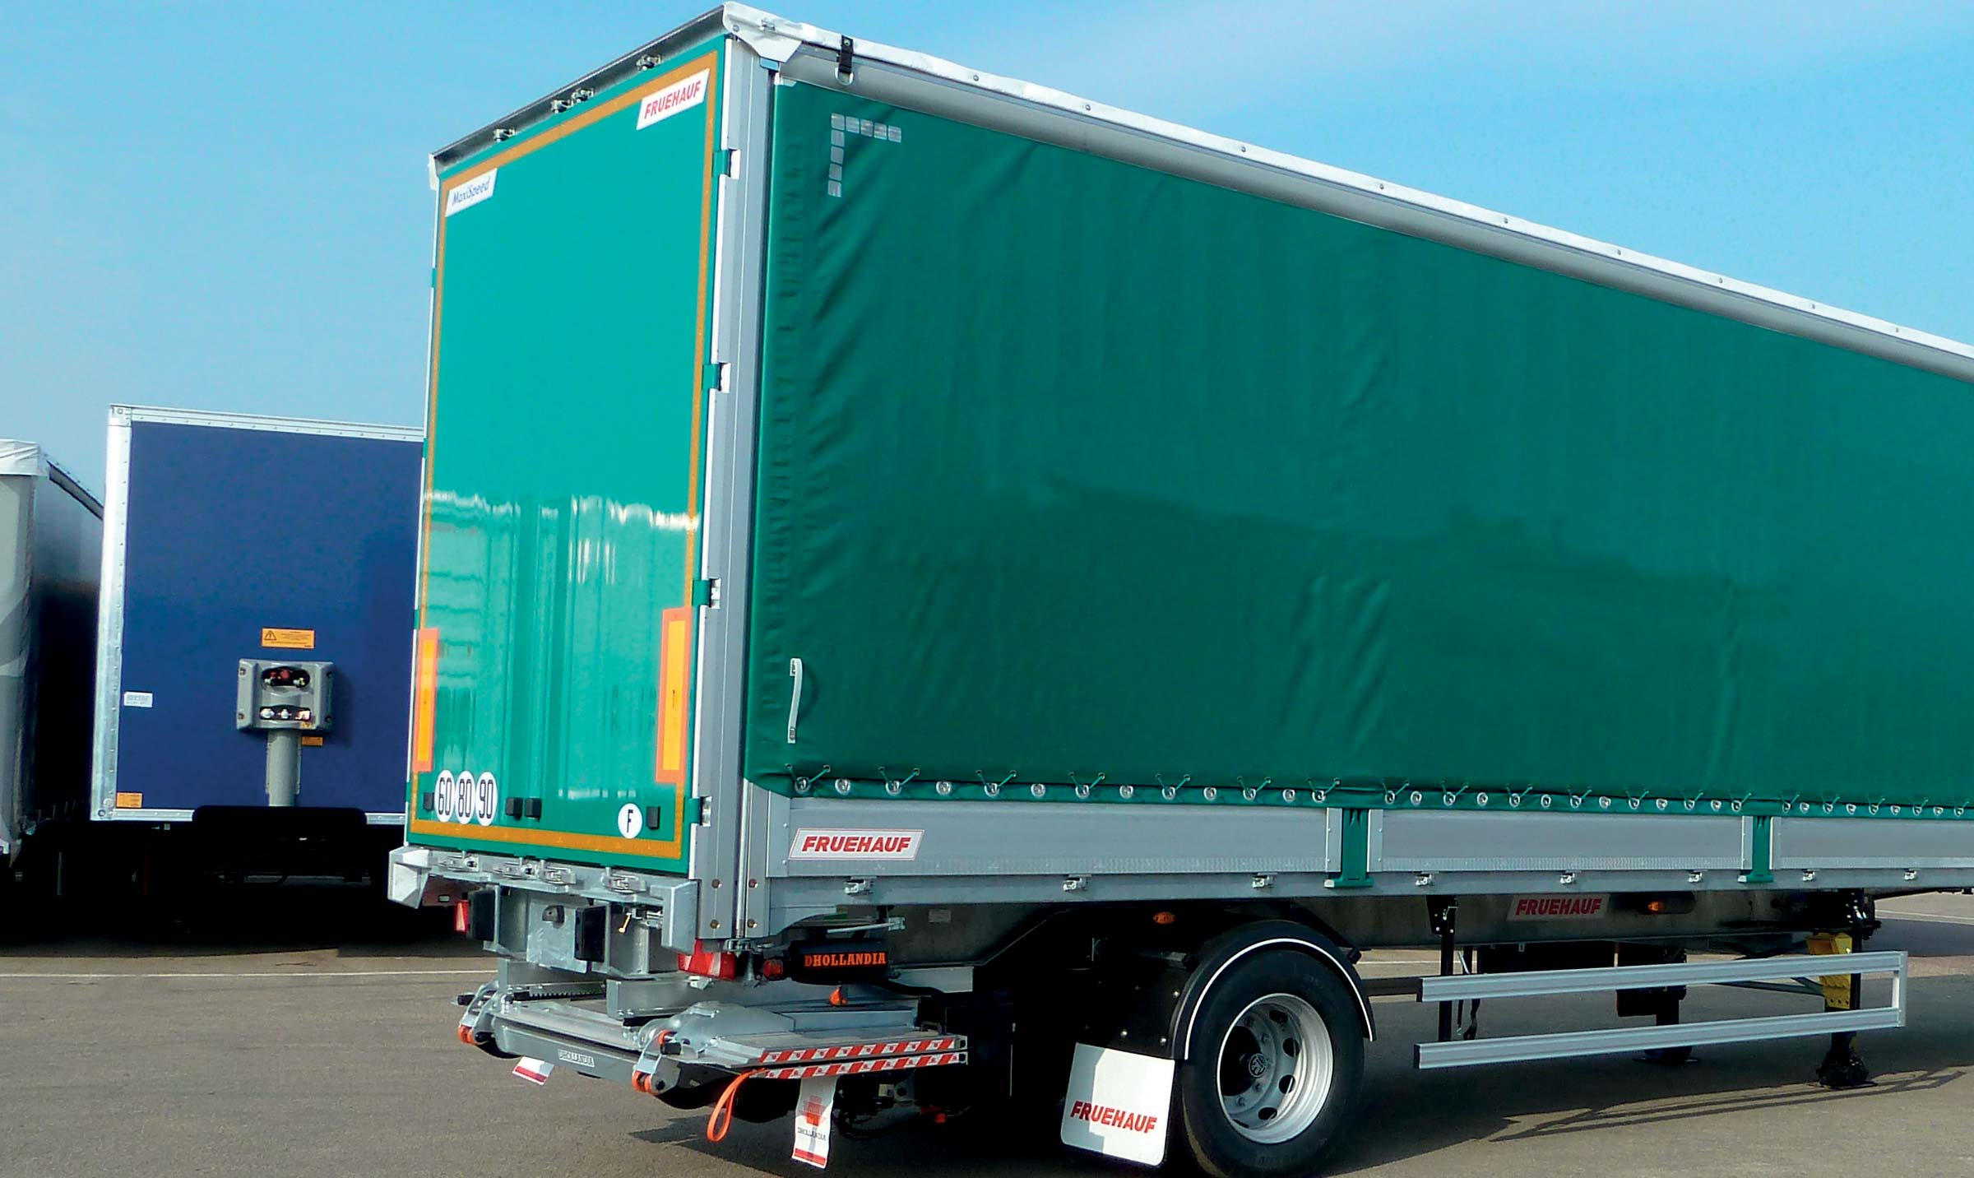
Gallery

Bodywork with drop sides
City - Urban - MaxiSpeed, MaxiSpeed City
Rear working lightsGuillaume Calviac2021-02-10T09:34:44+01:00
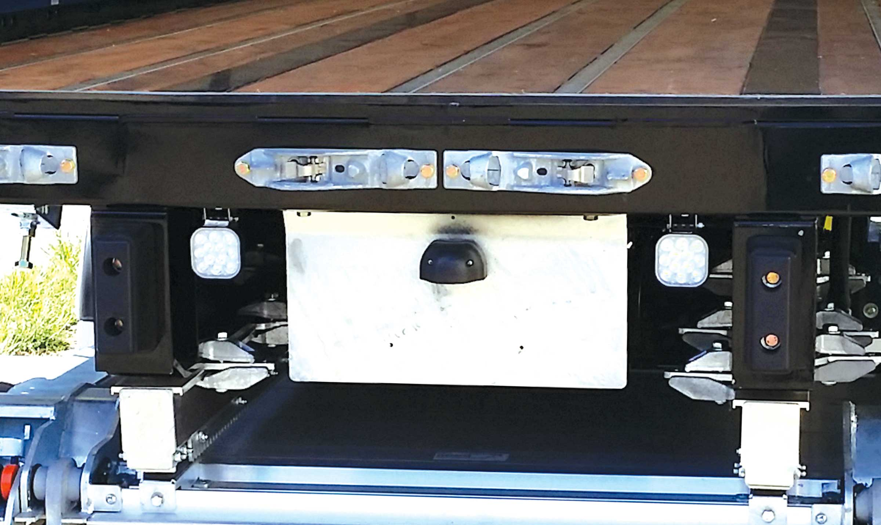
Gallery

Rear working lights
City - Urban - MaxiSpeed, MaxiSpeed City
MaxiSpeed CityFrançoise Bernerd2021-01-14T09:08:12+01:00
Gallery

MaxiSpeed City
City - Urban - MaxiSpeed, Innovations - City, MaxiSpeed City
Documentation
Demo Videos

Distribution - Local shops - Parcel Delivery
Equipped with a retractable or folding lift rear door, the ExpressLiner CITY, URBAN and DISTRICT vans are perfect for delivering to local shops and for courier companies.
For deliveries is large towns and cities where regulatory and environmental constraints are increasingly restrictive, ExpressLiner CITY, URBAN and DISTRICT vehicles are available in a range of versions: the PIEK compliance to limit noise emissions during night-time operations or limit the surface occupied by the vehicle to 29 m² (CITY).
- Productivity
- Safety
- Adaptability
Roll-up doorGuillaume Calviac2021-01-14T09:48:07+01:00
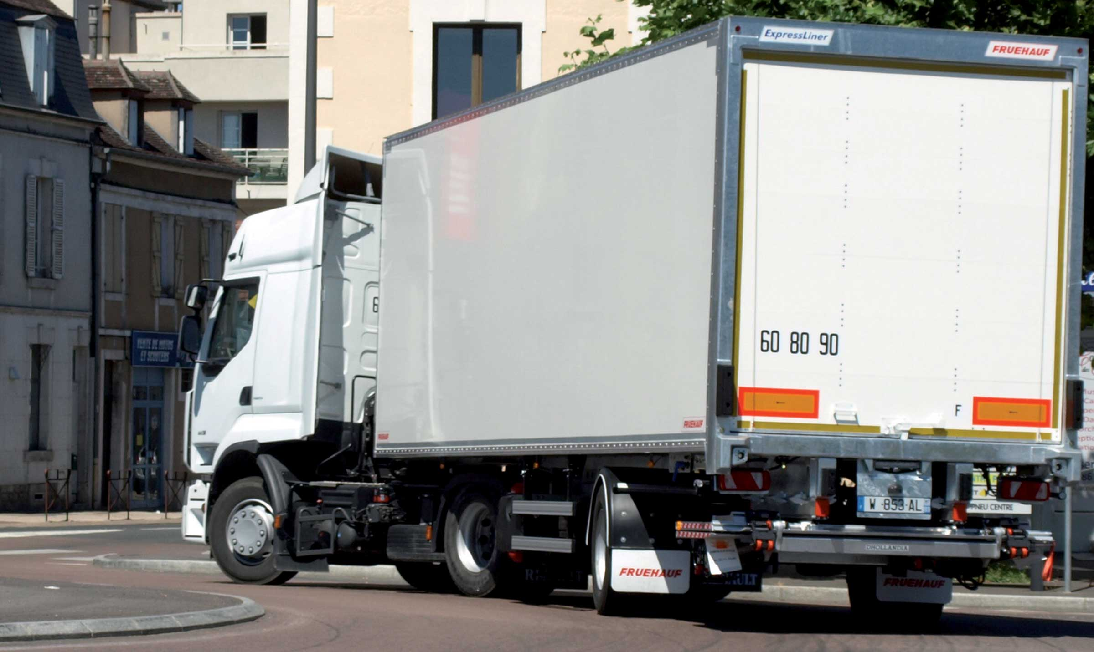
Gallery

Roll-up door
CITY - Urban - Fourgons EN, City Fourgon
Folding lift rear doorGuillaume Calviac2021-04-12T10:06:33+02:00
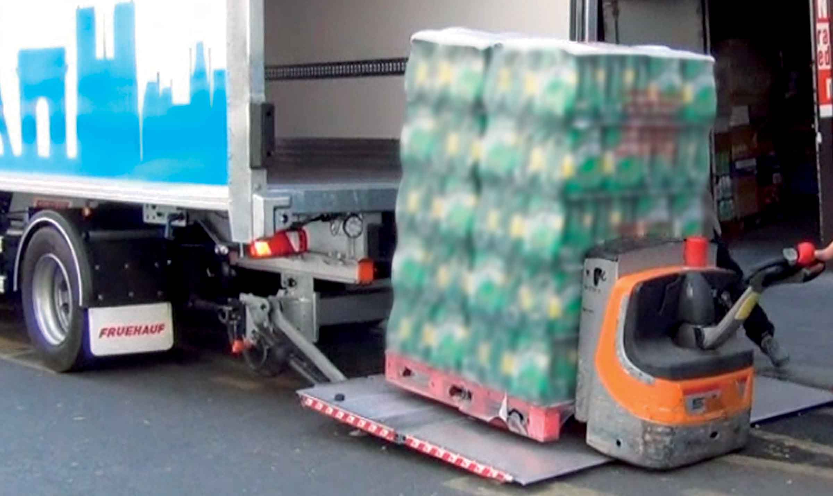
Gallery

Folding lift rear door
CITY - Urban - Fourgons EN, City Fourgon
UrbanGuillaume Calviac2021-01-14T09:42:37+01:00
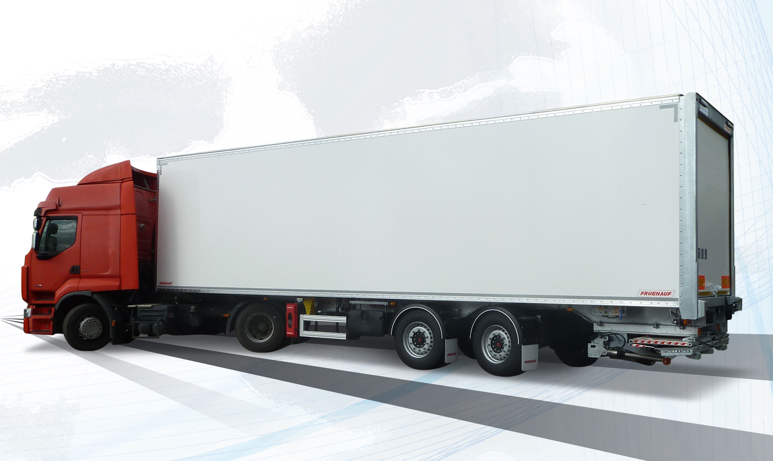
Gallery

Urban
CITY - Urban - Fourgons EN
Safety stabilizing crutchesGuillaume Calviac2021-06-01T13:42:45+02:00
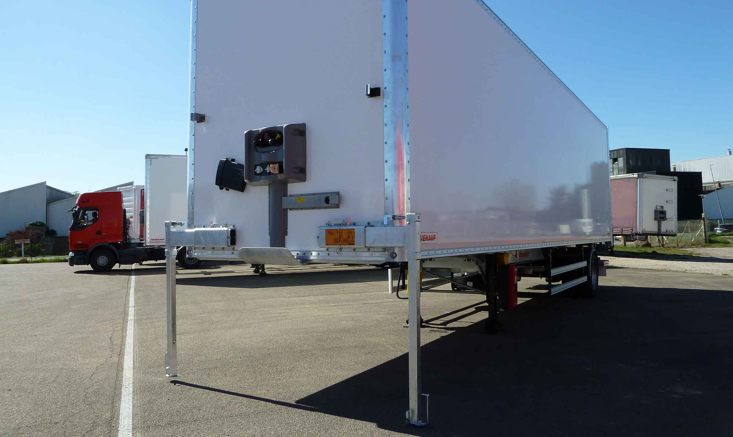
Gallery

Safety stabilizing crutches
CITY - Urban - Fourgons EN, City Fourgon
Retractable lift rear doorGuillaume Calviac2021-04-12T10:05:20+02:00
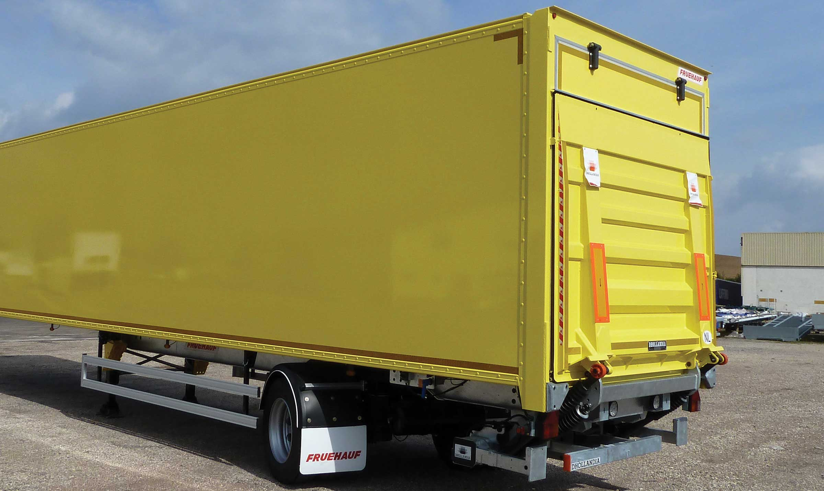
Gallery

Retractable lift rear door
CITY - Urban - Fourgons EN, City Fourgon
2nd load levelGuillaume Calviac2021-02-10T09:45:48+01:00
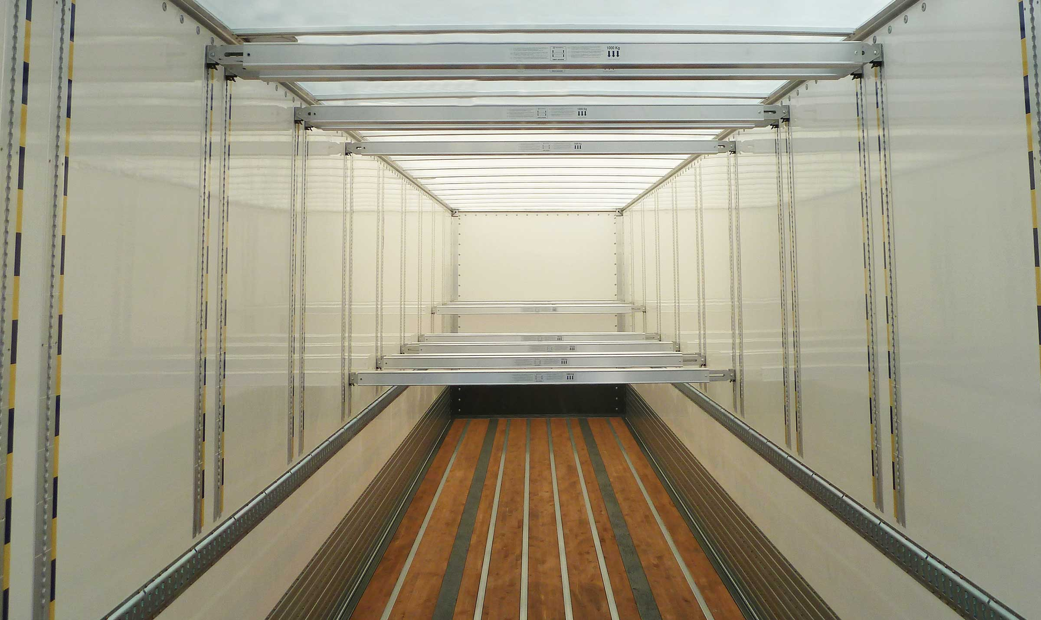
Gallery

2nd load level
CITY - Urban - Fourgons EN, City Fourgon, ExpressLiner Distribution Lots
Urban 2,5 t retractable tailgateGuillaume Calviac2021-04-15T11:11:09+02:00
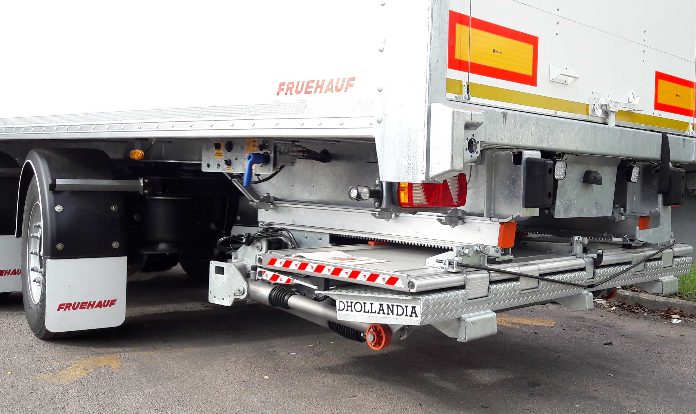
Gallery

Urban 2,5 t retractable tailgate
CITY - Urban - Fourgons EN
Documentation
Demo Videos

Site supplies
CITY, URBAN and DISTRICT platforms are perfect for supplying construction sites in an urban environment where there is little room to manoeuvre.
As some materials require specific equipment, CITY, URBAN and DISTRICT flatbeds are suitable for low-side, iron carrier, crane, removable racks and other layouts.
- Productivity
- Safety
- Adaptability
Iron carrier layoutGuillaume Calviac2021-01-14T10:37:54+01:00
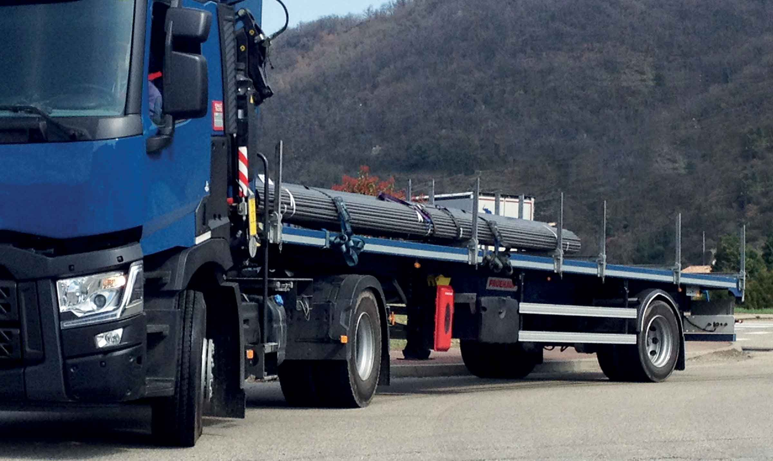
Gallery

Iron carrier layout
City plateaux EN
Crane platformGuillaume Calviac2021-02-10T09:49:13+01:00
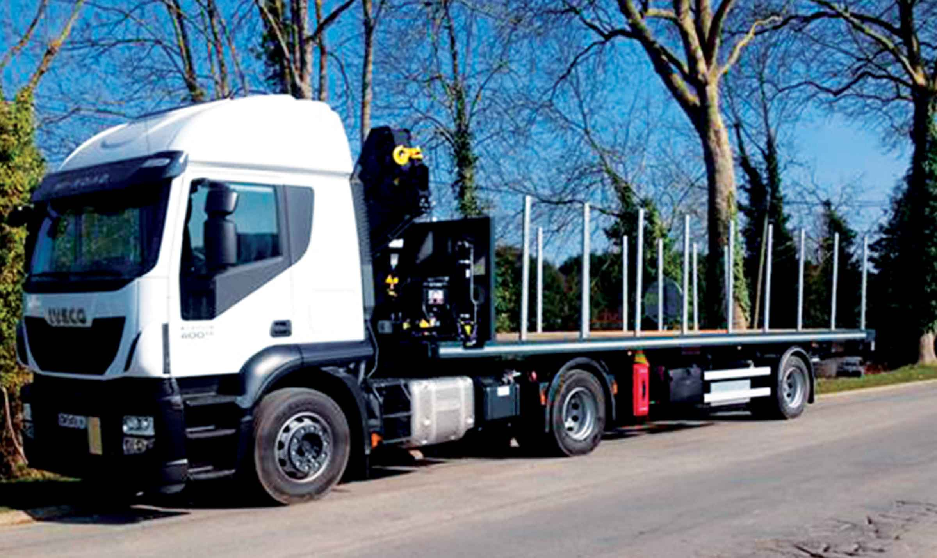
Gallery

Crane platform
City plateaux EN
Removable racksGuillaume Calviac2021-01-14T10:29:02+01:00
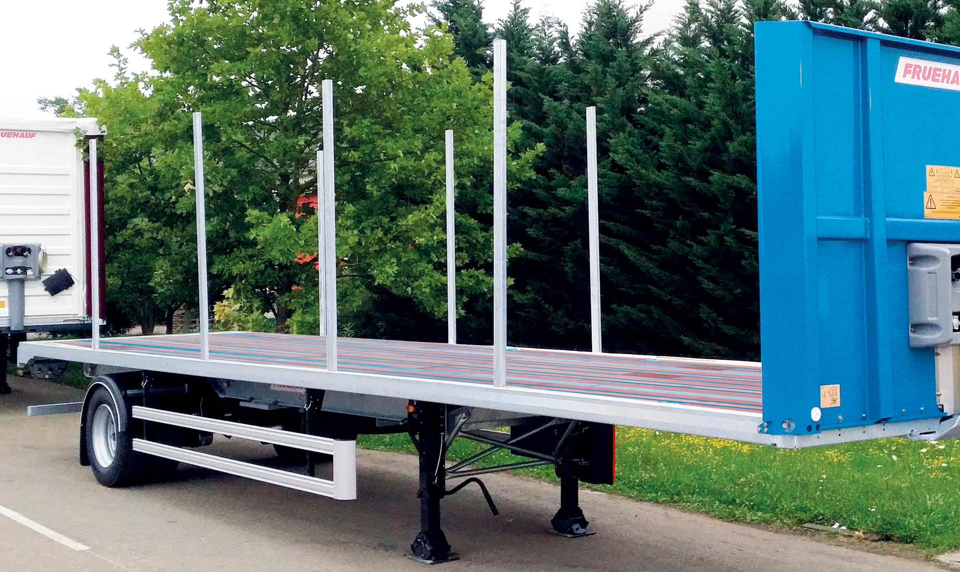
Gallery

Removable racks
City plateaux EN
PlatformGuillaume Calviac2021-01-14T10:27:01+01:00
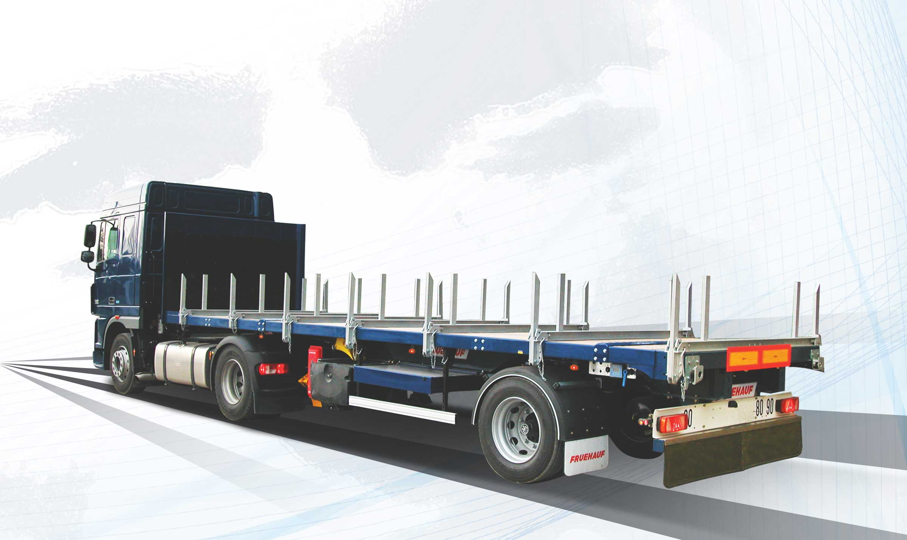
Gallery

Platform
City plateaux EN, Innovations - City
PlatformGuillaume Calviac2021-01-14T10:26:39+01:00
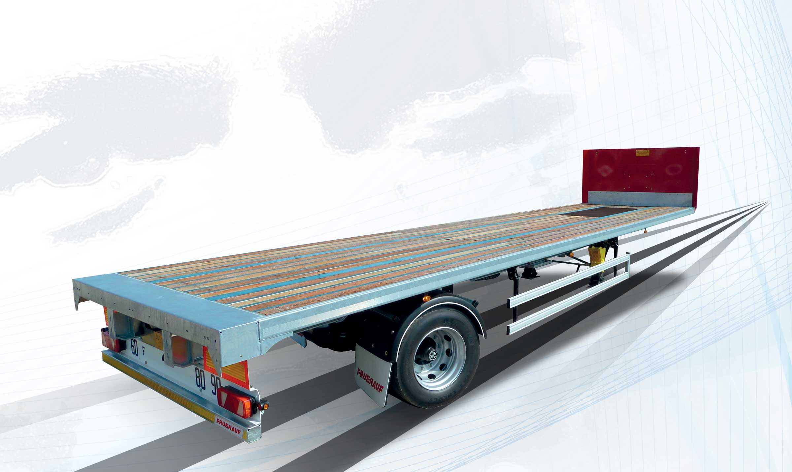
Gallery

Platform
City plateaux EN
Documentation

Refrigerated distribution
Fruehauf provides coachbuilders with bare chassis intended to take refrigerated bodies.
Their reinforced mechanically welded structure, the steering axle and the optimised wheelbase enable full adaptation by coachbuilders to their specific uses.
- Adaptability
- Productivity
- Simplicity
Refrigerated unit on pre-fitted chassisGuillaume Calviac2021-01-14T10:59:43+01:00
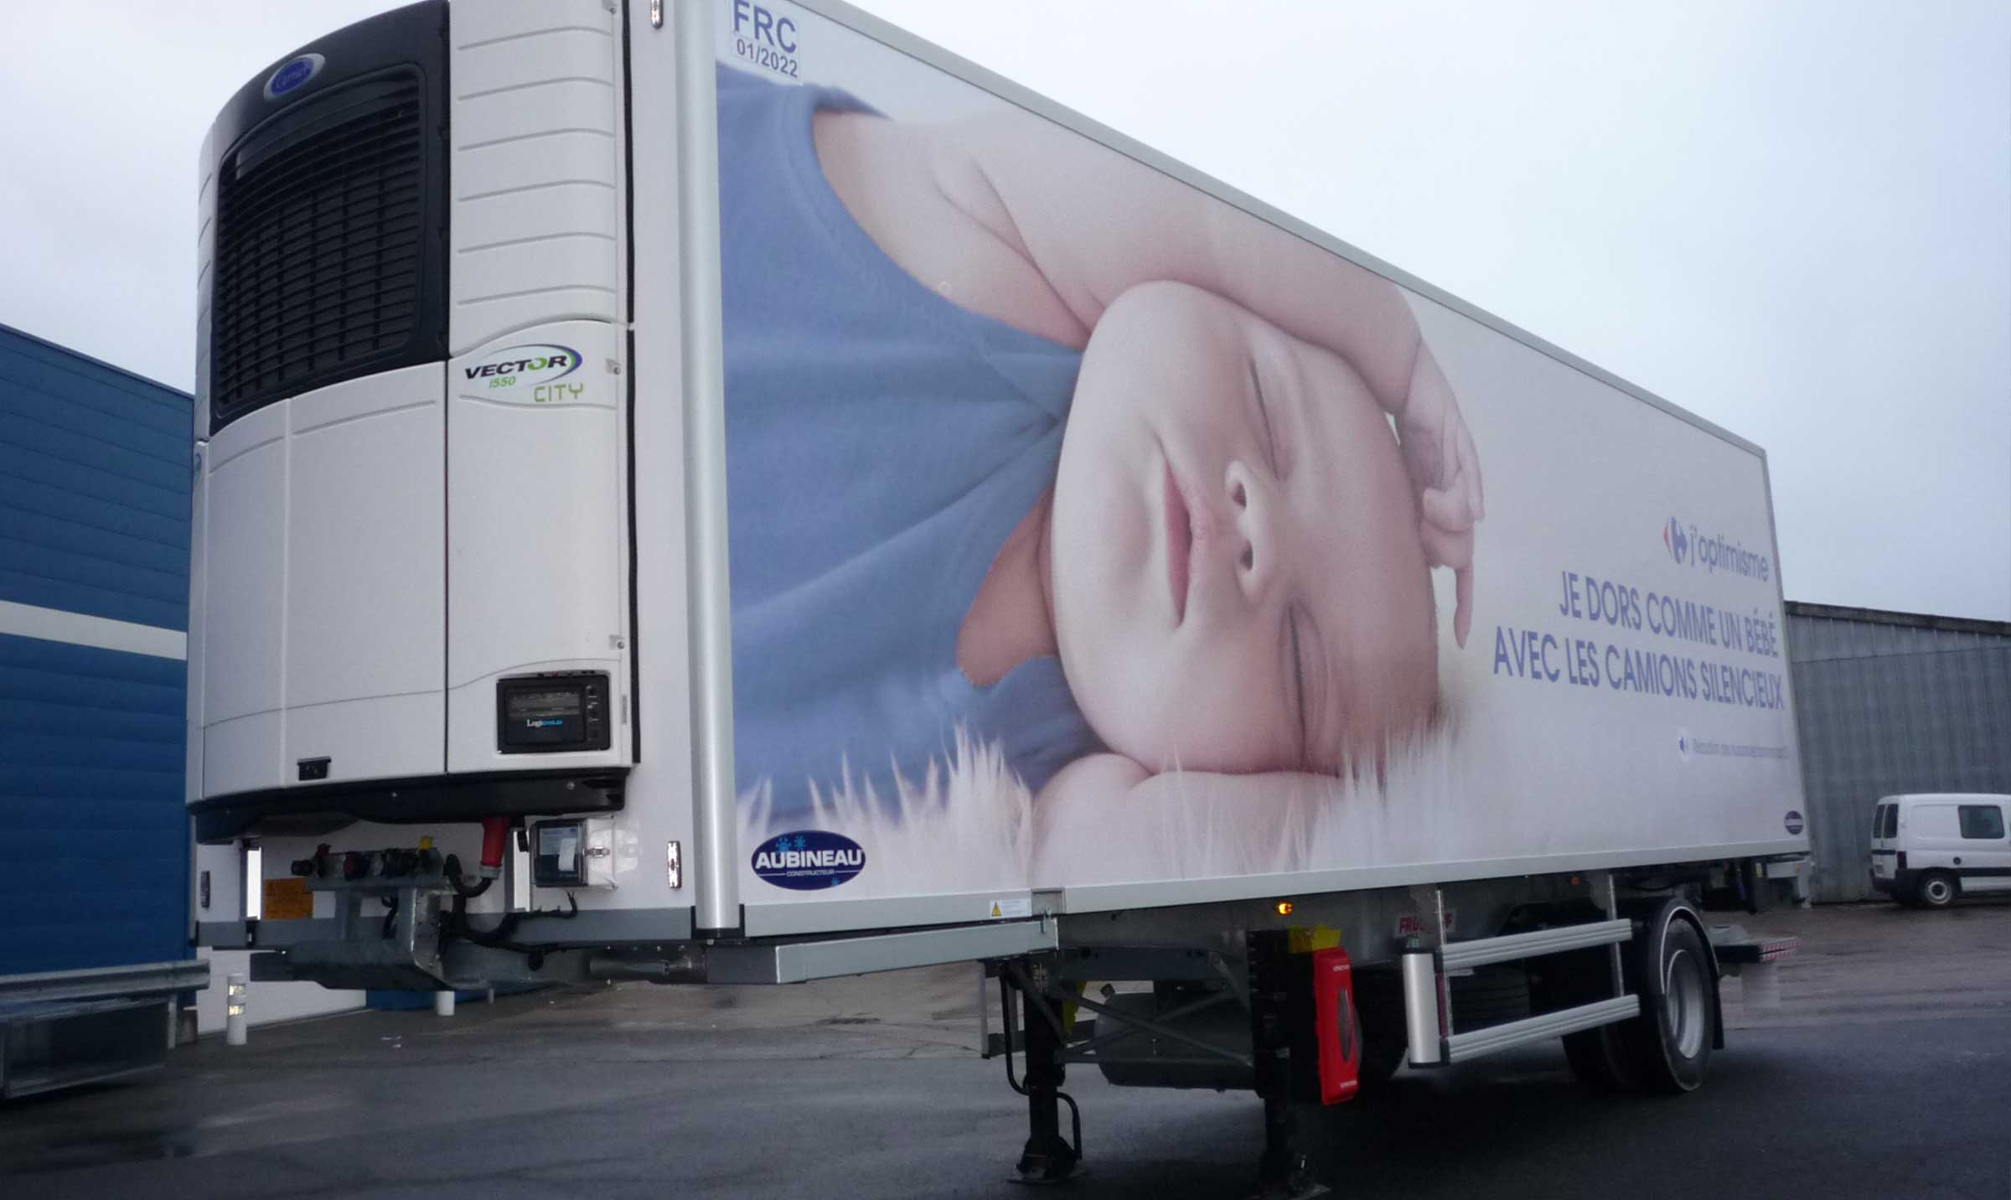
Gallery

Refrigerated unit on pre-fitted chassis
City frigo EN
Chassis pre-fitted for refrigerated unitGuillaume Calviac2021-01-14T10:59:05+01:00
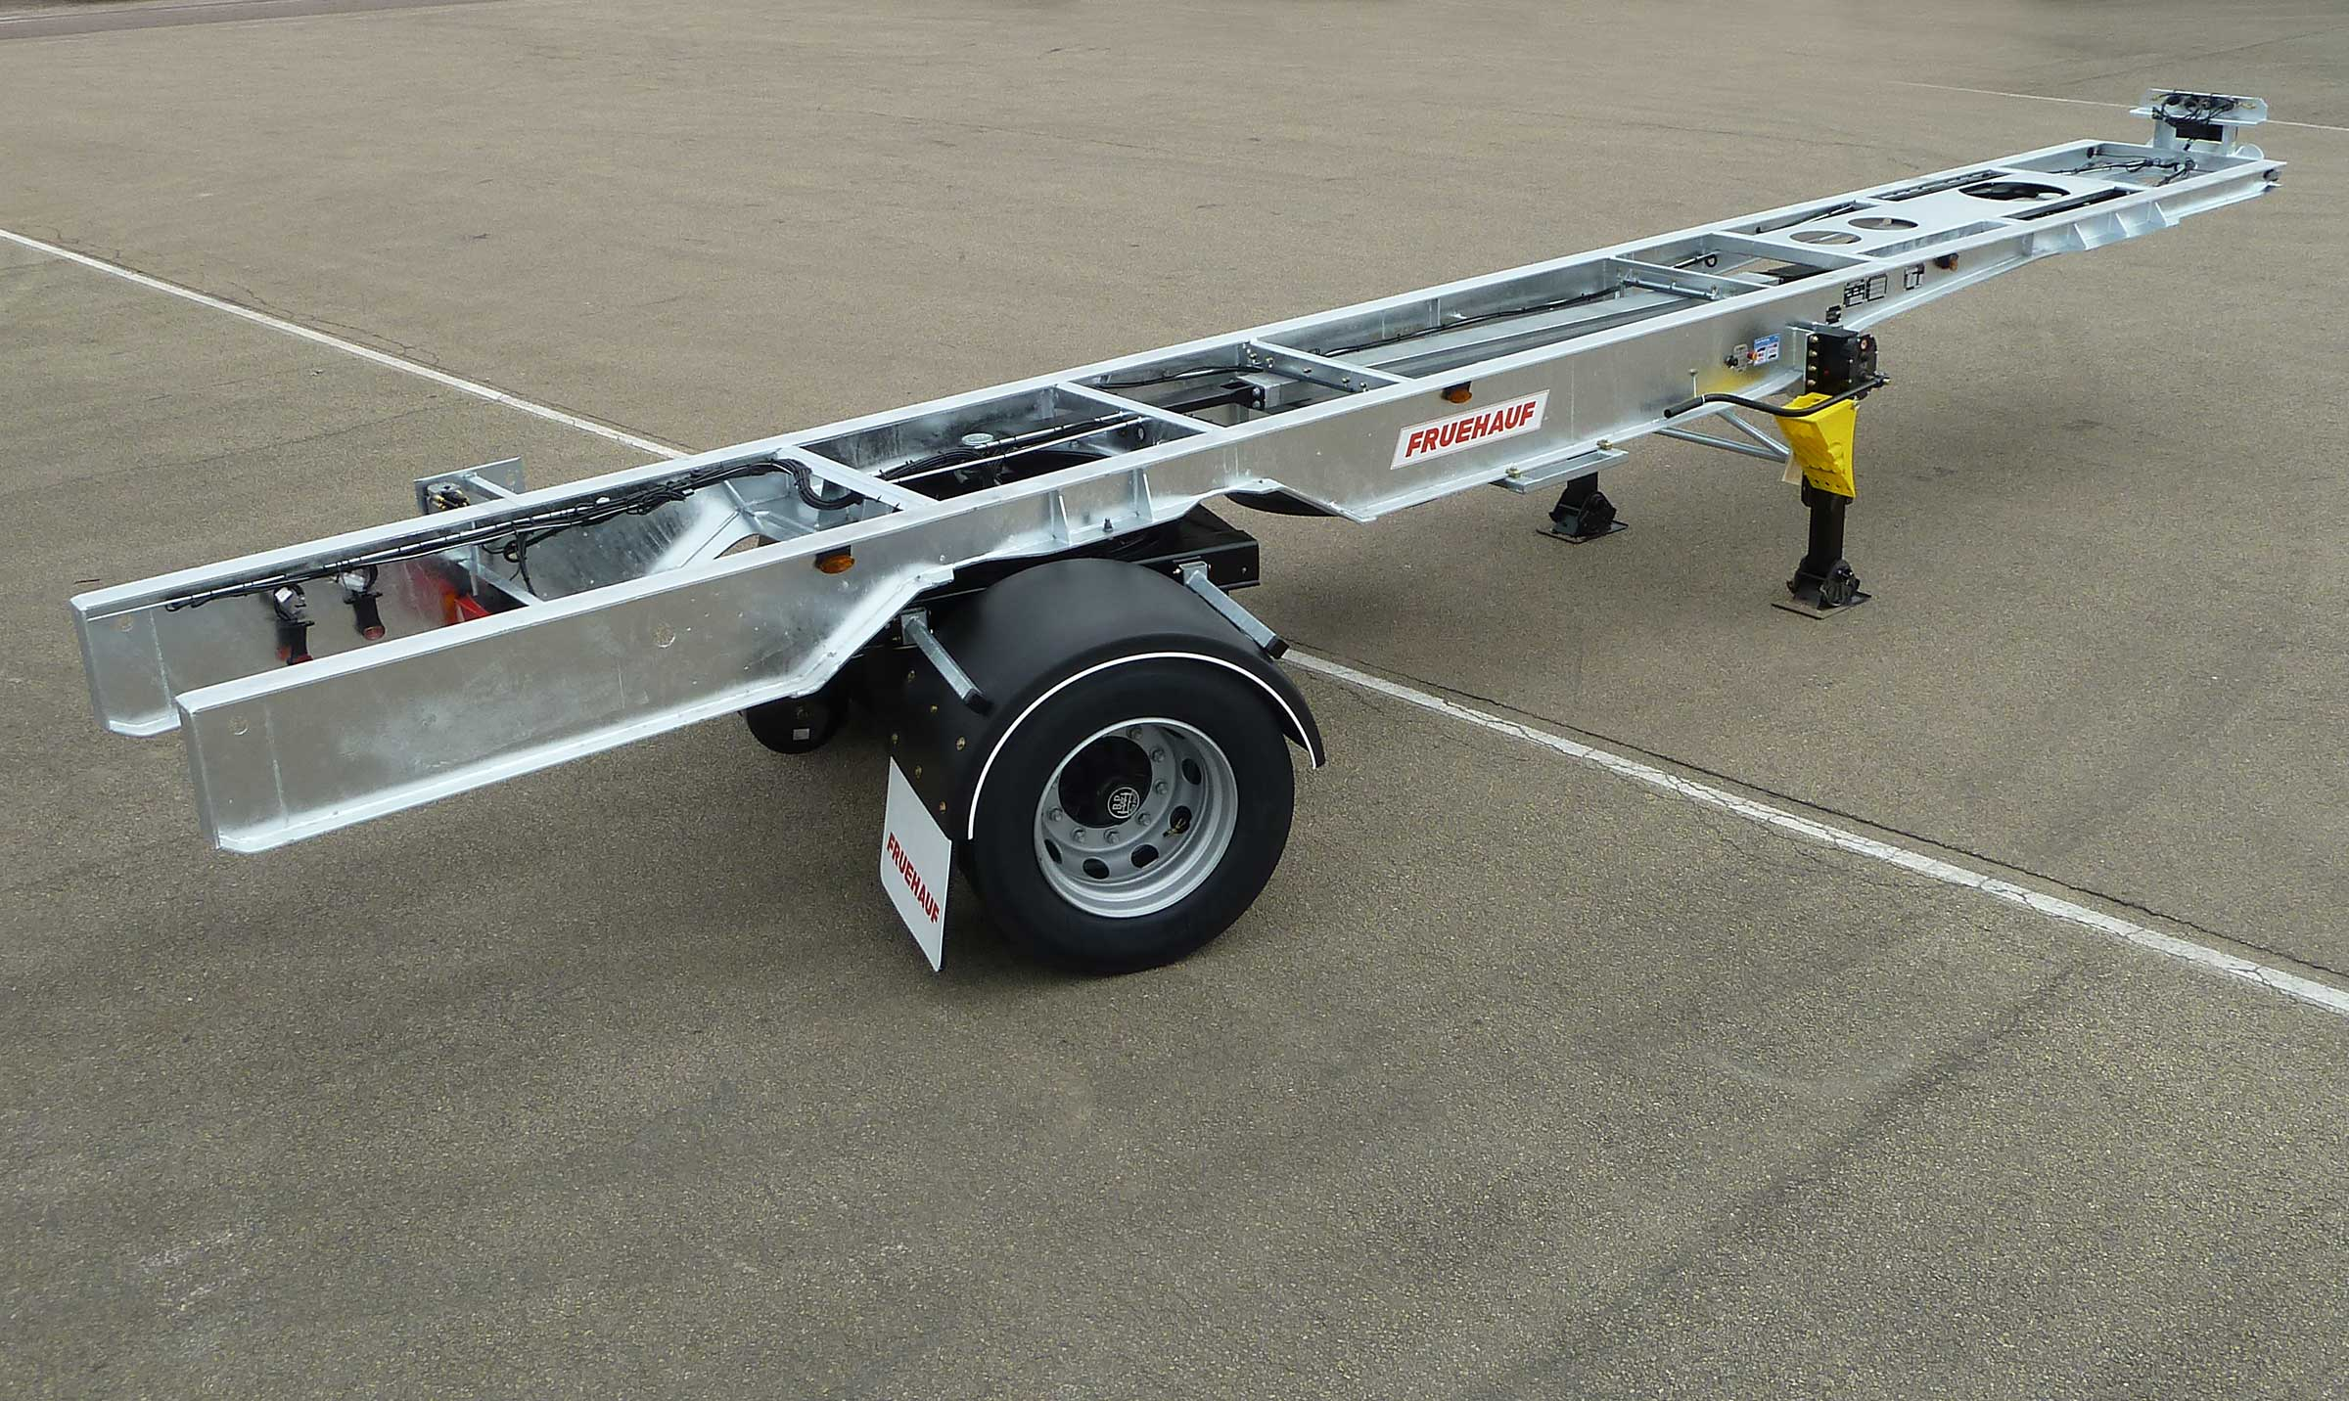
Gallery

Chassis pre-fitted for refrigerated unit
City frigo EN
Chassis pre-fitted for refrigerated unitGuillaume Calviac2021-01-14T10:58:18+01:00
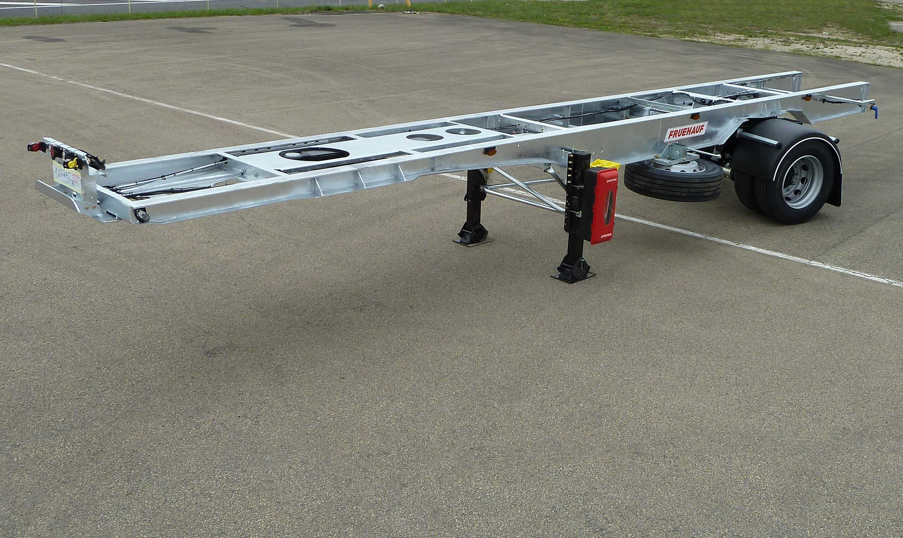
Gallery

Chassis pre-fitted for refrigerated unit
City frigo EN
Refrigerated unit on pre-fitted chassisGuillaume Calviac2021-01-14T10:56:24+01:00
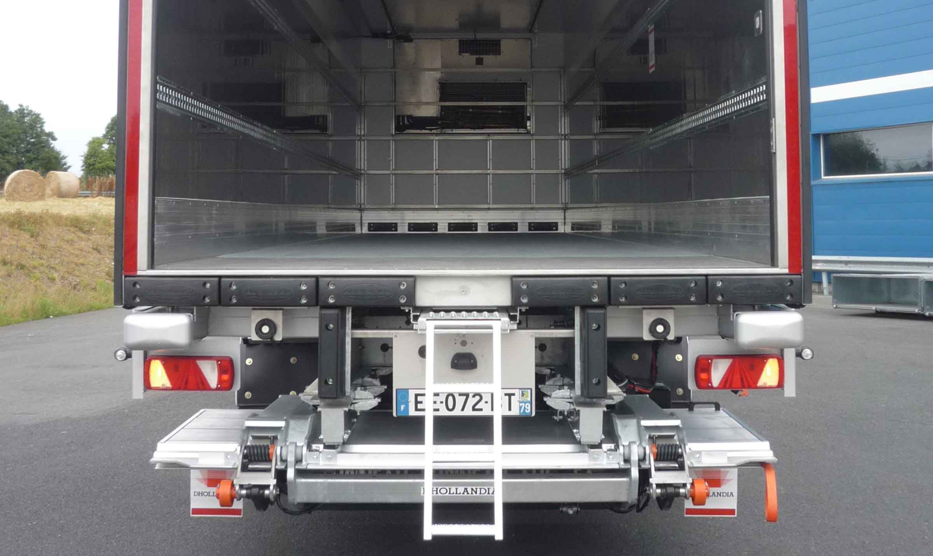
Gallery

Refrigerated unit on pre-fitted chassis
City frigo EN
Refrigerated unit on pre-fitted chassisGuillaume Calviac2021-01-14T10:55:51+01:00
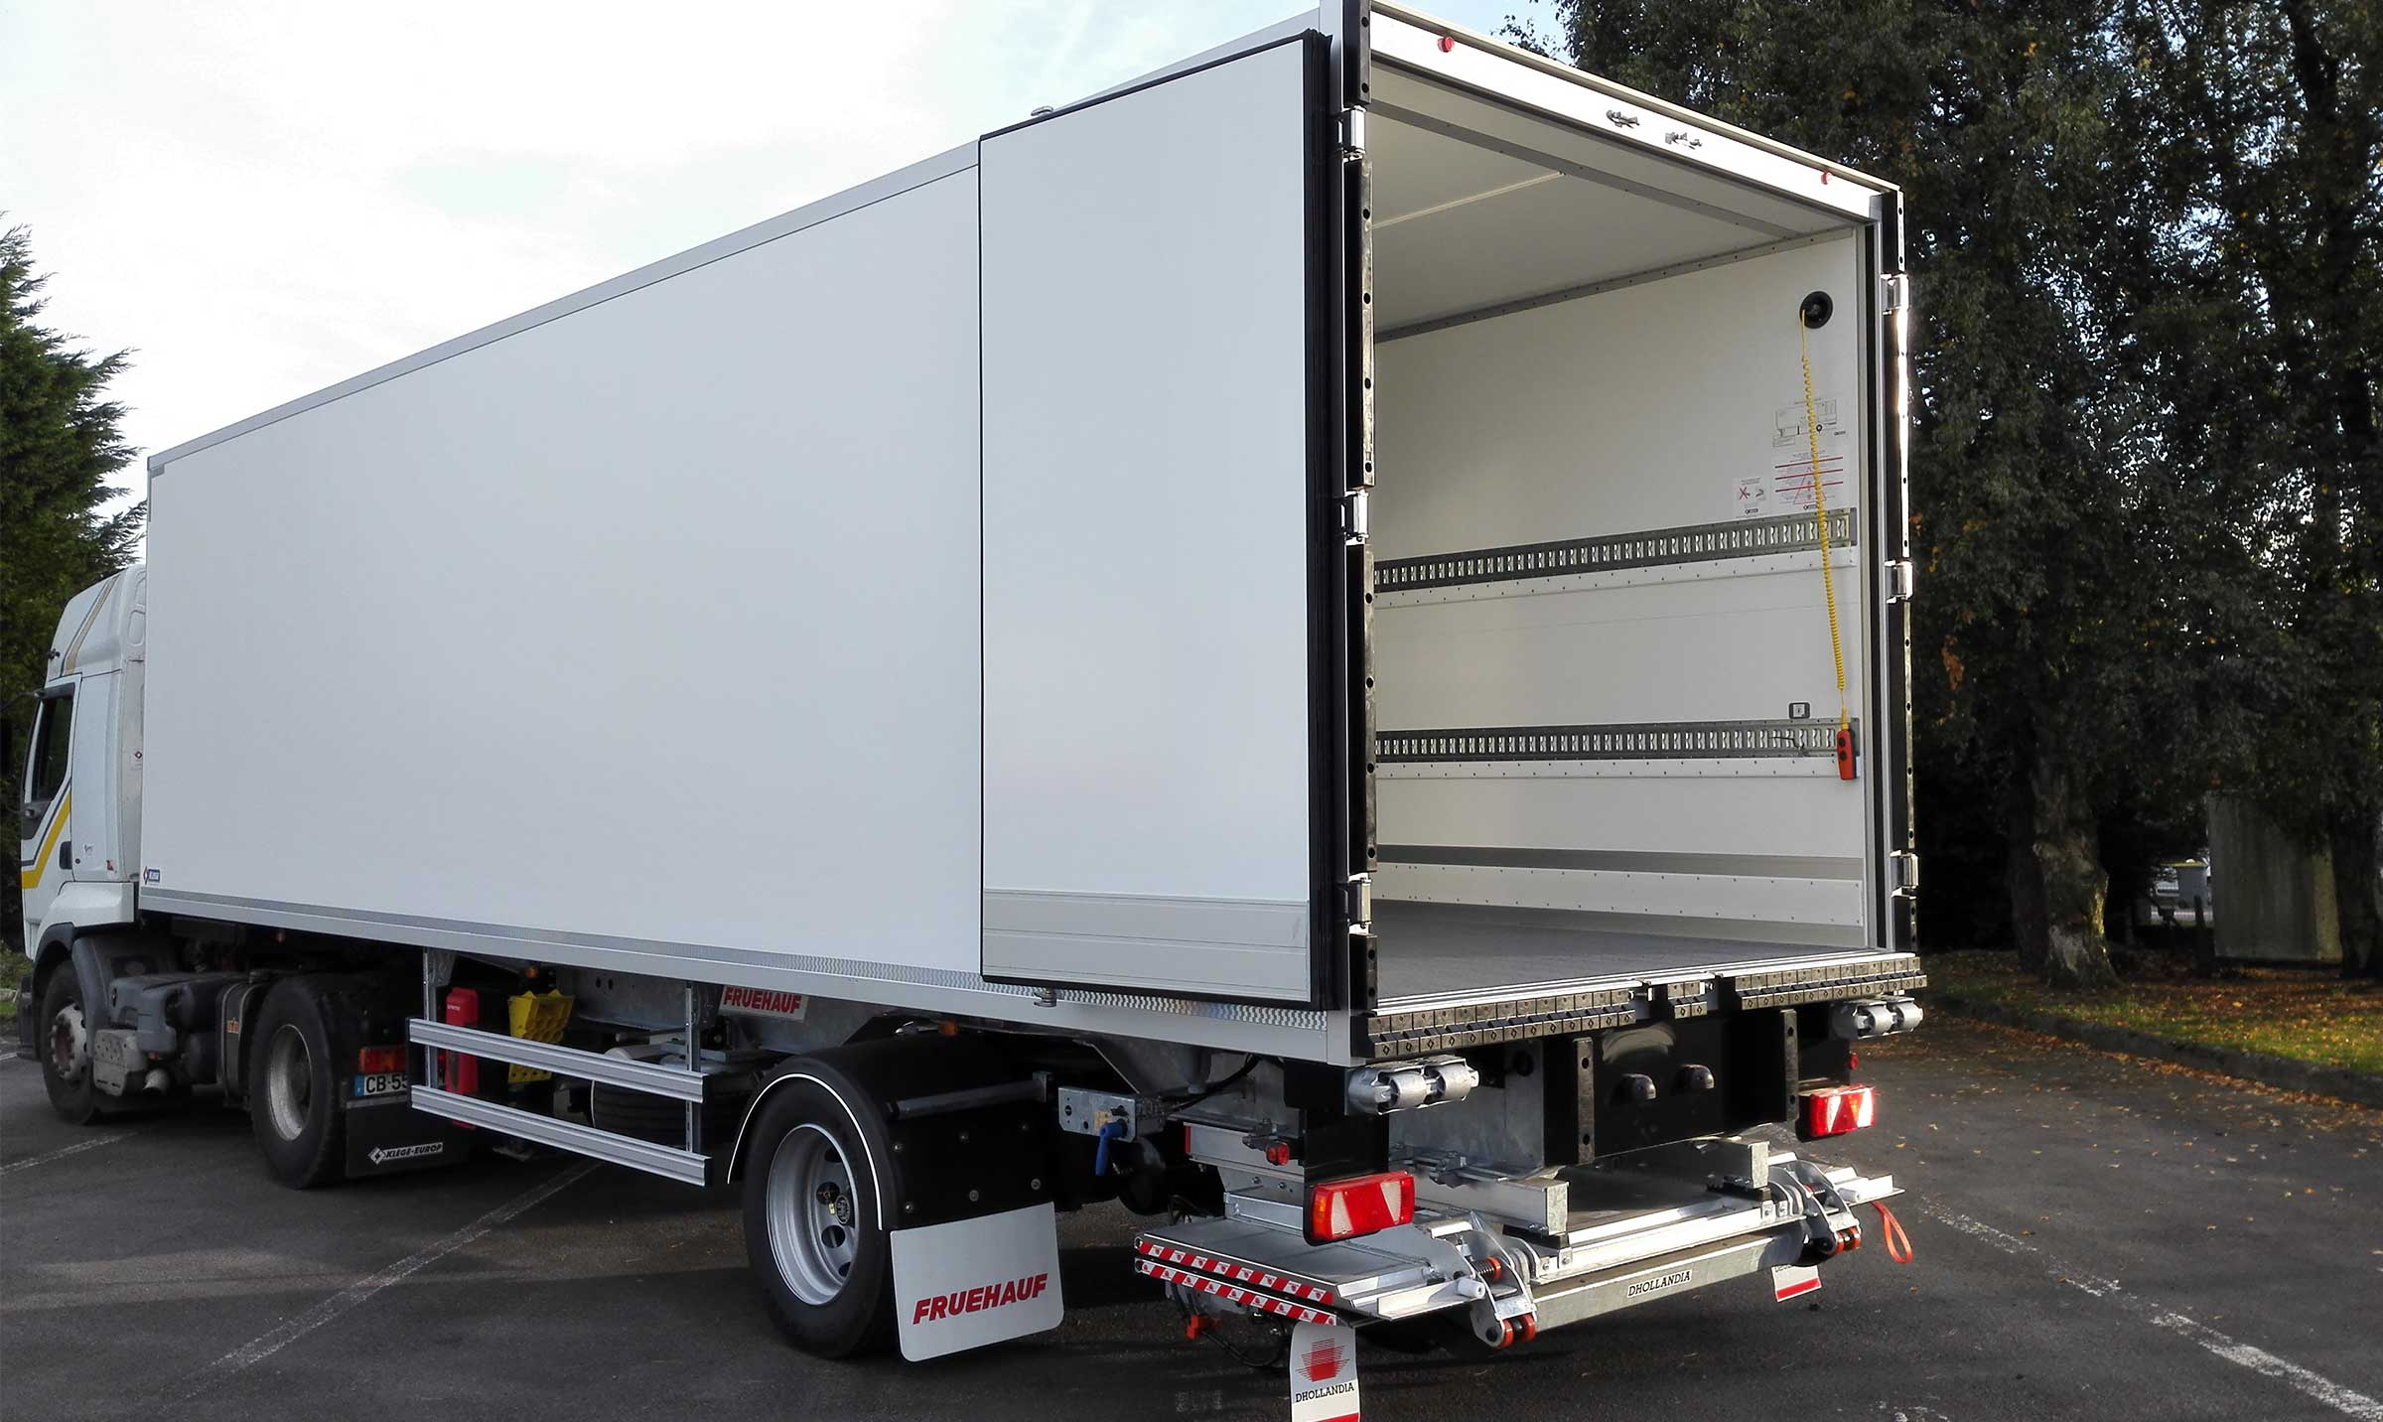
Gallery

Refrigerated unit on pre-fitted chassis
City frigo EN
Refrigerated unit on pre-fitted chassisGuillaume Calviac2021-01-14T10:55:22+01:00
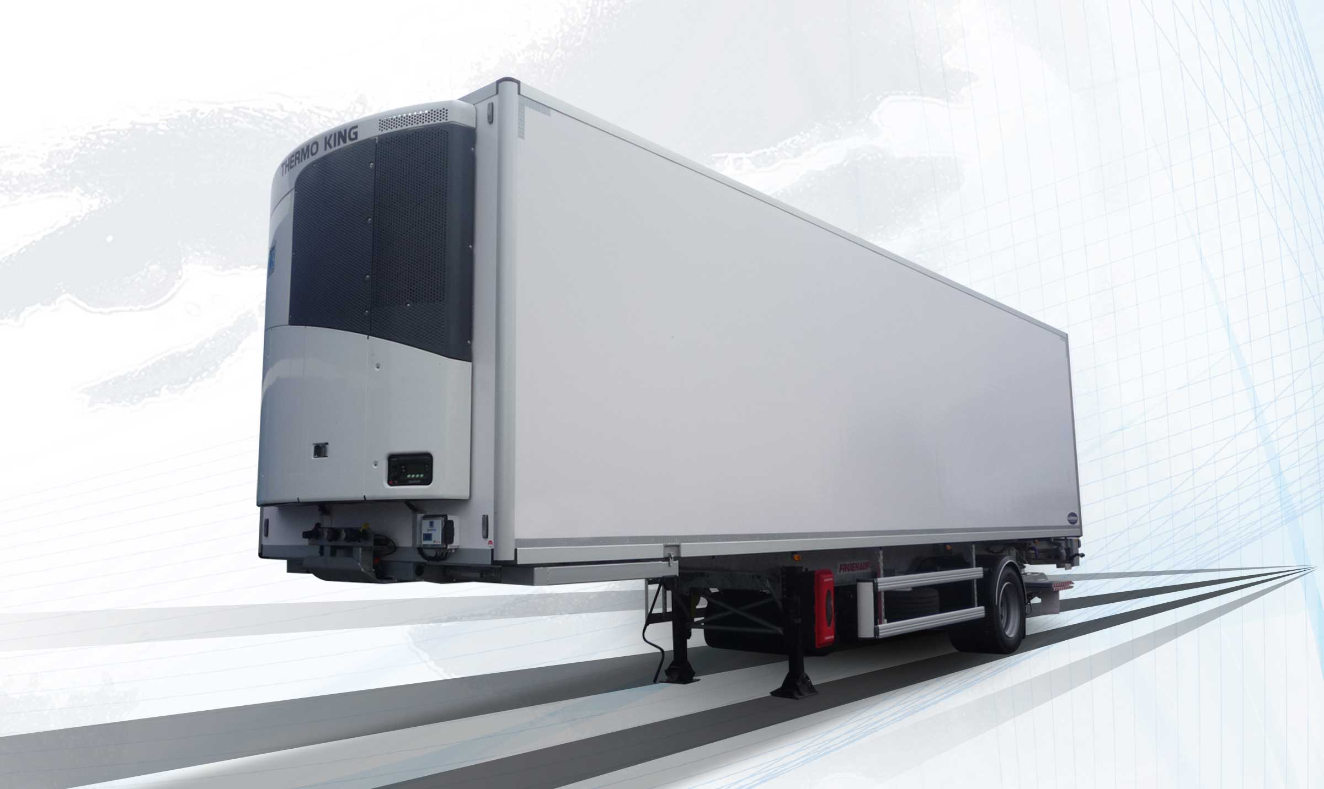
Gallery

Refrigerated unit on pre-fitted chassis
City frigo EN, Innovations - City
Documentation

Innovations
By listening to its customers and users, Fruehauf is able to continuously design new innovative and high-performance equipment for increased savings, productivity and safety.
Protection of personnel and equipment, tyre pressure and temperature monitoring, reduced fuel consumption, anticipation of new requirements.
- Ergonomics
- Productivity
- Safety
Automatic centralised lubricationGuillaume Calviac2021-02-12T12:14:34+01:00
Gallery

Automatic centralised lubrication
City - Urban - Rear steering axle, City Innovations EN
EASY up®Guillaume Calviac2021-03-04T10:35:57+01:00
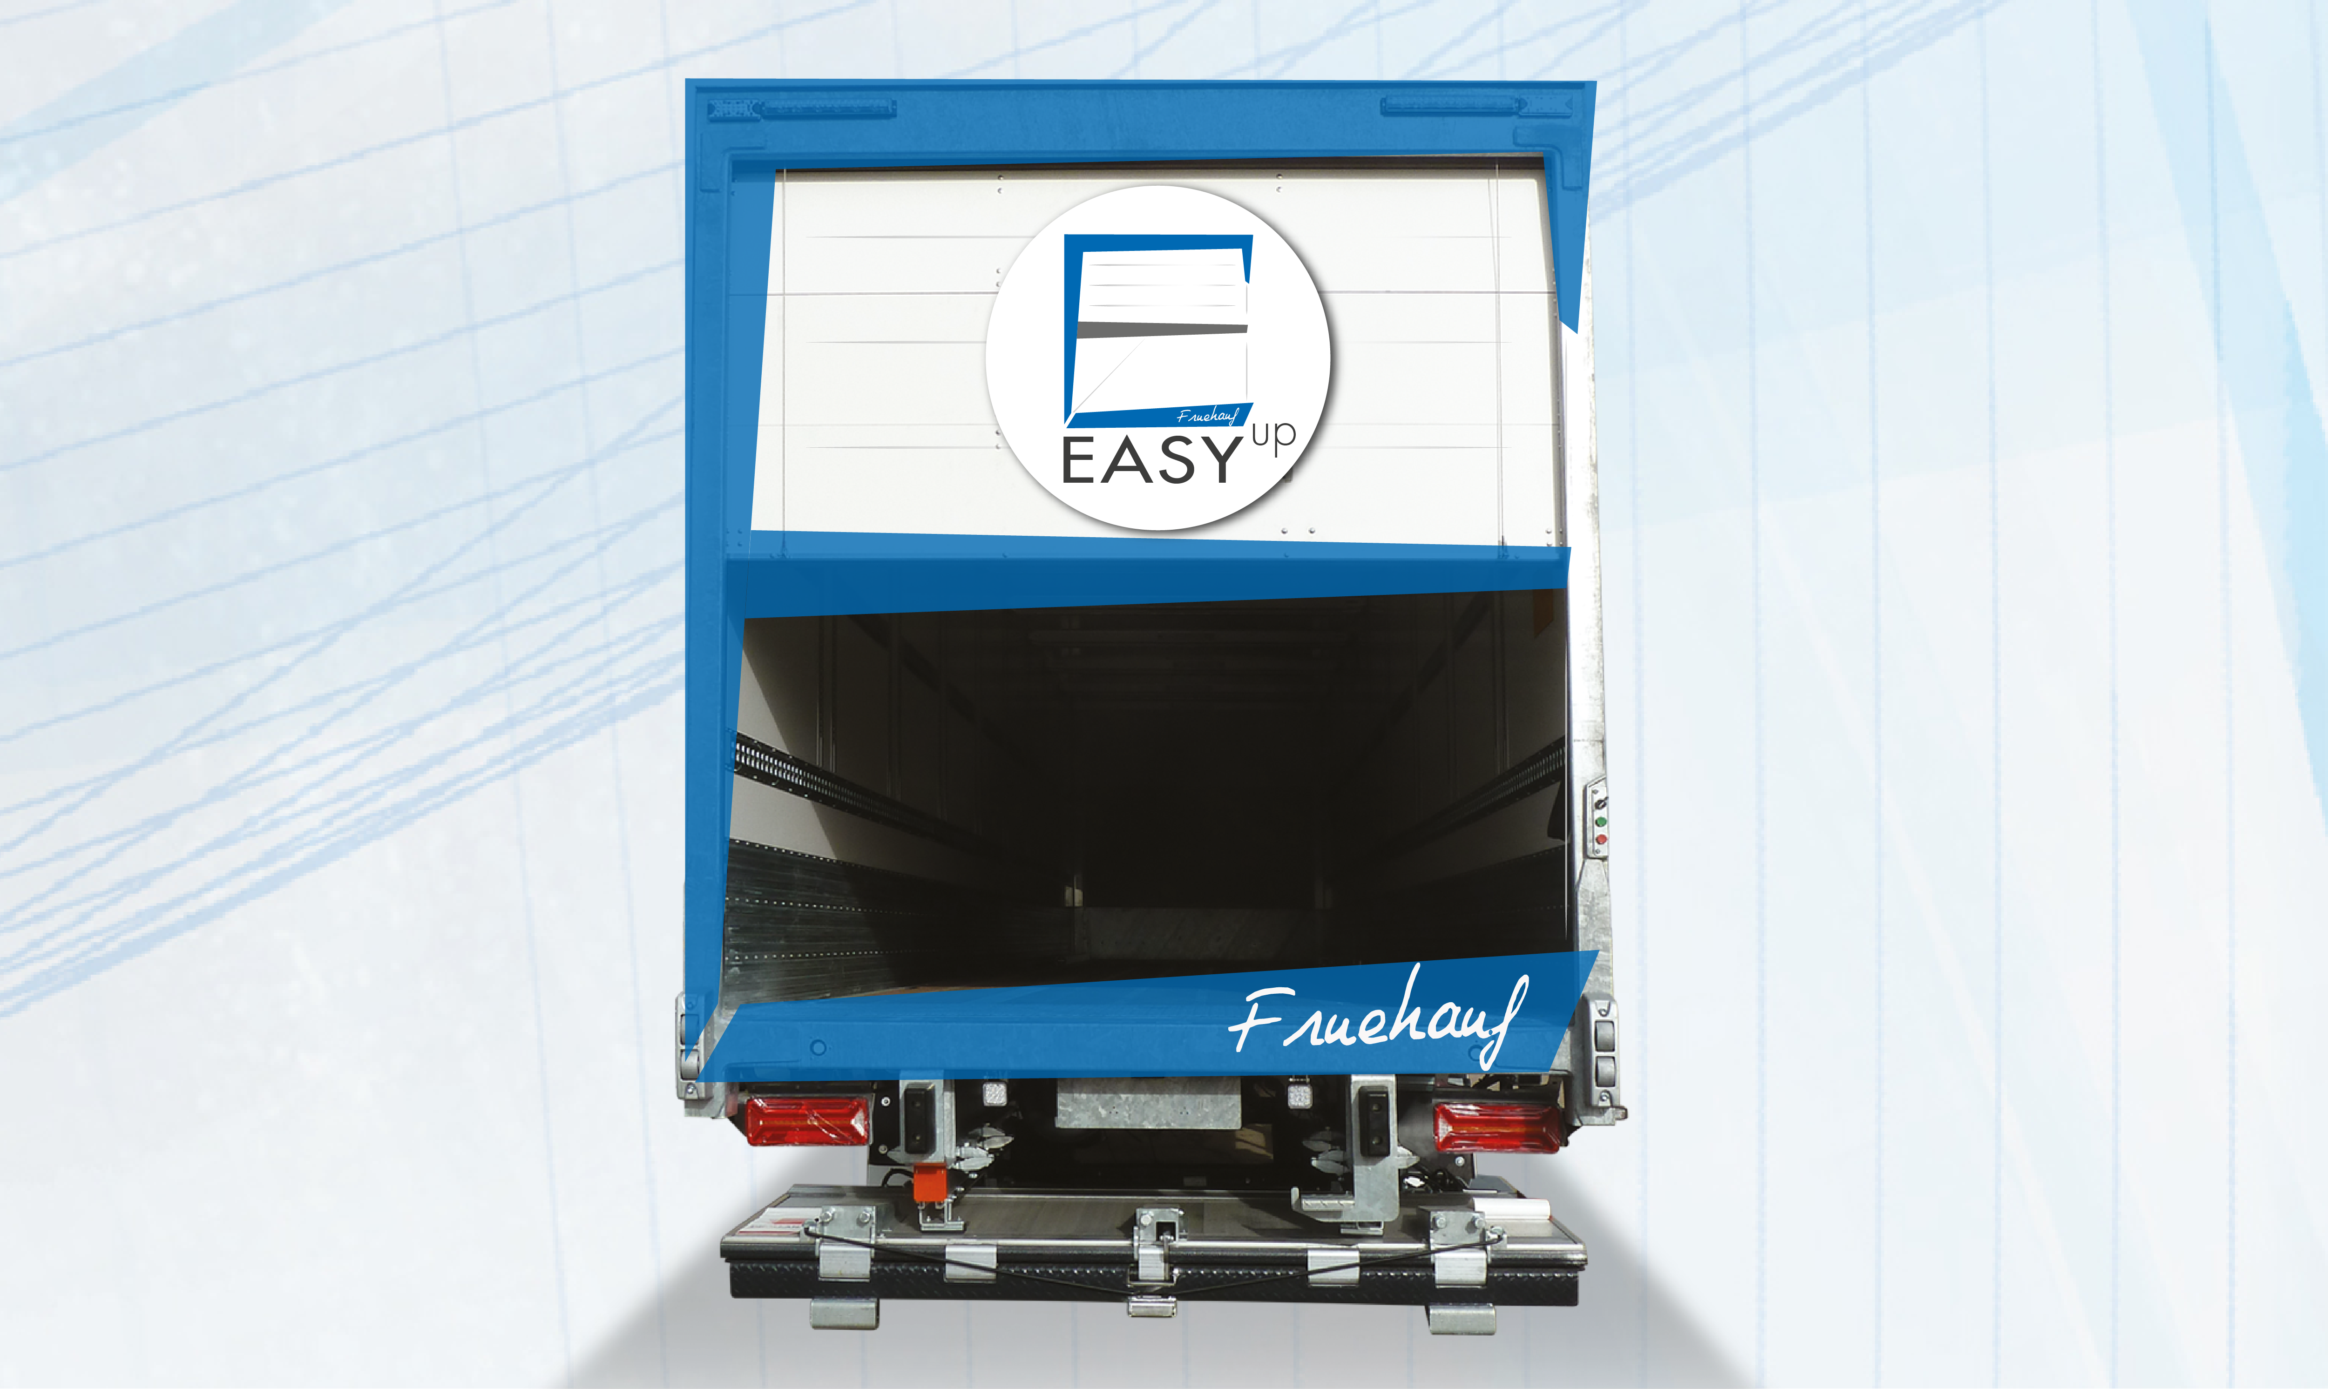
Gallery

EASY up®
City Innovations EN, Fourgons - Innovations, Innovations - Easy UP
Raise & Lower command InsideGuillaume Calviac2021-02-09T08:53:58+01:00
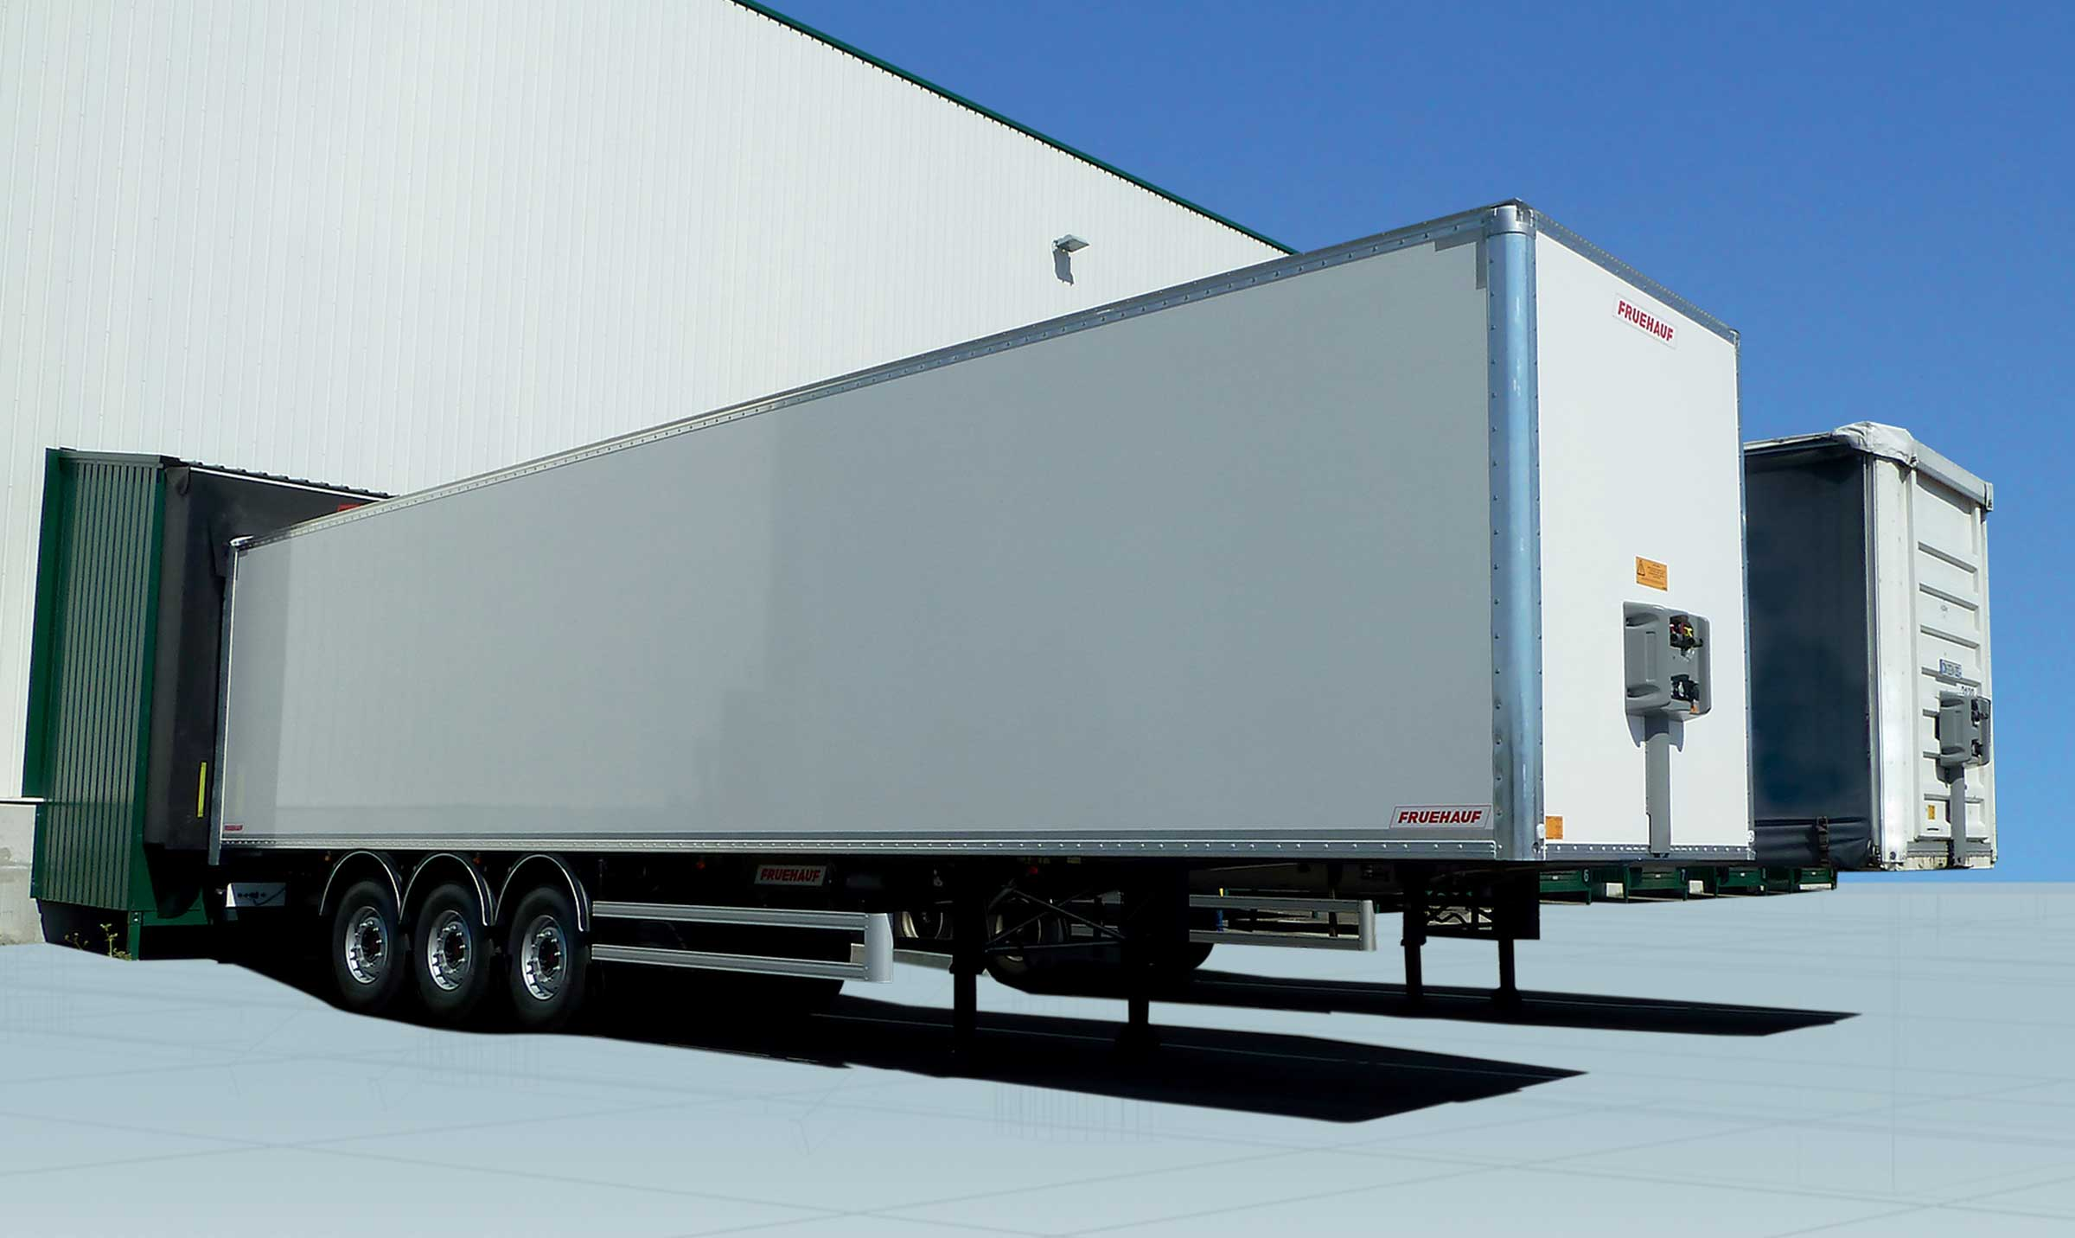
Gallery

Raise & Lower command Inside
ExpressLiner Innovations EN, Innovations - M&B Inside
Manual centralised lubricationGuillaume Calviac2021-02-12T12:10:07+01:00
Gallery

Manual centralised lubrication
City - Urban - Rear steering axle, City Innovations EN
Documentation
Demo Videos

Metadata
pyre_slider_type | no
pyre_slider | 0
pyre_wooslider
pyre_revslider | 0
pyre_elasticslider | 0
pyre_slider_position | default
pyre_avada_rev_styles | default
pyre_fallback
pyre_fallback_id
pyre_demo_slider
pyre_main_top_padding
pyre_main_bottom_padding
pyre_hundredp_padding
pyre_show_first_featured_image | no
pyre_display_header | yes
pyre_header_100_width | default
pyre_combined_header_bg_color
pyre_mobile_header_bg_color
pyre_header_bg
pyre_header_bg_id
pyre_header_bg_full | no
pyre_header_bg_repeat | repeat
pyre_displayed_menu | default
pyre_display_footer | default
pyre_display_copyright | default
pyre_footer_100_width | default
pyre_sidebar_position | default
pyre_responsive_sidebar_order
pyre_sidebar_sticky | default
pyre_sidebar_bg_color
pyre_page_bg_layout | default
pyre_page_bg_color
pyre_page_bg
pyre_page_bg_id
pyre_page_bg_full | default
pyre_page_bg_repeat | default
pyre_wide_page_bg_color
pyre_wide_page_bg
pyre_wide_page_bg_id
pyre_wide_page_bg_full | default
pyre_wide_page_bg_repeat | default
pyre_page_title | default
pyre_page_title_breadcrumbs_search_bar | default
pyre_page_title_text | default
pyre_page_title_text_alignment | default
pyre_page_title_custom_text
pyre_page_title_text_size
pyre_page_title_line_height
pyre_page_title_font_color
pyre_page_title_custom_subheader
pyre_page_title_custom_subheader_text_size
pyre_page_title_subheader_font_color
pyre_page_title_100_width | default
pyre_page_title_height
pyre_page_title_mobile_height
pyre_page_title_bar_bg_color
pyre_page_title_bar_borders_color
pyre_page_title_bar_bg
pyre_page_title_bar_bg_id
pyre_page_title_bar_bg_retina
pyre_page_title_bar_bg_retina_id
pyre_page_title_bar_bg_full | default
pyre_page_title_bg_parallax | default
fusion_builder_status | active
kd_featured-image-2_page_id
kd_featured-image-3_page_id
kd_featured-image-4_page_id
kd_featured-image-5_page_id
sbg_selected_sidebar | Array
sbg_selected_sidebar_replacement | Array
sbg_selected_sidebar_2 | Array
sbg_selected_sidebar_2_replacement | Array
pyre_header_bg_color
pyre_header_bg_opacity
avada_post_views_count | 367
avada_today_post_views_count | 2
avada_post_views_count_today_date | 12-12-2023

