Fruehauf - Semi-remorques Bennes Fourgons city
Author | webmaster
Date | 2015-10-28 23:02:07
Categories

Véhicules neufs
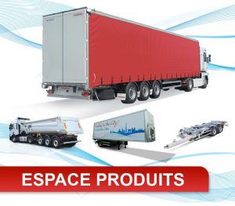

Véhicules d'occasion
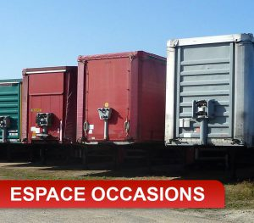

pièces de rechange
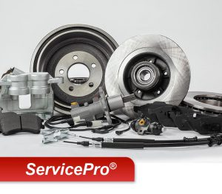

les produits

rideaux coulissants
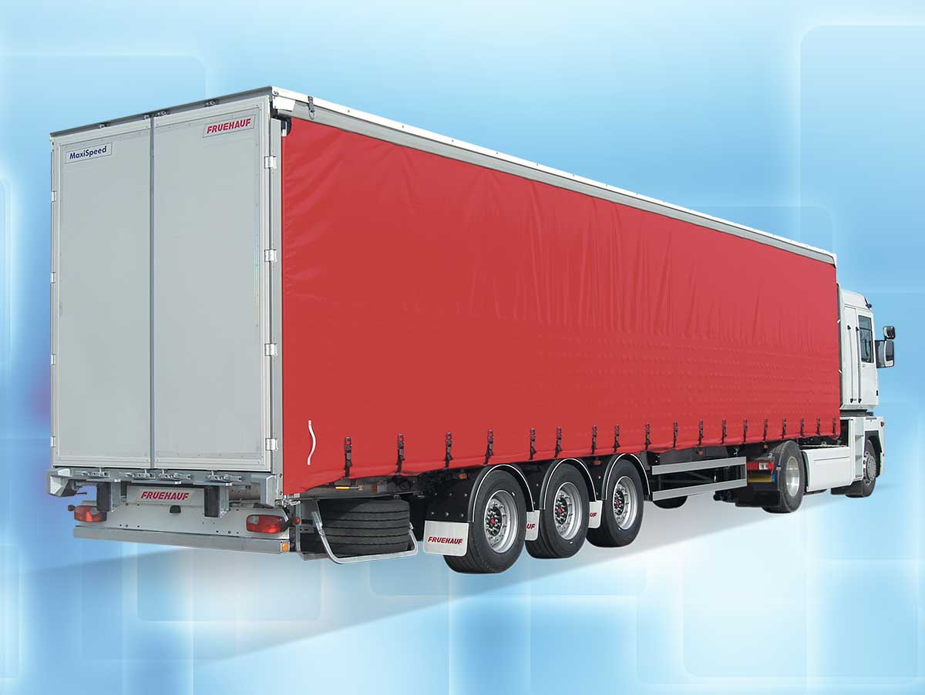
Du maxi charge au maxi volume

fourgons
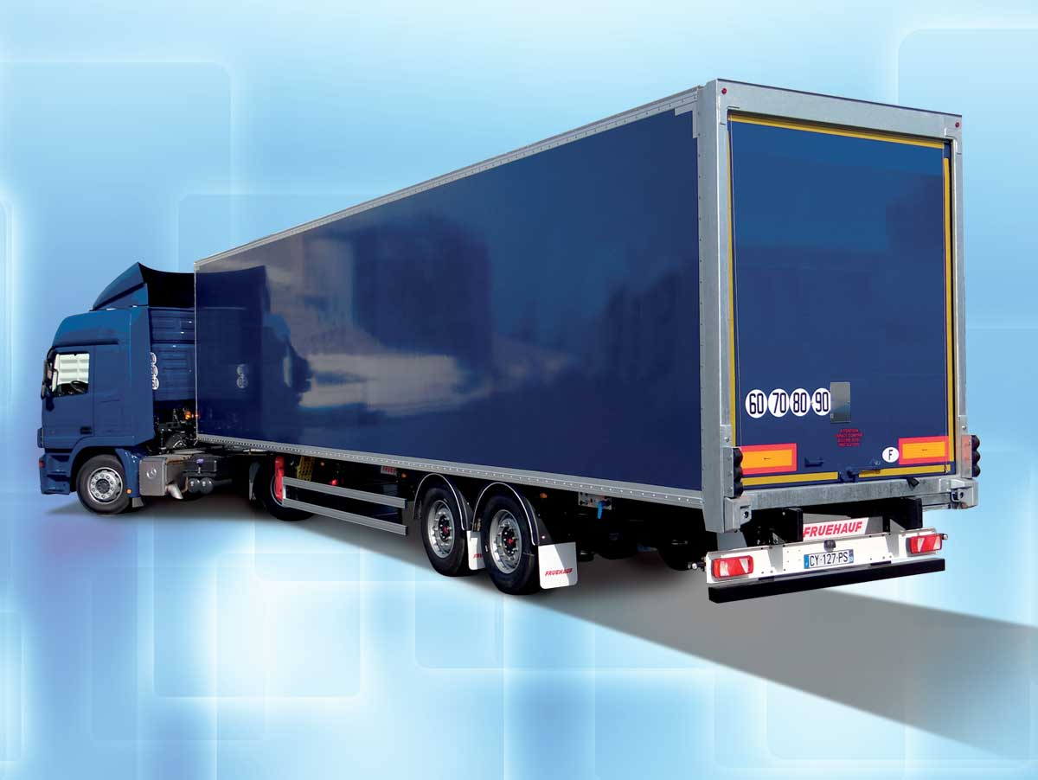
Le transport de fret en toute sécurité

City - Urban - District
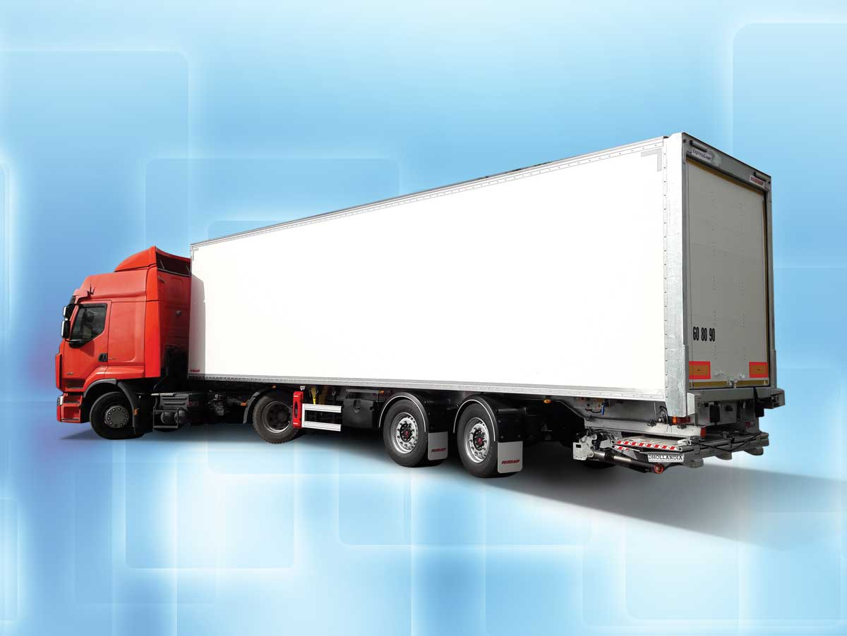
La meilleure solution pour la distribution

porte conteneurs
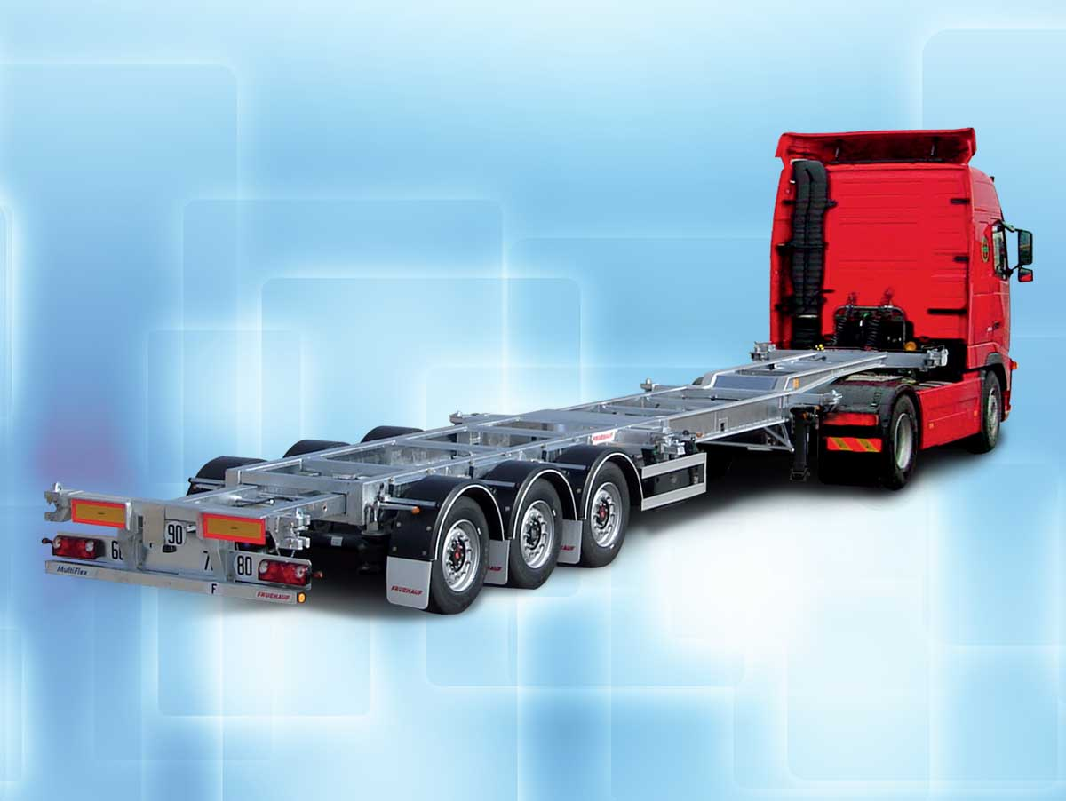
Du standard dédié au super polyvalent

plateaux
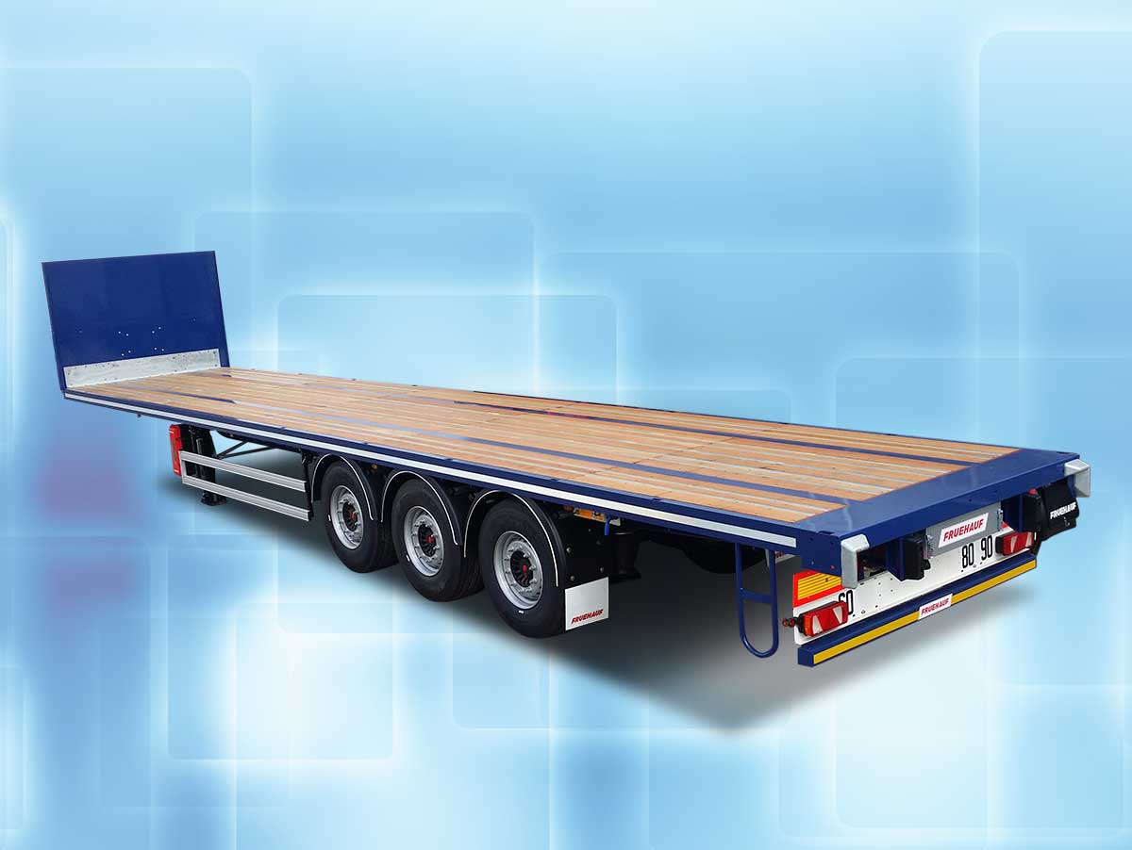
Du plus standard au plus spécialisé

remorques
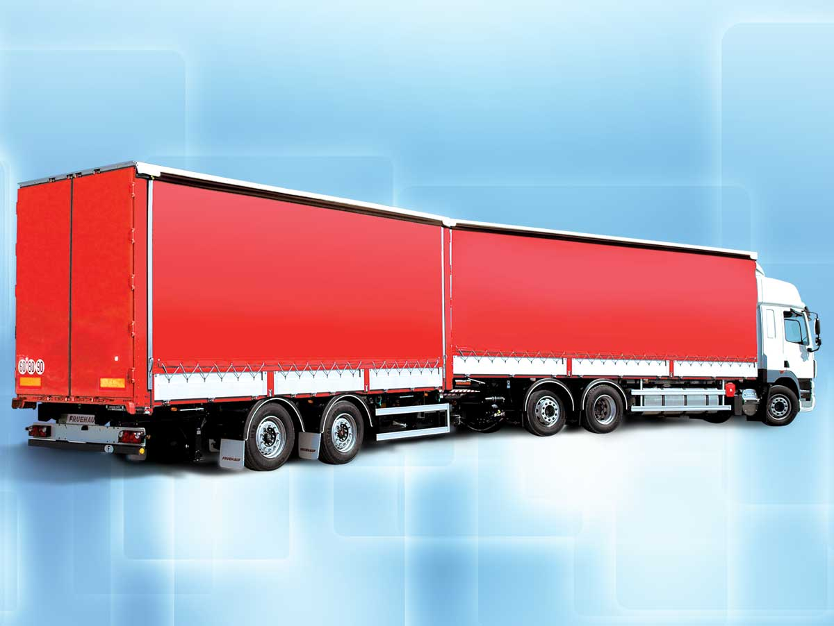
Robustesse et sur mesure au meilleur prix

bennes travaux publics
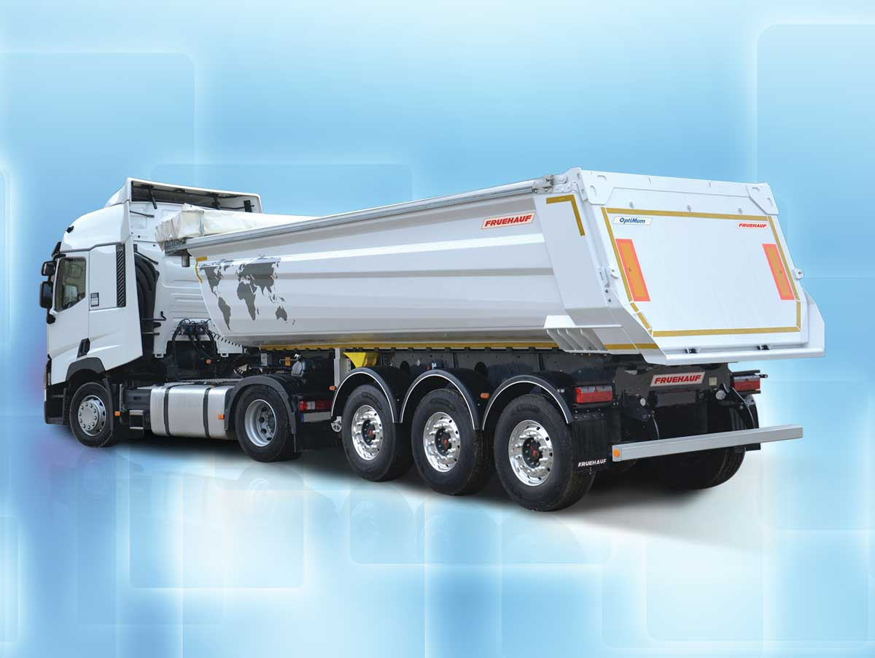
La qualité au meilleur prix

bennes grand volume
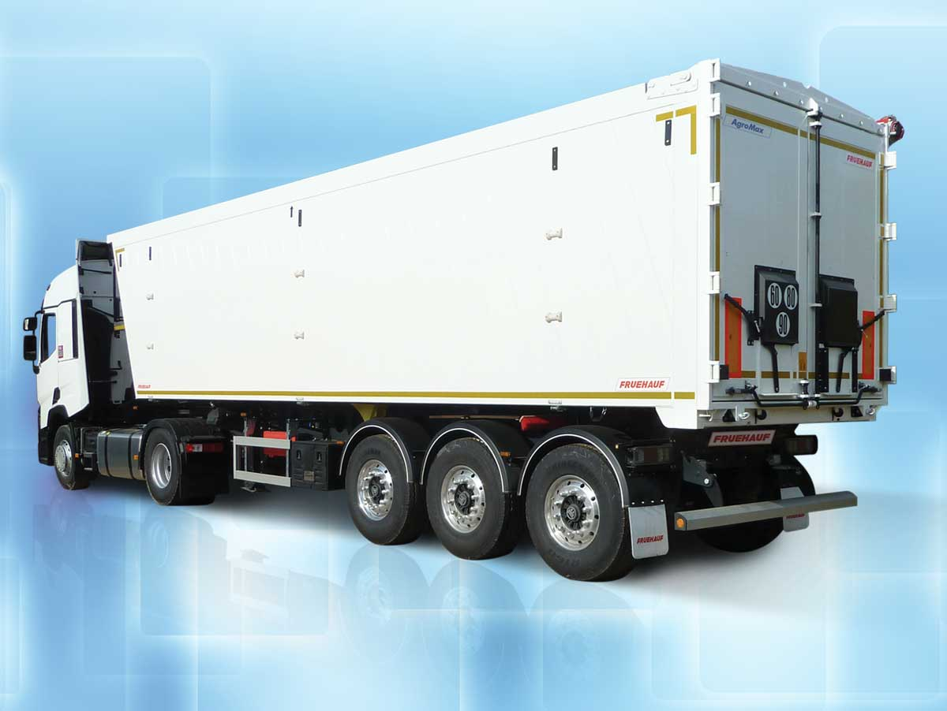
Légèreté et robustesse au meilleur prix

innovations


les services

Pièces de rechange
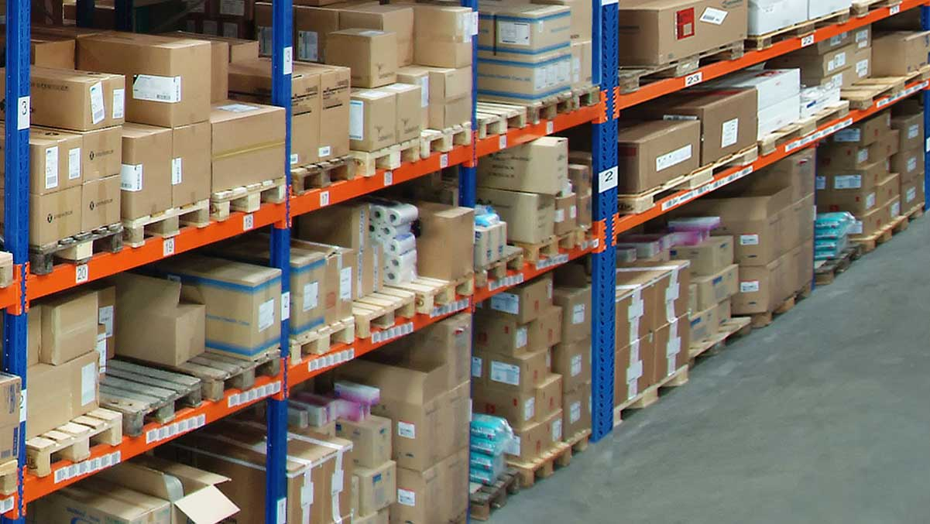

Centres Service
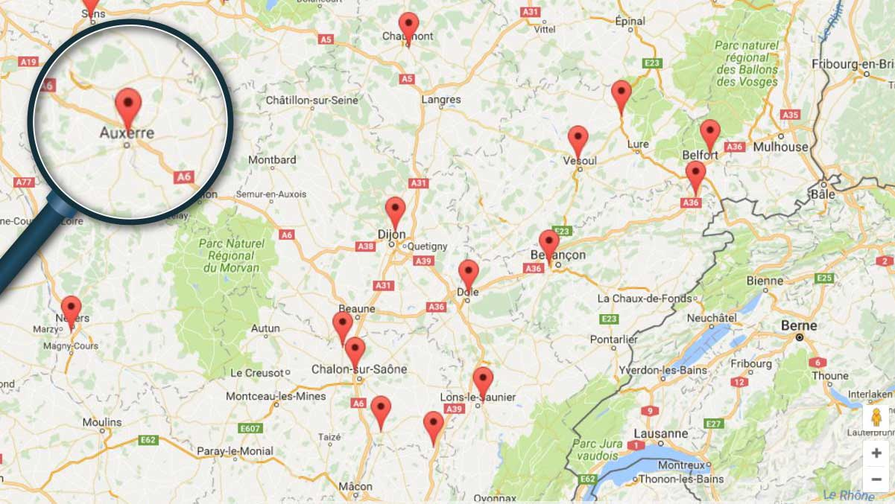

Financement


Attestations constructeur
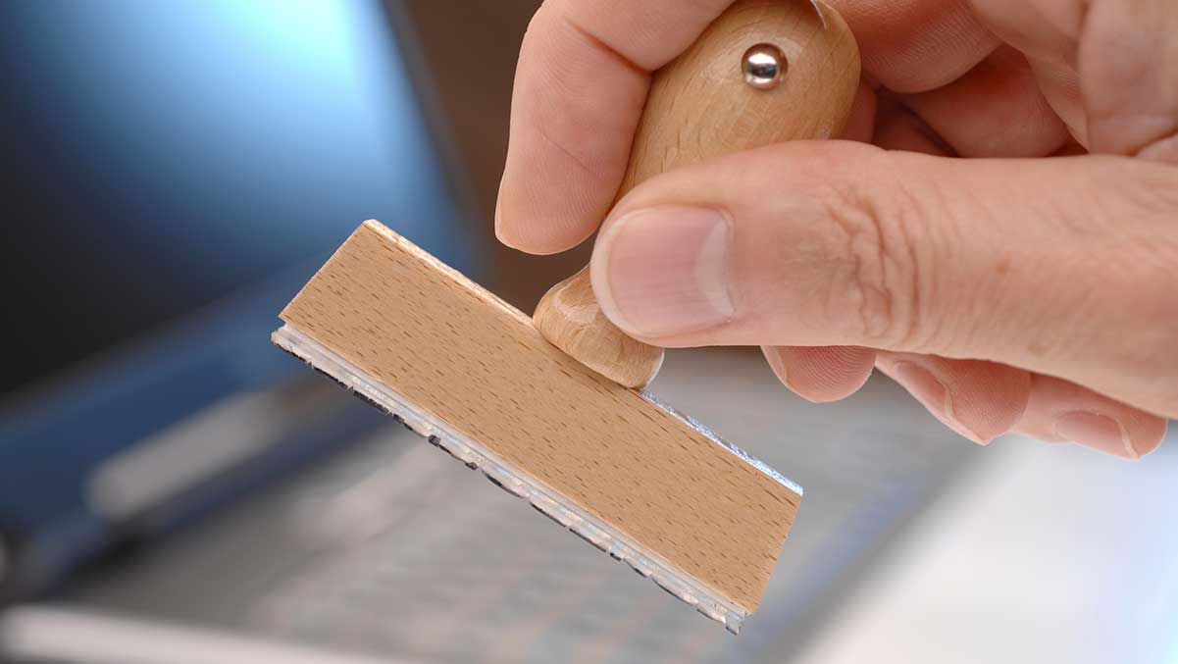

FRUEHAUF

Nos valeurs


FRUEHAUF TV
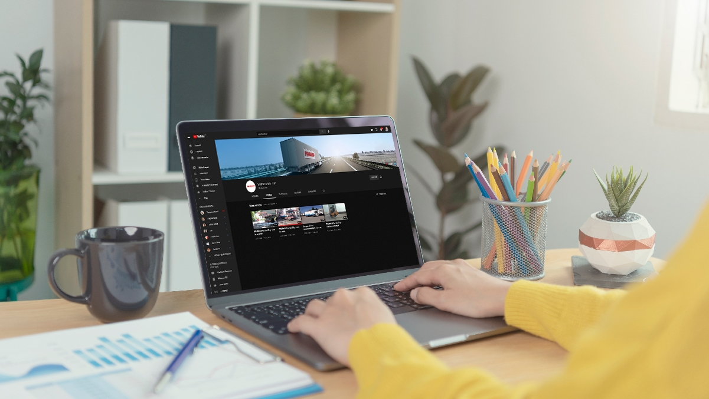

Actualités


Recrutement
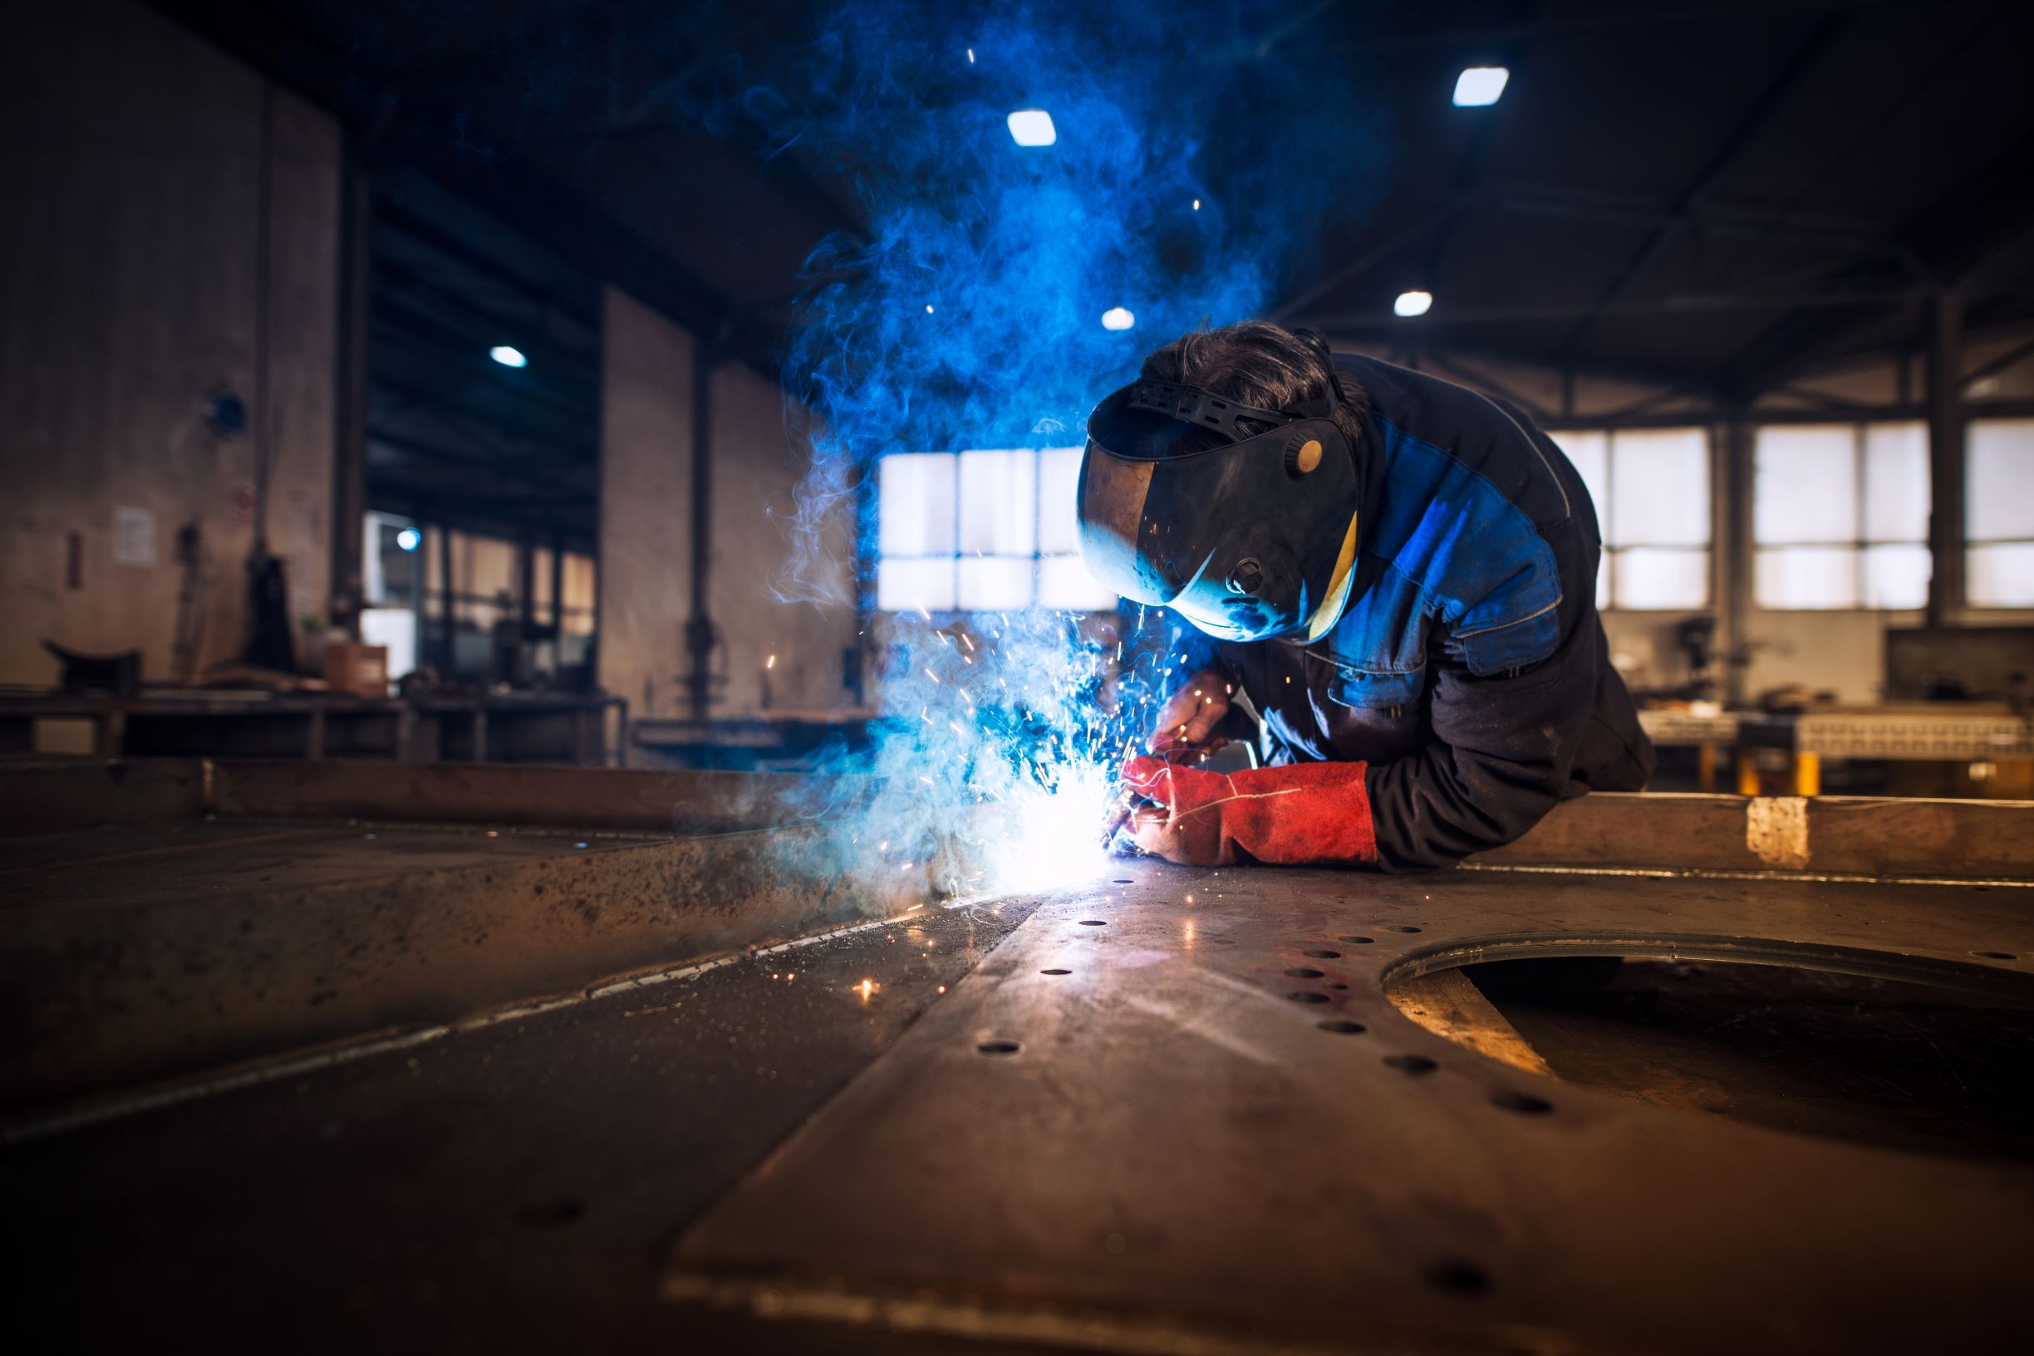

100 ans d'Innovation
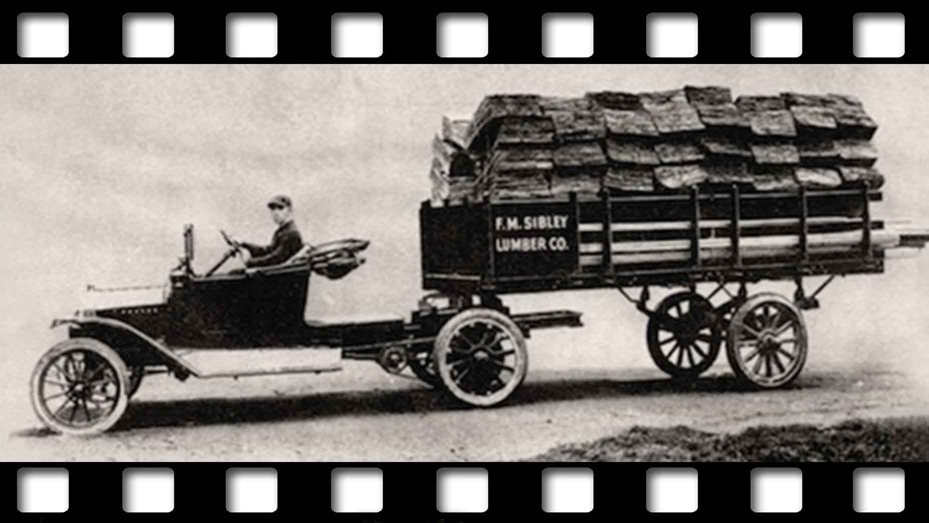

Metadata
fusion_builder_status | active
pyre_portfolio_width_100 | no
pyre_portfolio_content_length | default
pyre_portfolio_excerpt
pyre_portfolio_filters | yes
pyre_portfolio_text_layout | default
pyre_portfolio_featured_image_size | default
pyre_portfolio_column_spacing
fusion_builder_converted | yes
pyre_slider_type | no
pyre_slider | 0
pyre_wooslider
pyre_revslider | one-page-lp
pyre_elasticslider | 0
pyre_slider_position | default
pyre_avada_rev_styles | default
pyre_fallback
pyre_demo_slider
pyre_main_top_padding
pyre_main_bottom_padding | 0px
pyre_hundredp_padding
pyre_show_first_featured_image | no
pyre_display_header | yes
pyre_header_100_width | default
pyre_header_bg_color
pyre_header_bg_opacity
pyre_header_bg
pyre_header_bg_full | no
pyre_header_bg_repeat | repeat
pyre_displayed_menu | 3
pyre_display_footer | default
pyre_display_copyright | default
pyre_footer_100_width | default
pyre_sidebar_position | default
pyre_sidebar_bg_color
pyre_page_bg_layout | default
pyre_page_bg_color
pyre_page_bg
pyre_page_bg_full | no
pyre_page_bg_repeat | repeat
pyre_wide_page_bg_color
pyre_wide_page_bg
pyre_wide_page_bg_full | no
pyre_wide_page_bg_repeat | repeat
pyre_page_title | no
pyre_page_title_breadcrumbs_search_bar | default
pyre_page_title_text | default
pyre_page_title_text_alignment | default
pyre_page_title_custom_text
pyre_page_title_text_size
pyre_page_title_custom_subheader
pyre_page_title_custom_subheader_text_size
pyre_page_title_font_color
pyre_page_title_100_width | default
pyre_page_title_height
pyre_page_title_mobile_height
pyre_page_title_bar_bg_color
pyre_page_title_bar_borders_color
pyre_page_title_bar_bg
pyre_page_title_bar_bg_retina
pyre_page_title_bar_bg_full | default
pyre_page_title_bg_parallax | default
pyre_sidebar_sticky | default
pyre_page_title_line_height
kd_featured-image-2_page_id
kd_featured-image-3_page_id
kd_featured-image-4_page_id
kd_featured-image-5_page_id
pyre_fallback_id
pyre_combined_header_bg_color
pyre_mobile_header_bg_color
pyre_header_bg_id
pyre_responsive_sidebar_order
pyre_page_bg_id
pyre_wide_page_bg_id
pyre_page_title_subheader_font_color
pyre_page_title_bar_bg_id
pyre_page_title_bar_bg_retina_id
sbg_selected_sidebar | Array
sbg_selected_sidebar_replacement | Array
sbg_selected_sidebar_2 | Array
sbg_selected_sidebar_2_replacement | Array
avada_post_views_count | 20959
avada_today_post_views_count | 73
avada_post_views_count_today_date | 07-03-2024

