Fruehauf - Semi-trailers Tippers Van City
Author | Guillaume Calviac
Date | 2021-01-14 15:49:58
Categories

New Vehicles
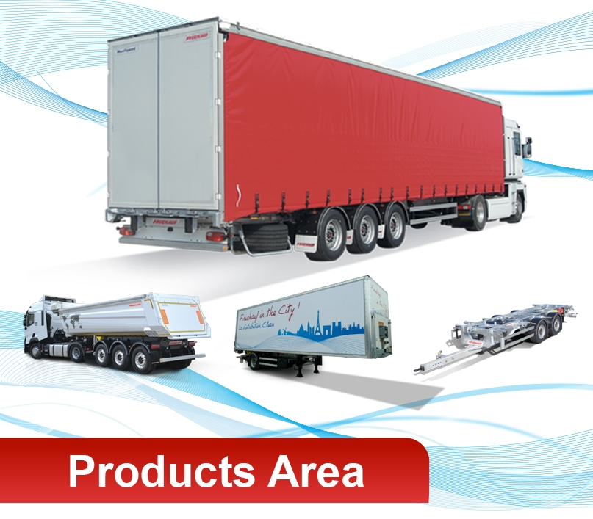

Second-hand vehicles
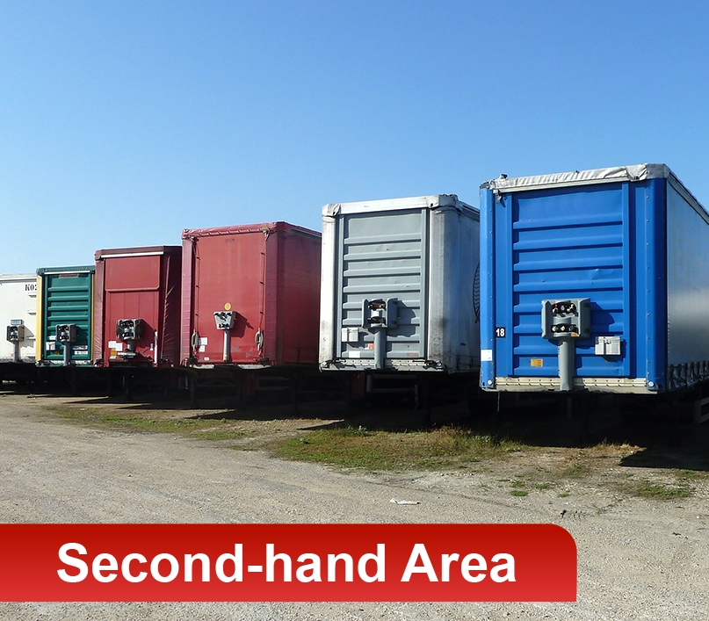

Spare parts
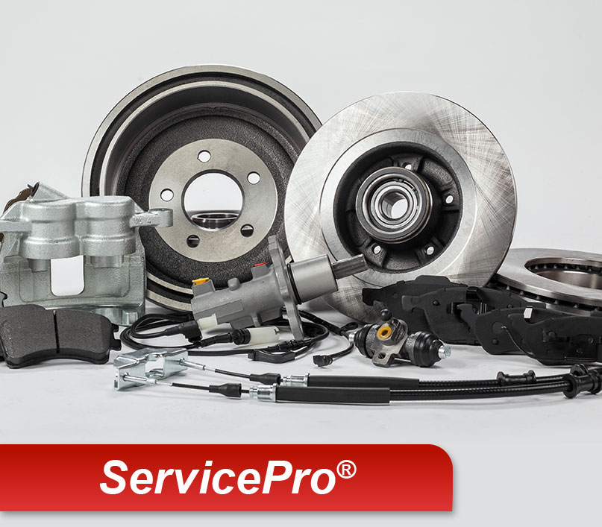

The products

Curtainsiders
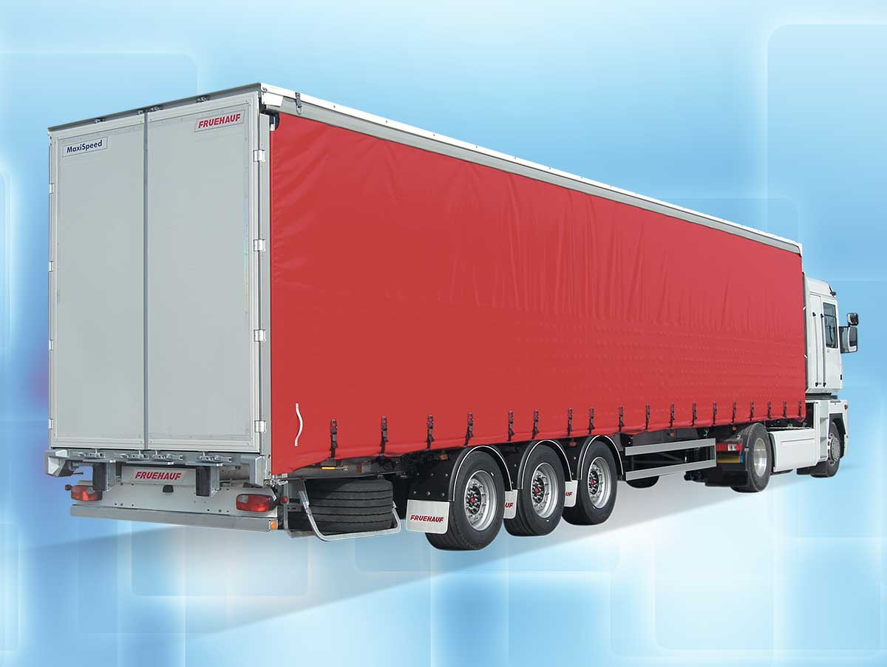
From maximum load to maximum volume

Van
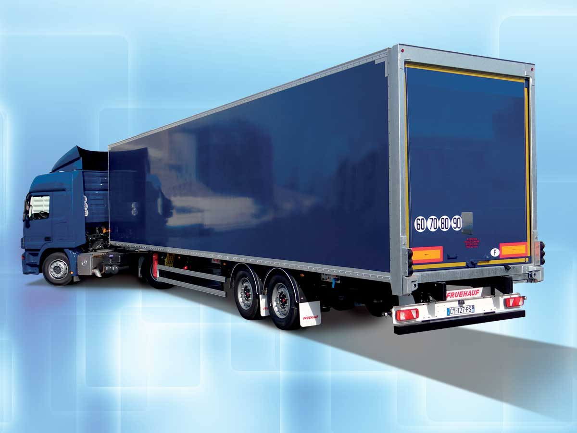
Secure freight transport

City - Urban - District
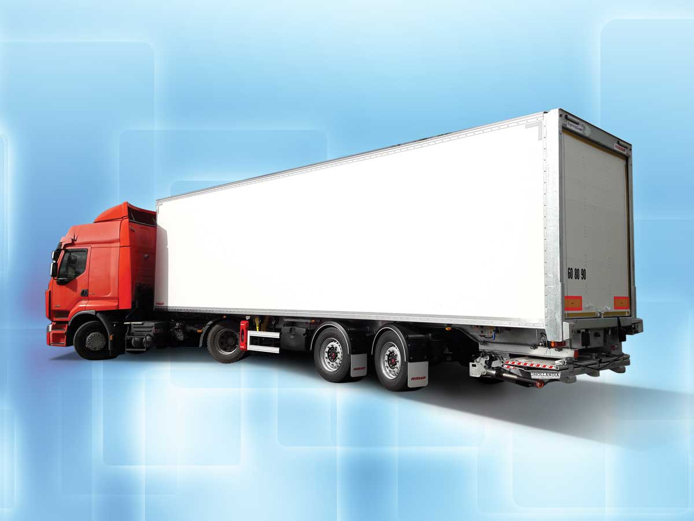
The best solution for distribution

Container Chassis & swap bodies
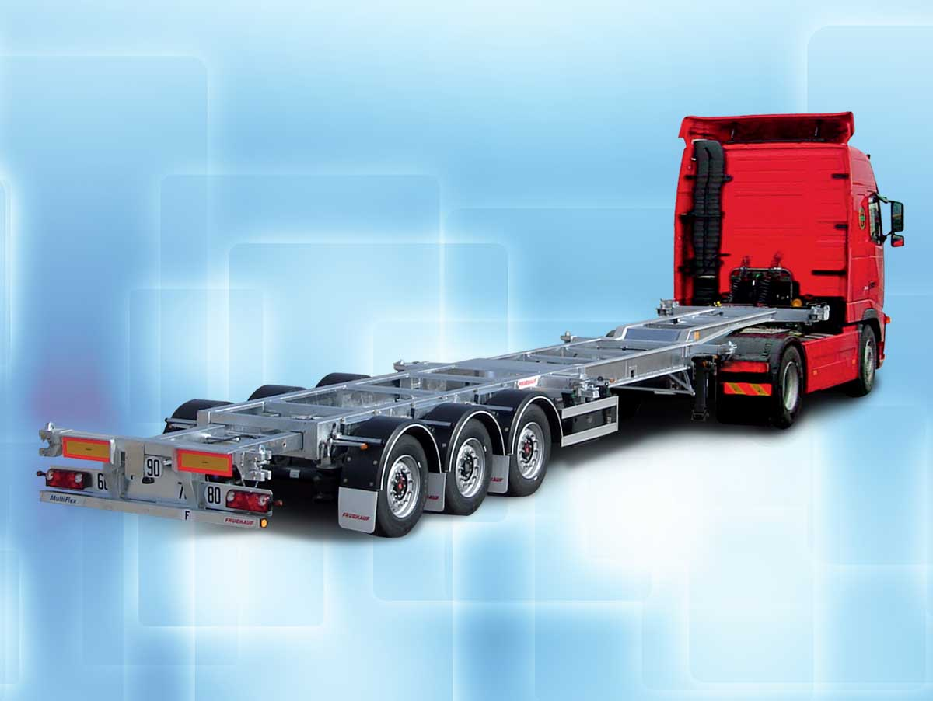
From standard dedicated to super versatile

Platforms
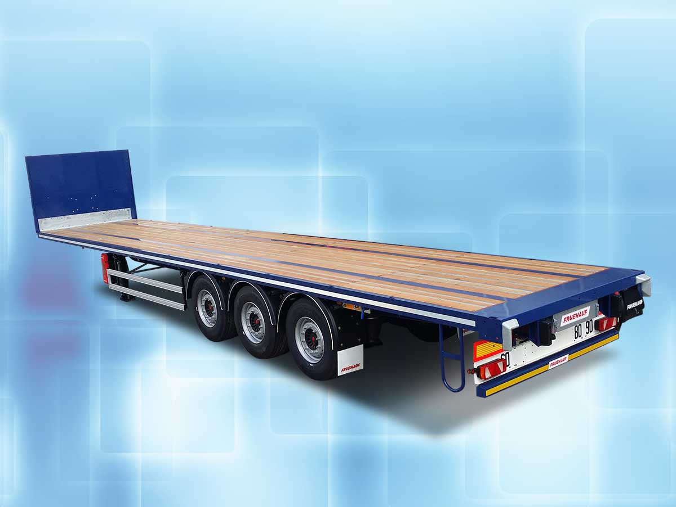
From standard to specialised

Trailers
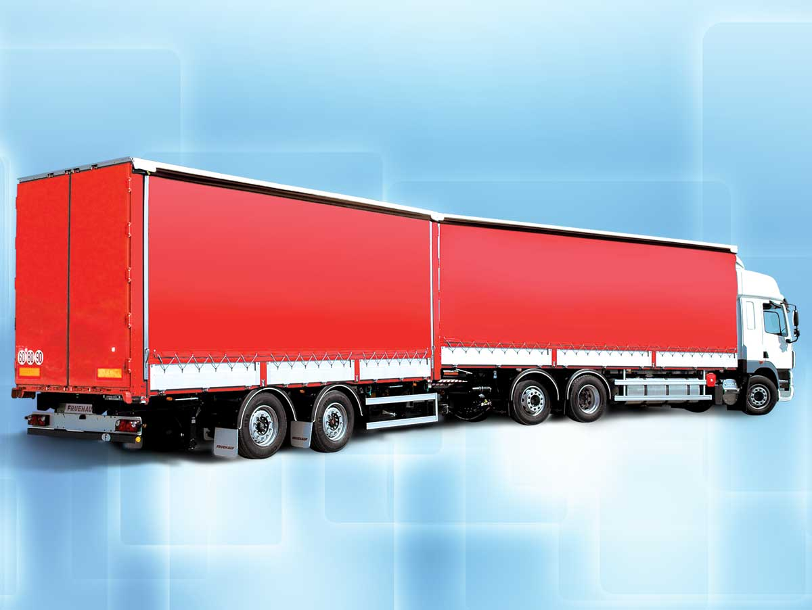
Sturdy and tailored at the best price

Public Work Tippers
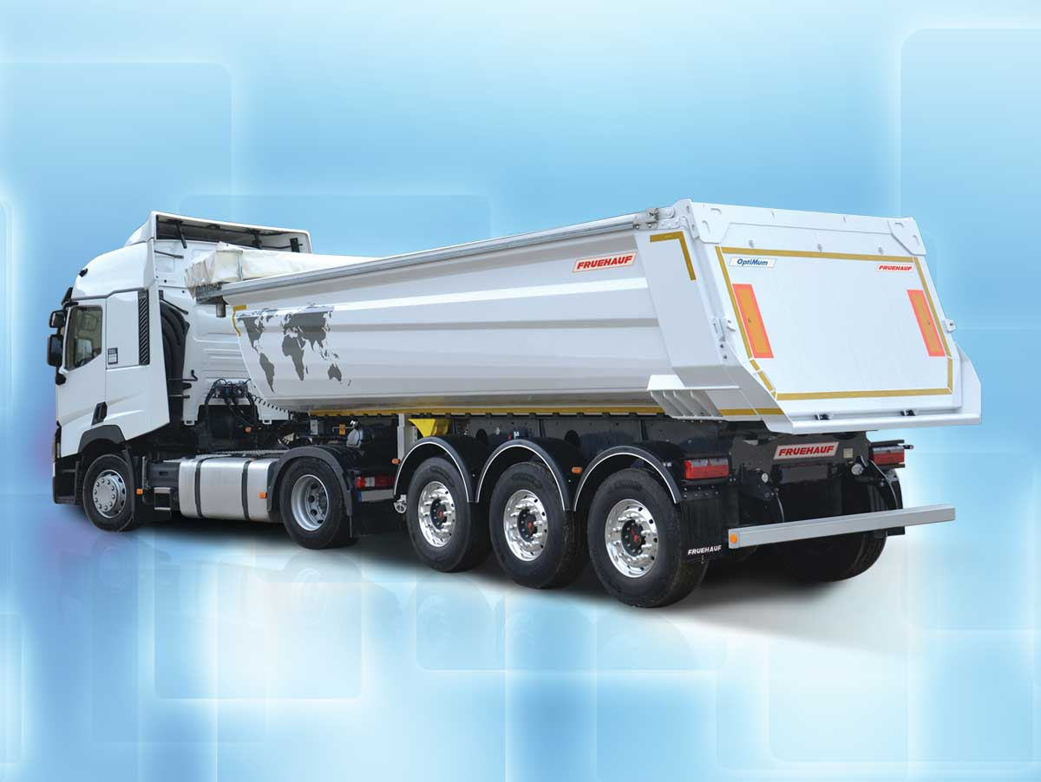
Quality at the best price

LARGE VOLUME TIPPERS
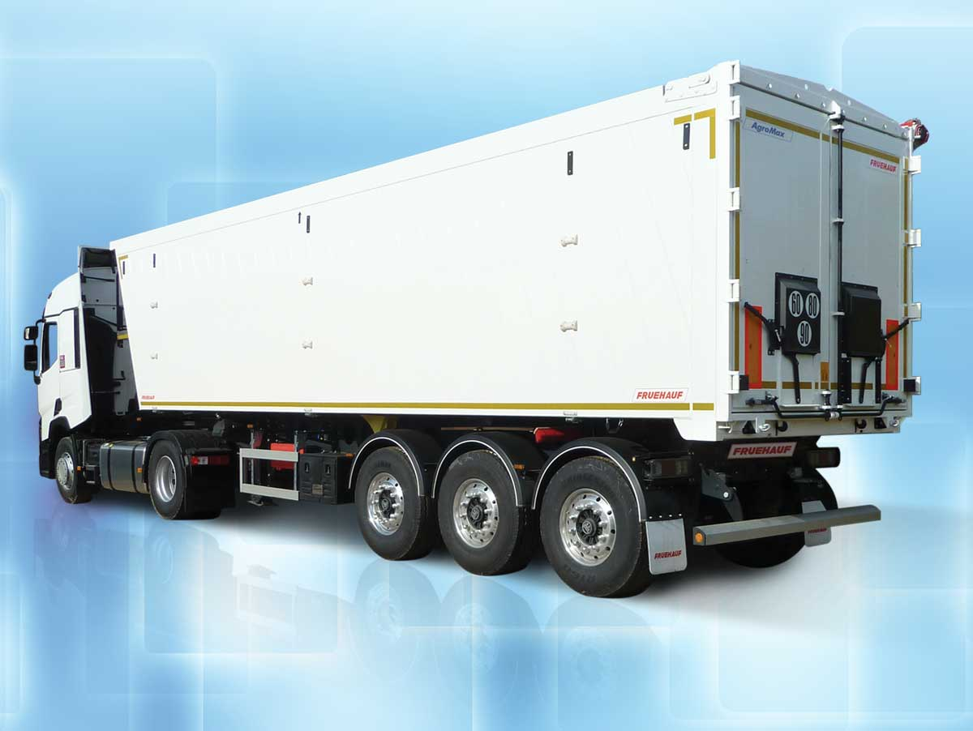
Lightness and robustness at the best price

innovations


The Services

Spare parts
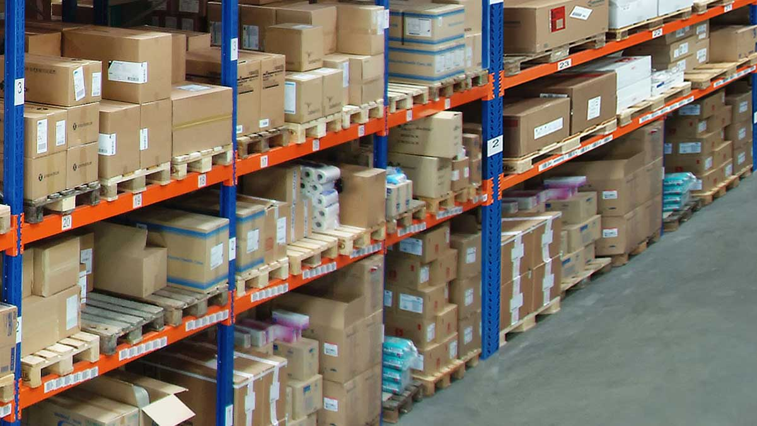

Service Centers
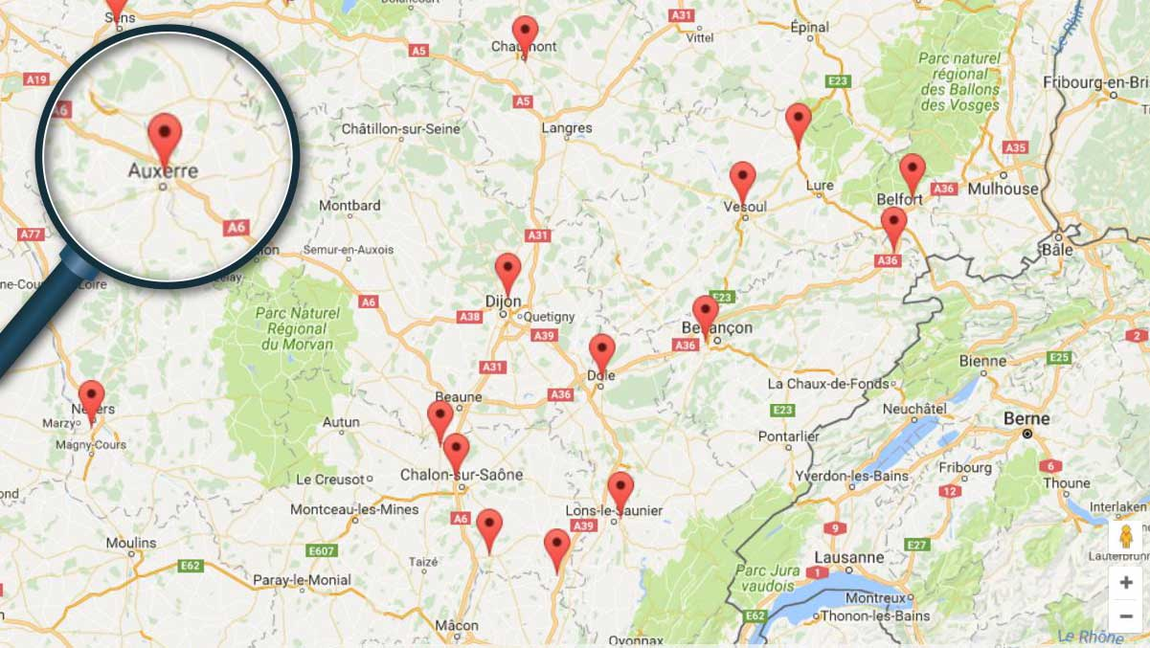

Finance


Manufacturer certificate
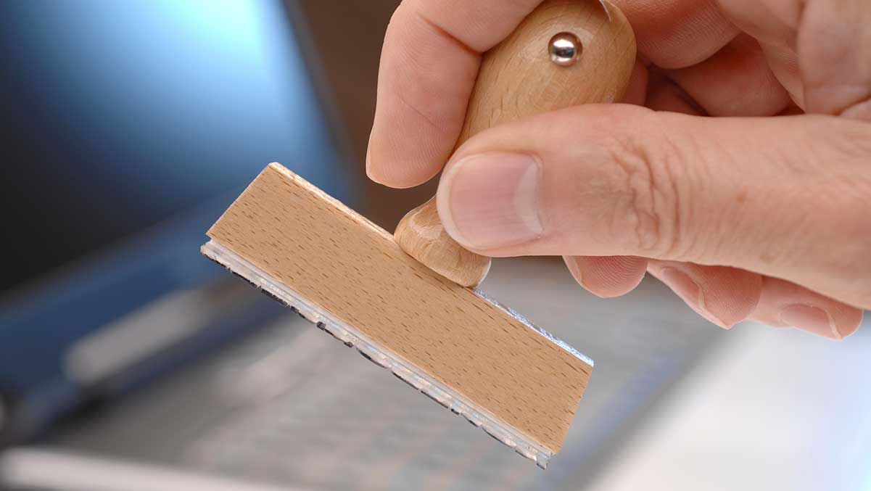

FRUEHAUF

Our values


100 years of Innovation
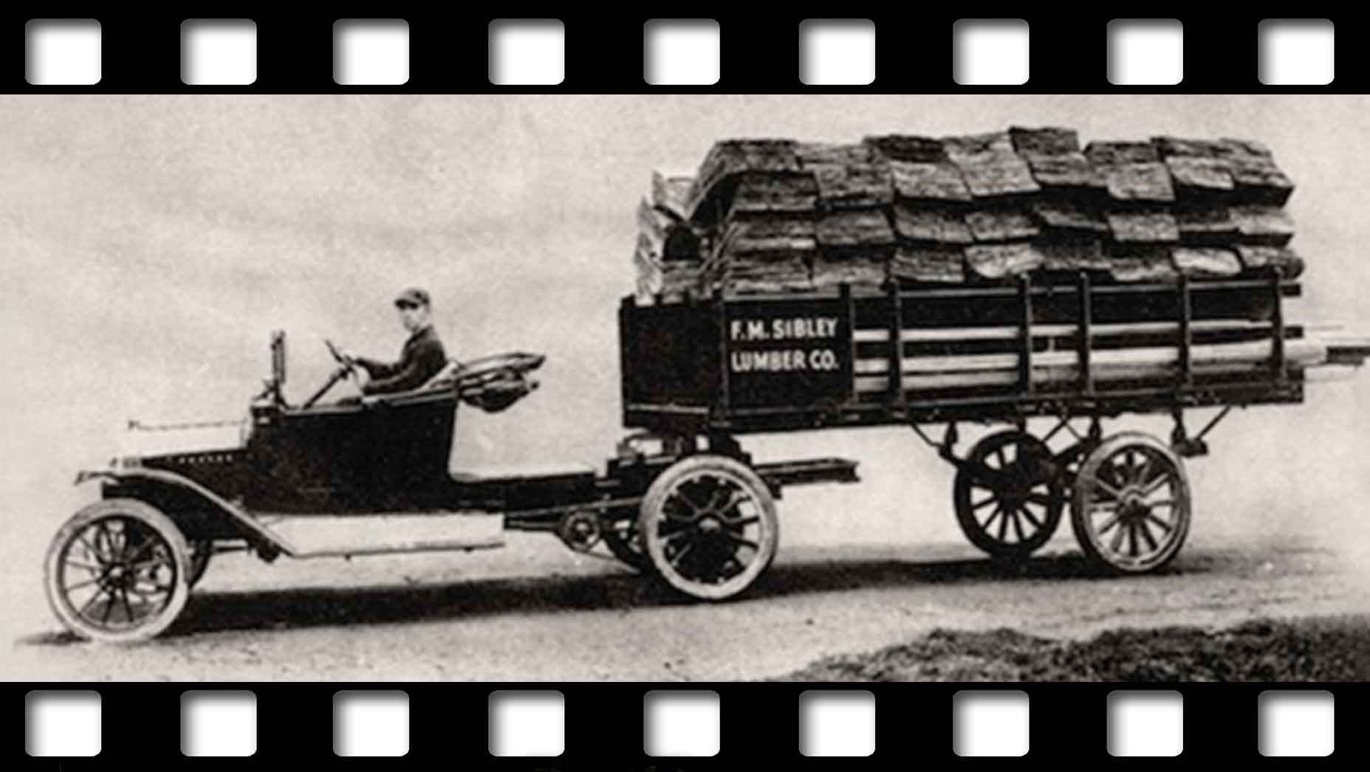

Metadata
pyre_slider_type | no
pyre_slider | 0
pyre_wooslider
pyre_revslider | 0
pyre_elasticslider | 0
pyre_slider_position | default
pyre_avada_rev_styles | default
pyre_fallback
pyre_fallback_id
pyre_demo_slider
pyre_main_top_padding
pyre_main_bottom_padding
pyre_hundredp_padding
pyre_show_first_featured_image | no
pyre_display_header | yes
pyre_header_100_width | default
pyre_combined_header_bg_color
pyre_mobile_header_bg_color
pyre_header_bg
pyre_header_bg_id
pyre_header_bg_full | no
pyre_header_bg_repeat | repeat
pyre_displayed_menu | default
pyre_display_footer | default
pyre_display_copyright | default
pyre_footer_100_width | default
pyre_sidebar_position | default
pyre_responsive_sidebar_order
pyre_sidebar_sticky | default
pyre_sidebar_bg_color
pyre_page_bg_layout | default
pyre_page_bg_color
pyre_page_bg
pyre_page_bg_id
pyre_page_bg_full | default
pyre_page_bg_repeat | default
pyre_wide_page_bg_color
pyre_wide_page_bg
pyre_wide_page_bg_id
pyre_wide_page_bg_full | default
pyre_wide_page_bg_repeat | default
pyre_page_title | default
pyre_page_title_breadcrumbs_search_bar | default
pyre_page_title_text | default
pyre_page_title_text_alignment | default
pyre_page_title_custom_text
pyre_page_title_text_size
pyre_page_title_line_height
pyre_page_title_font_color
pyre_page_title_custom_subheader
pyre_page_title_custom_subheader_text_size
pyre_page_title_subheader_font_color
pyre_page_title_100_width | default
pyre_page_title_height
pyre_page_title_mobile_height
pyre_page_title_bar_bg_color
pyre_page_title_bar_borders_color
pyre_page_title_bar_bg
pyre_page_title_bar_bg_id
pyre_page_title_bar_bg_retina
pyre_page_title_bar_bg_retina_id
pyre_page_title_bar_bg_full | default
pyre_page_title_bg_parallax | default
fusion_builder_status | active
kd_featured-image-2_page_id
kd_featured-image-3_page_id
kd_featured-image-4_page_id
kd_featured-image-5_page_id
sbg_selected_sidebar | Array
sbg_selected_sidebar_replacement | Array
sbg_selected_sidebar_2 | Array
sbg_selected_sidebar_2_replacement | Array
pyre_header_bg_color
pyre_portfolio_excerpt
pyre_portfolio_filters | yes
pyre_portfolio_width_100 | no
pyre_header_bg_opacity
avada_post_views_count | 836
avada_today_post_views_count | 4
avada_post_views_count_today_date | 12-12-2023

